Automatic Detecting Particles Approach using AdaBoost-SVM

JIANFEI YANG, TAKESHI OHASHI, TAKUO YASUNAGA
Department of Computer Sciences and Systems Engineering
Kyushu Institute of Technology
680-4 Kawazu, Iizuka-shi, Fukuoka, 820-8502, JAPAN
http://www.ohashi-lab.bio.kyutech.ac.jp

Abstract: - This paper describes that actomyosin complex particles are automatically detected. We propose a new approach, which combines the cascading classifier based on AdaBoost algorithm to select features with SVM classifier to detect actomyosin complex particles automatically. Experimental results show that the detection rate achieved 94% with false positive rate of 2.14% leading to a total rate of 96.57% of examples that were correct classified and the area under the ROC curve (AUC) is 0.9705.

Key-Words: - Actomyosin complex, Cryo-EM image, AdaBoost algorithm, Cascade of classifier, Support vector machine

1 Introduction
The single particle analysis has been widely used for 3D reconstruction of large molecular complexes from cryo-EM image [1]. Owing to the low signal to noise ratio in cryo-EM images, one will require a hundreds of thousands or even million of high resolution particles, which make it impractical to manually pick the particles [2]. Myosin is the best studying molecular motor. Myosin was known to exist in muscle and non-muscle tissue. About 50% protein in a muscle cell is myosin and about 30% myosin bound to action [3]. In order to understand how myosin produces force, it is necessary to visualize the structure of myosin during a power stroke, as it goes through the cycle of splitting ATP and binding to actin. And information on the myosin bound to actin can be obtained using cryo-EM. EOS (Extensible and Object-oriented System) is a group of small tools including three-dimensional reconstruction of macromolecules [4]. For particle analysis, the particle selection is critical and become a bottleneck in high the resolution structure determination of macromolecules using cryo-EM. This is an unresolved challenging problem. This demands development of fast and accuracy detection algorithm [5]. In order to enhance detection rate, speed up detection procedure, and reduce the false positive rate such as Yongyi Yang et al. proposed SVM approach of detection for microcalcifications [6], Zeyun Yun et al. proposed feature extraction from the edge map [7], Roseman, A.M. proposed particle finding using a fast local correlation algorithm [8], and Zhu,Y. et al. proposed fast detection of generic biological particles [9]. These algorithms (most of particles are spherical and rectangular) can achieve over 90% detecting rate and false positive rate ranging from 15% to 30%. The lowest false positive rate is 4.5% with a false negative rate of 23.2%.
The paper focused mainly on automatic selection asymmetric macromolecule particles in low contrast cryo-EM image. Since actomyosin complex shape is complex, its feature extraction is very difficult. We propose a new approach that combines cascading classifier based on AdaBoost algorithm to select features with SVM (support vector machine) classifier to detect actomyosin complex particles automatically.
The feature extraction of actomyosin particle will be key problems. In the system, the feature is computed using Haar-like rectangle feature and integral image, in which actomyosin particles are computed rapidly. Also, we adopt cascade of classifier for the purpose of achieving a high detection performance and reducing computational time radically. The learning goal for the cascade is to construct the efficient a set classifiers, which reject a large majority of negative sub-windows while detecting most of all positive examples. SVM classifier is used as final classifier to improve performance of classifier. The decision function of SVM classifier is computed by Support Vectors (SVs) that can represent all the information about classification in the training examples. The number of SVs is quite small compared with a total number of training examples. Our experimental results show that the number of SVs is approximately 13.14% of a total number of training examples, and so training time for SVM classifier is reduced. And the paper combines cascaded classifier based on AdaBoost algorithm to select features out of huge dataset, so that the detection process is speeded up. Therefore, training speed of system is faster than ANN (artificial neural network) or other methods. The paper is organized as follows: In section 2, the architecture of Ada-SVM, feature selection based on AdaBoost algorithm and SVM classifier are described. In section 3, the implementation of the automatic detection system is represented. The experimental results are presented in section 4. In the last section conclusions and a look towards future research are represented.

2 The Architecture of Ada-SVM
2.1 The Architecture of Ada-SVM
A combination approach, in which the actomyosin particle features are selected by AdaBoost algorithm and used for a reduced representation for training SVM (simplified Ada-SVM). The main idea of designing Ada-SVM is that actomyosin particle feature is computed very rapidly using Haar-like rectangle feature and integral image. And this system combines the cascading classifier with SVM classifier to speed up detection process and improve classifier performance. The architecture of Ada-SVM is shown in Fig. 1.
Fig. 1 The architecture of Ada-SVM

The automatic detection system is made up of two major parts of cascade and SVM. The first part consists of three stages cascade of classifiers. In the cascade, the multi-weak classifiers construct a strong classifier. The features of actomyosin particle are extracted using weak classifier with T round of boosting and AdaBoost algorithm is used to select a small number of the important features out of huge feature space given the training set to speed up detection process. The second part is composed of SVM classifier that is used for the final classifier and implement binary classes.

2.2 Haar-like Feature Types and Integral Image
Actomyosin particle is described by the over-complete Haar-like features. These are very simple features that compute very rapidly using the integral image. Four Haar-like feature types [10] are shown in Fig. 2.
Haar-like feature type is described as follows. The sum of pixels which lie within the white rectangles are subtracted from the sum of pixels in the grey rectangles. Since the two rectangle features defined above involve adjacent rectangular sums they can be computed in six array references, the case of the three-rectangular features can be computed in eight array references, and the special diagonal line features can be computed in nine array references.
Fig. 2 Four types of simple Haar-like feature
Rectangle features can be computed very rapidly using the integral image [11]. An integral image ii over an image i is defined as follow:
(1)
$$\text{ii}(\text{x,y})=\sum_{\text{x'}≤\text{x,y'}≤y}{i(x'\text{,y'})}$$

Any rectangular feature sum of pixels can be computed and shown in Fig.3.
Fig. 3 Computing the sum of the pixels within rectangle D

The sum of the pixels within rectangle D is computed with four array references: The value of the integral image at location 1 is the sum of the pixels in rectangle A, the value at location 2 is A+ B, the value at location 3 is A+ C, and the value at location 4 is A+B +C +D. Therefore, the sum within D is computed as (4+1)-(2+3).

2.3 Weak Classifier and AdaBoost Algorithm
In the paper, actomyosin feature is extracted using weak classifier and a few important features are selected using AdaBoost algorithm. Each weak classifier can be trained by one feature. Multiple the weak classifiers construct a final strong classifier. A weak classifier h_{j} (x) is defined as follows.
$$h_{j}(x)=\begin{aligned}\left\{1\text{ if }p_{j}f_{j}(x)<p_{j}θ_{j} | \right.\end{aligned}$$
(2)
Where x is sub-window of an image. $θ$_{j} is a threshold, and polarity p_{j} indicates the direction of the inequality sign.
The weak learning algorithm is designed to select the single rectangle feature which best separates the positive and negative examples. For each feature, the weak classifier determines the optimal threshold classification, so that incorrect classified examples are achieved a minimum. The fact is that training a weak classifier corresponds to setting its threshold.
AdaBoost algorithm [12] is described as follows.

◇Input: Training examples (x_{i} , y_{i}) , i=1, …, N with
positive (y_{i}=1) and negative (y_{i}=0) examples.

◇Initialize weights $w_{1,i}=\frac{1}{2m},\frac{1}{2l}$ with m negative
and l positive examples.
◇For t=1,…, T:
a) Normalize all weights
b) For each feature j train classier h_{j} with error
$ε_{j}=\sum{w_{t,i}\left|h_{j}(x_{i})−y_{i}\right|}$
c) Choose the best classifier ht with the lowest
error $ε_{t}$.
d) Update weights:
$w_{t+1,i}=w_{t,i}β_{t}^{1−e_{i}}$ with
$e_{i}=\begin{aligned}\left\{0:x_{i}\text{ correctly classified} | \right.\end{aligned}$ and $β_{t}=\frac{ε_{t}}{1−ε_{t}}$
◇Final strong classifier:
$h(x)=\begin{aligned}\left\{1:\sum{α_{t}h_{t}(x)}≥0\text{.}5\sum{α_{t}} | \right.\end{aligned}$ with $α_{t}=\text{log}(\frac{1}{β_{t}})$

The main idea of AdaBoost is to combine multiple weak classifiers to create a strong classifier with error rate much small than weak’s one. The final strong classifier is a weighted linear combination of the all T weak classifiers. The AdaBoost repeats over a number of T rounds. In each round, the space of all the features is searched exhaustively to train weak classifiers. And the best weak classifier h_{t} with the lowest error ε_{t} is chosen. After each round, all training examples are re-weighted. For incorrectly classified the examples, the weight will be increased, while the examples are classified correctly the weights will be decreased. In the next round, the new classifier will focus much more on previously misclassified examples (called the hard examples). Therefore, AdaBoost algorithm’s goal is to select a few important features out of huge feature spaces given the training set of positive and negative example image. In this paper, C4.5 decision tree is used as the weak classifier.
2.4 Non- linear SVM classifier
SVM is a separation hyperplane with its separation margin maximized and the number of incorrectly classified examples minimized [13]. By minimizing the number of training errors, SVM seeks good performance on the training data. By maximizing the margin, the generalization error is optimized. For a two-class classification problem, assume that we have a set of examples. Given the training data (x_{i} ,y_{i} ) where i= 1, 2,… ,n , x_{i}∈R^{d} , y_{i}∈{-1,+1}. Here -1 and +1 indicate the two classes. The goal is to construct a binary classifier or derive a decision function from the available examples. In non-linear case, SVM maps the training data nonlinearly into a higher-dimensional feature space via K (x_{i} ,x_{j}) and construct a separating hyperplane with maximum margin. This yields a nonlinear decision boundary in input space. By the use of kernel function, it is possible to compute the separating hyperplane without explicitly carrying out the map into the feature space. Support vectors are elements of training set that lie on the boundary hyperplanes of the two classes. The mapping function is performed by a kernel function. If we deal with Hilbert space, one only has to calculate the inner products between the support vectors and the feature vectors. The inner product in Hibert space is computed through a kernel function K(x_{i} , x_{j}):K(x_{i},x_{j})=φ(x_{i})φ(x_{j}).
The optimal hyperplane is the one with the maximal distance to the closest training data. This optimization is a convex quadratic programming problem.
$$\text{Max }W(α)=\sum_{i=1}^{n}{α_{i}−\frac{1}{2}}\sum_{i,j=1}^{n}{α_{i}α_{j}y_{i}y_{j}K(x_{i},x_{j})}$$
(3)
Subject to:
$\sum_{i=1}^{n}{y_{i}α_{i}=0}$ $i=1,\text{.}\text{.}\text{.}\text{,n}$ $0≤α≤C$
(4)
C is a regularization parameter, which controls the trade off between margin and misclassification error. The x_{j} are called support vectors only if the corresponding α_{i} >0. The decision function is
$f(x)=\sum_{i=1}^{n}{α_{i}^{}y_{i}K(}x_{i}⋅x)+b$ (5)

3 Implementation
Cryo-EM image of actomyosin complex is acquired by Yasunaga Lab. Cryo-EM image resolution is 1.72Å/pixel, image size is 2048×2048 pixels with 16bit gray level image, and file format is mrc. We design a 210×210 pixels window and shift it to obtain many actomyosin sub-images from region of interesting images. Then, these actomyosin sub-images are rotated at 45 degrees increments to obtain actomyosin sub-images totaled up to 1100.

3.1 Training Dataset
The example dataset contained 1100 hand labeled, scaled sub-images of actomyosin complex particle. Among 750 actomyosin particles are used as positive training examples. 1600 non-actomyosin particles are selected at different locations randomly. Among 900 non-actomyosin particles are used as negative training examples. Detection window size of actomyosin particle is 210×210 pixels and scaled to 48×48 pixels as sub-window. Remained 350 actomyosin and 700 non-actomyosin particles are used as test set. Actomyosin complex particles are shown Fig.4.

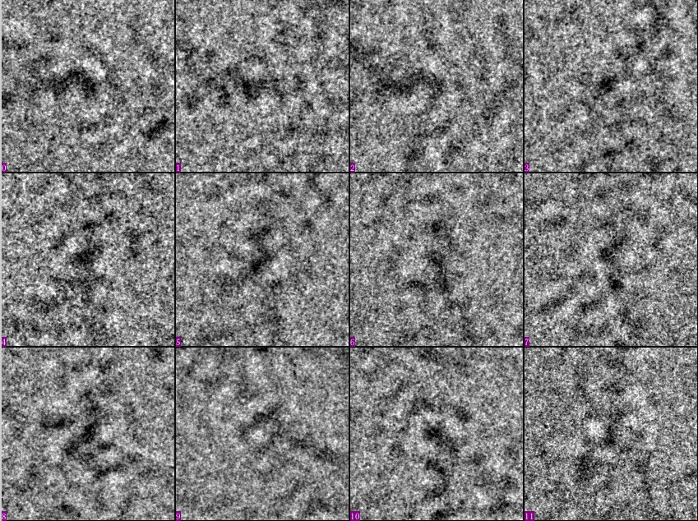
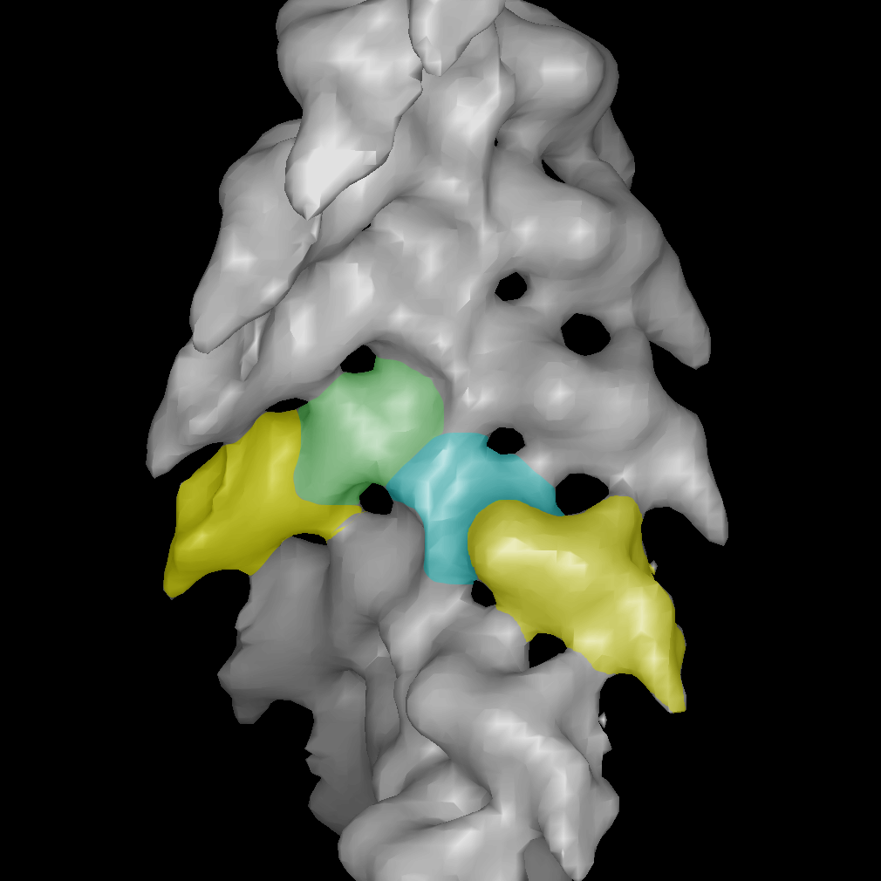

Fig.4 Actomyosin complex particles and 3D map of actin and myosin.

3.2 The architecture of cascade

Cascade part consists of three-stage cascading classifiers in which a total feature is 107. Each stage in cascade is required to have a very high detection rate, and suitable false positive rate. If an input sub-windows pass through all stages of cascade, it is classified as actomyosin particles. Otherwise it is rejected as non- actomyosin particles. In the cascade, subsequent classifiers are trained using those examples that pass all the previous the stages, therefore, the second classifier is faced more difficult task than first. The examples that make it through the first stage are hard than typical examples. The cascading classifier speeds up detection procedure because it rejects many of non-particle sub-windows.
The cascade of classifier is designed as follows. The first stage cascading classifier includes 2 layers that the number of feature per layer is 2, 5 respectively. The second stage cascading classifier includes three layers that the number of features per layer is 7, 9, 11. The third stage is 4 layers in which number of features per layer is 13, 15, 20, 25, and the features totaled up to 73. Negative sub-windows about 60-80% is rejected by first layer in cascade while detecting rate per layer is approximately 99.9% of actomyosin particles. About choosing the number of stages and features, which are chosen by a trial test. The number of features per layer is chosen by a trial in which the number of features is increased until the false positive rates are a significant reduction. More stags were added until the target detection and false positive rates are met for this stage. The rates are determined by testing on the validation set.
About training, each layer of the cascade is trained by AdaBoost. The cascading classifiers with total 107 features were trained with the 750 actomyosin and 900 non-actomyosin sub-windows using the AdaBoost. The non-actomyosin sub-windows used to train subsequent classifiers were obtained by scanning the partial cascade across large non- actomyosin images and collect false positives of the previous stage.
The second part consists of SVM classifier that is final classifier of system (see Fig. 1). The features that have been selected by AdaBoost process in the third stage cascade are used for input pattern representation of SVM classifier. For each input 48×48 sub-window, these feature values before applying SVM will be scaled to [-1, +1] to form a feature vector for SVM classifier. The final SVM classifier takes 25 features of the last layer in the third stage classifier used as feature vector and trained. In the last stage in cascade, negative examples (false positives of previous stages) are more complex and similar actomyosin particles, and classify them is more difficult. And convergence speed of cascading classifier will be very slow. If we want to classify them continuously, the number of feature and stage will be added, and computed time is also increased. Therefore, we replace subsequent stages in cascade of classifier with SVM classifier that is used as the final classifier to implement better detection performance and speed up detection process.

4 Experimental Results
In our experiments, the test set consists of 25 features, 350 sub-images of actomyosin, and 700 sub-images of non-actomyosin. The 5-fold cross-validation method is used to test and select the best available parameters to implement optimization model. C= 2.18 and γ=0.135 is selected with RBF kernel function. Experimental results show that only 1.62% hard examples are put into SVM classifier to make final decision classification. The detection rate achieved 94% with false positive rate of 2.14% leading to a total rate of 96.57% of examples that were correct classified and the area under the ROC curve (AUC) is 0.9705.
The experimental results are better than other algorithm. ROC curve is shown in Fig. 5.

5 Conclusion and Future Work
The experimental results shown good performance that detection rate and detection speed are enhanced and false positive rate is reduced. The detection rate achieved 94% and false positive rate is 2.14%.
In this paper, we emphasize simple and fast feature selection out of huge dataset, and classify actomyosin particles using SVM classifier. Also this approach represents progress that macromolecule asymmetric particles in cryo-EM image are detected automatically.
We will implement comparative performance of Ada-SVM, SVM and cascade of classification. 3D reconstruction of actin and myosin are implemented in the future.

References:
[1] M.S. Jurica, D. Souca and M. Moore, Three- dimensional Structure of Complex Spliceosomes by Electron Microscopy, Nature Structural & Molecularbiology, 2004, VOL.11, 265-269.
[2] W.V. Nicholson and R.M. Glaeser, Review: Automatic Particle Detection in Electron Microscopy, Journal of structural Biology, 2001,133, 90-101.
[3] Molecular Motors: Myosin, http://www.proweb.org/myosin/
[4] T. Yasunaga and T. Wakabayashi, Journal of Structural Biology, 1996, 116,155-160.
[5] Y. Zhu, B. Carragher, R.M. Glaeser, et al., Automatic Particle Selection: Results of A Comparative Study, J Struct Biol, 2004, 145(1-2):3-14.
[6] Y. Yang, M.N. Wernick, N.P. Galatsanos, and R.M. Nishikawa, A Support Vector Machine
Approach for Detection of Mirocalcifications, IEEE Transactions on Medical Imaging, 2002, 21,1552-1563.
[7] Z. Yu and C. Bajaj, Picking Circular and Rectangular Particles Based on Geometric Feature Detection in Electron Micrographs, Journal of Structural Biology, 2004, 145,168-180.
[8] A.M. Roseman, Particle Finding in Electron Micrographs Using A Fast Local Correlation Algorithm, Ultramicroscopy, 2003, 94, 225-236.
[9] Y. Zhu, B. Carragher, and C.S. Potter, Fast Detection of Generic Biological Particles in Cryo-EM Images Through Efficient Hough Transforms, IEEE International Symposium of Biomedical Imagin, 2002, p.205-208.
[10] R. Lienhart and J. Maydt, An Extended Set of Haar-like Features for Rapid Object Detection, In Proc. IEEE Intel Conf. Image Processing, 2002, vol. 1, pp. 900-903.
[11] P. Viola and M. Jones, Rapid Object Detection Using A Boosted Cascade of Simple Features, In Proc. CVPR, 2001, pp. 511-518.
[12] P. Viola and M. Jones, Robust Real-Time Ob- ject Detection, Technical Report CRL, 2001.
[13] M.A.Hearst, B.scholkopf,and S.Dumais, Trends and Controversies-Support vector machines, IEEE Intelligent Systems, 1998, B13 (4):18-28

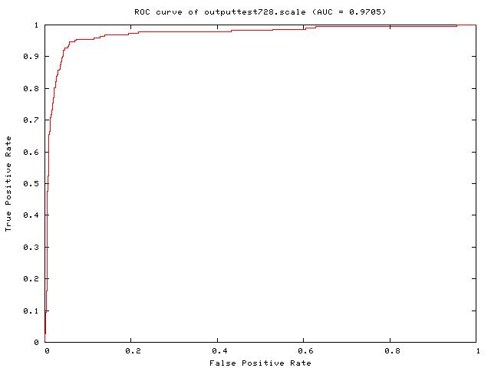

Fig.5 ROC curve using RBF kernel

