Trends in IT Empowered Enterprise Integration

ZELJKO PANIAN
The Graduate School for Economics and Business
University of Zagreb
J. F. Kennedy Sq. 6
CROATIA
http://www.efzg.hr

Abstract: - The latest IT industry contribution to business process improvement is Enterprise Application Integration (EAI), which focuses on improving a company's foundational integration architecture components. But, EAI is just one step in the enterprise integration evolution, after the data transport and data integration problems have been successfully solved. The next steps in this evolution, in our opinion, will be process integration, collaboration and ubiquitous enterprise integration. The observable trends in this context are examined in the paper.

Key-Words: - enterprise application integration, process integration, collaboration, ubiquitous integration, workflow

1 Introduction
To gain a kind of competitive advantage these days, organizations must be able to rapidly respond to changing business conditions. To respond to this quickly, they need real-time visibility into their business processes, as well as the ability to integrate numerous, disparate applications and application systems-
IT industry has responded to the market's demand for process efficiency with remarkable speed. The latest contribution to business process improvement is Enterprise Application Integration (EAI), which focuses on improving a company's foundational integration architecture components.
By integrating end-to-end business processes, workflows and data across multiple applications, the EAI value proposition is readily apparent [1]:
- increased timeliness and accuracy of information
- increased return on technology investment
- enhanced collaboration with business partners
- improved management of ubiquitous interactions that extend beyond the boundaries of the organization.
But, these results were not achieved overnight – they were achieved through an evolutionary development process.
This evolution is schematically presented in Fig. 1.

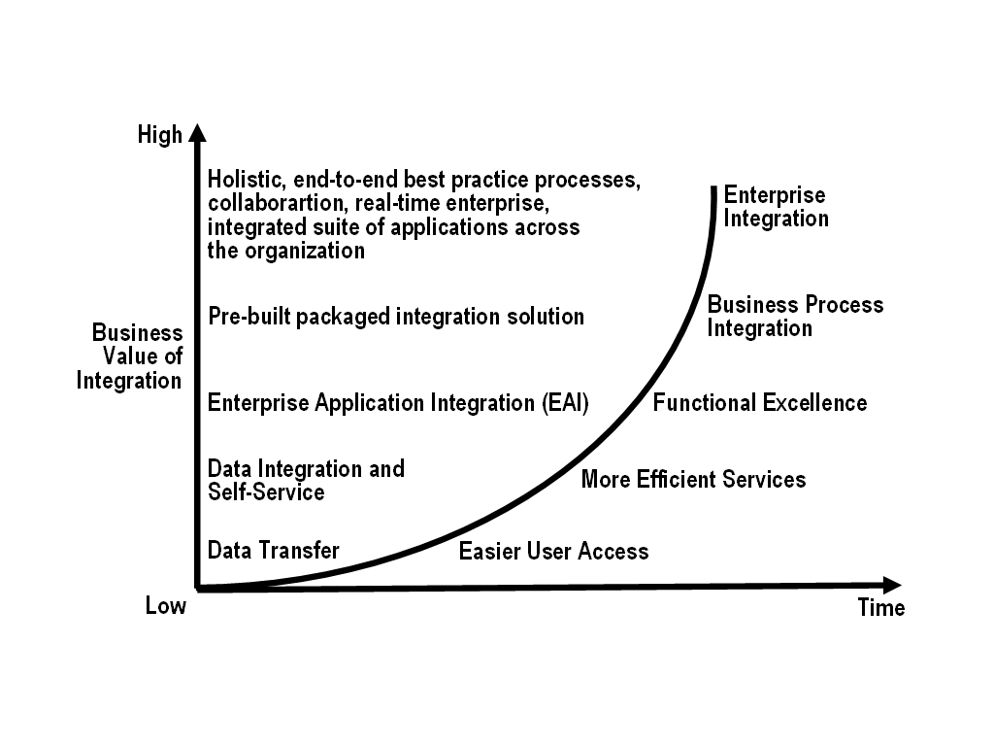

Fig. 1. Evolution of Enterprise Integration

2 Complexity and Cost of Integration
While Enterprise Application Integration has helped a lot of companies to improve their business process functionality, many of them whishing to integrate multiple applications and systems throughout the organization are surprised by the complexity and cost of EAI.
Large companies typically may run hundreds – if not thousands – of disjointed applications. Linking them all together requires that organizations have appropriate integration capabilities and, even more important, a clear understanding of what they want EAI to accomplish.
The most popular integration solutions tend to be proprietary, internal-facing and application-specific and these are characteristics that actually can limit an organization's ability to deploy real-time, cross-application business processes [2]. Consequently, many organizations that thought EAI would make their processes more agile and responsive are now facing a more rigid, inflexible IT infrastructure than originally expected.
The bottom line is that many organizations have achieved greater sub-process functionality with EAI (see level 3 in Figure 1), but they still lack an adaptable infrastructure that allows the enterprise-wide business process implementation and execution.
Today, all that is poised to change. Customers recognize that they need to control the technology chaos that often runs rampant in their organizations. They also need to make sure that additional technology investments result in bottom-line business value. Achieving business value simply requires more than pure-play EAI technologies can provide [3].
Rather, organizations need to analyze their complete set of business processes and partner with integration service providers that can implement the right combination of technology solutions to meet an organization's needs.
In addition, today's integration efforts need to focus on broader aspects of integration, i.e. people, application services, channels and trading partners that comprise and enable business processes. Many companies are adopting this broader view to process management and integration.
As a result, the integration space is becoming much more than an environment for application integration. It is fast becoming an environment that sets the stage for integration across the entire enterprise. This new wave of integration services may be referred as 'enterprise integration'.
In short, enterprise integration uses integration-capable technologies and standards to maximize business value. It involves leveraging the power of integration technologies to their fullest potential, in alignment with a vision of the future technology landscape and understanding of the Total Cost of Ownership (TCO) [4].
Enterprise integration is not a replacement of EAI technologies, but rather a means of increasing the scope and influence of integration beyond the capabilities supported by today's EAI technologies.
To understand the value of enterprise integration, it is useful to first understand previous integration paradigms and their limitations.
3 From Data Transfer to Enterprise Integration
Just a few years ago, business leaders began promoting the integration by sending series of batch files from one application to another. The result was a piecemeal approach do data movement that really ment no integration at all [5]. It allowed companies to transfer files and messages from one system to another through numerous, custom-built, point-to-point interfaces (see Fig. 2).
Given that there was no integrating technology in the market, IT leaders spent considerable time, money and effort cobbling together a host of tools and technologies that would allow, for the first time, disparate systems to communicate.
It did not take long for the market to notice the limitations of point-to-point data transfer. A host of providers reacted to this fact, offering true data integration by consolidating the emerging data transfer capabilities into one technology [6].
Data was no longer just transferred from one application to another – it was also synchronized, which meant, e.g., that an update to customer profile in a billing application automatically would appear in other applications, such as shipping, thereby reducing the need for human intervention.
With data integration, companies could satisfy their basic integration needs with one technology, as opposed to three or more. It also meant that companies could dramatically improve their efficiencies, especially as they related to supply chain and customer relationship management.
However advantageous this sort of data integration was, it was limited by the fact that none of the technologies enforced the use of common data models, which require significantly more work. Because each application typically was implemented to support an immediate need, organization built a separate interface – one that could not support an 'any-to-any' model.

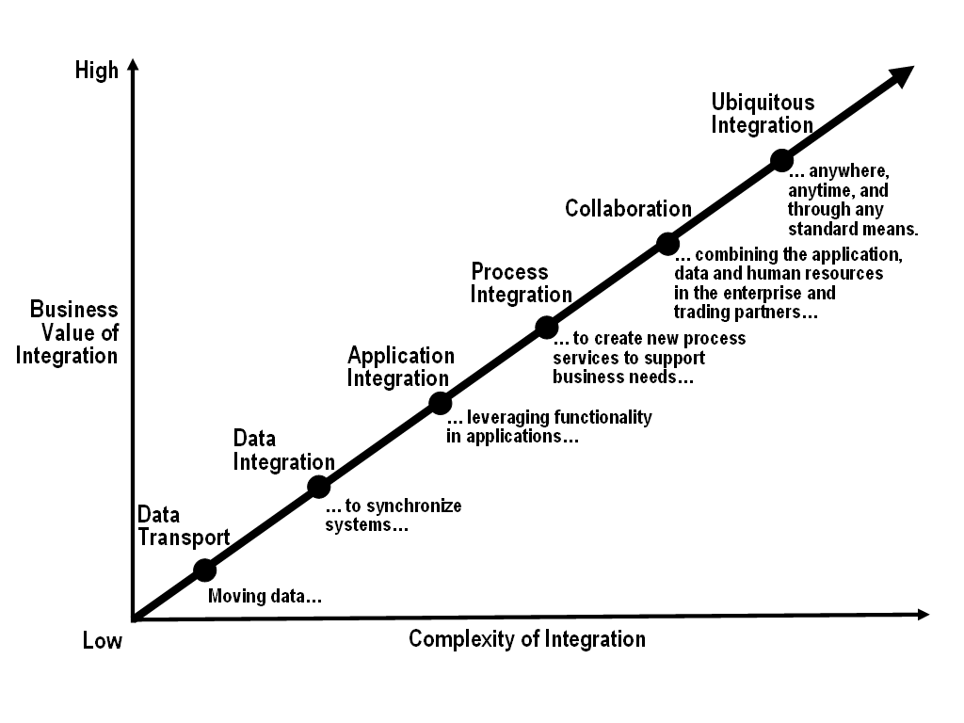

Fig. 2. Stages of Enterprise Integration

The result was multiple, point-to-point solutions, meaning that as companies changed or upgraded one application, they needed to ensure that the appropriate changes also were made in every linked application. As the number of application connections increased, so did the system's inflexibility.
At the same time, many large enterprise solutions vendors developed 'all-in-one' solutions that offered an integrated suite of transaction-based applications across the enterprise. In theory, this single-vendor approach to application management made sense. It would ensure that all of the applications within a suite – typically involving customer relationship management or supply chain management – were tightly linked, supporting a variety of complex and interrelated processes within the enterprise. By implementing just one system to manage multiple applications, the lifetime application management cost was significantly lower than the point-to-point, patchwork alternative. Finally, it seemed there might be a solution that would deliver greater process reliability, transparency and flexibility [7].
These single-vendor solutions, however, suffered from several serious drawbacks. Their success required that companies 'lock in' with only one vendor to meet their various application needs. As a result, companies would often have to abandon many – or even all – of their existing, costly, best-of-breed applications in favour of products that were, perhaps, inferior.
In addition, the functionality of these application integration solutions came to an abrupt stop at the business boundary; integrating the enterprise systems of suppliers and business partners required the implementation of complex and expensive middleware. Further, this proprietary approach assumed that the vendor's suite of applications would comprise all the functionality required by a customer.
It quickly became clear that no vendor had enough expertise to develop the leading applications that met each and every customer need. In short, these were 'vendor-centric' and not 'customer-centric' solutions, which provided a proprietary architecture and marketing channel through which large vendors would market their own set of products.
4 The Emergence of Business Process Integration
Despite all the drawbacks of previous approaches to business integration, the EAI solutions vendors deserve credit for raising the integration level. They – as well as providers of commercially available 'information busses', which provide a common network backbone for disparate applications – have shown that application management and integration is possible and, when done correctly, significantly lowers IT costs and improves organizational efficiencies and performance.
Yet, the major problem still remains: companies need greater visibility and accessibility to their major systems [8]. They also need more flexible – and increasingly automated – business processes that can respond quickly to changing market drivers [9].
To address the growing need for process efficiency and flexibility, vendors and businesses have taken a big step backwards. Namely, they have begun looking at the higher-level process goals that are enabled by point-to-point or proprietary data integration services.
Today, the industry is witnessing the next wave of solutions driving organizations toward enterprise integration. These solutions focus on understanding the context for a particular business process. They involve a confluence of evolving software applications that can give firms an increased ability to automate and manage complex business processes both within and between companies.
This new collaboration infrastructure, referred to as Business Process Integration (BPI), works much like an orchestra: A central conductor coordinates the actions of many participants around an organizing theme and provides the details of which parts they play, and when. Whether the goal is music or profit (or both, maybe ?!), a coherent effort from start to finish is the key to maximizing overall performance.
5 Business Process Integration Defined
A 'business process' refers to the complete thread of coordinated activities needed to deliver value to customers. Business processes typically are:

- Large and complex, involving multiple business units.
- Evolving, in response to customer demands and marketplace drivers.
- Widely spread, or distributed, spanning multiple applications and technology platforms.
- Partially automated, for the sake of speed and reliability.
- Dependent on human intervention, for those tasks that require personal interaction with customers or problem-solving capabilities.
- Difficult to make visible, given that they tend to be undocumented and implicit, embedded in the history of the organization.

BPI solutions embrace a 'big picture' view that rises above the necessity of linking discrete sub-processes and combine complementary sets of capabilities from workflow software and EAI solutions to automate most process flows. Yet, they also include human factors where needed.
The strength of workflow software lies in the ability to flexibly model, monitor and optimize a wide range of processes while leaving the execution of individual process steps to humans or some specific software applications.
The key strengths of workflow software are summarized in Table 1.

Feature | Strength
Process modeling | For BPI system to accurately represent, execute, and manage business processes, the details of those processes must be captured electronically. A modeling tool, typically based on universal modeling language (UML) and with a graphical user interface (GUI), allows business analysts to map processes in a format that is understandable by the BPI system.
Process execution | A workflow engine uses process models to guide the sequence of activities and information flows among the various IT systems and human factors working together toward some common result. The workflow engine ensures that each process is executed correctly and completely, and that the state of process remains consistent or is 'rolled back' to the beginning state if the process cannot be completed.
Process  management | Monitoring and exception management allow managers to intervene in ongoing processes in real time.

Table 1. The key strengths of workflow software
The strength of EAI applications, on the other hand, lies in the ability to offer single, real-time interface across multiple information systems, which simplifies integration efforts.
The key strengths of EAI applications are summarized in Table 2.

Feature | Strength
Application  connectivity | The BPI system must connect to legacy and packaged software applications to send and receive data and to invoke the specific functionality provided by these applications. Pre-built adaptors and custom adaptor development kits create the interfaces that allow existing applications to be brought into the BPI system.
Translation and  formatting | Data definitions, formats and software applications differ across departmental, business unit and company boundaries. Translation and formatting services ensure a common understanding of data elements and that messages between applications are interpreted correctly.
Communications  middleware | The BPI system must be able to locate and connect to different trading partners and software application in real time. Communications middleware accesses directory services to discover where and how to connect to trading partners, and manages the security, guaranteed delivery and actual transport of messages between applications contributing to a particular business process.

Table 2. The key strengths of EAI applications

Together, workflow and EAI functionalities form a relatively inexpensive, unified, flexible platform for describing, enabling, and managing business processes – and ultimately driving enterprise integration.
By providing a process design and execution framework, BPI solutions can offer some compelling advantages. In order to be truly successful, these solutions must include the specification of particular roles within a comprehensive set of business protocols. Connected corporations stand to gain significant competitive advantage by combining an increased focus on their core competences with a more efficient, flexible and responsive web of business relationships. Business Process Integration is the key enabler of the deep collaboration that is critical to seizing this advantage.
6 Holistic Approach to Enterprise Integration
There is a need to look at the enterprise integration in a holistic manner. The holistic approach to enterprise integration should take into account the following influencing factors:

- Business strategy
- Customers
- Employees
- Trading partners/suppliers
- Processes
- Technology

Holistic approach to enterprise integration is schematically shown in Fig. 3.

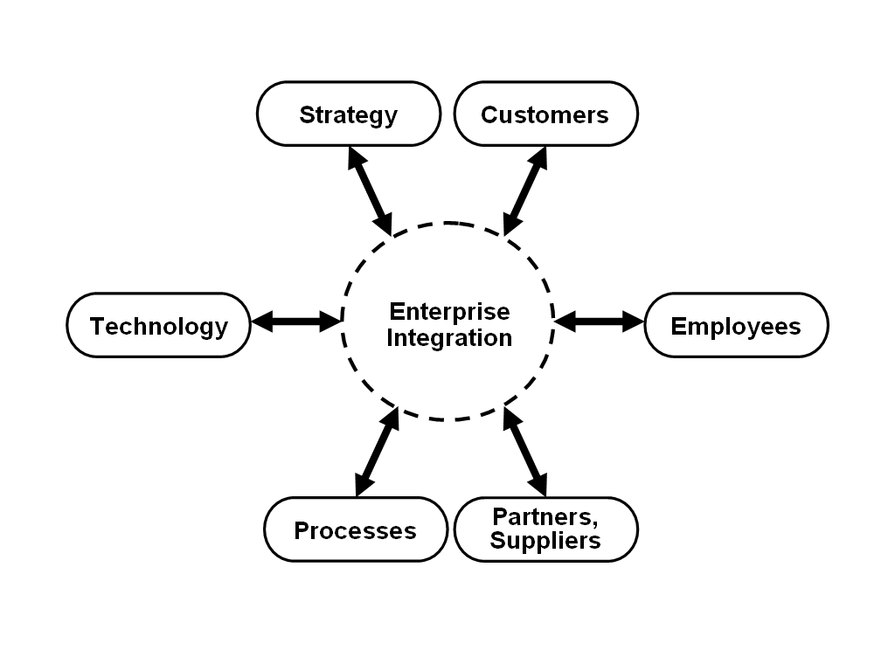
Fig. 3. Holistic approach to enterprise integration

From the business strategy point of view, enterprise integration should enable:

- Translating business objectives into sustainable technology models
- Defining the architecture vision of the enterprise
- Defining metrics, success criteria, and measurement principles

From the customers' standpoint, enterprise integration should provide:

- Access through multiple channels, including web site, portal, call center and e-mail
- No reductions in services across all these channels
- Completing all transactions immediately, i.e. in real time

Employees expect from enterprise integration:

- To involve them into process management since years of experience an background cannot be 'coded'.
- Wider breadth of factors to be considered when decision are to be made.
- To respect the fact that sometimes the best data validation is performed by people.
- To compensate for business rule changes immediately.

Trading partners and suppliers should benefit from enterprise integration in following ways:

- Collaboration to manage inventory movements, demand and raw material tracking.
- Workflow across organization.
- Portals as 'light' integration engine.
- Security validation.

From the process view, enterprise integration should help:

- Identifying process ownership critical to success of implementing business processes.
- Linking departments and business units to make the end-to-end process less difficult to define.
- Lessening the costs and risks of introducing changes in business process execution.

Holistic approach to enterprise integration looks at technology as:

- Combination of tools and platforms to meet all of the technical requirements.
- A means of support multiple flavours of application architectures, as well as establishing and maintaining enterprise standards.
7 Conclusions
The latest IT industry contribution to business process improvement is Enterprise Application Integration (EAI), which focuses on improving a company's foundational integration architecture components. Despite all the drawbacks of previous approaches to business integration, the EAI solutions vendors deserve credit for raising the integration level.
But, Enterprise Application Integration is just one step in the enterprise integration evolution. The following steps expected are: process integration, collaboration and ubiquitous enterprise integration.
To anticipate the trends and impacts of such an evolution the holistic view of enterprise integration is needed. The holistic approach to enterprise integration should take into account six influencing factors: business strategy, customers, employees, trading partners/suppliers, business processes, and technology.
Each of these influencing factors has its own features and impacts, which all must be considered to gain a big picture of enterprise integration trends and tendencies.

References
[1] X1. Gupta, M., Elements of a Successful Enterprise Application Integration, http://www.syntelinc.com/, 05/2002.
[2] X2. Correia, J., The Global Economic Impact on the Application Integration and Middleware Markets, http://www4.gartner.com/, 08. 08. 2001.
[3] X3. Ozzie, R., O'Kelly, P., Communication, Collaboration & Technology: Back to the Future, http://www.groovenetworks.com, 2003.
[4] X4. ***, Accelerating ROI – Lowering TCO For Business Applications and IT Operations, http://www.emc.com, 11/2002.
[5] X5. Joshi, M., Subrahmanya, V., Global Data Synchronization: An End-to-End Perspective & Solution Framework, http://www.wipro.com, 2003.
[6] X6. Bilderbeek, P., Transforming Enterprise Communications, http://www.idc.com, 10/2002.
[7] X7. Dortch, M., Business Applications and IT Infrastructures: Critical Interdependencies and How to Manage Them, http://www.rfgonline.com, 2002.
[8] X8. ***, Achieving Business/Technology Alignment: Dynamic Blueprinting and Enterprise IT Visibility, http://www.troux.com, 2003.
[9] X9. Brockmann, P., The Case for Inter-Business Process Automation: The business impact of lowering cost, accelerating business and scaling infrastructures, http://www.btrade.com, 01/2003.

