The MCM Simulation of Cluster Formation Process of Calcium Sulphate Particles Dispersion

A. PRISTOVNIK, D. GORICANEC*, J. KROPE*
A Self-employment Researcher,
Mariborska 48, 2310 Slovenska Bistrica
*Faculty of Chemistry and Chemical Engineering,
University of Maribor
Smetanova ul. 17, 2000 Maribor,
SLOVENIA

Abstract: The Magnetic Water Treatment (MWT) devices for scale control and for improvement of water dispersion separations can be used with great economical and ecological benefits. According to experimental results it can be established that effects of MWT devices are highly dependent on composition of treated dispersion system and their working conditions. To investigate the effects of magnetic field on cluster formation process in fine particle dispersion of Calcium Sulphate under the influence of external magnetic field of the MWT device, a theoretical model on the DLVO theory and statistical Monte Carlo Metropolis method have been used. The “Open Source” computer programs for the simulation and graphical presentation of clustering under the influence of external magnetic field have been developed. Obtained results have been analyzed by cluster analysis based on the partitioning and hierarchical methods (fuzzy, agglomerative and divisive analysis).

Key-Words: Magnetic water treatment, calcium carbonate, scale prevention, Monte Carlo Metropolis method, cluster analysis

1 Introduction
Scale formation on pipe walls and heat exchange equipment is a serious, common and costly problem encountered in almost all industrial processes in which water containing dissolved solid is heated. In heat exchange processes the over-saturation of scale-forming components is established and the minerals become less soluble with increasing temperature and form scale deposits. Such scale deposits significantly reduce heat-transfer efficiency and can lead to partial or even complete blockage of water flow passages.
Several methods and techniques to prevent or control scale buildup are known and commonly used, but they are costly and environment charging. Frequently used non-chemical method for scale control or/and scale prevention is so-called Magnetic Water Treatment (MWT) method. It is economically favorable and is one of the most controversial scale prevention methods. Scale prevention is achieved by passing the water through the magnetic field. Despite several decades of intensive research work done in this area, no scientifically confirmed theoretical explanation exists yet, which adequately describes how MWT devices work and what are the conditions under which is their operation most effective.
supplied natural waters are rich dispersion systems, which contain many colloids, ions, etc. Due to natural supersaturating of supplied water or supersaturating by changed operation conditions (such as pressure drop, temperature and pH) a hard scale precipitates on pipeline and equipment walls. The magnetic water treatment is particularly promising technique for manipulation and controlling the interactions between micrometer-sized colloidal particles dispersed in fluid suspensions [1].
Although many processes affect colloidal behavior, the balance between the thermal, attractive and repulsive terms determines a criterion of the stability of colloid dispersions in natural waters. Detailed consideration of this interplay is the basis of the DLVO [2] theory. The tendency of particles to aggregate via the short range van der Waals-London force is counter act by a charged layer on the particles. Thus the total interaction energy (E_{t}) between two colloidal particles is the sum of the double layers energy of interaction (repulsive energy E_{r}) and the energy of the interaction particles themselves due to van der Waals-London forces (attraction energy E_{a}) [2]:
(1)
Magneto static particle interactions modify the behavior of the fluid and can have a detrimental effect on the colloidal stability. When a dispersion of colloidal particles is placed in an external magnetic field additional magnetic force arises, which decreases the stability of the colloid particles when attractive. The energy of the magnetic attraction (E_{m}) between two spherical particles separated by a distance (R_{ii}) depends on magnetic density (B) and angle of the external magnetic field (Ψ), radius of the particles (α) and magnetic properties of the particles:
(2)
Thus the total energy of interaction (E_{t}) of colloid particles in the external magnetic field is:
(3)
Statistical numerical methods known as Monte Carlo methods are methods that utilize sequences of random numbers to perform the simulation. The presented model is based on the Monte Carlo Metropolis [4], [13] method and has been used to investigate the properties of colloid particle dispersion in water under the influence of magnetic field [2], [3], [4], [5], [6], [7], [8].
The model is based on a two-dimensional square cell with side length (A) containing (N) random distributed spherical particles (Figure 1a). All the particles are identical. The position of any particle (Figure 1b) is known and can be specified with coordinates (x, y , θ), where (θ) is the angle between the magnetic moment of the particle and the applied magnetic field [6].

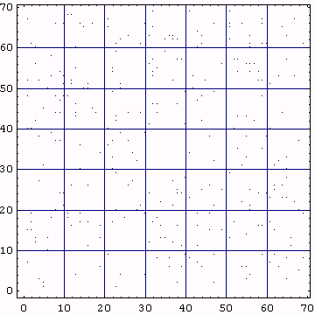 | 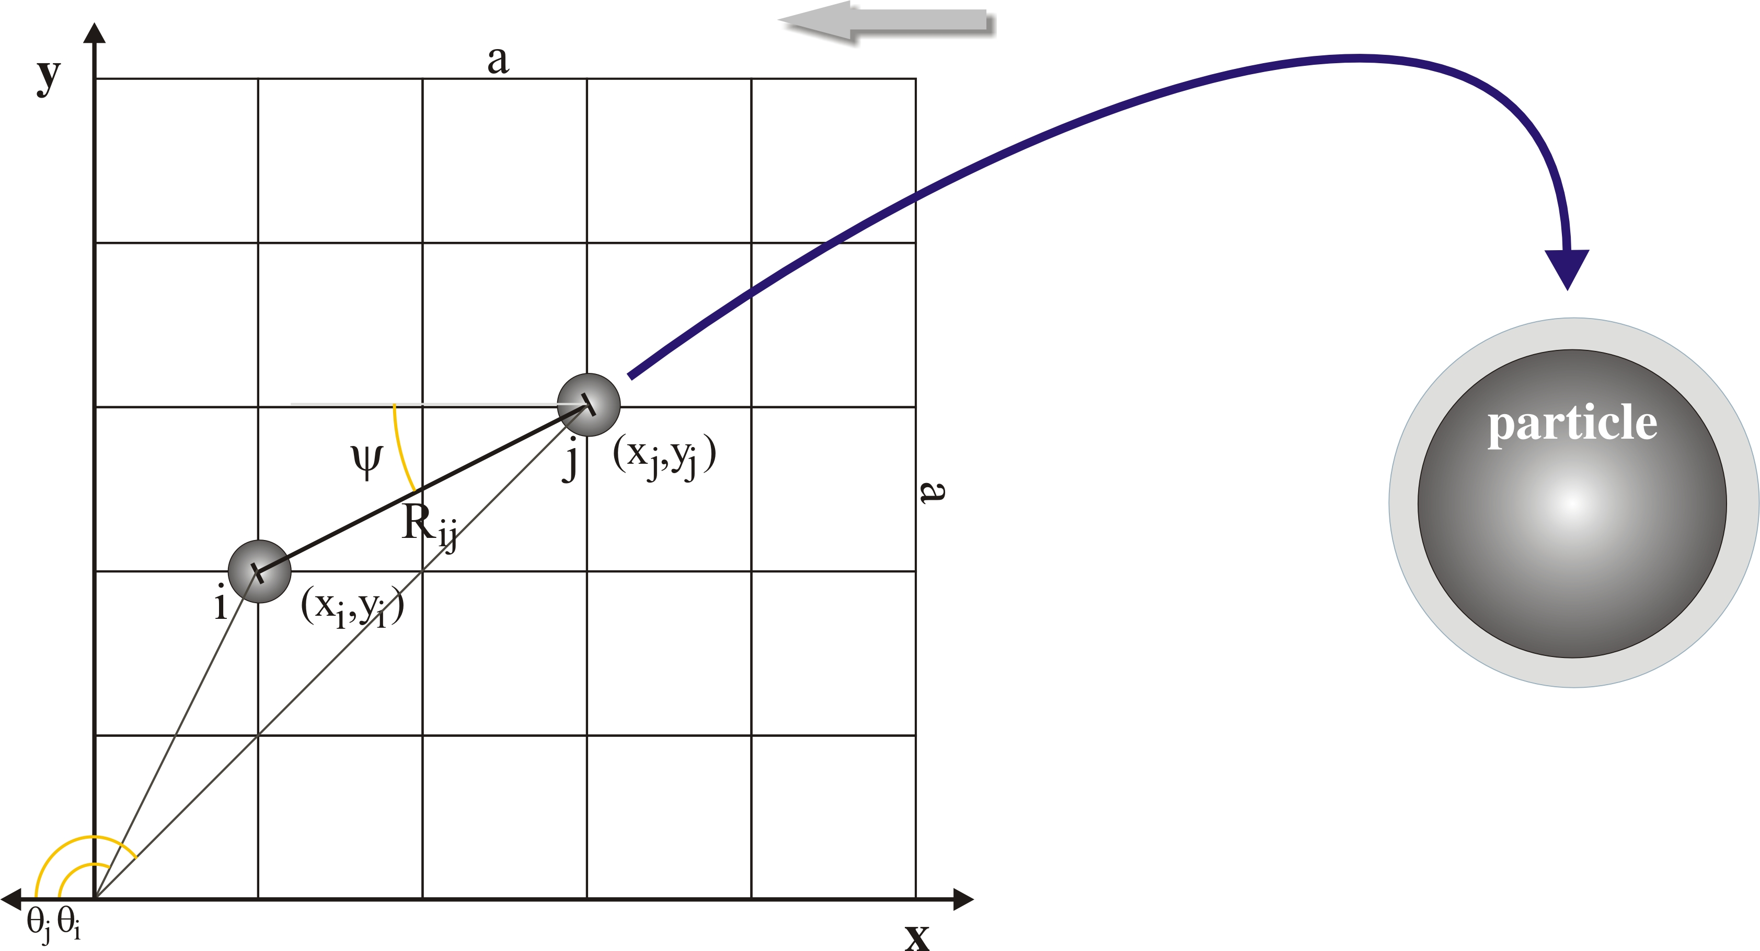
Figure 1: a) Random distributed (N=328) spherical particles [9] | b) Particle in the applied magnetic field (close look up) [9]

The base energy of the system (E_{s}) is determined as the sum of the total energy of interaction of all colloid particles in that square cell:

(4)

The technique consists of calculating the energy change (ΔE) when the coordinates of one particle of the representative ensemble are changed at random by a small amount.
If the new total energy of the system is less than previous, the particle stays in new position, otherwise the factor (P) is calculated and compared with random number (x; x ∈ [0, 1]):
(5)
If factor P is greater than random number the particle retains its new position, otherwise it is returned on its original position. This procedure is applied for all N particles in a square cell.
2 A computer program for the simulation of cluster formation
Well-known theories from the field of colloid, statistic and mathematics science have been taken into the consideration and been applied in the magnetic water treatment research. An “Open Source” computer program (MCM) [15] for-two-dimensional simulation of the cluster formation process in fine particles dispersion under the influence of external magnetic field which according to some authors [10], [11], take place in MWT device, was developed. For the graphical presentation (MCM View) [9] and cluster analysis (Fanny&Twins) [12] the set of computer programs were used.
The data are entered with two input files. In the first input file the size of the cell, number and physical properties of the particles are determined and structure for the intermediate output files is defined. In the second input file the origin position of the particles is determined.
The results of simulation are written in various formats and can presented with the programs such as Microsoft Excel [15] or Microcal Origin [15] as a front end. For the graphical presentation the “MCM View” program has been developed on the basis of Compaq Array Visualizer [15]. The results have been further analyzed with the partitional and hierarchical methods for cluster analysis of authors Kaufman and Rousseauw [12] (fuzzy, agglomerative and divisive analysis). For that purposes programs “FANNY” and “TWINS” have been used.

3 Results of the simulation
As the reference data for the primary numerical calculations, the physical properties of the hematite particles () in aqueous dispersion have been used. On this basis, the numerical calculation for the diamagnetic mineral calcium sulphate () has been carried out. The simulation of cluster formation has been carried following out physical and chemical conditions:
- Different number of particles and their radius in the square cell;
- Different angle(ψ) of the applied magnetic field (0, 30, 60 and 90 degree);
- Different retardation potential (ϕ), which determine the strength of the repulsion force (10, 20 and 30 mV);
- Different density (B) of the applied magnetic field (from 0 to 1T);
- Different pH values of the aqueous dispersions and others [9].
The total interaction energy for the diamagnetic calcium sulphate particles (N = 40 ÷ 300) with the diameter (d = 1 ÷ 10 μm), volume magnetic susceptibility (χ = -4⋅10⁻⁷, diamagnetic) and Hamaker constant (k_{h} = 1 ÷ 5⋅10⁻²⁰ J) in square unit cell with side length (A = 25 ÷ 70 μm) has been computed. The absolute temperature and pH of the dispersion have been set to 300 K and 7.0, respectively.
For the simplicity of the model all the simulations are done in two dimensions instead of three and that fact does not have effect on the results.

Figure 2: a) Position of the particles after 10 moves [9] |  | b) Position of the particles after 600 moves [9]
Figure 3: The intensity of the cluster formation process with pH change and graph approximation with the polynomial of forth* order [9]
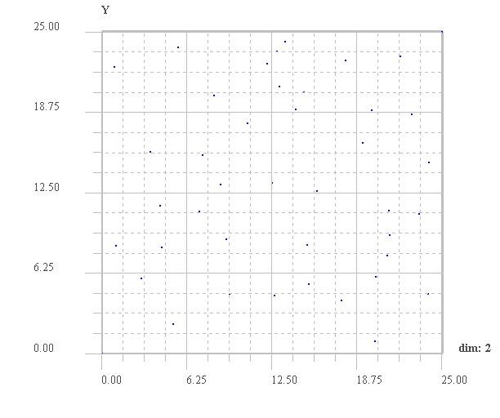 | 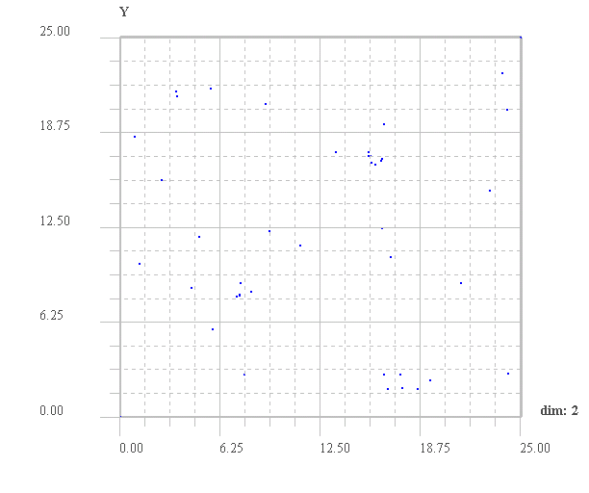
pH = 7 | pH = 9
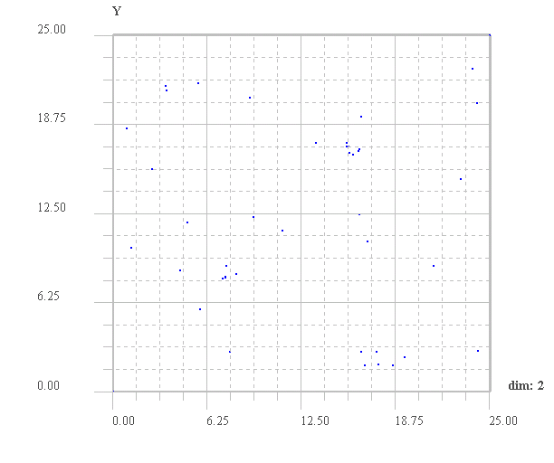 | 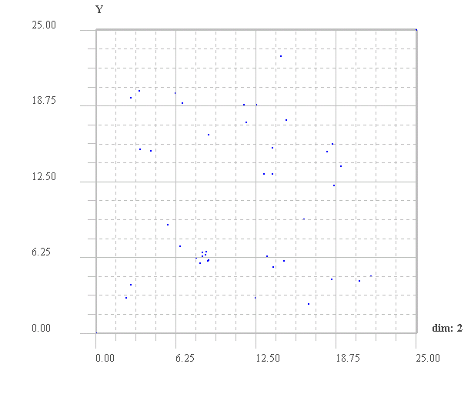
pH = 11 | pH = 12
Figure 4: The intensity of the cluster formation process of Calcium Sulphate after 800 moves under the different pH range (pH_{pzc} = 10.0, d = 10⁻⁶ m, B = 0.5T, α = 30°...) [9]

According to the previous research [6] the recommended rate of convergence is up to 600 moves per particle. The origin position of the particles has been set up as 5x8 matrix. Figure 2 presents position of the typical diamagnetic particles after 10 and 600 moves under magnetic field of density 0.75 T, applied at 60° angle. Figure 4 shows visually the intensity of the cluster formation process under the external magnetic field of the calcium sulphate particles at the different pH values
From the Figure 2.b it is quite easy to perceive the formation of one major and two minor clusters, which are well arranged in the direction of applied magnetic field. From the same figure, the intensity or even the size of the cluster can not be obtained, thus the results have to be analyzed with the adequate mathematical method suitable for cluster analysis. The Fuzzy clustering method, as a generalization of partitioning, was used in computer program Fanny. The intensity of the cluster formation process has been measured with the value of normalized version of the partition coefficient (S_{k=5}).
According to experimental results [13], the effects of the magnetic water treatment devices are high dependent on composition of treated dispersion system and working conditions. The pH value of the system is one of the most influential conditions for the cluster formation process. For the successful clustering of calcium sulphate particles the optimal pH range of treated dispersions is from 7.5 and up to 12.5 (Figure 3).

5 Conclusions
Despite the large volume of research work in past decades, the theoretical understanding of MWT mechanism is still incomplete. This is the main problem in design of efficient MWT devices. The MWT mechanism is very complex and directly depends on chemical composition of water as solution/dispersion system and working conditions.
The theoretical model for simulation of cluster formation with hematite particles as the reference data has been supplement and widens to the region of magnetic water treatment. The model is based on the DLVO theory, Monte Carlo Metropolis method and cluster analysis theory. With the computer programs based on presented model, the numerical calculations for most of the scale forming minerals (especially calcium carbonate and calcium sulphate) have been done. The obtained results have show that the model well predicts the essential operational conditions for the effective use of MWT devices, if the chemical composition of supplied water is known.

Symbols:
α radius of interacting spheres (m)
B magnetic field density (Vs/m²)
e_{o} electron charge 1.6⋅10⁻¹⁹ (As)
E_{a} attraction energy (J)
E_{r} repulsive energy (J)
E_{t} total interaction energy (J)
k_{h} Hamaker constant
N, n number of particles
R length between centers of particles (m)
s ratio between distance and radius
T temperature (K)
Z_{I} ion valence
δ extension of the double layer (m)
ε dielectric constant
θ angle between the magnetic moment of the particle and the applied magnetic field (rad)
ϕ_{o} surface potential (J/As = V)
ψ angle of the external magnetic field (rad)

References:
- Grier D.G., Behrens S.H.: Interactions in the colloidal suspensions, The James Franck Institute, The University of Chicago, 2001
- Svoboda J.: A Theoretical Approach to the Magnetic Flocculation of Weakly Magnetic Minerals; International Journal of Mineral Processing, No. 8, pp. 377-390, 1981
- Svoboda J.: Magnetic Flocculation and treatment of Fine Weakly Magnetic Minerals; IEEE Transactions on Magnetics, No. 2, Vol. 18, pp. 796-800, 1982
- Metropolis N., Rosenbluth A. W., Rosenbluth M. N., Teller A. H., Teller E.: Equation of state calculations by fast computing machines; J.Chem. Phys.; 21, pp. 1087-1092, 1953
- Chantrell R. W., Bradbury A., Popplewell J., Charles S. W.: Particle cluster configuration in magnetic fluids; J. Phys. D: Appl. Phys. 13(3), pp. 119-122, UK, 1980
- Chantrell R. W., Bradbury A., Popplewell J., Charles S. W.: Agglomerate formation in a magnetic fluid; Journal Appl. Phys. 53(3), pp. 2742-2744, USA, 1982
- Miles J. J., Chantrell R. W., Parker M. R.: Model of magnetic field indused ordering in dispersions of fine paramagnetic particles; Journal Appl. Phys. 57(1), pp. 4271-4273, USA, 1985
- Crepinsek L. L., Krope J., Crepinsek L.: Dispersion destabilization in magnetic water, J. colloid interface sci, 236, p.p. 60-66, 2001
- Pristovnik A.: Configuration and formation of clusters from dispersion particles during the magnetic water treatment, Draft of Doctoral Dissertation, University of Maribor, Faculty of Chemistry and Chemical Engineering, 2002
- Iovchev M.: The Effect of Magnetic Field on an Iron-Oxygen Water System, Khim. Tekhnol. Inst. 19:73-84 1966
- Herzog R. E., Shi O., Patil J., Katz J. L.: Magnetic Water Treatment - The Effect of Iron on Calcium Carbonate Nucleation and Growth, American Chemical Society, Langmuir, Vol. 5, No. 3, 861, 1989
- Leonard Kaufman, Peter J. Rousseeuw: Finding Groups in Data-An Introduction to Cluster Analysis, A Wiley-Interscience Publication, New York, Toronto, 1990
- Kulskii L.A., Kochmarsky V.Z., Krivtsov V.V.: Intensifying and Destabilizing Factors of Magnetic Antiscale Treatment of Water, Khimiya i Tekhnologiya Vody, Vol. 5, No. 4, pp. 296-301, 1983
- CSEP: Introduction to Monte Carlo Methods, electronic book, Copyright (C) 1991, 1992, 1993, 1994, 1995 by the Computational Science Education Project, http://csep1.phy.ornl.gov/CSEP/MC/MC.html
- Computer programs:
- MCM, MCMr_z_a in MCM view, Copyright© 1997-2001 Andrej Pristovnik
- COMPAQ ARRAY VISUALIZER 1.1 Copyright© 1998-1999 Digital Equipment Corporation
- Microsoft®Excel, version 97, Copyright© 1985-1996 Microsoft Corporation
- Microcal TM Origin, version 6.0, Copyright© 1991-1990 Microcal Software, Inc.

