Realization of Infinite Impulse Response in SAW Technology

PRIYANKA, SHIV DUTT JOSHI**, BRISHBHAN SINGH PANWAR
Centre for Applied Research in Electronics, Electrical Engineering Department**
Indian Institute of Technology Delhi
Hauz-Khas, New Delhi-110016
INDIA

Abstract: - Most of the work associated with Surface Acoustic Wave (SAW) devices deals with the realization of finite impulse response filters. For narrow band filter specifications, order of the FIR filter may be quite high, resulting in a large size FIR SAW filter. The present work introduces the realization of IIR filters on SAW devices; which can lead to substantial reduction in filter size. Reflections are utilized to realize poles in SAW filter. A model has been presented to get the p-matrix for a SAW unit cell having reflections. We then analyze this to get the transfer function of a SAW transducer comprising cascades of such unit cells. A SAW structure to realize a rational transfer function with proper second order denominator polynomial has been presented. Since the coefficients of the resulting transfer function depend on device parameters, it establishes the claim that it is possible to realize IIR filters on SAW devices. Simulation results are presented showing the validity of the given model.

Key-Words: - IIR filters, Pole Realization, Surface Acoustic Wave filters, Transfer Function.

1. Introduction and Motivation
Conventionally the SAW filters are designed as Finite Impulse Response (FIR) filters. The reflections caused by (i) due to impedance mismatch at the substrate conductor interface, (ii) due to regeneration phenomena; are intrinsic to the SAW devices. In case of FIR SAW filters these reflections are treated as a source of problem and are minimized by proper matching network or other means. SAW filters (using reflections), based on single-phase unidirectional transducers (SPUDT) were introduced in 1976 [1]. SPUDT’s has become one of the most interesting techniques for reducing the insertion loss of classical bi-directional transducers. The idea is to use acoustical reflective electrodes distributed in a way so that the radiated energy maximizes in a given preferred direction (towards OutIDT). Among the primary advantages of a SPUDT design over other low-loss design methods are [2]:
- Only a relatively inexpensive single level fabrication is required.
- Can be used with many materials and bandwidths.
- Uses no more substrate space than a bi-directional transducer.
- Have simple matching requirements.
In the classical SPUDT the reflections are used for canceling electrical regeneration only and thereby obtaining directivity. This is an artificial restriction; reflections may be utilized for decreasing shape factor as well as reducing the bandwidth [3]. Use of reflections to realize poles in the SAW filter is introduced in this paper, which results in a smaller size filter for the given specifications. Realization of poles perceives the SAW filter as Infinite Impulse Response (IIR) filter.

2. Basic Assumptions and Preliminaries
Kodama et. al. [4] presented the Distributed Acoustical Reflection Transducer (DART) structure for Single Phase Unidirectional Transducers (SPUDTs). This type of structure is now well established for use in SAW IF filter applications [5-7]. For IIR filter realization the present work utilizes two types of basic unit cells, one is having singlewide electrode of 3λ₀/8 width (reflector) and two narrow electrodes of λ₀/8 width, where λ₀ is unit wavelength at centre frequency equal to the period of the transducer. Using withdrawal weighting the transduction and reflection values can both be weighted. The transduction and reflection in this type of basic unit cell can take any of three values, expressed in normalized form as 1, 0, or –1 [8]. Reversing the polarity of the electrodes in unit cell can reverse the sign of transduction. If all the electrodes are connected to the same bus bar then transduction strength of unit cell will be zero. Similarly, sign of reflection can be reversed by moving the wide electrode by λ₀/4. Zero reflection is obtained by using two narrow electrodes of λ₀/8 width (with the λ₀/8 separation between them) in place of wide electrode of 3λ₀/8 width. These basic unit cells are same as the DART cells [5] but with these properties:
- Transduction centre is defined at the centre of space between two opposite polarity electrodes.
- Reflection centre is defined at the centre of wide electrode, because it is the centre of symmetry for shorted bus bar.
- There can be only one or no change in electrode polarity in a single unit cell.
- Distance between transduction centre and reflection centre, and between any reference plane and transduction/reflection centre should be in a way so that signal will experience ‘n’ times of unit delay at any of two reference planes of the SAW structure. Where unit delay is the delay experienced by the signal in traveling ‘λ₀’ distance and ‘n’ is a positive integer or equal to zero.
The other type of basic unit cell used in this work is having only two reflectors (electrodes of 3λ₀/8 width) attached to the same bus bar with λ₀/8 distance in between. There is no transduction in this type of basic unit cell.
In order to get the transfer function of a SAW transducer comprising cascades of these unit cells, we have to get p-matrix of each unit cell. The basic assumptions used to get p-matrix for a unit cell are now briefly outlined. The implications of these, wherever applicable, on the analysis are also discussed here.
- We assume that the resulting SAW filter is Linear time Invariant (LTI), hence the output of an exponential input is same exponential with the amplitude and phase dictated by the frequency response of the filter (this is because exponentials are the eigen functions of LTI systems).
- When an exponential signal exp{jωt} travels from a point A to a point B, a distance x₀ with a velocity ‘v₀’, it undergoes a time lag of t₀ = x₀/v₀, so the exponential received at point B becomes exp{jω(t-t₀)}. Note that this time lag t₀ does not depend on the frequency.
- If time taken by SAW to travel a distance equal to unit wavelength (λ₀ = length of unit cell) is ‘T’, the exponential will get modified by a multiplicative factor of exp{-jωT}, as is clear from the point a). We shall consider this delay as a unit delay experienced by the signal. The frequency dependence of the phase shift is clearly incorporated in the above setting.
- A regeneration phenomenon has been modeled as voltage controlled current source. The model for the regeneration process can be understood as follows: When an acoustic exponential wave strikes the finger pair (with opposite polarity), current proportional to the overlap of the fingers flows. The voltage generated by this current flow gives rise to stress in the piezo-electric substrate and will produce acoustic wave of the same frequency. This is because the current is being treated as linearly dependent on the sum. This acoustic wave will propagate in forward as well as in backward direction and will get coupled with the wave moving in the respective direction.
- Acoustic wave interacting with the reflector (electrode of 3λ₀/8 width) gets reflected from its center, (reflection center is taken at the center of reflector) and it is assumed that ‘r’ times the incident wave gets reflected (reflectivity of the reflector) and ‘t’ times the incident wave passes through. The reflected wave gets coupled (i. e. added) with the backward moving wave.
- Negligible reflection is assumed at narrow electrodes (of λ₀/8 width).
- The parameters ‘r’ and ‘t’ have been taken to be constants but it can be seen from the analysis that they can be easily generalized to have frequency dependence.
- On account of applied voltage ‘v’ the generated SAW signal is ‘αv’, where ‘α’ is the voltage to SAW transduction coefficient.

3. Modeling a SAW unit cell
In this section we present a model for a unit cell of SAW transducer, with reflections. We then analyze this to get the transfer function of a SAW transducer comprising cascades of such unit cells. We compute p-matrix for the unit cell with reflector shown in Fig. 1, and show that the input–output transfer function between input voltage ‘v’ and the output acoustic signal ‘b₂’ for a cascaded structure of having two or more reflectors is a rational transfer function. Since the coefficients of the resulting transfer function depend on device parameters, it establishes the claim that it is possible to realize IIR filters on SAW devices.

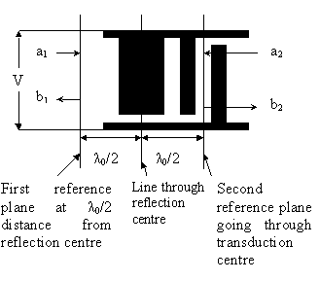
Fig. 1. A SAW unit cell with reflector

In Fig.1 a₁ and a₂ (b₁ and b₂) are input (output) acoustic signals at port1 and port2 respectively. To get the required p-matrix elements we need to get expression for output signals (b₁, b₂ and i) in terms of input signals a₁, a₂, and v. According to the basic assumptions we can write:
- ‘a₁’ is the input acoustic signal at port 1, signal ‘a₁ exp(-jωT/2)’ will reach the reflection center, where it will split in transmitted and reflected signals from reflector:
(a) The reflected part ‘a₁ exp(-jωT/2) r exp(-jωT /2)’ will reach the port 1 and will get added to outgoing acoustic signal from port 1 .
(b) Signal ‘a₁exp(-jωT/2)t’ will get transmitted through reflector and signal ‘a₁exp(-jωT/2) t exp(-jωT/2)’ will reach the transduction centre and will lead to the ‘γa₁texp{-jωT}’ current flow in the bus bar, where ‘γ’ is the acoustic to electrical signal conversion coefficient. After that the signal ‘a₁exp(-jωT/2) t exp(-jωT/2)’ will get added to the outgoing acoustic signal at port 2.

- Signal ‘a₂’ is the input acoustic signal at port 2, it will lead to ‘γa₂’ current flow due to transduction centre. After that signal ‘a₂ exp(-jωT/2)’ will reach the reflection center, and it will get split in two parts, one is reflected part and other one is transmitted:
(a) Reflected part ‘a₂ exp(-jωT/2) r exp(-jωT/2)’ will go to the transduction centre and will lead to ‘γa₂exp(-jωT/2)rexp(-jωT/2)’ current flow, after that acoustic signal ‘a₂exp(-jωT/2)rexp(-jωT/2)’ will go out from port 2 of unit cell.
(b) The signal ‘a2exp(-jωT/2)t’ will transmit through reflector, and ‘a₂exp(-jωT/2)texp(-jωT/2)’ will get added to outgoing acoustic signal at port 1.

- On account of applied voltage ‘v’, the acoustic signal ‘αv’ traveling in forward direction will get added to outgoing acoustic signal at port 2. The acoustic signal ‘αv’ will also travel in backward direction. The acoustic signal ‘αv exp(-jωT/2)’ will reach the reflection center and it will split in two parts:
(a) The reflected signal ‘αv exp(-jωT/2) r exp(-jωT/2)’ will reach at the transduction center, leading to the ‘γαv exp(-jωT/2) r exp(-jωT/2)’ current flow and then signal ‘αv exp(-jωT/2) r exp(-jωT/2)’ will get added to outgoing acoustic signal at port 2.
(b) Signal ‘αv exp(-jωT/2)t’ will get transmitted through reflector and ‘αv exp(-jωT/2) t exp(-jωT/2)’ will get added to outgoing acoustic signal at port 1.

As a result of (i), (ii), (iii) and (iv) one can write:
b₁ = a₁ r exp(-jωT ) + a₂ t exp(-jωT)
+ αv t exp(-jωT);
b₂ = a₁ t exp(-jωT) + a₂ r exp(-jωT)
+ αv + αv r exp(-jωT),
i = γa₁ t exp{-jωT}+ γa₂
+ γa₂ r exp(-jωT)+ p₃₃.v;
(1)
Where p₃₃ = G_{a} + jB_{a} +jωC_{t} [9], G_{a} is found from p₁₃ and p₂₃, using power conservation. B_{a} is the Hilbert transform of G_{a} and the capacitance C_{t} is found by standard electrostatics [9].
Eq (1) can be written in matrix form as:
$\begin{aligned}\left[\begin{matrix}b_{1} \\ b_{2} \\ i\end{matrix}\right]=\left[\begin{matrix}p_{\text{11}} & p_{\text{12}} & p_{\text{13}} \\ p_{\text{21}} & p_{\text{22}} & p_{\text{23}} \\ p_{\text{31}} & p_{\text{32}} & p_{\text{33}}\end{matrix}\right]\left[\begin{matrix}a_{1} \\ a_{2} \\ v\end{matrix}\right] \\ \text{where} \\ p_{\text{11}}=\text{r exp}(\text{-j}ωT);p_{\text{12}}=\text{t exp}(\text{-j}ωT); \\ p_{\text{13}}=α\text{t exp}(\text{-j}ωT);p_{\text{21}}=\text{ t exp}(\text{-j}ωT); \\ p_{\text{22}}=\text{r exp}(\text{-j}ωT);p_{\text{23}}=α+αr\text{exp}((\text{-j}ωT); \\ p_{\text{31}}=γ\text{t exp}(\text{-j}ωT);p_{\text{32}}=γ+γ\text{r exp}(\text{-j}ωT); \\ p_{\text{33}}=G_{a}(ω)+{\text{jB}}_{a}(ω)+{jωC}_{t}(ω)\end{aligned}$.
Or we can write:
$\left[\begin{matrix}b_{1} \\ b_{2} \\ i\end{matrix}\right]=P\left[\begin{matrix}a_{1} \\ a_{2} \\ v\end{matrix}\right]$, Where ‘$P$’is the p-matrix for unit cell in fig. 1.
Using the fact that p₃₂ = -2p₂₃ [10], we can write $γ=−2α$.

4. A SAW Structure to Realize Poles
Fig. 2 shows a SAW structure to realize a proper second order denominator polynomial in the rational transfer function of SAW filter. The structure in Fig. 2 can be considered as a cascaded combination of two unit cells. The first unit cell is having two wide electrodes and no narrow electrodes. Let us say ‘1’ is the normalized maximum reflectivity given by a singlewide electrode of 3λ₀/8 width. The first unit cell of structure in fig. 2 can be represented as cell (0,2), which conveys that the cell is having zero transduction and two reflectors. Similarly the second unit cell can be represented as cell (1, 1), which conveys that the cell is having one reflector and one transduction with phase of reflection as well as transduction equal to zero. In order to get the p-matrix of structure in fig. 2, we can compute p-matrices of two unit cells, and then cascade the two by using formula as given in [10]. If this structure is a part of InIDT of SAW filter with reflection less OutIDT and all other unit cells in InIDT are reflection less (no wide electrode), then for InIDT we can say that input acoustic signal at port 1 and port 2 is equal to zero. The transfer function of InIDT can be seen as the ratio of output acoustic signal at port 2 to the applied voltage ‘v’, which is nothing but equal to ‘p₂₃’. If we calculate p₂₃ for structure in fig. 2, it can be written as:
$p_{\text{23}}=N/D$ , where
$$\begin{aligned}N=α+(α^{2}r−{αr}^{2})\text{exp}(−jωT) \\ +(t^{2}αr−α^{2}r^{3})\text{exp}(−2jωT) \\ +(t^{4}αr−t^{2}{αr}^{3})\text{exp}(−3jωT); \\ D=1−2r^{2}\text{exp}(−jωT)+(r^{4}−r^{2}t^{2})\text{exp}(−2jωT)\end{aligned}$$
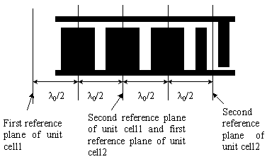
Fig. 2 A SAW structure to realize poles

If all other unit cells in InIDT cascaded with structure in Fig.2 are reflection less and the OutIDT is also reflection less then the denominator of transfer function of the SAW filter will be same as that of structure in fig. 2. If we consider exp(-jωT) as a unit delay, and represent it as z⁻¹, then the denominator polynomial ($D$) is :
$D=1−2r^{2}z^{−1}+(r^{4}−r^{2}t^{2})z^{−2}$, which is a proper second order polynomial. As the obtained transfer function of SAW filter is rational, with coefficients depending on device parameters, hence it establishes the claim that it is possible to realize IIR transfer function on SAW devices.

5. Simulation Results
In order to validate the model presented in section 3, the transfer function (‘p₂₃’ under unmatched condition) of a SAW InIDT with zero reflection and 275 unit cells is calculated by COM model, and present model. The original transfer function is the z-transform of impulse response sequence (with loss made equal to that of RAM/COM by dividing the z-transform by suitable value). The three transfer functions (‘p₂₃’) given by present model, COM, and original are plotted simultaneously in fig.3. It can be seen that the three transfer functions shown in fig.3 are extremely close to each other (one should not think that only one transfer function is shown). The figures are plotted using MATLB6.5.
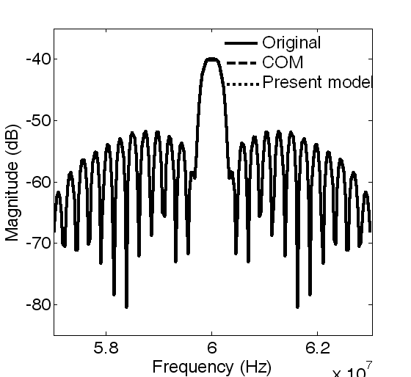

Fig. 3. Transfer function (p₂₃) of an InIDT with zero reflection and 275 unit cells.

To validate the model with reflections the transfer function (‘p₂₃’ under unmatched condition) of a SAW transducer using reflections to cancel the effect of electrical regeneration is plotted in fig. 4. This transducer is having 62 unit cells.
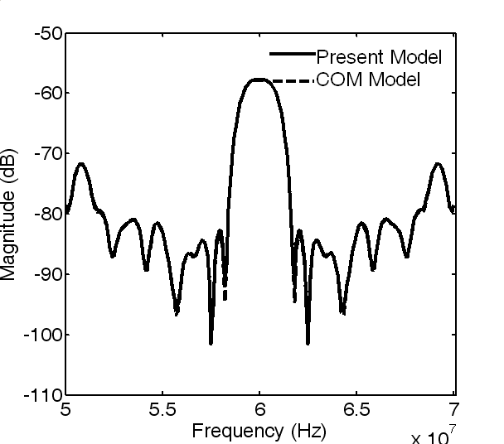

Fig. 4. Transfer function (p₂₃) of an InIDT with reflection and 62 unit cells.

6. Conclusion
The concept of IIR filter realization on SAW devices is introduced. A model has been presented to give the p-matrix of unit cells with reflections. The present model is analyzed to get the transfer function of SAW transducer comprising cascades of such unit cells. The simulation results showing the validity of the present model with/without reflections are given. A rational transfer function with proper second order denominator polynomial has been obtained for a SAW filter with reflectors, which establishes the claim that it is possible to realize IIR filters on SAW devices.

References:
[1] K. Hanma and B. Hunsinger, “A triple transit suppression technique”, IEEE Ultrason. Symp. Proc., pp. 328 –331, 1976.
[2] R. B. Brown and S. Gopani, “Apodized single-phase unidirectional transduer SAW devicse”, IEEE Ultrason. Symp. Proc., pp. 231 –234, 1991.
[3] C. W. Ruppel, Roland Dill, Jurgen Franz, Stefan Kurp and Werner Ruile, “Design of generalized SPUDT filters”, ”, IEEE Ultrason. Symp. Proc., pp. 165 –168, 1996.
[4] T. Kodama, H. Kawabata, Y Yashuhara, & H. Sato, “Design of low –loss SAW filters Employing Distributed Acoustic Reflection Transducers”, IEEE Ultrasonics Symposium Proceedings, pp. 59 –64, 1986.
[5] J. M. Hode, J. Desbois, P. Dufile, M. Solal, and P. Ventura, “SPUDT based filters: Design principles and Optimization”. Proc. IEEE Ultrason. Symp., pp. 39-50, 1995.
[6] B. S. Madhukannan and B. S. Panwar, “Design of low loss widhdrawal weighted SAW filters using the distributed acoustic reflectors”, Intern. Conf. Ultrason., pp. 148-151, 1999.
[7] Priyanka, S. D. Joshi, B. S. Panwar, “An iterative approach to design a SAW filter having desired response” Accepted for publication in IEEE Trans. Utrason., Ferroelect., Freq., Contr.
[8] D. P. Morgan, “Reflective array method for analysis and design of weighted DART transducers and filters” Proc. IEEE Ultrason. Symp., pp. 133-137, 2001.
[9] D. P. Morgan, “Reflective array modeling for reflective and directional SAW transducers” IEEE Trans. Ultrason., Ferroelect., Freq. Contr., vol. 45, pp. 152-157, 1998.
[10]B. P. Abott, C. S. Hartmann and, D. C. Malocha, “A coupling –of –modes analysis of chirped transducers containing reflective electrode geometries”, Proc. IEEE Ultrason. Symp., pp. 129 –134, 1989.
[11]Pascal Ventura, “Full Strip Reflectivity Study on Quartz”, Proc. IEEE Ultrason. Symp., pp. 245 –248, 1994.

