OBJECT-ORIENTED APPROACH IN DEVELOPING KNOWLEDGE BASE FOR A MULTIMEDIA E-LEARNING SYSTEM

Mohd Fairuz Mohd Yusof, Rafisha Ramly, Kai-Li Ng, Eng-Thiam Yeoh, Robin Salim, Kasturi Muthu Elandy
Faculty of Information Technology
Multimedia University, 63100 Cyberjaya, Selangor D.E
Malaysia

Phone: +60-3-8312-5477, Fax: +60-3-8312-5264

ABSTRACT

This paper describes the work of the research done to model a knowledge base. The knowledge base is one of the components of the Multimedia Knowledge Base E-Learning (MKBE-Learning) project which is still in progress [1]. The paper discusses the modeling of the knowledge base architecture using Object-Oriented Analysis and Design (OOAD) [2]. The process of the modeling follows the Rational Unified Process (RUP) [3]. The model is visualized and documented using the Unified Modeling Language (UML) [2]. The outcome of the OOAD modeling is blueprints of the knowledge base architecture. The blueprints are made up of static and dynamic elements of the Analysis and Design Model. The whole idea of the architecture is to design new representation of knowledge base that includes teaching and learning objects.

KEY WORDS

Knowledge Representation, Knowledge Acquisition, Multimedia, Object-Oriented Programming, E-Learning Systems.

1. Introduction

A lot of researches and products has been developed in the last few years concerning e-learning systems [4]. Current e-learning systems provide numerous interactive contents to the learners. The combination of multimedia and educational materials, results in the production of multimedia content applications that are interactive, multi-sensory, and visually challenging to the learners [5],[6],[7]. The multimedia contents are stored in the knowledge base.

The paper discusses the modeling of the knowledge base architecture using Object-Oriented Analysis and Design (OOAD) [2]. The process of the modeling follows the Rational Unified Process (RUP) [3]. The model is visualized and documented using the Unified Modeling Language (UML) [2].The results of the OOAD modeling is the blueprints of the knowledge base architecture. The blueprints are made up of static and dynamic elements of the Analysis and Design Model. These elements form the objects for the knowledge base. Some of these objects are shared objects. The purpose of object sharing is to promote knowledge sharing [8]. With object sharing, the knowledge objects of the architecture can be linked to any knowledge objects in the system.

2. MKBE-Learning System

The MKBe-Learning System is a multimedia e-learning system created to store, manage and retrieve concept-based multimedia educational material. Students will access the course materials using the system. It could be synchronous or asynchronous lectures while lecturers will use the system to organize and store education materials such as lectures and tutorials. The knowledge base will improve reusability of multimedia education materials, as well as providing flexibility in varying the presentations to the students based on student ability and preference.

The MKBe-Learning System [1] is an integrated e-learning system consisting of 6 components: intelligent interface, inference engine, presentation generator, authoring tool, knowledge base and learning management system. The major components of the system are:
- Intelligent Interface: provide access to multimedia lessons.
- Inference Engine: personalized the learning process according to the student needs.
- Presentation Generator: creates multimedia presentations based on personalization parameters.
- Authoring Tool: A tool used by lecturers to create learning materials
- Knowledge Base: stores lessons and learning objects.
- Learning Management System: maintains personal details of students. Also records students learning process

The components and their relationship are shown in Figure 1.
Learning Management
System
Intelligent Interface

Authoring
Tool
Inference Rule

Knowledge Base
Presentation
Parameters *
new concepts registration
Interface
Engine
personalization
Log in/out
Student
Input
Presentation
Personalization rule retrieval
*: student level of understanding and presentation preference
Instructor
concept retrieval/update
edited teaching material
Optimum teaching material based on presentation parameters

Presentation Generator

Figure 1: MKBe-Learning System

3. Use Case Analysis and Design

The scope of the OOAD for the knowledge base covers secure access, selective functionality for different user categories, course syllabus, content search facility and course content structure with lessons. The OOAD modeling goes through several flows as described in the RUP [3]. The output for each flow produces artifacts of the Analysis and Design Model. The artifacts are the Use Case Specifications, Use Case Diagrams, Activity Diagrams, Use Case Realization, Analysis Classes, Design Classes, Packages and Layers, Sequence Diagrams, Collaboration Diagrams, Class Diagrams, State Chart Diagrams, Component Diagram, and Deployment Diagram [2]. The Design Model is then realized to a working prototype by translating the Design Model into Data Model, Physical Model and executables.

3.1 Actors

There are 3 types of actors identified for the knowledge base system. The actors are:
- Student: A person who is registered to take courses.
- Instructors: A person who creates the knowledge base contents, and lessons.
- Administrators: A person who maintains the whole system and actor’s profiles. Super administrator maintains the profiles of other administrators.

3.2 Use Cases

The Use Cases defined for the knowledge base system are listed below [15]:
- Maintain Course
- Maintain Student Profile
- Maintain Instructor Profile
- Maintain Administrator Profile
- Instructor Maintains Lessons
- Instructor Models Instructional Design
- Instructor Select Authoring Mode
- Instructor Author Web Pages in the Novice Mode
- Instructor Author Web Pages in the Expert Mode
- Instructor Delete Web Page
- Instructor Publish Web Page
- Instructor Unpublished Web Page
- Instructor View Lesson
- Instructor Selects Course
- Student Registration to Use the System
- Student View Lesson
- Student Register for Course

Each Use Case is documented with a flow of events. The flow of events for a Use Case is a description of the events needed to accomplish the required behavior of the Use Case. The flow of events for a Use Case is described in the Use Case Specification. There are 4 Use Case diagrams to describe the interaction between the actors and the system. The 4 Use Case diagrams are made for all actors, student, instructor and administrator. Each actor performs their own use cases.

3.3 Analysis and Design Classes

Since the Use Case Analysis produces quite a number of analysis classes, these classes have to be grouped. By grouping these classes into packages, the system is much more maintainable since any updates on a particular class only involves those particular package only [9]. The packages and analysis classes are then analyzed to produce design-level classes and packages. The design-level packages are then called as Use Case Realization packages. These packages are grouped into 3 layers namely application, project services and middleware. These layers functionalities follow the typical layering approach of software layers [10]. The layers and the packages can be directly transferred to the 3-tiers “Thin Client” architecture [11]. The advantage of introducing layers in the design stage is that, the design packages inside the layers can be directly translated as the elements of the 3-tiers architecture. Layers provide separation of packages responsibilities and make the design architecture more flexible to convert into the Client/Server architecture [11].

3.4 Interaction Diagrams

One sequence diagram is drawn for each independent sub flow of the Use Case as laid out in the Use Case specification. There are 29 sequence diagrams for the knowledge base system. As each collaboration diagram is made to match corresponding sequence diagram, there are 29 collaboration diagrams for the knowledge base system. Sample of sequence diagram for creation of a course by an administrator is shown in Figure 2.
Figure 2: Administrator creates a course

3.5 Class Diagram

The knowledge base structure can be defined and viewed using two different hierarchies known as Instructional View and Knowledge Base View (Figure 3). The two hierarchies stand as a guideline to be followed in order to classify the different types of content.

Instructional View refers to the learning content organization by the instructor in developing the learning materials. The Instructional View structure consists of four levels: course, lesson, topic and webpage [15]. This view is defined as a principle in storing the necessary information or data and can be applied to any content regardless of the delivery format. The levels in the Instructional View are produced through discussion and research with the Authoring Tool research group.

The Knowledge Base View refers to the content development of the database that consists of lectures,
modules and media representations. The attributes used in developing the contents are gathered and analyzed based on items available in the use cases. The use case produces objects that will later be used as analysis class’s stereotypes.
The knowledge base class diagram is shown in Figure 3. Based on Figure 3, a course is a realization of the subject with specific learning objectives through a set of lessons.
Lesson is the content that is to be taught or the activity that is to be done that concerned with a specific skill and it is made up of a number of topics. Each course consists of 30 to 50 lessons, where each lesson can have 10 to 15 webpages [13]. These webpages contain topics and/or subtopics. Each lesson consists of 1 to 3 topics with possible 1 to 3 subtopics per topic. The contents of the webpages are derived from the concepts in the knowledge base, and each webpage is a presentation of one concept.

Concept is associated to many subjects whereby a subject is a branch of knowledge or field of study. A concept is a representation of an idea that can be taught, explained or presented by lecturer to the students. Concepts can be related to other concepts via typed-relations such as pre-requisite and related-to. Each concept is described through different characteristic such as General Information, Core, Example, Demonstration, and Use Case. Each characteristic will be presented through the media. The suitability of media for a concept is tested during the process of identifying the appropriate media type. There are five types of media identified i.e. text, graphics, audio, video and animation.

3.6 Run-Time Architecture and Deployment

For the run-time architecture, independent processes are identified and the design packages are mapped to these processes. It is decided to make one process for each main activity; i.e. one process per major interface for each activity. The processes for the application are:
- Course Management
- Course Content Management
- Search Process
- Profile Management

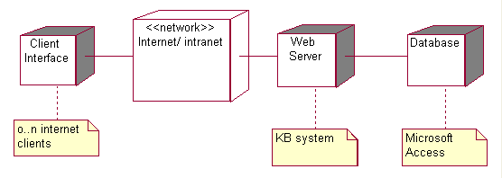
Figure 4: The Deployment Diagram for the Knowledge Base System
“Thin Client” application architecture is the distribution pattern chosen for the system [10]. The deployment diagram for the knowledge base system is shown in Figure 4. All the processes run on the web server.

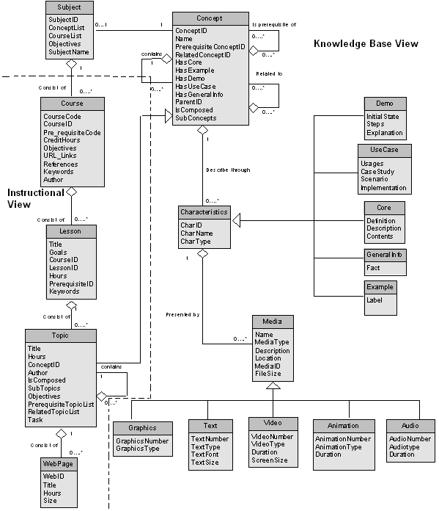
Figure 3: Class Diagram for the Knowledge Base

4. Subject Analysis Results

To demonstrate the usability of the object-oriented model (Figure 3), we applied the structure to many subjects offered by our Faculty. In this case, Subject Matter Expert (SME) is required to create storyboard that will fit into the model. The storyboard contains flow and description of learning contents. In this paper we present the results of Software Engineering subject contents as a sample [12]. Distribution of objects is given in Table 1. These distributions are made based on human perception. Take note that the level of granularity of the concept is not determined. So the results will be different if it is made by another person. The distribution was based on 6 lessons. The lessons are: Introduction to Software Engineering, Software Life Cycle, Software Project Management, Project Plan, Software Metrics and Software Cost Estimation. Based on Table 1, 116 concepts were found (concepts and subconcepts). The overall characteristic distribution for the concepts is shown in Figure 5. Based on Figure 5, Core characteristic is widely used to describe the concepts (72%).

 | Lesson 1 | Lesson 2 | Lesson 3 | Lesson 4 | Lesson 5 | Lesson 6 | Total
Concept | 1 | 5 | 2 | 4 | 3 | 3 | 18
Sub concept | 7 | 20 | 21 | 16 | 15 | 19 | 98
General Information | - | 6 | 2 | - | 3 | 3 | 14
Core | 7 | 18 | 19 | 17 | 13 | 16 | 90
Use Case | 1 | 1 | 1 | - | 2 | 4 | 9
Example | 1 | - | 1 | 3 | 2 | 3 | 10
Demonstration | - | - | - | 2 | 1 | - | 3
Text | 9 | 17 | 19 | 16 | 16 | 18 | 95
Graphics | 1 | 4 | 4 | 5 | - | 4 | 18
Audio | 2 | 6 | 7 | 6 | 11 | 8 | 40
Video | 1 | - | - | - | - | - | 1
Animation | 1 | 5 | 4 | 4 | 2 | 4 | 20
Table 1: The Distribution of the Concepts, Characteristic and Media Objects
This is because the concepts for Software Engineering subject are more likely to be presented as descriptive information. General information and example is the second and third highest which comprises of 11% and 8%. Seven percent of concept is used in use case characteristic. Demonstration is the least (2%) since the concepts for this subject are less likely to be presented using procedural illustration.

72%
Characteristics Comparison
General
Information
11%
Core
Example
8%
Demonstration
2%
Use Case
7%
Figure 5: Characteristic Comparison of Software Engineering Subject

The breakdown for the different type of media of the subject is shown in Figure 6. Based on Figure 6, text and audio are the most used media for the presentation of the subject which accounted for 55% and 23%. Animation (11%) and graphics (10%) are used more to illustrate and clarify the content and description of the concepts. Video is only applied for demonstration and use case. Since video files require more bandwidth, video is less likely used.

Media Comparison
Text
55%
Graphics
10%
Audio
23%
Animation
11%
Video
1%
Figure 6: Media Comparison for Software Engineering Subject

5. Prototype

A prototype has been built based on the design of the object-oriented model. The prototype will eventually become maintenance interface used by the instructor in order to use the knowledge base. By using this tool, instructor will be able to do modification toward subjects, concepts, characteristics and media. The modification includes creation, retrieval, update and delete.

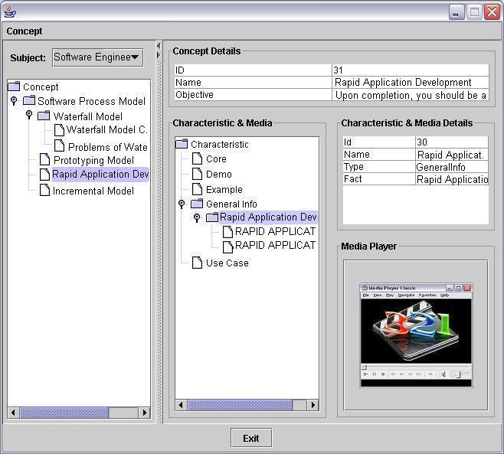
Figure 7: Main Interface for Knowledge Base System

Figure 7 is the main window for the maintenance tool. For preview purposes, the concepts tree for particular subject will be depicted at the left hand panel of the GUI. The tree visualizes the parent-child relationship among concepts resided in the knowledge base. Each concept has its own metadata and attributes. The small table on the bottom right panel is the detail of specific concept. The purpose is to display selected concept information. The information consists of unique identifier, name, objective and metadata. The smaller tree seen in the tool depicts available characteristics and media of particular concepts. By selecting a concept on the left hand panel tree, the tool will list down all available characteristics and media related to the concepts. If a particular characteristic or media is selected, the details of it will be displayed in the table. In addition, there is a media preview panel which could be enlarged. The panel is used to preview the related media file (for e.g. video, text, audio, video and graphic). Besides previewing concepts, an instructor may also add concepts and characteristics to the knowledge base. Figure 8 and Figure 9 shows the interface for adding concept and characteristic respectively. The instructor needs to fill up the information for each concept and characteristics.

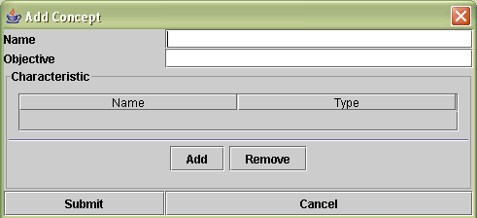
Figure 8: Interface to add concept
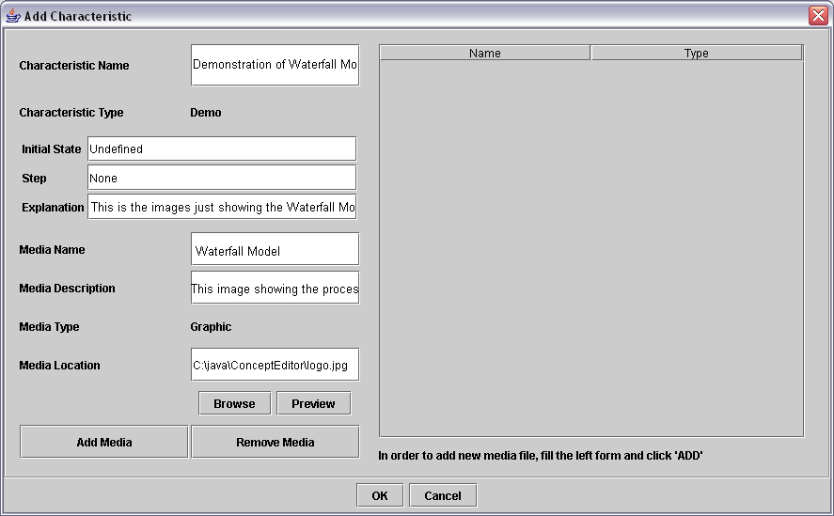
Figure 9: Interface to add characteristics

6. Further Development

To make the knowledge base system contents usable to any SCORM-compliant VLE systems, the content structure of the knowledge base will be organized into a SCORM Content Aggregation Model [14]. Besides that, security mechanism can also be added as one of the system components. Security mechanism plays an important role when the architecture of the knowledge base is to be realized and commercialized. Besides that, we did not discuss the analysis of subject comparison among all subjects. The next development phase will consider absolute values of comparison analysis between subjects. Furthermore, we will do analysis on learning outcome. We will evaluate the model based on what is being given and what is being learned by the students.

- Conclusion

The significance of OOAD modeling the knowledge base via RUP using UML is that; the object-oriented analysis and design process can be visualized and documented clearly [2]. The documentation covers the static properties and dynamic properties of the knowledge base elements. The dynamic elements represent the behavior of the system [2]. The behavior is captured in the interaction diagrams. The class diagram can be translated into any object-oriented programming language [2]. This makes the architecture of the knowledge base possible to be realized. The blueprints of the architecture can be written in Java, C++, FORTRAN, Smalltalk and many other object-oriented programming languages. The flexibility of the architecture for code-conversion becomes apparent if migration of programming language is needed.

References:

- Yeoh, E.T., Mohd. Yusof, M.F., An Integrated Multimedia E-learning System, Proceedings for the International Conference on Computers in Education (ICCE2003), Hong Kong, December 2003, pp. 794-801.
- Booch, G., Rumbaugh,J. and Jacobson, I. The unified modeling language user guide (NJ: Addison-Wesley, 1999).
- Rational Software Corp., Rational unified process, best practices for software development teams, Rational Software White Paper, TP026B, Rev 11/0, 2001.
- Edutools (2004) [Online] Available
http://www.edutools.info/course/index.jsp
- Ng. K.H., Komiya, R., Multimedia textbook for engineering courses, Proc. IWNA 3rd International Workshop on Networked Appliances, Singapore, March 2001,pp. 122-128
- Bennett, C.L., Pilkington, R.M., Using a virtual learning environment in higher education to support independent and collaborative learning, Proc. IEEE International Conference on Advanced Learning Technologies , 2001, 285 -288,
- Rami Ahmad, Piccoli, G., Ives, B., Effectiveness of virtual learning environments in basic skills business education: a field study in progress, Proc. of the International Conference on Information Systems, 2000 ,352-357
- Jackson, R.H. (2003), Web learning Resources [Online] Available http://www.knowledgeability.biz/weblearning
- Quatrani, T. Visual Modeling with Rational Rose 2002 and UML (Boston, MA: Addison-Wesley, 2003)
- IBM Corp. Object Oriented Analysis and Design Using UML booklet (Rational Software, 2002).
- Slovak,K. Poremsky,D. Boutqin,P., et al. Beginning Visual Basic 6 Application Development (UK :Wrox Press, 2000)
- Faculty of Information Technology, MMU (2003) Course Syllabus List [Online] Available http://fit.mmu.edu.my/03_academic/syllabusnd/syllabus.htm
- P.K Ng, C.S. Lee, C.K. Ho, Web authoring tool for novice mode user, Technical Report MKBE/AT/02, MKBe R&D Laboratory, Multimedia University, Cyberjaya, Malaysia, 2004.
- Advanced Distributed Learning Org. The SCORM Content Aggregation Model( ADL: ADL 10, 1, 2001)
- Norliana Maleh, C.S. Lee, C.K. Ho, Software requirement specification for instructor use case, Technical Report MKBE/AT/Norliana/001, MKBe R&D Laboratory, Multimedia University, Cyberjaya, Malaysia, 2004.

