An Improved Digital Controller for Three-Phase PWM Inverter with Insulating Transformer for Double Conversion UPS

Fernando Botterón, Humberto Pinheiro
UFSM – CT – NUPEDEE – GEPOC
Federal University of Santa Maria
97105-900 – Santa Maria, Av. Roraima s/n
Brazil
http://www.ufsm.br/gepoc/

Abstract: - This paper proposes an improved digital voltage controller adequate for three-phase three-leg PWM inverters with an isolator transformer used in double-conversion UPS. The proposed controller is derived from the internal model principle using a state-variable approach in αβ frame. By this control strategy it is possible to obtain a high performance in steady-state. In addition, with the selected internal model, the DC components are not amplified avoiding in this case the output transformer saturation. With this approach it is possible to obtain output voltages with reduced total harmonic distortion (THD) and a good transient performance for linear and non-linear load steps, that compliant whit the international Standard IEC 62040-3. In order to validate the proposed control strategy and to demonstrate the steady-state and transient performance, experimental results are obtained in a 10 kVA space vector modulated three-phase inverter, fully controlled by a DSP TMS320F243.

Key-Words: - Digital Controllers, Three-Phase PWM Inverters, Three-Phase Double Conversion UPS.

1 Introduction
Three-phase uninterruptible power supplies (UPS) are usually required to feed both single-phase and three-phase critical loads with low total harmonic distortion (THD) at the output voltages [1]. Among the three-phase inverter configurations, the one shown in Fig. 1 has been considered as a strong candidate since (i) it provides galvanic isolation to the load; (ii) it allows selecting the output voltage according to the customer needs, and (iii) it provides a neutral by the delta-star (ΔY) connection. There are many factors that contribute to the output voltage distortions: (i) load currents with high crest factor draw by rectifiers found within the critical loads, (ii) inherent nonlinearities of the PWM inverter, (iii) fluctuating of the DC-bus voltage, (iv) impedance of the output transformer and (v) unbalanced nonlinear loads, where the typical nonlinear load is a uncontrolled single phase diode rectifier with capacitive output filter. These factors must be taking into account in the controller design. It is important to note that one requirement to achieve high quality output voltage, in the inverter configuration of Fig. 1, is to make the measures of these voltages at the secondary side of the transformer, since in this way the transformer voltage drops can be compensated. In addition, quantization errors of the AD converters and digital pulse width modulators, combined with the inevitable real live circuit implementation non-idealities and then amplified by an inappropriate selection of the controller, can lead to the transformer saturation degrading the overall performance of the system [20],[21]. It is important to point out that the Standard IEC 62040-3 [1] specify that the total distortion factor “D” of a UPS with sinusoidal output voltage waveforms, must be under 8%. The reductions in the distortion factor D can be accomplished by reducing the UPS output impedance: (i) by means of the output passive filter, which has the disadvantage of increasing the size and weight as well as the current stress; (ii) by the adequate selection and design of the controller, which will be investigated in this paper.
With the Internal Model Principle [2]-[4] and its discrete-time implementation form, the well known Repetitive Controller [5]-[7], several high performance approaches have been proposed, in order to achieve high quality output voltages in single-phase and three-phase PWM inverters [8]-[19]. Related to three-phase UPS applications, in [10], a two-layer voltage controller scheme in synchronous frame is proposed: A PI regulator is used to ensure zero steady-state error at the fundamental frequency and a repetitive-based controller with a high-pass filter to compensate the harmonics at the inverter output voltages. However, inadequate choices of the high-pass filter cut-off frequency may lead to amplify DC components that can saturate the transformer at the inverter output. Moreover, the repetitive controller with a high-pass filter produce pole-zero cancellation which the plant, violating the internal model principle [2]-[4]. More recently, the modified plug-in repetitive controller proposed in [7] combined with the conventional OSAP compensator (One-sampling-ahead preview) in stationary αβ frame has been reported in [12] to improve the output voltage distortion due to a three-phase rectifier load. However, the output transformer is not considered. Then, if the isolator transformer will be connected at the inverter output, a pole zero cancellation occurs when inserted the plug-in repetitive controller. Subsequently, a discrete-time control strategy using a repetitive controller extended to a PI compensator structure in stationary αβ frame is proposed in [13] to compensate voltage distortions due to nonlinear and unbalanced loads. To improve the performance, a 30th order low-pass FIR filter is introduced after the measures to attenuate the high frequency components, making the voltage error to contain only lower frequencies. In order to avoid additional phase shift in the closed-loop, this filter is noncausal with zero-phase-shift and unity gain. In this way, this strategy improves the closed-loop system robustness. Nevertheless, this implementation presents cancellation of the repetitive controller pole with the zero of the plant introduced by transformer and eventually leaves the transformer to the saturation.
Different solutions that can also be described on the internal model principle have been presented [16]-[18]. In [16] and [17] selected harmonics of the three output voltages are detected by a discrete Fourier transform (DFT) and their mean values are compensated by PI compensators in stationary frame. The sum of the compensators outputs generates the harmonic distortion correction signal applied to the plant. In [18] a three-layer control scheme is proposed. It consist of a proportional compensator in stationary αβ frame, an integral controller in synchronous frame to compensate the fundamental component and a selective harmonic compensator in stationary frame based in a pass-band FIR filter with unity gain and zero phase at the selected harmonics. The delay introduced by the plant and the inner current control loop is compensated by introducing a block delay with positive feedback in the harmonic control layer. In reference [19] is proposed a robust controller based on the passivity theory for three-phase UPS. This controller guarantees asymptotic stability with good steady-state performance for nonlinear and unbalanced load. Although, the controllers proposed in [16-19] can be adequate solutions to reduce the output voltages distortion and to operate with an insulating transformer, the computational requirements for the implementation of these controllers increases significantly as the number of the harmonics to compensate increases. In [21], the dynamics of the output insulating transformer are considered in the nominal model allowing designing an adequate internal model for the plant to be controlled that not produce pole-zero cancellation, so the transformer does not saturate. The proposed internal model uses the structure of the modified repetitive controller [7] that results in a simple form for digital implementation. This developed controller presents a good steady-state performance for linear and nonlinear unbalanced loads; however the load transient performance is not good if will be consider [1].
In order to obtain output voltages with a reduced total distortion factor in steady-state and an improved load transient regarding the standard [1], this paper proposes an improved digital controller based on a state variable approach of the internal model principle in αβ stationary frame, to control the double-conversion UPS of Fig. 1. This digital controller use the same proposed internal model in [21], that not produce pole-zero cancellation, then the output transformer does not saturate. This control strategy improves significantly the transient response to load changes if compared with the control system presented in [21]. In addition, this paper presents a simplified model of the inverter, transformer filter and load in stationary coordinates. Therefore, the discrete-time model, that takes into account the real-time implementation delay, is presented, in order to make possible the design of the feedback gains.

Fig. 1. Three-phase PWM inverter, ΔY transformer, filter and load.

2 System Description
A typical double-conversion UPS power circuit is shown in Fig. 1. The DC bus voltage is considered almost constant and supplied by a six-pulse three-phase uncontrolled diode rectifier, in the normal operation mode, or by a battery bank, which provide energy to the inverter in the backup mode in absence of the utility grid. The DC to AC conversion is accomplished by an insulated-gate-bipolar-transistor (IGBT)-based space vector modulated three-phase three-leg inverter. The high frequency harmonics introduced by the modulation are filtered by the LC filter. As described previously the transformer provides galvanic isolation to the critical loads and the delta-star connection provides the neutral wire to single-phase loads. It is important to point out, that the filter inductors are located at the primary side of the transformer in order to not introduce distortions in the output voltages. These distortions are related to the zero sequence voltages produced by unbalanced load currents. These unbalanced currents will be shorted on the delta connection at the primary side. Note that this inverter it is not capable to control zero sequence voltages. Therefore, minimizing the zero sequence impedance of the transformer it is possible to diminish the resulting zero sequence voltages and the distortions produced, by the neutral currents, in the output voltages.
3 Three-Phase PWM Inverter, ΔY Transformer, Filter and Load Model
Stationary abc Model
Based on the circuit of Fig. 1 it is possible to obtain the dynamic equations of the inverter, transformer, filter and load, applying the Kirchhoff laws at the primary and secondary sides of the transformer. To simplify the system modeling, it is considered that the leakage inductances of the primary and secondary side of the transformer are concentrated at the secondary side. In addition, the coil resistances are considered negligible. Then, applying the voltage and current Kirchhoff laws can be obtained the following equations:
()
()
()
Where, M is the mutual inductance, L is the filter inductance, the equivalent leakage inductance, andis the filter capacitance. In the equations (), () and (), , are the line-to-line PWM voltages produced by the inverter, are the phase-to-neutral voltages, that must be controlled, referred to the primary side, and are the load currents, referred to the primary side, and are the phase current at the primary side of the transformer.
Stationary αβ Model
In order to obtain a decoupled state-space model useful to design the state feedback controller, the equations (), (), and () are transformed to the αβ frame. The state-space model in the alpha axis is in the following form, where the matrices A_{α}, B_{α}, and F_{α}, are given by,
()
Where and . By this state-space model are obtained the following equivalent circuits in αβ0 coordinates:
(a). Equivalent circuit of the α axis.
(b). Equivalent circuit of the β axis.
(c). Equivalent circuit of the 0 axis, or zero sequence component.
Fig. 2. Equivalent circuits in αβ frame of the inverter, transformer, filter and load.
4. Proposed Voltage Controller with an Internal Model in Stationary αβ Frame: a State Variable Approach
In this section will be introduced the design of the state variable controller with an internal model that not produce pole-zero cancellation with the plant, and to attend the requirements of asymptotic tracking of the reference and disturbance rejection. The design procedure of this controller based on the internal model principle is similar to the input-output approach presented in [21].
Let us consider the discrete-time equations of the plant described by the following equations:
()
Where G_{p}(n x n) and H_{p}(n x p) are the discrete-time matrices of the plant given in appendix and the matrices _{(q x n)} and . It is assumed that {G_{p},H_{p}} is controllable and {G_{p},C} is observable. It is also assumed that the disturbance signal w(kT) is generated by: , where . The problem is to design a control system so that the output of the plant will track asymptotically the reference signal r(kT) generated by: , where, . Let φ_{w}(z) and φ_{r}(z) the minimal polynomials of A_{w} and A_{r}, respectively, and let
()
be the least common multiple of the unstable roots of φ_{w}(z) and φ_{r}(z). Thus all roots of φ(z) are outside of the unit disc. The internal model can be realized as
()
()
as shown in Fig. 4. Note that the output of this compensator consist of all N numbers of state variables where N is the number of samples in a period of the reference signal. Now consider the tandem connection of the plant followed by the compensator in (). Its composite dynamical equation is given by,
()
This tandem connection will be controllable and observable if and only if and no pole of φ(z) is a zero of the plant. In a explicit form it is possible to express that () is controllable if and only if
()
If () is controllable, then the eigenvalues of the composite system represented in Fig. 4 can be arbitrarily assigned by state feedback, that is,
()
Hence by a proper choice of K_{re} and K_{c}, the feedback system in Fig. 4 can be stabilized. In order to accomplish the design of the feedback gain matrices, the steady-state discrete linear quadratic regulator approach has been used. This technique, result in an asymptotically stable steady-state solution for the cases of the interest. The design procedure of these gain matrices to obtain a desired performance has been presented in [23].
In order to satisfy the requirement that non of the roots of φ(z) must be a zero of the plant for the system presented in Fig. 1, φ(z) has been selected in the following form:
()
with m = N.
In this polynomial the zero-phase shift FIR filter proposed in [] has been used in order to increase the robustness of the closed-loop system at high frequencies. In Fig. 6 the open-loop pole-zero map of the proposed based-internal model compensator is presented. It is possible to see that this internal model does not include the pole at z = 1. In this way this proposed controller does not amplify residual DC components that could lead to the transformer saturation. The parameters to design the feedback gain matrices are given in Table I
Table I. System parameters
Switching Frequency | 4.98 Hz | Leakage Inductance | 65 μH
Plant Sampling Frequency | 9.96 Hz | Output Filter Inductor (L) | 250 μH
Internal Model Controller Sampling Frequency | 4.98 Hz | Output Filter Capacitor (C) | 120 μF
Fundamental Frequency | 60 Hz | Turns Ratio | 1.732
DC Bus Voltage | 450 V | Nominal output voltage | 3x220/127V
Mutual Inductance (M) | 200 mH | Samples per fundamental period (N) | 83

Fig. 4. Block diagram representation of the proposed voltage controller with an internal model in stationary αβ frame.

Fig. 5. Sampling instants, discrete-time control action and PWM phase voltages. T_{pwm}: Switching period. T: Plant Sampling period. T_{im}: Sampling period of the internal model.
Fig. 6. Pole-zero map of the proposed internal model based controller.
It is important to point out, that the matrices G_{p} and H_{p} taking to account the real-time delay of the digital implementation, and they has been obtained based on the sampling instants shown in Fig. 5. It is possible to see that the control action is updated at half of sampling frequency and it is computed using the average value of the two last samples. In addition to, the internal model-based compensator is computed at the same frequency of switching. This avoid that the internal model do not attempt to compensate harmonics at the switching frequency, becoming the system unstable.
5 Experimental Results
The circuit of Fig. 1 has been tested experimentally to verify the proposed digital voltage controller, using a DSP TMS320F243. The test has been performed with a single-phase and three-phase uncontrolled rectifier loads as well as a linear load. The system parameters are given in Table I. Figures 7 and 8 shows the three-phase line-to-neutral voltages and the load current in the phase a when the output load is a single-phase and a three-phase uncontrolled rectifier with a capacitive filter. These experimental results demonstrate that the total harmonic distortion at the output voltages in steady-state is reduced, even in Fig. 7 where the load is a
100 % unbalanced (the load is connected only at the phase a). In Fig. 9 the steady-state response of this controller with unbalanced linear load with acceptable low THD is shown, and in Fig. 10Fig. it is possible to observe the transient response when the load changes from full load to no load. It is possible to see that the output voltage return to the nominal value after one fundamental period.
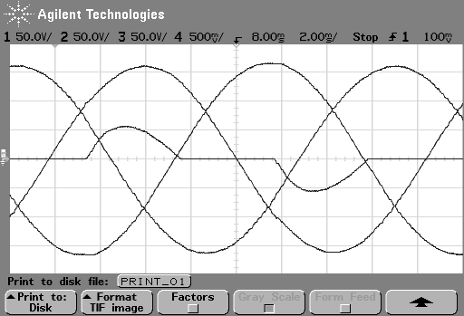
Fig. 7. Experimental result. Single-Phase uncontrolled rectifier. Output phase-to-neutral voltages, v_{an}, v_{bn} and v_{cn}, load current i_{a}. Voltage scale: 100 V/div.
Current scale: 50 A/div. THD = 1.3 %.
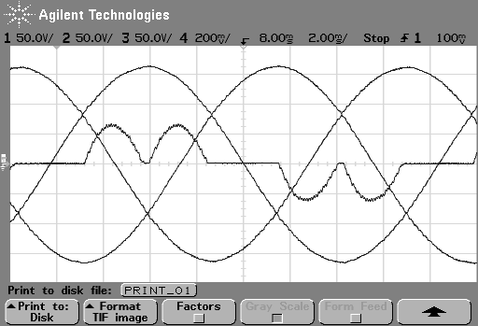
Fig. 8. Experimental result. Three-Phase uncontrolled rectifier. Output phase-to-neutral voltages, v_{an}, v_{bn} and v_{cn}, load current i_{a}. Voltage scale: 50 V/div.
Current scale: 20 A/div. THD = 0.9 %.
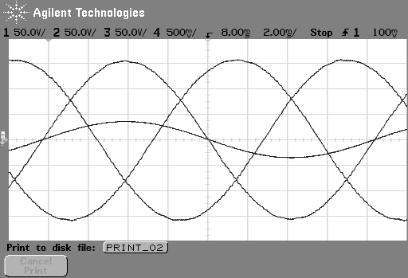
Fig. 9. Experimental result. Single-Phase linear load. Output phase-to-neutral voltages, v_{an}, v_{bn} and v_{cn}, load current i_{a}. Voltage Scale: 50V/div.
Current Scale: 50A/div. THD = 0.7 %.
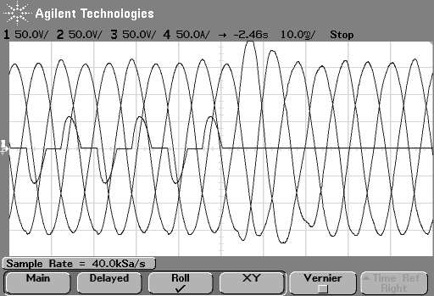
Fig. 10. Experimental result. Load transient. From full load to no load. Single-Phase uncontrolled rectifier. Output phase-to-neutral voltages, v_{an}, v_{bn} and v_{cn}, load current i_{a}. Voltage scale: 50 V/div.
Current scale: 50 A/div.

6 Conclusion
This paper proposes a digital voltage controller based on the state variable approach of the internal model principle in αβ stationary frame, adequate for three-phase three-leg PWM inverters that operate with an insulating output transformer for double-conversion UPS. The pole-zero cancellation issue presented by the conventional repetitive controller in the closed-loop with the presence of the output transformer make that the residual DC components of the digital implementation are amplified and eventually, saturate the transformer. This problem is solved in this paper selecting an adequate internal model that not produce pole-zero cancellation. This proposed controller allows to solve the saturation of the transformer and to improve the load transient response, for both linear and non-linear loads. In addition, in steady-state performance the resulting THD of the output voltages is reduced. The experimental results presented here demonstrate the good steady-state and load transient performance for non-linear loads. In steady-state the output voltages appear with reduced THD as expected. The load transient is improved if compared with the performance of the controller proposed in []. More experimental results will be included in the final version of this paper.

References:
[] Uninterruptible power systems (UPS) – Part 3: Method of specifying the performance and test requirements. International Standard IEC 62040-3. First Edition 1999-03.
[] B. Francis, O. Sebakhy and W. Wonham, “Synthesis of multivariable regulators: The internal model principle”, Applied Mathematics and Optimization, vol. 1, no. 1, pp. 64-86, 1974.
[] Uninterruptible power systems (UPS) – Part 3: Method of specifying the performance and test requirements. International Standard IEC 62040-3. First Edition 1999-03.
[] ___, “The internal model principle of control theory”, Automática., vol. 12, no. 5, pp. 457-465, 1976.
[] M. Tomizuka, “Zero phase error tracking algorithm for digital control”, Trans. ASME, J. Dynam. Syst., Meas. and Control, vol. 109, pp. 65-68, Mar. 1987.
[] M. Tomizuka, T. Tsao and K. Chew, “Analysis and synthesis of discrete-time repetitive controllers”, Trans. ASME, J. Dynam. Syst., Meas. and Control, vol. 111, pp. 353-358, Sep. 1989.
[] K. Chew and M. Tomizuka, “Steady-state and stochastic performance of a modified discrete-time prototype repetitive controller”, Trans. ASME, J. Dynam. Syst., Meas. and Control, vol. 112, pp. 35-41, Mar. 1990.
[] T. Haneyoshi, A. Kawamura and R. Hoft, “Waveform compensation of PWM inverter with cyclic fluctuating loads”, IEEE Trans. Industry Applications., vol. 24, no. 4, pp. 582-589, Jul/Aug 1988.
[] A. Kusko, D. Galler and N. Medora, “Output impedance of PWM inverters – Feedback vs. Filters”, in Conf. Rec. IEEE-IAS Annual. Meeting, 1990, vol.2, pp. 1044-1048.
[] H. Oshima and K. Kawakami, “Large Capacity 3-phase UPS with IGBT PWM inverter”, in Proc. IEEE PESC’91, 1991, pp. 117-122.
[] E. G. Carati, C. M. Richter and H. A. Gründling “A robust high performance three-phase uninterruptible power supplies”, in Proc. IEEE CCA’00, 2000, pp. 896-901.
[] K. Zhou and D Wang, “Digital repetitive learning controller for three-phase CVCF PWM inverter”, IEEE Trans. Ind. Electron., vol. 48, no. 4, pp. 820-830, Aug. 2001.
[] U. Borup, P. N. Enjeti and F Blaabjerg, “A new space-vector-based control method for UPS systems powering nonlinear and unbalanced loads”, IEEE Trans. Power Electron., vol. 37, no. 6, pp. 1864-1870, Nov/Dec 2001.
[] C. Rech, H. Pinheiro, H. A. Gründling, H. L. Hey and J. R. Pinheiro, “Comparison of digital control techniques with repetitive integral action for low cost PWM inverters”, IEEE Trans. Power Electron., vol. 18, no. 1, pp. 401-410, Jan 2003.
[] X. Kong, J. Wang, L. Peng, Y. Kang and J. Cheng, “The control technique of three-phase voltage-source inverter output waveform based on internal model theory”, in Conf. Rec. IEEE-IECON, 2003, pp. 788-793.
[] E. W. Rowand and D. J. Lucas, “Method and apparatus for harmonic distortion correction”, U.S. Patent 5 377 092, 1994.
[] A. Jouanne, P. Enjeti and D. J. Lucas, “DSP control of high-power UPS systems feeding nonlinear loads”, IEEE Trans. Ind. Electron., vol. 43, no. 1, pp. 121-125, Feb. 1996.
[] P. Mattavelli, “Synchronous-frame harmonic control for high-performance AC power supplies”, IEEE Trans. Ind. Applicat., vol. 37, no. 3, pp. 864-872, May/Jun 2001.
[] G. E. Valderrama, A. M. Stankovic and P. Mattavelli, “Dissipativity-Based Adaptive and Robust Control of UPS in Unbalanced Operaton ”, IEEE Trans. Power Electron., vol. 18, no. 4, pp. 1056-1062, Jul 2003.
[] H. Pinheiro, F. Botterón, J. R. Pinheiro, H. L. Hey and H. A. Gründling, “A Digital Controller for Single-Phase UPS Inverters to Reduce the Output DC Component”, in Conf. Rec. IEEE PESC, 2004, vol. 1, pp. 1311 – 1314.
[] F. Botterón and H. Pinheiro, “A New Discrete-Time Voltage Controller Based on the Internal Model Principle for Three-Phase Voltage Source PWM inverters with ΔY Output Transformer” in Conf. Rec. IEEE-PESC, 2004, vol. 1, pp. 2508 – 2514.
[] F. Botterón, H. Pinheiro, H. A. Gründling, J. R. Pinheiro, H. L. Hey, “An Improved Discrete Model for Three-Phase Voltage-Fed Space Vector Modulated Converters”, 7° Congresso Brasileiro de Eletrônica de Potência - COBEP, 2003, pp. 911 – 922.
[] F. Botterón, H. Pinheiro, H. A. Gründling, J. R. Pinheiro, H. L. Hey, “Digital voltage and current controllers for three-phase PWM inverter for UPS applications”, in Conf. Rec. IEEE-IAS Annual Meeting, 2001,vol. 4, pp. 2667 – 2674.

Appendix
The discrete-time matrices of the plant presented in section IV are given by,

and | ()
Where,
()
It is important to note that the state-vector , where is a additional state variable that represent the delayed control action with regard to the current sampling period T. This additional state variable allows modeling the real time implementation delay. Finally, the matrices G and H are given by the following equations:
and | ()

