Real Time application of Digital Chebyshev I filter for removal of Interferences in the Electrocardiogram Signal
Mahesh S. Chavan, M. D. Uplane*, R.A. Agarwala**
P.V.P.I.T. Budhgaon,*Shivaji University Kolhapur(M.S.),** NSIT New Delhi

Abstract-Present paper deals with real time application of the Chebyshev I IIR filter to the ECG signal. The three filters namely low pass, High pass and band pass have been designed for the order such that filter gives the stable response. The power line interference and baseline drift is the classical problem in the ECG processing, which produces the artifactual dada that makes it difficult to measure the ECG parameters accurately. In the paper responses if designed filters and their cascade combination is depicted. The resulted here clearly shows that filter works satisfactorily for the sample frequency 1000Hz. The complete design is in the Math lab and using computer interfacing add-on card 711-B for the real time application. Using power Spectrum and other Parameters of the signal performance of the filter studied.

Introduction
An Electrocardiogram (ECG) is a recording of the electrical activity on the body surface generated by the heart. Generally the skin electrodes placed at the designated locations on the body collects ECG information. The ECG signal is characterized by the six peaks and valleys labeled with successive letters of the alphabets P, Q, R, S, T and U (Figure 1). The front End of the ECG must be able to deal with extremely weak signals ranging from .5mV to 5mV, combined with DC component of up to ±300mV resulting from Electrode Skin Contact plus common mode component of up to 1.5V, resulting from

the Potential between the Electrodes and ground. The useful bandwidth of an ECG signal, Depends on the application, can range from .5 Hz to 50 Hz- for the monitoring application in the intensive care unit up to 1000Hz for late potential measurements (Pace maker detection). A Standard ECG application has a bandwidth of .05Hz to 100Hz.

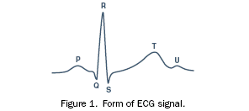

ECG signal May be corrupted by various kinds of the noise. The main sources of the noise are:
- Power line interference: 50-60Hz pickup and harmonics from the power mains.
- Electrode contact noise: Variable contact between the electrode and the skin, causing base line drift.
- Motion artifacts: shifts in the baseline caused by changes in the Electrode skin impedances.
- Muscle contraction: Electromyogram type signal (EMG) are generated and mixed with the ECG signal.
- Respiration, causing drift in the baseline.
- Electromagnetic interference from other electronics Devices, with the electrodes wires serving an antennas and
- Noise coupler from other electronic devices, usually at high frequencies.

For the meaningful and accurate detection, steps have to be taken to filter out or discard all these noise sources ^{[1,2,3,4,5]}.

Chebyshev Filter:
The Chebyshev approximation error is defined as the difference between Ideal characteristics and actual response. There are two types of the Chebyshev transfer function. Out of which the Chebyshev Type I has been used. These filters are all pole filters that exhibit equiripple behavior in the pass band and monotonic behavior in the stop band. ^{[6]} The magnitude squared frequency characteristic of type I Chebyshev filter is given by,
$${\left|H(Ω)\right|}^{2}=\frac{1}{1+ε^{2}T_{N^{2}}\left(\frac{Ω}{Ω_{p}}\right)}$$
In the above equation
ε = parameter related to the pass Band.,
Ω_{p} = Pass band Frequency
T_{N}(x)=Chebyshev Polinomial of the Order N.
T_{N}(x) can be defined as
$T_{N}(x)=\left\{\text{cos}(N{\text{cos}}^{−1}\right.x),$ For |x|≤ 1
=$\text{cosh}(N{\text{cosh}}^{−1}x)$ for |x| > 1
The poles of the Chebyshev Filter lie on an ellipse in the S plane with jΩ axis.The Characteristics of the Chebyshev Type I filter are of two types classified according to N odd or Even.

Implementation of the filter
The Proposed digital filters have been designed for the sampling frequency of 1000Hz. Firstly the low pass filter for the cutoff frequency of 100Hz. High pass filter for the cutoff frequency. 05Hz and to remove the power line interferences of 50 Hz the Notch filter Has been Design.
Low Pass filter:
The responses of the Low pass filter is show in the figure 4 Chebyshev I Low Pass Filter Order=10, Cutoff Frequency 100 Sampling Frequency 1000.
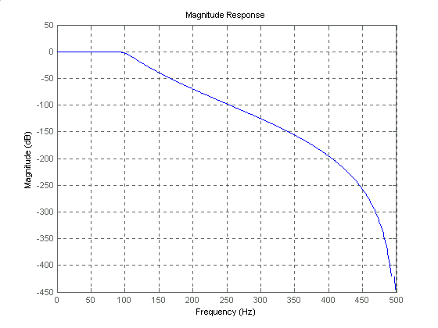

Figure 4.1 Magnitude response of the Chebyshev I Low Pass Filter

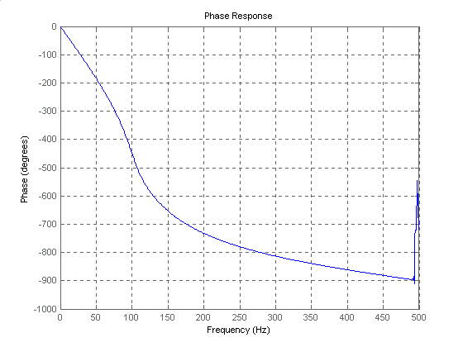

Figure 4.2 Phase response of the Chebyshev I Low Pass Filter

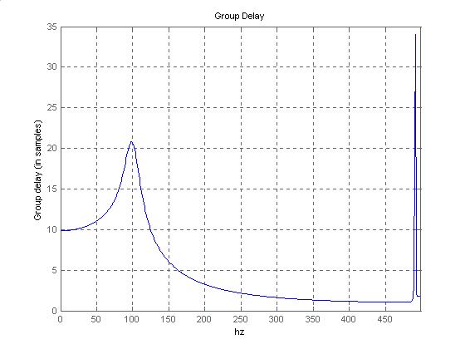
Figure 4.3 Group Delay of the Chebyshev I Low Pass Filter

High pass Filter:
Chebyshev I High pass Filter Has been designed for Order 3, Cutoff frequency .05Hz Sampling Frequency 1000. Its responses are shown in figure 5.
Notch Filter:
Chebyshev I Notch Filter has been designed for the Order 3, Cutoff 50 Hz And Sampling Frequency 1000Hz. Figure 6 Shows the responses of the filter designed.

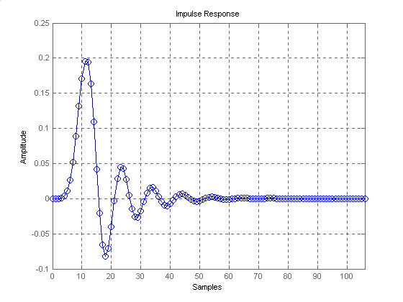

Figure 4.4 Impulse response of the Chebyshev Low Pass Filter

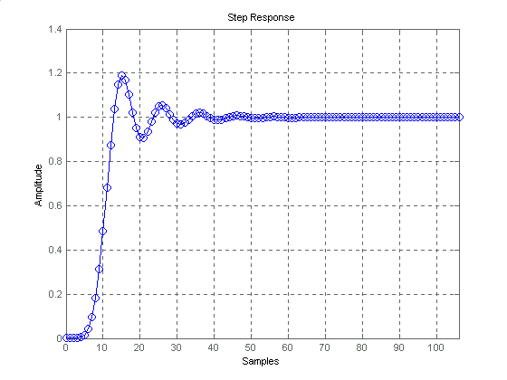
Figure 4.5 Step response of the Chebyshev I Low Pass Filter
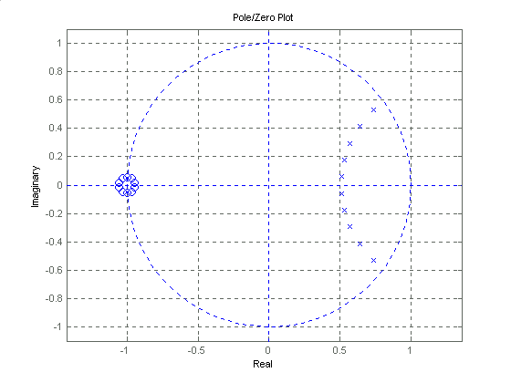

Figure 4.6 Pole Zero of the Chebyshev I Low Pass Filter

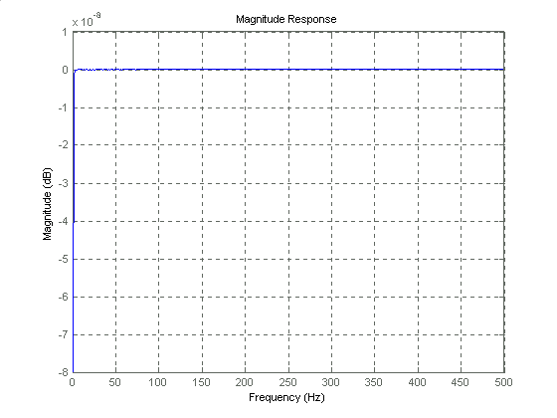
Figure 5.1 Magnitude response of the Chebyshev I Low Pass Filter

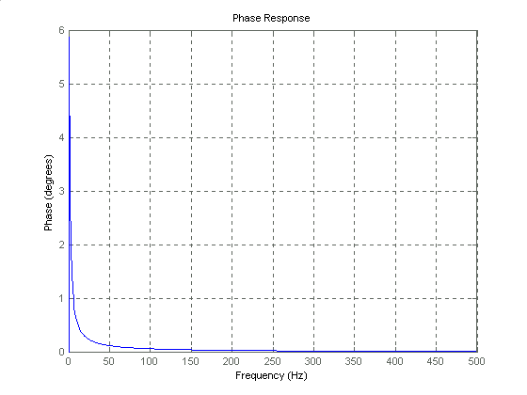
Figure 5.2 Phase response of the Chebyshev I High Pass Filter
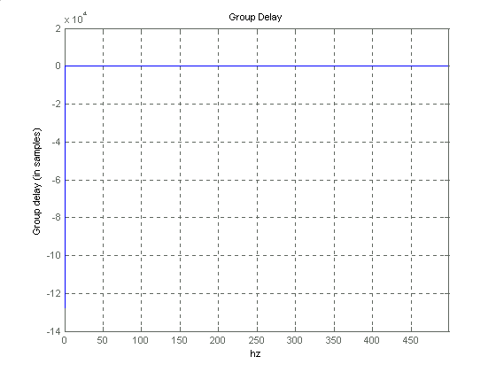
Figure 5.3 Group Delay of the Chebyshev High Pass Filter
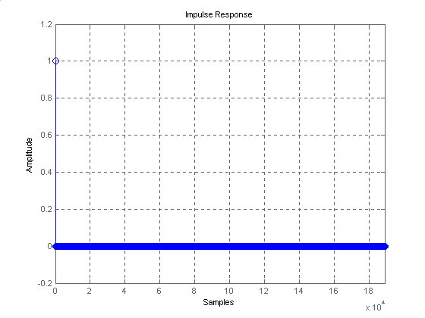
Figure 5.4 Impulse response of the Chebyshev high Pass Filter

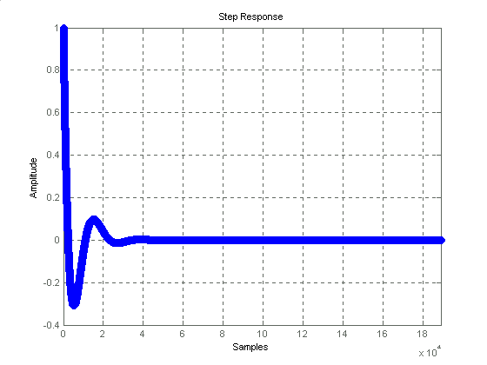Figure 5.5 Impulse response of the Chebyshev high Pass Filter

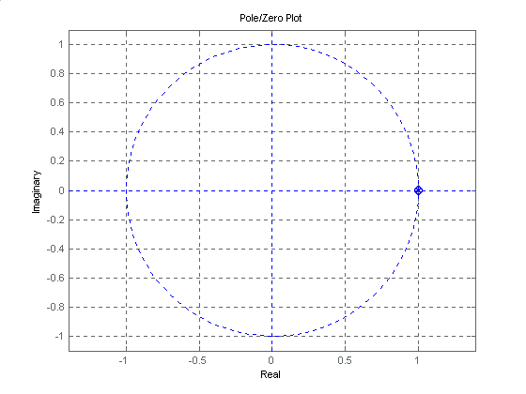
Figure 5.6 Pole Zero of the Chebyshev High pass Filter

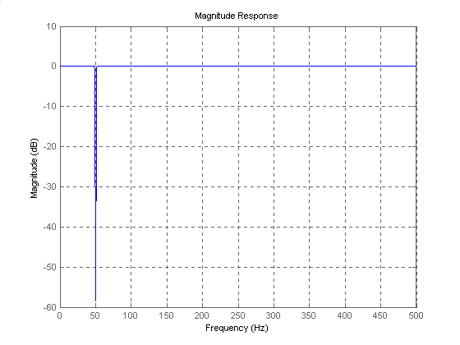
Figure 6.1 Magnitude response of the Chebyshev I Notch Filter
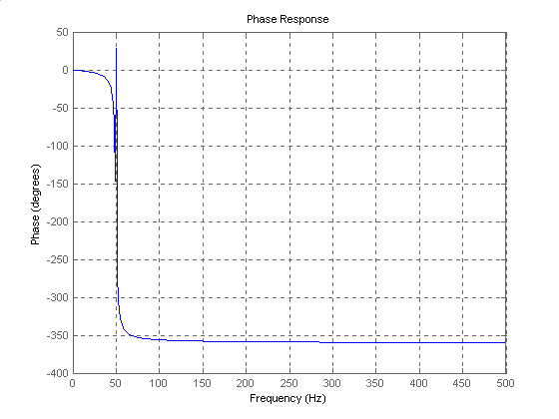
Figure6.2 Phase response of the Chebyshev I Notch Filter
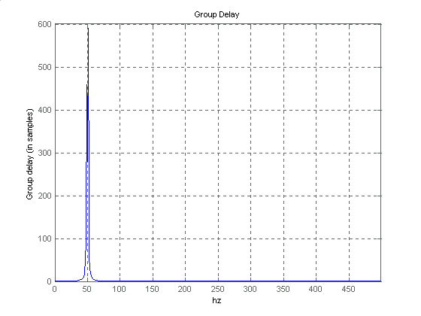
Figure 6.3 Group Delay of the Chebyshev I notch Filter

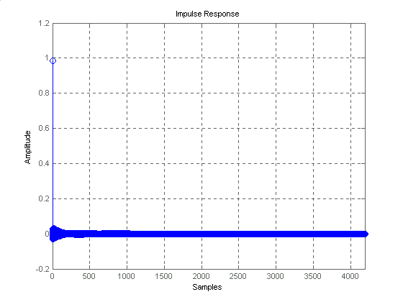
Figure 6.4 Impulse response of the Chebyshev Notch Filter
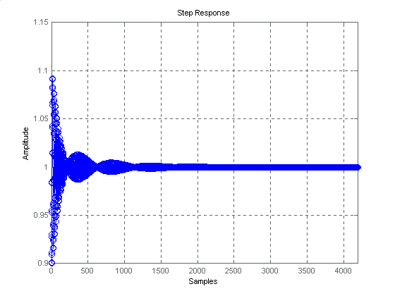
Figure 6.5 Step response of the Chebyshev I Notch Filter
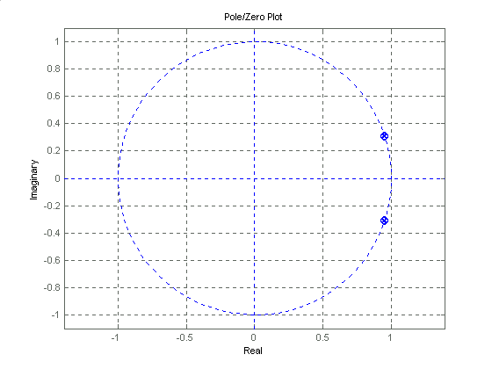

Figure 6.6 Pole Zero diagram of the Chebyshev I Notch Filter
Real time model for EGC noise filtration:
To Filter out ECG Noise artifacts real time model in the Mathlab Simulink has been developed. In the model low pass filter of 100 Hz, High pass filter of .05Hz, and notch filter of 50 Hz are cascaded. The order of the low pass filter is taken as 10,for high pass filter is taken as 4 and for notch filter also is taken as 4. The actual model is shown in figure.7

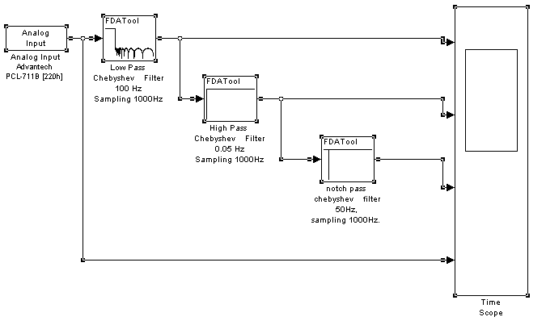

Figure 7 Real time model of the Proposed ECG Filtration System.

Result:

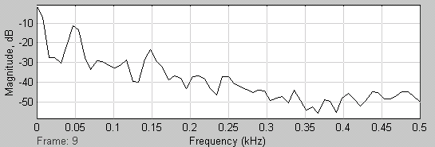

Frequency Spectrum for Chebyshev II Filter Before Filtration of the ECG Signal

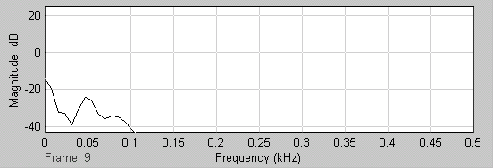

Frequency Spectrum for Chebyshev II Filter After Filtration of the ECG Signal

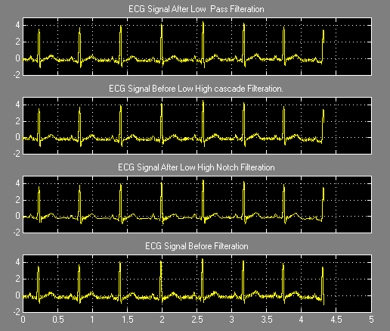

ECG lead 1 signal of Chebyshev-I cascade filter.

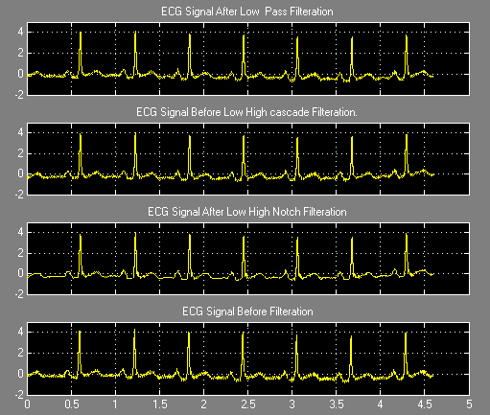
ECG lead II signal of Chebyshev-I cascade filter.

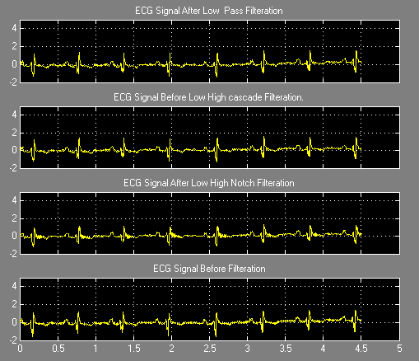
ECG lead III signal of Chebyshev-I cascade filter.

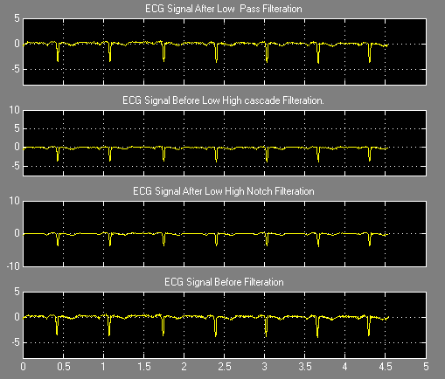
ECG lead aVR signal of Chebyshev-I cascade filter.

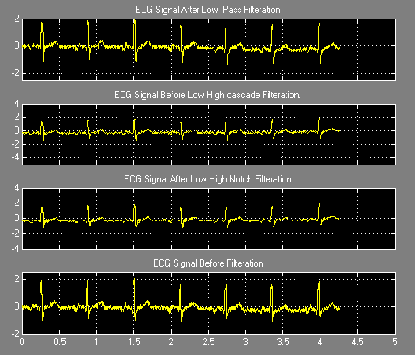
ECG lead aVL signal of Chebyshev-I cascade filter.
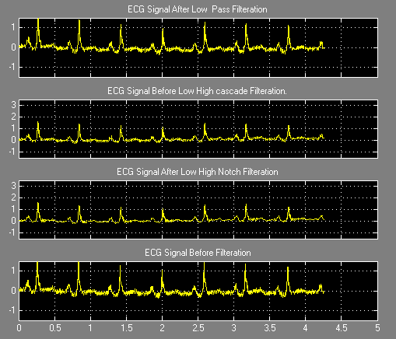
ECG lead aVF signal of Chebyshev-I cascade filter.

The Power Spectrum of the filter and visual Examination of the output shows that the signal distortion is minimum while the clinically important information is retained.

References:
- Eckart Hartman,“ECG Front End Design is Simplified with Micro-converter”, Analog Dialogue 37-11, November 2003.
- P.K. Kulkarni, VinodKumar , “ Removal of power line interference and baseline wonder using real time Digital filter”, Proceedings of international conference on computer application in electrical engineering Recent advantages. Roorkee, India.September 1997, pp 20-25.
- Encyclopedia, Biomedical Instruments
- Huta, J.C. and Webster. J.G. 1973, “60 Hz Interferences in Electrocardiography”, IEEE trans. BME -20, pp 91-101.
- Marques.De.Sa.J.P. 1982 “Digital FIR filtering for removel of baseline wonder,” Journal of Clinical Engineering vol. * pp. 235-240.
- Lonnie C. Ludeman, “Fundamentals of Digital Signal Processing”, H & R Publishers , New york.

