Artificial Cloning Applied to Industrial Process Control

ANTONIO F. MUÑOZ MONER¹, ALDO PARDO G²., JORGE L. DÍAZ RODRÍGUEZ³
*Laboratorio de Cómputo Especializado UNAB- ICP-ECOPETROL -IIDTA
**Departamento de Mecatrónica
Universidad de Pamplona
Ciudadela Universitaria, Pamplona
COLOMBIA

http://www.uniapmplona.edu.co

Abstract: - This work presents an artificial cloning technology for sensors used in industrial process control, using neural networks and genetic mapping. Neural networks allow developing the sensors intelligent structure and the random activation weights method is used to achieve the learning, starting from real devices information. The genetic mapping allows the codes generation for the cloning procedure; mutation, crossover and inversion operators are also used. The efficiency of the proposed technology has been illustrated with a cloned sensor example to determine the viscosity index for lubricant oils with phenol in an industrial process.

Key-Words: - Industrial Process Control, Artificial Intelligence, Cloning, Neural Networks

- Introduction

The artificial cloning technology for industrial sensors proposed in this work, consists of a group of methods and procedures based on artificial intelligence tools, which are applied in the high fidelity reproduction of real devices used in automation and control of industrial processes. This technology is based on the integration of neural networks and genetic algorithms. A method, a procedure and some utilities for this technology are presented in [1].
The method consists of the application and interpretation of the genetic mapping which contains the codes associated to the sensor functional structure. The mapping is achieved through codes which describe the sensor functional operative units; each operative unit is composed by unitary elements which represent a sensor operation part. The procedure is based on the application of a group of guidelines directed to the neural networks structural connections, facilitating the information flow for the cloned sensor learning. The utilities are associated to likenesses criteria presented in [2]; used to apply dimensional measures and include parametrical characteristics from real devices to reproduce the necessary features allowing a sensor to reach a cloned version.

- Artificial Cloning Process

The representation of possible solutions in the search space is defined with data structures which contain binary code to characterize process variables which allow the sensor output estimation and real sensor static and dynamics properties.

  - Cloning Process Stages

The artificial cloning process is composed by five stages [6].
Stage 1: In this stage the devices are selected to be cloned. The population is divided according to the number of objectives given in functional operative units; the group of operative units is called ”objective function”. For example, given N devices that constitute the population and a number of n operative units, the total population is divided according to the number of operative units, in groups of size N/n. Each subpopulation is processed by a genetic algorithm with different objective functions in order to achieve the individual’s selection, assuring the evaluation of each objective function. Then, a hierarchical classification is performed assigning priorities to the functions objective depending on the problem to be solved [3]. Finally, each function is selected according to its priority and it is evaluated on each subpopulation. This is carried out until all objective functions be evaluated, guaranteeing the population diversity. The weakest individuals are replaced in each subpopulation.
Stage 2: Partial solutions S1, S2, S3,...,Sn are obtained for each operative unit. The union of these solutions will allow generating a new global population, which is evaluated to an objective function that it has been randomly selected. This process is repeated until reaching a certain number of iterations (fixed as convergence criteria) assuring that each function objective be evaluated inside the total population with a high reliability.
Stage 3: For each subpopulation, the individuals that have the minimum objective function values are selected. The number of selected individuals (for each sub population) it is taken as information to define the coefficient that will ponder each one of the components of the multiple objectives function (the group of different operative units). Finally, the total population is generated as the union of all subpopulations and is evaluated using the multiple objectives function considered according to certain specifications.
Stage 4: An objective function is selected to evaluate, among the different operative units. It is necessary to ensure that all the functions are evaluated a minimum number of times specified.
Stage 5: An optimization process is carried out with the partial solutions obtained in the stage 3 using the multiple objectives function resulting in stage 4. This optimization process is based on ideas presented in [4, 5]. Genetic operators such as mutation, crossover and inversion are used in this stage to achieve the optimization process. Then, the number of individuals is determined, taking account the best solution which satisfy the corresponding multiple objective functions. This represents the cloned device.

3. Industrial Application

Consider a lubricant oils with phenol extraction plant (see Figure 1) where the whole instrumentation associated to the process monitoring and control are centralized in an automated operation interface.

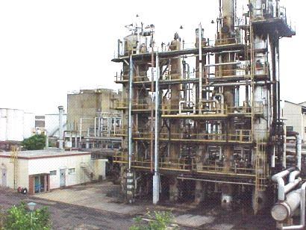
Fig. 1 Lubricant Oils Extraction Plant.

Consider as case of study in this work, an on line analyzer used in the extraction process, to determine the viscosity index for lubricant oils with phenol, which uses a refraction sensor, The sensor calculates the refraction index starting from a monochromatic light sheaf and then the viscosity index is calculated by a linear relationship respect to the refraction index [1]. This information is essential for monitoring and control decision making in the extraction process.

  - The Refraction Analyzer's Description

The refraction analyzer (see Figure 2) determines the refraction index through the solution S measuring the critical angle of refraction. The light coming from the light source L goes against the surface between a prism P and the solution S. The light rays meet this surface to different angles.
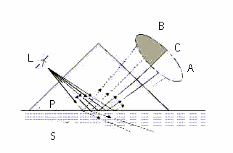
Fig.2 Phenol Concentration Analyzer

The reflected rays form an image ACB, where C is the position of the ray in the critical angle. The rays in A are reflected totally on the surface and the rays in B are partially reflected and partially refracted inside S. This way, the optic image it is divided into illuminated area A and a dark area B. The position of the limit C among the areas A and B shows the value of the critical angle and therefore of the refraction index of the solution of the process. The refraction index is usually increased while increasing the concentration.

  - Cloned Sensor Structure

The cloned sensor structure was developed using feedforward multilayer neural networks. As it is well known, these neural networks have been widely used for practice applications due to its non-linear characteristics for achieving inputs / outputs maps.
For this application, the neural structure consists of two layers: the hidden layer with nonlinear activation functions (sigmoid) and the output layer with only one node with linear function activation. See Figure 4.

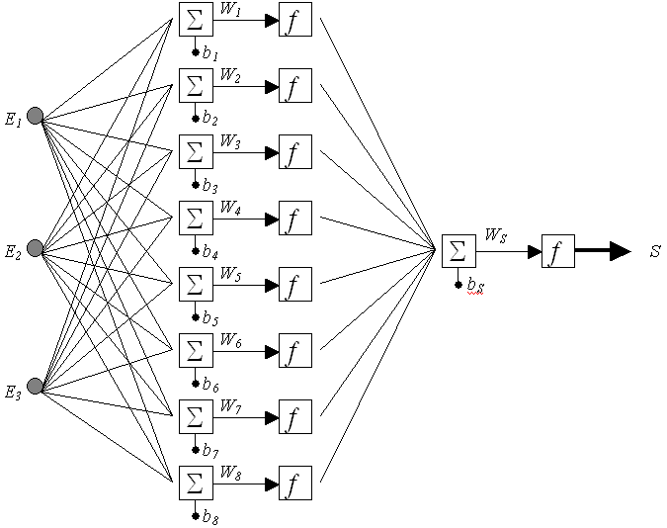
Fig. 3 Neural Network Structure for the Cloned Viscosity Sensor

The cloned sensor training was achieved taking into account the different operational conditions in the phenol unit, which are affected mainly, by the load changes. The neural network inputs for viscosity index estimation are associated to the phenol extraction column process variables, which also correspond to part of the genetic code in the chromosomes associated to the cloning process. The binary code specifies the active process variables operational ranges, according to the values registered by the monitoring systems. This code is further processed by essential component analysis algorithms [7, 8, 9] to be converted to values which take into account the influence of each variable on the viscosity index in a determined time instant.

The process variables used to the neural structure are the following

- Phenol Extraction Column Top Temperature
- Top-Bottom Differential Temperature
- Phenol Extraction Column Load
- Phenol Rate
- Phenol Quality
- Extraction Column Pressure

The learning algorithm used is the random activation weights method, which is not an iterative procedure and it has shown to provide better results, for practice applications, than conventional backpropagation algorithm [10]. The error terms considered to select the best structure are the Random Mean Square Error (RMSE) and the absolute maximum error (MAXE).

4. Experimental Results

According the learning algorithm presented in [10] three types of model may be considered to evaluate the best neural structure: the regression model, the correlation-dispersion model and the expert model. There were achieved several simulation experiments with the different models to select the best sensor structure.

4.1 Regression Model (RM)

Table 1 Experimental Results for Regression Model

# NEURONS | RMSE | MAXE
1 | 0.0017439 | 0.0033676
3 | 0.0013600 | 0.0031367
4 | 0.0021229 | 0.0038839
5 | 0.0015836 | 0.0035062
6 | 0.0016774 | 0.007212
7 | 0.0019241 | 0.0061608
8 | 0.0017042 | 0.008346
10 | 0.0013473 | 0.0058143
20 | 0.0018437 | 0.011341
30 | 0.0020754 | 0.031088
40 | 0.0058415 | 0.12686

Fig. 4 RMSE Vs. Number of Hidden Neurons for RM

Fig. 5 MAXE Vs. Number of Hidden Neurons for RM

These results illustrate that the error indexes reach the minimum values for a 10 neurons structure with the regression model.

4.2 Correlation-Dispersion Model (CDM)

Table 2 Experimental Results for Correlation-Dispersion Model

# NEURONS | RMSE | MAXE
3 | 0.0010291 | 0.0027133
5 | 0.0011054 | 0.0024877
10 | 0.003029 | 0.012585
12 | 0.00096497 | 0.012741
15 | 0.0036674 | 0.0073696
20 | 0.00072544 | 0.0071936

Fig. 6 RMSE Vs. Number of Hidden Neurons for CDM

Fig. 7 MAXE Vs. Number of Hidden Neurons for CDM

These results illustrate that the error indexes reach the minimum values for a 5 neurons structure with the correlation-dispersion model.

4.1 Expert Model (EM)

Table 1 Experimental Results for Expert Model

# NEURONS | RMSE | MAXE
5 | 0.0019238 | 0.003634
10 | 0.0017794 | 0.0037834
12 | 0.0016122 | 0.0035634
15 | 0.0021772 | 0.0071826
20 | 0.0035932 | 0.020569

Fig. 8 MAXE Vs. Number of Hidden Neurons for EM

Fig. 9 MAXE Vs. Number of Hidden Neurons for EM

These results illustrate that the error indexes reach the minimum values for a 12 neurons structure with the regression model.

Comparing the experimental results for the three models the best structure is the obtained with the correlation-dispersion model.

Table 4 Comparative Results Table

MODEL | # NEURONS | RMSE | MAXE
RM | 10 | 0.0013473 | 0.005813
CDM | 5 | 0.0011054 | 0.0024877
EM | 12 | 0.0016122 | 0.0035634

Figure 10 illustrate the efficiency of the cloned sensor trained with the correlation-dispersion model.

Fig 12 Cloned Sensor and Real Sensor Output

Fig. 10 Real Sensor Output Vs. Cloned Sensor Output

5. Conclusions

An artificial cloning technology, based on neural networks and genetic mapping, applied to a viscosity industrial sensor has been presented.
The genetic mapping allows the generation of codes, for the cloning process, which represent real sensor static and dynamical characteristics and process variables conditions. The codification associated to the process variables is transferred to a multilayer neural network, after appropriate preprocessing, which constitute the sensor structure. The learning algorithm used for the neural network learning was the random activation weight method [10] which provided satisfactory estimation properties. This cloned sensor currently replace the real sensor, when it presents faults allowing the appropriate control decision making related to the lubricant oils extraction process. This methodology may be applied to clone similar technologies to generate sensors for different process areas with a lower cost than a real instrument.

References:

- A. Muñoz Moner, Cloned sensor of the refractory meter. Oficina Internacional de Invenciones, Patentes y Marcas, Republica de Cuba. Registros No. 7-789735, 2003.
- J. Aguilar and P. Miranda, Resolution of the Left Ventricle 3D Reconstruction Problem using Approaches based on Genetic Algorithms for Multi-Objectives Problems. Proceeding of Conference on Evolutionary Computation, pp. 913-920, Washington, USA, 1999.
- A. Muñoz Moner and A. Pardo García, Nuevos controladores por Lógica Fuzzy. RCC, SIN 1657-2831, Vol. 2, No. 1, Junio, 2001.
- C. Fonseca C and P. Fleming, Multiobjective Optimization and Multiple Constraints Handling with Evolutionary Algorithms-Part I: A Unified Formulation. IEEE Transactions on Systems, Man, and Cybernetics-Part A: Systems and Humans, Vol. 28, No. 1, pp. 1-16, 1998
- D. Goldberg, Genetics Algorithms in Search, Optimization and Machine Learning. Addison-Wesley, Reading, Massachusetts, 1983.
- A. Muñoz Moner, Artificial Cloning of Industrial Sensors. Editorial Ciencia y Técnica, Academia de Ciencias de Cuba, 2002.
- J. M Bates and C. W. J. Granger, The combination of forecast, Operations Research Quarterly, Vol. 20, pp. 319-325,1969
- R. N. Dave, Boundary Detection through Fuzzy Clustering. Proceedings of the IEEE International Conference on Fuzzy Systems (FUZZ-IEEE), pp.127-134, San Diego, 1992
- H. J. L. Van Can, H. A. B. Braake, C. Hellings, A. Krijgsman, H. B. Verbruggen, K. Luyben, Ch. A. M. and J. J. Heijnen, Desing and real time testing of a neural model predictive controller for a nonlinear system. Chemical Engineering Science, 1994. Vol. 50, pp- 2419-2430.
- H. A. B. Braake and G. Van Straten, Random Activation Weight neural net (RAWN) for fast non-iterative training. Engineering Applications of Artificial Intelligence, Vol. 8, pp. 71-80.1995

