A Holonic Architecture for Continuous Processes
Supervision and Coordination

EDGAR CHACÓN R.
Departamento de Computación
Facultad de Ingeniería
Universidad de Los Andes
Mérida-Estado Mérida
Venezuela

EDMARY J. ALTAMIRANDA M.  Instituto de Investigación y Desarrollo de Tecnologías Aplicadas IIDTA  Universidad de Pamplona  Pamplona-Norte de Santander  Colombia | ELIEZER COLINA M.  Departamento de Sistemas de Control Facultad de Ingeniería  Universidad de Los Andes  Mérida-Estado Mérida  Venezuela
Abstract:-This paper presents an approach to build supervisory systems for complex continuous production processes. Local controllers perform local supervision tasks, and they are able to communicate with central systems where the coordination for the whole process is performed. Local controller’s architecture supports several software components, which perform supervision, monitoring, control activities, and communicate with a supervision center to ensure the coordination of the whole process. At the supervision center, a software architecture has an abstraction of local processes and is able to achieve production reconfiguration, for optimizing, taking into account the changes generated on the processes.

Key-Words: -Discrete events systems (DES); Supervisory control systems; Distributed Control Systems.

1 Introduction

A holon is defined as an autonomous and cooperative building block within a manufacturing process for transforming, transporting, storing and/or validating information and physical objects [1]. A holon has the autonomy to create and control the execution of its own plans, and can cooperate with other holons to develop mutually acceptable plans for achieving system goals. Cooperation among holons is accomplished through an evolutionary self-organizing holarchy (a system of holons). In a holonic production system, the objective is to achieve a complete spectrum of control functions ranging from production planning and control at the highest level, to process/machine control at the lowest level. Intelligent control involves not only the achievement of these control functions, but seamless integration of them as well [2].

The automation of continuous production processes is achieved, generally, by using DCS or SCADA technologies. These technologies make hard implementing concepts such as software control agents or holonic systems in control. New concepts trend to more flat architectures such as the proposed by the PABADIS consortium [3] or metamorphic systems [2]. The whole control is achieved through several software applications that cover monitoring, control and process optimization, for continuous and discrete event dynamics.

The aim of this work is to describe an Information and Telecommunication architecture that allows implementing supervisory systems [4,5,6], for continuous production processes [7], which control architecture is shown in figure 1.

Fig. 1 Supervision Scheme for Continuous Processes

2. The IT architecture for continuous production systems supervision.

2.1. Local IT technologies.

Process supervision of a local system is performed by the monitoring of events generated on the process and the habilitation of controlled events. Events monitoring detects undesired operational domains and the controlled events send control patterns, which allows reaching required specifications [8]. The process state consists of the elements dynamics composition that makes part of the production process: 1) Resources, 2) Production method, and 3) Production order, see figure 2. A change in one of the elements, changes the process state. A monitoring of each element is necessary to detect events. Production order must be monitored taking into account the process continuous dynamic and intelligent techniques may be used for events detection [9]. These monitoring activities are performed by local equipment that must transmit the necessary information to ensure the coordination in a complex production system.

Fig. 2 Production Process UML Model

Software components necessaries for supervision are:
- Event detector for process monitoring
- Event detector for resources monitoring
- Observer – composer for DES
- Decision system
- Actuator
- Coordination - Local supervision communication service.

Each local system has the total knowledge of “accepted goals”, control and monitoring methods and it generates a response for accepted goals. If a failure occurs, which make the system unable to reach goals, the local system informs to the superior production unit to achieve a new goal if it is possible. This consideration permits to the superior production unit to decide a new configuration to reach the global goal.

The sequence diagram that describes the interaction among the local supervisor components is given in figure 3. Resources monitoring implies communication with external systems that evaluates the availability of raw material and spare parts for equipment.

Fig. 3 Sequence Diagram for Local Control Devices.

2.2. Telecommunication Network for supervision.

Local production units interoperate by exchanging information about goals acceptation, rejecting, accomplishment, or abandoning, and the feasibility and probability of a goal accomplishment. The computer network interconnects local production units to a single geographical site. At the central site, the information is distributed among the actors participating in the production.

A communication protocol is established to exchange information among production units and the superior production unit. Hierarchies are defined according to production needs. These dynamical hierarchies allow having a response for changes generated in production conditions which may be internal o externals. This proposal matches with the holonic architecture for manufacturing [10].

The established protocol follows the recommendation of the Contract Net Protocol from FIPA [11].

2.3 Central site for supervision.

At the supervision center, supervisory functions are performed by a distributed system, which are connected by a middleware. Supervisory function performed at this level are:
- Event monitoring by transforming received messages from local supervisors.
- Decision making based on the composed dynamics of the production groups (holons).
- Transforming decisions into goals to local production systems in a parallel way.
- Reconfiguration of groups when a previously established group can not reach a specific goal.
- Sequencing operations in order to reach a desired final state.

Software components support all the above mentioned functions, and they communicate among them by a middleware to transfer the evaluation results. In figure 4, it is shown the technological architecture for the whole system.

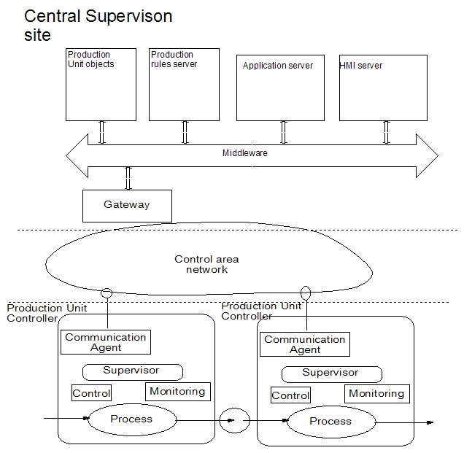
Fig. 4 IT – Architecture for Holarchical Supervision

The functionality of each component at the Central Supervision Site is described as follows:
- Production Unit Objects store dynamical rules, production methods, the state of production elemental units and the dynamically created production units to perform a temporary goal.
- Production Rules server is in charge of keeping the necessary workflow to supervise optimize production units and make reconfigurations of the temporary production units.
- Application Server supports the specific tasks for supervision and optimization. Techniques based on artificial intelligence s may be used to determine the optimal configuration [12-14].
- Human – Machine Interface (HMI) Server allows the communication with operators, in order to inform them about the state of each basic or created production unit, in order to reach a specific goal. In the same way, the communication it is possible with an upper level where Enterprise Resource Planning (ERP) systems perform financial functions, long term planning, marketing functions, etc.

3. Conclusion

A holonic architecture for supervision and coordination of continuous processes has been presented. This approach allows implementing supervisory systems for complex production processes, which allows the integration and coordination of all production units in order to satisfy process required specifications and to reach the goals defined. The proposed architecture also allows dynamic reconfiguration of local production units if generated events lead to undesired process states.

References

- J.H. Christensen, “Holonic Manufacturing Systems: Initial Architecture and Standards Directions, Proceedings of 1st European Conference on Holonic Manufacturing Systems, pp. 1-20, Germany,1994
- W. Shen, D. Norrie, An Agent-Based Approach for Dynamic Manufacturing Scheduling. Workshop Notes of the Agent-Based Manufacturing Workshop on Autonomous Agents. 1998.
- PABADIS Consortium. url: http://www.PABADIS.org
- W. M. Wonham. On the control of Discrete-event systems, edited by H. Nijimeijer and J.M. Schumacher, Three decades of mathematical systems theory, Vol. 135 in Lecture Notes in Control and Information, Springer Verlag, pp. 542-562, 1989.
- A. Bemporad and M. Morari, Control of systems integrating logic, dynamics, and constraints. Automatica, Vol. 35, No. 3, pp. 407-427, 1999.
- C. Cassandras and S. Lafortune. Introduction to Discrete Event Systems, Kluwer Academic Publishers, Boston, 1999.
- B. Lennartson et. al. Hybrid systems in process control. IEEE Control Systems, Vol. 16, No. 5, pp.45-56, October, 1996
- A. Sanchez. Formal Specification and Synthesis of Procedural Controllers for Process Systems. Number 212 in Lecture Notes in Control and Information Sciences, Springer Verlag, New York, 1996.
- E. Altamiranda, H. Torres, E. Colina and E. Chacón. Supervisory control design based systems and fuzzy event detection. Application to an oxichlorination reactor. ISA Transaction, Vol. 1, No. 4. pp. 485-499, October 2002.
- M Giebels, H. Kals, W Zijm. Building holarchies for concurrent manufacturing planning and control in EtoPlan. Computers in Industry. Vol. 46. pp. 301 – 314. 2001.
- FIPA. url://www.fipa.org
- F. Tapio; J., Esko K.. An Adaptive, Hierarchical Fuzzy Logic Advisory Tool (FLAT) for Anticipating the Demand of Transmission Products. 4th International Conference on Soft Computing, Iizuka '96. Vol. 1, 1996, Fukuoka, Japan.
- W. Chen and M. Muraki. An action strategy generation framework for on-line scheduling and control system in batch processing with neural networks. International Journal of Production Research, Vol. 35, pp 3483-3506, 1997.
- W.H.M. Raaymakers, J.A. Hoogeveen. Scheduling multipurpose batch process industries with no-wait restrictions by simulated annealing. To appear in European Journal of Operational Research, 2000.

