A New Shaft Position Control for Switched Reluctance Motor in Harsh Environment

E. AFJEI, M.M. NEZAMABADI, A. SAATI
Shahid Beheshti University, Saadat Research Center
TEHRAN-IRAN

Abstract:- This paper describes a new method for direct sensing of the rotor position in switched reluctance motor that can be utilized in a very harsh environment such as a furnace. In this method, a new sensorless technique applied to a mechanical sensing unit made up of a rotor and a stator laminations used in that motor. This detection method uses a sine wave signal applied to every other stator pole windings of the sensing unit and from the resulting induced signals obtained from the opposite coils, the position of the rotor is accurately determined. This sensing unit is immune from motor switching noises
An advancement technique for the dwell angle from zero degree at standstill to 10 degrees at an arbitrary pre set speed of 100 rpm is also utilized in the control circuit for achieving higher performance from the motor. Finally the experimental results are presented which demonstrate the robust functionality of the method.

Key-words: Switched Reluctance Motor Control, Shaft Position Sensing

1 Introduction
In the past decades the Switched reluctance motor (SRM) has received considerable attention for its ruggedness and variable-drive applications. Its simple construction due to the absence of permanent magnets, rotor cages, brushes, and also having high efficiency over a wide range of speed make the SRM drive an interesting alternative to dc permanent magnet and ac induction motor drives [1].
In switched reluctance motors, each individual phase excitation must be synchronized with the rotor position which necessitates the need for a position sensing scheme. In general there are two types of rotor position sensing method namely, direct and indirect [2]. In the direct position sensing method usually, a mechanical shaft position transducer, such as opto-couplers with a slotted disk, Hall-effect sensors and embedding permanent magnets within the teeth of the slotted disk, or a high precision encoder is mounted on the motor housing to produce the necessary and accurate rotor position information for the proper motor operation [3]. Fig. 1 shows opto-couplers with slotted disk together which is a common method in detecting the rotor position in the switched reluctance motor.
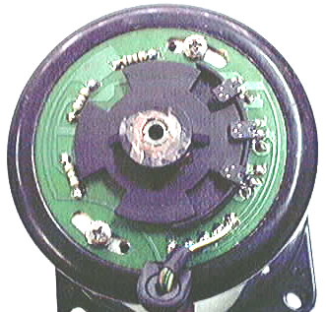

In the indirect position sensing, several different methods have been presented and published for the sensor less control of SRM drives. All of these schemes employ the phase inductance variation information in some way to detect the rotor position indirectly. Some Examples of these methods are the chopping current method [4], the impedance sensing [5],

Fig.1 Opto-Couplers with Slotted Disk

the flux-current scheme [6], different modulation techniques [7], the current gradient method [8], mutual inductance voltage approach [9], and the resonant procedure [10-11] ,finally the state observer technique [12].
In the present technique a stator lamination from the same motor with coil wrapped around each pole plus a rotor lamination are mounted on the back of the motor. This set resembles exactly the motor stator and rotor characteristics in smaller scales. Since this set
is independent of the motor itself therefore it is
immune from the noises produced in each motor phase windings. A new sensorless
technique for detecting rotor position is applied to the sensing unit and from there the actual rotor position is detected.

2 The new sensing unit
The new sensing unit comprises of a rotor which is free to rotate inside of a stationary part known as the stator which has windings on its salient poles. Each rotor and stator pieces made up of laminated steel, exactly the same shapes as the actual stator and the rotor pieces of the motor. This unit can also be made much smaller in size from the actual size of the motor laminations but the pole arcs should be the same as the actual size to resemble the motor stator and rotor poles. This unit installed behind a Motor is shown in Fig. 2

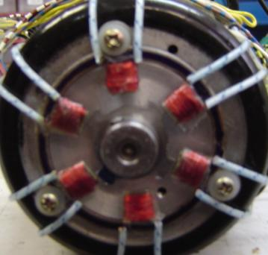

Fig. 2 The Sensing Unit

This sensing unit behaves like the motor itself and all the existing sensorless schemes can be applied to this unit easily, plus it can bear high temperatures since there is nothing there to burn. In the new method, a sine wave signal is inject into each pole windings in every other position hence, three of the poles carrying the actual signal while the opposite pole windings will have the induced signal in them. Since the rotor in the sensing unit has four salient poles like the motor itself then, the induced signals in opposite coils have different magnitudes according to the rotor positions.

V_{ind} = [V_{m} sin (ωt)] cos θ (1)

where; θ is the angle between a rotor pole with its corresponding stator pole
and ω is the frequency of injected signal
The reasons for the change in magnitudes of the induced signals are due to the variations in the difference in rotor and stator angles (i.e. cos θ) for each phase. There are three different magnitudes for each phase that can determine the rotor position and also provide the pulses for the motor operation. The frequency of the sine wave can vary from 500 Hz to 5 KHz.
Fig. 3 shows the input signal and corresponding induced output signal from one of the pole windings.

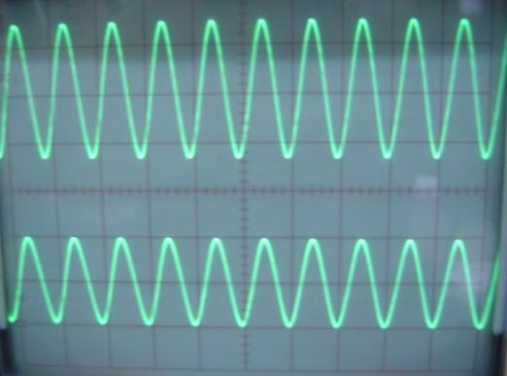
(a) .2v/div
.2msec/div

(b) .2v/div
.2msec/div

Fig. 3 a) Input injected signal
b) Output induced signal

In this experiment a signal with a frequency of 5 KHz has been used. Since this is an independent unit therefore it is immune from noises produced by the switching in the actual motor phase windings.
The induced signal from each phase will go under certain processes in order to produce the
proper signals for the use in the converter power transistors.

3 Principle Of Operation Of The Sensorless Technique
In order to detect the rotor position and also produce the appropriate phase pulses for the proper operation of a 6 by 4 SRM the following general block diagram shown in
fig. 4 is used
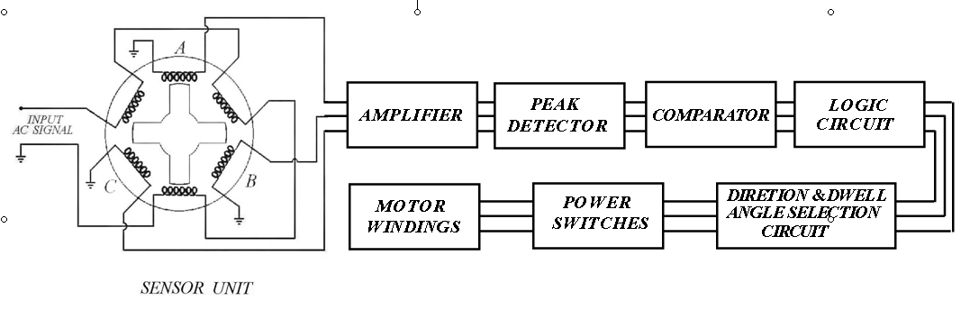

Fig. 4 The Block Diagram

The input signal injected to every other stator windings and three induced signals are obtained. These signals are then amplified individually by different gains to produce the same maximum peak voltage.
The reason for different amplification gains is for the correction in any misalignments exists in the mechanical assembly of the sensing unit. These signals are fed into a peak detector. One of the out put signals out of the phase detector is shown in fig. 5.
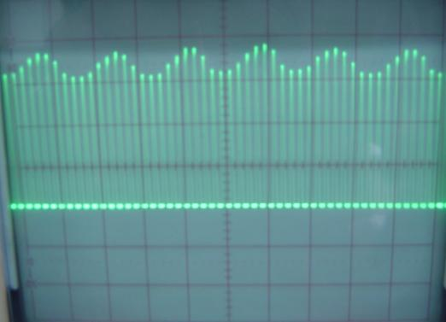

(a) 2v/div
.2msec/div

Fig. 5 Out put signal out of the phase detector

As shown in Fig. 5 the peak of output signal has been detected while the motor is turning. These signals are then fed into a comparator unit. Table 1 shows the comparing algorithm
for the signals A, B, and C out of the peak detector.
Output of the comparator is then corrected for any unwanted overlapping and also any advancement of the dwell angle by the logic circuit. Phase A and B pulses going into the motor power switches are shown in Fig. 6(a)

Table 1 Comparing Algorithm

Comp A and B | Comp C and A | Comp B and C | Results | Phase to turn on
0 | 0 | 1 | B>A>C | C
0 | 1 | 0 | C>B>A | A
0 | 1 | 1 | B>C>A | C
1 | 0 | 0 | A>C>B | B
1 | 0 | 1 | A>B>C | B
1 | 1 | 0 | C>A>B | A

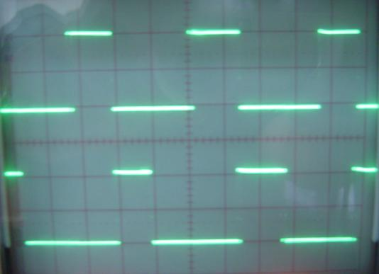

(a) 5v/div
2msec/div

(b) 5v/div
2msec/div

Fig. 6 (a) The input pulse for phase A
(b) The input pulse for phase B

and (b). As shown in Fig. 6 each phase takes one third of the whole period since the switched reluctance motor used is of a three phase 6 by 4 type.

4 Advancing The Dwell Angle
The start and duration of current pulses for each phase in a switched reluctance motor is controlled and synchronized with rotor position by means of a direct or an indirect shaft positioning scheme. The control strategies become an important issue in the motor behavior [13]. The performance of SRM drive can be greatly influenced by choosing the proper starting time for the phase turn on angle at different speed and also selecting the proper turn off time can greatly effect its performance. The time duration τ available for current in each phase winding is directly related to the speed of the motor. As the motor’s speed increases the amount of time, τ, decreases and at some point, it can reach a certain value such that, the control of the winding current to the desired value is impossible. At this high speed the current can neither rise nor decay quickly enough in the winding to reach the preferred level. Due to this reason, it is desirable to get current into the motor phase winding while the phase inductance is still relatively small.

Fig. 7 Torque-speed characteristics of the motor with & without the advancement action

One method to achieve this objective is by varying the dwell angle (difference between the firing angles) such that the phase commutation begins sooner and ends sooner.
Advanced conduction angle at the motor start (i.e. ω_{m} = 0) can have adverse effect on torque production mechanism since there are no overlapped areas between the rotor and the
stator poles at the beginning. At low speed, high advanced turn on angle results in higher current in the region of constant inductance
where no torque is produced. Also, at high speed but low advanced turn on angle, higher current due to the breaking effect is produced. Therefore, a means of producing variable advancements in commutation angle for different speeds is required.
In this respect, an electronic switch is introduced to change the dwell angle just enough (10 Deg.) at a certain speed (n = 100 rpm), so that the phase commutation begins sooner and ends sooner. This method is very effective in creating sufficient time for the phase current to rise to the desired value therefore, the motoring torque will not fall off, and also, the current will be out of the winding before the rotor reaches the negative torque region.
Using a torque meter the dynamic torque versus speed for the motor have been measured. Fig. 7 shows the normal torque vs. speed for the motor with and without the advancement of dwell angle.

This switching action is at a pre-set value of about 100 rpm, which will cause a position advancement of the rotor poles with respect to the stator poles of about 10 degrees. This pre set value for the speed is optional and can vary according to the motor applications.

5 Conclusion
In this paper, a new method for direct sensing of the rotor position in switched reluctance motor that can work in a very harsh environment such as a furnace has been introduced. In this method, a new sensorless technique applied to detect the rotor position. The new technique is based on injecting a sine wave signal into a set of coil windings and detecting the induced pulses on the other coil windings. One of the advantages of this method is the control unit is immune from motor switching noises. The whole control circuit has been fabricated in the laboratory and tested satisfactory on a 6 by 4 switched reluctance motor. In addition, for the proper operation of the reluctance motor, advancement in angle is necessary. If a fixed angle is utilized then, there will be positions in which the rotor poles and the corresponding stator poles have no overlapped area. At this position the starting torque is almost zero and the motor will stall. The advancing switch prevents the motor not only from stalling at the start but also producing higher starting torque due to larger overlapped area between stator and rotor poles and better performance at high speeds.

References:
[1] P.J. Lawrenson, J. M. Stephenson, P.T. Blenkinsop, J. Corda, and N.N. Fulton, "Variable-Speed Switched Reluctance Motor ".IEE,Vol. 127,Pt. B, No. 4 July 1980, pp. 253-265
[2] T.J.E. Miller, Switched Reluctance Motor Drive, Ventura, CA, Intertec Communications Inc, 1988
[3] R. Krishnan, Switched Reluctance Motor Drive: Modeling, simulation, Analysis, Design and application, Magna physics publishing, 2001
[4] J.T.Bass, M.Ehsani,T.J.E. Miller,”Robust Torque Control of Switched Reluctance Motors Without a Shaft Position Sensor”, IEEE Transactions on Industrial Electronics, Vol.IE-33, No.33, Aug. 1986,pp. 212-216.
[5] M. Ehsani, “ Position Sensor Elimination Technique for Switched Reluctance Motor Drives”,US Patent 507166
[6] M. Ehsani, I. Husain, A. B. Kulkami, “Elimination of Discrete Position Sensor and Current Sensor in Switched Reluctance Motor Drives”, IEEE Transactions on Industry Applications, Vol.28, No.1, Jan/Feb. 1992, pp. 128-135.

[7] [7] M. Ehsani, I. Husain, S. Mahajan, K. R. Ramani, “ New Modulation Encoding technique for indirect Rotor Position Sensing in Switched Reluctance Motors”, IEEE Transactions on Industry Applications, Vol.30, No.1, Jan/Feb. 1994,pp. 584-588.

[8] P.P. Acamley, R. J. Hill, C.W. Hooper,”Detection of Rotor Position in Stepping and Switched Reluctance Motors by Monitoring of Current Waveforms”, IEEE Transactions on Industrial Electronics, Vol.IE-3, No.3, Aug. 1985,pp. 215-222.

[9] [9] I. Husain, M. Ehsani, “Rotor Position Sensing in Switched Reluctance Motor Drives by Measuring Mutually Induced Voltages”, IEEE Transactions on Industry Applications, Vol.30, No.3, May/June. 1994, pp. 665-672
[10] P. Laurent, M. Gabis, B. Multon, “Sensorless Rotor Position Detection Using Resonant Method For Switched Reluctance Motors”, IEEE ISA Annual Meeting, pp. 687-694, 1990.
[11] E. Afjei and A. Aujloo, “A low cost sensorless control drive circuit for a low voltage switched reluctance motor”. International Journal of Engineering, Vol. 14, No. 3 pp. 201-208, 2001
[12] A. Lumsdaine, J.H. Lang, “State Observers for Variable Reluctance Motors”, IEEE Transactions on Industrial Electronics, Vol.IE-37, No.2, 1990,pp. 133-142.
[13] Vergalle M.F., Melkebeek J.A, Ghijselen J.A.” Excitation advance control schemes for switched reluctance motor”, Annual meeting IEEE-IAS, vol.2, Houston, 1992, pp.257-265

