A Complete and Novel Sensorless Method for Rotor Position Sensing in Switched Reluctance Motor Drives

E. AFJEI, M.M. NEZAMABADI, A JAVEH
Dept. Electrical & Computer Engineering
Shahid Beheshti University & Saadat Research Center
IRAN_TEHRAN

Abstract: - This paper presents a complete and novel method which is designed to detect the rotor position at standstill and also low speeds in switched reluctance motor. The method applies a high frequency sine wave signal to the three successive stator pole windings and then looks at the induced signals on the opposite pole windings to detect the rotor position at standstill. It then continues to sense the rotor position while the motor running by applying the same signal to the half of the un-energized phase winding and sensing the rotor position from the induced signal in the opposite half of that phase winding. The results obtained demonstrate the feasibility and practicability of the method.

Key words: Switch Reluctance motor, Sensorless operation of SRM, Indirect rotor
position sensing in SRM

1 Introduction
The switched reluctance motor (SRM) is a very attractive and promising candidate in the area of variable speed drives for different applications used in the industry. The high performance of SRM drive is dependent on the timing of the phase excitation in relation to the motor inductance profile hence, the rotor position information is essential for the proper operation of the motor. This objective traditionally has been achieved by utilizing a discrete shaft position sensor. Due to more ruggedness and reliability of the motor especially in harsh environment, the trends for the past decades have been to eliminate the direct shaft position sensor. In this regards, many different indirect position sensing techniques for the SRM drive have been proposed and presented by different researchers. In all of the methods utilized the instantaneous phase inductance variation information has been used in some way to detect the rotor position indirectly. In general, the indirect rotor position sensing can be obtained from terminal measurements of the voltages and currents and associated derivatives or, by injecting low level high frequency signals into the non-energized phase inductance and then measuring the related outcomes [1]. Some of the indirect positions sensing methods are as the followings:

A-Current magnitude and current waveform detection methods

As the motor turns, the inductance of each phase varies with the rotor position. Voltage pulses are placed on the non-energized phase windings and the resulting current magnitudes are measured and compared to detect the rotor position. As in the current waveform detection, the shape of the current or in another words the gradient of the current is monitored to determine the rotor position [2].

B-Modulation techniques

In this technique a high frequency carrier signal is injected to the non-energized phase. The signal containing the phase inductance information has smaller frequency variation compared to the carrier signal and can be decoded using a demodulation technique to yield the rotor position. Some of the modulation techniques are AM, FM, and PM [3]

C- Flux-Current method

One the simplest scheme is to measure the flux-linkage (λ) together with the phase current of the motor. Using these two information and also the non-linear static magnetization curve (λ, i, θ) of the motor to estimate the rotor position. Flux can be obtained by the following integration
(1)
Since current goes to zero in every cycle then λ₀=0 can be used [4].
d - Observer based method
In this method, the state of the motor on the basis of known system inputs are re-constructed and modeled in state space, the developed mathematical model is then run in parallel with the real motor. Now using the same inputs for both systems, the differences between the calculated and measured outputs are minimized. The position information produced by the mathematical model is used for the commutation of the actual motor [5].
E - Mutual Voltage scheme
The principle of this technique is based on measuring the mutually induced voltage in an un-energized phase winding either adjacent or opposite to the energized phase. The magnitude of the induced voltage varies significantly as the rotor belonging to the energized phase moves from un-aligned position to the full alignment. The mutually induced voltage in an adjacent pole is given by

(1)

where M(θ) is the mutual inductance and i is the phase current [6].

Of course other methods such as resonant scheme, neural networks, and fuzzy logic techniques have been cited in the literature [7-9], also different methods for proper phase detection are mentioned by different researchers in [10]

2 The Novel method
In order to run a SRM, two modes of operation must be considered namely, at standstill and running conditions. A cross section of the actual motor windings and rotor poles is shown in Fig. 1
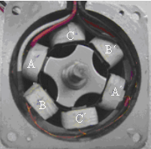

Fig. 1 Motor cross section

The motor is a three phase with six stator poles. Each phase consists of two windings wrapped over the opposite stator poles. In this study, one coil is the transmitter and the opposite coil is the receiver for each phase. The general block diagram of the controller circuit is shown in Fig. 2
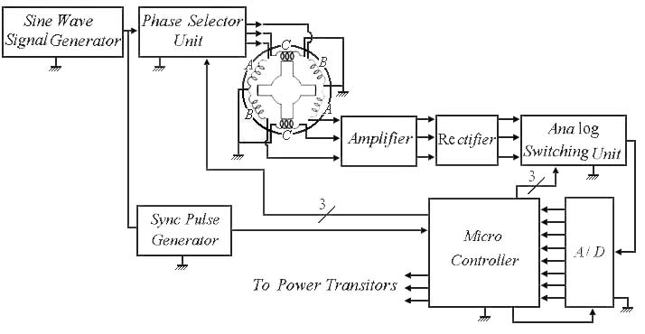

Fig. 2 Block Diagram of the Controller

A 5 KHz sine wave signal is generated and applied to each of the stator pole windings (i.e. the transmitter) sequentially via the phase selector unit and the resulting induced signal is obtained in the opposite corresponding pole winding (i.e. the receiver) respectively, as shown in Fig. 3
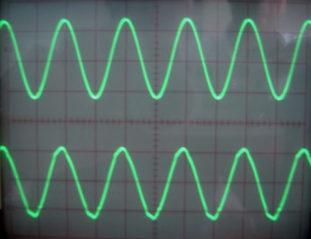

Fig. 3 Transmitted and received signals

The amplitude of the induced signal depends on the rotor poles positions with respect to the stator poles. The maximum amplitude is obtained when the rotor pole is completely aligned with the corresponding stator pole while the minimum magnitude is achieved when the poles are in full un-alignment.
In order for the microcontroller to make its measurements at the same instant of time for all three phases, a sync. pulse train has been generated from the input sine wave signal.
Fig. 4 shows the sync. signal and the resulting amplified and then rectified induced voltage for phase A.
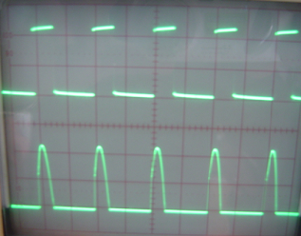

Fig. 4 The sync. signal and the resulting induced voltage

As shown in Fig. 4 the measurement of the output induced voltage starts at an arbitrary voltage level with respect to the applied input signal. Since the positive part of the induced voltage is going to be used for the detection of the rotor position therefore the negative part of it has been eliminated. Now for detecting the rotor position at standstill, the 5KHz diagnostic sine wave signal is applied sequentially to the consecutive stator poles (i.e. A, B , C) and the resulting induced signal in the opposite stator pole windings are measured and compared to identify the location of the rotor pole. Fig. 5 shows the induced signals in the three stator pole windings, simultaneously plus the sampling pulse train.


Fig. 5 The induced signals for all the phases plus sampling pulse train

As seen from Fig. 5 the first signal which belongs to phase A has the highest value of the induced voltage meaning, this phase has the highest rotor and stator overlapping. Considering these signals and the pre-determined direction of rotation a logic circuit has been set to select the proper phase to switch on. After this point, the motor starts to turn and the second mode of operation begins.
It is worth mentioning here that the unit for the analog switches shown in Fig. 2 gets its command from the microcontroller in order to allow one of the rectified signals belonging to the proper phase to pass to the A/D unit.
In the second mode of operation, the diagnostic sine wave is applied to the next un-energized transmitter coil continuously by the phase selector unit and the rate of change for the induced voltage magnitude in the receiver coil is monitored until it reaches a certain pre-set level. At this time the gate signal for the proper motor phase is produced. Fig. 6 shows the gate signal for two of the power transistor used to drive the motor.

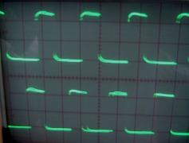

Fig. 6 The gate signal for the power transistors

As seen from Fig. 6 every phase is on for one third of the whole period since the motor is three phase.

3 Conclusion
This paper has presents a complete and novel method which is designed to detect the rotor position at standstill and also at low speeds for switched reluctance motor. This technique has been tested successfully on a 6 by 4 SRM. The method works fine in conjunction with pulse width modulation used to control the motor speed. The range of speed used for the motor starts at zero and goes to the motor rated speed which is about 7000 RPM. The motor has been also tested under different loads to check the reliability of the method and also if there are any unseen problems.

References:
[1] Perl , T.; Husain, I.; Elbuluk , M. Design trends and trade-offs for sensorless operation of switched reluctance motor drives. Industry Applications Conference, 1995. Thirtieth IAS Annual Meeting, IAS ’95., Conference Record of the 1995 IEEE. Oct. 1995. Akron Univ., OH , USA.PP. 278-285 Vol.

[2] Acarnley, P.P.,Hill,R.J. and Hooper,C.W, Detection of rotor position in stepping and switched reluctance motors by monitoring current waveforms . IEEE Trans. Industrial Electronics , Vol . IE – 32 (1985) , No . 3 , pp . 215-222.
[3] Ehsani, M., Husain, I., Mahajan, S. and Ramani, K.R. new modulation techniques for rotor position sensing in switched reluctance motors,” IEEE Trans. on Industry Applications, Vol. 30 (1994), No. 1, pp. 85-91.
[4] Lyons, j.p., MacMinn, S.R. and Preston , M.A., Flux/ Current methods for SRM rotor position estimation. IEEE – IAS Conf . Rec . , 19991 , pp . 482-487.
[5] Husain , I., Sodhi, S. and Ehsani, M., Sliding mode observer based control for switched reluctance motors. IEEE-IAS Conf. Rec . , 1994 ,pp. 635-643.
[6] Husain , I . and Ehsani , M., Rotor position sensing in switched reluctance motor drives by measuring mutually induced voltages. IEEE Transaction on industry Applications , Vol . 30 (1994) , No . 3 , pp. 665-672.
[7] E. Afjei and A. Aujloo. “A low cost sensorless control drive circuit for a low voltage switched reluctance motor”. International Journal of Engineering. Vol 14, No. 3 pp. 201-208, 2001

[8] D.S. Reay, B.Williams,” Sensorless position detectionusing neural networks for control of switched reluctance motors”, IEEE. proc.on Inter. Conf on Control Applications,Hawaii, Usa, Aug. 1999, pp 22-27,
[9] D. S. Reay, N. M. Moud, T. C. Green, B. W. Williams, “ Switched Reluctance motor control Via Fuzzy adaptive systems, IEEE control systems, June 1995
[10] R. Krishnan, Switched Reluctance Motor Drive: Modeling, simulation, Analysis, Design and application, Magna physics publishing, 2001

