Nonlinear PD Control of Underwater Robot in 3D Motion

JERZY GARUS, JOZEF MALECKI
Faculty of Mechanical and Electrical Engineering
Naval University
81-103 Gdynia, ul. Smidowicza 69
POLAND
http://www.amw.gdynia.pl

Abstract: - The paper addresses nonlinear control for underwater robot. For the tracking of desired trajectory, the way-point line of sight scheme is incorporated and autopilot consisting of four PD controllers used to generate command signals. Quality of control is concerned without and in presence of external disturbances. Some computer simulations are provided to demonstrate effectiveness, correctness and robustness of the approach.

Key-Words: - Underwater robot, Autopilot, Nonlinear control

Introduction
Underwater Robotics has known an increasing interest in the last years. The main benefits of usage of Underwater Robotic Vehicles (URV) can be removing a man from the dangers of the undersea environment and reduction in cost of exploration of deep seas. Currently, it is common to use URVs to accomplish missions as the inspection of coastal and off-shore structures, cable maintenance, as well as hydrographical and biological surveys. In the military field they are employed in such tasks as surveillance, intelligence gathering, torpedo recovery and mine counter measures.
The URV is operated manually with the joystick by an operator or automatically by means of a computer control system. Automatic control of underwater robots is a difficult problem caused by their nonlinear dynamics. Moreover, the dynamics can change according to the alteration of configuration to be suited to the mission. In order to cope with those difficulties, the control system should be flexible. To control dynamic behaviour of underwater robots can be used both classical and modern techniques [2,4,8,10,11]. But practical experiences show that one of the most important tasks in designing of control system is to apply fast and simply algorithm of control [1]. It is due to limited power of board computers. Therefore the objective of the paper is to present a usage of nonlinear PD algorithm to driving of the robot along the desired trajectory in 3-dimensional space.
The paper consists of the following four sections. Brief descriptions of dynamical and kinematical equations of motion of the floating object and the control law are presented in Section 2. Section 3 provides some results of the simulation study. Conclusions are given in Section 4.

Nonlinear control law for simultaneously 3-D control
The general motion of a marine vessel of 6 degrees of freedom (DOF) can be described by the following vectors [3,7]:
$\begin{matrix}η={\left[x,y,z,φ,θ,ψ\right]}^{T} \\ v={\left[u,v,w,p,q,r\right]}^{T} \\ τ={\left[X,Y,Z,K,M,N\right]}^{T}\end{matrix}$ (1)
where:
$η$ – the position and orientation vector with coordinates in the inertial frame;
x, y, z – coordinates of position;
φ, θ, ψ – coordinates of orientation (Euler angles);
v – the linear and angular velocity vector with coordinates in the body-fixed frame;
u, v, w – linear velocities along longitudinal, transversal and vertical axes;
p, q, r – angular velocities about longitudinal, transversal and vertical axes;
τ – describes the forces and moments acting on the robot in the body-fixed frame;
X, Y, Z – forces along longitudinal, transversal and vertical axes.
K, M, N – moments about longitudinal, transversal and vertical axes;
The nonlinear dynamical and kinematical equations of motion can be expressed as [4,5]:
$\begin{aligned}M\overset{˙}{v}+C(v)v+D(v)v+g(η)=τ \\ \overset{˙}{η}=J\left(η\right)v\end{aligned}$ (2)
where:
M – inertia matrix (including added mass);
C(v) – matrix of Coriolis and centripetal terms (including added mass);
D(v) – hydrodynamic damping and lift matrix;
$g(η)$ – vector of gravitational forces and moments;
$J(η)$ – velocity transformation matrix between robot and earth fixed frames.
Under assumptions that:
- vectors $η$ and v are measured;
- robot’s position and orientation in the earth-fixed frame is defined by the reference trajectory $η_{d}={\left[x_{d},y_{d},z_{d},φ_{d},θ_{d},ψ_{d}\right]}^{T}$;
- dynamical and kinematical model of the robot is represented by (2);
the PD control law takes the form [5,9]:
$τ=−K_{P}\tilde{η}−K_{D}v+g\left(η\right)$ (3)
where:
$\tilde{η}$ – control error;
$\tilde{η}=η−η_{d}$;
$K_{P}, K_{D}$ – diagonal matrices of gain coefficients.

Simulation results
For conventional URVs basic motion is movement in horizontal plane with some variation due to diving. Hence they operate in crab-wise manner in 4 DOF with small roll and pitch angles that can be neglected during normal operations. Therefore, it is purposeful to regard 3-dimensional motion of the robot as superposition of two displacements: motion in the horizontal plane and motion in the vertical plane.
A main task of the designed tracking control system is to minimize distance of attitude of the robot’s centre of gravity to the desired trajectory under assumptions:
- the robot can move with varying linear velocities u, v, w and angular velocity r;
- its velocities u, v, w, r and coordinates of position x, y, z and orientation φ, θ, ψ are measurable;
- the desired trajectory is given by means of set of way-points $\left\{\left(x_{\text{di}},y_{\text{di}},z_{\text{di}},ψ_{\text{di}}\right)\right\}$;
- reference trajectories between two successive way-points are defined as smooth and bounded curves;
- the command signal τ consists of four components: $τ_{1}=X$, $τ_{2}=Y$, $τ_{3}=Z$ and $τ_{4}=N$ calculated from the control law (3).
A structure of the proposed control system is depicted in Fig. 1.

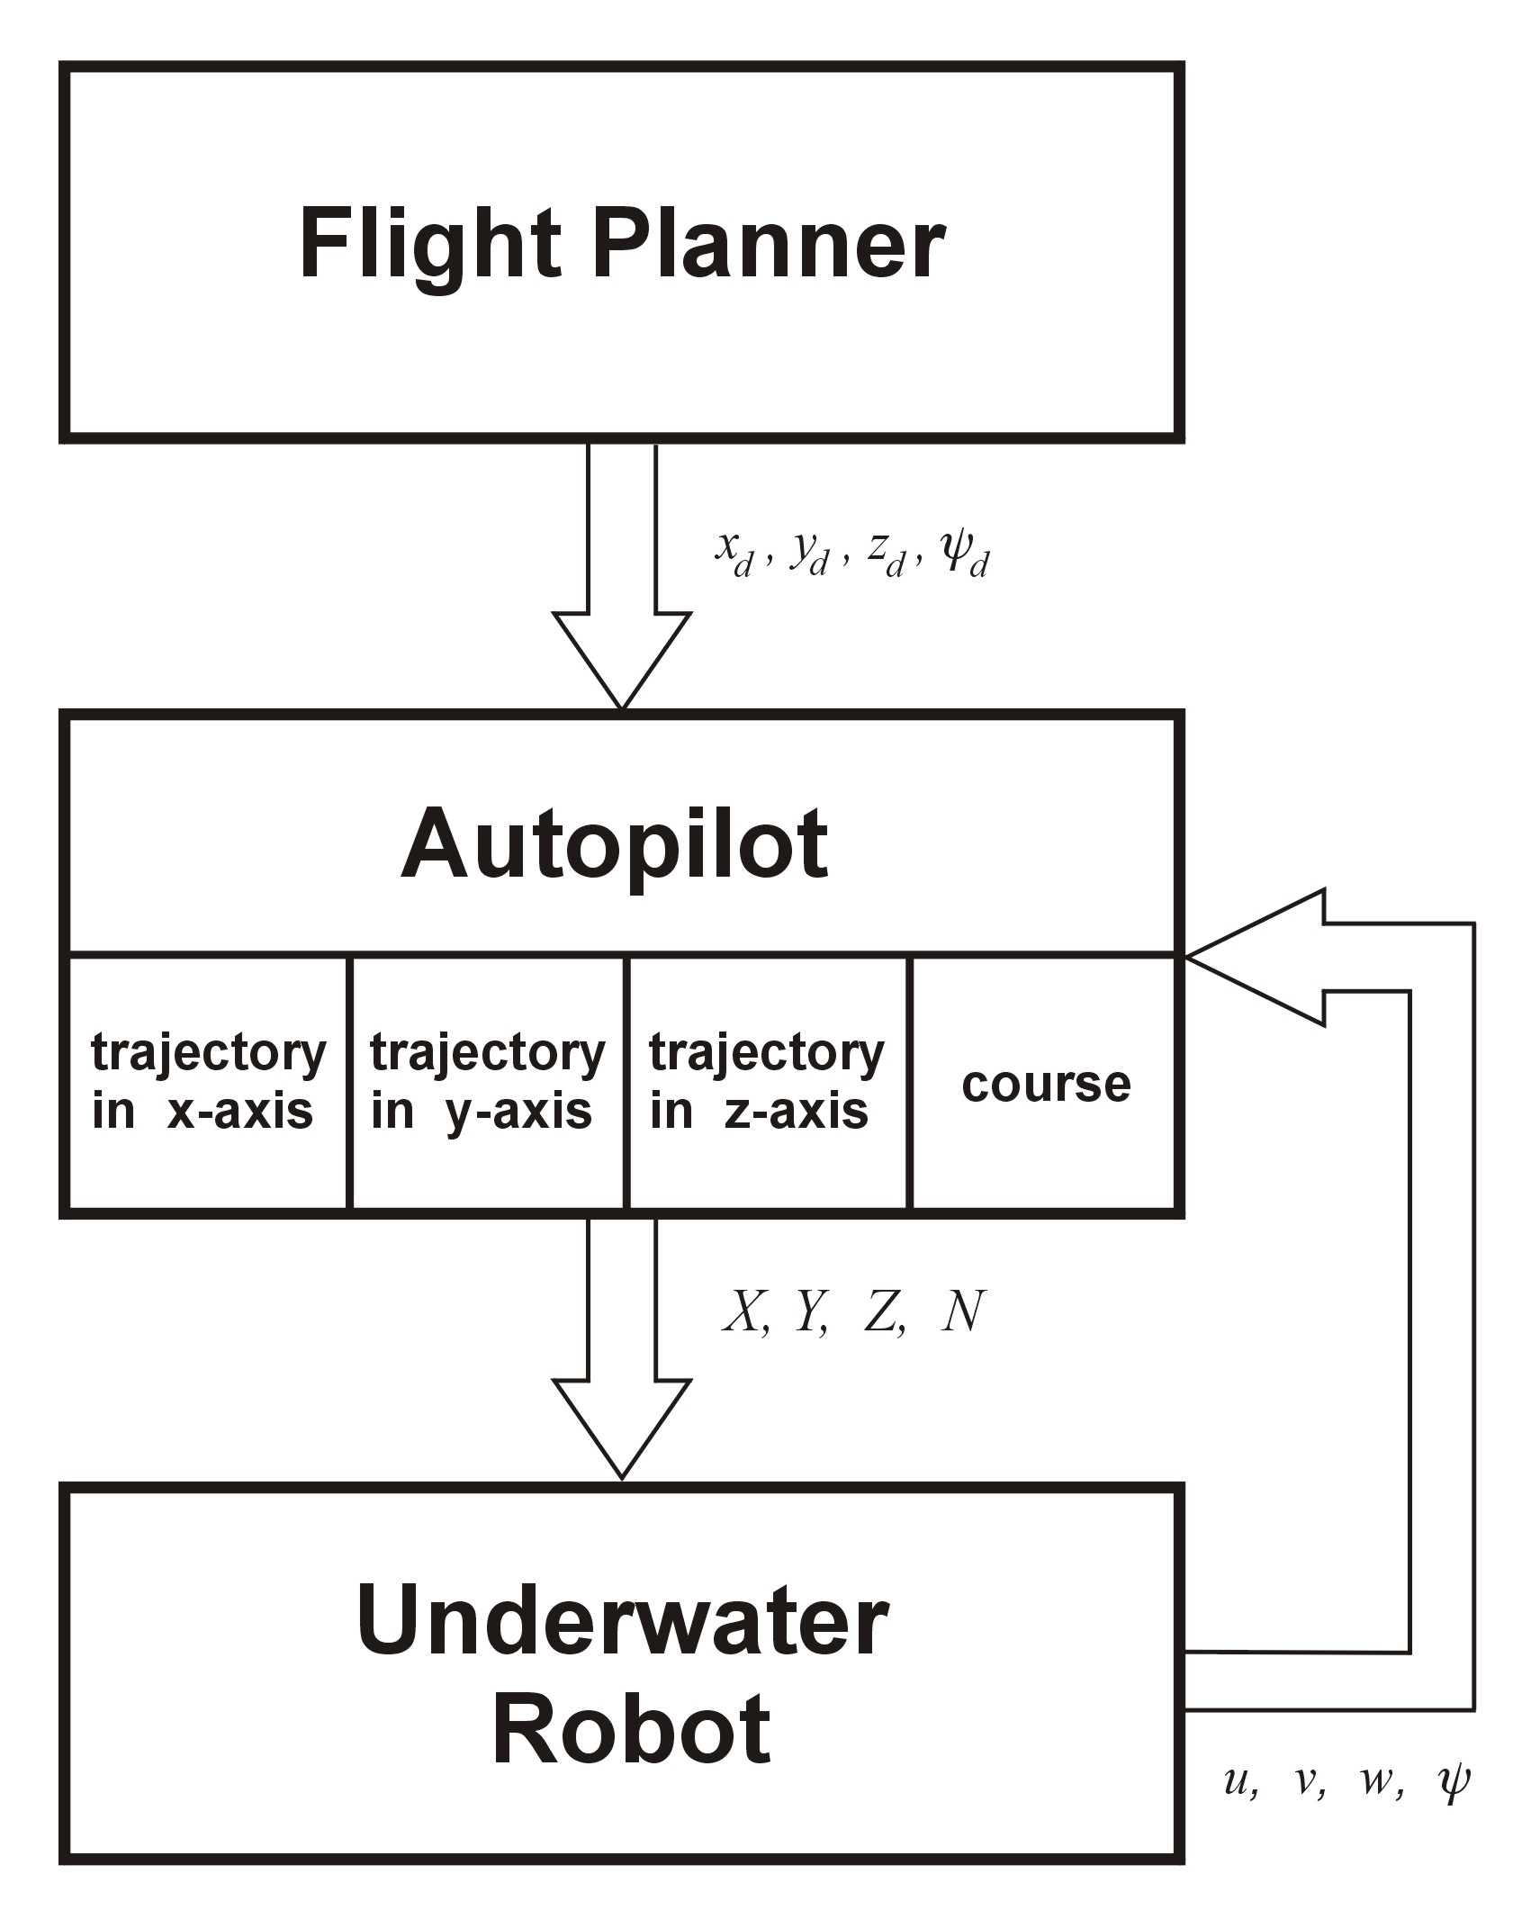

Fig. 1. A structure of the control system.
To validate the performance of the developed nonlinear control law, simulations results using the MATLAB/Simulink environment are presented. The model of the UVR is based on a real construction of a underwater robot called “Coral” designed and built for the Polish Navy. The URV is an open frame robot controllable in 4 DOF, being 1.5 m long and having a propulsion system consisting of six thrusters. Displacement in horizontal plane is done by means of four ones which generate force up to ±750 N assuring speed up to ±1.2 m/s and ±0.6 m/s in x and y direction, consequently. In vertical plane, on the contrary, two thrusters are used. They can develop a driving force up to ±400 N and reach speed up to ±0.5 m/s. All parameters of the robot’s dynamics and the default parameters of the autopilot are presented in the Appendix A.
Numerical simulations have been made to confirm quality of the proposed control algorithm for the following assumptions:
- the robot has to follow the desired trajectory beginning from (10 m, 10 m, 0 m, 0⁰), passing target way-points: (10 m, 10 m, -5 m, 0⁰), (10 m, 90 m, -5 m, 60⁰), (30 m, 90 m, -5 m, 0⁰), (30 m, 10 m, -5 m, 300⁰), (60 m, 10 m, 5 m, 0⁰), (60 m, 90 m, -5 m, 60⁰), (60 m, 90 m, 15 m, 0⁰), (60 m, 10 m, -15 m, 240⁰), (30 m, 10 m, -15 m, 180⁰), (30 m, 90 m, -15 m, 120⁰), (10 m, 90 m,
-15 m, 180⁰) and ending in (10 m, 10 m, -15 m, 240⁰);
- the turning point is reached when the robot is inside of the 1.0 metre circle of acceptance.
It has been assumed that the time-varying reference trajectories at the way-point i to the next way-point i+1 are generated using desired speed profiles [8]. Such approach allows us to keep constant speed along certain part of the path. For those assumptions and the following initial conditions:
$η_{\text{dk}}\left(t_{b}\right)=η_{0}$, ${\overset{˙}{η}}_{\text{dk}}\left(t_{b}\right)={\overset{˙}{η}}_{0}$,
$η_{\text{dk}}\left(t_{f}\right)=η_{1}$, ${\overset{˙}{η}}_{\text{dk}}\left(t_{f}\right)={\overset{˙}{η}}_{1}$,
${\text{max \{}\overset{˙}{η}}_{\text{dk}}\left(t\right)={\overset{˙}{η}}_{\text{max}}$,
where $k=\overline{1,4}$, the i^{th} segment of the trajectory in a period of time $t∈\left\langle t_{b},t_{f}\right\rangle$ has been modelled according to the expression [5]:
$$η_{\text{dk}}\left(t\right)=\left\{\begin{matrix}η_{0}+\frac{{\overset{˙}{η}}_{\text{max}}−{\overset{˙}{η}}_{0}}{2t_{m}}t^{2} & t_{b}≤t≤t_{m} \\ \begin{aligned}\frac{η_{1}+η_{0}−{\overset{˙}{η}}_{\text{max}}\left(t_{f}−2t_{m}\right)}{2}+ \\ + {\overset{˙}{η}}_{\text{max}}\left(t−t_{m}\right)\end{aligned} & t_{m}<t≤t_{f}−t_{m} \\ η_{1}−\frac{{\overset{˙}{η}}_{\text{max}}−{\overset{˙}{η}}_{1}}{2t_{m}}{\left(t_{f}−t\right)}^{2} & t_{f}−t_{m}<t≤t_{f}\end{matrix}\right.$$
where $t_{m}=t_{f}−\frac{η_{1}−η_{0}}{{\overset{˙}{η}}_{\text{max}}}$.
The figure 2 shows results of tracking control and courses of commands for no added environmental disturbances. As there is seen the real trajectory is almost totally as the desired one. Also a quality of track-keeping control is satisfactory.
Fig. 2. Track-keeping control without environ-mental disturbances: desired (d) and real (r) trajectories (upper plot), x-, y-, z-position and error of position (2nd  4th plots), course and error of course (5th plot), commands (low plot).

The regulation problem has been also examined under interaction of external disturbances i.e. sea currents. To simulate the current and its effect on robot’s motion the velocity of the current was assumed to be slowly-varying and the direction fixed. Results of track-keeping in presence of external disturbances and the courses of command signals are presented in Fig. 3. Although the tracking errors are higher, in comparing with the previous tests, the autopilot is able to cope with disturbances and reach the turning points with commanded orientation.
It can be seen that the proposed autopilot enhanced good tracking control of the desired trajectory in the spatial motion. The main advantage of the approach is using the simple nonlinear law to design controllers and its high performance for relative large sea current disturbances (comparable with resultant speed of the robot).
The simulation experiments also showed that the quality of tracking the reference trajectory can be improved by adequate choice of gain coefficients. (They were found by using a pole placement algorithm [4]). Therefore, in case of practical implementation of the proposed control law, values of the vectors K_{P} and K_{D} should be selected carefully.

Fig. 3. Track-keeping control under interaction of sea current disturbances (average velocity 0.3 m/s and direction 135⁰): desired (d) and real (r) trajectories (upper plot), x-, y-, z-position and error of position (2nd  4th plots), course and error of course (5th plot), commands (low plot).

Conclusion
In this paper the nonlinear PD autopilot for underwater robot has been described. The obtained results with the control system showed the presented autopilot to be simple and useful for the practical usage.
Disturbances from the sea current were added to verify the performance, correctness and robustness of the approach.
One of the main advantages of the proposed solution is its flexibility with regard to the robot’s dynamics.
A further work is devoted to the problem of tuning of the autopilot parameters in relation to the robot’s dynamics.

Acknowledgement
The authors are greatly indebted to the anonymous referees for their highly valuable comments.

References:
[1] G. Antonelli, F. Caccavale, S. Sarkar, M. West, Adaptive Control of an Autonomous Underwater Vehicle: Experimental Results on ODIN. IEEE Transactions on Control Systems Technology, Vol.9, No.5, 2001, pp. 756-765.
[2] J. Craven, R. Sutton, R.S. Burns, Control Strategies for Unmanned Underwater Vehicles. Journal of Navigation, No.51, 1998, pp. 79-105.
[3] R. Bhattacharyya, Dynamics of Marine Vehicles, John Wiley and Sons, Chichester 1978.
[4] T.I. Fossen, Guidance and Control of Ocean Vehicles, John Wiley and Sons, Chichester 1994.
[5] T.I. Fossen, Marine Control Systems, Marine Cybernetics AS, Trondheim 2002.
[6] J. Garus, Z. Kitowski, Non-linear Control of Motion of Underwater Robotic Vehicle in Vertical Plane. In N. Mastorakis, V. Mladenov (Eds): Recent Advances in Intelligent Systems and Signal Processing, WSEAS Press, 2003 pp. 82-85.
[7] J. Garus, Z. Kitowski, Designing of Fuzzy Tracking Autopilot for Underwater Robotic Vehicle Using Genetic Algorithms. In N. Mastorakis, I. F. Gonos (Eds): Computa-tional Methods in Circuits and Systems Applications. WSEAS Press, 2003, pp. 115-119.
[8] J. Garus, Z. Kitowski, Trajectory Tracking Control of Underwater Vehicle in Horizontal Motion. WSEAS Transactions on Systems, Vol.3, No.5, 2004, pp. 2110-2115.
[9] M.W. Spong, M. Vidyasagar, Robot Dynamics and Control, John Wiley and Sons, Chichester 1989.
[10] J.K. Yuh, Modelling and Control of Under-water Robotic Vehicles. IEEE Transactions on Systems, Man and Cybernetics, Vol.15, No.2, 1990, pp. 1475-1483.
[11] J.K. Yuh, R. Lakshmi, An Intelligent Control System for Remotely Operated Vehicle. IEEE Journal of Oceanic Engineering, Vol.18, No.1, 1993, pp. 52-62.

Appendix A

The URV model
The following parameters of the underwater robot’s dynamics were used in the computer simulations:

$$M=\text{diag}\left\{ \begin{matrix}\text{99}\text{.}0 & \text{108}\text{.}5 & \text{126}\text{.}5 & 8\text{.}2 & \text{32}\text{.}9 & \text{29}\text{.}1\end{matrix}\right\}$$

$$\begin{aligned}D\left(v\right)=\text{diag}\left\{\begin{matrix}\text{10}\text{.}0 & 0\text{.}0 & 0\text{.}0 & 0\text{.}\text{223} & 1\text{.}\text{918} & 1\text{.}\text{603}\end{matrix}\right\}+ \\ \text{diag}\left\{\begin{matrix}\text{227}\text{.}\text{18}\left|u\right| & \text{405}\text{.}\text{41}\left|v\right| & \text{478}\text{.}\text{03}\left|w\right| & \\ & 3\text{.}\text{212}\left|p\right| & \text{14}\text{.}\text{002}\left|q\right| & \text{12}\text{.}\text{937}\left|r\right|\end{matrix}\right\}\end{aligned}$$
$$C\left(v\right)=\left[\begin{matrix}0 & 0 & 0 & 0 & \text{26}\text{.}0w & −\text{28}\text{.}0v \\ 0 & 0 & 0 & −\text{26}\text{.}0w & 0 & \text{18}\text{.}5u \\ 0 & 0 & 0 & \text{28}\text{.}0v & −\text{18}\text{.}5u & 0 \\ 0 & \text{26}\text{.}0w & −\text{28}\text{.}0v & 0 & 5\text{.}9r & −6\text{.}8q \\ −\text{26}\text{.}0w & 0 & \text{18}\text{.}5u & −5\text{.}9r & 0 & 1\text{.}3p \\ \text{28}\text{.}0v & −\text{18}\text{.}5u & 0 & 6\text{.}8q & −1\text{.}3p & 0\end{matrix}\right]$$
$$g\left(η\right)=\left[\begin{matrix}−\text{17}\text{.}0\text{sin}(θ) \\ \text{17}\text{.}0\text{cos}(θ)\text{sin}(φ) \\ \text{17}\text{.}0\text{cos}(θ)\text{cos}(φ) \\ −\text{279}\text{.}2\text{cos}(θ)\text{sin}(φ) \\ −\text{279}\text{.}2\left(\text{sin}(θ)+\text{cos}(θ)\text{cos}(φ)\right) \\ 0\end{matrix}\right]$$

The values of matrices K_{P} and K_{D} corresponding to the nonlinear control law (3) were as follows:

$$K_{P}=\text{diag}\left\{\begin{matrix}\text{500} & \text{100} & \text{300} & 0 0 \text{50}\end{matrix}\right\}$$
$$K_{D}=\text{diag}\left\{\begin{matrix}\text{100} & \text{20} & \text{100} & 0 0 \text{10}\end{matrix}\right\}$$

