A Study on the Metallic Electrode Materials of the SAW Devices

HUANN-WU CHIANG and JUN-XIAN WU
Department of Materials Science and Engineering
I-Shou University, Taiwan
1, Section 1, Hsueh-Cheng Road, Ta-Hsu Hsiang, Kaohsiung County, 840 Taiwan

http://www.mse.isu.edu.tw

Abstract: - In this study, the properties of the metallic electrodes on the piezoelectric substrates were investigated.
By using nano-indentation technique, the hardness and elastic modulus of the electrode film were measured and it was found that they were varied with electrode type. After 150ºC high temperature storage test, the microstructure and consequently, the hardness and the elastic modulus were slightly changed. In addition, the adhesion between electrode film and substrate was also tested.

Key-Words: - Surface Acoustic Wave Resonator, Metallic Electrode, Nano-indenter, Atomic Force Microscope(AFM).

1. Introduction
The rapid and enormous growth in personal wireless local area network (LAN), digital-base mobile phone and the third generation communication technologies has lead to the development of the microwave communication system towards even higher frequency, better signal integrity, and smaller size. Surface acoustic wave (SAW) devices were originally utilized in the military applications and were commercialized and have played an important role as a key device in various consumer electronic products, such as in the wireless communication industry in recent years. Due to the advantages of small size, highly reproducible, low loss, good temperature stability, wide central frequency bandwidth, and good reliability, SAW devices have been widely used on the 3C products, particularly the mobile phone application is by far the most demanding, which contributing over 50 % of the market share and becomes the main stream product of the market[1-2].
In all SAW devices, the critical structures are arrays of narrow parallel metal strips, with space between the strips comparable to the width of the strip. Using photolithography to make SAW devices gives accurate control of the electrode geometry and the crystal substrate, which consequently have very reproducible properties, so that devices with very predictable performance can be produced. Since the electrode width is a crucial factor, photolithography is limited by the wavelength of the light used to reproduce the pattern on the substrate. The major problem for the SAW filters in high frequency applications is that if a low insertion loss is to be obtained, the size of the device needs to be enlarged or a higher level design needs to be utilized. This could be imparted by developing high wave velocity piezoelectric material and new filter’s structure.

The electrodes of the SAW devices have a function which is purely electrical, i.e. they serve simply to apply or detect electric field at the surface. For this purpose, the film thickness only needs to be enough to minimize losses due to resistivity. Typically the thickness will be in the range 300 to 3000 A. The metal film is nearly always aluminum, chosen because it has acoustic properties fairly similar to those of the substrate materials. Titanium is sometimes used under the aluminum to improve the power handling characteristics of the device[3].
Using various types of metallic film (Al、Au、Cu、Ag、W) as electrodes with different thickness on a bulk acoustic wave resonator devices, K. M Lakin et al.[4] found that the effective coupling coefficient varies with electrode material and increases with increasing electrode thickness and reaches a maximum value of certain electrode-to-piezoelectric thickness ratio.
Frank M. Cumbo et al.[5] pointed out that to gain a highly prefer orientated AlN piezoelectric film, the quality of the bottom electrode film has an decided influence. The function of the bottom electrode is strongly affected by its own homogeneity and microstructure. The polycrystalline bottom electrode with surface roughness (Ra) less than 5 nm is required for the highly prefer orientation AlN film to grow.
By composing heavy-metal film electrodes such as Ta or W on an ST-90ºX quartz substrate, M. Kadota et al.[6] developed very small longitudinal coupled resonator filters with large reflection coefficient, excellent temperature stability, low loss, large out-of-band rejection, and sufficient bandwidth without expansion coils.
All the electrical signals are connected with metallic electrode, and hence the properties of the electrode will affect the performance of the SAW devices. A precise control of the electrode width becomes a crucial technique for a successful SAW device. Furthermore, the interfacial properties and the adhesion between the metallic electrode and the piezoelectric substrate have a decided influence for the usability and reliability of the device. Hence, the objective of this present study is to investigate the influence of the film deposition process on the metallic electrodes. Different types of piezoelectric substrate and electrode materials are used for comparison. Furthermore, a 150ºC high temperature storage test is conducted on the samples for the reliability evaluation.

2. Experimental Procedures
The piezoelectric substrates used in this study are 132ºY-X Quartz and 42ºY-X LiTaO₃ wafers. Both substrates are sputter coated with aluminum and titanium as electrode materials for comparison. The experimental flow chart is as shown in Fig. 1.
Piezoelectric substrates
AFM
Cutting + Cleaning
Electrode deposition

250ºC reflow
150ºC HTS
α-step
Nano-indenter
SEM
Film adhesion tester
Fig.1 Experimental flow chart.
The surface roughness of the bare and the coated substrates were measured using atomic force microscope (AFM). A 25 watts DC sputter with an argon flow rate of 52 sccm and a partial pressure of 4 mTorr in vacuum was used for the electrode deposition. Sputtering times were set at 10 min, 20 min. and 30 min. Some coated samples were heated in a vacuum oven at 250ºC for 5 min. as simulating the reflow process of the SAW devices. After reflow, some substrates were heated in the oven for high temperature storage（HTS）test in air atmosphere. The heating temperature was 150ºC and samples were aged for 250 and 500 hours. The film thickness was measured with α-step. The hardness and elastic modulus of the electrode films were measured by utilizing a nano-indentation technique, which indents various micro loads on the film to form a micro indentation and by knowing the depth of the micro indentation, the hardness and the elastic modulus can be calculated. The adhesive strength of the electrode film was measured by using a film adhesion tester as shown schematically in Fig.2. Finally, a field-emission SEM was used for the microstructure observation.
substrate
Film to be tested
Binding polymer
Aluminum bolt
Force
Fig. 2. The schematic diagram of the film adhesion tester.

3. Results and Discussion
The relationship of the film thickness and the sputtering time is as shown in Fig. 3. The deposition rates for aluminum and titanium are 6.3 nm/min. and 5.2 nm/mim., respectively.

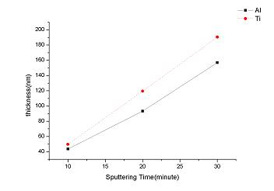
Fig.3. Film thickness vs. sputtering time.

The surface roughness of the bare substrate was around Ra = 0.5nm and the Ra for the deposited film increased to around 1.0nm, and are varied with sputtering power. AFM 3-D plots for the bare LiTaO₃ substrate and titanium deposited on LiTaO₃ substrate were shown in Fig. 4 and Fig.5, respectively.

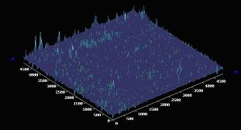
Fig. 4. 3-D AFM profile of the LiTaO3 substrate surface.

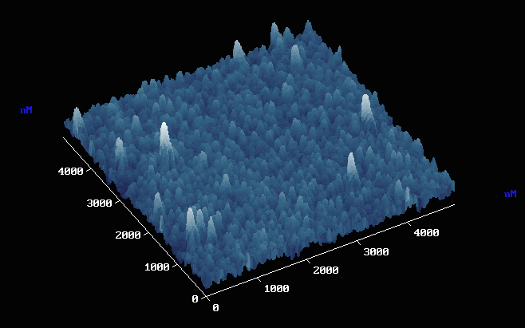
Fig. 5. 3-D AFM profile of the deposited titanium surface on LiTaO₃ substrate.

Using nano-indentation technique, electrode film hardness was measured and calculated, and the results were as shown in Fig. 6. Titanium film shows a higher hardness value than that of aluminum film. After 500 hours of 150ºC HTS aging, the hardness varies within 2 GPa for all samples. Figs. 7-8 show two indenter images of the titanium and aluminum electrodes after the indentation of the nano-indenter.

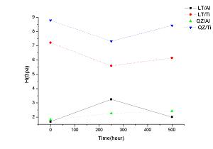
Fig.6 Film hardness Vs. HTS aging time.

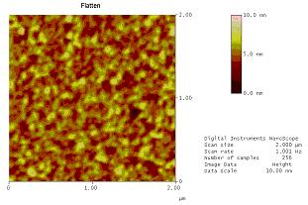
Nano-indentation
Fig.7. Nano-indentation on a titanium film.

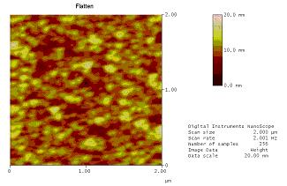
Nano-indentation
Fig.8. Nano-indentation on an aluminum film.

The elastic modulus of the electrode film measured from nano-indentater shows that the elastic modulus of the electrode film increases with increasing HTS aging time except for the quartz substrate coated with aluminum film as shown in Fig. 9.

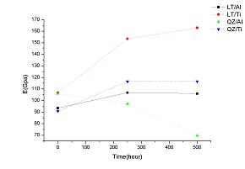

Fig. 9 Elastic modulus of the electrode film vs. HTS aging time.

The adhesive force between the electrode film and the piezoelectric substrate as a function of 150ºC HTS aging time is as shown in Fig. 10. It is interesting in the figure that the adhesive strength increases with increasing aging time for the LiTaO3 substrate while decreases with increasing aging time for the quartz substrate. Aluminum – substrate interface has a slightly higher adhesive strength than that of the titanium – substrate interface.
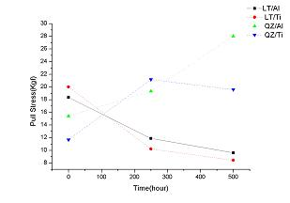
Fig. 10. Adhesive strength of the electrode vs. HTS aging time.

Compare the microstructures of the electrode film surfaces as shown in Figs. 11-14, titanium film has a smaller grain size than that of the aluminum film. No appreciable grain growth can be detected after 500 hours of 150ºC HTS aging. The substrate did not show any influence on the film grain structure for both titanium and aluminum electrodes.

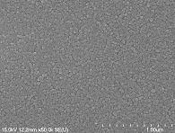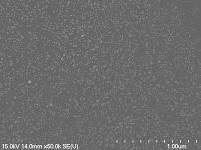
after reflow 150ºC 500hr HTS
Fig. 11. FE-SEM micrographs of the Ti film surface (on LiTaO₃ substrate).

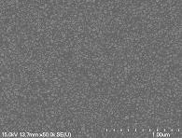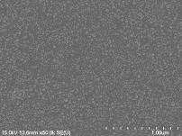
after reflow 150ºC 500hr HTS
Fig. 12. FE-SEM micrographs of the Ti film surface (on quartz substrate).

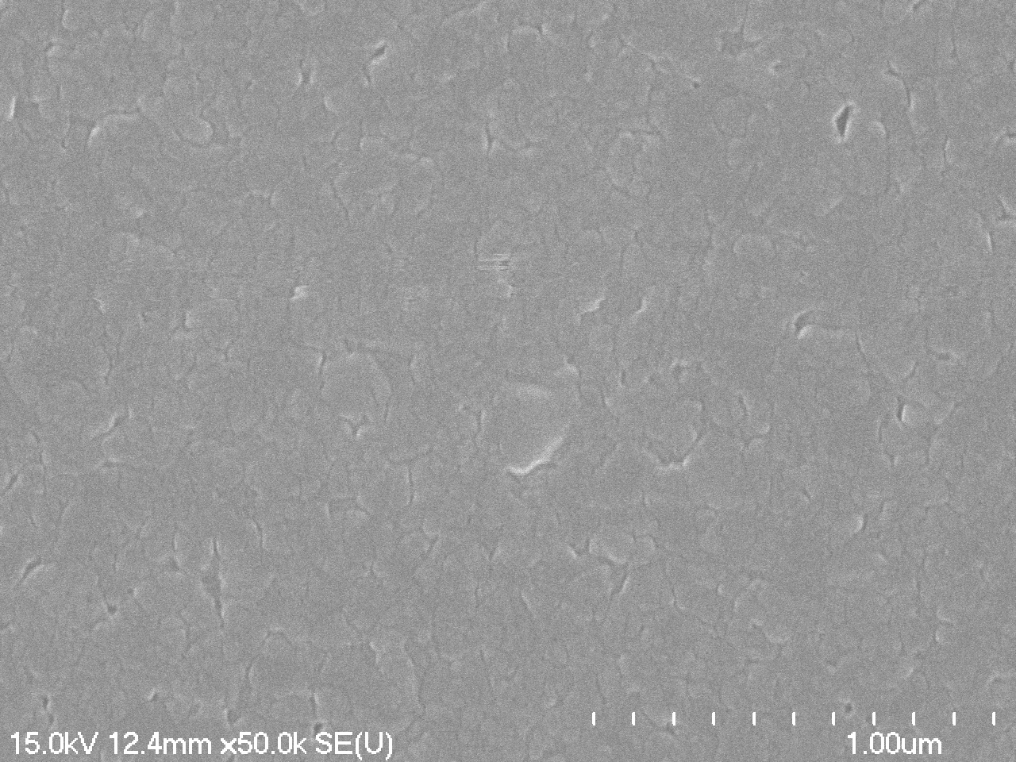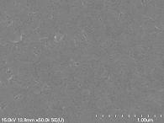
after reflow 150ºC 500hr HTS
Fig. 13. FE-SEM micrographs of the Al film surface (on LiTaO₃ substrate).

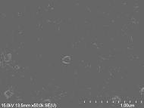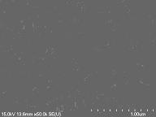
after reflow 150ºC 500hr HTS
Fig. 14. FE-SEM micrographs of the Al film surface (on quartz substrate).

4. Conclusions
In this paper, some mechanical properties of the metallic electrodes on the quartz and LiTaO₃ piezoelectric substrates were tested. It was found the sputtering process parameters affect the deposited film qualities such as film thickness and surface roughness. The hardness of the titanium film is greater than that of the aluminum film. In comparison with the surface micrographs, the grain size of the aluminum film is greater that of the titanium film and both grains were not affected by the substrate materials and the 150ºC HTS aging time.

Acknowledgements
Financial support of this work from National Science Council of Republic of China under NSC 93-2213-E-214-015 is gratefully acknowledged.

References:
[1] N. Kimuba, M. Nakano, M. Nakazawa, and K. Sato, The Power Durability of 900 MHz Band Double-Mode-Type Surface Acoustic Wave Filters and Improvement in Power Durability of Al-Cu Thin Film Electrodes by Cu Atom segregation, Jpn. J. Appl. Phys., Vol. 36, pp2101-3106, 1997.
[2] K. M. Larkin, G. R. Kline, and K. T. McCraaon, Development of miniature filters for wireless applications, IEEEE Trans. Microwave Theory Tech., Vol. 43, no. 12, pp2933-2939, Dec. 1995.
[3] COM DEV SAW Product Application Notes 102, www-saw-device.com
[4] K. M. Larkin, J. Belsick, J. F. McDonald, and K. T. McCarron, Improved Bulk Wave Resonator Coupling Coefficient For Wide Bandwidth Filters, IEEE 2001 Ultrasonics Symposium Paper 3E-5, Oct. 9, 2001.
[5] F. M. Cumbo, D. J. Metacarpa, Sr., and F. M. Serry, Film Bulk Acoustic Resonator Process Technology, FBAR Apps. , 7/02 ZP 2.5M, 2002.
[6] M. Kadota, T. Yoneda, L. Fujimoto, T. Kakao, and E. Takata, Resonator Filter Using Shear Acoustic Wave Consisting of Heavy-Metal Electrode and Quartz Substrate, IEEE Transactions, Ferroelectrics, and Frequency Control,Vol. 51, No. 2, Feb., 2004.

