Study of a parallel system with applications in micromechanics

GRACIELA VELASCO-HERRERA
Laboratory of Micromechanics and –Mechatronics
Center of Applied Sciences and Technological Development
National Autonomous University of Mexico
MEXICO
http://www.cinstrum.unam.mx

Abstract: This paper proposes a new mechanic design of a parallel system. It gives original contributions guide to tasks of the microassembles and micromachine-making of high precision.

Keywords: Closed system, Micromechanics, Microassemble, Micromachine-making

1 Introduction

The word "system" has many connotations. Its definition: is a set of interdependent and interactive elements; as well as a group of combined units organize them selves and whose result (output) is greater that the result than the units could have if they worked independently.

The term is also used for the completely structured systems, where the elements and relations are consisted of a peculiar and rigid way, which produces an invariable exit. The mechanical systems are an example of machines. As for their nature, the systems can be closed or opened.

Mechanical systems that allow a rigid body to move with respect to fixed base play a very important role in numerous applications. a rigid body in space can move in various ways, in translation or rotary motion The total number of degrees of freedom of a rigid body in space cannot exceed 6. The position and the orientation of the end-effector can be described by its generalized coordinates; these are usually the coordinates of a specific point of the end-effector and the angles that define its orientation. As soon as it is possible to control several degrees of freedom of the end-effector via a mechanical system, this system can be called a robot.
The last few years have witnessed an important development in the use of robots in the industrial world, mainly due to their flexibility. However, the mechanical architecture of the most common robots does not seem adapted to certain tasks. Other types of architecture have therefore recently been studied, and are being more and more regularly used within the industrial world.

This paper proposes a closed symmetrical mechanical system, as a new mechanical design that work through a system of levers, that we denominated micromanipulator, conserving the main characteristics of these mechanisms. This micromanipulator in essence is compact, light, versatile and exact. It gives original contributions, guided to tasks of the microassembles and micromachine-making of high precision

2. Concept of Micromachine
and Micromanipulator

Through the history, the Micromachines are defined of diverse forms, without losing the nature of their function[1,2,3].
In this work, we followed some of the ideas that define the name of our mechanical design: Micromanipulator [9]. The machines not only take their names according to their size, but also the size of their components, extending the definition to the size of the parts made by the machine. Retaking this definition, we can affirm that a parallel micromanipulator is a closed structure that takes its name not only according to its size, but also according to the size of the components that it manipulates, and to the processes that it makes.

3 Problem Formulations

Figure 1 shows the movements the lever makes, is the base for of the mechanical system.
When we proposed to apply the combination of lever and spheres, we kept in the mind the advantage of using levers was to obtain better resolution and simplicity.
Motion Screw
Levers
Flexible support
Levers
Motion Screw
Figure 1. Diagram
Figure 2 shows the different positions of the lever and the diverse positions of the movable platform, when a screw only moves

Motion Screw
Levers
Mobile platform
Figure 2. Movement of the system

Defining the angles of the symmetrical mechanical system, taking like reference the sides of the system, we obtain the following data in figure 3
M(x,y)
A
A
D
0
CA
l₃
l₂
l₁
l₅
l₄
C
B
X
Y
θ₄
θ₃
θ₁
θ₂

Figure 3. Diagram for the plane X,Y
In order to determine the position of point M, located in the extreme of the movable platform, we used as reference the figure 3. As the system is symmetrical, we can one of axis of symmetry of plane XY for its analysis. We proposed to apply sine and cosine law, and the sum of the internal angle of triangle to determine the values of the absent angles,

where

$$\begin{aligned}l_{3}=0\bar{A},l_{2}=A\bar{C},l_{1}=0\bar{C},l_{5}=D\bar{C},l_{4}=D\bar{B}, \\ \\ θ_{1}∠l_{3},l_{2};θ_{2}∠l_{3},l_{1};θ_{3}∠l_{1},l_{2};θ_{4}∠l_{4},⊥{\text{proyl}}_{4}\text{.}\end{aligned}$$
and, of the relations
$$\begin{aligned}θ_{1}+θ_{2}+θ_{3}=π, \\ l_{3}^{2}=l_{2}^{2}+l_{1}^{2}−2l_{1}l_{2}\text{cos}θ_{3} \\ \frac{l_{1}}{\text{sin}θ_{1}}=\frac{l_{2}}{\text{sin}θ_{2}}, \\ \frac{l_{1}}{\text{sin}θ_{1}}=\frac{l_{3}}{\text{sin}θ_{3}},\end{aligned}$$
it is possible to obtain the equations system, is possible to calculate the value for the point M(x,y)

$\begin{aligned}y=l_{5}⋅\text{sin}θ_{3}+l_{4}⋅\text{cos}θ_{4}, \\ x−(l_{1}−l_{5}⋅\text{cos}θ_{3})=l_{4}⋅\text{sin}θ_{4}\end{aligned}$ (1)

if the new angles of the geometric system are small in figure 3,
we obtain
$\begin{aligned}θ_{3}^{'}=θ_{3}+{Δθ}_{3}, \\ θ_{4}^{'}=θ_{4}+{Δθ}_{4},\end{aligned}$
where
$$\begin{aligned}θ_{3}^{'}\text{<<}1, \\ θ_{4}^{'}\text{<<}1,\end{aligned}$$
with the aid of a program in C++, we can find the point M of coordinates x,y

$$\begin{aligned}y=l_{5}⋅\left({Δθ}_{3}\text{cos}θ+\left[1−\frac{1}{2}{Δθ}_{3}\right]\text{sin}θ_{3}\right)+ \\ ……+l_{4}⋅\left(\left[1−\frac{1}{2}{Δθ}_{4}\right]\text{cos}θ_{4}−{Δθ}_{4}\text{sin}θ_{4}\right), \\ \\ x−(l_{1}−l_{5}⋅\left(\left[1−\frac{1}{2}{Δθ}_{3}\right]\text{cos}θ_{3}−{Δθ}_{3}\text{sin}θ_{3}\right)= \\ l_{4}⋅\left({Δθ}_{4}\text{cos}θ+\left[1−\frac{1}{2}{Δθ}_{4}\right]\text{sin}θ_{4}\right)\text{.}\end{aligned}$$
3 Design and Description
For the design of this new prototype, we started with simple elements, which allow us to simplify the assembly task.
The mechanism proposed in this design is symmetrical and is made up of three identical links, which are separated by the 120° one from other, and connect the fixed base with the movable platform (figure 4,5).

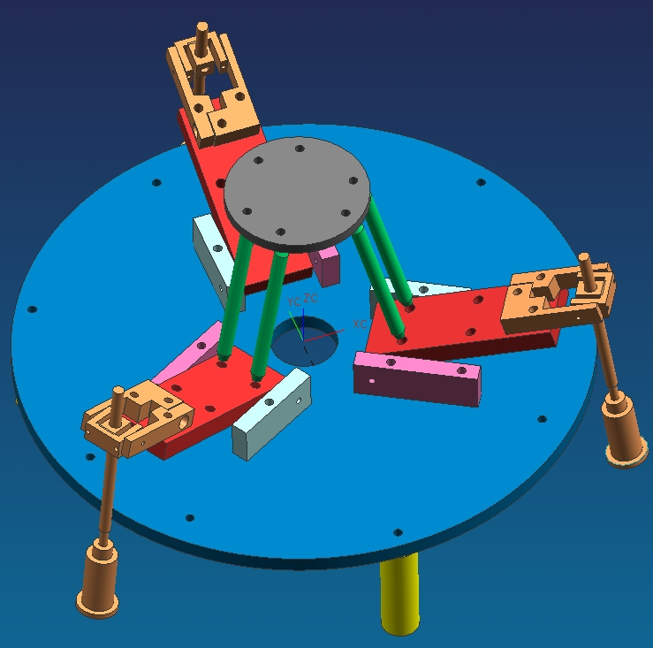
11
2
7
6
5
4
113
10
9
8
3
12
Fig 4. Parallel Micromanipulator
1 platform bases; 2, 3- supports; 4- parallel bars; 5- mobile platform; 6,7- Cardan joint; 8- supports of Cardan joint; 9- feed screw; 10- rocker lever; 11- supports of platform the bases, 12 flexible support.

The system is made in aluminium, tin and cold rolled. Has a size of 20x15x5 cm.
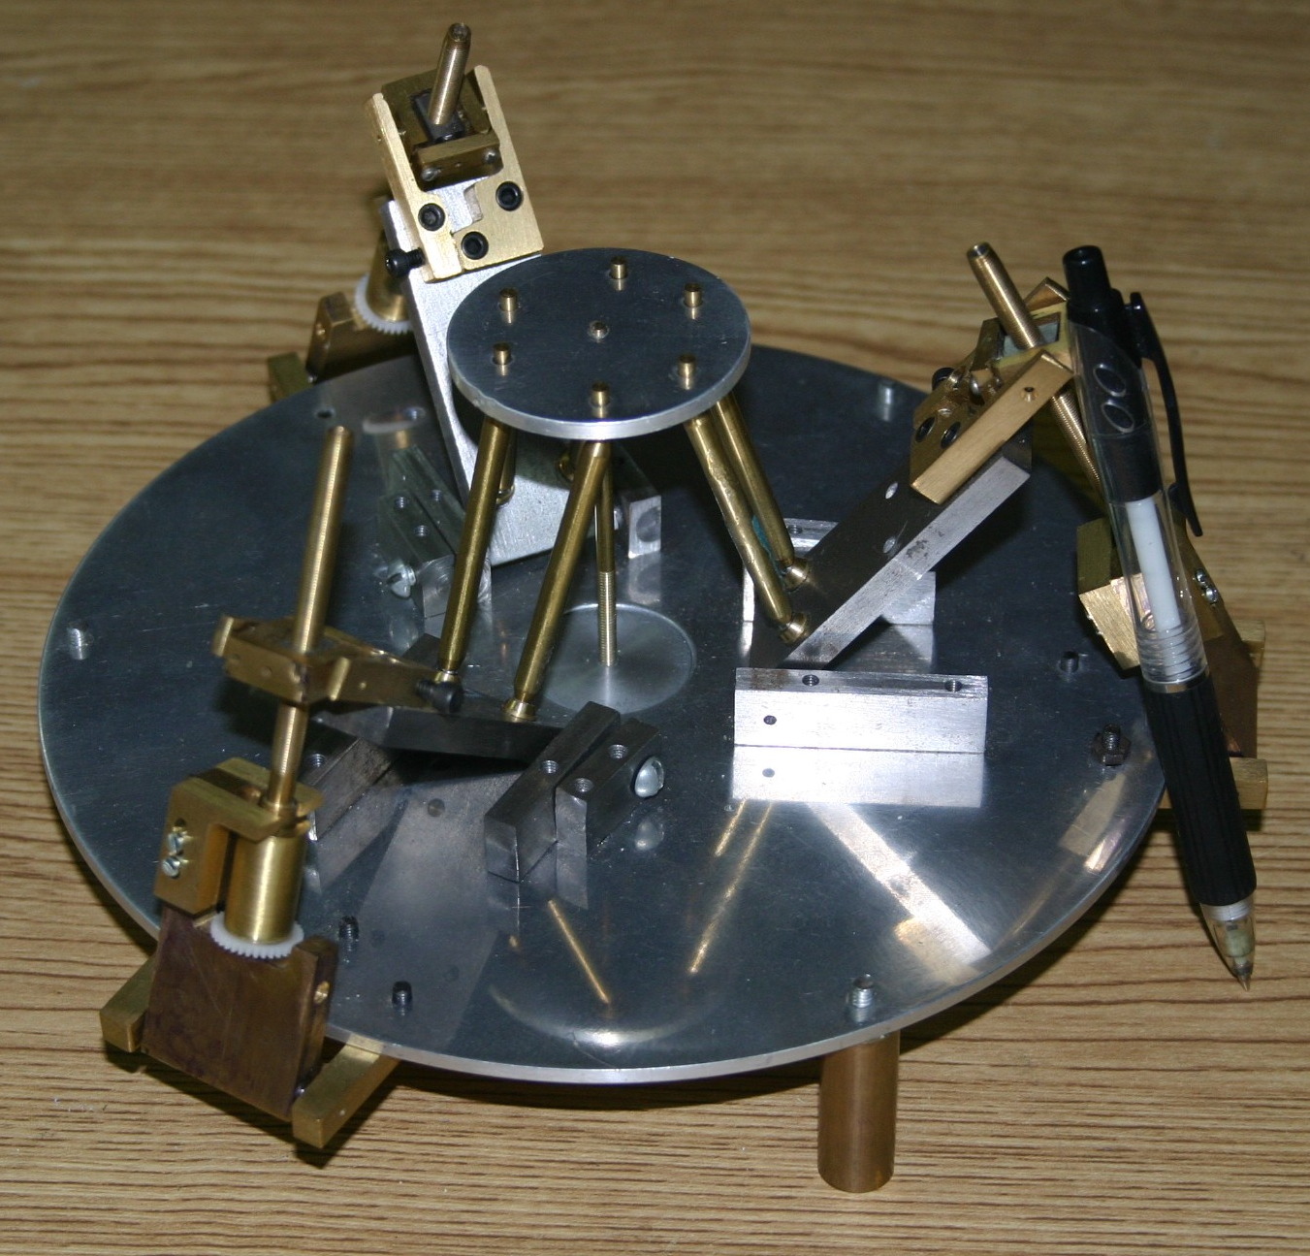

Figure 5. Prototype

3 Conclusions
We can conclude that the Micromechanics and Mechatronics Laboratory, has an approved capacity to contribute to the innovation and the technological development. The study of the design we propose here, is not only limited by micromechanical tasks, can also be used in other branches of applied science and the industry.

Acknowledgments
This work was supported by CCADET-UNAM, CONACyT – NSF project 39395-A, and PAPIIT UNAM projects IN112102, IN103903-2.

References:
[1] E.M. Kussul, D.A.Rachkovskij, T.N. Baidyk et al. Micromechanical engineering: a basis fot the low cost manufacturing of mechanical microdevices using microequipment. J. Micromech. Microeng. 1996. – 6. – P. 410-425.
[2] Ruiz Huerta Leopoldo. Diseño y construcción de un microcentro de bajo costo. Tesis de maestría, Facultad de Ingeniería, División de Estudios de Posgrado, 200, pp. 84.
[3] Stewart D. A platform with 6 degree of freedom. Proc. Of the Institucionof mechanical engineers. 1965, 180 (part 1, 15): 371-386.
[4] Merlet J.P. Les Robots paralleles. Ed. Hermes, 1997.
[5] Merlet J.P. Parallel manipulators: state of the art and perspectives. Adv. Robotics. 1994.8: 287-308.
[6]L. N. Simaan, M. Shoham. Geometric interpretation of the derivatives of parallel robots´ Jacobian matrix with application to stiffness control. Journal of mechanical design, ASME, march 2003, vol. 125, pp. 33-42.
[7] Waldron K.J. Raghavan M. Roth B. Kinematics of a hybrid series-parallel manipulation system. ASME J. Dyn. Measurement control 1989, 111(2):211-2
[8] Velasco Herrera Graciela, Gerardo Álvarez Sánchez, Diseño mecánico de un micromanipulador paralelo. SOMI XIX Congreso de Instrumentación 2004. Pachuca Hidalgo, editorial CD: MEMORIAS (sección: Mecánica) SOMI

