New Magnetic Force Expressions of the System: Filamentary Circular Coil–Massive Circular Solenoid with Rectangular Cross Section

SLOBODAN I. BABIC and CEVDET AKYEL
Département de Génie Électrique & de Génie Informatique
École Polytechnique de Montréal
Montréal, C.P. 6079, Succ. Centre Ville
H3C 3A7 QUÉBEC, CANADA

Abstract: - New and fast procedures for calculating the magnetic force between a thin circular filament coil and a massive circular solenoid with rectangular cross section in air are presented. These results are expressed in terms of the complete elliptical integrals of the first and second kind, Heumann's Lambda function and one term that has to be solved numerically. The Gaussian numerical integration is used. These new expressions are accurate and simple to apply for technical applications. Also, another comparative method based on an approximation of the massive solenoid by Maxwell coils is given. The paper discusses the computational cost and the accuracy. Results obtained by the two approaches are in excellent agreement.

Key-Words: - Magnetic force, mutual inductance, massive solenoid, filamentary circular coil

1 Introduction
Circular coils are widely used in various electromagnetic applications (RF radio frequencies, naval and spacecraft magnetics, microwave circuits, superconducting magnetic storage (SMES) problems, magnetic resonance, magnetically controllable devices and sensors, coil guns and tubular linear motors, telemetric systems applied in biomedical engineering, in transmission lines (TLM), modern VLSI design systems, in tubular linear brushless PM motors). The calculation of the magnetic force between two coils, carrying current, is subject closely related to the calculation of their mutual inductance. The mutual inductance as a fundamental electrical parameter can be computed by applying the Biot - Savart law directly or using other alternate methods ([1]-[11]). Today FEM and BEM methods are routinely used for magnetostatic problems, but these methods have accuracy problems near sharp surface discontinuities unless a high density of elements is used, [15]. Exact methods based on elliptic integral solutions for current loops, thin current cylinders, thin disks, massive coils have existed since at least the time of Maxwell but were laborious without computers. The purpose of this article is to present an elliptic integral-based solution for circular coils in air. It provides a fairly general accurate alternative to FEM and BEM. New expressions are derived and presented to compute the magnetic force of the system of a circular filament coil and a massive

solenoid. Coils have the same axe. The chosen configuration of conductors is relevant in particular to calculation of armature reaction in tubular linear brushless PM motors. These accurate expressions are obtained in terms of complete elliptical integrals of the first and second kind, Heumann's Lambda function and one term that has to be evaluated numerically because an analytical solution does not exist. In computing this term numerically, we use Gaussian quadrature because the kernel function is smooth and continuous on the interval of integration. Also, we give another approach based on the filament method, [6], [7] where some modifications lead to very simple procedures for calculating the mutual inductance between the thin circular coil and the massive solenoid using the well-known formula for Maxwell’s coils [9]-[11]. Computed magnetic force values obtained by the two proposed ways are in excellent agreement.

2 Problem Formulation
The calculation of the magnetic attraction between two coils, carrying current, is subject closely related to the calculation of their mutual inductance. Since their mutual energy is equal to the product of their mutual inductance by the currents in the coils, the component of the magnetic force (attraction or repulsion) in any direction is equal to the differential coefficient of the mutual inductance, taken with respect to that coordinate, and multiplied by the product of the currents. Evidently the force may be calculated by simple differentiation in any case where a general formula for the mutual inductance is available, expressed as function of coordinate along which the force is requested, [9]. The magnetic force of the presented system (See Fig 1) can be derived from the general expression for its mutual inductance, [3]. In [3] we gives the procedures to calculate the mutual induction of a system comprising a filamentary circular coil – a massive circular solenoid, where the filament coil is in the plane z_{Q} with the radius R and the massive circular solenoid with radii R₁ and R₂. Total number of turns of the massive circular solenoid is N₂. The higher of the massive solenoid is z₂ – z₁. If the current in the filamentary coil is I₁ and in the massive circular solenoid coil I₂ the magnetic force can be calculated by expression (see [9]),
$F=I_{1}I_{2}\frac{∂M}{∂z_{Q}} (1)$

Obviously that the magnetic force has only the axial component because the coils are coaxial.

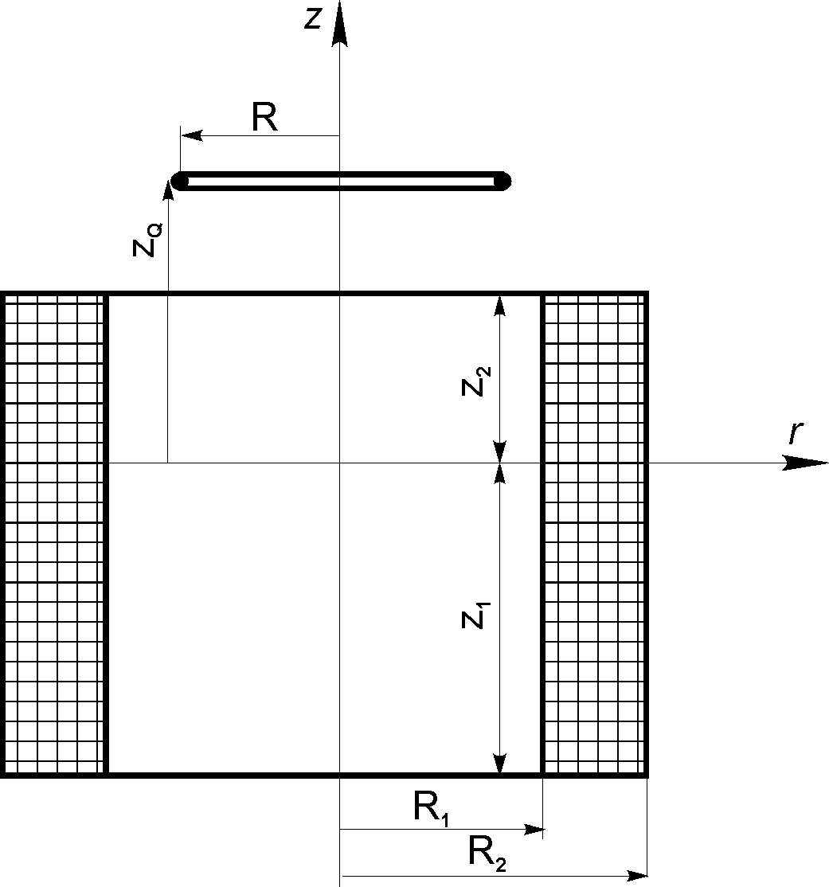

Fig 1. System: Filamentary circular coil-Massive
circular solenoid with rectangular cross section

3 Problem Solution
The mutual inductance of the system: filamentary circular coil-massive circular coil (Fig. 1) is given by [3],

$M=\frac{μ_{0}{\text{RN}}_{2}}{(R_{2}−R_{1})(z_{2}−z_{1})}\int_{z_{1}}^{z_{2}}{}\int_{R_{1}}^{R_{2}}{}\int_{0}^{π}{}\frac{\text{cos}θrdrdθ}{r_{Q}} (2)$
where

$$r_{Q}=\sqrt{R^{2}+r^{2}−2\text{Rr}\text{cos}θ+(z−z_{Q})^{2}}$$

Applying (1), we obtain the magnetic force for the proposed conductor arrangement in an analytical form,
$F=\frac{μ_{0}N_{2}I_{1}I_{2}}{(R_{2}−R_{1})(z_{2}−z_{1})}\sum_{n=1}^{4}{(−1)^{n}P_{n}} (3)$
where

$\begin{aligned}P_{n}=\frac{2ρ_{n}\sqrt{{Rρ}_{n}}}{3k_{n}}E(k_{n})−\frac{k_{n}^{3}t_{n}^{2}}{\text{24}{\text{Rk}}_{n}^{'2}\sqrt{{Rρ}_{n}}}\left\{ρ_{n}^{2}\right.+2R^{2}−3{Rρ}_{n}− \\ \frac{R(t_{n}^{2}−2R^{2})}{\sqrt{t_{n}^{2}+R^{2}}+R}−\frac{2ρ_{n}^{3}}{ρ_{n}+R}−\left.t_{n}^{2}\right\}E(k_{n})+\frac{k_{n}}{6}\sqrt{\frac{ρ_{n}}{R}}\left\{ρ_{n}^{2}\right.+4R^{2}− \\ 3{Rρ}_{n}−\frac{2R(t_{n}^{2}+R^{2})}{\sqrt{t_{n}^{2}+R^{2}}+R}−\frac{2ρ_{n}^{3}}{ρ_{n}+R}−2\left.t_{n}^{2}\right\}K(k_{n})+ \\ \frac{π}{4}\left|t_{n}\right|\sqrt{t_{n}^{2}+R^{2}}\left\{1\right.−Λ_{0}(θ_{n},k_{n})−\text{sgn}(\sqrt{t_{n}^{2}+R^{2}}−ρ_{n})×[1−Λ_{0}(ε_{n},k_{n})\left.]\right\}−\frac{ρ_{n}^{2}−3R^{2}}{\text{24}{RΔ}_{1}}k_{n}^{2}\left\{[E\right.(k_{n})−k_{n}^{'2}K(k_{n}){\text{sin}}^{2}ε_{n}]×\frac{k_{n}(R−ρ_{n})}{k_{n}^{'2}}−\left|t_{n}\right|\text{sgn}(R−ρ_{n})[K(k_{n})−E(k_{n})]\text{sin}ε_{n}\left.\text{cos}ε_{n}\right\}− \\ \frac{t_{n}^{2}−2R^{2}}{\text{12}Δ_{2}}\left\{\sqrt{m_{n}}\right.[E(k_{n})−k_{n}^{'2}K(k_{n}){\text{sin}}^{2}θ_{n}]+\frac{\left|t_{n}\right|\sqrt{t_{n}^{2}+R^{2}}}{2{Rρ}_{n}}×k_{n}^{2}[K(k_{n})−E(k_{n})]\text{sin}θ_{n}\left.\text{cos}θ_{n}\right\}+ \\ \frac{k_{n}(t_{n}^{2}−2R^{2})\text{sgn}(\sqrt{t_{n}^{2}+R^{2}}−ρ_{n})}{\text{24}{Rρ}_{n}Δ_{3}}×\left\{\sqrt{m_{n}}\right.\frac{\sqrt{α_{n}}}{\sqrt{R}}\frac{[E(k_{n})−k_{n}^{'2}K(k_{n}){\text{sin}}^{2}ξ_{n}]}{k_{n}^{'2}\left|\sqrt{t_{n}^{2}+R^{2}}−ρ_{n}\right|}×[R(ρ_{n}−R)^{2}+{\text{Rt}}_{n}^{2}−k_{n}^{2}t_{n}^{2}\sqrt{t_{n}^{2}+R^{2}}]+ \\ k_{n}\left|t_{n}\right|\sqrt{t_{n}^{2}+R^{2}}[K(k_{n})−E(k_{n})]\text{sin}ξ_{n}\left.\text{cos}ξ_{n}\right\}−R^{2}J_{0}(ρ_{n},t_{n})\end{aligned}$
ρ₁ = ρ₄ = R₁ ; ρ₂ = ρ₃ = R₂

t₁ = t₂ = z₂ - z_{Q} ; t₃ = t₄ = z₁ - z_{Q}

$$k_{n}^{2}=\frac{4{Rρ}_{n}}{(R+ρ_{n})^{2}+t_{n}^{2}}, k_{n}^{'2}=1−k_{n}^{2}$$

$$h_{n}=\frac{4{Rρ}_{n}}{(R+ρ_{n})^{2}}$$
$m_{n}=\frac{2R}{\sqrt{t_{n}^{2}+R^{2}}+R}, ε_{n}=a\text{sin}\sqrt{\frac{1−h_{n}}{1−k_{n}^{2}}}$$θ_{n}=a\text{sin}\frac{\left|t_{n}\right|}{\sqrt{t_{n}^{2}+R^{2}}+R}, ξ_{n}=a\text{sin}\sqrt{\frac{1−m_{n}}{1−k_{n}^{2}}}$
$$J_{0}(ρ_{n},t_{n})=\int_{0}^{π/2}{\text{asinh}\frac{ρ_{n}+t_{n}\text{cos}2x}{\sqrt{R^{2}+t_{n}^{2}{\text{sin}}^{2}2x}}dx}$$
$$\begin{aligned}Δ_{1}=\sqrt{1−k_{n}^{'2}{\text{sin}}^{2}ε_{n}}\text{ , }Δ_{2}=\sqrt{1−k_{n}^{'2}{\text{sin}}^{2}θ_{n}} \\ \\ Δ_{3}=\sqrt{1−k_{n}^{'2}{\text{sin}}^{2}ξ_{n}}\end{aligned}$$

E and K are complete elliptic integrals of the first and second kind and Λ₀ is the Heuman's Lambda function, [16],[17]. In these expressions are included the cases R < R₁ < R₂ ; R > R₂ > R₁ as singular cases z₁ = z_{Q} and z₂ = z_{Q} .
If z_{Q} = (z₂ + z₁)/2 the axial magnetic force is equal zero. Also, the magnetic force of the treated system can be calculated using the well-known filament method. The main idea of this approach is the representation of a massive solenoid by a set of thin circulars coils (Maxwell’s coils) as in Fig. 2 for which the mutual inductance is given by the next expression,

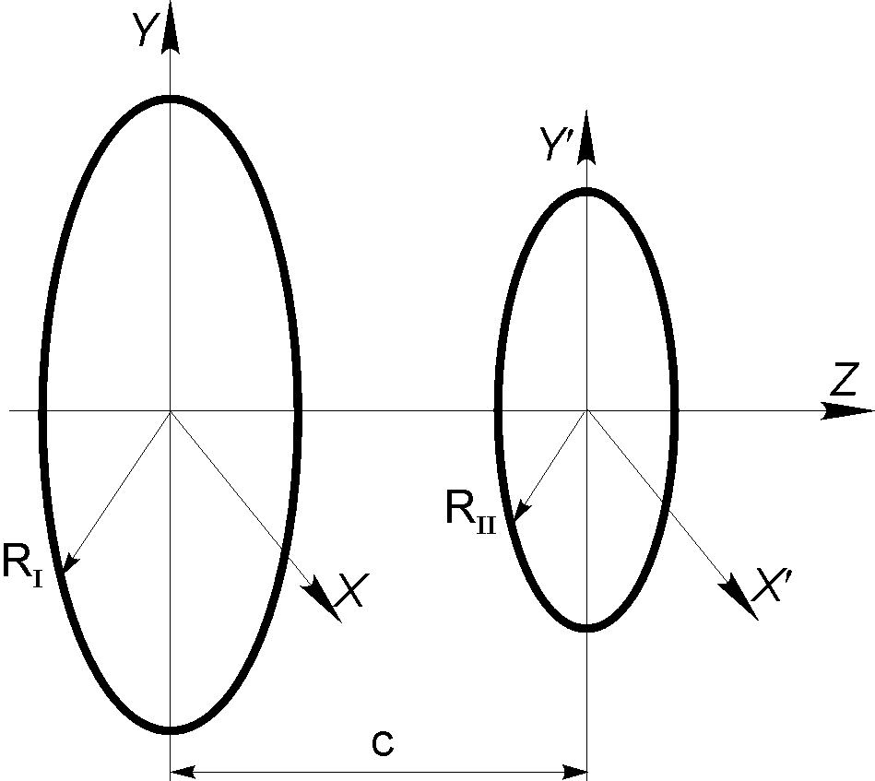

Fig 2. Maxwell’s coils

$M_{\text{Maxwell}}=\frac{2μ_{0}\sqrt{R_{I}R_{\text{II}}}}{k}[(1−\frac{k^{2}}{2})K(k)−E(k)] (4)$

where
$$k^{2}=\frac{4R_{I}R_{\text{II}}}{(R_{I}+R_{\text{II}})^{2}+c^{2}}$$

In this system (massive solenoid – circular coil) we subdivide the massive solenoid into (2P+1) by (2S +1) cells, [6], [7]. Each cell in this coil contains one filament, and the line current density in the coil is assumed to be uniform so that the filament currents are all equal (Fig. 3). The magnetic force for the previous system can be obtained by simplification of the expressions given in [7]. For the system under consideration the magnetic force is given by,
$F=\frac{1}{(2P+1)(2S+1)}\sum_{i=−P}^{P}{\sum_{j=−S}^{S}{F(i,j)}} (5)$
where,

$$\begin{aligned}F(i,j)=\frac{μ_{0}z(i)N_{2}I_{1}I_{2}k(i,j)}{4\sqrt{\text{RR}(j)}}[\frac{2−k^{2}(i,j)}{1−k^{2}(i,j)}E(k(i,j))− \\ 2K(k(i,j))]\end{aligned}$$
$R(j)=R_{I}+\frac{h_{p}}{2S+1}j$ , $z(i)=c−\frac{{}_{a}}{2P+1}i$

$$k^{2}(i,j)=\frac{4R(j)R_{\text{II}}}{(R(j)+R_{\text{II}})^{2}+z(i)^{2}}$$

N₂ is the total number of turns of the massive solenoid.

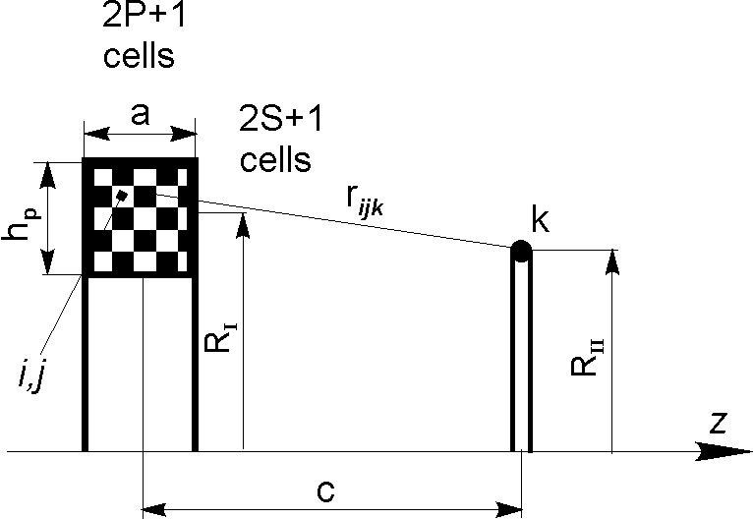

Fig 3. Configuration of mesh matrix, Circular coil-Massive solenoid

3.1 Example 1
To verify the validity of presented expressions, let us solve the following problem. The coil dimensions are as follows:

Test case: R=200(mm), R₁ =400(mm), R₂ = 600(mm), z₁ = - 100(mm), z₂ = 100 (mm), z_{Q} = 300(mm),
N ₂ = 1000, I₁ = 1(A), I₂ = 1(A).

The proposed approach yields magnetic force value,

F = 0.28163712 (mN)

The execution time was 0.066 seconds.
The mutual inductance has been obtained by the Gaussian numerical integration. All tests show that for more than 20 points there are not significant differences after ninetieth decimal place but it increases the computational cost. The number of Gauss points was 20 to correctly evaluate all integrals. To validate the elliptic-integral method, let us apply the filament method. In this case coil dimensions are as follows:

Filament method: R_{I} = 200 (mm), R_{II} = 500 (mm), a = 200 (mm), h_{p} = 200 (mm), c = 300(mm), N = 1000, I₁=1(A), I₂ =1(A).

Table 1 gives values of the magnetic force using the filament method expressions (4).

Table 1. Comparison of computational efficiency

The corresponding computational time and the absolute error of the calculation with respect to the exact value (3) are given. From Table I one can conclude that all results obtained using either expressions (3) or expressions (5) are in excellent agreement. But, to have approximately the same value of the magnetic force (as this one obtained by the proposed approach) using the filament method, one has to make more subdivisions, which increases the computational cost. However, this difference is not significant and all results obtained by these approaches are in excellent agreement. Either the presented method or the filament method represents very fast and simple procedures for calculating the magnetic force of the treated configurations that can reduce computational time. The comparative calculation was made in MATLAB programming on a personal computer with Pentium III 700 MHz processor.

3.2 Example 2
Let us calculate the magnetic force of the system: filament coil-disk coil, [8]. Coil dimensions, the distance between coils, the number of turns and corresponding currents are as follows:

R = 20(mm), R₁ = 40(mm), R₂ = 60(mm),
z_{Q} = 50(mm), N₂ = 100, I₁ = 1(A), I₂ = 1(A).

From [8] the magnetic force is,

F = 15.964475 (μN)

The execution time was 0.049 seconds.

Applying the proposed method (3) coil dimensions, number of turns and corresponding currents are as follows:

R = 20 (mm), R₁ = 40 (mm), R₂ = 60 (mm),
z₁ = 0.00001 (mm), z₂ = 0.00001 (mm),
z_{Q} = 50 (mm), N = 100, I₁ = 1 (A), I₂ = 1 (A).

The proposed approach yields magnetic force value,

F = 15.964475 (μN)

The execution time was 0.066 seconds.

Thus, we approve the validity of the proposed formula (3) that can be used for thin coils with infinitesimally thickness. All results are in excellent agreement.

4 Conclusion
New accurate magnetic-force expressions between a thin circular coil and a massive circular solenoid are derived and presented in this paper. This proposed approach has been verified by the filament method. Event though one might think that the proposed method is 'tedious' because of the elliptic integrals, Heuman’s lambda function and the one term that has to be solved numerically, we found procedures that considerably reduced the computational time and gave satisfactory accuracy. All programs were written in MATLAB. Thus, the magnetic force can be efficiently calculated with only a personal computer.

Acknowledgment
This work was supported by Natural Science and Engineering Research Council of Canada (NSERC)
under Grant RGPIN 4476-05 NSERC NIP 11963.

References:
[1] S. I. Babic, C.Akyel, "An Improvement in the Calculation of the Self - Inductance of Thin Disk Coils with Air-Core", WSEAS Transactions on Circuits and Systems, Issue 8, Volume 3, October 2004, ISSN 1109-2734, pp.1621-1626.
[2] S. Babic, S. Salon and C.Akyel, "The Mutual Inductance of Two Thin Coaxial Disk Coils in Air", IEEE Transactions on Magnetics, Vol. 40, No. 2, pp. 822-825, March 2004.
[3] S.Babic, C.Akyel and S. Salon:"New Procedures for Calculating the Mutual Inductance of System Thin Circular Coil Massive Circular Solenoid", IEEE Transactions on Magnetics, Vol. 38, No. 3, pp. 1131-1134, May 2003.
[4] C.Akyel, S.Babic and S. Kincic:"New and Fast Procedures for Calculating the Mutual Inductance of Coaxial Circular Coils (Disk Coil-Circular Coil)", IEEE Transactions on Magnetics, Vol. 38, No. 5, Part 1, pp. 2367-2369, September, 2002.
[5] S. Babic and C. Akyel, "An Improvement in Calculation of the Self-and Mutual Inductance of Thin-Wall Solenoids and Disk Coils", IEEE Transactions on Magnetics, Vol. 36, No.4, pp. 1970-1975, July 2000.
[6] Ki-Bong Kim, E. Levi, Z. Zabar and L. Birenbaum, "Mutual Inductance of Noncoaxial Circular Coils with Constant Current Density", IEEE Transactions On Magnetics, Vol. 33, No. 5, pp. 3916-3921, September 1997.
[7] Ki-Bong Kim, E. Levi, Z. Zabar and L.Birenbaum, "Restoring Force Between Two Noncoaxial Circular Coils ", IEEE Transactions On Magnetics, Vol. 22, No. 4, pp. 478-489, March 1996.
[8] C.Akyel, S. Babic and S. Salon, "New Expressions for Calculating the Magnetic Force of the System: Filament Coil-Disk Coil", INTERMAG 2003, 30 March – 03 April, 2003, Boston, USA.
[9] F. W. Grover, "Inductance Calculations", New York: Dover, 1964.
[10] H. B. Dwight, "Electrical Coils and Conductors", McGraw-Hill Book Company, INC. New York, 1945.
[11] Chester Snow, "Formulas for Computing Capacitance and Inductance", National Bureau of Standards Circular 544, Washington DC, December 1954.
[12] M. Catrysse, B.Hermans and R. Puers, "An Inductive Power System with Integrated Bi- Directional Data Transmission", Journal Sensor and Actuators A: Physical, ISSN: 0924-4247, Volume 115, Issue 2-3, 21, September 2004, pp. 221-229. (The 17 Th European Conference on Solid-State Transducers). Publisher: Elsevier Science Direct.
[13] S.F.Pichorim and P.J.Abatti, "Design of Coils for Millimeter and Sub-millimeter Sized Biotelemetry", IEEE Transactions on Biomedical Engineering. Vol.51, No.8, pp.1487-1499, August 2004.
[14] A. V. Kildishev, "Application of Spheroidal Functions in Magnetostatics", IEEE Transactions on Magnetics, Vol. 40, No. 2, pp. 846-849, March 2004.
[15] J.T.Conway,"Exact Solutions for the Magnetic Fields of Axisymmetric Solenoids and Current Distributions", IEEE Trans. On Magnetics, Vol. 37, No.4, pp. 2977-2988, July 2001.
[16] M. Abramowitz and I. A. Stegun, Handbook of Mathematical Functions, National Bureau of Standards Applied Mathematics, Washington DC, December 1972, Series 55, p. 595.
[17] I.S.Gradshteyn and I.M.Ryzhik, Table of Integrals, Series and Products, New York and London, Academic Press Inc., 1965.

