Dependability Evaluation of Dedicated Server Group Orphan Detection Method

M. Jahanshahi ª, M. Gholipour ª, M. Kordafshari ª, M. Dehghan ^{b}

ªDepartment of Electrical, Computer & IT, Islamic Azad University, Qazvin Branch, Qazvin, Iran
^{b}Department of ComputerEngineering, Amirkabir University of Technology, Tehran, Iran

Abstract

Orphan detection methods demonstrate different performance, memory consumption in different scenarios. Dedicated Server Group (DSG) method is one of the most proper one. In this paper, we overviewed DSG method and analyzed its advantages and disadvantages. Based on the analytical results, we improved the DSG method in both process overhead and communication/traffic overhead. The dependability of improved method is evaluated by Markov chain modeling using SHARPE package and the Availability, Reliability, and Mean-Time to Failure are calculated.

Keywords

Distributed systems, Orphan, Modified DSG, Reincarnation, Extermination, dedicated server group, load balancing, DSG.

1. Introduction

Generally speaking, a remote procedure call is implemented by first sending a massage to a server and then waiting for a reply from the server. In RPC systems, if a client requesting something from a server crashes immediately before getting the response, the initiated process in the server can not be associated to its parent waiting for the response. The mentioned process which has no parent is called “orphan”.
Orphan processes cause some problems such as wasting the processor cycle or locking the resources forever. In some cases, the client may resubmit the same request over and over which can lead to performing repeated actions in server [12]. Simple RPC systems only provide peer-to-peer communication involving the interaction of each client with only one server [4]. But nowadays a client will be served by several servers running on a set of independent nodes interconnected by a communication network. Each server can crash independently [3,6,7].
Different orphan detection methods consider different tradeoffs between performance, storage overhead, and simplicity of recovery. Some of them use message logging. Message logging methods cause some overheads: First, each message must be copied into the local memory of the process. This extra copy affects communication throughput and latency. Second, the volatile log must be flushed to stable storage to free up space. Third, message logging nearly doubles the communication bandwidth required to run the application for systems that implement stable storage via a highly available file system accessible through the network [17].
Pessimistic log-based protocols guarantee that orphan process is never created after a failure. Optimistic log-based rollback-recovery protocols reduce the failure-free performance overhead, but allow possible orphan processes to be created after failures. Message-passing systems may force some processes to roll back even when that processes have not failed, creating what is commonly called Rollback propagation. The dependency of processes complicates rollback recovery. In some situations, rollback propagation may extend back to the initial state of the computation and all the work performed before the failure loss. This situation is known as the domino effect. In large systems the management of message logging and rollback recovery has overhead. Some approaches use checkpoint to speed up. Checkpoints and event logs consume storage resources. As the application progresses, a subset of the stored information may become useless for recovery. Deleting of such useless recovery information is called Garbage collection [17]. Garbage collection is an important pragmatic issue in rollback-recovery protocols, because running a special algorithm to discard useless information incurs overhead.
All of the orphan detection methods suffer from broadcast overhead or logging burden on the disk and reducing these overhead improve the performance of the system.

2. DSG Method
Description of Dedicated Server Group method includes two parts. First part is related to updating the group servers from situation of each other in order to find the idlest group. Second part is related to request of the client and related response.
Part 1: Dedicated Server Group orphan detection method utilities server group concepts; in this method there is a token (As figure 1) containing three fields: UA, SG#, time_stamp. UA means the utilization amount of specific server group. Also SG# is the related server group [1].
In this method the mentioned token turns around the server groups on a ring topology. In each step of rotation if a server group realizes that its own utilization amount is less than the UA that written on the token then the mentioned server group overwrites its UA and SG# on the token.

SG # | Time_stamp | UA
Figure 1: Structure of token

For speed up in updating the server groups information about situation of each others, when a server group overwrites on the token it generates two copies of the token and sends them in the opposite direction on the ring (figure 2).
Token
Token

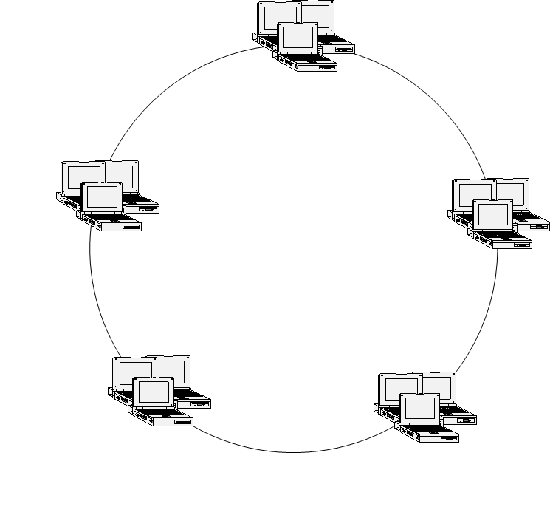
Figure 2: The server group overwrites its own UA and SG# on the token and generates two same tokens that turn around the ring in the opposite direction.

When two tokens reach to a server group simultaneously two cases can be occurred: In first case, if both of two tokens have identical Time stamp then the one that has a less UA be taken and another token is destroyed. In second case: if both of two tokens have different time stamp then the one that has higher time stamp be taken and another token is destroyed. During the said rotation, each server group takes a copy from the token, and overwrites it on the older version.
Part 2: Once new client restarts, it sends a request to the nearest server group. The server group considering its copied token redirects the request of the clients to the efficient server group that has lowest utilization amount. After it, all of the mentioned client’s requests are sent to this server group (Dedicated).
After this situation if the dedicated Server Group realizes that all of its servers are busy, considering its copied token, redirects the input request to the another server group that its SG# has been written in the token (Figure 3).

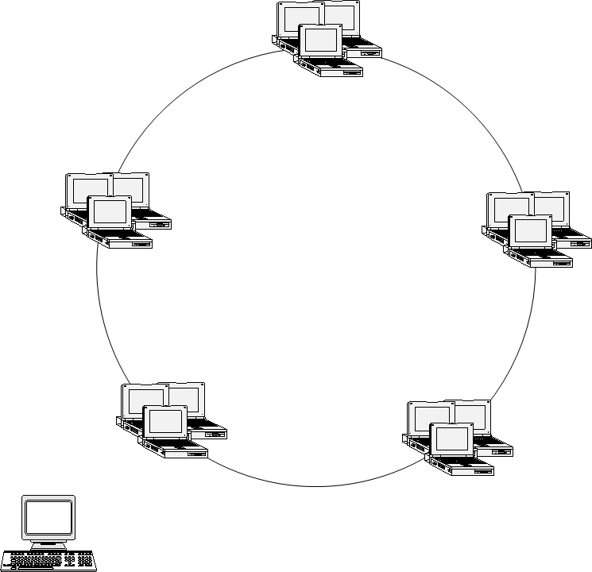
1(Request)
2 (Redirect)

3 (Dedicate)

Figure 3: Client sends the RPC request to Dedicated Server Group. Dedicated Server Group considering its copied token redirects RPC request to the perfect server.
After this situation, all of requests of that client are sent to both Dedicated Server Group and second server group (back up). After that all requests to the second server group were responded, the dedicated server group may select a different server group for the next time. Therefore traffic will be distributed in the network. In this method epoch massage is sent at most to (2xN; N is number of servers in each group). The advantage of this method is that it neither logs like Extermination method that causes high cost of logging and memory consumption, nor broadcasts to entire of networks like Reincarnation method that causes high traffic. By using this method, the requests of the clients can be redirected to other idled servers adaptively and this is another advantage of this method. Figure 4 shows that our developed method considering the number of messages that must be exchanged between nodes in an environment with N servers in each group is better and more logical and practical than reincarnation method. N refers to any number. In this chart N is fifty.
Figure 4: Comparison between Dedicated Server Group and Reincarnation methods

DSG method neither logs like Extermination method that causes high cost of logging and memory consumption therefore its speed is higher than previous ones, nor broadcast to entire of networks like Reincarnation method that causes high traffic [1, 2].
Another advantage of DSG method is that requests of clients can be redirect to other idled servers adaptively via load balancing. In contrast we list the advantages of DSG method as follow:
- Not taking any log comparing Extermination method
- Not broadcasting epoch message to the whole of the network comparing Reincarnation method
- Saving the resources
- Performing load balancing
- Being a perfect distributed method
- No need to running the garbage collection algorithm comparing message logging protocols
- No exponential roll back in spite of message logging protocols

In DSG method token turns around a ring continuously. Supposing there isn’t any group that its UA be lower than the UA written on the token. In this situation token turn around the ring vain and generates both of communication / traffic and processing overhead [2].
Moreover the groups take repeated copies from the token due to useless rotation of the token. In this section we point to modified DSG that has been presented by authors of this paper previously to overcome this problem as follows:
Initially first group generates two tokens then writes its SG# and UA on the tokens and sends them in the ring in the opposite direction in order to speed up. In this rotation each group realizes that its UA is less than the UA of the token, than it generates two tokens and writes its SG# and UA on the tokens. After that sends them on the ring in the opposite direction. When two tokens reach to a server group simultaneously two cases can be occurred: In the first case, if two tokens have identical Time stamp then each one that has a less UA is taken and another token is destroyed. In the second case: if two tokens have different time stamp each one that has higher time stamp is taken and another token is destroyed. During the said transfer, each server group takes a copy from token for itself and overwrites it on the older version.
When ever the token accomplishes a whole rotation without changing its information, the token stops and doesn’t turn around the ring. After that when ever a group realizes that its UA is lower than the token’s UA, it generates two tokens then writes its SG# and UA on the tokens and sends them on ring in the opposite direction. In this situation again if the token accomplishes a whole rotation without changing its information, stops and doesn’t turn around the ring. So this method has two advantages moreover DSG method:
1. Reducing communication / traffic overhead:
When the information of the token doesn't change, it isn’t necessary to rotate on the ring continuously and increase traffic and communication overhead.
2. Reducing process overhead:
When the information of the token doesn't change, it doesn’t need to take useless and repeated copies of the token.
Therefore modified DSG method reduces both communication/traffic overhead and also process overhead.

3. Dependability Evaluation of DSG

Figure 5 depicts markov chain model of DSG algorithm, Where B is probability that each server group be busy.

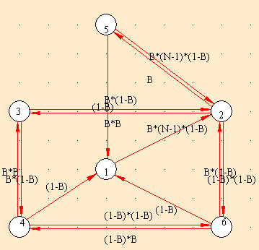
Figure 5: Markov chain model of DSG system

Table 1 describe mean of each node. In this notation number ‘1’ means that a group server is assigned and it is busy. Also number ‘0’ means that a group server is assigned and it isn’t busy. Symbol ‘*’ means that there isn’t any backup server group (second server group).
Now we compute state probability of all nodes as follow:
$$\begin{aligned}p_{1}(t+Δt)=p_{6}(t)B'+p_{5}(t)B'+p_{4}(t)B'=B'(p_{4}(t)+p_{5}(t)+p_{6}(t)) \\ p_{2}(t+Δt)=p_{5}(t)B(n−1)B'+p_{1}(t)B(n−1)B'+p_{6}(t)\text{BB}'+p_{3}(t)\text{BB}'= \\ \text{BB}'((n−1)p_{5}(t)+(n−1)p_{1}(t)+p_{6}(t)+p_{3}(t)) \\ p_{3}(t+Δt)=p_{2}(t)\text{BB}+p_{4}(t)\text{BB}=\text{BB}(p_{2}(t)+p_{4}(t)) \\ p_{4}(t+Δt)=p_{6}(t)B'B+p_{3}(t)B'B=B'B(p_{6}(t)+p_{3}(t)) \\ p_{5}(t+Δt)=p_{2}(t)B \\ p_{6}(t+Δt)=p_{4}(t)B'B'+p_{2}(t)B'B'=B'B'(p_{4}(t)+p_{2}(t))\end{aligned}$$
Initiate probabilities of all states are as follow:

$p_{1}(0)$=1,  $p_{2}(0)$=0 | $p_{3}(0)$=0,  $p_{4}(0)$=0, | $p_{5}(0)$=0,  $p_{6}(0)$=0

Availability of this system is sum of all state probabilities except state probability of node ‘3’. Therefore Availability equals to:
$p_{1}(t)+p_{2}(t)+p_{4}(t)+p_{5}(t)+p_{6}(t)$ (1)
Using “SHARPE” package state probability of all nodes is retrieved as follow:
$$p_{1}(t)=3\text{.}\text{36096385}∗{\text{10}}^{−1}$$
$$p_{2}(t)=3\text{.}\text{41603737}∗{\text{10}}^{−1}$$
$$p_{3}(t)=1\text{.}\text{98131323}∗{\text{10}}^{−2}$$
$$p_{4}(t)=1\text{.}\text{50326382}∗{\text{10}}^{−2}$$
$$p_{5}(t)=1\text{.}\text{99768267}∗{\text{10}}^{−2}$$
$$p_{6}(t)=2\text{.}\text{67477281}∗{\text{10}}^{−1}$$
Note that we analyze a system with 1000 clients and 10*10 servers. That means there are 10 servers in each 10 groups. N is number of server groups (in this implementation N equals to 10). B equals to 0.1 approximately (BNumber of servers / Number of clients).
Steady state availability of this system equals to $9\text{.}\text{80186868*}{\text{10}}^{−1}$. Also steady state unavailability of DSG system equals to$1\text{.}\text{98131323*}{\text{10}}^{−2}$.
Now we compute reliability of DSG system.
- Reliability of each server group:
Reliability of a group that its failure rate follows from exponential function equals to $e^{−λt}$. Also Mean-Time to Failure of such system equals to$1/λ$.
- Reliability of whole system:
Reliability of this system is ($1−R'^{n}$) because this system is unreliable while all of server groups don’t work simultaneously, where $R'^{n}$is unreliability of each server group. Mean-time to failure of DSG system is computed as follow:
$$\begin{aligned}\text{MTTF}=\int_{0}^{∞}{{\text{1- R'}}^{n}(t)\text{dt}} \\ \int_{0}^{∞}{[1−(1−R(t))^{n}]\text{dt}≈1/λ\sum_{i=1}^{n}{1/i}}=(1/λ)(\text{ln}n)\end{aligned}$$
State | Equivalence of Each State | Description
1 | 0* | Main server group is dedicated and isn’t busy. Also backup server group hasn’t been assigned yet.
2 | 10 | Main server group is dedicated and is busy. Also backup server group has been assigned and isn’t busy.
3 | 11 | Both of Main and backup server group have been assigned and are busy.
4 | 01 | Both of Main server group and backup server group have been assigned. But just backup server group is busy.
5 | 1* | Main server group is busy. Also there isn’t any second server group
6 | 00 | Both of Main and backup server group have been assigned and aren’t busy.
Table 1: Description of each state
(2)

Note that system life time is ln(n) times greater than one server group life time while it is expected to be n times greater than reliability of one server group. Causes of this turn to, all of these groups operate in parallel.

4. Conclusion
In this paper initially we introduced DSG method and then we mentioned its advantage comparing with other methods. Then we mentioned when there isn’t any group that it’s UA be less than the token’s UA, this method perform useless processes and take repeated copies. In the other hand there is traffic and communication overhead due to vain rotation of the token in this situation. We point to modified DSG method to reduce process and communication/traffic overhead. Finally we evaluated some dependability measurements such as reliability, mean time to failure and availability of DSG system and concluded that system life time is ln(n) times greater than one server group life time while it is expected to be n times greater than reliability of one group server. Causes of this turn to, all of these groups operate in parallel.

5. Future Research
We are interested to simulate this framework with Opnet (Network Simulator) Package in order to performance evaluation of this framework.

References:

[1] M. Jahanshahi, K. Mostafavi, M. S. Kordafshari, M. Gholipour, A. T. Haghighat, "Two new approaches for orphan detection", Proc. The IEEE 19th International Conference on Advanced Information Networking and Applications,Taiwan,2005
[2] M. Jahanshahi, M. S. Kordafshari, M. Gholipour, M. Dehghan, ”Improvement of Dedicated Server Group Orphan Detection Method”, IEEE International Conference on Service Operations and Logistics, and Informatics, Beijing, China, 2005
[3] Maurice P. Herlihy, Martin S. Mckendry, “Timestamp-Based Orphan Elimination”, IEEE transaction on software Engineering, VOL. 15, NO. 7, 1990.
[4] L. P. Barreto, I. Jansch-Porto, “Open and Reliable Group Communication”, Proc. Sixth Euromicro Workshop on Parallel and Distributed Processing, Madrid, Spain, 1998, pp. 389-394.
[5] V. Issarny, G. Muller, and I. Puaut, “Efficient Treatment of Failures in RPC Systems”, Proc. IEEE Transaction on Computer, 1994, 170-78.
[6]A. S. Tanenbaum, Distributed Operating System, Prentice-Hall, 2003.
[7]L. Alvisi, K. Marzullo, “Message Logging: Pessimistic, Optimistic”, Causal, and Optimal, Proc. IEEE Transactions on Software Engineering, VOL. 24, NO. 2, 1998.
[8] Om P. Damani, Vijay K. garg, “How to Recover Efficiently and Asynchronously When Optimism Fails”, Proc. IEEE Transactions on Software Engineering, VOL. 1063-6927, 1996, 108-114.
[9] Alvisi, L. and Marzullo, K., “Non-blocking and orphan-free message logging protocols”, Proc. 23rd IEEE International Symposium on Fault-Tolerant Computing, Toulouse, France, 1993, 145-154.
[10] R. Baldoni, J. Brzezinski, J.M. Helary, A. Mostefaoui and M. Raynal, “Characterization of consistent global checkpoints in large-scale distributed systems”, Proc. 5th
IEEE Workshop on Future Trends of Distributed Computing Systems, Chenju, Korea, 1995, 314 -323.
[11] F. Panzieri, S. K. Shrivastava, “A Remote Procedure Call Mechanism Supporting Orphan Detection and Killing”, Proc. IEEE Transaction On Software Engineering, VOL.14, NO.1, 1988.
[12] Shiva, S. Virmani, R., “Implementation of reliable and efficient Remote Procedure Calls”, Proc. IEEE, 1993 , Charlotte, NC, USA, On page(s): 5p.
[13] K. Ranvindran, S. Chanson, “Failure Transparency in Remote Procedure Calls”, Proc. IEEE Transaction on Computer, VOL. 38, NO. 8, 1989.
[14] A. K.Ezzat, “Orphan Elimination in Distributed Object-Oriented Systems, Proc. Second IEEE Workshop on Future Trends Distributed Computing Systems, Cairo,

Egypt, 1990, pp. 403-412.
[15] B. Yao, W. Fuchs, ”Message Logging Optimization for Wireless Networks”, Proc. 20th IEEE Symposium on Reliable Distributed Systems, 2001, pp. 0182.
[16] S. Pleisch, A. Kupsys and A. Schiper, “Preventing Orphan Requests in the Context of Replicated Invocation”, Proc. IEEE 22nd International Symposium on Reliable Distributed System,2003.
[17] E. N. (Mootaz) Elnozahy, L. Alvisi, Yi-Min Wang and D. B. Johnson, “A survey of rollback-recovery protocols in message-passing systems”, Proc. ACM Computing Surveys (CSUR), Vol. 34, Issue 3, 2002, Pages: 375 – 408.
[18] X. Fu, D. Wang, W. Zheng and M. Sheng, "GPR-Tree: A Global Parallel Index Structure for Multiattribute Declustering on Cluster of workstations", Proc. IEEE Transaction on Computer , 1997, 788-793
[19] Kwang-Sik Chung , Ki-Bom Kim , Chong-Sun hwang ,jin gon Shon and Heon-Chang yu, "Hybrid checkpointing protocol based on selective-sender-based message logging", Proc. International Conference on Parallel and Distributed Systems, 1997, pp. 788

