Propulsion and Levitation H∞ Optimal Control of Underwater Linear Motor Vehicle ME02

KINJIRO YOSHIDA ¹ M. El-Nemr ¹ Fayez F. M. El-Sousy ²
¹ Kyushu University, Graduate School of Information Science and Electrical Engineering
6-10-1 Hakozaki, Higashi-Ku Fukuoka 812-8581, Fukuoka, Japan
Japan
² Electronics Research Institute (ERI), Department of Power Electronics & Energy Conversion
Al-Tahrir Street, Dokki, Cairo, Egypt
Egypt

Abstract: - The linear motors drives with magnetic levitation (Maglev) technology are the most recommended candidate of the near future ground transportation. The Marine Express is a unique linear motor train able to run both on land and underwater along the same guideway. Due to large uncertainties and nonlinearities exist in the operation of the permanent magnet linear synchronous PM-LSM with combined propulsion and levitation; the control performance may be seriously influenced. As in practical application, strong robustness is always an important property that a good controller should achieve. To ensure the desired robustness, we propose H∞ controller as a new robust motion controller. The controller is combined with model following controllers MFC. The combinations of both controllers would insure the robustness and overcome the uncertainties of the system. Systematic methodology for controllers design is provided. Moreover, a simulated study is carried to testify the performance of the system under the new controllers. The results verify that the proposed controllers provide robust dynamic performance for PM-LSM Maglev drive system.

Key-Words: Marine Express, PM-LSM Maglev, H∞ control, Model Following Control (MFC).

1 Introduction
The Amphibious Maglev or Marine Express (ME) is a unique linear motor train able to run both on land and underwater along the same guideway. Typical system would network points on land with offshore airports, basis or cities across the sea. The Marine Express system infrastructure is remarkably cheap as it does not necessitate tunnels except at the transition between water and land. Especially when running underwater, the ME is subjected to wide variation in the airagap length, hydrodynamics resistance and virtual mass. From the controller point of view, a robust controller would be required to overcome the uncertainty existing. Therefore, hybrid H∞-model-following controllers (H∞-MFC) are proposed here for both propulsion and levitation motions. The robust H∞-MFC controllers combine the merits of the H∞ control and the model-following control (MFC). To demonstrate the effectiveness of the proposed controller, a simulated study is carried out for the second Marine Express underwater experimental vehicle (ME02).
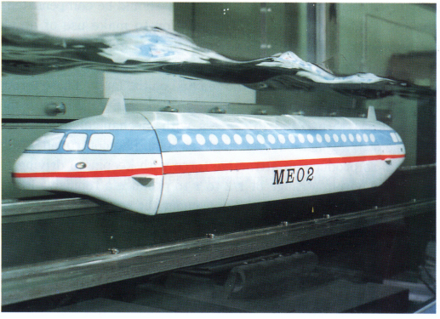
Fig. 1 Photography of ME02
The ME02 is a 1/25th scale experimental model vehicle existing in our laboratory, which has 11 kg weight, 105cm long and 17cm diameter. Fig. 1, shows photography of ME02 vehicle running underwater. The ME02 is levitated and propelled by the long-stator type linear synchronous motor with permanent magnets PM-LSM, which has the integrated function of linear synchronous motor propulsion and levitation.
Due to ME amphibious nature, its maglev system would implement both attractive and repulsive operation modes to overcome the buoyancy forces under sea surface and gravity forces on land respectively. The ME02 can be used as experimental simulator for both modes of operation [1-5]. In the current work, the effectiveness of the proposed controllers has been investigated for both modes.
Because, the motion of the ME02 used to follow a certain demand pattern using PID controller, a systematic mathematical procedure is derived to find the H∞ controllers transfer functions and the parameters of model-following controllers according to ME02 specifications. After that, the resulting closed loop transfer function of the ME02 and the PID controllers is used as the demand model. According to the model-following error between the outputs of the demand model and the PM-LSM Maglev system, the MFC generates an adaptive control signal which is added to the H∞ controller output to attain robust model-following characteristics under different operating conditions. The dynamic performance of the PM-LSM drive system and the effectiveness of the proposed H∞-MFC controllers will be clearly demonstrated by a computer simulation.

2 Marine Express Drive System
Figure 1 shows general topology of the drive system. Based on demand position x₂₀, z₂₀; demand vehicle speed v_{x20}, v_{z20}; actual vehicle position x₂, z₂ and actual vehicle speed v_{x2}, v_{z2}; the command force F_{x}*, F_{z}* is determined using PID controller. According to the decoupled control law, the command armature current I₁* and command load angle x₀* are obtained [6-10]. Such values are used to determine the command three phase instantaneous current i*, which in turn controls three phase inverter. Hence, instantaneous three phase current i is applied to the armature windings. The traveling wave generated by the armature winding current enforces the vehicle to move to its new position. The over all transfer function between command forces F_{x}* and F_{z}* to produced forces F_{x} and F_{z} is defined as G_{ds}(s). It is given by:
$\begin{aligned}\left[F_{x} | \right] \\ \end{aligned}$ (1)
In an ideal system with no errors G_{ds}(s) from becomes identity. As explained earlier, such system will be the demand model for the proposed new combined H∞ and MFC controllers. For the sake of completeness, in the next section the system dynamics would be briefly introduced. After that, the design and simulation details of the new controller will be introduced.

3 State Space Representation of ME Dynamics
In order to control the ME, which runs both under the water in attractive-mode and on land in repulsive-mode, the H∞-control is used on a basis of equations of propulsion and levitation motions. The thrust and lift forces have to be controlled quickly without coupling for the vehicle to levitate and run stably under the water and on land. Therefore, the decoupled-control strategy discussed above for motions of levitation and propulsion is adopted into the H∞-control system.
By using the proposed command model, the thrust and lift forces are supplied which are required not only to compensate the weight, buoyancy and running resistance of the vehicle but also to accelerate and decelerate the vehicle. The equations of propulsion and levitation motions of the ME are described by

(2)
(3)

Vehicle
Guideway

Inverter

Three
Phase
Trans.

Decoupled Control Law

H∞
Controllers

Fig. 2 Topology of ME02 drive system with decoupled control

Control Object
Decoupled Control System
-
-
H∞
Controllers
Demand
Model
Model-Following
Controller
G_{ds} (s)
B
A

Fig. 2 Control system diagram using H∞ control

where M is the mass of the vehicle, M_{x} the equivalent mass in the x-direction and M_{z} the equivalent mass in the z-direction, F_{x} the thrust force, F_{z} the lift force, F_{L} the buoyancy of vehicle due to water, g the acceleration of gravity. K_{dx}, K_{dz} are the coefficients of running resistance in the x- and z-directions, , , , the speeds and accelerations of vehicle in the x- and z-directions, respectively. Equations (1) and (2) are expressed by an equation of states as follows:

(4)
where
(5)
and
(6)

According to the optimal H∞ optimal control theory and the minimum error control method shown in Fig. 3, demand forces F_{x}* and F_{z}* can be deduced as follows:

$F_{x}^{}=(x_{\text{20}}−x_{2})\text{.}K_{∞}^{x}+F_{x0}+{δF}_{x}$ (7)
with
(8)
and
$F_{z}^{}=(z_{\text{20}}−z_{2})\text{.}K_{∞}^{z}+F_{z0}+{δF}_{z}$ (9)
with
(10)

The position control in x- and y-directions are finally stated as a tracking problems and must be achieved by the H∞-controllers in x- and z-directions.
$\underset{t→∞}{\text{lim}}\left|x_{\text{20}}(t)−x_{2}(t)\right|=ε_{1}$ (11)
$\underset{t→∞}{\text{lim}}\left|z_{\text{20}}(t)−z_{2}(t)\right|=ε_{2}$ (12)
where x₂₀, x₂, denote the command and measured positions, v_{x20} , v_{x2} the command and the measured speeds of propulsion motion, δ₀, δ the command and the measured air gap-lengths, z₂₀, z₂ the command and measured positions, v_{z20}, v_{z2} the command and the measured speeds of levitation motion respectively. F_{HD}, F_{VD} are the running resistances for propulsion and levitation motions, respectively. ε₁ and ε₂ are very small number.

3 PM LSM Uncertainty Representation
When mathematical models are used to describe the physical PM LSM Maglev system, satisfying assumptions are usually necessary for several reasons and hence one can expect difference between models and reality which are called uncertainties. The H∞ optimization methodology used requires linear time-invariant models to be applied, which is not the case of the system given by (4). To overcome this problem, we employ an uncertainty representation strategy which conveniently describe our Maglev vehicle by a linear fractional transformation (LFT) where the uncertain vehicle parameters appear explicitly parameterized in a feedback-like connection separately from the linear time-invariant vehicle model.
Since the system works in a previously determined operation range, its varying elements can be parameterized with nominal value and a range of possible variations. Thus, we can write

$\frac{K_{\text{dx}}}{M_{x}}=\left(\overline{\frac{K_{\text{dx}}}{M_{x}}}\right)\text{.}(1+δ_{1})$ and $\frac{K_{\text{dz}}}{M_{z}}=\left(\overline{\frac{K_{\text{dz}}}{M_{z}}}\right)\text{.}(1+δ_{2})$ (13)
with ${\overline{a}}_{\text{22}}=\left(\overline{{K_{\text{dx}}}/{M_{x}}}\right)$, ${\overline{a}}_{\text{44}}=\left(\overline{{K_{\text{dz}}}/{M_{z}}}\right)$, $δ_{1},δ_{2}∈[−1,1]$ and the superscript (-) representing nominal values. δ₁ and δ₂ represent the possible variations in the parameters. The state matrix become,
$A=A_{∘}+\sum_{i=1}^{2}{δ_{i}A_{i}}$ (14)
where $A_{∘}=\begin{aligned}\left[0 1 0 0 | \right]\left[0 {\overline{a}}_{\text{22}} 0 0 | \right]\left[0 0 0 1 | \right] \\ \end{aligned}$,
$A_{1}=\begin{aligned}\left[0 0 0 0 | \right]\left[0 δ_{1}{\overline{a}}_{\text{22}} 0 0 | \right]\left[0 0 0 0 | \right] \\ \end{aligned}$, $A_{1}=\begin{aligned}\left[0 0 0 0 | \right]\left[0 \text{ 0 0 0} | \right]\left[0 0 0 0 | \right] \\ \end{aligned}$

We can factorize the matrix A_{i} as
$E_{1}=\begin{aligned}\left[\text{0 } | \right]\left[{\overline{a}}_{\text{22}}δ_{1} | \right]\left[0 | \right] \\ \end{aligned}$, $E_{2}=\begin{aligned}\left[0 | \right]\left[0 | \right]\left[\text{0 } | \right] \\ \end{aligned}$, $G_{1}=\begin{aligned}\left[\text{0 } | \right]\left[1 | \right]\left[0 | \right] \\ \end{aligned}$, $G_{1}=\begin{aligned}\left[\text{0 } | \right]\left[0 | \right]\left[0 | \right] \\ \end{aligned}$

The PM LSM Maglev vehicle given by (4) is augmented by defining extra inputs w₁, w₂ and outputs z₁, z₂ as:
$\begin{aligned}\left[\overset{˙}{x} | \right]\left[z_{1} | \right]\left[z_{2} | \right] \\ \end{aligned}$ (15)
where $E_{i}∈ℜ^{{\text{nxr}}_{i}}$, $G_{i}∈ℜ^{r_{i}\text{xn}}$, n is the number of states and r_{i}=rank(A_{i}), for i=1, 2.

Fig. 3 PM LSM Maglev vehicle as LFT

The uncertain system given by (4) is represented by an upper LFT with respect to ∆ as shown in Fig. 3. In this representation, the perturbation output z=[z₁ z₂] and input w=[w₁ w₂] are related by w=∆ z. Where ∆ is change in the transfer function of the system model.

4 H∞ Optimal Control Design
The standard set up of the H∞ control problem consists of finding a static or dynamic feedback controller such that the H∞-norm of the closed loop transfer function is less than given positive number under constraint that the closed loop system is inherently stable. To apply this method, we must formaulate the PM LSM Magelv vehicle tracking problem into an equivalent H∞ control problem in which robust performance requirements are expressed in terms of H∞-norm constraints on the tracking error dynamics.
The H∞ control design as a frequency-domain optimal controller can easily combine several specifications such as disturbance attenuation, asymptotic tracking to achieve bandwidth limitations and robust stability. The design strategy is to directly shape the magnitude of the closed-loop transfer functions (sensitivity, S and complementary sensitivity, T, functions). Such a design strategy can be formulated as an H∞ optimal control problem. The solution of this problem is obtained by automating the actual controller design and selecting reasonable bounds, weights, on the desired closed-loop transfer functions [11-12].

  - Mixed Sensitivity (S/T) H∞ Control Optimization Formulation and Solustion
Mixed sensitivity is the name given to transfer function-shaping problems in which the sensitivity function S is shaped along one or more other closed-loop transfer functions and the complementary sensitivity function T. Practical control problems require weighting the inputs and outputs. Transfer function weights are used to shape the various measures of performance in the frequency domain. Tracking and disturbance rejection requires that the sensitivity transfer function be small in the low frequency range. The specification ${\left\|W_{S}S\right\|}_{∞}<1$ of the sensitivity function puts a lower bound on bandwidth, but not an upper one, and it does not allows us to specify the roll-off of G(s)K(s) above the bandwidth. To do this we use the specification ${\left\|W_{T}T\right\|}_{∞}<1$ of the complementary sensitivity function. We can specify an upper bound, $\left|W_{T}^{−1}\right|$, on the magnitude of T to specify the roll-off of G(s)K(s) sufficiently fast at high frequencies. Solving the so-called mixed sensitivity approach resulting in the following overall specifications can satisfy those requirements.
The S/T mixed sensitivity optimization problem can be put into the standard control configuration as shown in Fig. 4 to find a stabilizing controller, which leads to the smallest norm

$\underset{K}{\text{inf}}$ (16)
The solution of the mixed sensitivity H∞ control problem is obtained using MATLAB. In the control structure shown in Fig. 4, the closed loop transfer function and the sensitivity transfer function are given by:

$T(s)=\frac{G(s)K_{∞}(s)}{1+G(s)K_{∞}(s)}$ (17)
$S(s)=\frac{1}{1+G(s)K_{∞}(s)}$ (18)
$T(s)+S(s)=1$ (19)

Fig. 4 S/T mixed sensitivity optimization

  - The Tracking Error Perforrmance
According to the procedure described above, we first consider the determination of weighting functions W_{Sx}(s) and W_{Sz}(s) based on the sensitivity functions S_{x}(s) and S_{z}(s) to achieve small tracking errors. The resulting sensitivity functions are shaped in frequency according to the profiles specified by 1/W_{Sx}(s) and 1/W_{Sz}(s) as shown in Figs. (5-6). Hence the weighting functions are chosen to be:
$W_{\text{Sx}}(s)=\frac{(s+3\text{.}\text{3982})(s+0\text{.}\text{00001})(s+0\text{.}\text{00004})}{(s^{3}+4\text{.}\text{025}s^{2}+\text{246}\text{.}2s+0\text{.}\text{15})}$ (20)
$W_{\text{Sz}}(s)=\frac{{\text{10}}^{−4}(s+3\text{.}\text{68}\text{.}7)(s+0\text{.}\text{0001})}{(0\text{.}\text{0001}s^{2}+5\text{.}\text{6795}s+1\text{.}\text{6929})}$ (21)
  - The Robustness Performance
The PM LSM Maglev vehicle uncertainties have been expressed in terms of ∆(s). Similarly, the weighting functions W_{Tx}(s) and W_{Tz}(s) based on the sensitivity functions T_{x}(s) and T_{z}(s) to achieve robust performance. The resulting complementary sensitivity functions are shaped in frequency according to the profiles specified by 1/W_{Tx}(s) and 1/W_{Tz}(s) as shown in Figs. (7-8). Hence the weighting functions are chosen to be:
$W_{\text{Tx}}(s)=\frac{(\text{234}\text{.}3s+0\text{.}\text{11})}{(s^{3}+3\text{.}\text{3982}s^{2}+\text{234}\text{.}3s+0\text{.}\text{11})}$ (22)
$W_{\text{Tz}}(s)=\frac{(5\text{.}\text{6435}s+1)}{(0\text{.}\text{0001}s^{2}+6\text{.}\text{8755}s+1\text{.}\text{9865})}$ (23)
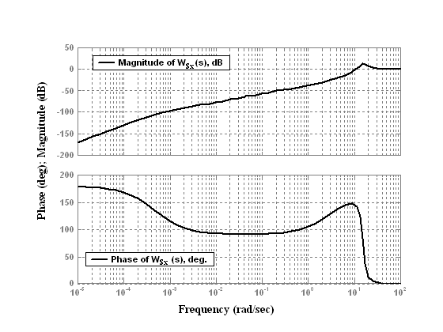
Fig. 5 Frequency response of the weighting function 1/W_{Sx}(s) in x-direction.
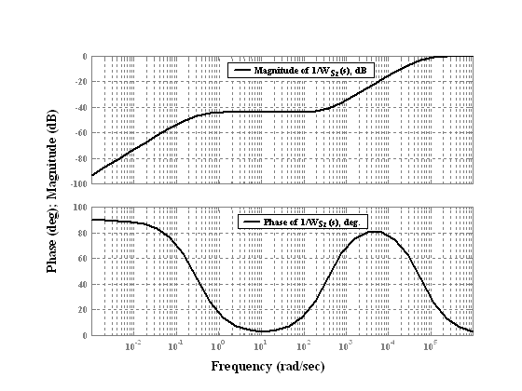
Fig. 6 Frequency response of the weighting function 1/W_{Sz}(s) in z-direction.

  - H∞ Controller Synthesis
Because there is not a method to calculate the controller directly from (16), the problem has to be stated. To do so, (16) will be assumed to be the norm of a multiple-input-multiple-output system. This is done in Fig. 4. The standard output feedback control loop shown in Fig. 4 is extended by weighting functions. Thus another input and output arise. The new problem is now to find a controller K∞(s) for the augmented system P(s), that uses output z₁ and input u to minimize the gain from input w to output z₁.

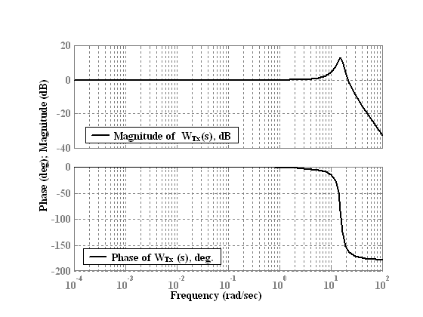
Fig. 7 Frequency response of the weighting function 1/W_{Tx}(s) in x-direction.
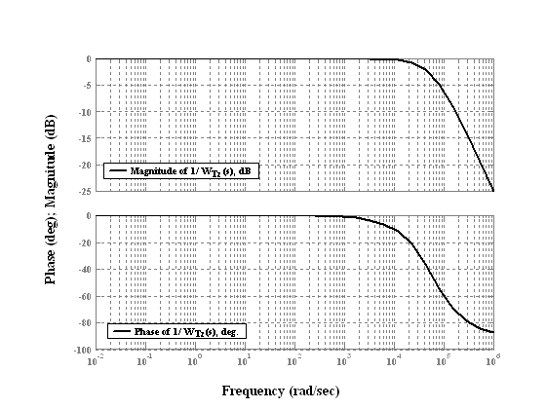
Fig. 8 Frequency response of the weighting function 1/W_{Tz}(s) in z-direction.

The controller design is done in state space, so it is necessary to transform the augmented system P(s) into state space with
$P=\begin{aligned}\left[A{\text{ B}}_{1}{\text{ B}}_{2} | \right]\left[C_{1}{\text{ D}}_{\text{11}}{\text{ D}}_{\text{12}} | \right] \\ \end{aligned}$ (24)
The numeric controller state space synthesis is done with γ-iteration method presented in [11-12]. By using this method when the augmented system P(s) meets certain constraints, we can solve the following Reccati equations:

$A^{T}X+\text{XA}+X(B_{1}B_{1}^{T}−B_{2}B_{2}^{T})X+C_{1}^{T}C_{1}=0$ (25)
${\text{YA}}^{T}+\text{YA}+Y(C_{1}^{T}C_{1}−C_{2}^{T}C_{2})Y+B_{1}B_{1}^{T}=0$ (26)
If (25) has positive semi-definite solution X≥0 that makes $A+(B_{1}B_{1}^{T}−B_{2}B_{2}^{T})X$ stable, (26) has positive semi-definite solution Y≥0 that makes $A+(C_{1}^{T}C_{1}−C_{2}^{T}C_{2})Y$ stable and the maximum eigenvalue of XY meets γ_{max} <1, then the optimal H∞ controller K∞(s) can be obtained.
$K_{∞}(s)=\begin{aligned}\left[K_{\text{11}} K_{\text{12}} | \right] \\ \end{aligned}$ (27)
where,
$$K_{\text{11}}=A+B_{1}B_{1}^{T}X−(1−\text{XY})^{−1}{\text{YC}}_{2}^{T}C_{2}−B_{2}B_{2}^{T}X$$
$K_{\text{21}}=B_{2}^{T}X$, $K_{\text{12}}=−(1−\text{XY})^{−1}{\text{YC}}_{2}^{T}$, $K_{\text{22}}=0$
In practice, we can handle the above procedures with the help of MATLAB. After γ-iterations, the H∞ controllers are solved at γ=0.9832. The transfer functions obtained for H∞ controllers are given by:

$K_{∞}^{x2}=\frac{1\text{.}\text{357}(s+\text{12648}±\text{20543}i)\text{.}(s+\text{965}\text{.}\text{75})\text{.}(s+\text{43}\text{.}6)}{(s+\text{30548}±\text{30540}i)\text{.}(s+\text{12}\text{.}\text{67}±\text{17}\text{.}\text{86}i)\text{.}(s+6\text{.}\text{48})}$(28)
$K_{∞}^{z2}=\frac{\text{103}\text{.}\text{54}(s+1\text{.}\text{02})\text{.}(s+\text{76}\text{.}\text{34})\text{.}(s+\text{98}\text{.}3)}{(s+\text{254}\text{.}\text{12}±\text{300}\text{.}\text{87}i)\text{.}(s+\text{456}\text{.}\text{15})\text{.}(s+0\text{.}\text{05})}$ (29)

5 ME02 Dynamics Simulations with H∞ Optimal Control
According to the control principle proposed above, the motions of levitation and propulsion of ME02 are simulated in both attractive and repulsive modes of operation. In repulsive-mode simulations for the ME running on land, an initial air gap-length is 10 mm with the vehicle supported by upper guide-rollers on the guideway, under an assumption that vehicle buoyancy is 0.95 times the vehicle weight. In attractive-mode simulations for the ME running under the water, an initial air gap-length is 13 mm with the vehicle supported by lower guide-rollers assuming that a vehicle buoyancy is 1.05 times the vehicle weight (M = 11kg). Figs. (9-10) shows the dynamic performance of the ME02 in repulsive and attractive model of operations. It is clarified from these simulated results that the vehicle is controlled to follow sufficiently the demand patterns of motion expressed by its position, speed and air gap-length in both repulsive and attractive modes. When the vehicle was accelerated, run at a constant speed and decelerated, the air gap-length was always kept at 13 mm in repulsive mode and 10 mm in attractive mode and varied very slightly with position and speed of the vehicle. This shows that the H∞ -control of levitation and propulsion has been realized satisfactorily.

6 Conclusions
A control methodology based on the H∞ optimal control technique was successfully applied in this paper to approach the PM LSM Maglev vehicle problem. The new combined levitation-and-propulsion control technique using H∞ optimal control for PM LSM Maglev vehicle is the most suitable candidate for the ME running both on land and under the water where force requirements should be satisfied. The H∞ optimal controller can make the closed loop system stable and can handle large parametric uncertainty. The uncertainty treatment employed resulted in a new representation for the PM LSM Maglev vehicle model that were posed as an H∞ optimization problem in a general analysis. The proposed controller is superior to PID controller. The performance of the Maglev vehicle was numerically analyzed and verified by computer simulation. The results confirm that good dynamic performance and high robustness can be achieved by the proposed controller.

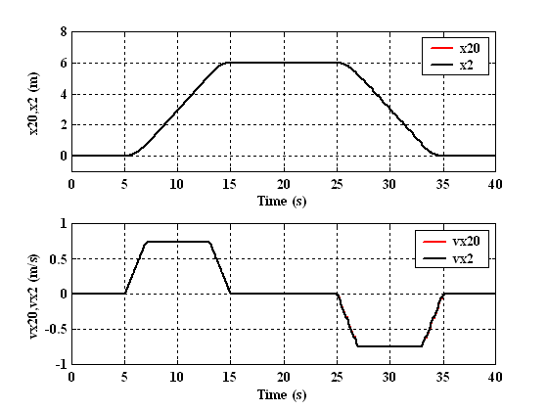
a
b
c
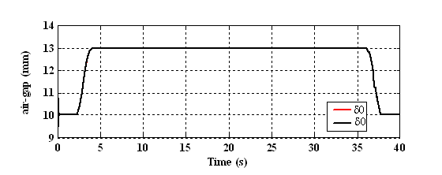
Fig. 9 Levitation and propulsion in repulse-mode
(a) Demand and simulated positions, (b) Demand and simulated speeds (c) Demand and simulated air gap-lengths
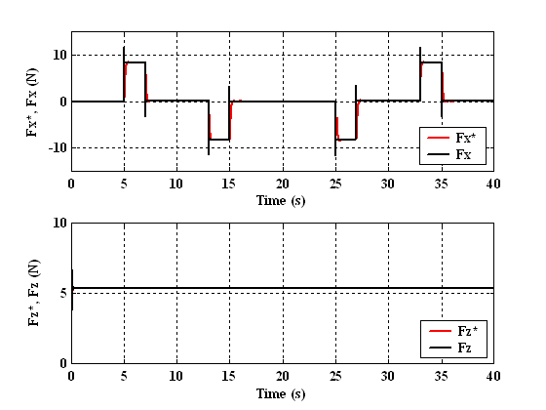
d
e

Fig. 9 Levitation and propulsion in repulse-mode
(d) Command and simulated thrust forces (e) Command and simulated lift forces.

a
b
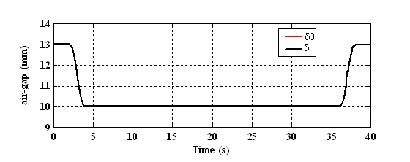
c

Fig. 10 Levitation and propulsion in attractive-mode
(a) Demand and simulated positions, (b) Demand and simulated speeds (c) Demand and simulated air gap-lengths.
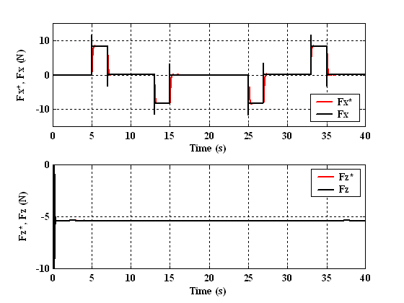
d
e
Fig. 10 Levitation and propulsion in attractive-mode
(d) Command and simulated thrust forces (e) Command and simulated lift forces.
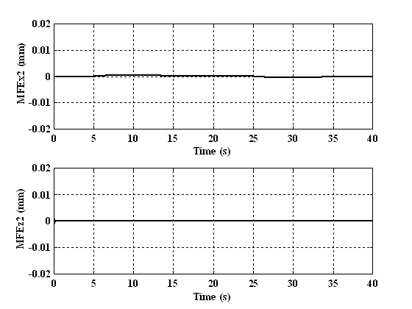
a
b
Fig. 11 Model following error in levitation and propulsion positions.
(a) Model following error in x-direction
(b) Model following error in z-direction

References:
[1] K.Yoshida "Linear Synchronous Motor Propulsion Method for Guided Vehicle", Japanese Patent Publication No. 1991-27703.
[2] K.Yoshida, H. Muta and N. Teshima: "Underwater Linear Motor Car", Journal of Applied Electromagnetics in Materials 2, 1991, pp.275-280.
[3] K. Yoshida and H. Weh : " Theory of a Controlled-PM Linear Synchronous Motor ", Proc. of 10th Inter. Conf. on Maglev'88, 1988, pp.259-268.
[4] K. Yoshida, T. Takaki and H. Muta : " System Dynamics Simulation of Controlled-PM LSM Maglev Vehicle ", ibid., 1988, pp.269-278.
[5] K. Yoshida, H. Takami and T. Hirakawa : " The Levitation and Propulsion Control Principle of Marine Express 02 on land and under the water ", Record of 1994 Joint Conference of Electrical and Electronics Engineering in Kyushu, p.259.
[6] K.Yoshida, H. Takami, L. Shi and A.Sonoda : " Underwater-Levitation Experiment During a Standstill of Marine-Express Model Vehicle ME02", 1996 National Convention Record I.E.E.Japan, 1996, No. 1116.
[7] K. Yoshida, H. Takami, L.Shi: "Attractive-Mode Levitation Control During a Standstill of an Underwater Travelling Marine-Epress Model Vehicle ME02, Proc. of ICEMA’96, pp. 175-178.
[8] K. Yoshida, A. Nafa: "New Method for Pitching Motion Control in attractive Mode of Underwater LSM Vehicle ME02 Using Air-Core Electromagnet", Proc. of the 11th International Power Electronics and Motion Control Conference”, Riga, Latvia, 2004.
[9] K. Yoshida, A. Nafa, Y. Nakamura: "LSM Design and Motion Control of ME02 on Steep Slope for Water-Land Transition", 7th International Conference on Modeling and Simulation of Electric Machines, Converters and Systems, Montreal, Canada, CD ROM, August 2002.
[10] K. Yoshida, M. El-Nemr:"FEM Hydrodynamics Simulation in ME02 for Water-Land Transition", 8th International Conference on Modeling and Simulation of Electric Machines, Converters and Systems, ELECTRIMACS 2005, Tunisia, CD ROM, April 2005.
[11] J.C Doyle, K. Glover, P. P. Khargonekar and B. A. Francis, “State space solution of standard H₂ and H∞ control problem,” IEEE Trans. Automat. Contr., Vol. 34, pp. 831-847, Aug. 1989.
[12] Fayez F. M. El-Sousy, Faeka M.H. Khater and Farouk I.. Ahmed, " Design of Optimal Controller for Induction Machine Drives," The Proceedings of Japan-USA Symposium on Flexible Automation, USA , July 23-26, 2000.

