Fuzzy Systems and Neural Networks Methods to Identify Hand and Finger Movements Using Surface EMG signals

ABDELHAFID ZEGHBIB¹; FRANK PALIS¹; GEORGI TSENOV²; NICOLA SHOYLEV³; VALERI MLADENOV²
¹ Otto-von-Guericke-Universität Magdeburg, Institut für Elektrische Energiesysteme
39016 Magdeburg, Germany

² Department of Theoretical Electrical Engineering, Technical University of Sofia,
8 Kl. Ohridski St., BG-1000 Sofia, Bulgaria
³ Department of Electrical Engineering, University of Chemical Technology and Metallurgy,
8 Kl. Ohridski St., BG-1756 Sofia, Bulgaria

Abstract: - With help of exploitation of myoelectric signals, amputee persons can have a chance to improve their life with myoelectric prosthesis which are able to function with the amputee’s muscle movements. The myoelectric signal (MES) is the electrical manifestation of muscular contraction. This signal recorded at the surface of the skin of the forearm has been exploited to provide the recognition of the movement of the hand and finger Movements of healthy subject. The objective of the paper is first to describe the identification procedure, based on EMG patterns of forearm activity using Fuzzy logic and Neural Networks methods. Second to show the advantage of using features in Time-frequency domain, in comparison to those in time domain. Suitable features in time-frequency domain give high classification rates. Third is to compare between different intelligent computational methods of identification, which are used in this work: Multi-Layer Perceptron (MLP), Radial Basis Function Networks (RBF) and Learning Vector Quantization network (LVQ) as supervised methods and fuzzy Subtractive Clustering (FSC) as unsupervised method.

Key-Words: - EMG signals, Hand and finger Movements Identification, Neural Networks, Fuzzy Logic, Subtractive clustering, Feature extraction, Short Time Fourier Transform.

1 Introduction
MES classification is one of the most difficult pattern recognition systems because there usually exist large variations in Electromyograph (EMG) features. The EMG signal has been used as a tool to provide advanced man-machine interfaces [1], rehabilitation of the handicapped people, functional electrical stimulation devices (FES) [2] and control commands for limb prostheses [3,4].
The classification problem may be divided into three steps: signal presentation, feature extraction and pattern recognition. It is shown in this paper that classification performance of hand and finger movements depends significantly upon feature extraction, which is very important to improve considerably the accuracy of classification. Many researches proposed several EMG features for classification that showed good performance [5] [6] [7]. These identification methods belong to two categories, first are supervised methods, like Multi-Layer Perceptron, Radial Basis Networks, and Learning Vector Quantization network, Second are unsupervised methods, like Self Organizing Map, Fuzzy Subtractive Clustering and Competitive Layer. Some features in time domain and time-frequency domain are extracted from raw EMG signal and used for identification of movements with help of the above mentioned intelligent computational methods. In practice, determination of relevant features is very difficult. The aim of this paper is to distinguish between three finger movements (thumb, index and middle) and hand closing.

2 EMG Signal Preprocessing
Surface muscle activity signals cannot be analysed using classical methods, since they are non-stationary and have complex time-frequency characteristics. EMG signals, fig 1, which are evolving in time in an unpredictable way (like a speech signal or an EMG signal) require the notion of frequency analysis for each local time. Although frequency-domain representations such as the power spectrum of a signal often show useful information, these representations don’t show how the frequency content of a signal evolves over time. Time-Frequency Analysis can identify not only the frequency content of a signal, but also how that content evolves over time.

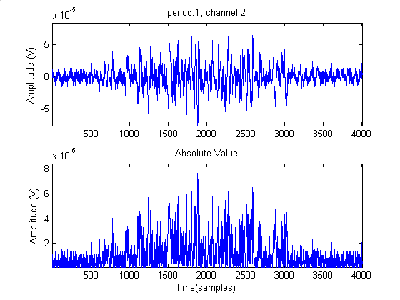
Fig. 1. Measured raw EMG signal from channel 2 (extensor digitorum) muscle, and his absolute value.

There are a number of different methods available for Time Frequency Analysis. Each type shows a different time-frequency representation. The Short Time Fourier Transform (STFT), which is used in this paper, is the simplest TFA method and the easiest to compute.

3 Experimentation

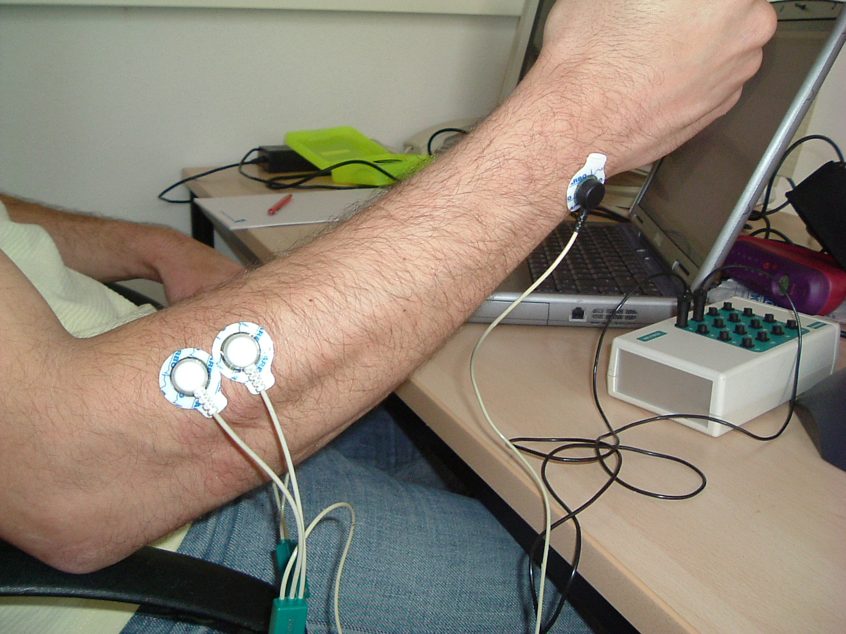
Fig. 2, EMG training and test patterns recorded using two pairs of electrodes in Max Planck Institute laboratory in Magdeburg, Germany.

Four types of finger and hand movements to be classified are selected: thumb, pointer, middle and hand close. The placement of EMG surface electrodes on muscle groups is important to have more information about each movement. Two EMG surface electrodes are placed on two muscle groups, palnaris longus (channel_1) and extensor digitorum (channel_2), the locations of electrodes on the subject’s arm is given in fig. 2, from the input feature space, the classifier must be able to classify the three output classes exploiting the EMG signals measurements.
For each channel the signal was acquired using a single bipolar surface electrode pair. A differential amplifier with an isolated input is used. The signal was sampled at a rate of 4Khz using A/D board in an IBM PC/AT compatible microcomputer; this algorithm is developed with MATLAB 6 and is performed in a PC-based off-line process. The human subject was asked to produce a number of continuous movements, 34 single contraction periods are separated from the corresponding sets of continuous movements. Each single contraction period extracted from the raw signal by determined threshold is analysed with Short time Fourier Transform (STFT), which gives a measure of time and frequency information, fig 3 and fig 4, for small segments of a signal. For the two channels we prepare some EMG training and test data, each class has 17 training and 17 test patterns. The four classes labelled 1, 2, 3 and 4 have 68 train-samples and 68 test-samples.

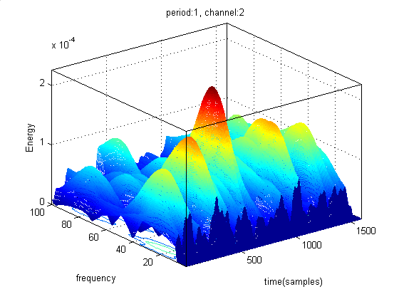
Fig. 3. Thumb: 400 ms EMG Signal analyzed with STFT method.

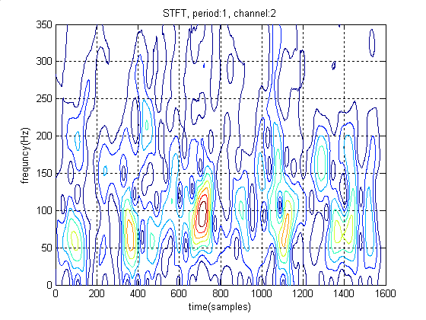
Fig. 4. Contour presentation for the same above signal
4 EMG Feature extraction
The problem of classification is the partitioning of the feature space, into regions (classes). Relevant features will lead to high and accurate classification rates. In the time domain, four features are extracted: Mean absolute value (MAV), Variance (VAR), Waveform length (WL), and Median Value (Med).
$\text{MAV}=\frac{1}{N}\sum_{k=1}^{N}{\left|{\text{emg}}_{k}\right|}$, (1)
$\text{VAR}=\frac{1}{N−1}\sum_{k=1}^{N}{{\text{emg}}_{k}^{2}}$, (2)
$\text{WL}=\sum_{k=1}^{N−1}{\left| {\text{emg}}_{k+1}−{\text{emg}}_{k}\right|}$ (3)

Where emg_{k} is the k^{th} sample data, which is N samples in length. The following Table shows us the worse classification with these features

In time-frequency domain using STFT (Short Time Fourier Transform), the Hannaford’s moments of first and second order are extracted as time-frequency features with the dominant frequency value FDV, which present the frequency value of maximum amplitude obtained from spectral analysis.
The nth moment of the frequency distribution at time t is defined as:
$M_{n}\left(t\right)=\sum_{k}{ω_{k}^{n}\left|\text{STFT}\left(t,k\right)\right|}$ (4)
n: order, t: time, $ω$: frequency.

5 Methods and results
There is a large set of neural networks and fuzzy logic methods in the literature addressing identification problems. Some of these methods are applied, using different features, to identify our four fingers and hand movements and to compare their performances. These methods in case of supervised learning employ optimisation techniques to processes the inputs and compare their resulting outputs against the desired outputs. Errors are then calculated, causing the system to adjust the parameters. In case of unsupervised learning, training algorithms attempt to locate clusters in the input data, which approximate the distribution of the data. More details about clustering data in [Kaufman & Rousseeuw, 1990].

5.1 Fuzzy system initialised with Subtractive Clustering method
The subtractive clustering algorithm was proposed by Chiu (1994). It estimates the number of clusters and the cluster centres in a set of data by an iterative procedure. The clusters obtained, with iterative optimisation-based clustering methods fuzzy c-means (fcm), are used to initialise the fuzzy sets, for model identification method ANFIS. As initial model the first order Takagi-Sugeno (T. S.) model is used. We test some values of cluster radius, which are: 0.3, 0.4 and 0.7. For these values we test our model during 20 epochs using the four-extracted time features, see table 1 for results.

Table 1: accuracy and number of correct instances for each class with extracted time features.
 | Classification accuracy (test data) %
cluster  radius | Thumb | Pointer | Middle | HC | average
0.3 | 52.94 | 23.52 | 0 | 5.88 | 20.58
0.4 | 58.82 | 17.64 | 0 | 17.64 | 23.52
0.7 | 88.23 | 11.76 | 0 | 5.88 | 26.47
Cluster  radius | # of correct classified instances /17
 | Thumb | Pointer | Middle | HC | Total
0.3 | 9 | 4 | 0 | 1 | 14
0.4 | 10 | 3 | 0 | 3 | 16
0.7 | 15 | 2 | 0 | 1 | 18

In the same way we test, table 2, our features extracted with help of time –frequency analysis (STFT).

Table 2: accuracy and number of correct instances for each class with extracted time-freq features.
 | Classification accuracy (test data) %
Cluster  radius | Thumb | Pointer | Middle | HC | average
0.3 | 82.35 | 70.58 | 76.47 | 82.35 | 77.94
0.4 | 88.23 | 64.70 | 76.47 | 82.35 | 77.94
0.6 | 94.11 | 76.47 | 100 | 94.11 | 91.17
0.7 | 94.11 | 76.47 | 100 | 82.35 | 88.23
Cluster  radius | # of correct classified instances /17
 | Thumb | Pointer | Middle | HC | Total
0.3 | 14 | 12 | 13 | 14 | 53/68
0.4 | 15 | 11 | 13 | 14 | 53/68
0.6 | 16 | 13 | 17 | 16 | 62/68
0.7 | 16 | 13 | 17 | 14 | 60/68

5.2 Neural Networks Methods
Various ANN based models were applied to identify these different four movement classes. Hykin publishes a comprehensive foundation for the study of Neural Networks [8]. There are many functions and variables to be determined for each neural network model. The four neural networks methods are trained during 100 epochs.

5.2.1 Multi Layer Perceptron (MLP)
This network is used in many different types of applications. This architecture has a large class of network types with many different topologies and training methods. The number of neurons in the only hidden layer is determined based on their performance in training process. For the one-neuron output-layer we use log sigmoid transfer function “logsig”, which gives an output in the range of 0 to 1. Our output range between 0 and 1 will be divided in four ranges, since we have four classes to be identified, see Table 3.

Table 3:
Classes | Target  output | Output  range | Type of  Movement
Classe 1 | 0.125 | 0 – 0.25 | Thumb
Classe 2 | 0.375 | 0.25 – 0.5 | Pointer
Classe 3 | 0.625 | 0.5 – 0.75 | Middle
Classe 4 | 0.875 | 0.75 - 1 | Hand close

The classification results are summarized in table4.

Table 4: Rate of classification and correct classified instances (extracted time features) for each class and average value with four different hidden layer neurons number.
 | Classification accuracy (test data) %
# of  neurons | Thumb | Pointer | Middle | HC | average
5 | 17.64 | 35.29 | 17.64 | 64.70 | 33.82
10 | 35.29 | 11.76 | 29.41 | 29.41 | 26.47
20 | 52.94 | 0 | 5.88 | 41.17 | 25
50 | 41.17 | 23.52 | 5.88 | 52.94 | 30.88
# of  neurons | # of correct classified instances /17
 | Thumb | Pointer | Middle | HC | Total
5 | 3 | 6 | 3 | 11 | 23/68
10 | 6 | 2 | 5 | 5 | 18/68
20 | 9 | 0 | 1 | 7 | 17/68
50 | 7 | 4 | 1 | 9 | 21/68

We test our MLP Network with different number of neurons in hidden layer: 5, 10, 20 and 50 neurons for four extracted time features, (IEMG, WL, VAR and Med, see table 4. It’s obvious in table 4 that there is no effect of the number of neurons in hidden layer on the rate of classification. The increasing in number of neurons in hidden layer doesn’t enhance the accuracy.

In case of extracted time-frequency features, we obtained the results, which are resumed in table 5.

Table 5:
 | Classification accuracy (test data) %
# of  neurons | Thumb | Pointer | Middle | HC | average
5 | 100 | 52.94 | 94.11 | 94.11 | 85.29
10 | 100 | 76.47 | 100 | 94.11 | 92.64
20 | 88.23 | 41.17 | 94.11 | 94.11 | 79.41
50 | 94.11 | 64.70 | 70.58 | 94.11 | 80.88
# of  neurons | # of correct classified instances /17
 | Thumb | Pointer | Middle | HC | Total
5 | 17 | 9 | 16 | 16 | 58/68
10 | 17 | 13 | 17 | 16 | 63/68
20 | 15 | 7 | 16 | 16 | 54/68
50 | 16 | 11 | 12 | 16 | 55/68

5.2.2 Radial basis Functions (RBF)
The RBF Network is a one hidden layer neural Network with several forms of radial basis activation functions, like Gaussian function. We use the method, which creates neurons one at a time. In each iteration the input vector is used to create a new neuron. The error of the new network is checked, and if it is not low enough the next neuron is added. This procedure is repeated until the error goal is met, or the maximum number of neurons is reached. The output layer is linear and the rate of classification is determined by the spread of the hidden unit. We give many values between 0.5 and 2.5 with a step of 0.2 to find the optimal value of spread, which is in our application equal to 0.6 and 0.7, see fig. 5.
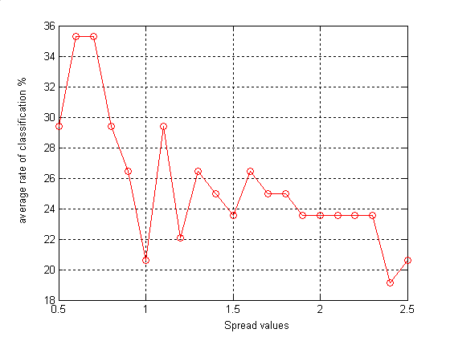
Fig. 5. Average accuracy according to spread’s values

For this value of spread we test our network using the four extracted time features, see table 6 for results.

Table 6: accuracy and number of correct instances for each class with extracted time features.
 | Thumb | Pointer | Middle | HC | average
Acuracy  (Test) % | 29.41 | 11.76 | 23.52 | 76.47 | 35.29
 | # of correct classified instances /17
 | Thumb | Pointer | Middle | HC | Total
Correct  (# / 17) | 5 | 2 | 4 | 13 | 24 / 68

With the same method we test the classification accuracy for the extracted time-frequency features with two values of spread: 0.7 and 1.5, see table 7.

Table 7: accuracy and number of correct instances (extracted features in time-frequency analysis domain) for each class and average value with different values of spread.
 | Classification accuracy (test data) %
Spread  value | Thumb | Pointer | Middle | HC | average
0.7 | 88.23 | 88.23 | 76.47 | 82.35 | 83.82
1.5 | 76.47 | 70.58 | 64.70 | 76.47 | 72.05
Spread  value | # of correct classified instances /17
 | Thumb | Pointer | Middle | HC | Total
0.7 | 15 | 15 | 13 | 14 | 57/68
1.5 | 13 | 12 | 11 | 13 | 49/68

We get the best rate classification for Gaussian functions with spread value of 0.7 by extracted features in time-frequency analysis domain.

5.2.3 Learning Vector Quantization (LVQ)
Learning Vector Quantization [9, 10] networks can classify, faster than other neural network techniques like Back Propagation, any set of input vectors; not only linearly separable sets of input vectors. Its architecture resembles to that of unsupervised competitive learning network, except that each output is assigned to a target class and works in two steps. First it uses an unsupervised data clustering method to locate several clusters. Second it optimises the cluster centres. The number of clusters can be specified a priori or determined via cluster techniques. It is able to reduce large data sets to a smaller number of codebook vectors (cluster centres) suitable for data compressing.
LVQ network used in this work has 4 neurons in the first competitive layer and one neuron for each class in the second linear layer. In comparison with previous methods, LVQ needs only 30 to 40 epochs to converge, see table 8 and 9.

Table 8: Rate of classification (time extracted features) for each class and average value.
 | Classification accuracy (test data) %
competitive  neurons | Thumb | Pointer | Middle | HC | average
6 | 76.47 | 0 | 5.88 | 41.17 | 30.88
12 | 64.70 | 0 | 11.76 | 58.82 | 33.82
28 | 70.58 | 0 | 5.88 | 64.70 | 35.29

Table 9: Rate of classification (time-frequency extracted features) for each class and average value.
 | Classification accuracy (test data) %
competitive  neurons | Thumb | Pointer | Middle | HC | average
6 | 100 | 64.70 | 94.11 | 88.23 | 86.76
12 | 100 | 64.70 | 94.11 | 88.23 | 86.76
28 | 100 | 64.70 | 100 | 88.23 | 88.23

6 Methods comparison
To resume the results obtained with the features extracted in time-frequency analysis, we present for all methods their classification rate according to some determined parameters. In fig. 6 four first values of classification accuracy, with MLP method, are presented according to number of neurons used in hidden layer, which are: 5, 10, 20 and 50 neurons. The second four values group given by unsupervised fuzzy subtractive clustering method corresponding to the different values of cluster radius, 0.3, 0.4, 0.6 and 0.7. The two classification accuracy values obtained with RBF method corresponding to 0.7 and 1.5 spread parameter values. Finally LVQ method shows three rate of classification, corresponding to three values of number of neurons (6, 12 and 28) in competitive layer.
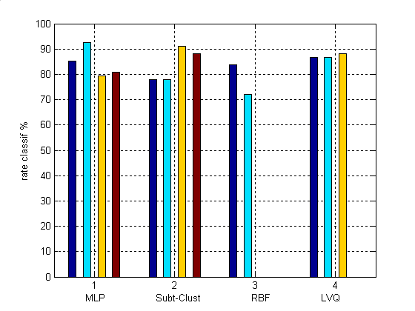
Fig. 6. Classification accuracy comparison between four different methods using extracted features in time frequency domain analysis.

7. Conclusion
As conclusion, first we can conclude that the identification methods cannot and don’t help to perform accuracy classification if the feature measures selected are not a relevant features. For this reason the determination of a complete set of discriminatory features is very important.
Both methods Neural Networks and Fuzzy Logic are showed clearly that the selection of the feature are of great importance to enhance the recognition rate of myoelectric patterns for the four movements, hand close and three finger (Thumb, pointer and middle). In this case the use of time-frequency domain as features extraction domain is necessary to perform the identification.

Acknowledgement
This work is supported by the DAAD PPP-program 2005-2006 between Otto-von-Guericke-Universität Magdeburg, Germany, and University of Chemical Technology and Metallurgy, Sofia, Bulgaria.

References:
- [1] Chang G-C, Kang W-J, Luh J-J, Cheng C-K, Lai J-S, Chen J-JJ, Kuo T-S, “Real-time implementation of electromyogram pattern recognition as a control command of man–machine interface”. Med Eng Phys. 1996 Oct;18(7):529-37. PMID: 8892237 [PubMed – indexed for MEDLINE].
- [2] Hefftner G, Jaros G, “The electromyogram (EMG) as a control signal for functional neuromuscular, Stimulation, part I: Autoregressive modeling as a mean of EMG signature discrimination”. IEEE Trans Biomed Eng 1988, 35(6), pp. 228–35.
- [3] Zardoshti-Kermani M, Wheeler BC, Badie K, Hashemi RM, “EMG feature evaluation for movement, control of upper extremity prostheses”. IEEE Trans Rehabil Eng 1995;Vol.3, No.4, pp. 324–333.
- [4] C. Bonivento, A. Davalli, C. Fantuzzi, R. Sacchetti, S. Terenzi, “Automatic tuning of myoelectric prostheses” Journal of Rehabilitation Research and Development Vol. 35 No. 3, July 1998, pp. 294-304.
- [5] K.Englehart, B. Hudgin, and P. A. Parker, “A
- wevelet based continuous classification scheme for multifunction myoelectric control”, IEEE Transactions on Biomedical Engineering, vol. 48, no. 3, pp. 302-311, Mars 2001.
- [6] Z. K. Mahyar, W. C. Bruce, B. Kambiz, and M. H. Reza, EMG feature evaluation for movement control of Upper extremity prostheses”, IEEE Transactions on Rehabilitation Engineering, Dec 1995.
- [7] B. Hudgins, P. Parker and R. N. Scott, “New strategy for multi-function myoelectric control ”IEEE Transactions on Biomedical Engineering, vol. 40, no. 1, pp. 82-94, Jan. 1993.
- [8] S. Haykin, Neural Networks: A Comprehensive Foundation, (2nd Edition 1998), ISBN: 0132733501. Prentice Hall, 1998.
- [9] T. Kohonen. Self organization and associate memory. Springer-Verlag, London, 3rd edition, 1989.
- [10] T. Kohoenen. Improved versions of learning vector quantization. In International Joint conference on Neural Networks. Vol:1, p:545-550, San Diego, 1990.

