RSFQ Technique for Generation of Ultra-Fast Pulse Chains Having Controlled and Variable Time-Domain Parameters

BOYKO DIMOV¹, VALERY TODOROV², VALERI MLADENOV³,
F. HERMANN UHLMANN¹
¹ Department of Fundamentals and Theory of Electrical Engineering,
Technische Universitaet Ilmenau, P.O.Box 100565, D-98684 Ilmenau, Germany

² Department of Electrical Engineering, University of Chemical Technology and Metallurgy
8 Kl. Ohridski St., BG-1756 Sofia, Bulgaria
³ Department of Theoretical Electrotechnics, Technical University of Sofia,
8 Kl. Ohridski St., BG-1000 Sofia, Bulgaria

Abstract: - A novel RSFQ circuit allowing the generation of an SFQ pulse chain containing a fixed number of pulses and precisely controlled picosecond variable time interval between them is presented. The generation of such SFQ pulse chains is necessary in many applications, but especially by the high-speed on-chip testing of RSFQ digital devices. The proposed circuit can be extended to a generator of an ultra high-speed rectangular voltage pulses with controlled and variable duration, suitable for readout by the conventional semiconductor electronics. Thus, an ultra high-speed digital data generation can be performed.

Key-Words: - Rapid Single-Flux Quantum (RSFQ) technique, Josephson junction, RSFQ generator, SFQ pulses.

1 Introduction
According to the authoritative forecasts of the Semiconductor Industry Association [1], the decreasing of the feature sizes of the silicon chips will continue in the future with the same speed, but the previously exponential growth of the clock frequency will slow. The main reason for this is the fact, that the dominant part of the clock interval of the modern silicon chips is taken by the recharging of the interconnects capacitances by the output currents of the logic gates, and only a small part of the clock interval is determined by the intrinsic switching speed of the transistors. The speeding up of this recharging process proportionally increases the total dissipated power density and the overcoming of this problem requires the involving of the newest technological solutions and a huge manpower for R&D, which finally results into enormous amount of money for reinvestments. This has motivated the search for alternative techniques, allowing more effective (in terms of speed and price) digital information processing.
One of the promising candidates for this are the Low-Temperature Superconductive (LTS) Rapid Single Flux Quantum (RSFQ) electronics [2] based on the Josephson effect [3]. The digital circuits realized with this technique are characterized by extremely low power dissipation (of order of 10-19 Joule per switching) and operation frequencies approaching 1THz [4]. Nevertheless, the operation temperature of the LTS materials is about 4K and can be achieved only with special cooling devices. The latter causes serious problems with the communication between the RSFQ circuits and the conventional room-temperature electronics, especially in the case of broad-band signal exchange. Therefore, the generation of ultra high-speed data streams should be performed on the RSFQ chip.
In this paper, we present an electrical scheme of an RSFQ generator, which produces chains of a fixed number of Single Flux Quantum (SFQ) pulses with precisely controlled time-domain parameters. The generation of such SFQ pulse chains is necessary in many applications, but especially by the high-speed on-chip testing of RSFQ digital devices. In the following Section, we describe the basics of the RSFQ data coding and signal generation, as well as the methods for manipulating of the time-domain behavior of the RSFQ circuits. Next, in Section 3 we describe the topology and the operation principle of the proposed RSFQ generator. Further, in Section 4 we extract its time-domain parameters and determine the ranges, within which they can be varied. In Section 5, we present a general concept for the conversion of the SFQ pulse chains into voltage signals suitable for readout from the conventional semiconductor electronics. Section 6 summarizes the main results of the paper.

2 Basis of the RSFQ Technique
The switching element of the RSFQ electronics is the tunnel Josephson junction. It is a thin nonsuperconductive barrier separating two superconductors designated as S₁ and S₂ in Fig. 1. Let θ₁ and θ₂ be the phases of the complex pair wave functions of the both superconductors and φ = θ₁ – θ₂ be their difference.

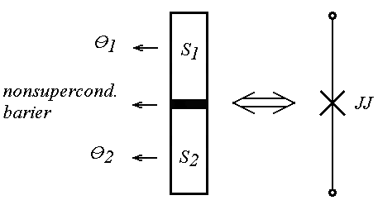
Fig. 1. A tunnel Josephson junction – structure (left) and electrical symbol (right).

Let I_{s} be the lossless supercurrent flowing through the Josephson junction, I_{c} - its maximum value (also called critical current of the Josephson junction) and U(t) - the voltage drop over the junction. Then:
$I_{s}=I_{c}\text{sin}φ(t)$ (1)
and
$\frac{dφ}{\text{dt}}=\frac{2πU(t)}{Φ_{0}}$ (2)
with Φ₀=2.07mV.ps - a fundamental constant named the Single Flux Quantum (SFQ). These relations are first predicted by B. D. Josephson [3] and are popular as the dc (1) and ac (2) Josephson effect, respectively.
For RSFQ applications, the tunnel Josephson junction should be properly shunted by a resistor R [2]. If the resulting structure is biased by a dc current I_{bias}<I_{c} and a non-dc excitation I_{exc}(t) is applied on it, two additional components of the current through the junction appear: the capacitive current I_{cap}(t)=C_{J}(dU(t)/dt) through the capacitance C_{J} formed by the superconductor contact electrodes, and the dissipation current I_{R}(t)=U(t)/R. The balance of the currents over the junction becomes:
$I_{\text{bias}}+I_{\text{ext}}(t)=I_{c}\text{sin}φ(t)+\frac{U(t)}{R}+C_{J}\frac{\text{dU}(t)}{\text{dt}}$ (3)
Taking into account (2), (3) is transformed into:
$\begin{aligned}I_{\text{bias}}+I_{\text{ext}}(t)= \\ I_{c}\text{sin}φ(t)+\frac{1}{R}\frac{Φ_{0}}{2π}\frac{dφ(t)}{\text{dt}}+C_{J}\frac{Φ_{0}}{2π}\frac{d^{2}φ(t)}{{\text{dt}}^{2}}\end{aligned}$ (4)
which is the main differential equation describing the time-domain behavior of the tunnel Josephson junction. With a proper choice of its parameters, this equation has equilibrium solutions φ=2nπ+arcsin(I_{bias}/I_{c}) about the superconductive phase drop φ(t), with n - nonnegative integer. The transition between two neighboring equilibrium states is named a switching of the Josephson junction, and according to (2), such a 2π phase change causes a voltage pulse with a picosecond duration, named SFQ pulse, which is used as a data carrier within the RSFQ technique. The typical shape of an SFQ pulse is shown in Fig. 2.
The speed of the Josephson junction’s switching (i.e. the speed of RSFQ digital circuits) is determined by the parameters of (4). In [5]-[7], we have analyzed the possible methods to manipulate this speed. As the most efficient ones we have estimated the scaling of the junctions shunt resistors R and the variation of the dc bias current I_{bias} (see (4)). These two methods will be used in Section IV for the manipulation of the time-domain characteristics of the proposed RSFQ generator.

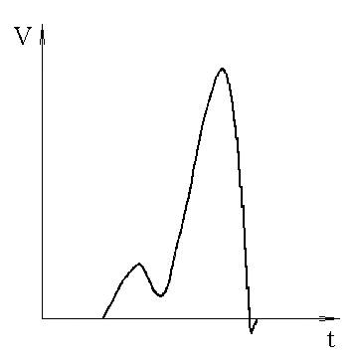
Fig. 2. Typical shape of an SFQ pulse.

3 Generation of SFQ Pulse Chains with Fixed Lengths
The electrical scheme of the RSFQ generator of a chain with a fixed number of SFQ pulses is shown in Fig. 3.
The general idea of its structure is proposed by [8]. The circuit consists of a chain of n mergers [2], [9] formed by the junctions Ji,1, Ji,2, Ji,3, Ji,4, and Ji,5, i=1,2,...,n, respectively. If an SFQ pulse appears at the input in, it flips the junction J1,1 and is split - it goes through the merger formed by J1,1, J1,2, J1,3, J1,4, and J1,5 to the output out, but also flips J2,1, thus entering the next merger from the chain. The SFQ pulse generated by the flipping of J2,1 is also split - once it goes through the merger formed by J2,1, J2,2, J2,3, J2,4, and J2,5 and flips J1,2, which then transmits the SFQ pulse through the merger formed by J1,1, J1,2, J1,3, J1,4, and J1,5 to the output out; once it enters the third merger formed by J3,1, J3,2, J3,3, J3,4, and J3,5. The flow repeats in the same way until the SFQ pulse passes through the all n mergers. Thus, the single SFQ pulse at in results into a sequence of n SFQ pulses at out. The time interval between each two of these pulses is determined by the delay of the corresponding merger in the chain.

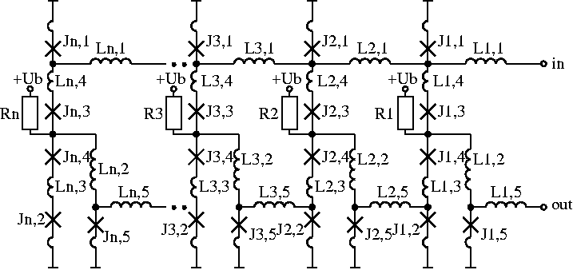

Fig. 3. RSFQ generator of SFQ pulse chains with fixed lengths.

A layout of the circuit has been designed according to the rules of the 4μm 1kA/cm² Nb/Al₂O₃-Al/Nb fabrication technology of PTB-Braunschweig [10]. Next, the circuit's elements have been optimized with respect to maximize its fabrication yield. The following values of the circuit's elements have been obtained after the optimization (i=1,2,...,n): Li,1=Li,5=4pH, Li,2=3.4pH, Li,3=Li,4=1.7pH, Ri=5Ω, Ub=2.6mV, critical currents of the Josephson junctions: Ji,1=Ji,2=Ji,5=250μA, Ji,3=Ji,4=225μA, shunt resistors of the Josephson junctions: R_{Ji,1}=R_{Ji,2}=R_{Ji,5}=1Ω, R_{Ji,3}=R_{Ji,4}=1.11Ω.

4 Time-Domain Characteristics of the Generated SFQ Pulse Chains and Their Manipulation
We have simulated the electrical scheme in Fig. 3 with the transient electrical simulator for RSFQ circuits JSIM [11]. The delay d of each merger (i.e. the time interval between two neighboring SFQ pulses from the generated pulse chain) is found to be 35ps.
Next, all junctions' shunt resistors have been scaled with a factor k_{r}, while the bias voltage Ub (i.e. all dc bias currents) has been scaled with a factor k_{b}. For each pair of values (k_{b}, k_{r}), the corresponding value of d has been determined by simulations with JSIM. The results are given in Fig. 4.
With such a scaling, the delay d can be manipulated within a large interval of values (from d_{min}=14ps obtained at k_{b}=1.3 and k_{r}=2.0, up to d_{max}=160ps obtained at k_{b}=0.8 and k_{r}=0.5). If we define the frequency of the generated SFQ pulse chain as f_{SFQ}=1/d, then f_{SFQ} can be varied between 6.25GHz and 71.43GHz.

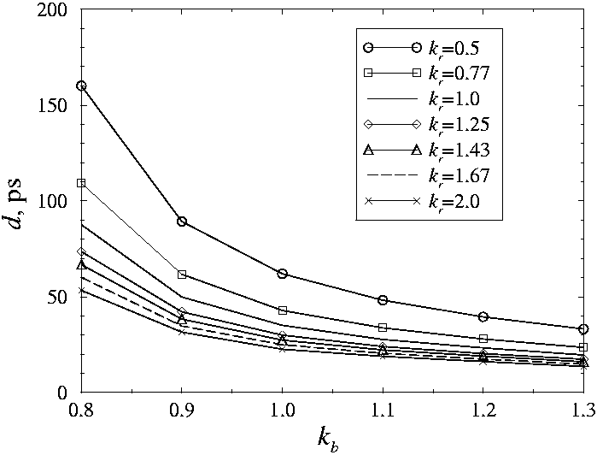
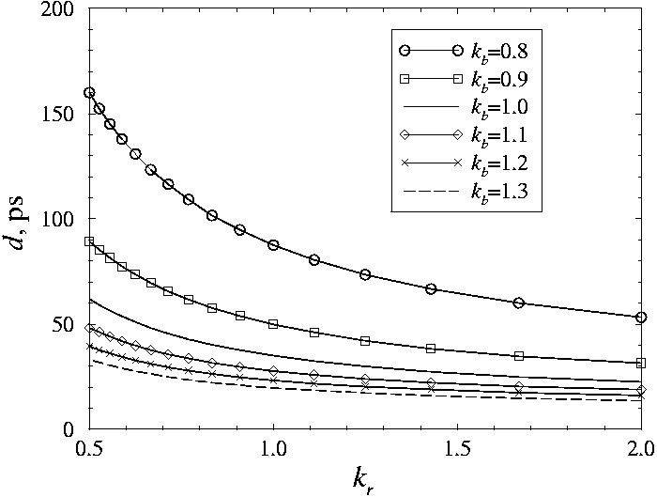
Fig. 4. The dependence of the time interval d between two neighboring SFQ pulses on the scaling factors k_{b} and k_{r}.

5 Conversion of an SFQ Pulse Chain into a Chain of Voltage Level Signals
A transformation of a SFQ pulse into a voltage level signal can be performed by an SFQ/DC converter [9], [12], whose electrical scheme is shown in Fig. 5. Its behaviour depends on the internal state of the T-flip-flop, formed by the junctions J2-J5. Two states are possible - with and without circulating current in the superconductive loop J4-L6-L7-J5. The nominal dc biasing of the junction J7 is high enough to switch it. This switching applies a phase drop over the junction J6. The value of this drop depends on the internal state of the T-flip-flop described above. If there is no circulating current in the loop J4-L6-L7-J5, this phase drop is high enough to switch J6. The switching of J6 causes a switching of J7, which causes again a switching of J6 and so on. Thus, a continuous chain of SFQ pulses with a frequency f ≈ 75GHz is generated at the output out of the SFQ/DC converter. The mean voltage of this SFQ pulse chain is $\bar{V}=Φ_{0}\text{.}f≈\text{150}μV$.

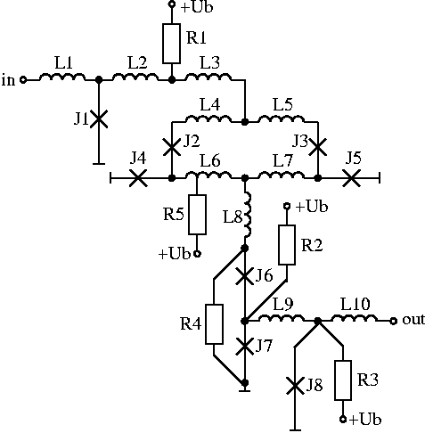
Fig. 5. Electrical scheme of an SFQ/DC converter according to [9], [12].

If there is circulating current in the loop of the T-flip-flop, the phase drop over J6 after the switching of J7 is not enough to switch it. The continuous switching of J6 and J7, described above, does not take place and the mean voltage at out is 0.
The internal state of the T-flip-flop changes only when an SFQ pulse appears at in. If there is no circulating current in the superconductive loop J4-L6-L7-J5 and an SFQ pulse appears at in, then the junctions J3 and J4 flip and such a circulating current is generated. The circuit remains in this state until another SFQ pulse appears at in, which flips the junctions J2 and J5, thus destroying the loop. The latter means, that the SFQ pulses appearing at in change alternatively the internal state of the T-flip-flop, i.e. alternatively switch the mean voltage at out between 0 and ≈150μV.
If the SFQ pulse chain generator in Fig. 3 is terminated by the SFQ/DC converter in Fig. 5, each even SFQ pulse at the output of the generator will switch the mean voltage at the output of the SFQ/DC converter from 0V to ≈150μV, while each odd SFQ pulse at the output of the generator will switch the mean voltage at the output of the SFQ/DC converter back from ≈150μV to 0V. If a properly designed low-pass filter is connected to the output of the SFQ/DC converter, only the mean voltage component will be propagated, resulting in the signal flow in Fig. 6.

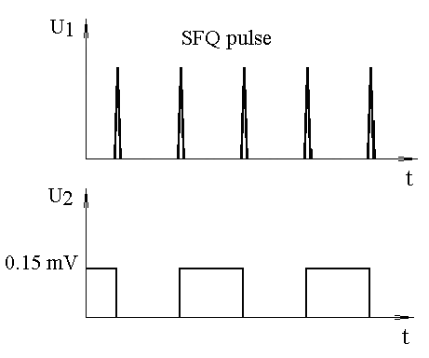
Fig. 6. Conversion of an SFQ pulse chain into a chain of voltage level signals. U1 - the output voltage of the SFQ pulse chain generator, U2 - the output voltage of the SFQ/DC converter terminating the generator after filtering with a proper low-pass filter.

Thus, the chain of SFQ pulses with controlled time-domain characteristics can be efficiently transformed into a chain of rectangular voltage pulses with precisely controlled duration and distance between them.

6 Conclusions
In this paper, we have presented an optimized electrical scheme of an RSFQ generator, which produces ultra-fast SFQ pulse chains with fixed length. We have demonstrated, that with a proper scaling of the global bias voltage and of the shunt resistors of the Josephson junctions, one can tune the period of the generated chain within a large interval of values. If the RSFQ generator is terminated with a SFQ/DC converter, whose output signal is properly filtered, the SFQ pulse chain can be transformed into a chain of rectangular voltage pulses suitable for readout by the conventional semiconductor electronics. With a proper manipulating of the time-domain parameters of the SFQ pulse chain, one can precisely control also the duration and the distance between the resulting rectangular voltage pulses.

Acknowledgement
This work is supported by the DAAD PPP-program 2005-2006 between University of Technology Ilmenau, Germany, and Technical University of Sofia, Bulgaria.

References:
- "International Technology Roadmap for Semiconductors", public.itrs.net.
- K.K.Likharev, V.K.Semenov, "RSFQ Logic/Memory Family: A New Josephson-Junction Technology for Sub-Terahertz-Clock-Frequency Digital Systems", IEEE Trans. on Appl. Supercond., vol. 1, No 1, pp.3-28, March 1991.
- B.D.Josephson, "Possible New Effects in Superconductive Tunneling", Phys. Lett., vol.1, pp.251-253, 1962.
- W.Chen, A.V.Rylyakov, V.Patel, J.E.Lukens, K.K.Likharev, "Rapid Single Flux Quantum T-Flip Flop Operating up to 770 GHz", IEEE Trans. Appl. Supercond., vol.9, pp.3212-3215, 1999.
- B.Dimov, F. H. Uhlmann, "High-Speed Asynchronous RSFQ Logic Cells with Flexible Gate Delays", Proc. 6th European Conference on Applied Superconductivity, EUCAS 2003, IOP Publishing, Conference Series No 181, pp. 3429-3436, 2004.
- B.Dimov, V.Mladenov, F.H.Uhlmann, "Asynchronous RSFQ Gates with Flexible Delays", Proc. 48. Internat. Wiss. Kolloquium, 22.-25. Sept. 2003, TU-Ilmenau, Germany, pp.387-388, 2003.
- B.Dimov, M.Khabipov, D.Balashov, C.M.Brandt, F.Im. Buchholz, J.Niemeyer, F.H.Uhlmann, "Tuning of the RSFQ Gate Speed by Different Stewart-McCumber Parameters of the Josephson Junctions", at Applied Superconductivity Conference ASC/04 3.-8.10.2004, Jacksonville, USA, to be published in IEEE Trans. Appl. Supercond., vol.15, June 2005.
- Z. J.Deng, N.Yoshikawa, S.R.Whiteley, T. van Dutzer, "Self-Timing and Vector Processing in RSFQ Digital Circuit Technology", IEEE Trans. Appl. Supercond., vol.9, pp.7-17, 1999.
- B.Dimov, "The Asynchronous Rapid Single-Flux Quantum (RSFQ) Logic - a Promising Alternative to the Conventional Synchronous RSFQ Electronics", www4.tu-ilmenau.de/EI/ATE/kryo/asyn/index.htm.
- R.Dolata, M.I.Khabipov, F.-Im.Buchholz, W.Kessel, J.Niemeyer, "Nb/Al2O3-Al/Nb Process Development for the Fabrication of Fast-Switching Circuits in RSFQ Logic", Appl. Supercond., vol.2, pp.1705-1708, 1995.
- E.S.Fang, T.van Duzer, "A Josephson Integrated Circuit Simulator (JSIM) for Superconductive Electronic Application", Ext. Abstr. 2nd ISEC, Tokyo, Japan, pp.407-410, 1989.
- J.Weber, Th.Ortlepp, F.H.Uhlmann, "Untersuchungen der Schalt - und Verzoergungszeiten einer supraleitenden Hochgeschwindigkeitselektronik im Pikosekunden-Bereich", Tagung Kryoelektronische Bauelemente 2003, Blaubeuren, 05.10.-07.10.2003.

