Optimal Position Control Strategy in Manipulators Robot Using Shooting Method.

Jaime Estévez, Rubén S. García.

Instituto Tecnológico de Puebla.
Av. Tecnológico No. 420, Colonia Maravillas Puebla, Pue. México. 72220
Teléfono (52) 222-229-88-24 Fax (52) 222-222-21-14

Abstract.

The optimal position control for a robotic manipulator in the coordinate space, is related with the determination of a control law which restricts the movement of the end-effector through of a specific trajectory on a time as short as possible. Its principal application is in finding the optimal trajectories of position in robotic manipulators. This article propose an alternative design method based on Pontryagin maximum principle and the development of the necessary conditions for the employ of the shooting method on a specific trajectory. This method is simulated in a 2-DOF planar robotic manipulator.

Keywords.

Pontryagin Maximum Principle, Shooting Method, Necessary Conditions.

1. Introduction.

The position control defines the way to find the best regulation in the movement of the end-effector between two points, considering a workspace in a finite time, (Graig, 1989; Spong, 1989; Girinevsky, 1997, Moreno et. al., 2003; Ángeles, 1997), this control is applied to make activities of repetition like transport of pieces in a production line, glass extraction in furnaces, automotive painting, translation of mechatronic systems, etc.
One of the advantages in optimal control is the guarantee to find the “best” possible optimal trajectory, restricted to two points (initial and final) with a control law for a specific movement.. This method was developed by Pontryagin (Pontryagin, 1962) in his Maximum Principle, which offers the conditions of optimality. A recent analysis (Vinter, 2000 y Piccolo, 2002), it propose trajectories find that satisfy these optimal conditions. The optimal control of position offers to determine a control law that allows to guarantee the arrival to the wished point (final restriction), coming out of a starting point (initial restriction) in a possible minimal time, (Reyes and Estévez, et. al, 2004) where the initial and final point are given as .

This article is organised as follows. In section 2, is development the theory of the Optimal restrictions necessary for application of the Pontryagin Maximum Principle and we brief review of the dynamic of a manipulator arm of n- links. The section 3, we propose the Optimal Control of Position, including the analysis the necessary conditions to apply Shooting method. Section 4 describes an example of application on the planar robotic manipulator and we showed a simulation of this in a planar robotic arm of 2-DOF . The conclusions are expressed in section 5.

2. Theory Development

2.1 Optimal restrictions needed.

The restrictions necessary are assumed that exist in an admissible control defined as optimum, unique and satisfy the next conditions necessary:

a) Canonical equations.

state equation (1)

co-state equation (2)

where * denotes optimality.

- Frontier conditions.
(3)

- Hamiltonian minimization.

(4a)

(4b)

where Ω is the set of all admissible controls. H should have first derivate, which assures the maximum, therefore the restriction (4) guarantees exponential stability and when optimality point is reached, its final behavior is constant; otherwise it won’t, converge neither optimal control. These restrictions are part of the complete method proposed by Pontryagin (Pontryagin, 1962, Pallu, 1967), which is analyzed as follows

1.2 Pontryagin Maximum Principle.

Pontryagin Maximum Principle offers the conditions necessary to obtain the optimal control law in a local definition (Pallu, 1980 ) and global (Vinter, 2000) under certain restrictions for a specific problem, where the conditions of the first order establish the possibility to find the optimal admissible control that minimize the cost integral, regulating the manipulator position, associated with the evolution of the states between a start point and a objective point given , and the co-states . Where it is has been guide for diverse applications (Shin You, et. al., 1993; Fourquet, et. al 1993; y Zhiwie Lui, et. al 2000, Coke, 1997 ), which at first law used for linear, digital systems and pathwise systems (Vincent, 1997, Piccolo, 2002); next this technique in a series of steps is enunciated to define. Given an index of cost given in (5), fixed subject at an initial and final interval what for our case

(5)

Step 1. – Derive the index of performance (5) and the dynamic system in variables of state in the form of the pseudo Hamiltonian.

( 6)

where λ is the Lagrangean vector or co-state, it is the dynamic system in state variables and is the derived one from the performance index.

Step 2. – solve the derived partial from the equation (6) with respect to u and make equal u to zero to obtain the relation of the optimal entrance, denoted in (7).

(7)

Step 3. - Replace the entrance of control (7) within the pseudo Hamiltonian H (6), to leave to H based on the variables of state x, the co-states λ and the time:

(8)

Step 4. - Solve (8) according to the canonical equations (1) and (2) of optimality:

(9)

(10)

under the conditions of border and

Step 5, - Solve the system of equations differentials of analytical or algorithmically form later to replace the solutions of and of step 4 in the optimal entrance (7), then we obtain the optimal control for a trajectory given in a dynamic system.

  - Dynamics of the arm robot.

Before of continue, it is important to analyze the basic characteristics of the dynamics of a rigid manipulator robotic of n-links, represented in state variables, which denote the form in which the joints of the same one evolve when appearing torques applied by the actuators or of some external force applied to the manipulator (Graig, 1989; Spong 1989; Zhiwei, et al., 2000) and it can be represented of the following form:

(11)

where it is vector n x 1 of generalized coordinates of joint that describe the position of the manipulator, it is vector n x1 of speeds of joint, is the vector n x 1 of accelerations of joint, it is vector n x 1 of torques of entrance, is the symmetrical matrix of positive joint-space n x n of inertias defined, is the matrix n x n that describes the effects of Coriollis and centripetal forces where torques of the centripetal force is proportional to whereas torques of Coriollis they are proportional to , are vector n x 1 gravitational one of torques obtained as the energy gradient power of the robot due to the gravity and finally describes viscous friction and of Coulomb in relation to the generalized coordinates.

Where it has great interest the values that take, it forces of Coriollis, centripetal and the frictions to be of nature non-linear.

3. Optimal Control of Position.

Specifically, we look a control for that diminishes the cost integral when the starting point and final is fixed.
Retaking the dynamic model of the robot (11), which we can represent it in the form of a system of feedback in state variables, we can obtain:

(12)
The following control tanh-D, proposed by (Kelly, Santibáñez, and Reyes et. al., 1998), of such form that the performance index is follow:

(13)

where, K_{P} ∈○^{n x n} it is the proportional gain and it is a diagonal matrix K_{v} ∈○^{n x n} it is the derivative gain, also it is a diagonal matrix, it is the position error, it is torque or restrictions applied to robot and I ∈○^{n x n} is the identity matrix.
The Hamiltonian for our problem of optimal control is:

(14)

where, λ it is co-state about to of the system to solve.
In order to obtain the optimal entrance we make:

(15)

therefore
(16)
replacing the equation (16) in (14), and derived partially according to the canonical equations (9) and (10) we obtain the system of differentials equations to solve

(17)

where (12) it represents the system of equations for and (17) for . Finally solving the system of equations we have the state and the co-states that satisfy the two canonical equations (12) and (17) and replacing in (16) we found our controller of optimal position for the robot manipulator.

  - Necessary conditions for the shooting method.

By the difficulty of to be able to find values of control tanh-D optimal of position proposed, in form analytical, is necessary to apply an algorithmic method (Vincent, 1997, Hol, et. al.,K 2001, Moreno, et. al., 2003) that facilitate the obtaining of the controller, for this, is used the shooting technique (Mathews, 1992), that uses as base a Runge - Kutta of 4º, and by its own characteristics has the disadvantage of which it is necessary to know or to guess the possible trajectories, in addition that it is easy to fall in divergences if it is not had well defined the starting point and final point.

In order to make its application possible, first we looking within the canonical equations (12) and (17) the structure , that it can able be left independent some co-state λ in (17). This can be obtained, placing within the performance index (Reyes and Estévez, et. al., 2004), a quadratic difference that involves so much to the gravity as to torque, in this case is , that it guarantees the independence of the co-states in (17), avoiding divergences.

We have then, a new index of performance

(18)

therefore, making the passages from the 1 to the 4 of the method we have the new system of equations for.

(19) where it can observes that λ₁ is independent, therefore we can obtain the solution the systems (12) and (17) with the convergence security, in addition of which the trajectory is known a priori the controller tanh-D, starting points and final can be denoted easily .

4. Application example.

The controller tanh-D in form of optimal control of position and the conditions of design were applied to a robot planar (Kelly, Santibáñez, and Reyes, et al., 1998) that has the following mathematical model in state variables.

(20)

where τ_{I} he is torque applying in i-th joint, m_{i,j} is the mass of i-th and j-th joint of the robot planar which is defined positive, c_{i,j} represents the Coriollis effect, existing between the joints, g(q_{i,}), it is the gravity presence and f_{i} is the forces of friction and Coulomb presents; the parameters of the robot are given in table 1.

The relations of the elements of the matrix of Coriollis , the matrix of gravity and the viscous frictions and of Coulomb are enunciated in table 2. Applying the canonical equations (12) and (17) in the mathematical model in variables of state of the robot manipulator planar (20), we obtain (21), can now introduce it to the shooting algorithm, with the purpose of finding the trajectory that causes the optimal control of position tanh - D on each joint of the robot.

Simulating the computational algorithm in MatLab 6.5© for an interval given by and for the
first link and in link two, the comparative curves of the possible optimal trajectories are
obtained, in the position errors and within interval 0-1 second and of 0-5 seconds for different values from K_{p} and K_{v}, (figures 1, 2, 3 and 4).

Table 1. Parameters of the manipulator.
 | Annotation | Value | Unit.
Length  link 1 | l₁ | 0.25 | M
Length  link 2 | l₂ | 0.16 | M
Center of gravity link 1 | l_{c1} | 0.20 | M
Center of gravity link 2 | l_{c2} | 0.14 | M
Mass  link 1 | m₁ | 9.5 | Kg
Mass  link 2 | m₂ | 5.0 | kg
Inertia  link 1 | I₁ | 4.3 x 10⁻³ | Kg.m²
Inertia  link 2 | I₂ | 6..1 x 10⁻³ | Kg.m²
Acceleration of the Gravity | G | 9.8 | m/s²

Table 2. Relations between elements.

C₁₁= -m₂l₁l_{c2}sin(q₂)
C₁₂= -m₂l₁l_{c2}sin(q₂)
C₂₁= m₂l₁l_{c2}sin(q₂)
C₂₂= 0
C₁₁= -m₂l₁l_{c2}sin(q₂)
C₁₂= -m₂l₁l_{c2}sin(q₂)
G₁(q)=
G₂(q)=
f₁=0.569 si ó –0.395 si ó 0 si
f₂=0.141 si ó –0.007 si ó 0 si

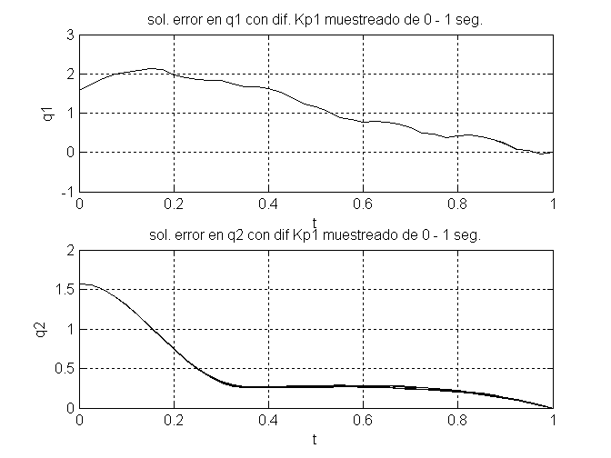

Fig 1a. Trajectory of the optimal control of position for and to 0 - 1 seconds with values different from K_{p1}.

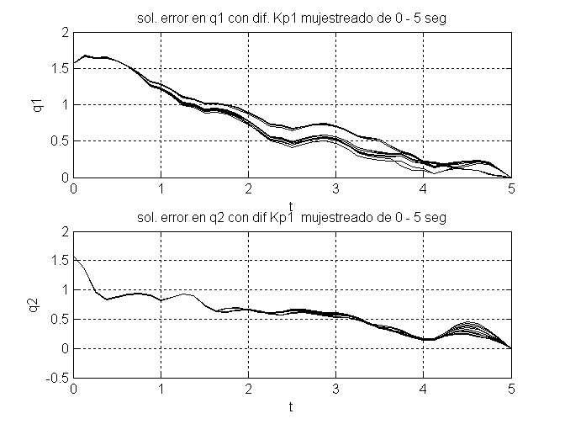

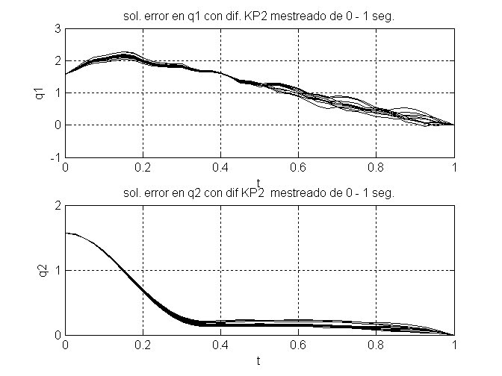
Fig 1b. Trajectory of the optimal control of position for and to 0 - 5 seconds with values different from K_{p1}.

Fig. 2a. Trajectory of the optimal control of position for and to 0 - 1 seconds with values different from K_{p2} .
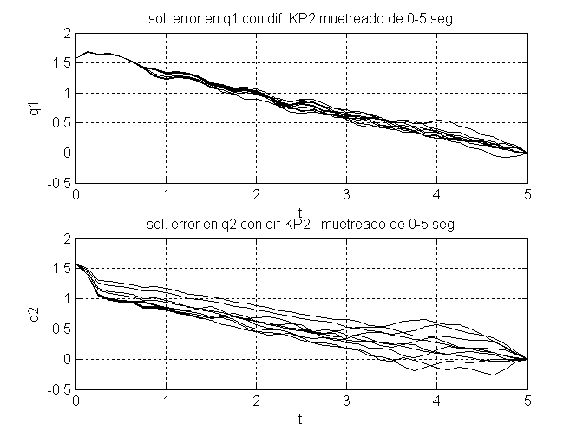

Fig. 2b. Trajectory of the optimal control of position for and to 0 - 5 seconds with values different from K_{p2} .
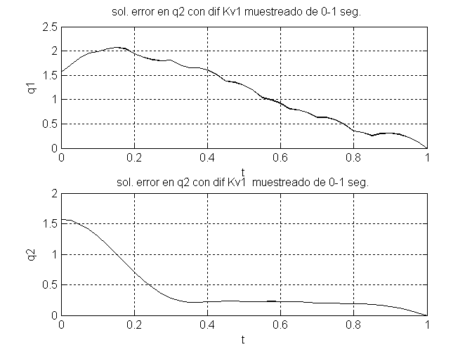

Fig. 3a. Trajectory of the optimal control of position for and to 0 - 1 seconds with values different from K_{v1}.
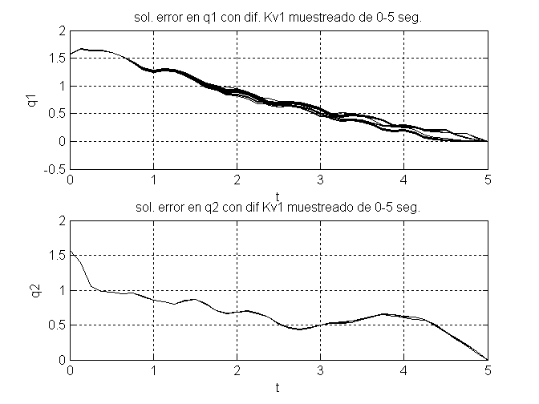

Fig. 3b. Trajectory of the optimal control of position for and to 0 - 5 seconds with values different from K_{v1}
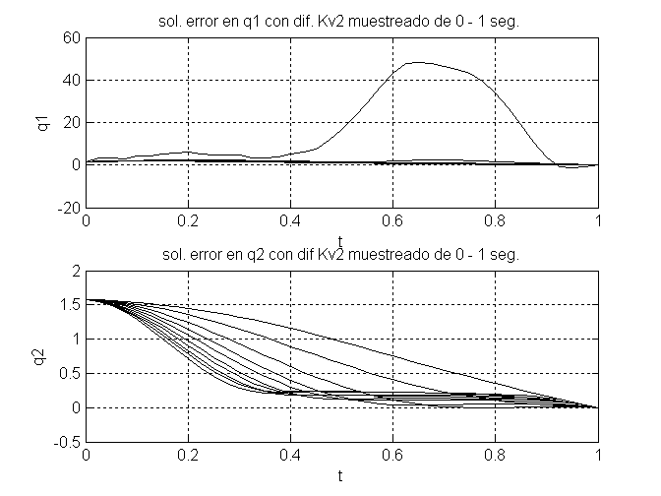

.
Fig. 4a. Trajectory of the optimal control of position for and to 0 - 1 seconds with values different from K_{v2}
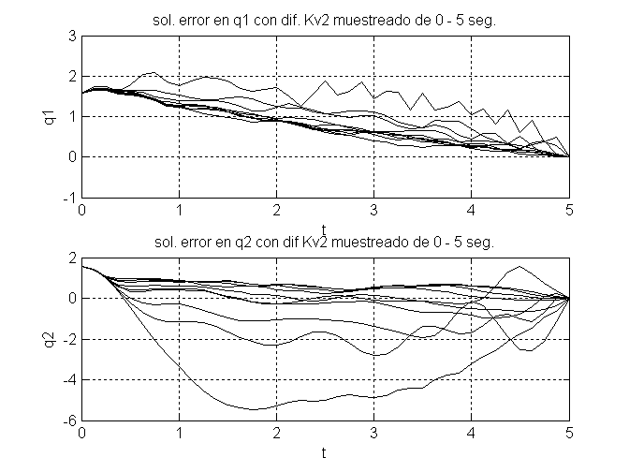

Fig. 4b. Trajectory of the optimal control of position for and to 0 - 5 seconds with values different from K_{v2}

By first instance it is important to mention that the figures 2 and 4 (K_{p2} y K_{v2}) represent the worse case, where the possible loads or momentary deviations due to some collision that can receive the manipulator robotic in the superior end, the graphs show that in spite of this, the manipulating robot does not lose its trajectory and is able to arrive at the wished point, this is important because the optimal controller of position gives sample that has an important degree of insensibility before external disturbances.

According to the curves of behavior developed and the given restrictions, note that, the controller is able to generate all possible trajectories for different values from K_{p} and K_{v}, and in all the cases of taking to the manipulator robotic to the wished point; this behavior is important because the version of the controller tanh - D optimal of position, behaves like so, when demonstrating that it has the ability to generate position trajectories in such a way that all converges of stable form to the wished position and most of these, do not undergo a well-known deviation among them.

Although the primary target of this paper is not to determine "the better" trajectory of optimal position for the robot of position at issue, become interesting observations for the family of generated optimal trajectories of position via shooting method; in the figures, note that, for all the constants exists a smaller variation in its trajectories for the interval of 0 -1 seconds, this is important because, is denoted that within this interval the region of greater convergence is, within this interval, also its important note that the figures 1a and 3a (graphics of K_{p1} and K_{v1}), a variation considerable on the constants produces very few changes in "the better" trajectory of optimal position for link 1, facilitating the tuning with link two (K_{p2} and K_{v2}), where the situation is different, whose graphs (figures 2a and 4a) single it has limited the region where one occurs to the fast convergence but in time and therefore the space of greater attraction to the wished point, with sights to find "the better" trajectory of optimal position.

By all the previous one, the conditions imposed in the application of the shooting method in the design of the optimal controller tanh-D of position, do necessary to notice here that the conditions developed in the present paper are sufficient to be able to use them in the solution of the canonical equations of optimality (9) and (10), for the generation of a family of optimal trajectories where is "the better" optimal trajectory of position that satisfies the imposed restrictions; this is important because they give the mathematical sustentation to the propose methodology and lays way to a new family of controller of optimal of position via shooting method.

Although that has not been made a complete analysis in relation to the robustness of the controller, it is considered that the shown thing is sufficient to base the reliability of the generation of stable asymptotic trajectories version controller tanh - D optimal of position.

5. Conclusions and future work.

In this paper was introduced the conditions necessary to apply to the shooting method in the design of an optimal controller of position in a manipulating robot type planar, obtained via Maximum Principle of Pontryagin; being carried out by means of an exhaustive analysis of the own characteristics of the dynamic model of a rigid manipulating robot of n-links when applying to him of the Maximum Principle for starting point and final fixed; being able to find a way to make independent a co-state (λ), by means of the introduction of a factor quadratic differential in the performance index, that in the end represents the important condition but for the use of the shooting method; giving like result the accomplishment of all the possible curves under the imposed restrictions, as well as the determination of a region of Maximal convergence within which is "the better" optimal trajectory of position, verifying that the controller tanh - D optimal of position under these restrictions, takes to all asymptotically stable the trajectories possible to converge of a form, even though this receives external disturbances in its final effector; all this analysis gives the necessary endorsement him to the propose methodology, making of this a new family of optimal controllers of position via shooting method.

This method lays the way to future investigations, to near the application of other strategies of control with different restrictions, that they can work in the diverse types of manipulators robotics for a task specifies. It is possible to indicate that the robustness and the analysis for other applications of the control method will have to be analyzed in future projects.

6. Acknowledges.

The authors want to express thanks to the Instituto Tecnologico de Puebla for the laboratories facilities and their valuable help. The present work was supported by the Consejo Nacional de Ciencia y Tecnología, the Asociación Nacional de Universidades e Instituciones de Educación Superior, the Consejo del Sistema Nacional de Educación Tecnológica and the Dirección General de Educación Superior Tecnológica (DGEST).
References.
[1] C.W.J. Hol, L.G. van Willigenburg, E.J. van Henten and G. Van Straten (2001). A new optimization algorithm for singular and non – singular digital time – optimal control of robots. Proceedings of the 2001 IEEE. International Conference on Robotics and Automation. May 21 –26.
[2] Dimiktry M. Girinevsky, Alexander M. Formalsky and Anatoly Yu Schneider (1997). Force Control of Robotics Systems. CRC press, Germany.
[3] J. Moreno Valenzuela (2003). Time Scaling of Trajectories for point to point robotic tasks, IATED International Conference Circuits, Signals, and Systems May, Cancun, México, pp 128-133.
[4] J.Y. Fourquet (1993). Optimal Control Theory and Complexity of the Time Optimal Problem for Rigid Manipulators. IEEE/RSJ International Conference on Intelligent Robots and Systems, Yakohama, Japan, July, pp. 84-90.
[5] John J. Graig (1989).. Introduction to robotics Edited by Addison Wesley Longman, Canada.
[6] John H. Mathews and Kurtis D. Fink (1999). Numerical Methods Using MatLab Third Edition. Edited by Prentice Hall, Upper Saddle River N.J.
[7] Jorge Angeles (1997).. Fundamentals of Robotics Mechanical Systems. Edited by Springer Canada.
[8] Kelly, Rafael, Santibañes Victor and Reyes F (1998). A class of adaptive regulator for robot manipulator. International Journal of Adaptive Control and signal Processing. Vol 12,41-62.
[9] L. Shin Yiu, and Bor-Sen Chen. Optimal hybrid position/force tracking control of a constrained robot (1993). International Journal Control, Vol 58, No. 58, No. 2, pp 253-275.
[10] Piccoli Benedetto (2002). A Short Introduction to Optimal Control. Edited by LAC-CNR.
[11] Pontryagin L. S., V.G. Boltyanskiy, R. V. Gramkredize and E. F. Mischenko (1962). The mathematical Theory of Optimal Process, Intercience, New York.
[12] Peter Coke (1997). Visual Control of Robots, John Willey and Sons Inc.
[13] R. Pallu de la Barriere (1980). Optimal Control Theory. Editied by Bernard R. Gelbaum, New York USA.
[14 ]R. Vinter (2000). Optimal Control. Edited by Birkhauser.
[15 ]Reyes Fernando, Jaime Estévez (2004). Optimal Position Control algorithm considering gravity. Proceedings WSEAS Conferences ASCOMS, TELEINFOR, AEE, MCP and ICA.P Cancún México.
[16] Spong M.W. & Vidyasagar, M. (1989). Robot Dynamics and Control. John Wiley and Sons Ny.
[17] T.L. Vincent and W.J. Grntham, (1997). Nolinear and Optimal Control System, John Wiley & Sons, INC.
[18] Zhiwei Lui, Hideyuki Ando, Shigeyuki Hosoe (2000). Spatial Generalization of Optimal Control for Robots Manipulator. 0-7803-6456-2/00. IEEE.

