Novel Detection Methods for Overhead Contact
System Zigzag Based on Neural Networks

CHEN TANGLONG XIAO JIAN
School of Electrical Engineering
Southwest Jiaotong University
Chengdu 610031
CHINA

Abstract: - Some new methods for the zigzag detection of overhead contact system (OCS) of high-speed electrified railway are discussed in this paper. Firstly,the algorithm for the computation of OCS zigzag is given.A low-pass filter is adopted to reduce the system errors.Then the modelling and system design using neural network and adaptive neural network fuzzy logic inference are given respectively.Finally,the efficiency and performance are verified with simulations and comparable to the practical test results.

Key-Words: - Overhead contact system, Zigzag, Pantograph, Dynamic detection, Neural network, Fuzzy logic inference

1 Introduction
With the rapid development of electrified railway, the dynamic detection of OCS and the acquisition of dynamic parameters of the high-speed pantograph-catenary system are significant to ensure railway transport safety and raise the current collection quality.
OCS zigzag is defined as the value that the contact line alternate pulls to both sides relative to the center of the line. More than sixty inducing sensors are equipped under pantograph to acquire the OCS zigzag in the conventional detection method. Therefore, the safety of pantograph-catenary is decreasing since the additive mass of the sensors adversely affects the contact property of the pantograph and catenary. In the detection method of OCS zigzag presented in this paper, only four sensors are fixed at each corner of the pantograph, and an acceleration meter is fixed at the center of the pantograph.Comparison with the tranditional method, the approach has many advantages. On one hand, the elasticity, contact force and impact force of the catenary can be measured directly. On the other hand, based on the obtained data, the corresponding OCS zigzag can be worked out using the mathematic model.
The paper is organized as follows. Firstly, in section 2, the low-pass filtering analysis is made to reduce the system errors, the neural network model and the adaptive neural network fuzzy logic inferencing system are designed in section 3, and the model training, subtraction clustering and the checking data to avoid producing some redundant structure of the system are studied in detail in section 4. Finally the modeling and simulation of nonlinear system is carried out, through comparison between the result obtained from using linear regressing analysis and detected data of Beijing railway, the feasibility of the detection method is verified. Each of those three methods mentioned has its own advantages and disadvantages, and they can be combined and used as complementary to each other.

2 Digital Filtering Analysis
The original data used in this paper are obtained from the line detection vehicle of Beijing railway station in May of 2004. The device was equipped with two pantographs, and the essential detection parameters include vehicle speed, off line, temperature, impact acceleration of the pantograph and catenary, height of contact line, left compensation value of vehicle vibration, right compensation value of vehicle vibration, level compensation value of vehicle vibration, left resultant forces of pantograph($f_{1}$) and right resultant forces of pantograph($f_{2}$). Since the OCS zigzag curves directly reflect the dynamic characteristics of pantograph and catenary when the vehicle is running, we focus our study in this paper on the modelling of the OCS zigzag based on the parameters mentioned above.

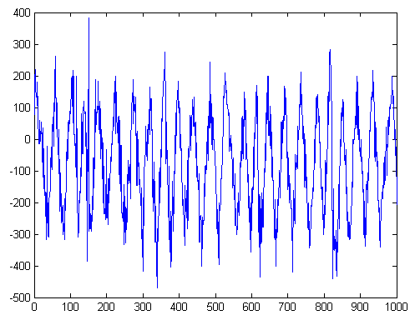

Fig.1 The original OCS zigzag curve obtained from classical dynamics model

From the classical dynamics analysis, the expression of OCS zigzag is expressed as:
Z＝C（$f_{1}$ －$f_{2}$）/($f_{1}$ +$f_{2}$) (1)
Because of the complexity of the pantograph-catenary system when locomotive is running at high speed and acute dithering of the catenary and pantograph, the computation error which results from above expression is significant, As shown in Fig.1 , the curve is dithering and not smooth.
Power spectral density analysis is carried out on the OCS zigzag calculated from the above expression, and is shown in Fig.2. It can be seen that the primary energy concentrates around 50Hz while the “small waves” of OCS zigzag curve is corresponding to the high frequency part of power spectral density. By adopting a lowpass filter, the OCS zigzag curve after filtering is shown in Fig.3, where ‘*’denotes bigger zigzag error points after filtering.

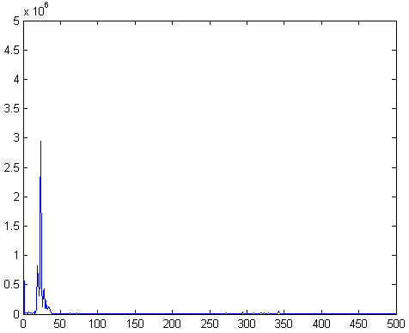
Fig.2 Power spectral density of OCS zigzag

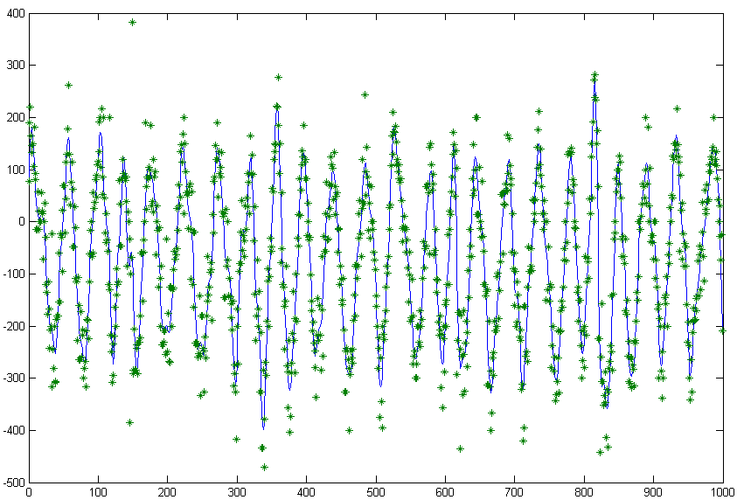

Fig.3 The OCS zigzag curve after filtering

3 The Design of BP Neural Network Model
From the physical structure of the vehicle,it can be concluded that the vibration of vehicle directly affects the accuracy of OCS zigzag computed through measured contact force. Comprehensively considering vehicle speed, off line, temperature, impact acceleration of pantograph and catenary, height of contact line, left compensation of vehicle vibration, right compensation of vehicle vibration, level compensation of vehicle vibration etc., and the nonlinear nature of the pantograph-catenary system, the neural network is chosen as a means of system modelling[1].
BP network is a multilayer feed forward network, and can be considered as a highly non-linear mapping from input to output. That is: F：R${}^{n}$－>R${}^{m}$，f（X）＝Y. As for the sample set: input x${}_{i}$（∈R${}^{n}$）and output y${}_{i}$（∈R${}^{m}$）, it can be supposed that some mapping g exists such that ： g（x${}_{i}$）＝y${}_{i}$, where i＝1，2，…,n. In the sense of least squares, f and g are very close. Neural network can approximate complicate nonlinear function by adequate combination of many simple nonlinear functions. In our case, we use some detected parameters of the neural network as the input to the neural network, OCS zigzag is the output of the neural network. Multilayer structure is adopted to reflect the inherent characteristics of the pantograph-catenary system.
3375 groups of representative original measurement data are chosen to train the neural network, and these data are divided into 4 groups: two for training, one for testing, and the other for validation. The parameter variations during the training process are shown in Fig.4. By adopting 5- layer BP network, the linear regression analysis demonstrates the center of almost coincide with that of optimal regressing and actual regressing which is shown in Fig.5. Fig.6 shows that the output curve further approaches to the goal if a low-pass filter is added after the neural network.

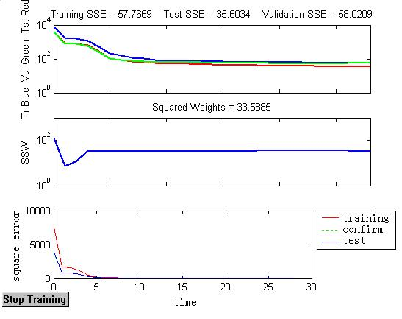
Fig.4 Output of training
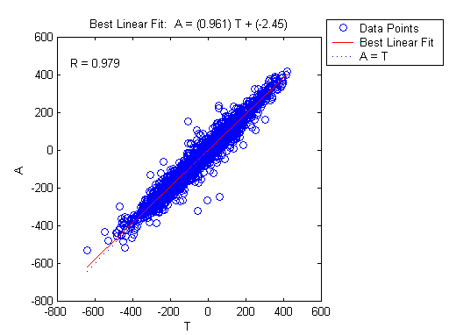
Fig.5 Linear regressing analysis results
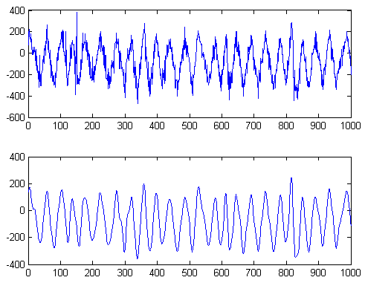
Fig.6 The comparison of the original OCS zigzag values and the output values generated by neural network plus filter

4 The Design of Adaptive Neural Network System Based on Fuzzy Inference
Subtraction clustering is a fast algorithm which can be used to estimate the number and the center of clustering in a group of data. The result can be used to initialize the fuzzy clustering and fuzzy identification based on the interaction process[2][3].
Supposing every data point to be the possible center of clustering in the subtraction clustering method, computation and analysis are performed according to the density surrounding each data point. Choosing one data point to be the center of the clustering, the actual center of clustering can be worked out. Processing other data points in the same way until the possibility of being the center of clustering for all the rest data points is lower than the specified threshold.
The fuzzy system and its rule bases are obtained on the basis of expert membership function. In this way, the essence of fuzzy rules is comes form the explanation of the characteristics of the model according to expert experience. The neural network system is characterized by self-learning function, and it can effectively figure out the best parameters of membership function. The combination of these two techniques and its application to the analysis of the model characteristics, form the adaptive neural network technique.
The configuration of adaptive neural network and fuzzy inference system (ANFIS) is very similar with that of the neural network. Mapping inputs through input variables membership function and corresponding parameters, and then through the mapping of output variables and corresponding parameters, the input data are mapped into the output space. The parameters affecting the shape of membership function can be adapted through learning process. The parameter estimation of the membership function can be implemented by applying back propagation algorithm of least squares.
Input variable and its membership function, fuzzy rules, output and its membership function are related to each other by the parameterized model. Organizing training data according to certain format, the ANFIS program can be used to train the parameterized FIS model. The parameters of membership function is adjusted in term of error rules so that the output of FIS model successively approximate the given training data.
In general, good results can be the characteristics of expected if the model we need is well represented with the obtained data. But it is not always the case. In practice, testing data contain noise, and then the results are not good. So the validity of the training of the process and results must be tested.
Not all data need to be used in the training in the construction of the model by ANFIS, since the computation time of ANFIS increasing with the increase of the data. Of cause the calculation will increase sharply if there is a mass of practicing data. In some cases, larger computations will cause worse training results. In our cases, the training data are divided into 3 groups, one for model training, one for model script of the training process, and the other for the testing of the model.
As mentioned previously, the choice of training data might affect the result, some preparing work are required for the acquisition of training data. Model validation in the training process and final results are also very important.
In the validation process, data not used in training process are used to check if the training model approximate well. In ANFIS functions, anther group of data named checking data set are also used to control the training process, so that the overall leaning model can be found.
The checking data and training data are sent to ANFIS function simultaneously. Generally, minimum modelling error of the checking data principly used to select adequate structure of the model. The testing data are not directly used as the training data to enter training process, but are auxiliarily used for judgment and selection. If the selected training data are not the representative of the system characteristics or contain large amount of noise, it is necessary to use checking data to avoid producing some redundant structure of the system.
The checking data are different to the validating ones; the latter are used to perform the corresponding calculation and comparison only after the final model is obtained, while the former are used and calculated simultaneously with the training data. During the training process, it happens that when system are not matched, there is a possibility that at certain interaction of the training process the error associated with training data set is getting smaller , but the error associated with checking data set is moving up sharply. In some cases, it can be seen that the system parameters do not match the training data.
The fuzzy inference engine of adaptive neural network is far more complex than that of ordinary fuzzy system, the fuzzy logic tool box of MATLAB only contains Sugeno type of fuzzy inference engine[4], and also has following restrictions:
- Only one or zero ranked Sugeno system is admitted.
- Only single output system is admitted, as well as to anti-fuzzy, only average weighting method can be adopted.
- All the rules must pick up unit 1 for weighting factor.
As for fuzzy inference control system of adaptive neural network, because of the different speed unit, taking into account that the speed affects the truncation error of OCS zigzag, the value of speed vector is lessen 10 times and corresponding proportion transform is also made.
As for input data, in order to avoid configuration redundancy, only some basic parameters are employed which can reflect all configuration characteristics of the system, and 1000 data points are introduced for system training, checking and testing.
Separately replacing variable P and T with training data, choosing 0.1 as Radii, subtraction clustering fuzzy logic inference system is created by learning. The accuracy is limited since the subtraction clustering fuzzy logic inference is carried out through one-time fast calculation, so the adaptive fuzzy neural network is required to optimize the system characteristics. In the system design procedure. the training parameter is picked by 100 steps, and the object error is 0.01.The simulation results are shown as following figures.

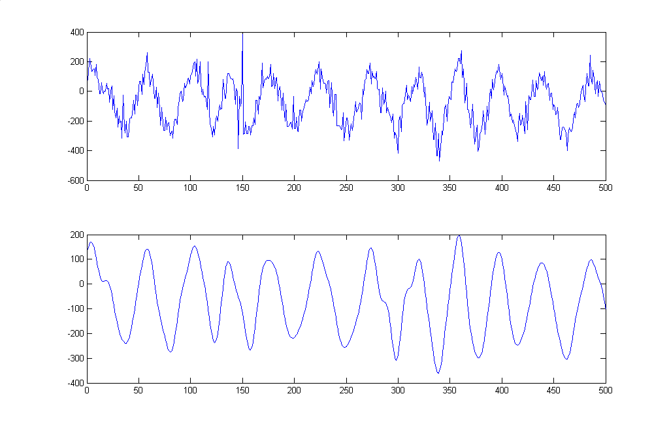
Fig.7 The OCS zigzag comparison of original and output of simulation with training data
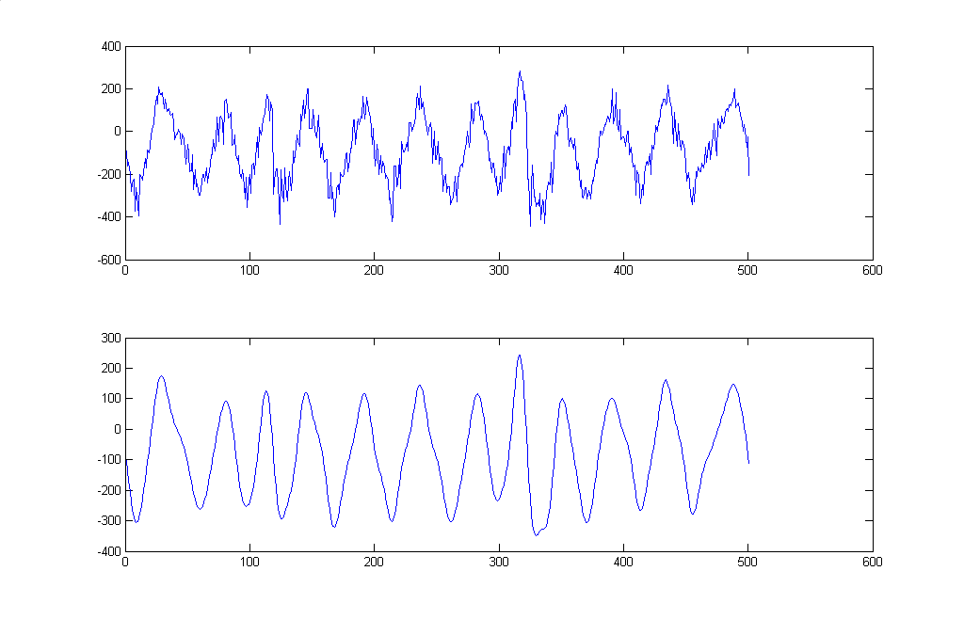
Fig.8 The OCS zigzag comparison of original and output of simulation with testing data

5 Conclusion
It is feasible to pick-up OCS zigzag by testing OCS elastic parameters. To achieve this goal, the following methods can be used: digital filtering analysis, BP neural network model,and the modelling and analysis of adaptive neural network fuzzy inference system. Each of those three methods has its own advantages and disadvantages, and they can be combined and used as complementary to each other.
Based on classical dynamics formula and adopt 50Hz lowpass digital filter, one can process detection data quickly and effectively and is adequate for analysis of pantograph and catenary system when locomotive is running at low speed. While for the OCS parameter detection of electrified railway when locomotives is running at high speed, besides taking dynamic contact force into account, some data must be considered synthetically such as impact acceleration, off-line, vibration of vehicle, speed etc. Using neural networks and fuzzy inference adaptive neural network system, and artificial intelligence method to process the detection data, has the ability of self-learning and processing non-structured information. Therefore, when these methods are used to analyze and model the non-linear system of OCS zigzag detection, one can get better results. However, the computation amounts is relatively large and the whole system is rather complex, also the redundant structure of the system has to be avoided in the training process.

References:
[1]Simon Haykin,Principle of Neural Network,Science Press,2001
[2] WEN Xin. Simulation and Application of Neural Network. Science Press, 2002
[3] ZHANG Junying, LI Li, Theory and Application of Binary forward Artificial Neural Network, Xidian University Publishing House, 2002
[4] WU Xiaoli, WANG Jianxing, Auxiliary Design of Fuzzy System by MATLAB, Xidian University Publishing House, 2003

