Improvement of transient stability by variation generator parameters and high speed fault clearing

S.Jalilzadeh  Electrical Engineering Department  Zanjan university | S.Jadid  Electrical Engineering Department  Iran university of scince and technology

Abstract: In recent years, power systems have been operated under more stressed conditions and close to their stability limits. Due to recent blackouts, power system security has become a major concern. Under these circumstances, an important problem that is frequently considered for secure operation is the severity of transient stability. This paper presents a study on transient stability of two IEEE test systems. The influence of bus loads, generation changes, network changes and generator parameters variation on transient stability are investigated in this paper. It is shown that transient stability is improved by various parameter changes such as increase in generation, inertia constant, open circuit transient time constant, decrease in transient reactance and decrease in line reactance.

Keywords: Transient stability, Generator parameters, Contingency

1 Introduction

In system operation, dynamic security analysis encompasses a large class of problems, such as finding the security levels of the power system, the power transfer limit in a transmission line, the worst contingency in some specified area of the system, etc. Transient stability analysis is the evaluation of the ability of the system to withstand contingencies by surviving the transient conditions to acceptable steady-state operation and gives indications about the remedial actions when necessary. Transient stability calculation plays such an important role in power system planning and operation,

which makes affectability to the security and
efficiency of the power grid. Models of the electrical equipments are the critical factors that influence the result beside the algorithm of the simulation program. These studies provide necessary information to select the proper set of relays and circuit breakers such that a fault is cleared in time without losing system stability.
Modern power system, exhibits a wide range of complex dynamic behaviour. Security of power system is its ability to withstand some unexpected, but probable disturbances without violating the operating constraints in the remaining system. Typical examples for

contingencies are bus bar faults, load and generator losses, transmission line trips, etc. Keeping the system in secure state requires a data acquisition and real time control system.
One of major responsibilities of the control system is monitoring the real time power system to assess the security and apply control if necessary.
In general, outage or change in the independent parameters, gives rise to transient phenomena in the electrical and electromechanical states of the power system. Large power systems require the analysis of all the credible contingencies within a very short time. For large complex power systems, it is impractical and unnecessary to perform full detail analysis on the influence of every contingency. Contingency studies determine the effects of line/equipment outage on the rest of power system. Therefore, a screening algorithm that filters out very stable cases and selects more severe contingencies, has been adopted as a key function in the transient stability monitoring.
Different criteria are discussed in the literature to determine if an operating regime is secure from a transient stability viewpoint. One criterion suggests that an operating condition is stable if all load bus voltages increase when a source voltage increases, or a shunt capacitor is switched in [1]. Another criterion is investigated probabilistic voltage stability indexes [2]. A simple and practical method of synthesizing the load dynamic characterization is showed in [3]. Dynamic load modelling is necessary for power system dynamic simulation. New contingency ranking technique in cooperation on voltage stability criterion is discussed in [4]. Also new ranking method for power system security analysis investigated in [5]. This paper highlights the fact that incorporation of the transient stability analysis, the load increasing procedure, affects the increase of
active power generation. Variation of generator parameters in transient stability improvement is also investigated. This paper is organized as follows: section 1 presented the justification of the developed scientific research work. Section 2 describes the system modelling. In section 3

effect of parameter variation and numerical results are presented. And finally some techniques for stability improvement is investigated.

2 System modelling
The 9 and 14 bus IEEE test system data are constructed based on PSS/E format raw data. The 9-bus system has 3 generators GENROE and 3 exciter, IEEET1 type.
The 14-bus system has 5 generator GENCLS type. Load flow data for test systems is taken from [6].
Three-phase short circuit fault is applied on the selected bus in both the test systems and then removed after 5 cycles (0.1 second). To study the stability of the test systems, the generator’s rotor angle is plotted for 7 seconds. If the rotor’s angle is more than 90 degree, then it implies that the system is unstable.
Considering the two test systems, a three-phase short circuit fault is simulated on line 5-7 of 9-bus system and on line 6-12 of 14-bus system, which are removed after 0.1 second. It is seen that due to the above fault, both the above systems are stable (Fig. 1,2). Then by change in parameters such as increase in loads in selected buses the phenomena of system and how to improvement stability is investigated.

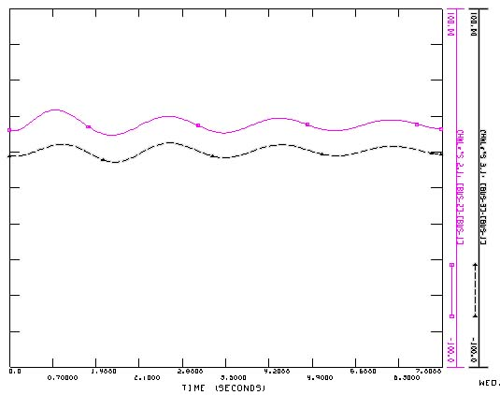
Fig. 1:angle of generator 2 and 3(9 bus)

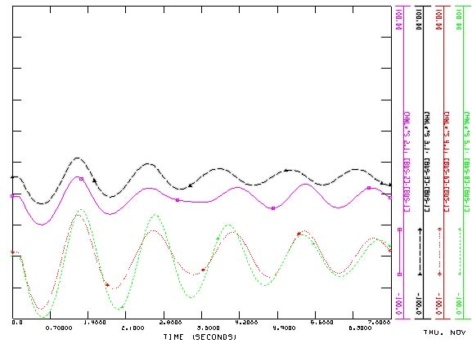
Fig. 2:angle of generator 2,3,6 and 8(14 bus)

3 Effect of parameter variation
Maintaining stability is easier if electric power is large because for any loads, rotor angle is small and for any given increase in load, the increase in rotor angle is small.
Loads play very important role in transient stability. Loads of power system often changes. The location and level of loads effects the operation state and transient stability of power system.
Stability limits are derived for the following parameter changes:
1-generation and generator parameters changes.
2-load changes.
3-network changes.
Phenomena of power system for these changes would assist the system operator in determining how the system responds to a change in any one of the above parameters.
To start with an unstable network, the system load is increased until it becomes unstable (Fig. 3,4).

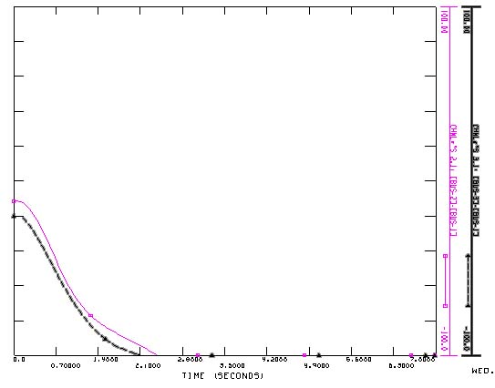
Fig. 3: angle of generator 2 and 3 after increase load (9 bus)

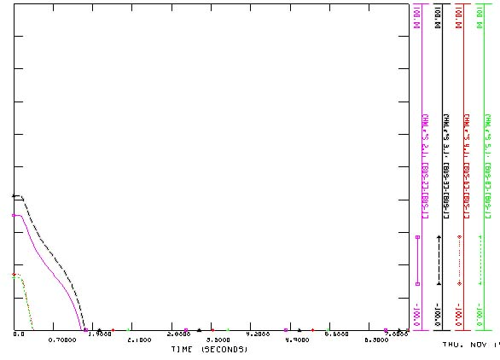
Fig. 4:angle of generator 2,3,6 and 8 after increase load (14 bus)

The loads have increased in steps of 0.05 pu in buses 5,6 and 8 in 9 bus and similarity buses in 14-bus system. Base loads in selected buses in both systems before increasing and after increasing until instability is shown in Table 1.

Table 1: base loads in two test systems in pu
system | Base load on selected bus
9 bus IEEE | Pl5=0.5 , P6=0.5 , Pl8=1.25
14 bus IEEE | Pl2=0.217 , Pl6=0.112 , Pl9=0.33

With increase the loads by 0.05 pu in each stage this system is unstable when loads in selected bus is reach to 1.43, 1.43 and 2.295 pu for bus 5,6 and 8 respectively. Similarity load in selected buses in 14bus system increase by 0.05 pu in each stage. This system is unstable when loads in selected buses are reach to 0.317,0.212 and 0.4391 pu for bus 2,6 and 9 respectively.

3.1 generation
To improve the system stability, the generator active power is increased, Fig. 5 shows the effect of increasing P_{g2} &P_{g3} (in 9 bus system) output from 1.63 and 0.85 pu to 1.6354 and 0.852856 pu respectively, which caused that, the system is more stable. Also Fig. 6 shows the effect of increasing P_{g2} , P_{g3}, P_{g6} and P_{g8} (in 14 bus system) output from 0.8039,1.0445,0.1007and0.0011pu to 0.8539,1.0945,0.1507and 0.0511 pu respectively.
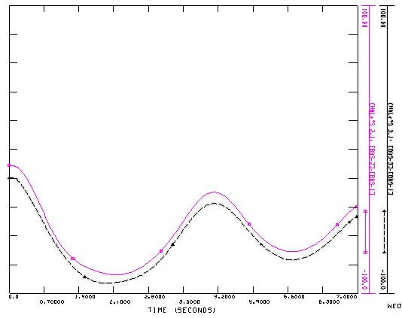
Fig. 5: stable states in generator angles after increase of generation (9 bus).

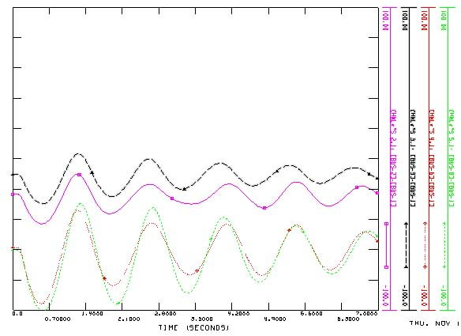
Fig.6: stable states in generator angles after increase of generation (14 bus).

3.2 Inertia Constant $H$
A heavy machine has grater inertia and is more stable than a light machine. A salient pole generator operates at lower angle and is preferred than cylindrical rotor generators from considerations of stability.
Inspection of the swing equation, shows that increasing the inertia constant H of a synchronous machine reduces angular acceleration.
(1)
With increase the inertia constant, oscillation in rotor angle is decreased and thus system becomes more stable [7]. Fig. 7 illustrates generator angles after increase of H from 23.64 to 24.1 in 9bus system. Similarity figure 8 shows effect of changing H from 5.145 to 7 for swing generator in 14bus system.

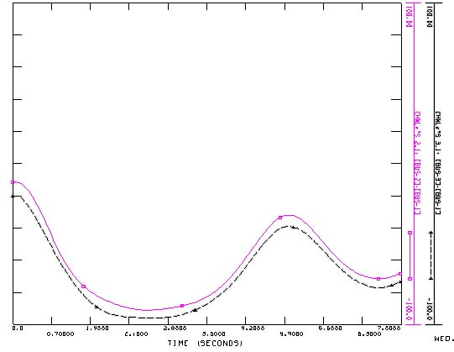
Fig. 7: effect of increase H in 9-bus system

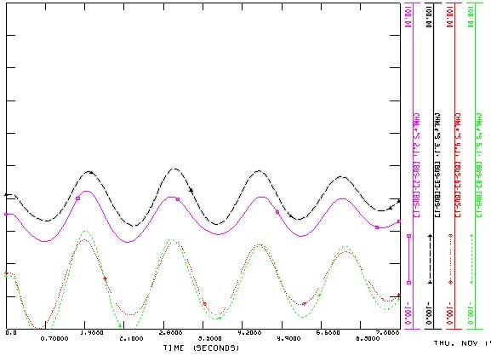
Fig. 8: effect of increase H in 14-bus system

3.3 Open circuit transient time constant ($T_{\text{do}}^{'}$)
Increase of open circuit transient time constant causes decrease of transient reactance and consequently decreases generator reactance which makes the system more stable as shown in equation (2):
$X_{d}^{'}=ωL_{d}^{'}={ωL}_{d}(\frac{T_{d}^{'}}{T_{\text{do}}^{'}})$ (2)
Then open circuit transient time constant has been changed in the generators model from 8.96 to 10.5 in 9-bus system and the result is shown in Fig. 9.
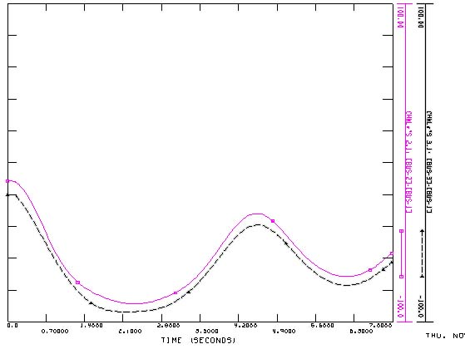
Fig. 9: effect of changing $T_{\text{do}}^{'}$ in 9-bus system

3.4 generator reactance $X_{d}$
Stability is also improved by reducing machine reactance, which increases power transfer capability during fault or post-fault periods as shown in equation (3).
(3)
Decrease in generator reactance from 0.146 to 0.1 for swing generator become that system is more stable as shown in Fig. 10.

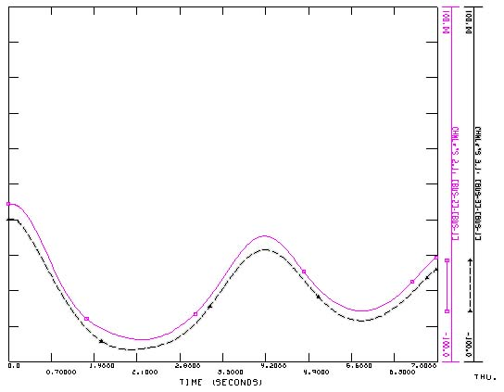
Fig. 10: angle of generator 2 and 3 after decrease generator reactance.

3.5 Rapid fault clearing time
High speed fault clearing is fundamental to transient stability. Standard practice for EHV systems is 1-cycle relaying and 2-cycle circuit breakers, allowing for fault clearing within 3-cycle(0.06second).

Three-phase short circuit fault is applied on the selected bus in both the test systems and then removed after once 5 cycles (0.1 second) and in next stage in 3 cycles(0.06 second). As seen in Fig. 11 and Fig. 12 when clearing time faulted is very short, the system is going toward stability.
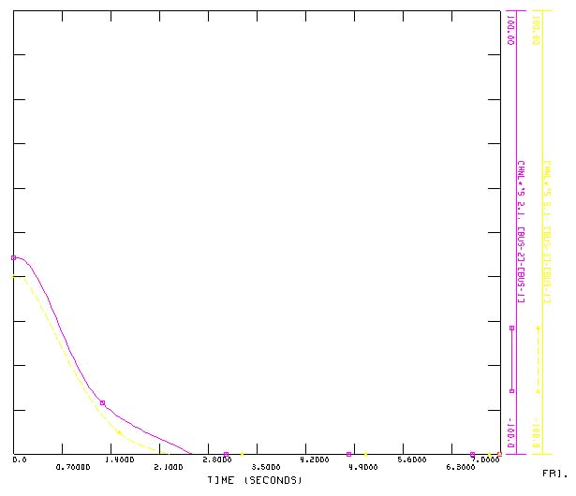
Fig. 11: angle of generator 2 and 3 for fault clearing time 0.1 second

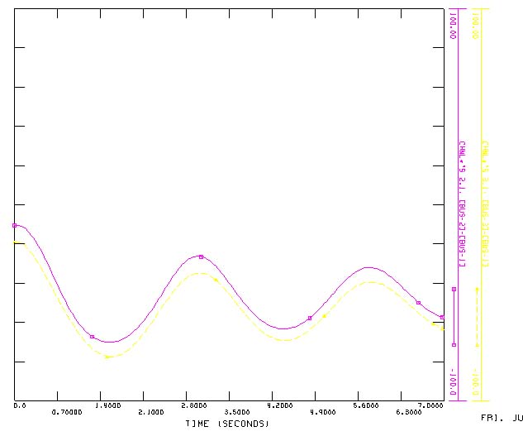
Fig. 12: angle of generator 2 and 3 for fault clearing time 0.06 second.

4 network changes
The effect of change of line impedance on transient stability for a specific contingency is investigated in this study. Reactance in line 5-7 in 9 bus IEEE test system is 0.16 which decrease to 0.06.Fig.13 shows the decrease of line impedance on stability with respect to previous condition.

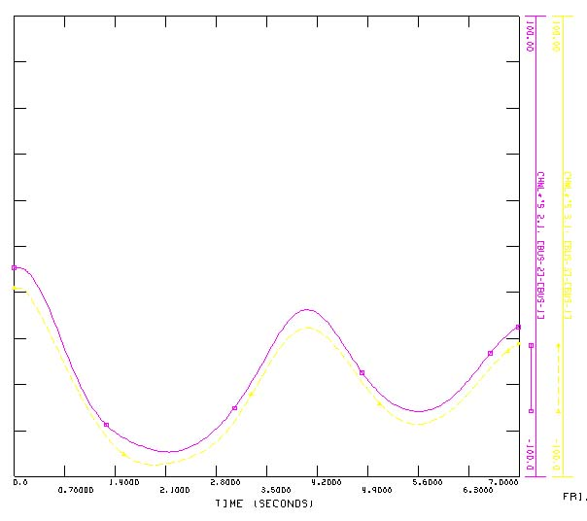
Fig. 13: angle of generator 2 and 3 for decrease reactance in line 5-7 from 0.16 to 0.06.

5 Techniques for stability improvement
The major techniques for improving stability can be classified into techniques:
1-Design of generator with high inertia constant H.
2-Rapid fault clearing.
3-Reduction in transfer reactance: The amplitude of power angle curve is proportional to the transfer reactance. This reactance can be reduced by connecting more lines in parallel. The use of bundled conductor lines and compensation of line reactance by series capacitor helps in reducing reactance and improving stability.
4-Automatic reclosing: Most of the faults on the transmission lines are of transient nature and are self clearing. In modern circuit breakers when a fault occurs, the faulted line is de-energised to suppress the arc in the fault and then circuit breaker recluses, after a suitable time interval. Automatic reclosing helps in improving stability.
5-Increase of voltage: the amplitude of the power angle curve is directly proportional to the internal voltage of the machine. An increase in voltage increase the stability limits.
6-Fast valving.
7-Braking resistor.
8-High gain exciters.

6 Conclusions
This paper demonstrated that various generator parameters affect the stability of the power system. It was shown that increase of active power, inertia constant, and open circuit transient time constant, and decrease of generator reactance, line reactance, fault clearing time can improve the stability of the power system. It is clear that investigating the trend of changes in various models; one can obtain typical value of different parameters in a real power system, in which usually the exact values are not accessible.

References
[1]S.Abe and A.Isono. Determination of power system voltage instability, pts.1 and 2. Tranc.IEE (Japan), 96-b, 1976,pp171-186.
[2]T.AM.Sharaf & G.J.Berg. Probabilistic voltage stability indexes. Generation,Transmission and Distribution, IEE Proceeding, Vol.138, No.6, 1991, pp 499-504.
[3] Z.Hongbin .at.al. Application of different load models for transient stability calculation. Power system technology Procceding of power conference 2002,Internationalconference.Vol.4,13-17 Oct.2002,pp2014-2018.
[4] G. B. Jamson & L. H.CC. Le Beng. New contigency ranking technique in coorperation a voltage stability criterion. IEEE proceeding C, Vol.140 , No.2 , March 1993 .
[5] Lo. K. L. & Bismil. M. A. A new ranking method for power system security analysis. proceeding of university power engineeing conference Huddesfield, 1985, pp 408-411.
[6]www.uwaterloo.ca.edu
[7]Prabha.Kundur.Power system stability and control.New York.McGrawHill.Inc.1993.

Appendix
Generator models

GENCLS(swing equation generator)

$$\overset{\text{.}}{δ}=ω_{s}n$$
$2H\overset{\text{.}}{n}=\frac{1}{1+n}(P_{M}−D_{n})−\frac{E_{\text{fd}}V\text{sin}(δ−θ)}{X_{s}}$

IEEET1(IEEE type 1 exciter)

$$T_{E}{\overset{\text{.}}{E}}_{\text{fd}}=−(K_{E}+S_{E}(E_{\text{fd}}))E_{\text{fd}}+V_{R}$$
$$T_{E}{\overset{\text{.}}{R}}_{f}=−R_{f}+K_{F}E_{\text{fd}}$$
$$T_{A}\overset{\text{.}}{V_{R}}=−V_{R}+\frac{K_{A}}{T_{F}}(R_{f}−K_{F}E_{\text{fd}})K_{A}(V_{\text{ref}}−V_{T})$$
GENROU(round rotor generator)

$$\begin{aligned}T_{\text{do}}^{'}\overset{\text{.}}{E^{'}q}=−E_{q}^{'}−(X_{d}−X_{d}^{'})(I_{d}− \\ \frac{(X_{d}^{'}−X_{d}^{''})(ϕ_{d}+(X_{d}^{'}−X_{l})I_{d}−E_{q}^{'})}{(X_{d}^{'}−X_{l})^{2}})−S_{\text{fd}}+E_{\text{fd}}\end{aligned}$$
$$T_{\text{do}}^{''}{\overset{\text{.}}{ϕ_{d}=−\overset{\text{.}}{ϕ}}}_{d}+E_{q}^{'}−(X_{d}^{'}−X_{l})I_{d}$$

$\begin{aligned}T_{\text{qo}}^{'}\overset{\text{.}}{E_{d}^{'}}=−E_{d}^{'}−(X_{q}−X_{q}^{'})(I_{q}− \\ \frac{(X_{q}^{'}−X_{q}^{''})(ϕ_{q}+(X_{q}^{'}−X_{l})I_{q}+E_{d}^{'})}{(X_{q}^{'}−X_{l})^{2}})+S_{1q}\end{aligned}$

$$T_{\text{qo}}^{''}\overset{\text{.}}{ϕ_{q}}=−{\overset{\text{.}}{ϕ}}_{q}+E_{d}^{'}+(X_{q}^{'}−X_{l})I_{q}$$
$$\overset{\text{.}}{δ}=ω_{s}n$$
$$\begin{aligned}2H\overset{\text{.}}{n}=\frac{1}{1+n}(P_{M}−D_{n})−\frac{X_{d}^{''}−X_{l}}{X_{d}^{'}−X_{l}}E_{q}^{'}I_{q}− \\ \frac{(X_{d}^{'}−X_{d}^{''})}{X_{d}^{'}−X_{l}}ϕ_{d}I_{q}−\frac{X_{q}^{''}−X_{l}}{X_{q}^{'}−X_{l}}E_{d}^{'}I_{d} \\ −\frac{(X_{q}^{'}−X_{q}^{''})}{X_{q}^{'}−X_{l}}ϕ_{q}I_{d}−(X_{q}^{''}−X_{d}^{''})I_{d}I_{q}\end{aligned}$$

$X_{d}$: d-axis synchronous reactance
$X_{d}^{'}$: d-axis transient reactance
$X_{d}^{''}$: d- axis subtransient reactance
$X_{q}$ : q-axis synchronous reactance
$X_{q}^{'}$: q-axis transient reactance
$X_{q}^{''}$: q axis subtransient reactance
: field circuit time costant $T_{E}$
$K_{F}$: stablizer gain
$K_{A}$: amplifier gain
$T_{F}$: stablizer time constant
$T_{\text{do}}^{'}$: d-axis open circuit transient time constant
$T_{\text{do}}^{''}$: d-axis open circuit subtransient time constant

