Detection and Reconstruction for 3D – Wreck and Recognition by Using Neural Network Classification Technique

ONSY A. ABDEL ALIM AND HATEM AWAD KHATER
Elec. Eng. Dep., Faculty of Eng., Alex. University

Abstract

Automated identification and classification of signals obtained from active sonar is a complex problem because of the large variability in the received signals from underwater objects. This paper presents the following tasks: First, we determined the boundary of the underwater objects by analysis the reflected echoes from the surface of different underwater objects in horizontal beam aspect to get the 2D- image of the underwater objects in addition to a time delay method focusing processor sums the hydrophone outputs to form 2D matrix image pixels representing a vertical slice of the object. A sequence of vertical slices forms 3D – image which can be viewed from different angle to allow visualization of the object. Practical measurements were carried out the Research Center (R.C) in Alexandria that is supported with a standard water tank. Second, In the preprocessing step we detect the edge detection for the image by using "Canny algorithm ". Third, we based on the statistical analysis to extract vector features of image. Fourth, Fast Back-propagation algorithm (FBP) is designed and evaluated which leads to higher classification accuracy and also provides a mechanism for recognizing by using 3 layer perceptions. An efficient approach to reduce the computation time taken by Neural Network algorithm for the searching process is introduced. A recognition rate of 98% has been achieved over real tests.
Key words: 3D objects Detection, Pattern recognition, Edge detection, Neural Network, feature extraction.

1.Introduction

Side-Scan sonar system are used to image the sea bottom in order to detect man – made objects that can be distinguished from the background structure of the sea bottom [1] and to detect the other bottom [2] contacts which although not hazardous to navigation are of considerable importance in both submarine and mine-warfare operations also used to detect the wrecks and obstructions that may be dangerous to surface and subsurface navigation which lie between sounding lines. Two frequencies of Transmissions are often used; one for normal search operations and another, higher Frequency for every high resolution, the pulse repetition frequency is governed by the selected range. All side scan sonar transmits and receives acoustic pulses of energy. Most of the energy arriving on to the seabed is scattered forward in the specular direction, with a small portion absorbed by the seabed itself. However a small portion of energy is scattered back to the sonar, amplified and recorded, the strength of the returning echo will be governed by several factors which are linked by the sonar equations. This is a complicated equation which links the strength of the returning echo to the level of energy transmitted, the loss due to attenuation, spreading, and the target strength. The time shift between the transmission and reception is directly proportional to the distance between the sonar and its target (the slant rang). Signal amplitude is related to the amount of back scattering from the seabed. The active sonar performance may be either noise or reverberation limited, depending on which type of interfering is dominated [3]
-Noise limited case :
SE = SL + TS + RD + DI + 2PL (1)
- Reverberation limited case :
SE = SL + TS – RD - RL – PL (2)
Where, SE: signal Excess, SL: source level, TS: target strength, RD: Recognition differential, NL: Noise level, DI: Directivity index, PL: Propagation loss, RL: Reverberation level.
In symbols: T.S = 10 log $\left|\frac{I_{r}}{I_{i}}\right|$r=1 (3) where :
I_{r}: is the intensity of return at 1 yd, I_{i} : is the incident intensity
In modern underwater missions, the use of automatic or autonomous [4] devices is constantly increasing in order to avoid the direct involvement of human operators in dangerous tasks and to support the operator in making decisions about manipulation and navigation tasks. For instance, the analysis of the acoustic images acquired with an underwater devices quality of images is poor and the operator relaxes his attention owing to the long duration of the mission. As a sequence, Neural Network algorithm is able to recognize an object on the basis of a priori knowledge of the model and to estimate at the same time its attitude are surely very useful dependent on extract the vector features of the image.

2.Experimental Set Up

The experimental measurements carried out at the research center (R.C) in Alexandria [3]. Measurements were made at frequency 50 KHZ, pulse width 2.5 msec. The sweep time 5 m sec/div, amplitude 5v/cm.The transducer and hydrophone are placed at 0.75 m above the underwater object and 0.15 meter under the surface water in the anechoic water tank. The output pulse from the signal generator was amplified by a transmitter power amplifier and fed to the transducer, which radiates the acoustic signal through the medium. The reflection from the object was received by a hydrophone whose output was amplified and filtered. In all cases, the objects were irradiated in horizontal beam aspect to get the boundary of the underwater objects. We repeated the previous cases under the same conditions and in these cases the objects were irradiated from vertical direction aspect to get the third dimension of the object (height). The pulse repetition rates of 400 pulse / sec permitted two way transmissions in water for the maximum range and for an average speed of sound in water equal 1480 m/s. We used mathematical programs to gather and manipulate the boundary and the height of the object to get the 3d- image of the objects. In the preprocessing step we detect the edge detection for the image by using "Canny algorithm ". Then we based on the statistical analysis to extract vector features of image. The fast back-propagation algorithm (FBP) is designed and evaluated which leads to higher classification accuracy an also provides a mechanism for recognizing by using 3 layer perceptions. . In the input layer of the network, there exist five nodes for five features and five neurons in the output layer for five objects. The number of nodes in the two hidden layer are determined experimentally in our simulation, we select the number which gives the best recognition result i.e. (12 neurons in the first hidden layer and 10 neurons in the second hidden layer were used). An efficient approach to reduce the computation time taken by Neural Network algorithm for the searching process is introduced. A recognition rate of 98% has been achieved over real tests.

3.Edge Detection (Image Preprocessing)

We can use the Edge function to detect edges [4], which are those places in an image that correspond to object boundaries. To find Edges, this function looks for places in the image where the intensity changes rapidly using one of this criteria:
- Places where the first derivative of the intensity is larger in magnitude than some threshold.
- Places where the second derivative of the intensity has a zero crossing.
Edge provides a number of derivative estimators, each of which implements are of the definitions above. For some of these estimators, you can specify whether the operation should sensitive to horizontal or vertical edge, or both edge returns a binary image containing 1's where edges are found and 0's elsewhere.
- Edges take an intensity image 1 as its input, and return a binary image BW of the same size as 1's, with 1's where the function finds edges in 1's and 0's elsewhere.
- Edge support six different edge – finding methods.
In this research we prefer to use canny method which finds [4] edges by looking for local maxima of the gradient of 1. The gradient is calculated using the derivative of a Gaussian filter. The method uses two thresholds, to detect strong and weak edges, and include the weak edges in the output only if they are connected to strong edge. This method is therefore less likely than the others to be "fooled" by noise, and more likely to detect true weak edges

4.Shape Analysis and Representation

Shape analysis is useful in number of applications of machine vision, including underwater image analysis, medical image analysis and manufacturing. The various representations that have been used fall into five classes. The first class is a representation of global features which can be used through binary representations where the pixels inside the object have value one and pixels outside the object have value zero. Commonly used feature 2D – Shape representation includes area, perimeter, moments, eccentricity, and elongation [5]. The next representation class is local features representation which characterizes an object by its local features and their properties and whose edges represent relationships among features [2],[9], [10].Next class is boundary representation, which is the most common representation for 2D – objects. There are three way to represent boundary, one a sequence of points, second by its chain code and the last sequence of line segments [6].Skelton representation is the fourth representation class. It depends on the shapes, which contain long thin parts called Strokes. It can be described as a sequence of segments that satisfy the linearity of the strokes. The symmetric axis is one example of a description of 2D – object. The final class depended on decomposition of the entire shape into smaller 2D – parts [5].

5. Feature Extraction

When we process an image, we want to obtain information about how certain features of the image change. The image is divided into a group of sub image. Each one differs from its neighbor by a step of one pixel [6]. In order to make the algorithm invariant to illumination changes. We based on statistical analysis method to extract the vector features of these images. These features values are applied to the MBP algorithm in the recognition step.

6.Neural Network Approach

In this section a brief introduction to the concepts of the neural networks and the back- propagation algorithm used to train neural networks are presented. Neural networks are inspired mainly from the neural networks of the human nervous system. It is not noted that human neural networks are formed of large number of simple processing units connected to each other by massive connections and that these connection strength named synaptic weights varies and this network learns from experiences it faces. The elasticity of these connections and the parallel operation of neurons (simple processing unit) constitute the power of the human nervous System. Following this paradigm, artificial neural network models are constructed. Neural network model is characterized by three main things : the network topology (the layout of the arrangement of neurons and the way in which they are interconnected), the activation function of the neurons, (which represents the simple operation (function) that this neuron performs on its input), the training algorithm that is used to train the network (the rule following which the weights connecting the neurons are modified in order to make the network learn the function that it is being taught).

7.Result

Figs (1, 2, 3, 4, and 5) represent samples of the echo which returned and received by the hydrophone from five different objects. The first pulse represents the pulse that coming direct from transducer and the following pulses represent the echo which returns from the objects which help us to determine the third dimension of these objects by using a time delay method. we reconstruct 3d- image of these objects dependent on 2D- image of side scan sonar and the third dimension of the objects. We determined the edge detection of the images; figs (6, 7, 8, 9, and 10) represent the edge detection images for five different objects. We based on the statistical analysis, and extract the vector features of the image, in FBP algorithm to reduce the computationally complexity and to avoid local minima problem, we adaptedively vary the learning rate and moment factor. In the input layer of the network, there exist five nodes for five features and five neurons in the output layer for five objects. The number of nodes in the
two hidden layer are determined experimentally in our simulation, we select the number which gives the best recognition result i.e. (12 neurons in the first hidden layer and 10 neurons in the second hidden layer were used).Recognition rate of 98% has been achieved over our tests.

8.Conclusion

This paper demonstrates that the acoustic echo which returns from different underwater objects in vertical beam aspect to detect the third dimension of these objects by using a time delay method. Then we reconstruct 3D – image of these objects dependent on 2D – image of side – scan sonar. We detect the edge detection for these images using canny algorithm. We based on statistical analysis method to extract the vector features of these images. These features values are applied to the MBP algorithm in the recognition step. Simulation results shows that the proposed Neural Network algorithm using statistical analysis feature extraction gives better recognition results than the conventional methods.

References

[1] BJARNE STAGE, AND BENOIT ZERR "DETECTION OF OBJETS ON THE SEA BOTTOM USING BACK SCATTERING CHARACTERISTICS DEPENDENT ON THE OBSEVVATION POINT" OCEANIC ENGINERING, VOL.22, PP.40 – 46, 1997.
[2] R.J.URICK, PRINCIPLES OF UNDER WATER SOUND FOR ENGINEERS "NEW YORK. MCGRAW-ILL, 1983.
[3] ONSY A ABDEL ALIM , AND HATEM AWAD KHATER, "RECOGNITION OF UNDER WATER TARETS USING SCATTERING CHARACTERISTICS DEPENDENTON TURBULANCE "IN NATIONAL RADIO SCIENCE CONF , EGYPT F2 PP1 – 8, 2000.
[4] GIAN LUCA FORESTI, VITTORIO MURINO "AVOTING – BASED APPROACH FOR FAST OBJECT RECOGNITION IN UNDERWATER ACOUSTIC IMAGES,"OCEANIC ENG. VOL.22, PP57 – 65, 1997.
[5] SAID E. EL-KHAMY, ONSY A.ABDEL-ALIM, AND MARIAM M. SAII “ NEURAL NETWORK FACE RECOGNITION USING STATISTICAL FEATURE EXTRACTION” IN NATIONAL RADIO SCIENCE CONF , EGYPT C31 PP.1 -8, 2000.
[6] HAZEM. M, MOHY. A, AND M.S.KAMEL, "MODULER NEURAL NETWORKES FOR FACE DETECTION "NRS CONF EGYPT C3 PP1-8, 2000.
[7] IRAKY.H .AND MOHAMED .S "SHAPE SIGNATURE FOR RECOGNITION PROCESS "NRS. CONF, EGYPT C17 PP1-8, 2000.
[8] STEVEN G, AND LESTER, R, AND STADI PANADA "SPATIAL AND TEMPORAL PULOS DESIGN CONSIDERATIONSFOR A MARINE SEDIMENT CLASSIFICATION SONAR, OCEANIC ENG, VOL.19, PP406-415, 1994.
[9] -S.G.SCHOCK AND J.WULT "WWW.OE.FAU.EDU/CHIRP/BURIED OBJECT SCANNING SONAR FOR AVUs.pdf", PP1-8,2003

[10] S.REESE AND SUKTHANKAR, " WWW.INTEL-ESEARCH.NET / PUBLICATIONS / PITTSBURGH' , PP 1-9, 2003.

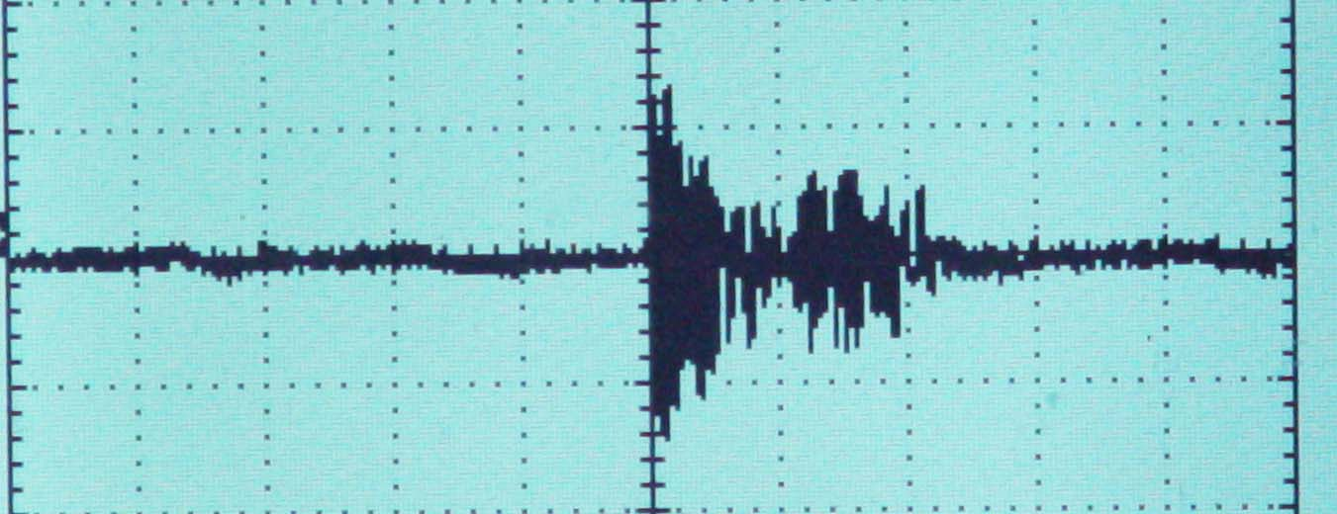
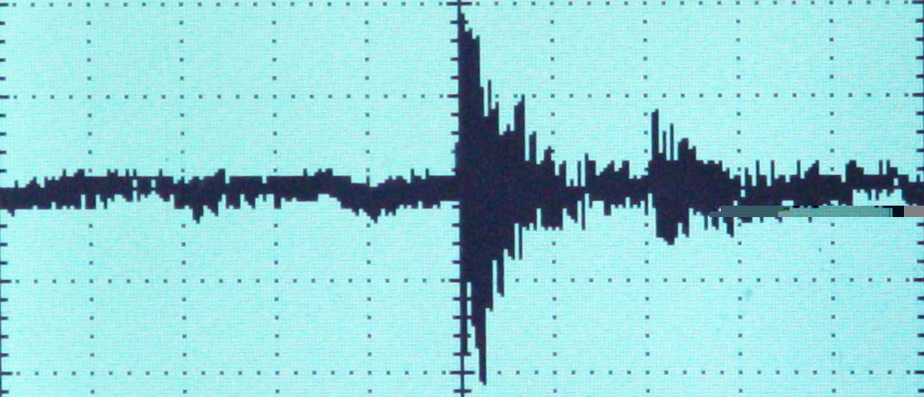

Fig. (1-a, b) represent samples of the echo which returned and received by the hydrophone from target (1) at frequency 50 KHZ, pulse width 2.5 msec., sweep time 5 m sec/div, amplitude 5v/cm

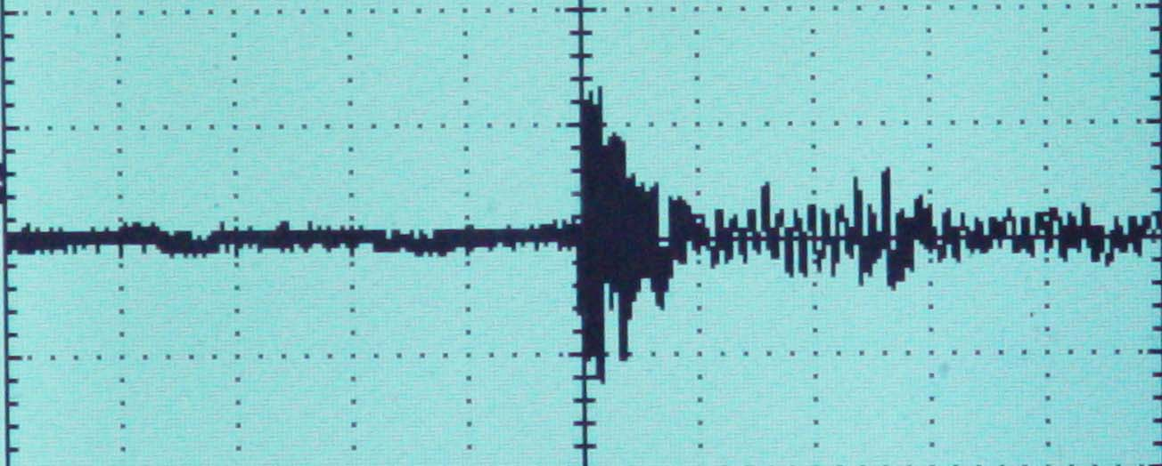
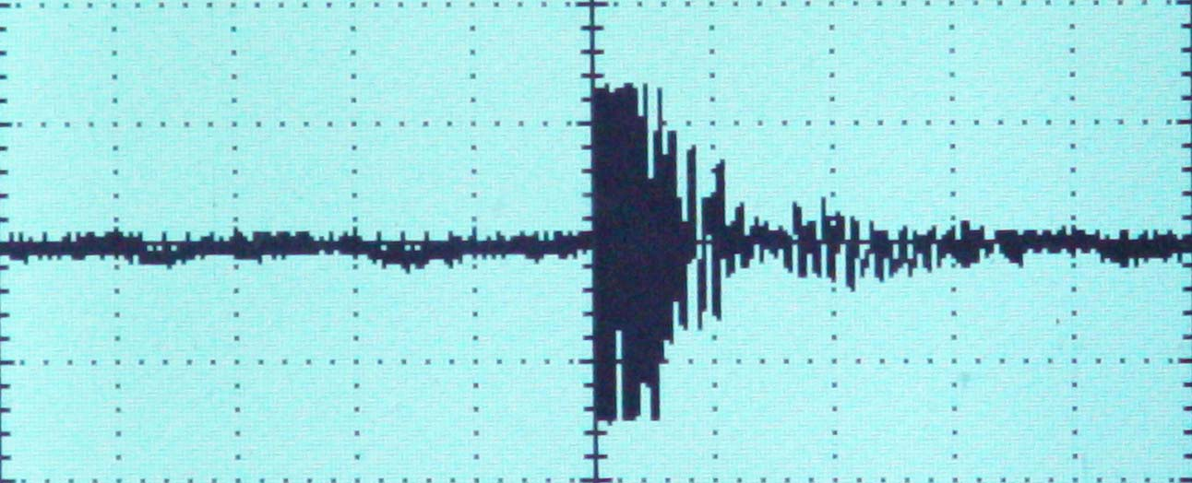

Fig. (2-a, b) represent samples of the echo which returned and received by the hydrophone from target (2) at frequency 50 KHZ, pulse width 2.5 msec., sweep time 5 m sec/div, amplitude 5v/cm

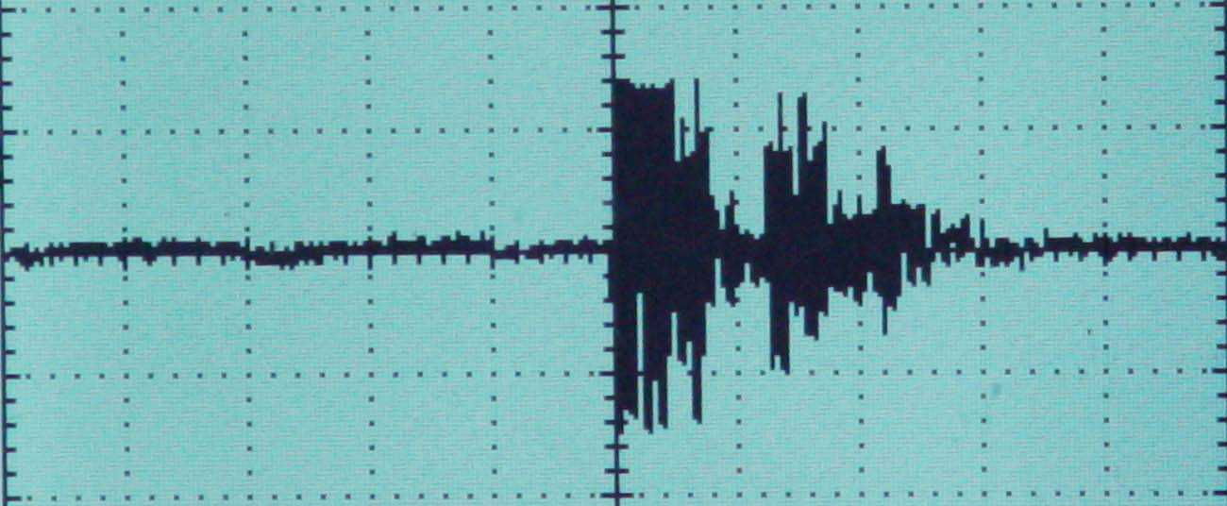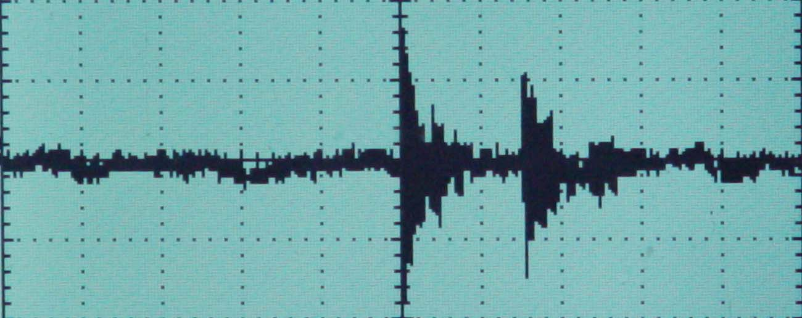

Fig. (3-a, b) represent samples of the echo which returned and received by the hydrophone from target (3) at frequency 50 KHZ, pulse width 2.5 msec., sweep time 5 m sec/div, amplitude 5v/cm

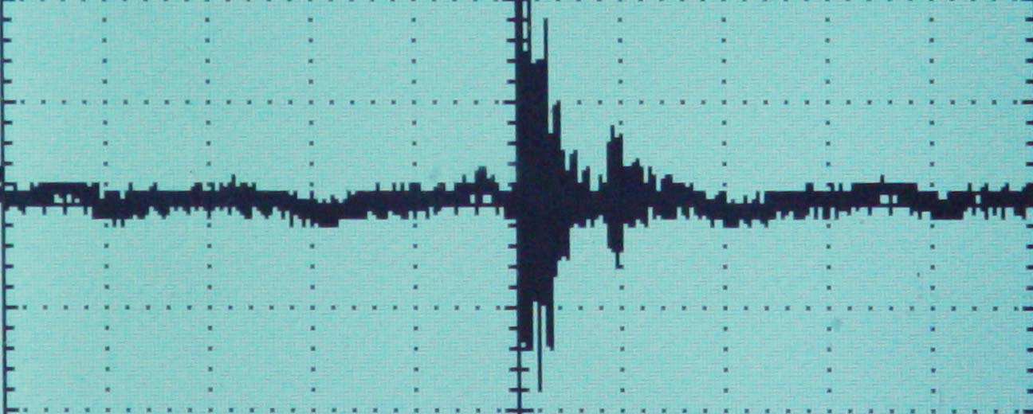
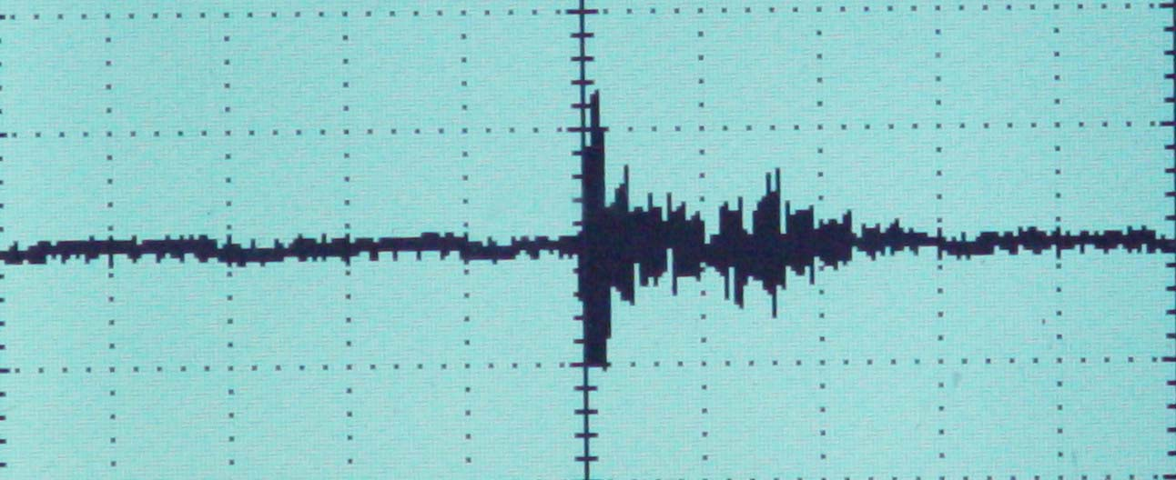

Fig. (4-a, b) represent samples of the echo which returned and received by the hydrophone from target (4) at frequency 50 KHZ, pulse width 2.5 msec., sweep time 5 m sec/div, amplitude 5v/cm

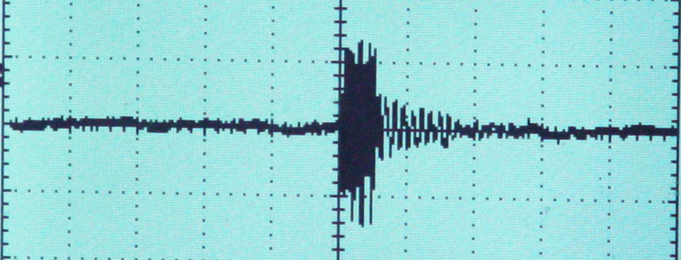
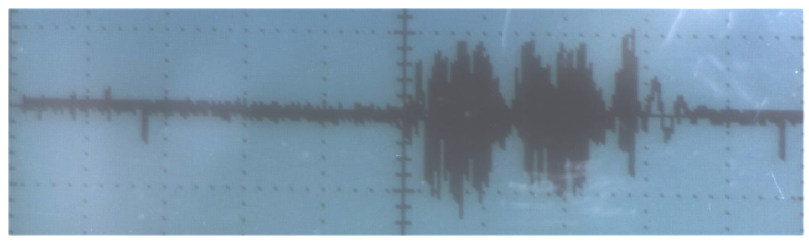

Fig. (5-a, b) represent samples of the echo which returned and received by the hydrophone from target (5) at frequency 50 KHZ, pulse width 2.5 msec., sweep time 5 m sec/div, amplitude 5v/cm

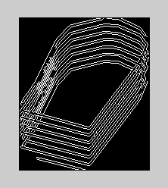
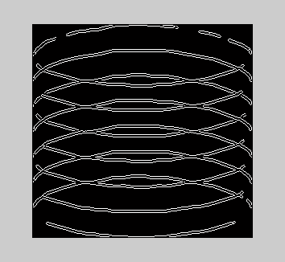

Fig.(6&7) Represent Edge Detection for Target No. (1 &2)

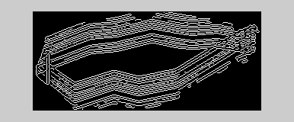
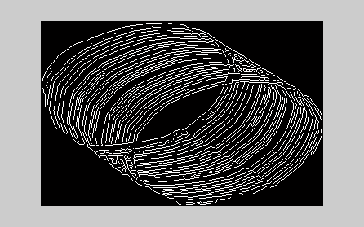

Fig.(8&9) Represent Edge Detection for Target No. (3 &4)

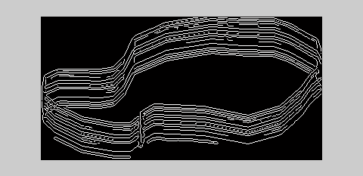

Fig. (10) Represents Edge Detection for Target No. (5)

