Improvement of DSG method

M. Jahanshahi, M. Gholipour, M. Kordafshari, M. Dehghan

Department of Electrical, Computer & IT, Islamic Azad University, Qazvin Branch, Qazvin, Iran

Abstract

Different orphan detection methods prefer different tradeoffs between performance, storage overhead, and simplicity of recovery. There exist some methods for orphan detection. One of them called DSG method that has been presented in [1]. In this paper initially we introduce DSG method and then we present its advantages. Finally we improve this method in either process overhead and communication/traffic overhead.

Keywords

Distributed systems, Orphan, Modified DSG, Reincarnation, Extermination, dedicated server group, load balancing, DSG.

1. Introduction

In the simplest case a remote procedure call is implemented by first sending a massage to a server and then waiting for a reply from the server. In RPC systems if client requests something from server, and immediately before response to come back it crashes, a process shall be performed that no parent is waiting for response. The mentioned process which has no parent is called “orphan”.
Orphans cause some problems including wasting the processor cycle or lock the resources forever, even client may request for the same previous RPC and cause re-execution of it which shall have special consequences [11].Initially RPC systems only provided peer-to-peer communication involving the interaction of each client with only one server[3].But nowadays distributed applications run on a set of independent nodes interconnected by a communication network that nodes can crash independently [2,5,6].
Different orphan detection methods prefer different tradeoffs between performance, storage overhead, and simplicity of recovery. Some of them use message logging. Message logging cause some overhead: First, each message must in general be copied to the local memory of the process that directly affects communication throughput and latency. Second, the volatile log is regularly flushed to stable storage to free up space. Third, message logging nearly doubles the communication bandwidth required to run the application for systems that implement stable storage via a highly available file system accessible through the network.
Pessimistic log-based protocols guarantee that orphans are never created due to a failure. Optimistic log-based rollback-recovery protocols reduce the failure-free performance overhead, but allow orphans to be created due to failures. Message-passing systems may force some processes to roll back that did not fail, creating what is commonly called rollback propagation. This dependency complicate rollback recovery .In some situation, rollback propagation may extend back to the initial state of the computation and all the work performed before a failure loss. This situation is known as the domino effect. In large systems this synchronization has overhead. Some of them for speed up use checkpoint. Checkpoints and event logs consume storage resources. As the application progresses, a subset of the stored information may become useless for recovery. Deleting of such useless recovery information called Garbage collection [16]. Garbage collection is an important pragmatic issue in rollback-recovery protocols, because running a special algorithm to discard useless information incurs overhead.
Totally all of orphan detection methods have broadcast overhead or logging burden on the disk

2. DSG Method

DSG method uses server group concepts; in this method there is a token containing three fields: UA, SG#, time_stamp (figure 1). AU means that the utilization amount of dedicate server group and SG# is the related server group.
The token moves around the server groups on a ring topology. In each step if a server group realizes that its utilization amount is less than the UA of the token then it overwrites its UA and SG# in the token.

SG # | Time_stamp | UA

Figure 1: structure of token
When a server group overwrites in the token it generates two copies of the token and sends them in opposite direction in order to speed up (figure 2).

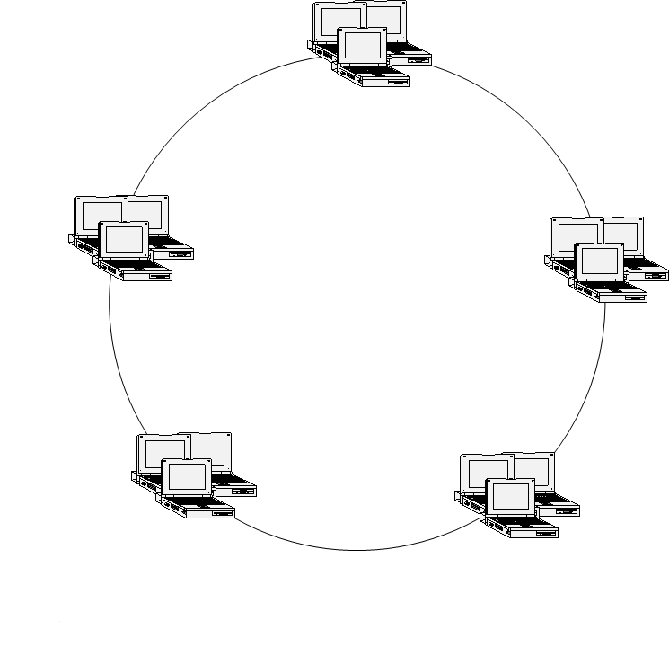
Token
Token

Figure 2: The server group overwrites its own UA and SG# on the token and generate two same tokens that move around the ring in the opposite direction. When two tokens arrive to a server group simultaneously each of them that have upper time stamp can be taken and another token is destroyed.

When two token reach to a server group simultaneously two cases can be occurred: First case, if two tokens have identical Time stamp then each of them that has a lower UA can be taken and another token is destroyed. Second case: if two tokens have different time stamp each of them that has higher time stamp can be taken and another token is destroyed. During the said transfer, each server group takes a copy from token for itself. And overwrite it on the older version. Once new client restarts, it sends a request to the nearest server group. Considering its copied token the server group redirects the request of the clients to the efficient server group that has lowest utilization amount. After it, all of this client’s requests are sent to this server group (DEDICATED).
After it if the DEDICATED SERVER GROUP realizes that the all of its servers are busy, considering its copied token, redirects the input request to the another server group that its SG# has been written in the token (Figure 3).
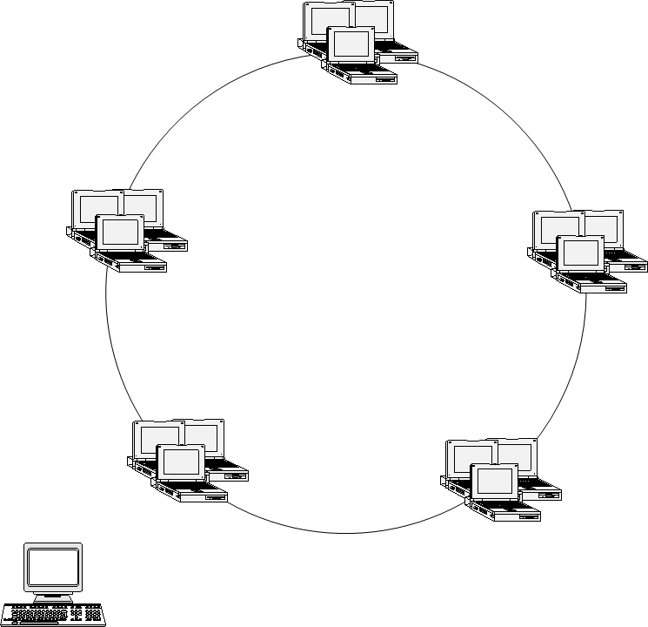
1(Request)
2 (Redirect)

3 (Dedicate)

Figure 3: Client sends the RPC request to DEDICATED SERVER GROUP and considering its copied token the server group redirects RPC request to perfect server.
After it, all of requests of that client are sent to both DEDICATED SERVER GROUP and second server group (back up). Next time after that all requests to the second server group have been responded, the dedicated server group may select a different server group. Therefore traffic is distributed in the network.
In this method epoch massage sent at most to (2 * N; N is number of servers in each group). The advantage of this method is that it neither logs like Extermination method that causes high cost of logging and memory consumption, nor broadcast to entire of networks like Reincarnation method that causes high traffic. Another advantage of our method is that requests of clients can be redirect to other idled servers adaptively. Figure 4 shows that our method considering the number of messages that must be exchanged between nodes in an environment with N servers in each group is better than reincarnation method. N can be any number. In this chart N is fifty.

Figure 4: Comparison between DSG and Reincarnation methods
3. Advantages of DSG method

DSG method neither logs like Extermination method that causes high cost of logging and memory consumption therefore its speed is higher than previous ones, nor broadcast to entire of networks like Reincarnation method that causes high traffic.
Another advantage of DSG method is that requests of clients can be redirect to other idled servers adaptively via load balancing. In contrast we list advantage of DSG method as follow:
1. Don’t take any log in opposite of Extermination method
2. Don’t broadcast epoch message to the whole of the network in opposite of Reincarnation method
3. Save the resources
4. Perform load balancing
5. Is a perfect distributed method
6. No need to running the garbage collection algorithm in opposite of message logging protocols
8. There is not exponential roll back in spite of message logging protocols

4. Modified DSG method

In DSG method token turn around the ring continually. Suppose that there isn’t any group that UA of it be lower than the UA of the token. In this situation token turn around the ring vain and generate both of communication / traffic and processing overhead.
Moreover groups take repetitive copies from the token due to vain rotation of the token. In this section we present modified DSG to overcome this problems as follows:
Initially first group generate two tokens then writes its SG# and UA on the tokens and sends them in the ring in opposite direction in order to speed up. In this rotation each group realizes that its UA is lower than the UA of the token, generate two token then writes its SG# and UA on the tokens and send them in the ring in opposite direction. When two token reach to a server group simultaneously two cases can be occurred: First case, if two tokens have identical Time stamp then each of them that has a lower UA can be taken and another token is destroyed. Second case: if two tokens have different time stamp each of them that has higher time stamp can be taken and another token is destroyed. During the said transfer, each server group takes a copy from token for itself. And overwrite it on the older version.
When ever the token accomplish a whole rotation and its information didn’t change, token stop and don’t move around the ring. After it when ever a group realizes that its UA is lower than the token UA, generate two token then writes its SG# and UA on the tokens and send them in the ring in opposite direction. In this situation again if the token accomplish a whole rotation and its information didn’t change, stop and don’t move around the ring.

5. Performance evaluation

This method has two advantages Moreover of DSG method:
1. Reducing communication / traffic overhead:
When the information of the token doesn't change, don’t need to rotate on the ring continually and increase traffic and communication overhead.
2. Reducing process overhead:
When the information of the token doesn't change don’t need to take useless and repetitive copies of the token.
Therefore modified DSG method reduce both of communication/traffic overhead and also process overhead.

6. Conclusion

In this paper initially we introduce DSG method and then we mentioned its advantage respect to other methods. Then we mentioned when there isn’t any group that its UA be lower than the token UA, this method perform useless process and take repetitive copies. In other hand there is traffic and communication overhead due to vain rotation of the token in this situation. Finally we present modified DSG method to reduce process and communication/traffic overhead.

References:

[1] M. Jahanshahi, K. Mostafavi, M. S. Kordafshari, M. Gholipour, A. T. Haghighat, "Two new approaches for orphan detection", Proc. The IEEE 19th International Conference on Advanced Information Networking and Applications,Taiwan,2005
[2] Maurice P. Herlihy, Martin S. Mckendry, “Timestamp-Based Orphan Elimination”, IEEE transaction on software Engineering, VOL. 15, NO. 7, 1990.
[3] L. P. Barreto, I. Jansch-Porto, “Open and Reliable Group Communication”, Proc. Sixth Euromicro Workshop on Parallel and Distributed Processing, Madrid, Spain, 1998, pp. 389-394.
[4] V. Issarny, G. Muller, and I. Puaut, “Efficient Treatment of Failures in RPC Systems”, Proc. IEEE Transaction on Computer, 1994, 170-78.
[5]A. S. Tanenbaum, Distributed Operating System, Prentice-Hall, 2003.
[6]L. Alvisi, K. Marzullo, “Message Logging: Pessimistic, Optimistic”, Causal, and Optimal, Proc. IEEE Transactions on Software Engineering, VOL. 24, NO. 2, 1998.
[7] Om P. Damani, Vijay K. garg, “How to Recover Efficiently and Asynchronously When Optimism Fails”, Proc. IEEE Transactions on Software Engineering, VOL. 1063-6927, 1996, 108-114.
[8] Alvisi, L. and Marzullo, K., “Non-blocking and orphan-free message logging protocols”, Proc. 23rd IEEE International Symposium on Fault-Tolerant Computing, Toulouse, France, 1993, 145-154.
[9] R. Baldoni, J. Brzezinski, J.M. Helary, A. Mostefaoui and M. Raynal, “Characterization of consistent global checkpoints in large-scale distributed systems”, Proc. 5th IEEE Workshop on Future Trends of Distributed Computing Systems, Chenju, Korea, 1995, 314 -323.
[10] F. Panzieri, S. K. Shrivastava, “A Remote Procedure Call Mechanism Supporting Orphan Detection and Killing”, Proc. IEEE Transaction On Software Engineering, VOL.14, NO.1, 1988.
[11] Shiva, S. Virmani, R., “Implementation of reliable and efficient Remote Procedure Calls”, Proc. IEEE, 1993 , Charlotte, NC, USA, On page(s): 5p.
[12] K. Ranvindran, S. Chanson, “Failure Transparency in Remote Procedure Calls”, Proc. IEEE Transaction on Computer, VOL. 38, NO. 8, 1989.
[13] A. K.Ezzat, “Orphan Elimination in Distributed Object-Oriented Systems, Proc. Second IEEE Workshop on Future Trends Distributed Computing Systems, Cairo, Egypt, 1990, pp. 403-412.
[14] B. Yao, W. Fuchs, ”Message Logging Optimization for Wireless Networks”, Proc. 20th IEEE Symposium on Reliable Distributed Systems, 2001, pp. 0182.
[15] S. Pleisch, A. Kupsys and A. Schiper, “Preventing Orphan Requests in the Context of Replicated Invocation”, Proc. IEEE 22nd International Symposium on Reliable Distributed System,2003.
[16] E. N. (Mootaz) Elnozahy, L. Alvisi, Yi-Min Wang and D. B. Johnson, “A survey of rollback-recovery protocols in message-passing systems”, Proc. ACM Computing Surveys (CSUR), Vol. 34, Issue 3, 2002, Pages: 375 – 408.
[17] Kwang-Sik Chung , Ki-Bom Kim , Chong-Sun hwang ,jin gon Shon and Heon-Chang yu, "Hybrid checkpointing protocol based on selective-sender-based message logging", Proc. International Conference on Parallel and Distributed Systems, 1997, pp. 788
[18] X. Fu, D. Wang, W. Zheng and M. Sheng, "GPR-Tree : A Global Parallel Index Structure for Multiattribute Declustering on Cluster of workstations", Proc. IEEE Transaction on Computer , 1997, 788-793

