Performance Comparison of DSP and VHDL implementation of Trellis Coded Demodulation

AMIT S. AWATI, HRISHIKESH R. KANITKAR, MAHIMA NANDA,
NIKHIL G. LADDHA, SAVITA G. KULKARNI, ANURADHA C. PHADKE and ALWIN D. ANUSE
Electronics and Telecommunication Department
Pune University
Maharashtra Institute of Technology
Paud Road, Kothrud
Pune – 411038.
India

Abstract:
In most wireless communication systems, convolutional coding is the preferred method of error correction coding to overcome transmission distortions. In this paper we have compared the performance of trellis coded demodulator (viterbi decoder) implemented on TMS320C54XX DSP chip and FPGA Spartan II XC2s50PQ208 kit. In this paper we also present a modified viterbi algorithm in which we have completely eliminated register exchange and traceback approach i.e. no retracing of the survivor path is required which thereby reduces memory requirement, power consumption and reduces the time required for getting the decoded output.

Introduction:
Viterbi decoders are used to decode convolutional coding which has been used in deep communication as well as wireless communications. A wireless cellular standard for CDMA (code division multiple access), IS-95 employs convolutional coding. A third generation wireless standard adopts turbo coding.
The Viterbi algorithm is to find a maximum-likelihood sequence of state transitions, equivalently a path, in a trellis by assigning a transition metric to possible state transitions. A transition metric is called branch metric, and the cumulative branch metrics along the path from the initial state to a given state is called the path metric of the state. When two or more paths end at the same state, the path with the smallest path metric is selected as the most likely path. The survivor path obtained by backtracking in time corresponds to the decoded output.
The design of high performance viterbi decoders has been investigated intensively in the past three decades. A previously implemented algorithm using traceback method uses the cumulative approach for recording the survivor path whereas in our algorithm we have completely eliminated register exchange and traceback approach i.e. no retracing of the survivor path is required which thereby reduces memory requirement, power consumption and reduces the time required for getting the decoded output.
The hardware complexity of the viterbi decoder is proportional to the number of states in the trellis, which is equal to the number of states of the corresponding convolutional encoder.
For the development of viterbi decoder, rapid prototyping approach is used so as to reduce the development time. Today rapid prototyping means using VHDL as a description language and verifying behavior. In implementation technology FPGAs are used to validate the concept or to emulate the physical prototype and software. Using FPGAs instead of ASICs reduces the implementation time from a few weeks to a few hours [1].

Viterbi Algorithm:

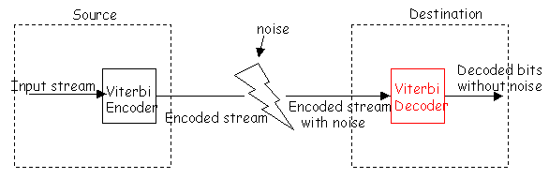
Figure 1

Fig.1 shows the generalized schematic communication module. The decoder shown uses the viterbi algorithm. This algorithm is commonly expressed in terms of a trellis diagram. The maximum likelihood detection of a digital stream with inter-symbol interference can be described as finding the most probable path through a trellis of sate transitions (branches). Each state corresponds to a pattern of recently received data bits and each branch of trellis corresponds to the reception of the next (noisy) input. The branch metric represents the cost of traversing along a specific branch. The state metrics, or the path metrics, accumulate the minimum cost of ‘arriving’ into a specific state. The decoding of every input corresponds to a ‘stage’ in the algorithm.[3]

DSP implementation of viterbi decoder:
Viterbi decoder was implemented by using a TMS 320C54XX DSP chip. This chip uses 16 bit fixed point words and can run as low as 0.45mW or at 120mW at 200MIPS. The TMS320C54XX is highly optimized to perform the viterbi decoding. Since in a single cycle compare, select and store is used to compare branch metric, record the larger value and store the appropriate decision bit, all in one cycle. Dual accumulators allow for dual add / subtract operations to occur in one clock cycle [2].

VHDL implementation of viterbi decoder:
System Architecture:
In this section we describe our modified Viterbi algorithm which completely eliminates the trace back approach.
The major building blocks of the Viterbi Decoder are shown in Figure 2.The role of each block is described briefly below.
Trellis: This block consists of all the possible combinations of the code trellis that have to be compared with each input to calculate branch metrics.
S to P: This is the serial to parallel converter that converts the input serial data into two-bit parallel form and finally appends zeros to this to convert it to the required format.

Comparator: This comparator compares each input with the all the combinations of the code trellis stored in the trellis block to calculate the branch metrics. Branch metric is calculated as the hamming distance between the received symbol and the expected symbol.
RAM units: This is the storage unit of the decoder which contains branch metrics as well as appended code.
ACS units: Each ACS (Add Compare and Select) unit receives two branch metrics and the path metric of that particular stage. It adds each incoming branch metric to the path metric and compares the two results to select a smaller one.
Compnmux unit: This block consists of comparators and multiplexers. The output of this unit is the smallest path metric out of the four obtained from the ACS units.
CPA units: These are carry propagate adders whose inputs are the branch metrics of stage 1 and stage 2 and whose output is path metric upto stage 2.
FSM: The finite state machines shown in the Figure 2. are used to update the survivor path, calculate the path metric and append the code after every stage.

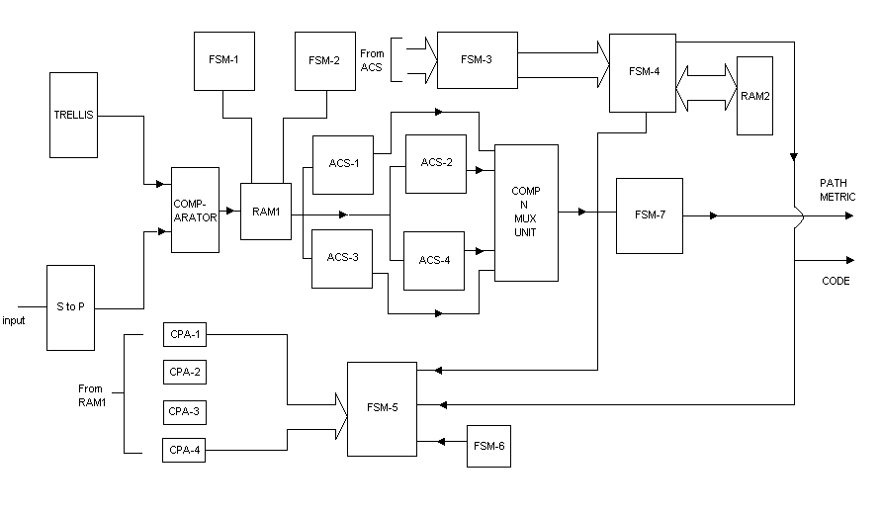

Figure 2

Algorithm Description:
Figure 2. shows the block diagram of the viterbi decoder in detail. The decoder mainly consists of the ACS units, RAM units and number of FSMs (Finite State Machine) controlling them.
The input to the decoder is the encoded bits in serial form. These are converted to parallel form by the serial to parallel(s to p) converter. The code trellis consists of all possible combinations of the encoded inputs.
The comparator compares each of these combinations with the input to find the respective branch metrics. These branch metrics are then stored in the RAM1. This process is repeated for all the inputs.
The branch metrics of the first two stages are added in the CPA1, CPA2, CPA3, and CPA4 to find the path metric up to the second stage of decoding.

The path metrics obtained at the output of the CPA adders are added with the branch metrics of the third input by the ACS units (ACS1, ACS2, ACS3, and ACS4) to get the path metrics up to stage 3. The least path metric is then selected by the comp-n-mux (comparator and multiplexer) unit. All the possible paths have been considered upto this stage. This least path metric obtained is given to the input of the FSM-4 to obtain the first 3 bits of the code. FSM-1 and FSM-2 are used to enable the CPA adders and the ACS units respectively when they receive proper inputs from RAM1.
Depending upon the code obtained in the previous stage, one particular ACS out of four units is selected. This process is performed by FSM-5.The path metric obtained in the previous stage is given to the particular ACS selected whose branch metrices are obtained from the RAM1.
This process of getting the code after stage 3 is repeated for all the inputs henceforth. Thus, the corresponding 8 bit code is obtained. The requirement of the survivor path unit, which consists of all the possible combinations of the path metrics, is completely eliminated. There is no need for backtracking to get the code at all.
We have considered all the possible combinations of the code (path metrics also) only up to stage 3 of the decoding. For every stage after stage 3, either a zero `0’ or a one `1’ is appended to the code.

VHDL synthesis results:
The Viterbi algorithm is used to find a maximum-likelihood sequence of state transitions, equivalently a path, in a trellis by assigning a transition metric to possible state transitions. A transition metric is called branch metric, and the cumulative branch metrics along the path metric of the state. When two or more paths end at the same state, the path with the smallest path metric is selected as the most likely path. The simulation results (fig 3) show appending of the code with appropriate ‘0’s and ‘1’s corresponding to each input obtained from the encoder. It can be seen that along with the flow of the inputs the survivor path is automatically selected and there is no need to backtrack to obtain the survivor path. Thus, after every stage the code will be automatically appended.
The simulation has been shown for eight input bits given to a (2, 1, 2) encoder i.e.
Coded word length = 2,
Uncoded word length = 1 and
Constraint length = 2.

Device utilization summary:
Selected Device : 2s50pq208-5

No. of Slices: 498 out of 768 64%
No. of Flip Flops: 464 out of 1536 30%
No. of LUTs: 850 out of 1536 55%
No. of IOBs: 25 out of 144 17%
No. of GCLKs: 1 out of 4 25%

Results and Conclusion:
The project would be completed in one engineer week from start to finish using the latest tools.
Group of four engineers worked on VHDL implementation of the decoder and group of three engineers worked on DSP implementation of viterbi decoder simultaneously.
For a frame size of 100Kbits and frame rate of 1Hz, we require 18.42 MIPS of well below the 100 MIPS provided by our processor. Alternatively, the processor can handle up to 582 Kbps performing only decoding, provided that the memory it must access can be loaded quickly enough.
The SPARTAN II chip is an excellent choice for a low data rate implementation of the viterbi decoder. The chip fast, low power and has specialized instructions that greatly accelerate the speed of decoding.
SPARTAN II has system performance supported upto 200Mhz. It consumes 30mW of power with complete utilization of system resources. As seen from the device utilization summary the viterbi decoder consumes approximately 50% of the system resources. This allows the processor to perform other operations than just decoding.

Future Work
Some directions to continue this work are the following:
- The use of the internal SRAM of the FPGA in order to hold the metrics of the last stage of the forwarding logic is needed in the implementation of large Viterbi Decoders. When parameter K is larger than 5 the Viterbi Decoder does not fit in the FPGA unless the internal SRAM is used. Using the internal memory of the FPGA large Viterbi Decoders can fit in one FPGA.
- Finally the implementation of more complex Viterbi Decoders using the proposed architecture can be studied.

References:
- C.V.Joshi and Alwin.D.Anuse, “Use of VHDL in Rapid Prototyping”,WSEAS Transactions on Circuits and Systems,vol 3 ,issue 5 , July 2004
- www.s.ti.com/sc/psheets/spra071/spra071
- Rolf Johannesson, Kamil Sh. Zigangirov
Fundamentals of Convolutional coding

