Implementation of Pictbridge Protocol For Real Time Embedded Applications

S.ANANTHAKANNAN, R.RAMESH, DR.V.RAMACHANDRAN,
Department of Electrical and Electronics Engineering
College of Engg,Guindy, Anna University,
Chennai,TamilNadu-600025
India
http://www.annauniv.edu

Abstract: - Currently in real time embedded applications, it is not possible for Users to print directly from their Mobile Camera to printer. The objective of this paper is to develop a protocol to improve the usability of digital photography. The proposed PictBridge protocol defines a set of protocols and operations that enable an image source device to create and send a print job to an image output device. The proposed protocol supports for printing a single image or a collection of images and for providing the user with ongoing status results. The proposed PictBridge protocol makes it possible for any digital camera and printer to be combined, regardless of manufacturer or model, as long as they both support the PictBridge standard.

Key words:- PictBridge protocol, Mobile Camera, Digital Photo Solutions.

1 Introduction
In real time applications, mobile phones equipped with megapixel-class cameras. There is growing demand for the ability to print photos taken with a mobile phone. Until now, however, the only available options were to use a special dedicated printer or using a fee-based printing service.

The proposed protocol makes it possible to print images on ordinary printers which is supported by
PictBridge protocol in easier and more accessible manner. This standard defines a protocol enabling
interoperability between a digital still photography device as typified by a Mobile Phone Camera (MC) and an image output device as typified by a Printer. The protocol defines a set of capabilities in terms of operations and their parameters and specifies an unambiguous wire protocol for their communication.

Usability is a key aspect of this targeted solution, as both MC's and Printers are mass-market devices Manufacturers undertaking implement- ation of either side of the interface are strongly encouraged to provide the best possible user feedback on the overall printing process. Specifically, the user should be able to discern:

- When a connection has been made or has been lost between the two devices.
- When the devices are communicating appropriately, i.e., "Things are working".
- When a problem has occurred; for common problems (e.g., paper out), the user should be able to determine what has happened and how to recover and continue.

2 Proposed Pictbridge Architecture
The DPS (Digital Photo Solutions) [1]architecture is designed to operate at the application layer and to be independent of the specifics of the underlying data transport. It defines mechanisms for Discovering device capabilities, Job initiation and configuration, Retrieval of print data by the Printer, Asynchronous notification to the MC by the Printer of key events and status changes. DPS actions take the form of operations and events. Asynchronous events are sent from the Printer to the MC.DPS is also designed around a flexible system architecture, where system functional components are not rigidly assigned to a particular device type. The Proposed pictbridge architecture is shown in figure.1.

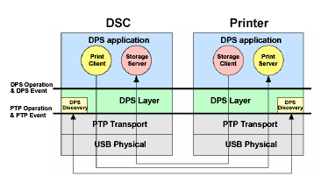
Figure 1. Pictbridge architecture

2.1 System Components
The following four system components are defined for DPS architecture.

2.1.1 MC Print Client
It controls the flow of system operations after the configuration step is completed. Requests the print job, indicating which images should be printed and what attributes should be applied to them; monitors printing progress and reports status to the user. This component is also responsible for gathering input from the user about the print request.

2.1.2 Storage Server
Manages access to the MC's physical storage[2]. It provides an abstraction that is physical device and file system independent.

2.1.3 Print Server
Processes requests for print jobs, printer capabilities, status, etc. Provides asynchronous notification of progress and status. Manages overall printer resources, including print engine.

2.1.4 Storage Client
Retrieves objects including images from the MC's Storage Server[7].

2.2 Device and Service Discovery
As device and service discovery processes are specific to a physical link and the operating environment, and since DPS is an application layer protocol that is independent of the underlying transport, DPS does not define the mechanism by which the devices or services discover each other.

2.3 DPS Job Overview
The actual device discovery process is link dependent. After discovery, if the job is controlled from the MC, the Print Client in the MC queries the Printer about its capabilities and then, issues a request for a print job conforming to the Printer's capabilities. The Printer retrieves the print data from the MC's image Storage Server, and provides status information, including an indication that the job has completed. If the job is controlled from the Printer, the Printer simply retrieves the appropriate print data from the MC and prints it, providing the user with ongoing status. the status change.

2.4 Operations and Events
DPS has two kinds of actions: DPS operations and DPS events [6]. DPS actions consist of a request phase followed by a response phase; both the request and response are well formed XML. The request includes one or more input parameters; the response includes one or more output parameters, where the first output parameter is the result of the operation.

2.5 DPS Print Service

2.5.1 printing Operations State Transitions and Sequence Diagrams
In this paper explain only the Single image print opertions.

      - Single Image Print
The Print Server state transition has been shown in Figure.2. The print server state transitions and the sequence of DPS actions starts when processing a print job using DPS_Get File .After the Print Client issues a DPS_StartJob operation, the Print Server starts a print job and updates the dps Print Service Status value from Idle to Printing.

The prints server issues a DPS_Notify Device Status event to notify the Print Client of status changes.
At the start of the first page, the Print Server issues a DPS Notify Job Status event to provide progress information to the Print Client. At this time, the number of the current page (N) in the progress value is the current page number being printed.
The Storage Client issues a DPS_GetFile operation or DPS_GetPartialFile operations repeatedly to

retrieve image data from the Storage Server.After retrieving the image data, the Print Server does the necessary pre-processing of the image data, and sends data to the print engine.
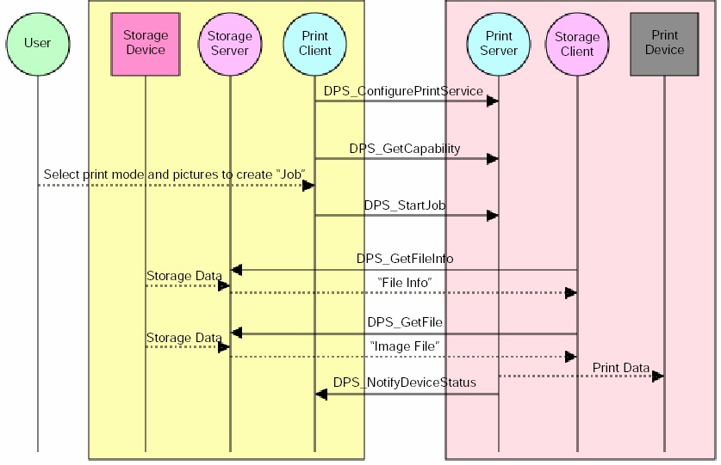
When the images to be printed are completed, theprint Server updates the dpsPrintServiceStatus value from Printing to Idle.

Figure2. State Transitions Diagram While processing a normal job

The Print Server issues DPS Notify Device Status event to the Print Client to Notify it of the job completion and the status change.

3 Pictbridge protocol modules
The core module in the proposed protocol is “PictBridge Protocol Handler” module and “User
Interface API”, the other modules are mere abstraction to existing layers/modules within the target platform on which the PictBridge suppose to run. Pictbridge handler modules in a typical Digital Still Camera[5] Device are shown in Figure3
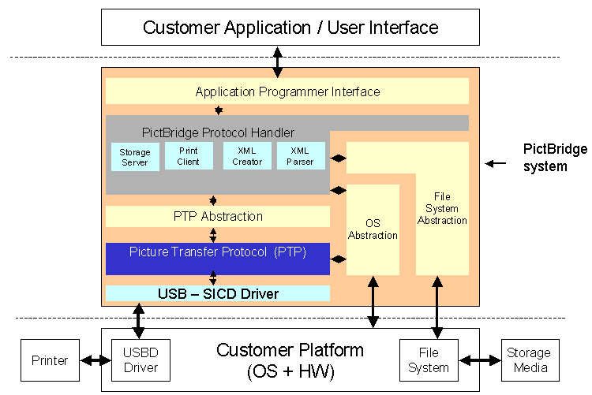

figure 3. Pictbridge protocol modules

The Implementation of pictbridge protocol modules followed CIPA(Camera&Image Photo Association)DC-001-2003 Standard.[4]

3.1 Picture Transfer Protocol(PTP)
This Picture Transfer Protocol (PTP)[3] will describe a recently emerged standard for connectivity of digital still photography devices that intends to replace and unify the communication between still imaging devices and other receiving devices like printer. A number of new ,high-speed interface transports have recently been developed, including IrDA, USB,,IEEE1394 and Bluetooth. This standard is designed to provide requirements for communicating with still imaging devices. The picbridge modules USB is used.

3.2 DPS – Print client command handler

The following DPS commands will be exported to “User Interface API layer”, so this module should handle the following DPS print service operations and events.

3.2.1 Operations
- DPS_ConfigurePrintService
- DPS_GetCapability
- DPS_GetJobStatus
- DPS_GetDeviceStatus
- DPS_StartJob
- DPS_AbortJob
- DPS_ContinueJob

3.2.2 Events
- DPS_NotifyJobStatus
- DPS_NotifyDeviceStatus

3.3.1 XML script parser
DPS responses from printer will be received as XML scripts, so the XML parser should be present to identify the response/request from printer.

3.3.2 XML script Creator
All DPS requests will be sent as XML scripts to PTP and same will be forwarded to other end of PictBridge complaint printer via USB driver. The XML creator should be designed such that, the XML tags can be added for new DPS command to be introduced in future.

3.3.3 DPS – Storage server
Though this module does not really export any APIs to upper layer (User Interface). The only one DPS storage server operation needs to be implemented is “DPS_GetFileID”. Infact, this operation also required, only if DPOF AutoPrint support is enabled.

3.3.4 User Interface API Layer
For the following reasons this module is required. Hide the complexity of various parameters in a single DPS – Print service operations, and Register the UI callbacks for notifications received from printer (Error/ Warnings such as paper Jam/no toner, etc).

The following APIs needs to be exported to User Interface layer. These APIs needs to be mapped to section 3.2 DPS Print Client command handler operations / Events exported.Some APIs are given below
- PictBridgeInit
- ConnectionInit
- RegisterPrinterconnectedEventHandle
- GetCapability
- StartPrint
- SetFileNamePrint

4 Conclusion
Pictbridge protocol is an extremely flexible imaging protocol, designed to interconnect imaging and printing devices. The Pictbridge protocol seems to become the imaging transfer protocol of choice for many digital camera manufacturers. The proposed protocol is more powerful for wireless and wired envirorment. This section aims was to identify potential problems of real time embedded application in digital photography that the Picbridge protocol might have and proposes quick fixes to those problems.

References:
[1]Camera & Imaging Products Association, Picbridge Standard of Camera & Imaging products Association DC-001-2003Digital Photo Solutions for Imaging Devices, feb 3 2003, pp.1-106.
[2]C.Herley,Storage of digital camera images, Int.Con$ Image Proc. (ICIP’99), Kobe, Japan,0ct. 24-28,1999,vol. 3, pp. 940-942.

[3]Peter Corcoran et. al ,Digital Services Using PTP (Picture Transfer Protocol), IEEE Consumer Electronics Transactions, Feb 2002 ,pp. 55-58.
[4]Camera&ImagingProductsAssociation,Logo Certification guidelines CIPA Dc-01-2003,
Digital Photo Solutions for Imaging Devices,
May 6 2003 , v.001 pp.1-20.
[5]Mark Chrystler ,Canon : More than just cameras, IEEE Spectrum, Nov 1990, pp.113-115.

[6]Camera&ImagingProductsAssociation,
Implementers guidelines for CIPA Dc-001-2003 Digital Photo Solutions for Imaging Devices,
April 4 2003, pp.1-147.

[7]Rene J Van der Vleuten , Richard P Kleilhorst and Christian Hentschel ,flexible image storage method that offers attractive new features for digital still image cameras, IEEE Spectrum ,
Jan 2001,p.1097-1100.

