Turbulence Intensity Modelling of In-Cylinder Swirl Flow using Genetically/SVD Designed Polynomial Neural Network

K. Atashkari, N. Nariman-zadeh, A. Jamali
Department of Mechanical Engineering, Engineering Faculty, The University of Guilan
P.O. Box 3756, Rasht, IRAN

Abstract:- Some aspects of in-cylinder swirl flow in reciprocating internal combustions engine have been investigated employing Laser Doppler Velocimetry (LDV) and modelled using generalized GMDH-type (Group Method of Data Handling) neural networks. In this approach, Genetic Algorithm (GA) and Singular Value Decomposition (SVD) are deployed simultaneously for optimal design of both connectivity configuration and the values of coefficients, respectively, involved in GMDH-type neural networks which are used to model turbulence intensity of the swirl flow. In particular, the aim of such modelling is to show how the turbulence intensity changes with the variation of important parameters involved in the swirl flow. In this way, a new encoding scheme is presented to genetically design the generalized GMDH-type neural networks in which the connectivity configuration in such networks is not limited to adjacent layers. Such generalization of network's topology provides optimal networks in terms of hidden layers and/or number of neurons so that a polynomial expression for the turbulence intensity can be achieved consequently.

Key-Words:- LDV, GMDH, Genetic Algorithms (GAs), Swirl Flow, SVD.

1. Introduction
The flow field within the cylinder of an internal combustion engine is the most important factor controlling the combustion process. It can be classified as compressible (low Mach number), turbulent, unsteady or non-stationary (in both the spatial and temporal domains) and three dimensional. An important characteristic of a turbulent flow is its irregularity or randomness and statistical methods are necessary to define the flow field. Turbulence intensity (rms velocity) is the most important parameter to affect the combustion process [1].

Swirl is a form of rotating flow inside the engine cylinders. The axis of this type of flow is parallel to the axis of the cylinder. In general the purpose of introducing swirl flow into the cylinder of spark ignition engines is to increase turbulence intensity. This in turn increases combustion rate and extends the flammability limit which may lead to improve thermal efficiency. Along with improving efficiency, fast burning may reduce hydrocarbon (HC) and carbon monoxide (CO) emission because of reduction in cyclic variations [2].

The objective of this work is to employ LDV turbulence measurements of in-cylinder swirl flow [3] for modelling of this complex process using input-output data. In order to obtain measurements data as input, two different types of inlet ports, no swirl and axial swirl generating angle ports (at 20° and 40° to the radial), were employed. The measurements were made in the mid-plane of the clearance volume of a modified two-stroke engine. Three different crank angle positions were selected. All data were obtained under motoring condition at a fixed speed of 1500 rpm. Measurements in motored engines can provide useful information about flow patterns and turbulence up to the instant of ignition in spark ignition engines (fuel injection in compression ignition engines), while avoiding the experimental difficulties associated with firing conditions [4].

System identification techniques are applied in many fields in order to model and predict the behaviour of unknown and/or very complex systems based on given input-output data [5]. Theoretically, in order to model a system, it is required to understand the explicit mathematical input-output relationship precisely. Such explicit mathematical modelling is, however, very difficult and is not readily tractable in poorly understood systems. GMDH algorithm is self-organizing approach by which gradually complicated models are generated based on the evaluation of their performances on a set of multi-input-single-output data pairs $(X_{i}, y_{i})$ (i=1, 2, …, M). The main idea of GMDH is to build an analytical function in a feedforward network based on a quadratic node transfer function [6] whose coefficients are obtained using regression technique.

Recently, genetic algorithms have been used in a feedforward GMDH-type neural network for each neuron searching its optimal set of connection with the preceding layer [7,8]. In the [8], authors have proposed a hybrid use of genetic algorithm for a simplified structure GMDH-type neural network in which the connections of neurons are restricted to adjacent layers.

In this paper, it is shown that GMDH-type neural network can effectively model and predict the turbulence intensity, each as a function of important input parameters of in-cylinder swirl flow. In this way, genetic algorithms are deployed in a new approach to design the whole architecture of the GMDH-type neural networks, i.e., the number of neurons in each hidden layer and their connectivity configuration, in combination with using SVD to find optimal set of appropriate coefficients of quadratic expressions.

2. LDV Measurement System
A modified engine in conjunction with instrumentation for LDV investigation was used to measure instantaneous local velocity (in a specific direction) and evaluation of the turbulence intensity. The engine utilized for the current test was originally a two-stroke spark ignition engine. The engine had a bore of 80 mm and stroke of 74 mm and its other principal dimensions were given in [3]. To generate varying axial swirl three sets of ducts directed the charge into the cylinder at 0°, 20° and 40° to the radial. A Lexel Model 95-2 argon ion laser was used as the light source. A fiber optics system was employed to transport the 514.5 nm wavelength light from the light source. A schematic diagram of the LDV data acquisition for the engine under consideration is shown in figure (1).

The principle upon which LDV technique is based is the Doppler frequency shift of the laser light. A problem with this technique is that signals occur at random, and the data is often lower than required for the assumption of a continuous signal. Hence, the signal is usually averaged over a finite time or crank angle window. For simplicity ensemble averaging has been used for in-cylinder velocity data. It can be estimated as:

${}_{{\bar{U}}_{\text{EA}}}(θ,Δθ)=\frac{1}{N_{t}}\sum_{i=1}^{N_{c}}{\sum_{j=1}^{N_{i}}{U_{i,j}}}(θ±\frac{Δθ}{2})$ (1)

where ${\bar{U}}_{\text{EA}}(θ,Δθ)$is the ensemble averaged mean velocity within the crank angle window (Δθ=2° in the present work) $θ±\frac{Δθ}{2}$, $N_{i}$ is the number of velocity measurements taken within the relevant crank angle window in a given cycle, $N_{c}$ is the number of cycle, $N_{t}$, is the total number of velocity measurements ($N_{t}$=5000 in this study) and $U_{i,j}(θ±\frac{Δθ}{2})$ is $j$th instantaneous measurement in the $i$th cycle. A measure of the intensity of the ensemble averaged velocity fluctuations ($u^{'}$) is provided by the rms standard deviation of the instantaneous velocity about the ensemble mean velocity [1]:

(2)

Processing of the Doppler signals was done using a Burst Spectrum Analyzer (BSA). In such analyses, all the information in Doppler signals is used [9].

3. Modelling Using GMDH-type Neural Networks
The formal definition of the identification problem is to find a function $\hat{f}$so that can be approximately used instead of actual one,$f$ in order to predict output $\hat{y}$ for a given input vector $X=(x_{1},x_{2},x_{3},\text{.}\text{.}\text{.},x_{n})$ as close as possible to its actual output $y$. Therefore, given M observation of multi-input-single-output data pairs so that

$y_{i}=f(x_{i1},x_{i2},x_{i3},\text{.}\text{.}\text{.},x_{\text{in}})$(i=1,2,…,M), (3)

It is now possible to train a GMDH-type neural network to predict the output values $\hat{y_{i}}$for any given input vector$X=(x_{i1},x_{i2},x_{i3},\text{.}\text{.}\text{.},x_{\text{in}})$, that is
$\hat{y_{i}}=\hat{f}(x_{i1},x_{i2},x_{i3},\text{.}\text{.}\text{.},x_{\text{in}})$(i=1,2,…,M). (4)
The problem is now to determine a GMDH-type neural network so that the square of difference between the actual output and the predicted one is minimised, that is

$\sum_{i=1}^{M}{ [}\hat{f}(x_{i1},x_{i2},x_{i3},\text{.}\text{.}\text{.},x_{\text{in}})−y_{i}]^{2}→\text{min}$ (5)

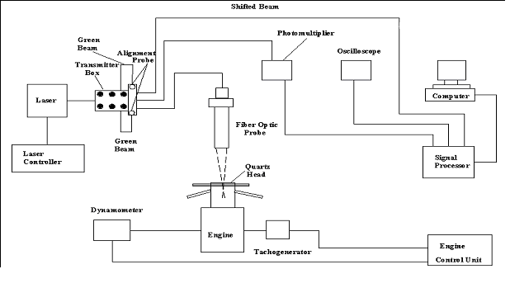
Figure 1: Schematic diagram of LDV system for in-cylinder flow measurements.

General connection between inputs and output variables can be expressed by a complicated discrete form of the Volterra functional series in the form of

$y=a_{0}+\sum_{i=1}^{n}{a_{i}}x_{i}+\sum_{i=1}^{n}{\sum_{j=1}^{n}{a_{\text{ij}}x_{i}x_{j}+\sum_{i=1}^{n}{\sum_{j=1}^{n}{\sum_{k=1}^{n}{a_{\text{ijk}}x_{i}}x_{j}x_{k}}}+}}\text{.}\text{.}\text{.}$ (6)

which is known as the Kolmogorov-Gabor polynomial [6]. This full form of mathematical description can be represented by a system of partial quadratic polynomials consisting of only two variables (neurons) in the form of

$\hat{y}=G(x_{i},x_{j})=a_{0}+a_{1}x_{i}+a_{2}x_{j}+a_{3}x_{i}x_{j}+a_{4}x_{i^{2}}+a_{5}x_{j^{2}}$ (7)

The coefficients $a_{i}$ in equation (7) are calculated using regression techniques [10] so that the difference between actual output, y, and the calculated one,$\hat{y}$, for each pair of $x_{i}$, $x_{j}$as input variables is minimized. In this way, the coefficients of each quadratic function $G_{i}$are obtained to optimally fit the output in the whole set of input-output data pair, that is
$E=\sum_{i=1}^{M}{(y_{i}−G_{i}())^{2}}M → \text{min}$ (8)
The application of least-squares methods and SVD techniques for multi-regression analysis to find the coefficient embodied in equation (7) in order to minimize equation (8) has been thoroughly given in [8].
4. Application of SVD to the Design of GMDH-type Networks
Singular Value Decomposition is a method for solving most linear least squares problems that some singularities may exist in the normal equations. The SVD of a matrix, $A∈ℜ^{M×6}$, is a factorisation of the matrix into the product of three matrices, column-orthogonal matrix $U∈ℜ^{M×6}$, diagonal matrix $W∈ℜ^{6×6}$ with non-negative elements (singular values), and orthogonal matrix $V∈ℜ^{6×6}$ such that
$A=U W V^{T}$ . (9)
The most popular technique for computing the SVD was originally proposed in [11]. The problem of optimal selection of vector of the coefficients in equations (7) is firstly reduced to finding the modified inversion of diagonal matrix W in which the reciprocals of zero or near zero singulars (according to a threshold) are set to zero. Then, such optimal $a$ is calculated using the following relation

$a=V [\text{diag}(1/{w_{j}})] U^{T} Y$ (10)
Such procedure of SVD approach of finding the optimal coefficients of quadratic polynomials, $a$, improves the performance of self-organizing GMDH-type algorithms that is employed to build networks based on input-output observation data triples.
However, such parametric identification problem is part of the general problem of modelling when structure identification is considered together with the parametric identification problem simultaneously. In this work, a new encoding scheme is presented in an evolutionary approach for simultaneous determination of structure and parametric identification of General Structure GMDH (GS-GMDH) neural networks [8] for the modelling of turbulence intensity of a two-stroke engine using 4-input-single output data samples.

5. Genome Representation Of Gs-GMDH Neural Networks

In the General Structural GMDH neural networks, neurons connections can occur between different layers which are not necessarily very adjacent ones, unlike the Conventional Structure (CS-GMDH) [8] neural networks in which such connections only occur between adjacent layers. For example, a network structure which depicted in figure (2) shows such connection of neuron b directly to the output layer. Using the same procedure of defining a chromosome described in [8], it can now be readily modified to include GS-GMDH networks. This is accomplished by repeating the name of the neuron which directly passing the next layers. In figure (2), neuron b in the input layer is connected to the output layer by directly going through the first and second hidden layer. Therefore, it is now very easy to notice that the name of output neuron (network's output) includes b twice as abacbbbb. In other words, a virtual neuron named bbbb has been constructed in the second hidden layer and used with abbc in the same layer to make the output neuron abbcbbbb as shown in the figure (2). It should be noted that such repetition occurs whenever a neuron passes some adjacent hidden layers and connects to another neuron in the next 2nd, or 3rd,or 4th,or … following hidden layer. In this encoding scheme, the number of repetition of that neuron depends on the number of passed hidden layers, ñ, and is calculated as $2^{ñ}$.
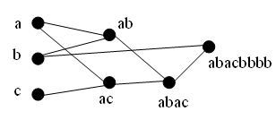
Figure 2: A Generalized GMDH Network Structure of a Chromosome
The incorporation of genetic algorithm into the design of such GMDH-type neural networks starts by representing each network as a string of concatenated sub-strings of alphabetical digits. The fitness, ($φ$), of each entire string of symbolic digits which represents a GMDH-type neural network to model turbulence intensity is evaluated as
$φ=1E$ (11)
where E, is the mean square of error given by equation (8), is minimized through the evolutionary process by maximizing the fitness $φ$.

6. Modelling Results

The parameters of interest in this multi-input-single-output system that affect the turbulence intensity are flow angle, crank angle position, center-distance in x-direction and y-direction. There have been a total number of 126 input-output experimental data considering the above four input parameters. The GMDH-type neural networks are now used for such input-output data to find the polynomial model of turbulence intensity in respect to their effective input parameters. In order to genetically design such GMDH-type neural network described in the previous section a population of 50 individuals with a crossover probability of 0.7 and mutation probability of 0.08 have been used in 200 generation which no further improvement has been achieved for such population size. The structure of the evolved 2-hidden layer GMDH-type neural network is shown in figure (3) corresponding to the genomes representation of abaacdbb , in which a, b, c and d stand for flow angle, crank angle position, centre-distance in x-direction and y-direction, respectively. The very good behaviour of such GMDH-type neural network model is also depicted in figure (4).

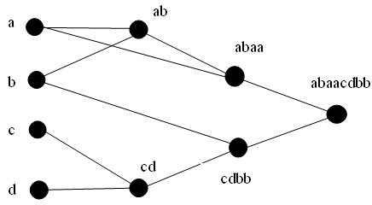
Figure 3: Evolved structure of generalized GMDH-type neural network for turbulence intensity modeling

However, in order to demonstrate the prediction ability of evolved GMDH-type neural networks, the data have been divided into two different sets, namely, training and testing sets. The training set, which consists of 103 out of 126 inputs-output data pairs, is employed for training the neural network models using the evolutionary method of this paper. The testing set, which consists of 23 unforeseen inputs-output data samples during the training process, is merely used for testing to show the prediction ability of such evolved GMDH-type neural network models during the training process. The structure of the evolved 2-hidden layer GMDH-type neural network is the same as the one shown in figure (3). The very good behaviour of such GMDH-type neural network model is also depicted in figure (5).

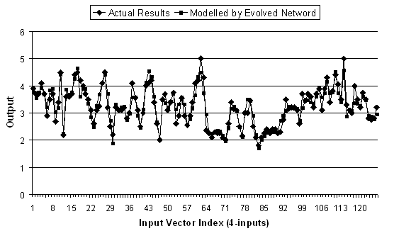

Figure 4: Variation of turbulence intensity with input data.

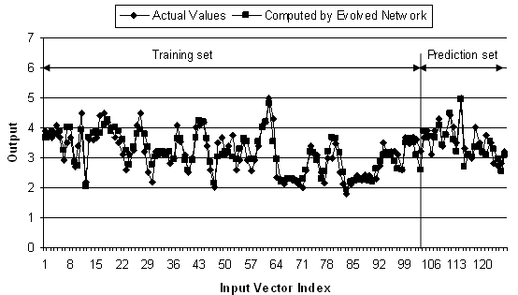
Figure 5: Variation of turbulence intensity with input data (modelling & prediction).

Table 1: Comparison of mean square errors and networks' complexity in modeling
 | Mean Square of Error |  | Number of  Hidden Layer | Number of  Neurons
 | SNE | SVD | Number of  Hidden Layer | Number of  Neurons
Method I [12] | 0.233 | 0.245 | 3 | 6
Method II [12] | 0.185 | 0.184 | 6 | 21
Method III [12] | 0.169 | 0.167 | 12 | 12
GS_GMDH | 0.151 | 0.146 | 2 | 5

Table 2: Comparison of mean square errors and networks' complexity in modelling & prediction
 | Mean Square of Error |  |  |  |  |  | Number of  Hidden Layer | Number of  Neurons
 | SNE |  |  | SVD |  |  | Number of  Hidden Layer | Number of  Neurons
 | Training | Test | Total | Training | Test | Total | Number of  Hidden Layer | Number of  Neurons
Method I [12] | 0.229 | 0.361 | 0.253 | 0.229 | 0.355 | 0.253 | 3 | 6
Method II [12] | 0.194 | 0.34 | 0.221 | 0.193 | 0.332 | 0.219 | 5 | 15
Method III [12] | 0.196 | 0.321 | 0.219 | 0.194 | 0.312 | 0.217 | 11 | 11
GS-GMDH | 0.115 | 0.104 | 0.113 | 0.113 | 0.104 | 0.111 | 2 | 5

Tables (1) and (2) demonstrate the comparison of the results obtained by Method I and Method II [12] in terms of mean squares of errors, number of hidden layer and number of neurons with those obtained by evolutionary process mentioned in this work. It is evident, from these tables, that much simpler GMDH-type neural networks (GS-GMDH) can be evolutionarily designed which have very comparable mean square of errors with those of more complex structures given in [12].

7. Conclusion

Evolutionary methods for designing generalized GMDH-type networks have been proposed and successfully used for the modeling and prediction of the complex process of turbulence intensity of in-cylinder swirl flow. In this way, it has been shown that GMDH-type networks provide effective means to model and predict the turbulence intensity. A new encoding scheme has been presented to genetically design GS-GMDH in which the connectivity configuration in such networks is not limited to adjacent layers, unlike the conventional GMDH-type neural networks. Such generalization of network's topology provides optimal networks in terms of hidden layers and/or number of neurons and their connectivity. It has also been demonstrated that Singular Value Decomposition can be effectively used to find the vector of coefficients of quadratic sub-expressions embodied in such GMDH-type networks.

7. References
[1] J.B. Heywood, "Internal Combustion Engine Fundamentals", McGraw-Hill Company, 1988.
[2] P.G. Hill and D. Zhang, "The Effects Swirl and Tumble on Combustion in Spark-Ignition Engines". Prog. Energy Combust. Sci. Vol. 20, pp373-429, 1994.
[3] K. Atashkari, “Experimental study of flow and turbulence in a V-Flame burner and a S.I. engine”, Ph.D. Thesis, Mech. Eng. Dept., The University of Leeds, 1997.
[4] C. Arcoumanis and J.H. Whitelow, "In-cylinder Flow Measurements in Motored Internal Combustion Engines", IMechE C433/060, 1991.
[5] K.J. Astrom, and P. Eykhoff, “System identification, a survey”, Automatica 7-123-62, (1971).
[6] S.J. Farlow, ed., “Self-organizing Method in Modelling: GMDH-type algorithm”, Marcel Dekker Inc., (1984).
[7] E.F. Vasechkina, and V.D. Yarin, “Evolving polynomial neural network by means of genetic algorithm: some application examples”, Complexity International, Vol. 9, (2001).
[8] N. Nariman-Zadeh, A. Darvizeh, R. Ahmad-Zadeh, “Hybrid Genetic Design of GMDH-type Neural Networks Using Singular Value Decomposition for Modelling and Prediction of the Explosive Cutting Process”, Proceedings of the I MECH E Part` B Journal of Engineering Manufacture, Volume: 217, Page: 779 – 790, (2003).
[9] L. Lading, "Spectrum Analysis of LDV Signals" In "Instrumentation for Flows with Combustion", Edited by Taylor, A.M.K.P., Academic Press, 1987.
[10] A.G. Ivakhnenko, “Polynomial Theory of Complex Systems”, IEEE Trans. Syst. Man & Cybern, SMC-1, 364-378, (1971).
[11] G.H. Golub and C. Reinsch, “Sngular value Decomposition and Least Squares Solutions”, Numer. Math., 14(5), pp. 403-420, (1970).
[12] A. Darvizeh, N. Nariman-Zadeh, and H. Gharababei, “GMDH-type Neural Network Modelling of Explosive Cutting Process of Plates Using Singular Value Decomposition”, ESM’2001, Prague, June, (2001).

