Sensorless Speed measurement of Ac machines using time frequency analysis
P.Susan Prakasi,Dr.P.Vanaja Ranjan
Electrical and Electronics department
Anna university
College of engineering ,guindy,Chennai-15
INDIA

Abstract : - In spite of the robustness of ac drives, the requirement of a shaft-mounted sensor renders them less attractive. This work is directed to develop a new method for sensorless speed estimation of AC machines. The stator current signal of induction motor contains speed related harmonics. The Time-Frequency analysis of stator current signal can be used to measure the instantaneous frequency without the use of sensors. Short-time Fourier transform and Analytic wavelet transform are the Time-Frequency analysis methods to be made use of in this project. Resolution and computation time required by spectral estimation techniques are better compared to other speed estimation technique. The resolution can be improved by ridges algorithm. This method can be implemented on hardware and can be further extended for fault identification and real time speed estimation.

Key-Words: -Sensorless, Ac machines, Time frequency analysis ,slot harmonics, Short time fourier transform, Wavelet transform, Ridges algorithm

1 Introduction

Advances in power semiconductor technology have led to the widespread use of ac drives using advanced control techniques such as field oriented control or direct torque control. However in spite of the robustness of variable speed ac drives, the requirement for a shaft-mounted sensor renders them less attractive.
Estimators, observers, and spectral analysis methods are the frequently used techniques for sensorless speed estimation. The performance of speed estimators depends on the accuracy of the machine model and parameter estimator. Observers for speed detection have a relatively long time delay time that can limit speed detection during a transient. The resolution obtained with spectral analysis is restricted by uncertainty principle. Ridges algorithm can solve this problem efficiently.
The short-Time Fourier Transform (STFT) is a practical tool to measure the frequency variations in time. The time-frequency information is contained in plane boxes called atoms, defined by the spread in time and frequency that contain enough energy density to be useful in signal processing. When a classical window is employed (Gaussian, Hanning, Hamming, etc.), the information is spread over a rectangular atom in the Time-Frequency plane; this atom area is minimum when a gaussian window is used . In the STFT, the atom is the same at all
time instants for every window as shown in fig 1.The instantaneous frequency can be obtained from ridge analysis, thereby increasing the time-frequency resolution of the Heisenberg boxes. This method has been widely applied in sensor less speed estimations of AC machines.

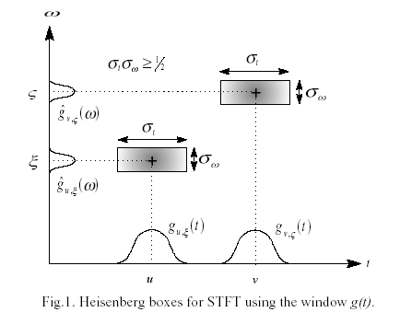
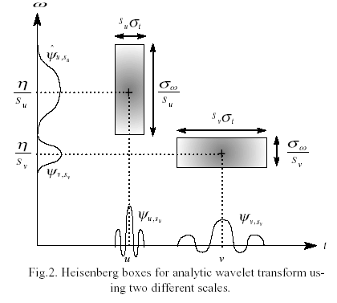

Wavelet analysis is a more general transformation and is also based on internal products of functions. However, in this case the concept of scale replaces the frequency variable of the Fourier transform. Although the Heisenberg atom area is not smaller than in the STFT with a Gaussian window, the time or frequency resolution can be conveniently changed using different scales, increasing one variable and decreasing the other (equal area atoms). This idea is illustrated in Fig.2. This additional degree of freedom can improve the angular speed resolution.

2 Sensorless speed measurement techniques
The frequently used sensor less speed estimation techniques are
- Estimators,
- observers, and
- spectral analysis methods

The performance of speed estimators depends on the accuracy of the machine model and parameter estimator. Observers for speed estimation have a relatively long delay time that can limit speed detection during a transient. The resolution obtained with spectral analysis is restricted by the uncertainty principle represented by the Heisenberg boxes. Ridges algorithm can solve this problem efficiently[1].
Among the various methods available for sensor less speed estimation time frequency analysis method is found suitable for sensor less speed estimation. A methodfor measuring rotor speed is based on sensing the rotor slot harmonics [3]. The stator current signal contains speed related harmonics that arises due to magneto motive

force spatial distribution, stator and rotor slots, and dynamic and static eccentricity.
Methods for frequency estimation of squirrel cage induction motor without the use of sensor and independent of machine parameters are based on time frequency analysis of stator current signal[7].
The speed information obtained can be used to a direct torque control drive. Time frequency analysis of stator current signal can be extended for fault identification purpose too[7]. The entire method can be implemented in a digital signal processor and extended for real time speed estimation.

2.1 Detection of Rotor slot harmonics
Sensorless speed measurement of ac machines using time frequency analysis techniques discussed in this paper is based on estimating speed making use of rotor slot harmonics which is present in the stator current signal even at no laod condition. The principal slot harmonic present in stator current signal is identified and a variation in the slot harmonic frequency indicates a variation in speed, on estimating the slot harmonic frequency from the spectrogram speed of the motor can be estimated. This method is independent of parameters of the motor since it does not require detail regarding the motor whose speed is to be measured other than the number of slots in the rotor .The rotor slot harmonic frequency is given by,

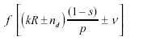 -----------1

where nd = 0 in case of static eccentricity, and nd = 1 in case of dynamic eccentricity ( nd is known as eccentricity order), f is the fundamental supply frequency, R is the number of rotor slots, s is the slip, p is the number of fundamental pole pairs, k is any positive integer, and n is the order of the stator time harmonics that are present in the power supply driving the motor ( n= ±1 ±3 ± 5 , , , etc.). The principal slot harmonics are also given by the above equation with nd = 0, n= 1,k= 1 . When one
of these harmonics is a multiple of three, it may not exist theoretically in the line current of a balanced three phase three wire machine.

2.2 Time frequency analysis
Powerful tools for measurements of frequency changes with time are the so-called time-frequency representations of signal (TFRs) .
Short-Time fourier transform is the most widely used tool for time frequency (TF) analysis of non-stationary signals. Analytic wavelet transform is a more general transform that can be used for TF analysis. STFT is nothing but windowed Fourier transform. Time frequency analysis of stator current signal using STFT and AWT yields a better result compared to other conventional and parameter based techniques and can be used over the entire speed range, because the method is independent of machine parameters and speed related harmonics exists even at zero speed[1].

2.2.1 Short time fourier transform
Analysis with Fourier transform is applicable to stationary signal whose properties do not evolve in time.
The Fourier transform is defined as
∞
X (f) = ∫ x(t)e^{- j2πt}dt --------2
-∞

Where the analysis coefficient X(f) define the global frequency f content of the signal. As seen in equation they are computed as inner product of signal with sine wave bases function of infinite duration. As a result Fourier analysis works if x (t) is composed of few stationary component.
Fourier transform gives the spectral content of signal, but it gives no information regarding where in time these spectral components occur.
The changes in time in non-stationary signal have their frequency spread. The approach to analyze such signal is to introduce time dependency in Fourier analysis by introducing windowing techniques. This requires the assumption that some portion of the signal is stationary. This revised Fourier transform is called Short-Time Fourier transform (STFT)
Short-Time Fourier Transform is also known as the windowed Fourier transform.The function of the window is to extract a finite portion of the signal. The Short-Time fourier transform (STFT) is a practical tool to measure the frequency variations in time. The time-frequency information is contained in plane boxes called atoms, defined by the spread in time and frequency that contain enough energy density to be useful in signal processing. When a classical window is employed (Gaussian, Hanning, Hamming, etc.), the information is spread over a rectangular atom in the time frequency plane; this atom area is minimum when a Gaussian window is used. In the STFT, the atom rectangle is the same at all time instants for every window[1].
The frequency content of the stator current spectrum as a function of time can be analyzed using the STFT ,also called windowed Fourier transform (WFT). In the STFT, a Gabor atom, is used to measure the frequency variations in a time signal[1]. A family of time-frequency Gabor atoms is obtained by modulating the real and symmetric function (window), g(t), by the frequency   and translating it by u .

The stft of a function f(t) at time u and frequency ξ is given by

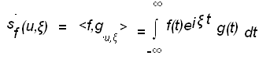-----3

The spectrogram of the function f(t) is the
energy density of this signal and can be defined as
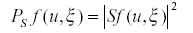-------4
The spectrogram can be represented in a three dimensional plot and its ridges represent the instantaneous frequency ω (t) is given by

ω(t)=d ∕ dt (φ(t))--------------------------5

where f(t)= a(t) cos φ(t).

The resolution in time and frequency of the STFT depends on the spread in time and frequency of the selected window (Rectangle, Hamming, Gaussian, Hanning, etc.). The instantaneous frequency can be obtained from ridge analysis[1].

2.2.2 Window selection
The type of window used also plays an important role in the STFT time frequency analysis .The time width and frequency width of the window determines the resolution .Since the area of the window is fixed in STFT, resolution of either time or frequency can be obtained only on sacrificing resolution of the other variable [15].

2.3 Analytic wavelet transform
Similar to STFT analytic wavelet transform can be used for estimating the instantaneous frequency. In analytic wavelet transform, the time or frequency resolution can be conveniently changed using different scales This additional degree of freedom can improve the angular speed resolution. The analytic wavelet transform defines a local energy density called scalogram, which has to be interpolated to obtain a linear spectrogram and then ridges algorithm can be applied[1].

2.4 Ridges algorithm
The instantaneous frequency defined in ω(t) can be estimated by ridges detection in the spectrogram. The spectrogram can be obtained using any time-frequency transform such as: STFT, AWT or Wigner-Ville.

3 Experimental result
Stator current signal of 3 phase squirrel cage induction motor during start up and steady state is obtained. The motor under test is a 4 pole,1430 Rpm,50 Hz ,7.5 Amps ,415 V, 5 HP submersible squirrel cage induction motor. Fig.1 shows current in one phase of the motor during startup under no load condition .The current is obtained as a 2000 point data using a storage oscilloscope for a period of 5 seconds. The current obtained is filtered using a butterworth filter to obtain frequency components that relate to speed , that is the rotor slot harmonics. Fig 3 shows the filtered current signal .Fig .4 and Fig .5shows the frequency components present in the current signal before and after filtering. Fig.6 shows the spectrogram for the filtered current signal under steady state and transient state. Applying ridges algorithm to the spectrrogram speed of the motor is estimated.

4 Conclusion
Stator current signal obtained from one phase of the motor is found to have a frequency component at 50 Hz and components near 150Hz and 250 Hz before filtering as in fig.2 ,with this fundamental component and its harmonics speed could not be estimated,So the fundamental component is removed and rotor slot harmonic components alone that relate to speed of motor are separated first using a butterworth filter,The rotor slot harmonics are not present for all combination of rotor stator slot numbers ,so selection of motor for sensorless speed measurement using rotor slot slot harmonics is an important criteria. spectrogram for the filtered current signal is obtained ,the instantaneous frequency obtained from spectrogram is used to estimate the speed .Wavelet transform technique can be applied in the abovesaid procedure to estimate speed which is expected to improve the resolution. Since speed measurement using this method is independent of motor parameters , and slot harmonics are present even under no load condition ,speed measurement can be done at all time instants further the method is very simple and could be implemented in a dsp processor to obtain online speed estimation.

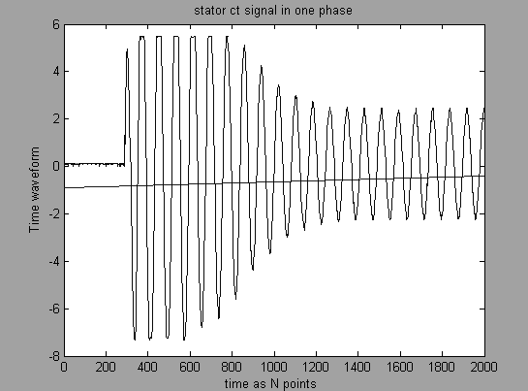Fig .1 current in one phase of the motor during startup
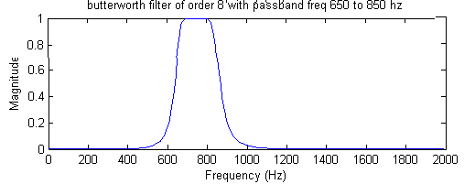
Fig.2 bandpass butterworth filter of order 8 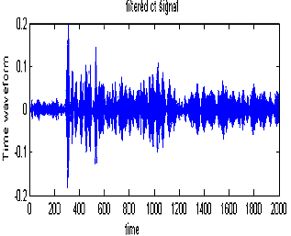 Fig3. stator current signal after filtering using the BPF 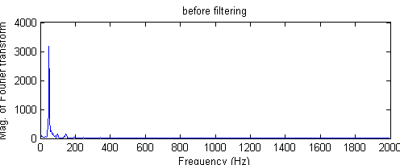
Fig .4 fundamental frequency component present in stator current signal before filtering

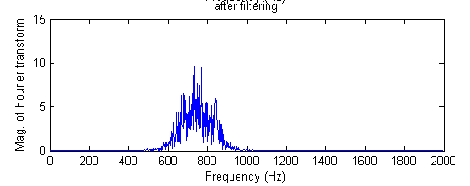
Fig .5 frequency components present in filtered current signal
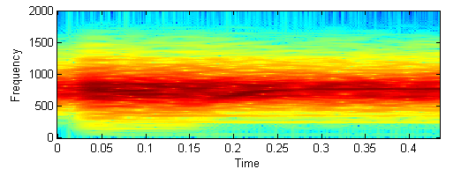
Fig .6 spectrogram of filtered current signal .

References:
[1]J. M. Aller,T. G. Habetler, R. G. Harley, R.M. Tallam and S.B. Lee “Sensor less Speed Measurement of AC Machines using Analytic Wavelet Transform”,IEEE Transaction on indudtrial application, vol 38, no. 5, september/october 2002.

[2]K.D.Hurst and T.g.Habetler, “ A Comparison of spectrum estimation techniques for sensorless speed detection in induction machines” , IEEE transactions on industry applications, VOL..33,pp 898-905,jul/aug.1997.

[3]J.A.Restrepo and P.Bowler, “Analysis of induction motor slot harmonics in the Tf domain”, in proc of .IEEE First Int. caracus conf on.Devices,Circuits and system,caracus,venezuala,1995,pp127-130

[4]J.A.restrepo,M.I.Gimenez,V.M.Guzman,J.M.aller,and A.bueno, “Kernel selection for sensorless speed measurement of ac machines”, in procee.IEEE IECON’98,vol.2,Aachen,Germany,1998,pp.991-996.

[5]N.Delprat,B.Escudie,P.guillemeain,R.kroland-artinet,P.tchamitchian,And B.Torresani , “Asymptotic wavelet and Gabor analysis ;Extraction of instantaneous frequencies”,IEEE trans on inform Theory,vol.38,pp644-664,mar 1992.

[6]J.Nash, “Direct torque control ,induction motor vector control without an encoder”,IEEE transaction on Ind.Application,vol33,pp333-341,mar/apr,1997

[7]E.H. Benbouzid, M. Vieira, C. Theys, “Induction motors’faults detection and localization using stator current advanced signal processing techniques”, IEEE Trans. on Power Electronics, vol. 14, no. 1, Jan. 1999, pp. 14–22.

[8]Malik E. Elbukuk ,M.David kankam ,”speed sensorless induction motor drives for electrical actuator :schemes ,trends and tradeoff” technical memorandum ,National aeronautics and Space Administration , lewis research center Cleveland,ohio,may 1997.

[9]Jan Blaska, Milos Sedlacek, “Use of the Integral Transforms for “Estimation of Instantaneous Frequency”, measurement science review, Volume 1, Number 1, 2001.

[10]Zbigniew Lonowiz,Tadeusz Lobos,Tomasz sikorski ,”Time frequency analysis of threee phase signals using wigner distribution “, IV international workshop “computational problem of electrical engineering”,zakopane 2002

[11]Douglas L.Jones and Thomas W parks, “A resolution comparison of various time frequency representations”,IEEE trans on signal processing vol 40,no 2, feb 1992 .

[12]Jose M.Aller ,Jose A.Restrepo,Alexander Bueno,Maria i.Gimenez, and Gaston Pesse, “squirrel cage induction machine model for the analysis of sensor less speed measurement methods” IEEE 1998.

[13]Henry K.c.kwok & Douglas L.Jones(1996), “Instantaneous frequency estimation using adaptive short time fourier transform”,proceedings of ASILOMAR-29.1996 IEEE.

[14]“Stankovik .l,Quadriatic and higher order time frequency analysis based on stft”,signal processing and application ,first international symposium on2001.vol2 13 –16,aug 2001.pp 581-582.

[15]kadambe.s, “On the window selection and the cross term that exists in the magnitude squared distribution of the short time fourier transform”,statistical signal and array processing ,1992,conference proceedings,IEEE sixth special workshop on 7 – 9 oct 1992.pp 22 – 25.

[16]Kwok.H.K.Jones .d.l’ “Improved instantaneous frequency estimation using adaptive stft”,IEEE trans on signal processing vol 48,issue 10,2000,pp 2964-2972.

[17] Stephen borum,Kristopher Jenson. “additive analysis & synthesis using analytically derived windows”, procee. Of 2nd COST G-6 workshop on digital audion effects.(dafx 99),ntnu,Trondheim dec 9 – 11 ,1999

