Design of CMOS Based Transimpedance Amplifier
for Integrated Optical MEMS Applications

Paresh Rathod, Muthukumaran Packirisamy and Ion Stiharu

Mechanical and Industrial Engineering
Concordia University
1455 de Maisonneuve Blvd. West, Montreal, Quebec, H3G-1M8
CANADA
http://www.concordia.ca

Abstract: - Novel and simple designs of transimpedance amplifiers (TIA) that can be integrated with optical MEMS devices and optical sensors for conversion of current signal into voltage are proposed using standard CMOS technology. The transimpedance amplifiers are designed with variable gain and dynamic range so that they can be selected depending upon the specific application requirement. Design of different types of photodiodes using the TSMC 0.18um CMOS technology was implemented using the proposed TIA. It is known that CMOS photodiode sensitivity is limited to light wavelength from 100nm to 1100nm. Even though now days CMOS photodiode are widely used as photo-detectors because of its simple layout and easy integration with other circuitries on the same chip at lower cost. Complete design of linear transimpedance amplifier was carried out using Cadence for conversion of photodiode current in to voltage. Photodiodes are utilized in many applications such as spectroscopy, photography, analytical instrumentation, optical position sensors, beam alignment, surface characterization, laser range finders, optical communications, and medical imaging instruments. Proposed CMOS photodiode and Transimpedance amplifiers are suitable for Biophotonics applications. Motivation of this project is the implementation of integrated BioMEMS device for detection of biological and chemical materials.

Key-Words: - Transimpedance amplifier, Analog VLSI, Current to voltage converter, Sensor circuit.

- Introduction

Several ways of guiding an autonomous robot around obstacles have been studied in the past recent years. The fuzzy approach seems to have been predominant. Tchongchai and Kawamura [1] used fuzzy control and sonar to make a mobile robot
Trend of integrating optical sensors, circuits, microsystems and detectors on single chip [1-3] is increasing very rapidly in the fields of Biophotonics and MOEMS (Micro Opto Electro Mechanical Systems) for variety of applications such as optical position sensors, and spectroscopy to detect biological and chemical agents. Using CMOS process technology, it is not only possible, but also practical and economical to use CMOS photodiodes integrated with transimpedance amplifiers for many optical applications. Proposed transimpedance amplifier circuits can be easily integrated with CMOS photodiode and current based sensors. In an implementation of current-mode circuits and optical sensor circuits, TIA perform current to voltage conversion and hence it is very essential to use efficient TIA circuit for the good performance of systems [4, 5].

Light Source

MEMS element for sensing

Photodetector
Fig. 1 Schematic diagram of a Biophotonics system

Figure 1 shows block diagram of simple Biophotonics system which include light source, photo detector and MEMS device for sensing. With continued advancement of technology in medical imaging, Biophotonics device on single chip are becoming a reality. Hence, Biophotonics devices will be more practical and economical in nearly future. The portability and smaller size of device for medical purposes make some measurements possible that could not be done otherwise using large instruments.
Microinstruments could be attached to human body for continuous monitoring and transmitting information to a remote receiver. These biomedical microinstruments will change our daily life in the next decade. The motivation for this project is to initialize practical implementation of biomedical microinstrument and to explore new research field of microsystems technology. CMOS process technology is most versatile technology used for IC market due to low-power dissipation and high density integration. This makes the CMOS technology as a best option to implement on chip biomedical instruments. For biomedical micro instruments, range of our interest is 440nm to 720nm. CMOS photodiode sensitivity is limited to light wavelength from 100nm to 1100nm which includes our range of interest for biomedical micro instruments and also CMOS photodiode has simple layouts that can be easily integrated with other circuits on the same chip.
Figure 2 shows schematic diagram of biomedical micro instrument.
This paper aims at the design of different types of physical layout of photodiodes using TSMC 0.18 CMOS technology. Basic principle of CMOS photodiode for the photocurrent generation is that light absorption in the depletion region of semiconductor produces electron-hole pairs, which will be separated by the applied electric field. This phenomenon generates current flow in the diode. The electron-hole pairs are generated outside the depletion region when a reverse bias is applied to the diode, one side of which should be as near to the surface as possible. In general, the depletion width varies with the doping profile of the N+, P+ diffusion and fabrication process, and it will certainly affect the performance of other circuits when they are integrated in a single chip. In order to keep to the standard fabrication, layout design is the only parameter that would allow optimizing the performance of photodiode.
Proposed transimpedance amplifier circuits as shown in Figure 3 are efficient for current to voltage conversion with wider linear range. The sensitivity and dynamic range are made adjustable in order to get optimum performance for specific application in terms of gain and range. Proposed circuits can perform inverting operation that results in high voltage when the input current is low, and visa versa. Proposed circuits consist of only a few transistors without any passive components and can be implemented using CMOS process technology.

CMOS
Photodiode
Transimpedance
Amplifier
Voltage
Amplifier
Control Logic
for Power
Management
Dual-slope
ADC
Data
Storage

Multiplexer

D
S
P

Interface
MEMS device
Fig. 2 Block diagram of biomedical microinstrument

- Analysis
Figure 3 shows a circuit diagram of the proposed basic transimpedance amplifier for current to voltage conversion, which consists of one PMOS and three NMOS. In Figure3, I is input current signal, V0 is output voltage and Vb is biased voltage. VGSI and VDSI represent gate-to-source voltage and drain-to-source voltage, respectively, and $\frac{W_{I}}{L_{I}}$ is aspect ratio for MI transistor for I=1, 2, 3 and 4.

  - Calculation of quiescent operating point (V_{Q}, I_{Q})
Equations 1 to 3 govern the calculation of quiescent point.

When I=0, I_{Q}=I₁=I₂=I₃=I₄, then V_{GSQ}=V_{GS4} and V_{Q}=V₀=V_{DD}-V_{GS3.}
Where:
$β_{j}=μ_{N}\frac{W_{j}}{L_{j}}$ Where, j=2, 3, 4
$$β_{1}=μ_{P}\frac{W_{1}}{L_{1}}$$

V_{TP} and V_{TN} are the threshold voltage, λ_{P} and λ_{N} are Channel-length-modulation factors of the PMOS and NMOS, respectively, and µ_{N} and µ_{P} are mobilities of electrons and holes respectively

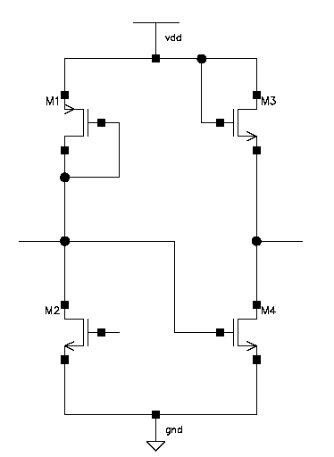
I
I₁
I₂
I₃
I₄
V₀
V_{b}
Fig. 3 Circuit diagram of the proposed basic TIA

Quiescent operating point (V_{Q}, I_{Q}) depends on transistor parameters and biasing voltage Vb.
I₂ remains almost constant and is equivalent to I_{Q} as V_{b} is constant and I₁=I₂+I. Therefore, when input current signal I is present I₁ will change. In this case, gate-to source voltage of M4 changes with small amount${ΔV}_{\text{GS}4}$. This small variation of ${ΔV}_{\text{GS}4}$ tends to change I₄, and hence the output voltage as $V_{0}=V_{Q}+{ΔV}_{0}$ where, ${ΔV}_{0}$ is change of output voltage due to the presence of input current signal I.
When,
I<0, $V_{0}=V_{Q}+{ΔV}_{0}$ where ${ΔV}_{0}$>0
I>0, $V_{0}=V_{Q}+{ΔV}_{0}$ where ${ΔV}_{0}$<0
When input current signal I changes, I ₂ remain almost constant. Thus,
I₁=I+I_{Q}, I₃=I₄,
and
Therefore,
The above equation 6 shows that conversion of input current I into output voltage V₀ is related to channel modulation effect. Negative sign in equation 6 demonstrates inverting operation of the proposed TIA circuit.
For the circuit diagram shown in Figure 3, the transimpedance is, (7)

  - Circuit optimization
Figure 4 is the improved circuit diagram of the proposed basic TIA with enhanced dynamic range.

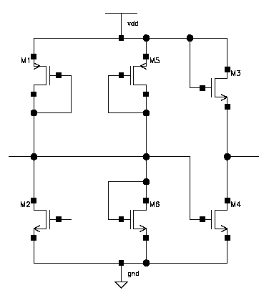
I₂
I₃
I₄
I₅
I₆
I
I₇
V₀
V_{b}
I₁

Fig. 4 Circuit diagram of the improved TIA to extend dynamic range

The transistors M5 and M6 are added in proposed basic TIA circuit diagram in order to improve further the operating range. For the circuit shown in Figure 4, the transimpedance is,

- Simulation results
The circuits shown in Figures 3 and 4 are simulated with HSPICE using TSMC 0.18 µm process based transistor model with 3.3Volt supply voltage. The supply voltage V_{DD} and bias voltage V_{b} for both circuits are 3.3Volts and 1.6Volts, respectively. For both circuits, the transistor aspect ratios are as follow:

$\frac{W_{1}}{L_{1}}=\text{10}$, $\frac{W_{6}}{L_{6}}=\text{21}$

and

Figure 5 shows DC sweep response of circuit in Figure 3 for the input current range of -300µA to 300µA, which shows that for the range of -150µA to 150µA, the proposed basic TIA circuit operation is very linear with the gain of 0.7/150 (V/µA). Figure 5 confirms that the output voltage is high when input current signal is low, and visa versa. Figure 5 also shows that circuit performance is also quite good for entire simulated dynamic range. Output voltage range is from 0.3V to 2V for simulated dynamic range. The gain and range of operation can modified for possible best performance for specific application by adjusting biasing voltage V_{b}. These characteristics of proposed circuits show that these circuits can be easily integrated with sensors.
Figure 6 shows DC sweep response of the improved circuit of Figure 4 for the input current range of -1mA to 1mA. It shows that addition of two transistors increased the dynamic range of operation. The improved design has approximately three times larger dynamic range compared to proposed basic TIA circuit shown in Figure 3.
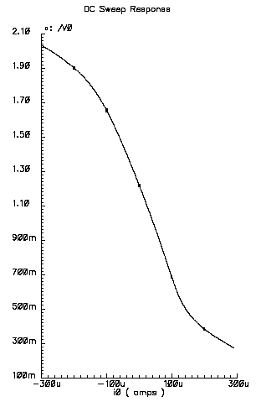
Fig. 5 Simulation result of circuit
shown in Figure 3

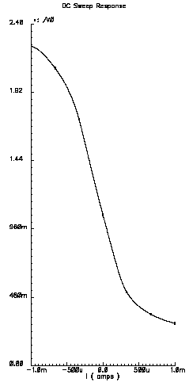
Fig. 6 Simulation result of circuit
shown in Figure 4

- Conclusion
For current to voltage conversion two novel and very simple circuits of transimpedance amplifier are proposed using CMOS 0.18um technology which can be integrated with photodetectors, current based sensors and optical sensors. The gain and dynamic range of proposed circuits of TIA are dependent on bias voltage and transistor parameters. Bias voltage can be modified to adjust gain and dynamic range for specific application. The improved design also increased the linear range from -350µA to 350µA with the gain of 0.75/350 (V/µA).

References:
[1] T. K. Woodward, A. V. Krishnamoorthy “1-Gb/s Integrated optical detectors and receivers in commercial CMOS technologies” IEEE J. of Select. Topics Quantum Electronics, Vol. 5, No. 2, March/April 1999, pp. 146-156.
[2] W. Chen, H. Duan, S. H. Jones “Integrated 1.2µm CMOS photodiodes, transimpedance amplifier, 12 bits A/D converter, and DSP interface for microinstrument applications” Proc. IEEE Conf 1999.
[3] G. N. Lu, P. Pittet, G. Carrillo and A. El Mourabit “On chip Synchronous detection for CMOS photodtector” Proc. IEEE Conf 2002.
[4] Chunyan Wang and Jiqiang Wang “Design of Linear Transimpedance Amplifiers” Proc. IEEE Conf 2001.
[5] Jiqiang Wang and Chunyan Wang “Efficient Transimpedance Amplifiers Using Digital CMOS technology” Proc. IEEE Conf 2000.

