Study on Birefringence of Anisotropically
Micromachined SOI Waveguides

Muthukumaran Packirisamy and Hong Zhao

Mechanical and Industrial Engineering
Concordia University
1455 de Maisonneuve Blvd. West, Montreal, Quebec, H3G-1M8
CANADA
http://www.concordia.ca

Abstract: - The use of SOI (Silicon On Insulator) wafers for integrated optical MEMS will become the very useful choice in the future due to many inherent advantages, such as, micromachining capability, stress free mechanical properties, optically flat surfaces, good optical and mechanical properties, etc. This paper attempts to model and predict the influence of stress relieving groove on the anisotropically micromachined SOI rib waveguides that have tremendous potential for telecommunication and non-telecommunication applications. This paper also presents the predicted results on the parametric study of stress relieving grooves on birefringence.

Key-Words: - SOI, Birefringence, MOEMS, Anisotropic micromachining, Telecommunication applications.

Introduction
Today, silicon-based microelectromechanical (MEMS) technologies are widely used in the micromechanical world because of their small scale and easy possible integration with other electronic and optical elements [1]. Using photolithography, film deposition and etching, the MEMS process can make microstructures with high precision [2]. For instance, diffractive microlenses, micro-optical fibers and silicon waveguides are fabricated as high precise MEMS devices. Due to their inherent advantages silicon waveguides have great utilization in the optical propagation.
This paper will focus on the effect of stress relieving grooves on anisotropically etched rib silicon waveguides to propagate wavelength of 1550nm based on 5μm SOI wafer. The designing process contains not only modal analysis but also birefringence analysis. The effect of stress releasing grooves on the birefringence will also be estimated. The presented results will have important application in telecommunication and spectroscopy applications. The detailed comparison on the influence of different stress releasing grooves was completed by using FEMLAB [3].
The most commonly used approach in microsystem design is to apply finite-difference or finite-element techniques to a differential problem formulation [4]. Wave equation and its eigenvalue equation are special partial differential equation, which also can be solved by finite element method.
One of the ways of fabricating the SOI waveguides of different geometry is through anisotropic micromachining. Hence, this paper presents the analysis on effect of stress relieving grooves on different micromachined rib waveguides.

Mathematical Modeling

2.1 Wave equation
When a monochromatic light is considered propagating in a planar waveguide, it can be assumed to have exp (-ωt) time dependence where ω is the angular frequency. Depending on whether electric or magnetic field, namely, -field or -field formulation is used, solving the Maxwell’s equation is equivalent to solving the following vectorial wave equation
$∇×\left(p∇×\vec{ϕ}\right)−k_{0}^{2} q \vec{ϕ}=0$ (1)
where k₀ is the free space wavenumber, and q=n²(x,y,z) when is the electric field $\vec{E}$ while p=1/n²(x,y,z) and when is the magnetic field $\vec{H},$ n(x,y,z) being the refractive index distribution. When a uniform planar waveguide is considered where$n(x,y,z)=n(y)$, the TE (Transverse Electric) and TM (Transverse Magnetic) modes propagating in the z direction take the following form

$\vec{ϕ}=\begin{aligned}\left[v(y) | \right]\left[0 | \right] \\ \end{aligned}$ (2)

where the propagation constant β and the eigenvector v(y) are solution to the eigenvalue problem

$$\frac{∂}{∂y}\left(p(y)\frac{∂v(y)}{∂y}\right)+(k_{0}^{2}q−p(y)β^{2})v(y)=0$$
(3)
The above equation has been solved using finite element method based FEMLAB software.

3. Modeling
The rib waveguide is shown in Figure 1 [5].
The rib silicon waveguide can be fabricated by etching a 5μm SOI (silicon-on-insulator) wafer. SOI structures consist of a layer of Silicon crystalline and a layer of SiO₂ on the Si substrate as shown in Figure 1. As the mechanical properties of SOI monocrystalline films are better than those of polycrystallinesilicon, SOI wafers are suitable to make many micro-electro-mechanical systems and mirophotonic elements. Because Si and SiO₂ have a big refractive index difference, SOI can make small waveguides with sharp bends [6] and they are very sensitive to birefringence variations [7].
In this case, the wavelength of the infrared light in vacuum is 1550nm, and the thickness of SOI wafer is 5μm. The refractive index of Si is 3.5, and the refractive index of SiO₂ is 1.5. The refractive index of air is 1.0 as shown in Figure 1.

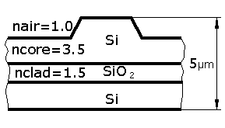
Fig. 1 Structure of silicon-on-insulator (SOI) rib waveguide

The Figure 2 is the schematic of a rib silicon waveguide with stress releasing grooves. The geometrical dimensions are as follows: L=2.25μm, d=0.3μm, x1=1μm, Detch=1.4μm and α=54.74º.
The predicted first TE and TM modes for waveguide with no stress relieving grooves are shown in Figures 3 and 4. The corresponding birefringence (γ) of this case is equal to 0.003913. The birefringence, γ is defined as the difference between the effective indices of TE and TM modes, as
$γ=n_{\text{eff}}^{\text{TE}}−n_{\text{eff}}^{\text{TM}}$ (4)
Similarly the birefringence has been estimated for the geometry shown in Figure 2 as 0.003897 which is less than the birefringence of 0.003913 with no stress relieve grooves. Thus it is seen that stress relieve grooves reduce the birefringence and it is also dependent on the groove geometries.

Fig. 2 Schematic of a rib silicon waveguide with stress releasing grooves

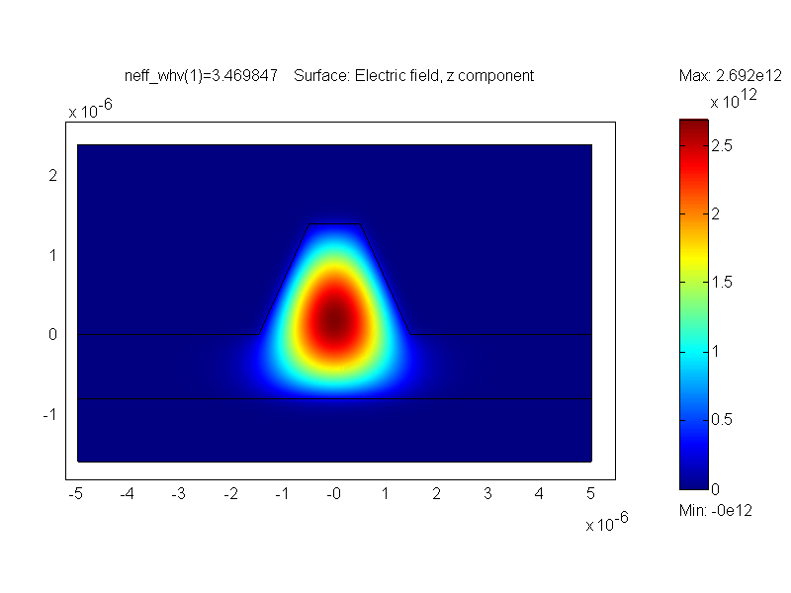
Fig. 3 First TE mode

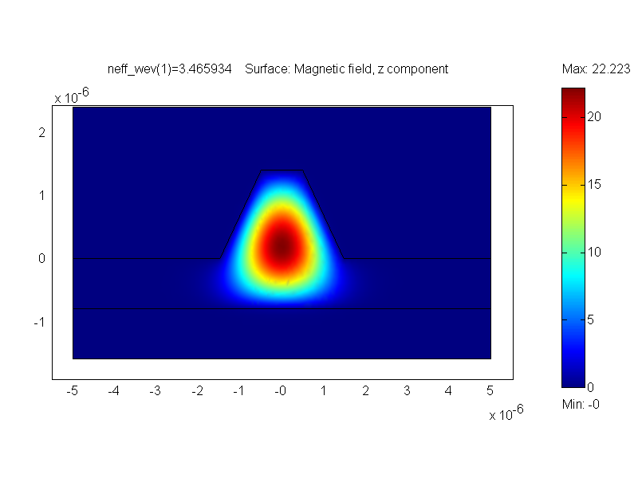
Fig. 4 First TM mode

4. Effect of Groove geometry on
Birefringence
In this section, results on the effect of different groove geometries are evaluated for different anisotropically etched rib waveguides.

The variation of birefringence against sidewall angles and etch depth
The variation of birefringence against different sidewall angles with the different etch depths are shown in Figures 5 to 8. The geometry used for the simulation are L=2.25μm, d=0.3μm and x1=1μm. 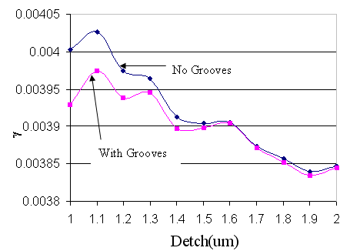

Fig. 5 At α=54.74º, x1=1μm, the birefringence variation with etch depth

The Figure 5 shows the reduced birefringence under the influence of stress relieving grooves for the angle of α=54.74º while the Figures 6, 7 and 8 show the birefringence variation for the α=60º, 80º, 90º, respectively.

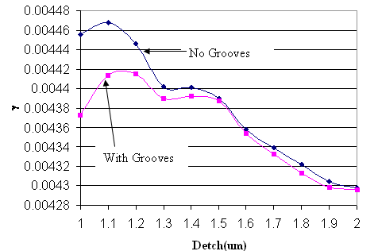

Fig. 6 At α=60º, x1=1μm, the birefringence variation with etch depth
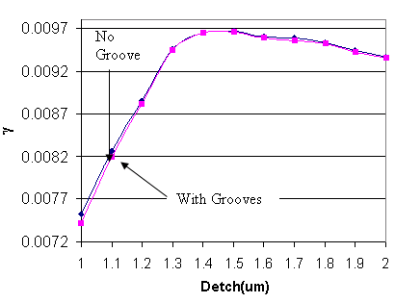
Fig. 7 At α=80º, x1=1μm, the birefringence variation with etch depth
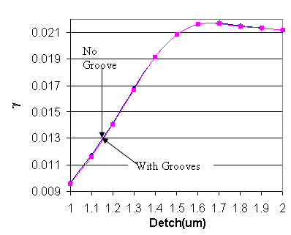
Fig. 8 At α=90º, x1=1μm, the birefringence variation with etch depth

It can be concluded from Figures 21 to 24 that
- For sidewall angle 54.74º and 60º, the birefringence will be reduced significantly by adding the stress releasing grooves, especially for etch depth between 1μm and 1.5μm.
- For sidewall angle 80º and 90º, there is no significant reduction in birefringence due to stress releasing grooves.
In brief, the stress releasing grooves are more useful for the small angle than the large angle, and the stress releasing grooves can reduce the birefringence effectively at low etch depth.

The variation of birefringence with groove length L
The variation of birefringence with the different length L of stress releasing grooves with d=0.4μm, x1=1μm, Detch=1.4μm, α=54.74º can be seen in Figure 9. It can be observed that the birefringence reduces significantly when stress releasing groove is close to the rib edge of the waveguide.

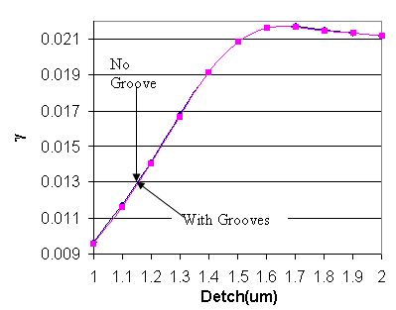
Fig. 9 The variation of birefringence with t length L of stress releasing grooves

4.3 Variation of birefringence with the different width d of stress releasing grooves
The variation of birefringence with L equals to 3μm and 2.25μm and different width d of stress releasing grooves, x1=1μm, Detch=1.4μm, and α=54.74º is shown in Figure 10. Because L=3μm is far away the rib edge, the birefringence almost has no change irrespective of whether grooves are big or small. However, for L=2.25μm, the birefringence tends to decrease while the width of stress releasing grooves increases.

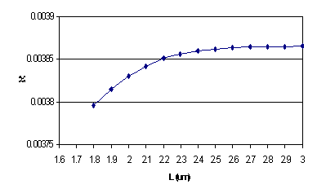

Fig. 10 The variation of birefringence with width d of stress releasing grooves

5. Conclusions
This paper presented theoretical results on the birefringence of anisotropically etched SOI based rib waveguides using stress relieving grooves. The effect of plane emerging angle, groove spacing, grove width are presented using finite element method. The predicted results show significant improvement on the birefringence and also strong dependence of groove parameters on the birefringence. For this silicon waveguide without stress releasing grooves, the birefringence is more sensitive to the change of bottom width than the change of top width. Meanwhile, the birefringence was noticed to decrease as the top and bottom widths increase. In addition, it was observed that the small sidewall angle and the small etching depth will generate the minimum and stable birefringence. Adding stress releasing grooves can reduce the birefringence significantly for small sidewall angles especially when the stress releasing grooves are close to the rib edge of the waveguide. However, very far stress releasing grooves have no influence to the birefringence.

References:
[1] Ral Choudhury P, “MEMS and MOEMS Technology and Applications”, pp.210.
[2] Hiroyuki Fujita, “MEMS/MOEMS Application to Opitical Communication”, MEMS Components and Applications for Industry, Automobiles, Aerospace, and Communication held in San Francisco, USA, October 22-23,2001, pp.xxi.
[3] COMSOL, “FEMLAB 3 Multiphysics Modeling”, Product Catalog. (www.comsol.com).
[4] Igor Balk, “A New Approach for 3D Full Wave Electromagnetic Analysis”, Design, Test, Integration, and Packaging of MEMS/MOEMS 2001, pp.209.
[5] Ral Choudhury P, “MEMS and MOEMS Technology and Applications”, pp.212.
[6] G.K.Celler and Sorin Cristoloveanu, “Frontiers of Silicon-on-Insulator”, Journal of Applied Physics, Volume 93, Number 9, 1 May 2003, pp.4956.
[7] Xiuli Zhao, Y. Z. Xu, and Chunfei Li, “Birefringence Control in Optical Planar Waveguides”, Journal of Lightwave Technology, Vol.21, No.10, October 2003, pp.2352.

