3D Indoor Geolocation
With Received Signal Strength Fingerprinting Technique
And Neural Networks

CHAHÉ NERGUIZIAN¹ AND LAMIA HAMZA¹
VAHÉ NERGUIZIAN² AND MAAROUF SAAD²

¹ Electrical engineering
École Polytechnique de Montréal
2500 Chemin de Polytechnique, Montreal, Quebec, H3C-3A7
CANADA

² Electrical engineering
École de Technologie Supérieure
1100 Notre Dame West, Montreal, Quebec, H3C-1K3
CANADA
http://www.polymtl.ca

Abstract— Three dimensional location of a user is highly desirable in indoor environments since it represents an extension to the GPS system where signals can not penetrate the in-building environments. In this paper, we present a method for 3D user location using WLAN’s received power (RSS) data applied to an artificial neural network (ANN). The proposed fingerprinting system learns off-line the location RSS ‘signatures’ for line of sight (LOS), obstructed line of sight (OLOS) and non-line of sight (NLOS) situations. It then matches on-line the observation received from a user against the learned set of ‘signatures’ to accurately locate its three-dimensional position. The x-y location precision of the proposed system, applied to the three floors of a building simultaneously, has been found to be 3 meters for 78% and 63% of trained and untrained data, respectively. As for the z-axis precision, the proposed system has succeeded to identify the exact floor for 92.5% and 85.5% of trained and untrained patterns, respectively.

Key-Words: 3D indoor user location, Artificial neural network, Wireless local area network.

- Introduction
A problem of growing importance in indoor environments is the location of the users on two or three dimensions especially when signals from GPS system can not penetrate the in-building environments. In indoor environments, traditional parametric indoor geolocation techniques such as received signal strength (RSS), angle of arrival (AOA), time or time difference of arrival (TOA/TDOA) or their combinations fail to provide adequate location accuracy because of the presence of multipath and the lack of direct path between the transmitter and the receiver. For these techniques, all the paths used for triangulation must have a line of sight (LOS) to ensure an acceptable accuracy, a condition that is not always met in an indoor environment. An improvement of the accuracy may be obtained by using the location fingerprinting technique [1] in which the effect of multipath is used as constructive information.
This paper provides a method to localize an in-building user in three dimensions using a fingerprinting technique. The signature or the fingerprint involved consists of RSS data obtained from a WLAN network and the considered pattern matching algorithm is composed of an artificial neural network. For the studied in-building environment, results show an x-y distance location accuracy of 3 meters for 78% and 63% of trained and untrained patterns, respectively. As for the elevation accuracy, results give correct floor identification for 92.5% and 85.5% of trained and untrained patterns, respectively.
In section 2, we give an overview of the existing geolocation systems using the fingerprinting technique. In section 3, we present the proposed system and give 3D-location accuracy results by applying the measured indoor data to an artificial neural network. Finally, we close this paper with a conclusion in section 4.

- Existing geolocation systems using the fingerprinting technique
Several geolocation systems, using the fingerprinting technique, have been recently deployed in outdoor and indoor environments. The main differences between these systems are the types of fingerprint information and pattern-matching algorithms.
Systems such as RADAR [2], WILMA [3] and DCM [4] use RSS information gathered at multiple receiver locations to find the user’s coordinates. RadioCamera system [5] uses multipath angular power profile (APP) information gathered at one receiver to locate the user’s coordinates. DCM [6] and [7] use channel impulse response (CIR) information to locate and track mobile units. The pattern-matching algorithms involved in these systems use the measure of proximity, the cross-correlation metric and the artificial neural network based algorithms. As a measure of performance, the median resolution of the location estimate for these indoor and outdoor geolocation systems is reported to be in the range of 2 to 3 meters and 20 to 150 meters, respectively.
Moreover, all these systems provide only the user’s 2D-position estimate. Only few research works have been involved with 3D indoor geolocation using the fingerprinting technique [8, 9].

- Three dimensional geolocation in an in-building environment using the fingerprinting technique

  - Collection of fingerprint information
(RSS)
WLAN RSS measurements were conducted at the 2nd, 4th and 5th floors of the J. Armand Bombardier five-storied building situated in the campus of the University of Montreal. Figure 1 gives the measurement site of 825 meter squares (section D) within the building. Figure 2 illustrates the 3D-view of the measurement floors which consisted of rectangular blocs (composed of rest areas and offices) and several corridors. The measurement area, identified by the squared grid, stretches over a maximum length of 30 meters with a maximum width of 18.50 meters per floor (no measurements have been performed in the 3rd floor because it consisted of an empty area). Sections with black points in Figure 2 represent open areas between the floors.
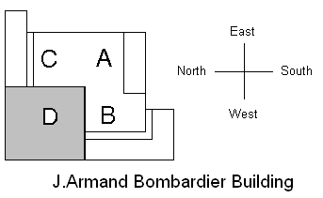
Fig. 1 Top view of the in-building map with the measurement area (gray section D)

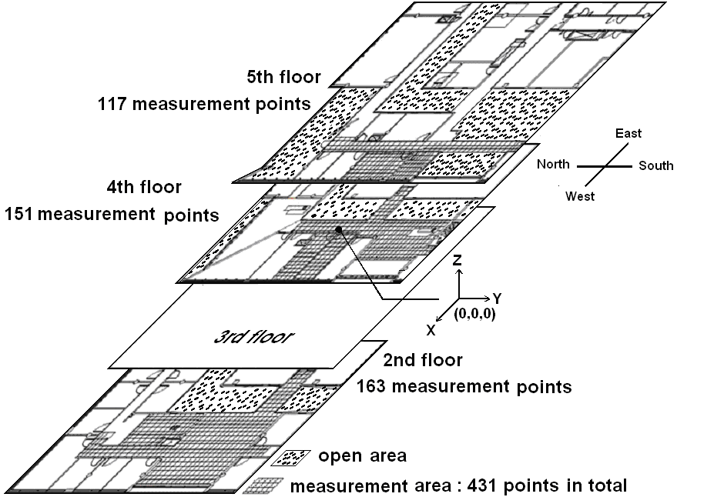

Fig. 2 Map of the measurement area (3D view)
A measurement procedure has been applied for RSS data collection by using a communication link between the user’s notebook and the four access points (APs) of an IEEE802.11b WLAN system. Using the handset based approach (downlink communication), the access points were used as transmitters and the notebook as the receiver. The software written in [2] has been used for the conversion of the received signal strength to a power value in dBm. Since the PCMCIA card of the receiver had a sensitivity of -91 dBm, a value of
-92 dBm has been assigned for measurement points where the received signal was below the sensitivity of the receiver. The four APs were located on three different floors (one on the first floor, one on the second floor and two on the fifth floor). Their locations were (x=-29.10 m, y=-5.60 m, z=-11.40 m) for AP₁, (x=-6.20m, y=25.50m, z=-7.60m) for AP₂, (x=-10.10m, y=47m, z=3.80m) for AP₃ and
(x=-10.10m, y=-2m, z=3.80m) for AP₄ with respect to the predefined referential (x=0, y=0, z=0) taken on the 4th floor of the building (Figure 2).
Four sets of 431 power measurements have been collected for each orientation (north, south, east and west) by varying the user’s position, with respect to the predefined referential. The grid of the measurement points was composed of squares with sides of 0.62 meter and covering the entire three-floor measurement area with a vertical distance of 3.8 meters between floors. Figure 2 illustrates the number of measurement points per floor. Each power measurement corresponded to the mean value of twenty consecutive received powers (0.5 second between them) taken at the considered measurement point.
A preliminary user’s localization test had shown that the contribution of the orientation as an additional parameter of the fingerprint data was not significant. Accordingly, only the south RSS measurement data have been employed as signatures for the proposed geolocation system.
Finally, for a number of measurement points (located in the offices of the 4th and 5th floors), some of the AP-transmit signals were unable to reach the receiver because of obstructed and non line of sight propagations. Consequently, when the number of received AP-signals was less than 3, the considered measurement point was discarded and therefore the sets of 431 power measurements were reduced to 357.

  - ANN-based pattern-matching algorithm
The pattern-matching algorithm of the proposed geolocation system can be viewed as a function approximation problem (nonlinear regression) consisting of a nonlinear mapping from a set of input variables containing information about the four received signal strengths (power levels) onto a set of three output variables representing the three dimensional location (x, y, z) of the user’s mobile station (Figure 3).

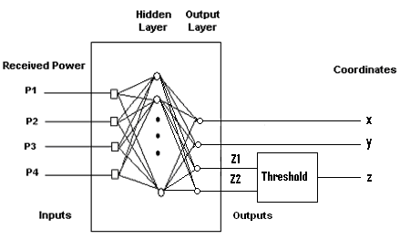

Fig. 3 Proposed pattern-matching ANN

The feed-forward artificial neural networks that can be used as a function approximation are of two types, Multi-Layer Perceptron (MLP) networks and Radial Basis Function (RBF) networks. A generalized regression neural network (GRNN), which is an RBF-type network with a slightly different output layer, and an MLP type network have been tested for the proposed geolocation system. The GRNN showed a lower location error, compared to the MLP network, during the memorization of the data set and the generalization phase of the network. Consequently, the GRNN-type network has been chosen for the pattern-matching algorithm used in the proposed geolocation system.
For the learning (off-line) phase, a set of four powers has been applied to the input of the ANN (Figure 4a). This phase, where the weights are iteratively adjusted to minimize the network performance function, is equivalent to the formation of the database (recording of the set of fingerprints as a function of user’s location). During the real-time phase (Figure 4b), the aforementioned fingerprint (four RSSs) from a specific user is applied to the input of the ANN giving an output corresponding to the estimated value of the user’s location.

(a)

(b)
Fig. 4 Operation of the proposed system,
a) learning phase (off-line phase), b) recalling phase
(real-time phase)

  - Location estimation results
The proposed neural network architecture has been designed using the function newgrnn.m of the Neural Network Toolbox of Matlab [10]. The used GRNN architecture consisted of four inputs corresponding to the four RSS measured data, one hidden layer (radial basis layer with Gaussian transfer function) and an output layer (special linear layer) with four neurons, corresponding to
(x, y, Z₁, Z₂) location of the user (Figure 3). Since the vertical location coordinate is discontinuous (no user location between floors), variable z has been divided into two binary bits Z₁ and Z₂ taking the value of zero or one. The second floor corresponded to [0, 0], the fourth floor to [0, 1] and the fifth floor to [1, 1]. These bits have been transformed to the continuous z variable during the localization phase (3.80 meters between each floor).
The simulation results showed that a spread constant value of 2 for the GRNN network was adequate to do the required regression with a good generalization property. In the learning phase, the set of the four measured RSS data and the measured true user positions have been used as the input and as the target of the ANN, respectively. From the 357 measured data, 267 patterns have been employed to train the network. For the recalling phase, as a first step, the same 267 patterns have been applied to the pattern-matching neural network to obtain the location of the user (validation of the memorization property). The 2D location errors as well as their cumulative density functions (CDF) have been computed for analysis purposes. The plots of the corresponding location errors and CDFs of location errors are given in Figures 5 and 6. For the training set of data, it can be seen (Figure 5) that the location error in x varies between –4.70 meters and 4.20 meters, the location error in y varies between
–6.20 meters and 8.10 meters. Moreover, the maximum, the mean and the standard deviation of the location error in 2D- Euclidean distance d are found to be equal to 8.50 meters, 2.20 meters and 1.60 meters, respectively.

Fig. 5 Location errors in x, y and 2D-Euclidean distance d, with inputs corresponding to the training set of data defined by the number of positions of the mobile station

It can also be seen, from Figure 6, that the distance location accuracy of 3 meters is found for 78% of the trained patterns.

Fig. 6 Cumulative distribution functions (CDFs) of location errors in x, y and d, with inputs corresponding to the training set of data defined by the number of positions of the mobile station
As a second step, the remaining 90 non-trained patterns have been applied to the network to verify the generalization property of the proposed geolocation system. The 2D location errors as well as their cumulative density functions (CDFs) have been computed and plotted (Figures 7 and 8).

Fig. 7 Location errors in x, y and 2D-Euclidean distance d, with inputs corresponding to the untrained set of data defined by the number of positions of the mobile station
For the untrained set of data, it can be seen
(Figure 7) that the location error in x varies between –5.20 meters and 3.20 meters, the location error in y varies between –6.90 meters and 8.70 meters. Moreover, the maximum, the mean and the standard deviation of the location error in 2D- Euclidean distance d are found to be equal to 8.80 meters, 3.10 meters and 2.10 meters, respectively.

Fig. 8 CDFs of location errors in x, y and d, with inputs corresponding to the untrained set of data defined by the number of positions of the mobile station
It can also be seen, from Figure 8, that the distance location accuracy of 3 meters is found for 63% of the untrained patterns.
It has to be noted that the error of the network on the training set has not been driven to a very small value in order to have a network with good generalization property (giving the right location for an unseen and non trained input) and to avoid the need to train the network on all possible input/output pairs.
On the other hand, the obtained results showed slightly lower location accuracy compared to [11]. The main difference between the two studies is the environmental parameters. For the considered environment, there are some open areas on each floor and all the APs are not situated on the same floor. Moreover, it is probable that there is an existence of similar set of signal strengths (power measurements) for some distant measurement points. To circumvent this situation, wideband measurement parameters may be used [12].
Finally, results show that the proposed system identifies the exact floor for 92.5% and 85.5% of trained and untrained patterns, respectively.
Table 1 gives a summary of the z-axis precision.

Error  Data | Percentage of error in floor identification
Trained data | 7.5 %
Untrained data | 14.5%
Table 1 Error in floor identification for trained and untrained data

- Conclusion
This paper has shown that the RSS fingerprinting technique using an artificial neural network can give an acceptable 3D-location estimate in the studied in-building environment. In practical applications, a 3D-geolocation process is essential for multi-storied indoor environments.
Results showed a 2D-distance location accuracy of 3 meters for 78% and 63% of trained and untrained patterns, respectively. Moreover, the proposed system identified the exact floor for 92.5% and 85.5% of trained and untrained data, respectively.
The use of an artificial neural network as a 3D pattern-matching algorithm is convenient for any fingerprinting geolocation technique because of its implementation’s simplicity.

References:
[1] C. Nerguizian, C. Despins and S. Affès, “A Framework for Indoor Geolocation using an Intelligent System,” 3rd IEEE Workshop on WLANs, Boston, Massachusetts, September 2001.
http://www.wlan01.wpi.edu/proceedings/
wlan44d.pdf
[2] P.Bahl and V.N.Padmanabhan, “RADAR: An In-Building RF-based User Location and Tracking System,” Proceedings of IEEE INFOCOM 2000,
Tel Aviv, Israel, March 2000.
[3] Wireless Internet and Location Management Architecture. http://www.wilmaproject.org.
[4] H. Laitinen, T. Nordström and J. Lähteenmäki, “Location of GSM Terminals using a Database of Signal Strength Measurements,” URSI XXV National Convention on Radio Science, Helsinki, Finland, September 2000.
[5] M. Wax and O. Hilsenrath, “Signature Matching for Location Determination in Wireless Communication Systems,” U.S. Patent 6,112,095.
[6] S. Ahonen, J. Lähteenmäki, H. Laitinen and S. Horsmanheimo, “Usage of Mobile Location Techniques for UMTS Network Planning in Urban Environment,” IST Mobile and Wireless Telecommunications Summit 2002, Thessaloniki, Greece, June 2002.
[7] T. Nypan, K. Gade and T. Maseng, “Location using Estimated Impulse Responses in a Mobile Communication System,” 4th Nordic Signal Processing Symposium (NORSIG 2001), Trondheim, Norway, October 2001.
[8] Jeffrey Hightower, Roy Want, and Gaetano Borriello, “SpotON: An Indoor 3D Location Sensing Technology Based on RF Signal Strength,” UW CSE 2000-02-02, University of Washington, Seattle, WA, Feb. 2000.
[9] J.R. Beal Jr, “Conceptual geolocation: a specialized application for improving indoor location awareness in WLANs,” Midwest instruction and computing symposium, Duluth, Minnesota, April 2003.
[10] H. Demuth and M. Beale, Neural Network Toolbox for use with Matlab (User’s Guide), The MathWorks Inc., 1998.
[11] C. Nerguizian, V.Nerguizian, S.Belkhous, A.Azzouz and M.Saad, “Mobile robot geolocation withreceived signal strength (RSS) fingerprinting technique and neural Networks,” IEEE International Conference on Industrial Technology, Hammamet, Tunisia, December 2004.
[12] C. Nerguizian, C. Despins and S. Affès, “Geolocation in Mines with an Impulse Response Fingerprinting Technique and Neural Networks,” IEEE 60th International Conference on Vehicular Technology (VTC2004fall), Los Angeles, California, September 2004.

