Optimized Fuzzy Logic Navigation Algorithm
for autonomous mobile robot control

AHMAD M. MAHMOUD
Computers and Systems Department
Electronics Research Institute
11 Tahrir Street, Cairo
EGYPT

Abstract: - This paper presents an evolutionary approach to design a mobile robot navigation system based on reactive fuzzy logic controller and moves in non-structured environment. The fuzzy rule base was synthesized by human heuristics according to various situations of the changing environment, and then a genetic algorithm (GA) was deployed to learn the membership parameters. The controller acts according to a combination of both goal seeking and open area seeking approaches. Simulation results are provided to show the effectiveness of the proposed learning scheme.

Key words: - Fuzzy Logic Control, Mobile Robot Navigation, Genetic Algorithm, Evolutionary learning and Computer Simulation.

- Introduction
For research in the area of autonomous mobile robot systems, fuzzy logic control provides a tool to solve some of the outstanding problems such as collision avoidance. There are several approaches proposed to solve this problem, including the model-based [1-2], the fuzzy logic based [3-9], evolutionary algorithms [10-11], reactive and neural network based [12-13]. Fuzzy logic or neural network based navigation is fast in reaction, and tolerant to sensing noises. Robot reactions are decided through the reasoning of various types of qualitative behaviours using fuzzy logic or through prediction using neural network, which is trained by a database quantitatively representing the behaviours [14-16].
Fuzzy logic has some advantage in intelligent systems such as navigation control as it does not require exact world maps, individual fuzzy rules can be formulated independently, additional rules can be easily added to the control system if needed and allows firing all types of behaviours simultaneously [8-9]. Fuzzy logic also has been used as one approach in behavior-based control as it provides the opportunity to decompose each relevant behavior and quantitatively formulate it in the shape of fuzzy sets and rules.
The design of the navigation system using fuzzy logic depends mainly on the knowledge of a real operator for such system or using trial and error to specify the linguistic variables or to drive the system rules. Both approaches may be deployed if the search space is small depending on the cleverness of the operator but suffers from the local minima problem in a lot of cases according to the size of the search space. The main design procedure of the FLC depends on the parameter setting of the chosen membership functions then the composition of the derived rules. The genetic algorithms may be deployed to build the structure of the FLC membership functions [17-20] by estimating their parameters that may also include the membership function type. They may also be deployed to weight the FLC rules [10].
Figure 1 demonstrates the system configuration where the genetic algorithm only changes the FLC membership parameters each life span trial (begins with the robot moving from the initial position till reaching the goal position or fails due to reaching the number of trials, touches any of the environment obstacles or touches the boundaries of the field). According to the best value of the fitness function output the values of the member ship parameters are chosen by the end of all generations.

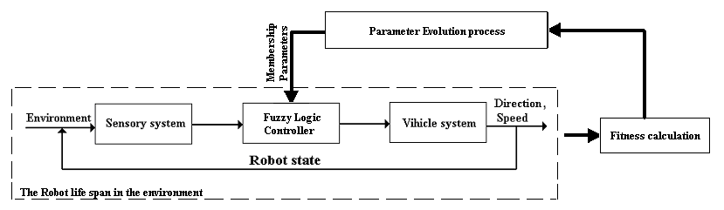
Fig 1 Structure of the Autonomous Navigation System

In this work learning process is proposed to evolve a tuned FLC or the reactive behaviour. A rule base is first learned through a backup updating provided with initial values of the membership parameters. The output actions are discrete commands, each of which can make the robot moves a single step in different directions. Real value GA learning is adopted to tune the memberships’ parameters that enable the robot to move towards the target in the minimum number of steps with maximum speed.
The work demonstrated in this paper is organized as follows: the robot environment is described in section 2, the generation of rule base and defining the membership structure is described in section 3, and GA learning mechanisms of the membership parameters are addressed in section 4, the simulation results are given in section 5 and finally section 6 presents brief conclusions.

- The implemented system overview
The robot control system described in this paper is designed to operate in an unstructured environment. This means that the robot is not equipped with any map of its environment and has to be able to account for the appearance and disappearance of objects within the workspace. The proposed algorithm has been simulated to control a non-holonomic mobile robot with a sensory system consisting of a set of distance measuring sensors and a signal-processing unit [21-22]. The processing unit produces, as an output, a set of angle/distance pairs describing the position of the target, the nearest open area towards the target as well as those of the detected obstacles in the surrounding environment with respect to the mobile robot [8], [23] as demonstrated in figure 2.

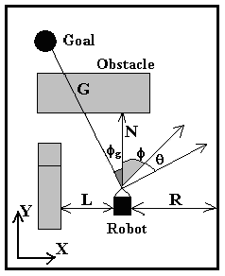
Fig.2 Geometry of the Mobile Robot Environment, G, N, Φg, Φ, θ, R, L and direction resemble the goal distance, the obstacle distance goal direction, open area direction, steering angle, minimum right distance, min left distance, and the resultant robot direction respectively.

Since simulations of the mobile robot performance were planned, the kinematics and dynamics of the mobile robot were needed. A non-holonomic vehicle, which is a car-like robot, was chosen to test the proposed navigation control algorithm. Consequently, simple kinematics’ equations (1)-(3) representing its step motion were employed for autonomous navigation from a starting position to a target position defined by the user as absolute points in the environment. The fuzzy logic controller calculates an escape vector whenever an obstacle is detected in the path of the robot. Each command generation is done using only sensory input values available from current readings, for example, the mobile robot moved forward from (x, y) position to (x', y') position at an iteration, then (1)-(3) represent this motion.
Φ’ = Φ + θ (1)
y' = y + speed . Sin (Φ’) (2)
x' = x + speed . Cos (Φ’) (3)

where Φ is the current angle of the robot's direction, and θ is the steering angle with which the current angle should be modified as a result of the new control action to steer away from obstacles, and approach the main target. The following interval values, or constraints, are assumed for the variables used in simulations: x є (0, 50), Y є (0, 100) and Φ є [-90⁰, 270⁰]. At each control cycle the outputs of the controller are the steering angle θ, and the recommended speed of the robot assuming that the speed ranges from 0 to 2 meter per second, and that the angle θ є [-40⁰, 40⁰].
The task of the data processing unit is to convert the set of (angle, distance) pairs into information that can be used by the robot controller for obstacle avoidance. This information is used to judge the directions and positions of both the target and the detected obstacles, and where the position of the most favourable open area (gate) from the start point to the main target. It also calculates the speed and direction of the moving obstacles, which are driven from the current and previous readings of the range finder sensors of the system. If the moving obstacle is detected within close distance that prevents the motion of the robot the decision of this step is only switching off the fuzzy controller for one moving step.

- Fuzzy Logic controller implementation
The first step to design the fuzzy logic controller is to identify the problem in details as described in section 2, then to identify all important variables and their ranges. According to figure 2 the fuzzy logic variables are defined as G-direction is the direction of the target with respect to the mobile robot, 0-direction is the direction of the open area with respect to the mobile robot, N-distance is the distance between the mobile robot and the nearest obstacle, L-distance is the distance between the mobile robot and the nearest obstacle to its left-hand side, R-distance is the distance between the mobile robot and the nearest obstacle to its right-hand side, θ is the steering angle of the mobile robot, and Speed is the mobile robot’s speed.
The second step is to determine membership profiles for each variable range. Figure 3 demonstrates the identified variables of the membership functions profiles taking into consideration the sequence of ranges by means of the membership functions’ centers.

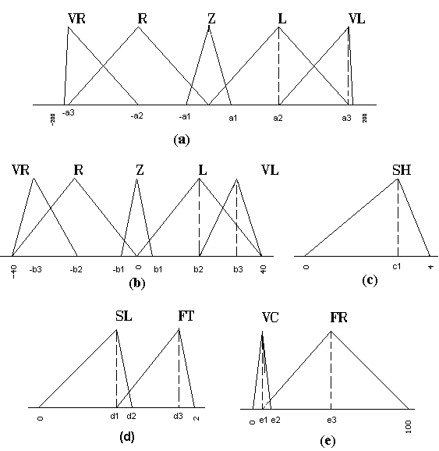

Fig.3 Membership Functions of the Controller inputs and outputs (a) both goal and open area directions (b) Steering Angle (c) both min left and min right distances (d) Speed and (e) the obstacle distance.

Rule No. | If | Condition 1 | And | Condition 2 | Then | Result
R1 | If | G-direction is Far Right | And | N-distance is Long | Then | θ is Far Right
R2 | If | G-direction is Right | And | N-distance is Long | Then | θ is Right
R3 | If | G-direction is Straight | And | N-distance is Long | Then | θ is Zero
R4 | If | G-direction is Left | And | N-distance is Long | Then | θ is Left
R5 | If | G-direction is Far left | And | N-distance is Long | Then | θ is Far Left
R6 | If | 0-direction is Far Right | And | N-distance is Short | Then | θ is Far Right
R7 | If | 0-direction is Right | And | N-distance is Short | Then | θ is Right
R8 | If | 0-direction is Straight | And | N-distance is Short | Then | θ is Zero
R9 | If | 0-direction is Left | And | N-distance is Short | Then | θ is Left
R10 | If | 0-direction is Far Left | And | N-distance is Short | Then | θ is Far left
R11 | If | L-distance is Short | And | - | Then | θ is Right
R12 | If | R-distance is Short | And | - | Then | θ is Left
R13 | If | N-distance is Long | And | - | Then | Speed is Fast
R14 | If | N-distance is Small | And | - | Then | Speed is Slow

Table 1 If-Then Rule Used for Reactive Fuzzy Control

The third step is to determine rules including action needed. The Control strategies are modeled and represented by if-then rules; the obstacle avoidance is realized with these fuzzy If-Then rules, which makes a proper decision to avoid any obstacle at the suitable time. This rule set is designed using the experience and knowledge of a human driver as listed in table 1.
The first five rules are used to drive the mobile robot towards the main target, while the distance between the mobile robot and the nearest obstacle is long. Rules from R6 to R10 are used to turn the mobile robot towards open area when it becomes close to any obstacle. R11 and R12 are used to keep the mobile robot away from the left-hand side of the nearest right-hand side fixed obstacle, and from the right-hand side of the nearest left-hand side fixed obstacle, while passing between them. Finally R13 and R14 are used to control the speed of the mobile robot based on the distance between the robot and the nearest obstacle, to avoid collision. The input data of the previous linguistic variables, e.g. the sensory data, are fuzzified and mapped to linguistic terms based on the specified membership functions as shown in figure 3.
The fourth step is to select the inference and deffuzification methodology. In this work, the Max-Min inference is used to infer with the above fuzzy rules. In the deffuzification process, the centre of gravity (COG) method is used to compute the exact control signals (steering angle θ, and speed) which may be simply switching off the controller in case of detecting moving obstacle in close distance and in the direction of the robot moving.
These four steps are repeated each moving step till reaching the target position or failing due to touching any obstacle or the hostile boundaries or reaching the maximum acceptable number of moving steps.

- Evolving the FLC algorithm
Actually the described fuzzy logic controller above achieves the goal correctly but without guarantee of performance optimization. One of the main reasons for this non-optimal behaviour is that the performance of the system depends to large extent on the membership shape and parameters of the fuzzy sets. One of the central factors in the design of efficient and robust fuzzy logic controllers is the selection of the membership types and parameters. To avoid the heuristic or try and error methods of building the membership functions I use a genetic algorithm to modify the sets through an evolutionary process until an optimal set is produced [11]. The aim of the developed algorithm is to approach the target in the shortest path through maximizing the speed and choosing the best path. The fitness function output should be designed to guide the evolution of the FLC memberships’ parameters. To achieve this purpose the fitness function is defined in equation (4).

$\text{Fitness}={\text{GG}}_{1}(\frac{\sqrt{Δ\text{.}x^{2}+Δ\text{.}y^{2}}}{S})$ (4)

The variable G is defined as a binary scaling factor which takes the value 0 to indicate that the Robot could not reach the goal in the maximum allowable number of steps to enforce the fitness function to zero and takes the value 1 otherwise. The variable G1 is large scaling factor to expand the fitness function range and enable us to make it integer value without side effects. Then according to the relative value between the number of steps and the actual distance to the target we calculate the fitness function. S is the actual number of steps from the robot start position till reaches the target, Δx and Δy are the actual distances between the target and the start position in x and y directions respectively. S is assumed the full cost during the whole movement knowing that we are not concerned in individual step evaluation.
The genetic algorithm used in this work uses the concept of non-overlapping populations. In each generation, the entire population is replaced with new individuals. Each chromosome combines the parameters indicated in figure 3.
After applying the fitness function for each generation, the crossover and mutation principles are applied to produce the following generation chromosomes. Crossover: create a new chromosome by combining two existing chromosomes with high fitness ratings and selected using the weighted roulette wheel principle. Probability of crossover is 0.65. Mutation: randomly change the value of a gene in a chromosome; a 0 is changed to a 1 and vice versa. Probability of mutation is 0.01. 50 generations are to be generated were each generation has a population of 10 chromosomes. The initial population is generated randomly and tested. Then, best parents are chosen from the initial populations. Selected parents produce children with the number weighted by their individual fitness. The fitness value is calculated for each population chromosome in all generations.
- Simulation results
The evolving algorithm was tested against different environments and positions using the same values defined in section 4 and rules presented in section 3. Figure 4 shows one case results of the simulation in different generations as well as that corresponds to the best fitness value achieved. The circles in the figure indicate the robot’s trajectory. Each circle is plotted at a step of the control cycle while all circles are omitted from 4.a and only the trajectory of the centers is plotted to simplify the figure and make it visible. The maximum speed is assumed to be 2 m/s. Thus, when the mobile robot is far away from any obstacle, it moves towards the main target position with the maximum speed, and when it faces an obstacle, it changes its direction towards the most favourable open area to avoid the obstacle(s) with changeable speed according to individual situations. More circle overlapping indicates lower speed, and fewer circles overlapping represent higher speed. As can be seen from the results, the trajectory that the robot drew is not the optimum path in most of the cases because the robot does not have a-priori knowledge of the environment and the locations of obstacles but improved through the genetic algorithm. In some trials the system may create a "dead-lock" problem through the blocked corridor, where the mobile robot cannot avoid this problem before getting into the blocked corridor. The reason is that the robot does not have the high-level map reading ability a human being enjoys, thus moves in a very "short-sighted" manner. The average fitness value in each generation, which converges to the maximum as the generation number increases, is shown in figure 5.

- Conclusions
In this work, a navigation controller has been developed using fuzzy logic controller, which has been optimized using a genetic algorithm. The design strategy is to make use of both the heuristic experience and autonomous exploration of robot’s environment to yield a good reactive controller and evolutionary strategy to improve the Robot behaviour through tuning the fuzzy membership functions’ parameters. This algorithm has been implemented through computer simulations for several structures of the environment involving the sensing and reaction strategies. The experimental results proved that the used algorithm of obstacle avoidance is effective for successful mobile robot navigation control. The results for chosen structure are demonstrated to show the effectiveness of the algorithm. The trace of the fitness value indicates the improvement of the robot behaviour with increasing the number of generations. Better results than the demonstrated in this paper may be achieved by increasing the number of generations as much as possible. Through simulating the system for different structures of the environment the resultant fitness traces change consequently without changing the evolutionary learning strategy or the used fuzzy rules.

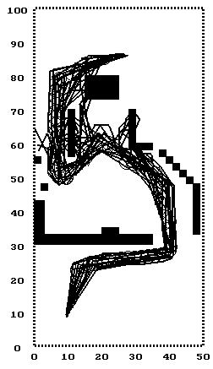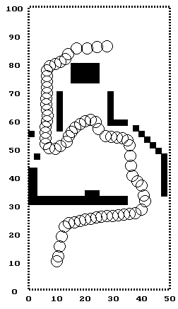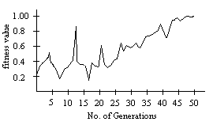

(a) (b)
Fig. 4 The robot system simulation results (a) composition of different generations
(b) the best resulted trace due to the best fitness value.

Fig 5 fitness functions of the three environmental cases simulated respectively

References:
[1] M. Sugeno and T. Murofushi, T. Mori, T. Tatematsu, and J. Tanaka, “ Fuzzy Algorithmic Control of a Model Car by Oral Instructions”, Fuzzy sets and systems 32, North-Holland, 1989, pp.207-219.
[2] M. Maeda, Y. Maeda, and S. Murakami, "Fuzzy drive control of an autonomous mobile robot," Fuzzy Sets Syst., vol. 39, no. 2, pp. 195-204, 1991.
[3] P. S. Lee and L. L. Wang, "Collision avoidance by fuzzy logic control for automated guided vehicle navigation," J. Robot. Syst., vol. 11, no. 8, pp. 743-760, 1994.
[4] B. Beaufrer and S. Zeghloul, "A mobile robot navigation method using a fuzzy-logic approach," Robotica, vol. 13, no. 5, pp. 437-448, 1995.
[5] Cox, Earl. The fuzzy systems handbook : a practitioner's guide to building, using, and maintaining fuzzy systems, 2nd ed. c1999
[6] W. L. Xu and S. K. Tso, "Real-time self-reaction of a mobile robot in unstructured environment through fuzzy reasoning," Eng. Applicat. Artif. Intell., vol. 9, no. 5, pp. 475-485, 1996.
[7] S. Ishikawa, "A method of autonomous mobile robot navigation by using fuzzy control," Adv. Robot., vol. 9, no. 1, pp. 29-52, 1995.
[8] A. Mahmoud and A. Nabawi, “Mobile Robot Navigator Using Fuzzy Logic controller,” International Conference on industrial electronics, technology and automation IETA2001, Cairo, Egypt, pp. 451-456, Dec. 19-21, 2001.
[9] F. G. Pin and Y. Watanabe, "Navigation of mobile robots using a fuzzy behaviorist approach and custom-designed fuzzy inference boards," Robotica, vol. 12, no. 6, pp. 491-503, 1994.
[10] A. Kanarachos , D. Koulocheris , H. Vrazopoulos, “Evolutionary algorithms with deterministic mutation operators used for the optimization of the trajectory of a four-bar mechanism,” Mathematics and Computers in Simulation, v.63 n.6, pp.483-492, 24 November 2003
[11] William E. Hart, “Locally-adaptive and memetic evolutionary pattern search algorithms,” Evolutionary Computation, v.11 n.1, pp.29-51, Spring 2003
[12] P. Reignier, V. Hansen, and J. L. Crowley, "Incremental supervised learning for mobile robot reactive control," Robot. Auton. Syst., vol. 19, no. 3, pp. 247-257, 1997
[13] K. P. Prabir and K. Asim, "Mobile robot navigation using a neural net," in Proc. IEEE Intern. Conf. Robotics and Automation, Piscataway, NJ, 1996, pp. 1503-1508.
[14] N. Tschichold-Ounnan. "The neural-network model rulenet and its application to mobile robot navigation," Fuzzy Sets Syst., vol. 85, no. 2, pp. 287-303, 1997.
[15] W. Li, C. Y. Ma, and F. M. Wahl, "A neuro-fuzzy system architecture for behavior-based control of a mobile robot in unknown environments." Fuzzy Sets Syst., vol. 87, no. 2, pp. 133-140, 1997.
[16] Li W, Ma C and Wahl F, “A Neuro-fuzzy system architecture for behaviour-based control of a mobile robot in unknown environment”, Fuzzy Sets and Systems 87 (1997) pp. 133-140.
[17] Bonarini, A., “Evolutionary Learning of Fuzzy rules: competition and cooperation, In Pedrycz, W. (Ed.), Fuzzy Modelling: Paradigms and Practice,” Kluwer Academic Press, Norwell, MA, 1996, pp. 265-284.
[18] Juang, C. F., Lin, J.Y., and Lin, C. T., “Genetic Reinforcement learning through Symbiotic Evolution for Fuzzy Controller Design,” IEEE Transactions on SMC-Part B, Vol. 30, No. 2, April 2000, pp. 290-301.
[19] Matellan, V., Fernandez, C., Molina, J. M., “Genetic Learning of Fuzzy Reactive Controllers,” Robotics and Autonomous Systems, Vol. 25, 1998, pp. 33-41.
[20] Leitch D, Probert PJ, New techniques for genetic
development of a class of fuzzy controllers, IEEE Transactions on systems man and cybernetics, Part C-Applications and reviews, 1998, Vol.28, No.1, pp.112-123.
[21] J. Borenstein and Y. Koren," obstacle avoidance with ultrasonic sensors,” IEEE J. Robot. Automat., vol. 4, no. 2, pp. 213-218, 1988.
[22] H. R. Beom and H. S. Cho, "A sensor-based navigation for a mobile robot using fuzzy-logic and reinforcement learning," IEEE Trans. Syst., Man, Cybern., vol. 25, no. 3, pp. 464-477, 1995.
[23] A. Kato, and K. Kamikawa, “obstacle avoidence based on approximate reasoning for mobile robots,” IEEE International Workshop on Intelligent robots and systems, 1989, Tsukuba, Japan, pp.115-121.

