Dynamic Tracking Hot Topics in Scientific Domain*

Yanping Zhao, Weizhuo Yang, Donghua Zhu
School of Management & Economics
University (Beijing Inst. Of Tech)
Beijng 100081, China
P.R.China

Abstract: - This paper presents three models for topic tracking, in combination of the advanced approaches in the fields of natural language processing and automatic summarization. We carry out topic tracking function using lexical chain and WordNet, put automatic summarization methods into topic tracking, therefore, our system can provide the tracking result in a more concise and tangible form. Base on these models we established a tracking system prototype for scientific domain hot topics, the system can provide topic-specific tracking conveniently, and analyze the change of hot topic between time intervals. What’s more, our system also possesses the potential of tracking several topics at the same time.

Key-Words: - topic tracking, lexical chain, automatic summarization

- Introduction
In recent years, scientific and engineering documents increased explosively with the flourish of the scientific research.. The storage, reading and processing of all kinds of scientific information are gradually mounting to a new high. Therefore, professionals long for an automatic tracking of hot topics newly emerged in their interested fields, and a better working efficiency.
There are several online tracking tools available in the market, such as Internet Difference Engine (AIDE) [1] by AT&T, Information, Netmind[2], Khoo Khyou Bun and Mitsuru Ishizuka’s Models[3], etc. Generally speaking, these web page tracking tools keep the users in apprisal merely of the update of web pages or the emergence of new pages. Issues such as the covert topic change or transference are left to the analysis of users alone. As a further study of topic tracking in the scientific field, this paper introduces three models, which not only inform users the hottest new topics, but disclose the change and transference of topics in specific scientific fields.

2.Dynamic Tracking Models for Hot Topics

2.1Statistical methods and Natural Languages Combined Topic Tracking(Model 1)

Based on the idea[3] proposed by Khoo Khyou Bun and Mitsuru Ishizuka, this paper tries to make
improvement with the help of our statistical methods
and natural languages combined topic tracking in the CiteSeer[8], a worldwide famous digital library. The system model is shown as fig.1.
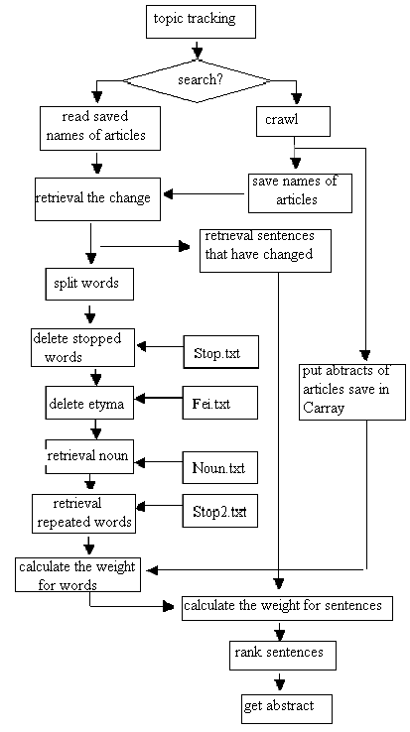
Fig. 1 the Topic Tracking Model 1
Step1: Save the returned topics for a future comparison, if it is the first time that a certain keyword has appeared in this system; otherwise, track the saved topics.
Step2: Search with the keywords used last time when tracking, compare the result with the reserved relevant topics, and save abstracts of the new ones, which are to be segmented words, deleted stop-words, reserved the nouns by compared with the noun database of WordNet, and save their frequencies and the information of relevant articles.
Step 3: To pick out the high-weight sentences which represent the abstract of new topic for the topic tracking, in order to streamline the information, as well as improve the working efficiency. We use the following formula:

$W_{j}=\frac{\sum{F_{\text{jd}}}}{\text{max}}$ (1)
Where Wj is the weight of jth word, Fjd is the frequency of the jth word occurred in the document d, and m is the total number of the words in the documents(new abstract), K is the number of the documents.
Then uses the weights of the words to compute the sentences weights, The formula is as follows:

$S_{j}=\frac{\sum{w_{j}}}{\text{max}}$ (2)
Where is the weight of ith sentence, R is the total number of the words in the jth sentence. n is the total number of the sentence in the document.
Stop.txt: general database of stop words; Stop2.txt: database of stop words in scientific fields; Fei.txt：Database of irregular nouns; Noun.txt：WordNet noun database. System’s efficiency is improved with the involvement of nouns database, as shown in our test, the system’s operation time from over 10 minutes reduced to several seconds, without any depreciation of the accuracy.

2.2 Topic Tracking by Statistic Methods(Model 2)
Statistic methods are excellent with a faster speed and a better performance. Therefore, a statistical model designed for the topic tracking in the scientific fields is proposed as Fig. 2.
Step 1: Extract the article information (including the title, abstract and keywords—concept phrase) from the text stream. Generate a class CPaper object for each paper, and put it into CArrayPaper (an Array data structure).
Step 2: From every CArrayPape paper, extract the included sentence, from each of which a CSentence object is generated and put into CArraySentence. Every concept phrase in the CArrayPape’s paper is processed accordingly, and the CWord object is put into CArrayWord.

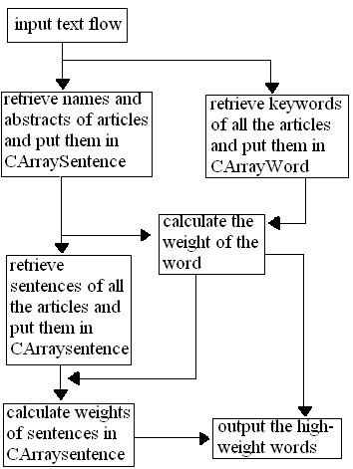
Fig.2 the Topic Tracking Model 2

Step 3: Calculate the word weight, as well as the sentence weight according to the calculated word weight (as formula (1)and(2))
Step 4: Sort the word and sentences according to the weight, and output the specified words and weights.
The model could process the EI Compendex search output result from system[3] , thereby keep dynamic topic tracking in specified fields, providing changes of a certain topic between time intervals.

2.3 Topic Tracking by the Lexical Chain (Model 3)
Because the natural language processing could catch the semantic meaning of the article, we try the lexical chain method[6] in natural language processing to realize the topic tracking, and compare it with method 1. The system model is shown as Fig.3.
Step1: Importance rank sorting of articles. Impor- tance is measured by the composite indicator [3] :

$$\text{IC}(P)=α_{1}\text{IS}(P)+α_{2}\text{IP}(P)+α_{3}\text{IA}(P)+α_{4}\text{IF}(P)\text{.}$$
IS(p) is the indicator of similarity, IP(p) is the indicator of cited number,authority, IA(p) is the indicator of authority, IF(p) is the indicator of the freshness. Locate the relevant articles in CiteSeer[8] through the title list of the papers provided by users, and our system can sort them with the chosen composite indicator(s), to provide the ranked articles of the highest relevant indicator(s).
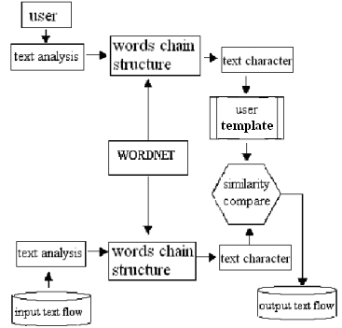
Fig.3 the Topic Tracking Model 3

Step 2:Topic Identification.According to results of the step1, make all the collected papers in one file, and use lexical chain model with the support of the WordNet, to get nouns and their synonyms, to construct the lexical chains which represent the underlined semantic classes of the results. The each lexical chain can be viewed as the related new topics to the first search.
Step 3: Topic Tracking. Users can input natural language topics, and the system processes them to a user’s template. The lexical chain is extracted from the searched articles and its similarity to the user’s template is calculated with the following Index of Significance formula:

IS(P)=Sim(P)· Exp(IA(P))·Exp(IB(P))·Exp(IC(P) ·Exp(M·IS(P)

where the Sim(P) is the VSM[9] Cosine measure, IX(P) are the indicators of the set X, A for authors, B journals, C affiliations, S survey phrases respectively, M is a amplifier.
For the tracking of a new topic, the articles are sorted with the calculated IS(P) and the new articles are put to the step2 and similar step3 in model 1 to the user.

3. Testing Results
The three models are writen in VC++6.0. The user input the topics he interested, for the first tracking, there is no previeus articles, so all the collected articles are new results, but for the second and latter tracking, the system only returns new results compared with the previously collected titles. The topic“data mining and information retrieval”is tested as the input for an initial searching. The consequent hot sentences are shown in Fig.4:
In the test of model 2,“knowledge management”is input for testing. With the top new words set to 10, two time intervals of 1989-2002 and 2002-2004 are as the time parameters, after processing, the returned information is as table 1. The results of model 3 are similar to the first two.
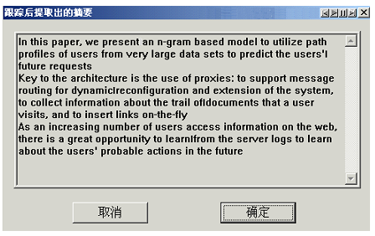
Fig.4 result of the model 1

Table 1: the result of model two
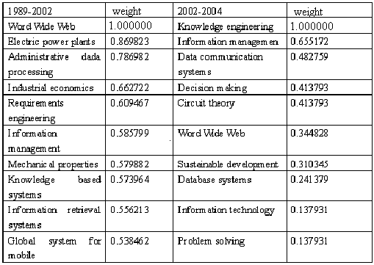

4.Discussion and Further Work
The paper initializes a topic tracking model which combines both natural languages processing and statistical methods. The model infuses automatic summarization, simplifies the topic tracking operation, improves the working efficiency and also streamlines the returned information. The models are suitable to many scientific forecasting and monitoring for government, military department, industry and companies.

References:
[1] Fred Douglis, Thomas Ball, Yih-Farn Chen and Eleftherios Koutsofios (1998). The AT&T Internet Difference Engine (AIDE): Tracking and Viewing Changes on the Web. World Wide Web, Volume 1 Issue 1, 1998, page 27-44.
[2] http://informant.dartmouth.edu/and
http://www.netmind.com/
[3] Khoo Khyou Bun，Mitsuru Ishizuka. Information Area Tracking and Changes Summarizing System in WWW.
[4] ZHAO Yanping, ZHU Donghua. Evaluation of the Collected Pages and Dynamic Monitoring of Scientific Information. International Conference of Computational Methods in Sciences and Engineering 2004 (ICCMSE 2004) Attica, Athens, Greece, 19-23 November 2004
[5] Tu Chengsheng , Lu Mingyu, Luyuchang. Web Mining Research Survey. Computer Engineering and Application. 2003
Dear Conference Secretary:
I am sorry to send you this paper again.I have rework it.title:
Dynamic Tracking Hot Topics in Scientific Domain
authors are Yanping Zhao, Weizhuo Yang, Donghua Zhu
E-mail：zhaoyp@bit.edu.cn, Yangweizhuo@bit.edu.cn
[6] R,Elhadad M.Using Lexical Chains for Text Summarization. In ACL/EACL-97 Summarization Workshop,Madrid,1997:10-18
[7] ZHAO Yanping, ZHU Donghua. Intelligent Scientific Information Acquisition and Dynamic Monitoring. 2004 International Conference on Service Systems and Service Management. July 19 to 21, 2004, Friendship Hotel, Beijing, China. Co-sponsored by: IEEE Systems, Man and Cybernetics Society and School of Economics and Management, Tsinghua University. (Vol.I 513-517)
[8] Citeseerhttp://citeseer.ist.psu.edu/cis
[9] Salton,G. (Ed.) Automatic Text Processing. Addison Wesley, Massachusetts, 1989

* This research is supported by the National Natural Science Foundation of China, the project code: 70471064, and Research Foundation of Beijing Inst. of Tech

