DEPARTMENT OF PRODUCTION TECHNOLOGY
MIT., ANNA UNIVERSITY
MASTER OF ENGINEERING IN MECHATRONICS
Title : “SUPERPLASTIC FORMING PROCESS CONTROL”
Name : M.Manigandan M.E.,(MECHATRONICS)
Guide Name : Mr.K.KALAICHELVAN M.E.,(Ph.D)

1) INTRODUCTION:

In the fast developing industrial scenario all industries are going for automation. Automation is basically the delegation of human control functions to technical equipment aimed towards achieving the following needs.,

- Higher productivity
- Superior quality of end product
- Efficient usage of energy and raw materials
- Improved safety in working conditions
- To reduce human involvement

There are many metal forming processes of which Super plastic forming is an important process, which finds its application in manufacture of glass bottles and thermoplastics to titanium structures in aerospace. Super plastic forming refers to extreme specific constrained conditions. In this forming process, controlling the forming pressure determines the desired shapes. Since this Super plastic forming takes larger time for getting good formed shape, automation using computer Interfaces becomes essential to effectively control the forming pressure and to make the process more flexible.
Reason for going ultrasonic/potentiometer :
The whole process is done in a furnace at very high temperature of 200-350 degree Celsius. Since no sensor supports this his temperature *Ultrasonic/potentiometer is used to measure the deformation height.

2) SIGNIFICANCE OF THE STUDY:

The Figure 1) shows the basic concept on superplastic forming deformation is calculated by means of trial and error method this is also one of the time consuming process of in order to reduce the fatigue during process to neglect the fracture that occurs due to excess amount of pressure. The displacement is measured by means of potentiometer by means of proper mechanical rearrangement and all sensors are connected through low cost DAQ and drivers are created using VC++ and interfaced with the PC so that continuous monitoring of various parameters such as Temperature, Pressure and Displacement are done.Parameters mentioned above are measured through the HPVEE PRO software (VIRTUAL INSTRUMENTATION) interfaced through DAQ card & PC.

Some of the advantages are.,
- Programming makes the process more flexible and efficient.
- To make the Super Plastic Forming process as fully automated.
- Low cost automation system.
- Cost of control valve is reduced since an new *mechanical designed* has been done which does the work of control valve.
Why HP VEE?
- It is an graphical programming language optimized for instrument control.
- Is is being used in a wide range of test and measurement application.
- Driver writing tool.
- Integration with conventional languages like C, C++, Visual Basic, Pascal, FORTRAN.
- Reduced development and maintenance time with graphical programming.

3) OBJECTIVES:

This project aims is to control the applied pressure by means of PC through Stepper Motor and measuring the various parameter such as Temperature, Pressure and also the deformation area of the material (by proper mechanical alignment of potentiometer the displacement is measured continuously) when the forming process reaches its extreme condition level then pressure is turned off through Stepper Motor so that any fracture of the material can be avoided completely.

- PARAMETERS TO BE MEASURED:
Pressure, Temperature and Deformation Height
- PARAMETER TO BE CONTROLLED:
Pressure.

Note :
* Patented

SUPERPLASTIC FORMING WITH HUMAN INTERVENTION:

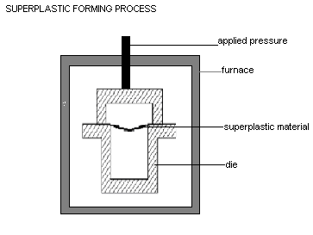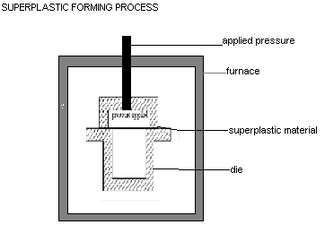

4) EXPERIMENTAL SETUP:

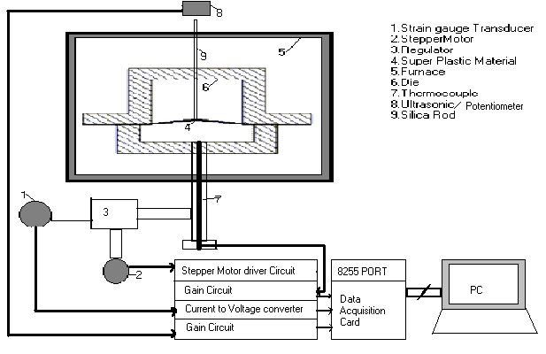

5)METHODOLOGY:
Installing the DAQ card with PC so that the system is ready for acquiring input.

Connecting the sensor with DAQ card i.e. the CH0-CH3
Install the HPVEE software in PC and creating the DLL driver file using VC++ to access the DAQ
Access the DAQ card with its base address. So that signals from the sensor can be monitored through VC++
VC++ programming is done to acquire the data from sensor to DAQ card.
Gain circuit and Current –Voltage circuit is done in order to improve the gain of the thermocouple output and to convert the strain gage output into voltage respectively

