CONTROL AND SIMULATION OF FAULT AND CHANGE EFFECT IN A BACK TO BACK SYSTEM OF HIGH VOLTAGE DIRECT CURRENT NETWORK

Mohsen Kalantar¹, Naser M. Tabatabaei², Mehdi Rashidi^{1,2}

¹Department of Electrical Engineering, Iran University of Scince and Technology, Tehran, Iran
²Electrical Engineering Department, Azarbaijan University of Tarbiat Moallem, Tabriz, Iran

Abstract- The primary knowledge of human being from electrical energy was in the form of statistic electricity and the first transmission line was DC. But because of primary problems in transmitting electrical power in DC form with average and low voltage levels and because of the higher efficiency of AC machines in comparison with DC machines and presence of AC transistors in different capacitance, have caused the electrical power to be transmitted in AC form. But with the advancement of electrical engineering technology in the 20th century, the transition systems were used in HVDC form, and from that time an the HDVC technology passed its improvement process so fast. In this paper in addition to discussing the advantage of HDVC systems and back to back instruction, the fault and change effect in a back to back system is discussed.
Keyword: Back to Back, HVDC, Control, Sımulatıon, fault

I. INTRODUCTION
At first we mention same of the advantages of HVDC system in comparison with the HVAC systems.
- Decrease of transitions lines from n (n>3) to 2, and with making use of earth wire the HVDC systems have the ability to use just one wire.
- The capability of connection of networks with different frequencies.
- Considering the decrease of the insulation surface the size of the Tower in this system is smaller shorter and has a simple’s appearance.
- Decrease of corona losses, radio noises and isolation surface.
- Increase in the allowed transmitting power because of the absence of limitations of passive form and line reactance.
- Not needing to mid secondary system for compensating the reactuie power that is needed in HVAC systems.
- Not having the problems of compensating voltage decrease in HVDC line.
- The proper control of changes of amplitude and direction of transmitting power with the help of transistors with high switching frequencies.
- Not having skin effect because of equal distribution of transmitting current on the surface of conductor and also of charging current because of absence of the reactive current.
- Decrease in transmission charges in comparison with HVAC systems in the distances more than 650 Km.(Show figure 1)
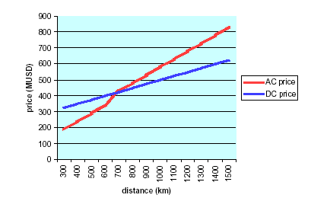
Fig1. Price To Distance

II. INSTRUCTION OF BACK TO BACK SYSTEM
In these systems two converter are situated at the same site these two transfers are directly connected to each other without interference of any transition line. One of the main purposes of in this system is power transition between two systems and also the possibility of connecting two AC systems with different frequencies. in fact this instruction a scheme with a vast use in HVAC systems.(Show figure 2)
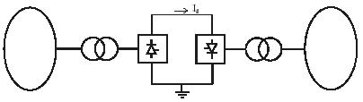
Fig2. Simple Figure of Back to Back System

III. FAULT REMOVAL IN HVDC SYSTEM
Short circuit in DC circuits is different from short circuit in AC circuit. in AC circuit at the time of short circuit the circuit is automatically breaked with circuit breaker, but in DC circuits the situation is different and until the current hasn’t decreased to zero the circuit wouldn’t break. Of course in DC circuits the DC circuits breakers can be used but because of high prices of these equipment they are rarely used and so other controlling techniques are used. One of the techniques is current control , in technique by controlling the converter, current is decreased to zero and then the circuit is breaked.

IV. SIMULATION OF HVDC SYSTEM
At first the way of connection and system controlling are introduced and then the simulation results of fault and change effect that are analyzed by MATLAB are taken into consideration.

V. CONNECTION OF CONVERTERS AND TRANSFORMATORS
The transformers that are used have a primary winding in Y form and two secondary windings are in Y form and the other one in ∆ forms that each are connected to a converter. (Show figure 3)
(a)
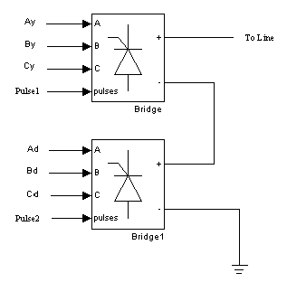
Fig3. Connectıon of Converters and Transformators

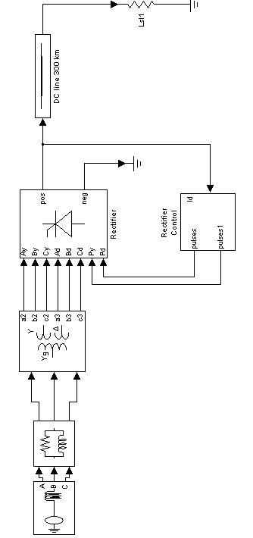
VI. CONTROL SYSTEM
In this simulation we should make use of a PI controls. (Show figure4)
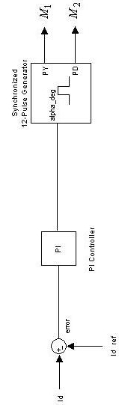

Fig4. Control System
The closed loop system takes samples from the out put current and compares with a source current then gives the comparison result as output. In this system the current of DC transmission system as input of control system is compared with the source current and the resultant that is obtained from the comparison. Goes to PI block that its alteration function is as below:
$G(s)=K_{P}+\frac{K_{I}}{S}$ (1)
The output of control block enters the pulse generators as firing command of the thyristor. In this block there are two converter that each has 6 pulses and each group of the pulses is transmitted to are unit, so that the setting time of the thyristor would be specified.
The amplitude of converter out put current can be modified as a function of time as source current.
The numerical parameters that are used with the purpose of simulation are as below:

Table1.Numerıcal Parameter
65 | K_{P}
5000 | K_{I}
U_{n}=400 KV ,f=60 HZ | Generator_{rec}
U_{n}=200 KV ,f=50 HZ | Generator_{inv}
U_{n}=400 KV,  S_{n}=500 MVA | Transformer_{rec}
U_{n}=200 KV,  S_{n}=500 MVA | Transformer_{inv}
R=0.1 Ω ,L=1 H | Series Reactor in DC side
C=10 μf | Shunt Capasitor

If we assume the source current 2000A, we can have C₁ and C₂. C₁ is modified as the network current to the section and C₂ is the network current, connected to the inverter.
C₁ has a 2.4 KA pick and its frequency is 60 Hz and C₂ has a 2.3 KA pick and its frequency is 50 Hz.
One of the most important goals of back to back systems that is connection of network with different frequencies, can be easily viewed in this instance. (Show figure 5)

VI. INVESTIGATION OF REACTIVE POWER
As it can be understood from the results the reactive power in both networks is positive that means, both of them give the reactive power to the converters.
(Show figure 6)

VII. INVESTIGATION OF ACTIVE POWER
As it can be viewed in the results the active power of the first network is positive and the active power of the second one is negative. And its meaning is that the second network takes the power and the negative quantity shows this case. And the little difference between absolute values is because of the wasted power in converter.
(Show figure 7)

VIII. FAULT APPLYING TO THE SYSTEM
In a proportional balance time of the system we apply the AC fault of 0.05 in a period of t=0.1s and DC fault of 0.01s in a period of t=0.2s and then deliberate the results. The effect of the AC fault in more than the DC fault and more time is needed to achieve the balance time. (Passive time) and it’s more effective. (Show figure 8)

IX. VOLTAGE AND CURRENT HARMONICS
As it can be viewed in the results the highest harmonic amplitude of voltage and current are in the harmonics 11 and 13.These harmonics cause noise for the radio and communication lines. Present beside the HVDC lines. Usually for emitting these harmonics, active or passive filters are used. (Show figure 9)
A sample of suggestion filters are shown in figure 9.c

X. SYSTEM RESPONSE TO STEP BY STEP FREQUENCY CHANGES IN ONE OF THE SYSTEM
According to Iran and most of the countries frequency of electrical network we consider the frequency connected to the inverter 50 Hz. We decrease the frequency of network %16 at t=0.1s and at t=0.2 we turn it back to its primary situation. The whole investigation shows that when the frequency is 50 Hz an increase in frequency more than %4 and decrease in frequency more than 30% cause noise in HVDC system and in this condition the DC voltage falls down to zero.
After this in the case of frequency increase the system would be disabled. But if the frequency decreases the system response would be a decrease in efficiency and there is a direct relationship between the voltage and frequency of the network. (Show figure 10)

XI. THE SYSTEM RESPONSE TO THE CHANGES OF THE SOURCE CURRENT
The source current is set at 1000A but at t = 0.1s, we increase the current 5%. step by step and investigate the voltage and current response . it would be seem that the voltage would go up more than the ultimate amount and then would fall down.
It means that a sinus voltage pick is produced for 0.02 s. at first the current goes a raising and falling direction and reaches its ultimate amount .these increases can be viewed at t = 0.2s. (Show figure 11)

XII. SYSTEM RESPONSE TO STEP BY STEP CHANGES OF THE VOLTAGE AT ONE OF THE SYSTEM
At t = 0.1s we increase(20%) the voltage connected to the inverter network, that its voltage is about 200 KV. and at t =0.2s, again we decrease it to the primary amount.
In this case opposite the previous case the passive changes in each system are sensible. But usually the voltage has its ultimate changes and the current remains almost stable. (Show figure 12)

REFRENCES
[1] S. Rao, ''EHV-AC, HVDC Transmission and Distribution Engineering", Third Edition, New Nirman Printing Press, Dehli, 1999.
[2] Roerto Ruder vall, J. P. Charpentier, ''High Voltage Direct Current(HVDC)Transmission Systems'' ,ABB power Systems.
[3] Lee, H.A., Denis, Andersson, G.,“Voltage Stability Analysis of Multi-Infeed HVDC Systems”, IEEE Transactions on Power Delivery, Vol.12 No.3, pp.1309-1316, July 1997
[4] Jenny Paulinder, ''Operation and Control of HVDC links embedded in AC systems'', Thesis for The Degree of Licential of Engineering, Chalmers University of Technology, Sweden 2003.
[5] Gannar Asplund, ''50 years HVDC.ABB from pioneer to world leader'', ABB Review2003.
[6] john G. Webster ''Electrical and Electronics Engineering'', volume 10, Awiley- Interscience publication
[7] Cuiqing Du, ''The Control of VSC-HVDC and its use for large indusrial power systems'', Thesis for The Degree of Licential of Engineering, Chalmers University of Technology, Sweden 2003.

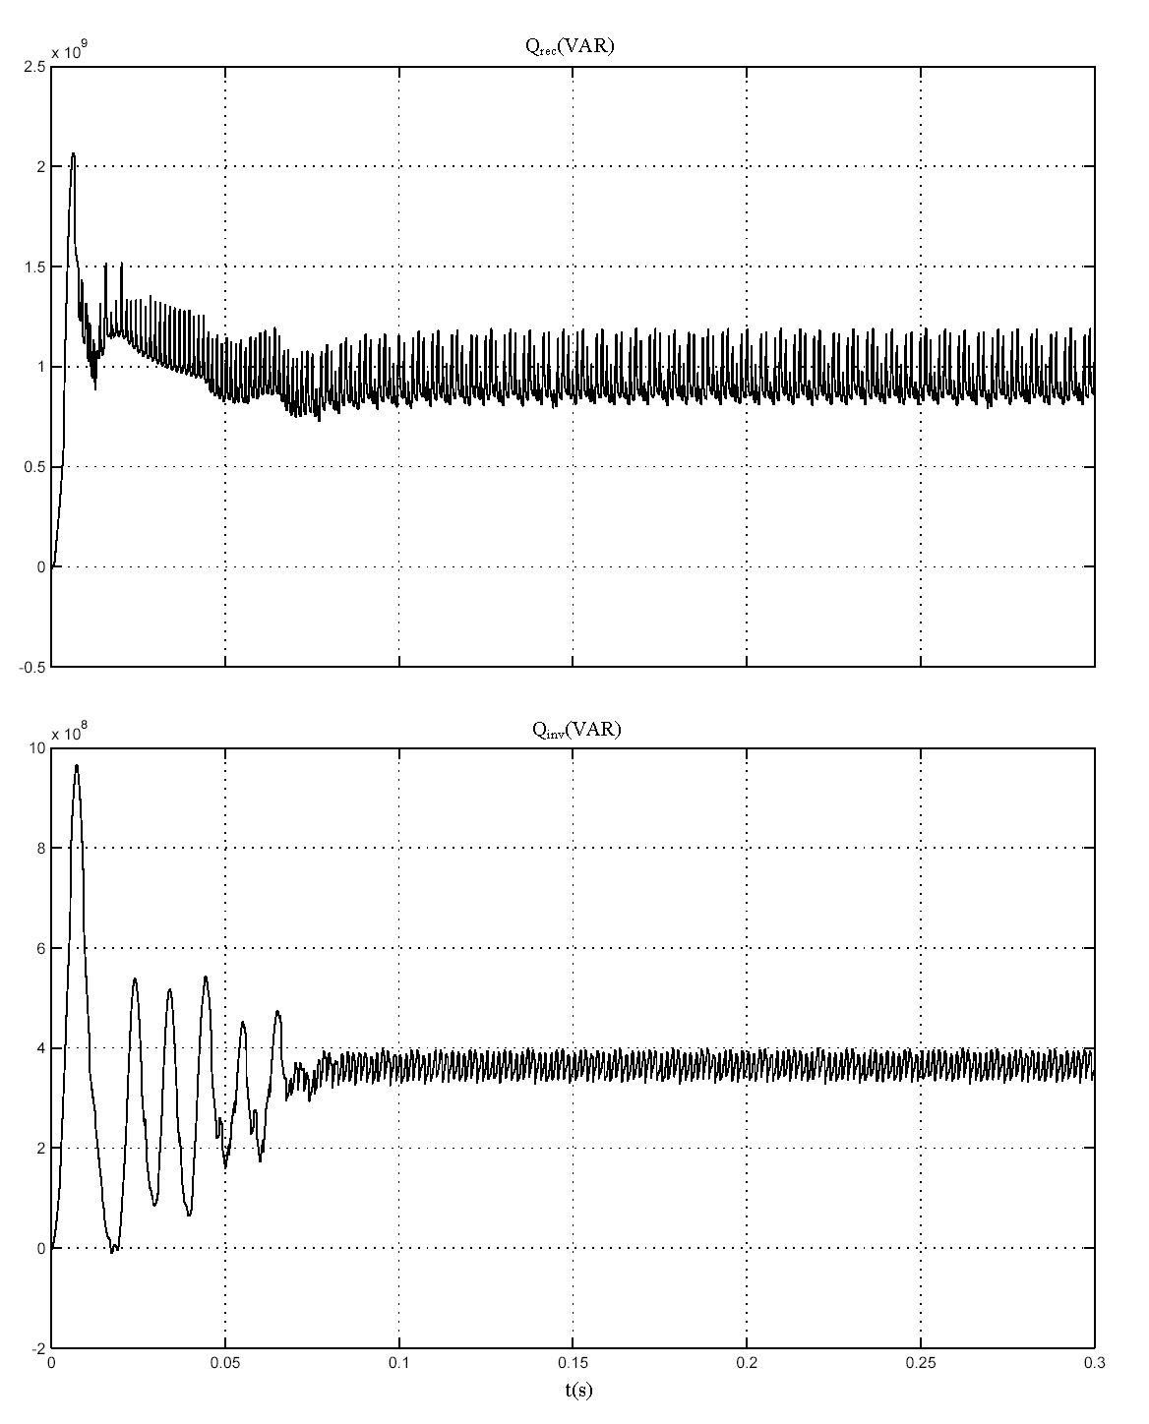
Fig 6. Reactive Power in the Rectifier and Inverter Sides
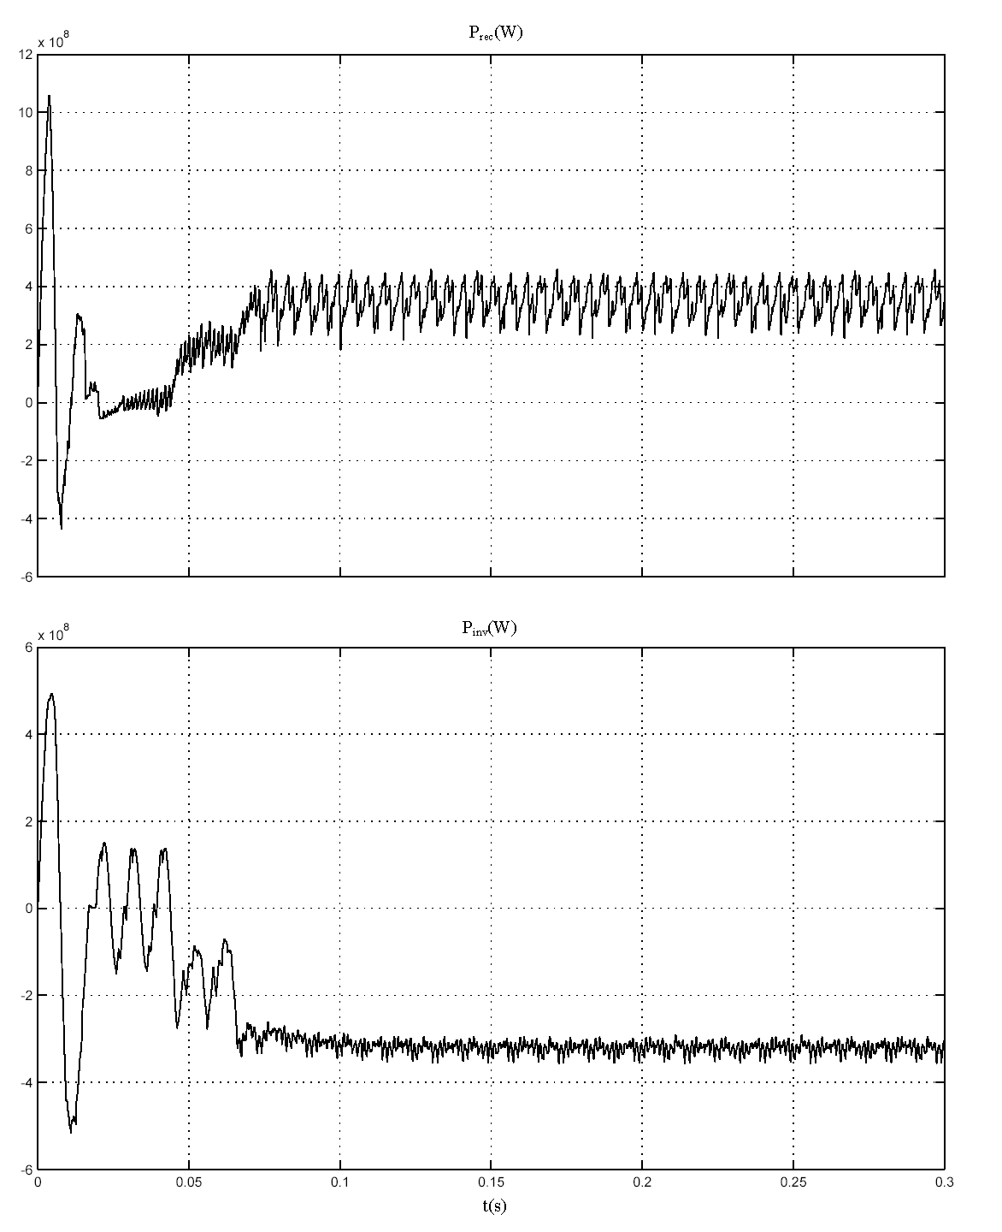
Fig 7. Active Power in the Rectifier and Inverter Sides

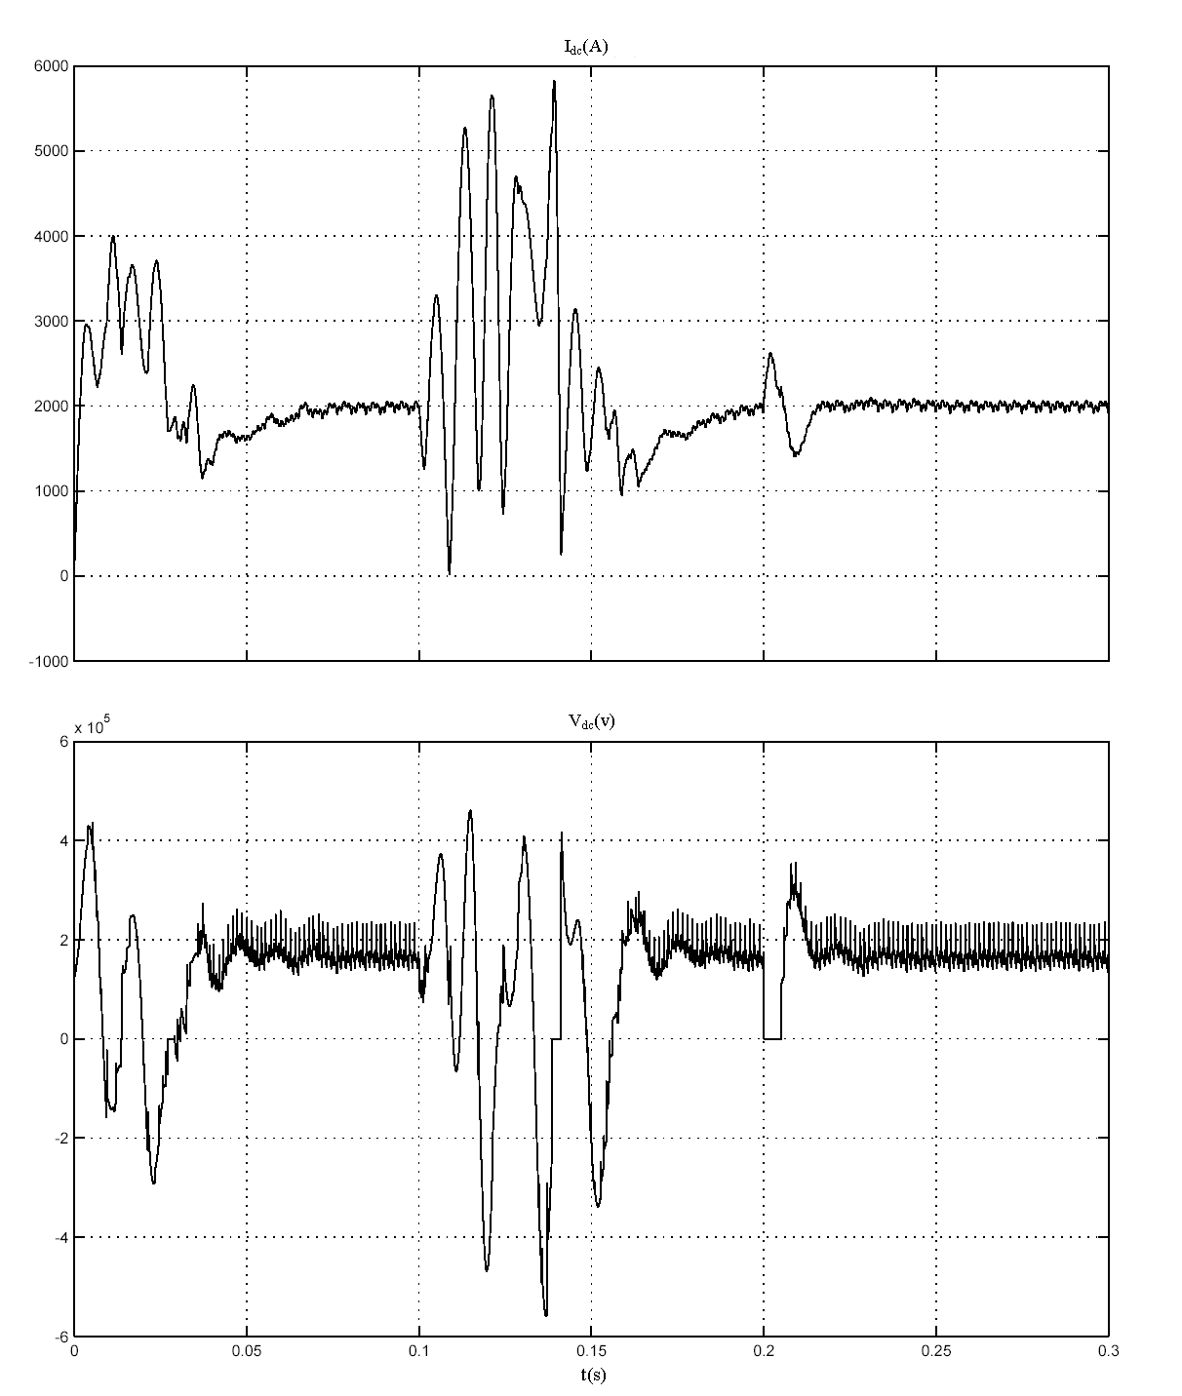
Fig 8. DC Current and DC Voltage with AC and DC Fault
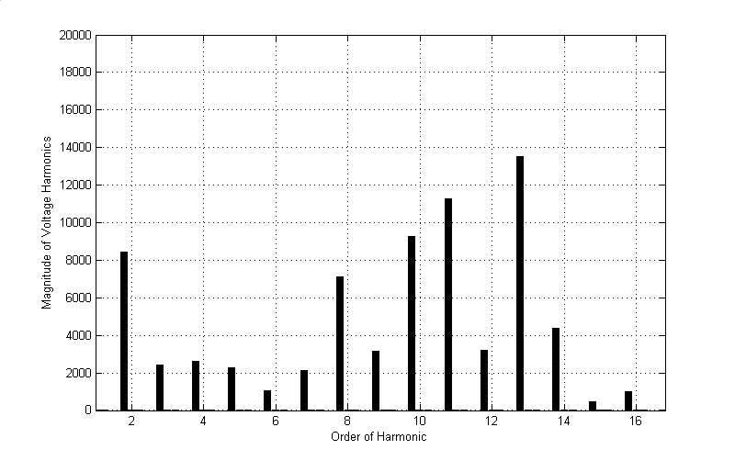
Fig 9.a) Amplitude of Voltage Harmonic

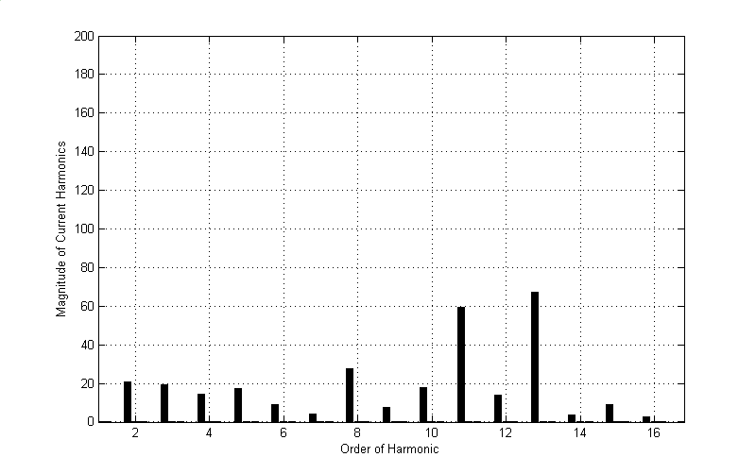
Fig 9.b) Amplitude of Current Harmonic

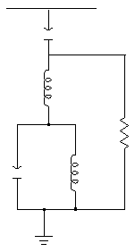
Fig 9.c) Simple of the 13/11 Harmonic Filter

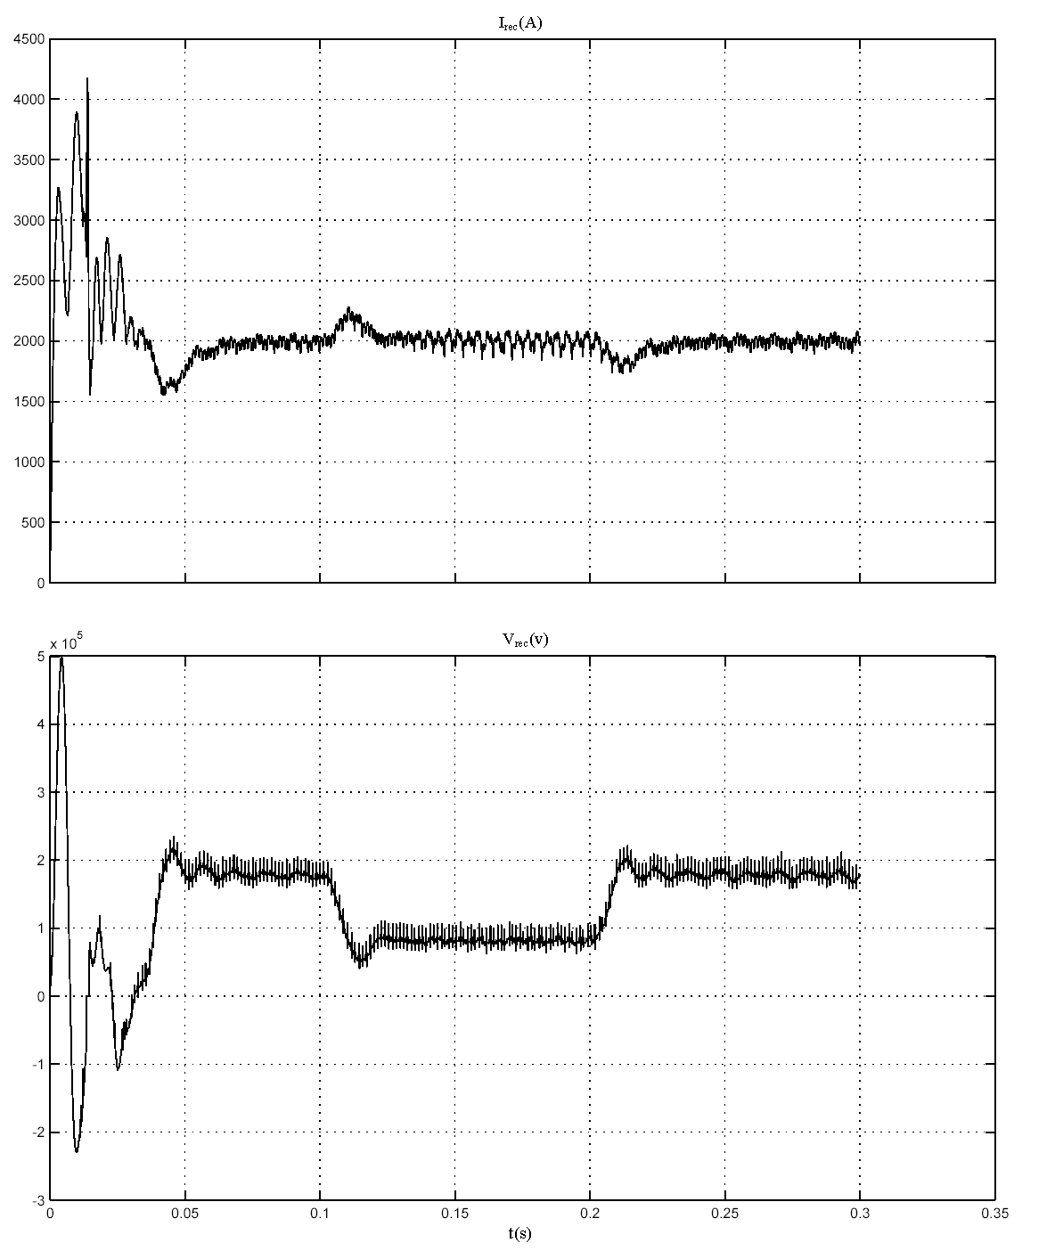
Fig 10) Current and Voltage Response to Step by Step Frequency Changes in Connection Network to Inverter (8 Hz)

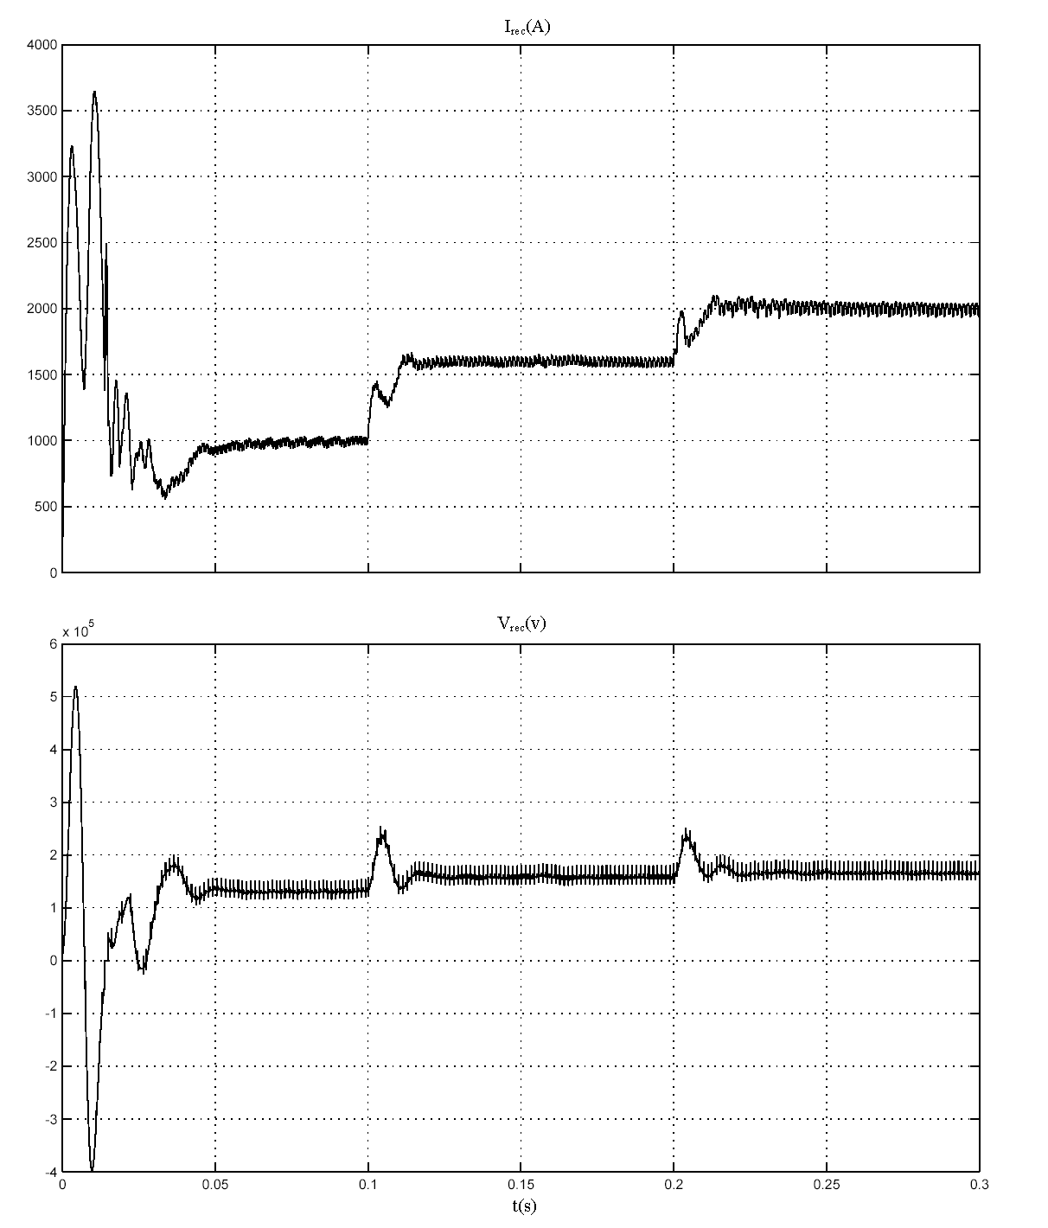
Fig 11) Current and Voltage Response to the Changes of the Source Current

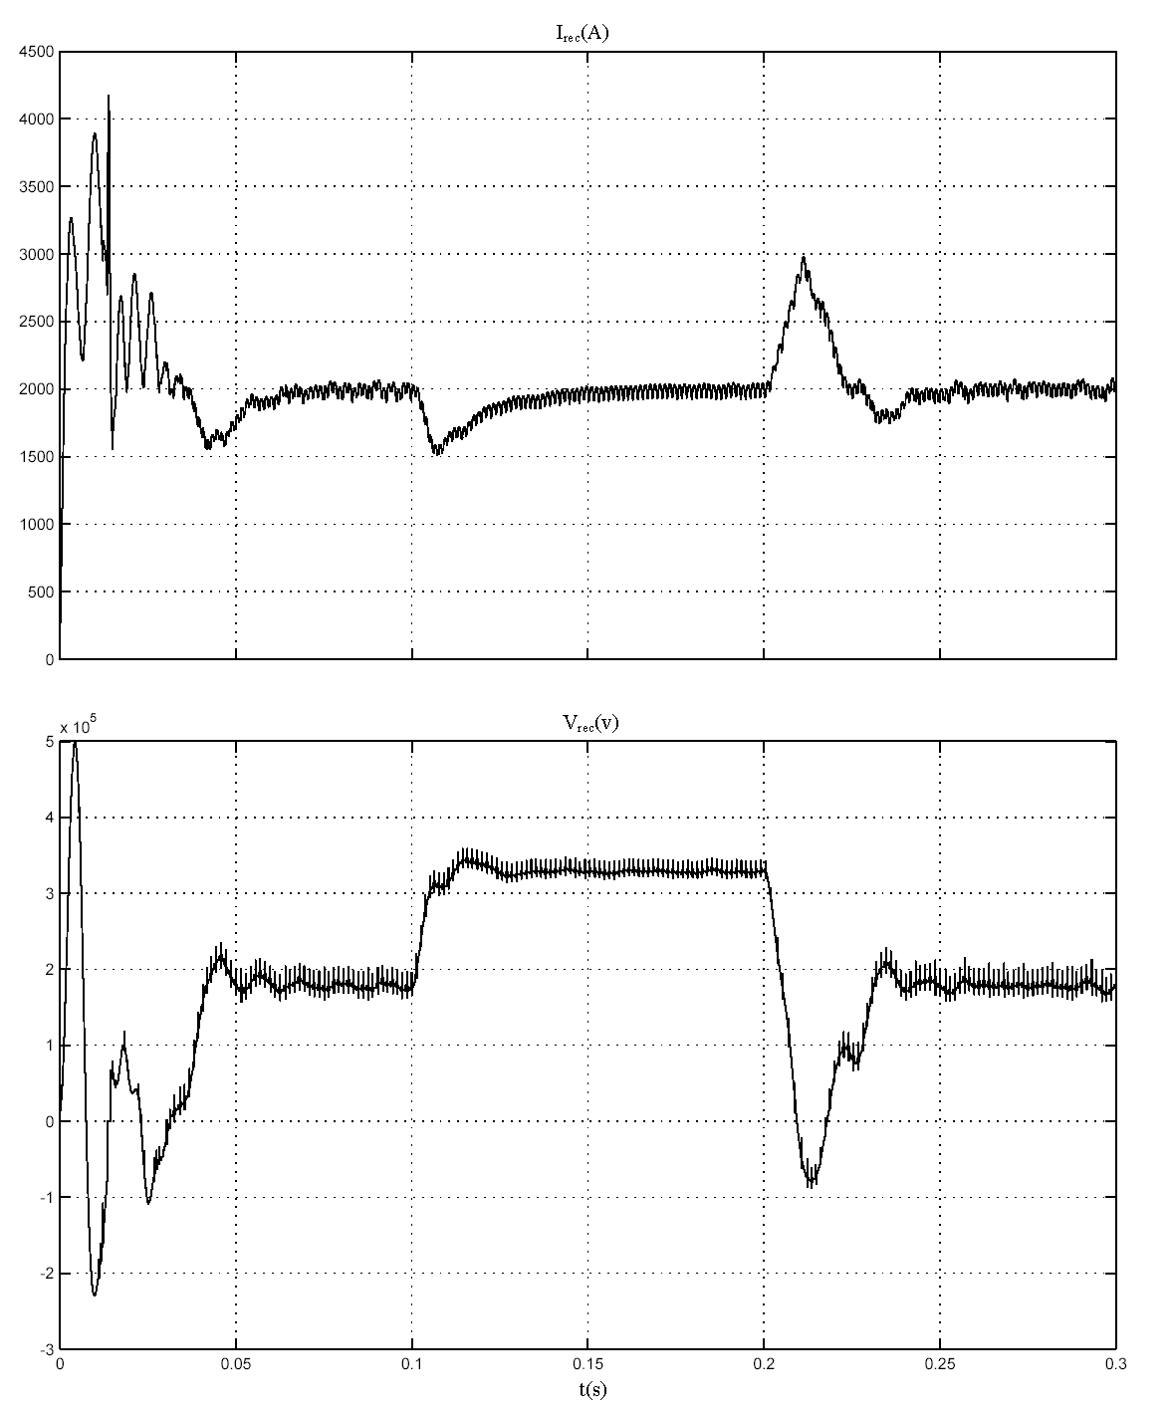
Fig 12) Current and Voltage Response to Changes of the Voltage in Connection Network to Inverter

