TEST POINT INSERTION FOR IMPROVING THE PSEUDO-RANDOM TESTABILITY OF BOOLEAN CIRCUITS

J . EDWIN SAMRAJ
Department of Electronics & Communication
Vlsi Design
Anna University
Guindy , Chennai – 600 025.
India
http://www.annauniv.edu

ABSTRACT

The main subject of this dissertation is to facilitate testing by means of Test Point Insertion ( TPI ) for on-chip tests. Efficient production testing is frequently hampered because current complex digital designs require too large test sets, even with powerful ATPG tools that generate compact test sets. An alternative is Built-In Self-Test ( BIST ); by embedding the test on-chip, expensive test equipment costs and test time can be reduced. However, BIST approaches often suffer from fault coverage problems, due to random pattern resistant faults. These problems can successfully be removed, or even eliminated, by means of Test Point Insertion ( TPI ). A TPI algorithm is proposed to achieve better pseudo-random fault coverage improvements for Boolean circuits.

KEY-WORDS : Test Point Insertion , Built-In-Self Test , Control Point , Observation
Point , Pseudo-Random , Boolean Circuit.

1. INTRODUCTION

Due to the technological progress the clock-frequencies on which ICs run are ever increasing. To be able to detect timing-problems, it can be important that the IC is tested at-speed, i.e., it is tested at the clock frequency it will run in normal application mode. As a result, for new ICs often new testers are required which are able to operate at these high frequencies and which are accurate enough to capture the responses of the ICs. To cope with this increasing complexity of circuits, faster testers with much more memory will be required, which will become very expensive. With on-chip testing it is possible to test the ICs at-speed. A circuit with an on-chip test is often referred to as a circuit with Built-In-Self-Test ( BIST ). Both the Test Pattern Generator (TPG ), which applies the test stimuli to the inputs of the core, and the Output Response Analyzer ( ORA ), which compares the output responses with the responses of a fault-free circuit, are embedded on the IC.

2. TEST POINT INSERTION

One way to solve test problems is by inserting Test Points ( TPs ) in the circuit. TPs provide extra inputs and/or outputs to internal parts of the circuit. TPs are often divided into control points ( CPs ) and Observation Points ( Ops ). A CP provides an extra input to the circuit while an OP provides an extra output. With a CP, internal signal lines can be set to a specific value such that it becomes easier to activate fault in the fan-out cone of the CP. At an OP, internal parts of the circuit can directly observed. This way fault-effects from faults in the fan-in cone of the inserted OP can not propagate further through the CUT, but can be observed directly at the extra inserted output.

- COST FUNCTION AND THE COST GRADIENT VALUES

The goal of TPI for BIST is to obtain maximal improvement in the PR testability of a circuit with as few as possible. During the selection of the TP positions, it is not advisable to exclusively rely on the COP controllabilities and observabilties, since due to their local nature, they are lacking the capability to analyze and describe the circuit’s testability problems from a more global point of view. In [Lis 87], a cost function is introduced, which represents the global testability of the circuits and the testability of individual faults. It is defined as the summation of the inverses of all detection probabilities. When a fault is easy to detect, its detection probability is large and the inverse is small, which means that the impact of this fault on the cost is minimal. On the contrary, a fault with a very small detection probability has a large inverse and thus a high impact on the cost.
The equation for the CF given in [Lis 87] is:
F
K = ∑ K_{f} ; K_{f} = 1 / Pd_{f} ( 3.1 )
f=1
where K is the global cost function of the CUT, F is the number of stuck-at-faults, K_{f} is the cost contribution of fault, and Pd_{f} is the detection probability of a fault in the CUT. For every signal line l in the CUT, two SAFs exist, eg., the SA0 and SA1 fault. Therefore Eq.3.8 can also be written as
L
K = ∑ ( K_{l / SA0} + K_{l / SA1} ) ( 3.2 )
l=1

L
K = ∑ ( 1 / Pd_{l / SA0} + 1 / Pd_{l / SA1} ) ( 3.3 )
l=1
[Lis 87] also introduces the cost gradient values. They are used to estimate the impact of controllability and observability changes of a line on the rest of the circuit. For each line, two gradient values are defined, namely dK/dC_{l} and dK/dW_{l} .They are the derivatives of the CF K with respect to the 1-controllability, respectively the observabilty, of line l and are called the controllability gradient and the observability gradient of line l.
The COP detection probability estimates for the SA0 and SA1 faults on line l become:

Pd _{l / SA0} = C1_{l} .W_{l} ( 3.4 )

Pd _{l / SA1} = C0_{l} .W_{l} ( 3.5 )

Changing the observability of a PI x still only influences the COP detection probabilities of PI x and hence only influences the cost contribution of the Sa0 and SA1 on x.

dK/dWx = d(1/Pdx_{/SA0}) / dWx + d(1/Pdx_{/SA1}) / dWx
= d(1/Cx.Wx) / dWx + d(1/(1-Cx).Wx) / dWx
= - Cx / (Cx.Wx) ² + (Cx-1) / ((1-Cx).Wx) ²

= - Cx / Pdx_{/SA0} ² + (Cx-1) / Pdx_{/SA1} ² ( 3.6 )

The CF will not only change by the two terms with respect to the SA0 and SA1 fault of output z, but also by the observability on these gate inputs, it is possible to apply a chain-rule to compute the derivative with respect to observability changes on the gate output z. The derivatives of the CF with respect to observability changes on the gate output z is given in Eq.3.11, where xi represents the i th input of the gate.
X
dK/dWz = dKz_{/SA0} / dWz + dKz_{/SA1} / dWz +∑dK/dWxi
i=1
. dWxi/dWz ( 3.7 )

In case Eq.3.1 is used as cost contribution for a fault, the above Eq. becomes:

dK/dWz = - Cz / Pdz_{/SA0} ² + (Cz-1) / Pdz_{/SA1} ².
X
+∑dK/dWxi . dWxi/dWz ( 3.8 )
i=1

The first two terms of Eq. 3.1 are due to the observabilty changes on output z itself, and the summation is due to the observabilty changes on the X inputs of the gate. The quantities dWxi/dWz depend on the gate type and represent a transfer function that dictates how a gate’s input observabilty will change, given a change in output observabilty. The derivative of the CF K with respect to a controllability change on PO z is
dK/dCz = dKz_{/SA0} / dCz + dKz_{/SA1} / dCz

And using Eq.3.1 as cost contribution for a fault, the above Eq. becomes:

dK/dCz = d(1/Pdz_{/SA0}) / dCz + d(1/Pdz_{/SA1}) / dCz

= - Wz / Pdz_{/SA0} ² + Wz / Pdz_{/SA1} ²
( 3.9 )

The two terms in Eq.3.9 represent the cost change caused by the SA0 and SA1 detectabilities changes on PO z. Propagtion of dK/dC proceeds in backward direction, beginning with initialized POs, according to the following equation:

dK/dCxj = dKxj_{/SA0} / dCxj + dKxj_{/SA1} / dCxj
X
+ ∑ dK/dWxi . dWxi/dCxj +
i=1, i≠j Z
∑ dK/dCzk . dCzk/dCxj
k=1
where X are the number of inputs of the gate, Z the number of inputs, xi and xj are the gate inputs and zk are the gate outputs. Using Eq.3.8 as cost contribution for a fault, the above Eq. becomes:

dK/dCxj = - Wxj / Pdxj_{/SA0} ² + Wxj / Pdxj_{/SA1} ²
X
+ ∑ dK/dWxi . dWxi/dCxj +
i=1, i≠j Z
∑ dK/dCzk . dCzk/dCxj ( 3.10 )
k=1
The first two terms calculate the cost impact of controllability changes at line xj itself. The third term, the summation over all other inputs of the gate, gives the cost impact of the observabilty changes on these other inputs due to the controllability change on input xj. The last term, the summation over all outputs, gives the cost impact of the controllability changes on the gate outputs due to the controllability changes on input xj.

- COP IN THE PROPOSED TPI ALGORITHM

The HCRF TPI algorithm has been chosen as a base for further TPI development. In the IC industry extra scan flip flops are used to control and observe the TPs. Using transparent SFFs (TSFF) as TPs removes the necessity of using extra AND/OR gates for CPs.
Transparent scan flip flops ( TSFFs ) have two properties different from AND / OR TPs :

- The inserted TSFFs will act as a CP and an OP at the same time; you cannot insert a CP apart from an OP. The TSFF will control the output cone of the line where it is inserted and will observe the input cone of this line.
- TSFFs will not decrease the observability in their fan-in cones, which is the case for AND –and OR- gate CPs. To the contrary because a SFF TP can observe its input, the line connected to the SFF will become fully observable.

Given a TP candidate at line l in fig., in regions 1 and 2 the event-driven mechanism will propagate the COP controllability/observability changes caused by TP. When these changes drop below a threshold ( Boundaries A and B ), they are not propagated and explicitly recalculated any further. Because the controllability and observability changes have become small ( below the threshold ), it is assumed that the cost gradient equations are accurate enough to reflect the impact of the TP remaining part of the circuit, i.e., the impact on regions 3 and 4. The cost reduction estimate for each TP candidate is calculated and finally the TP candidate with cost reduction is the TP that will be inserted .

HCRF = ∑ ( 1 / Pd_{f} _{org} – 1 / Pd_{f} _{m} ) - ( 1 / Pd_{l} _{SA0}
f∈Regions 1&2

+ 1 / Pd_{l} _{SA1} ) - ∑ ( dK / dC0 _{lbA} .
lbA∈Bound A

ΔC0 _{lbA} + dK / dC1 _{lbA} . ΔC1 _{lbA} ) - ∑ ( dK / dW _{lbB} .
lbB∈Bound B

ΔW _{lbB} ) ( 3.11 )

ALGORITHM

Input : CUT , desired cost ( Kdesired ) , Tpmax

Output : CUT with TPs

While ( K > Kdesired ) and ( # TPs < # Tpmax ) do
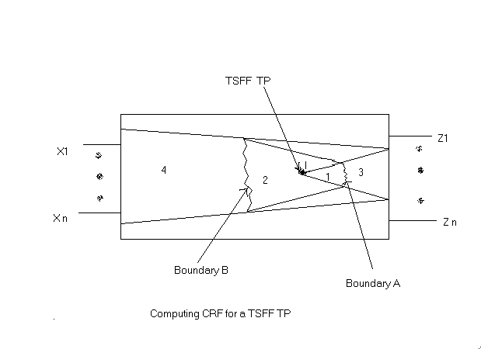
For all lines l ∊ CUT do

Evaluate Controllability Cl and Observability Wl

Compute the gradients dK/dWl and dK/dCl

Compute HCRFl

Select line lTP with HCRFmax

Insert a TSFF at line lTP

5 . EXPERIMENT RESULTS

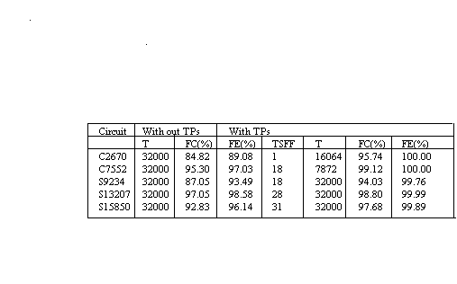
The proposed TPI algorithm for boolean circuits has been implemented in the Delft Advanced Test Generation System ( DAT ). It has been implemented in
TP - Test Point , T - No. of Test Patterns , FE - Fault Efficiency
FC - Fault Coverage , TSFF – Transparent Scan Flip Flop

such a way that no TPs are inserted at signal lines that can float, as TSFF cannot deal with floating values. The algorithm has been tested upon ISCAS benchmark circuits , that suffer from RPR faults. The table shows the fault coverages and efficiencies after the application of 32,000 patterns for respectively Boolean benchmark circuits.

6. CONCLUSIONS
In this dissertation the modified hybrid CRF TPI algorithm is proposed which uses Transparent Scan Flip Flop as TPs instead of AND / OR TPs and the experiment result showed that the improvement in the pseudo-random fault coverage of Boolean circuits.

7. REFERENCES

1.C.Chen, and S.Gupta(1995), “A methodology to design efficient bist test pattern generators”. Proc. of the IEEE Int. Test Conf., pp.814-823
2. R.Lisanke(1987),“Testability-driven random test-pattern generation”,IEEE Transaction on CAD,pp.1082-1087
3. C.Schotten and H.Meyr(1995), “Test point insertion for an are efficient bist”, Proc. of the IEEE Int. Test Conf., pp,515-523
4. B.H.Seiss(1991), “Test point insertion for scan-based bist”, Proc. of 2nd European Test conf., pp.253-262
5.N.Tamarapalli(1996), “Constructive multi-phase tets point insertion for scan-based bist”,Proc. of IEEE Int. Test Conf.,pp.649-658
6.N.A.Touba(1996), “Test point insertion based on path tracing”, Proc. of 14th IEEE VLSI Test Symposium,pp.2-8
7.H.C.Tsai(1997), “A hybrid algorithm for test point selection for scan-based bist”,Proc. of 34th Design Automation Conf.,pp.478-483
8. Jan.M.Rabey and Anand Chandrahasan(2003), “Digital Integrated Circuits”,2nd edition.
9. M.J.Smith(2000), “Application-Specific Integrated Circuits”.
10. Parag.K.Lala(1997), “Digital circuit testing and testability”.
11. Niraj Jha and Sandeep Gupta(2003), “Testing of Digital Systems”
12.Alfred L.Crouch(1999), “Design-for-Test for Digital IC’s and Embedded Core Systems”.

