Mathematical modeling and computer simulation of the Ia monosynaptic reflex fluctuations
Zamora C, Fraguela A, Gómez A, Cervantes L, Manjarrez E
Facultad de Ciencias Físico-Matemáticas and Instituto de Fisiología
Benemérita Universidad Autónoma de Puebla
14 Sur y Av. San Claudio., Col. San Manuel., CP. 72570
MEXICO

Abstract: - The simplest possible neural circuit that mediates some elementary unit of behavior is the monosynaptic reflex pathway formed by muscle spindle afferents (Ia) and their synaptic connections with alpha motoneurons. Since Sherrington in 1906 is very well known that successive stimuli applied on Ia afferents produce monosynaptic reflexes of variable amplitude. The sources of this variability include presynaptic and postsynaptic influences from other neurons within the central nervous system. The purpose of the present study is to present a mathematical modeling and a computer simulation of the variability of the Ia monosynaptic reflexes of the cat spinal cord. We used the Hodgkin-Huxley formulation to obtain a mathematical model of the membrane potential of motoneurones based on the influence of synaptic sources from dorsal horn neurons, inhibitory neurons, and excitatory supraspinal neurons. Amplitude fluctuations of the monosynaptic reflexes were computed using the solutions of the mathematical model for 100 motoneurones. In addition, we have obtained a model which reproduces many of the characteristics of the macroscopic field potentials generated by the spontaneous electrical activity of these dorsal horn neurons.

Key-Words: - Monosynaptic reflex, motoneurons, Hodgkin-Huxley equations, amplitude fluctuations, variability, spinal cord

1 Introduction
The observation that stretch reflexes are highly variable was first reported by Sherrington (1906) [1]. Further work demonstrated that ipsilateral spinal monosynaptic reflexes (MSRs) produced by constant afferent stimuli exhibit considerable variations in size [2] [3] [4] [5]. In other studies, the origin of this variability has been attributed to excitability fluctuations within the motor pool, which are introduced either pre- and/or postsynaptically [6] [7] [8] [9] [10] [11].
Recently, Manjarrez et al. [12] demonstrated that in cats there is a high correlation between amplitude fluctuations of ipsilateral MSRs and amplitude fluctuations of ipsilateral negative spontaneous cord dorsum potentials (CDPs). This fact suggests that the main cause for the ipsilateral MSR fluctuations was the variable activity of ipsilateral dorsal horn neurons. These fluctuations could be attributed to a mechanism in which these neurons control, in a random manner, the time in which the threshold of each motoneuron is reached. The MSR is the result of the summation of these individual effects.

The purpose of the present study was to present a simulation (based on the Hodgkin-Huxley equations [13]) for the fluctuations of the MSRs.
The present study is important because we have obtained a model of the influence of the noisy activity of dorsal horn neurons on the motoneurons, based on experimental results.
The results of this simulation were compared with experimental data obtained from the anaesthetized cat.

2 Problem formulation
2.1 Experiment
Experiments were carried out in 6 adult cats (weight range, 2.4-3.8 kg) initially anaesthetised with pentobarbitone (35 mg/kg of weight, intraperitoneally). The blood pressure was monitored through the carotid artery. The left radial vein was also cannulated to administer additional doses (10 mg/kg, intravenously) of pentobarbital to maintain (after induction) the animals in deep anaesthesia. Guidelines contained in National Institutes of Health Guide for the Care and Use of Laboratory Animals (85-23, revised in 1985) were strictly followed. The lumbo-sacral and low thoracic spinal segments were exposed and the dura mater was removed. After the surgical procedures, the animal was restrained in a stereotaxic apparatus using spinal and pelvic clamps. The left and right ventral roots L5-S2 were dissected and sectioned. Pools were formed with the skin around the exposed tissues, filled with mineral oil (after placement of the electrodes) and maintained at a constant temperature (37 ºC). Adequacy of anaesthesia was assessed by verifying that the pupils were constricted, and that blood pressure was stable (usually between 100-120 mmHg). The animals were paralysed with pancuronium bromide (Pavulon, Organon), and artificially ventilated.
Gastrocnemius plus Soleus (GS) or Posterior Biceps and Semitendinosus (PBSt) nerves were stimulated with single pulses of 1.2-1.4 times the threshold level (xT) of the afferent volleys recorded on the surface of the spinal cord. The frequency of stimulation was adjusted to 0.5 Hz [12].
We recorded monosynaptic reflexes from the central end of the sectioned L7 ventral root (Fig. 1).
MSR
Stim
Fig. 1. Scheme of the experimental arrangement. Monosynaptic reflexes (MSR) recorded from the lumbar L7 ventral root were evoked by stimulation applied to Ia afferents. Stim (pulse of stimulation of 0.5 ms).

2.2 Numerical Model
We used the Hodgkin-Huxley (HH) equations (1), and a model of the contribution of the synaptic input, to obtain a mathematical model of the fluctuations in the amplitude (and frequency) of the membrane potential at the soma of a typical motoneuron in the lumbar L7 ventral horn.

I_{inputs}=C_{m}dV_{i}/dt + g_{maxNa}m³h(V_{i}-E_{Na}) + g_{maxK}n⁴(V_{i}-E_{K}) + g_{maxL}(V_{i}-E_{L}) (1)

where I_{inputs} are described in section 2.3.
Using this model we calculated the membrane potential V_{i} at the soma for i = 1 to 100 motoneurons belonging to a nerve, from which the MSRs were obtained.
The parameters of the HH equations (1) were similar to the parameters employed by Kelvin and Bawa [14]. The voltage and time dependence of the activation and inactivation variables was given by the equations:

dθ/dt = α_{θ}(1-θ) –β_{θ}θ = (θ∞− θ)/τ_{θ}
τ_{θ}=1/(α_{θ}+β_{θ})
θ∞= α_{θ} /(α_{θ}+β_{θ})

where
Na+ current:
g_{maxNa} = 500 mS/cm2
E_{Na} = 115 mV
α_{m} = (4-0.4V)/(exp((10-V)/5)-1)
β_{m}= (0.4V-14)/(exp((V-35)/5)-1)
α_{h} = 0.16/exp((37.78-V)/18.14)
β_{h} = 4/(exp((30-V)/10)+1)

K+ current:
g_{maxK} = 100 mS/cm2
E_{K} = -10 mV
α_{n} = (0.2-0.02V)/(exp((10-V)/10)-1)
β_{n} =0.15/(exp((V-33.79)/71.86)-0.01)

L current:
g_{maxL} = 0.25 mS/cm²
E_{L} = 10 mV

Each MSR was modeled from the addition of the membrane potential variations for all of the 100 motoneurons. The H-H equations were calculated independently for each one of the motoneurons. Then the solutions obtained from this analysis were summated and the result was considered as the MSR (2). We simulated the fluctuations in the amplitude of 100 successive MSRs evoked at 0.5 Hz (or 5 Hz, or 2Hz) (one MSR every 2 seconds, or 200 ms, or 500 ms)

MSR = V₁(t) + V₂(t) + … + V₁₀₀(t) (2)

2.3 Modeling of the synaptic inputs
The contributions of the synaptic noisy inputs on the motoneurons were considered in the HH equations. These inputs were represented as:

I_{inputs} = E_{w}(t) + NI_{afferent}(t)- MI_{inhibitory}(t) + I_{nSCDPs}(t) (3)

where t is between 0 and 60000 ms, and M and N indicate the number of excitatory and inhibitory synapses, respectively.
The function E_{w}(t) represents the influence from supraspinal centers on the motoneuron. E_{w}(t) is defined as a periodic function with a frequency w= π/2 Hz with a Gaussian profile.

E(t) = A exp [ -0.5( (t-t₀)²/X₀)] (4)

where A is the maximum amplitude (μA/cm²)

I_{afferent}(t) = a (P(t)-V_{syn} ^{afferent} ) exp [bt]
(5)

I_{afferent}(t) indicates the synaptic excitatory input from the Ia afferent on the motoneuron.

I_{inhibitory}(t) = c (P(t)-V_{syn} ^{inhibitory} ) exp [dt]
(6)

I_{afferent}(t) indicates the synaptic inhibitory input from the interneurons on the motoneuron.
In (5) and (6), P(t) is a square pulse (mV) applied to simulate the excitatory and inhibitory synaptic inputs. V_{syn} ^{afferent} and V_{syn} ^{inhibitory} are the reversal potentials for the synaptic actions of the afferents and the inhibitory interneurons. a, b, c, and d are parameters. We selected the magnitude of “a” such that the maximal amplitude of I_{afferent} (t) could be similar to the threshold value required for the firing of the motoneuron.
The noisy synaptic inputs from the dorsal horn neurons (the negative spontaneous cord dorsum potentials: nSCDPs) were modeled as Gaussian functions of random amplitude and their wave forms were compared with the experimental results. The experimental results show that the Gaussians have a duration of approximately 30 ms. For this reason the range of the possible frequencies vary between 1 to 30 Hz.
The dependence of the amplitude A(w) of the nSCDPs versus their frequency w of occurrence was determined by a fitting of the power spectrum of nSCDPs. The best function to fit these data was:

A(w)=αexp(-γw) (7)

The profile of each nSCDP corresponding with each frequency w was modeled as:

A(w)exp(-0.5(t-t₀(w))²/X₀) (8)

We define R_{k}(t) as the periodic function with the profile showed in (8) for the frequency w=k, were k= 1 to 30. Then the noisy synaptic input generated by the dorsal horn neurons can be modeled by:
I_{nSCDPs}(t)= g$\sum_{k=1}^{\text{30}}{p_{k}R_{k}(t)}$ (9)

where p_{k} is the probability of occurrence of the frequency w=k:

0≤p_{k}≤1, $\sum_{k=1}^{\text{30}}{p_{k}}$= 1 (10)

3 Problem solution
3.1 Simulation of the spontaneous cord dorsum potentials
The spontaneous cord dorsum potentials were simulated with the equation (9) where p_{k} were selected in a random manner and satisfying the relation (10).
We used Matlab software (Mathworks, Inc.©, v. 6.5) to simulate the random occurrence of the nSCDPs.
Fig. 2A illustrates a numerical simulation of the nSCDPs in a time window of 2000 ms. nCDPs are similar to the nSCDPs recorded in a typical experiment (Fig. 2B).

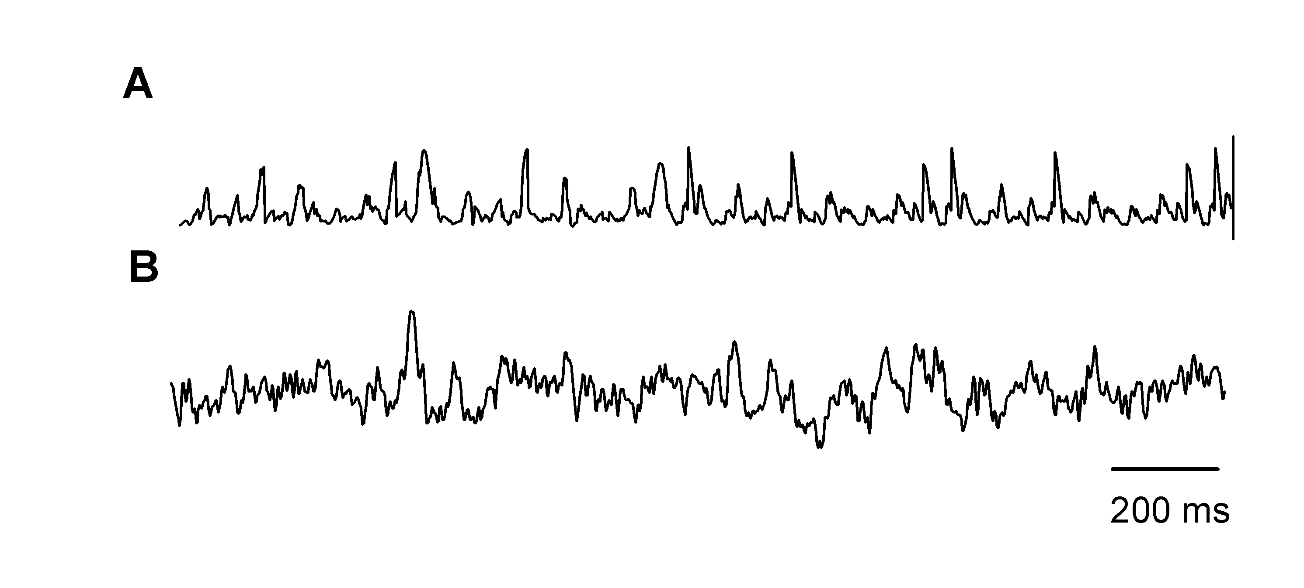
Fig. 2. Numerical versus experimental nSCDPs. A, Negative spontaneous cord dorsum potentials (nSCDPs) obtained from the numerical simulation. B, Recording of the nSCDPs from the spinal cord of the anaesthetized cat.

3.2 Simulation of the response of a single motoneuron
We obtained the numerical solution of the Hodgkin-Huxley system corresponding to the equation (1) for one motoneuron. The procedure to obtain the parameters of the model was the following. First, we considered the model (1) with I_{inputs} = constant, and the threshold value for this constant =29.74 μA/cm² was determined. Second, we defined the parameters b=0.001/ms and V_{syn}^{afferent}=0 and a stimulation pulse of 0.5 ms, with frequency of 0.5 Hz (or 5 Hz, or 2Hz) and amplitude of 1 mV. Third, we selected the parameter a=(0.002)mS/cm² to obtain the maximal amplitude of I_{afferent} near to 29.4 μA/cm². Fourth, we considered the parameters for I_{inhibitory}: c=(0.01)mS/cm², d=0.00009/ms, and V_{syn}^{inhibitory}=0 to obtain the maximum amplitude of I_{inhibitory} near to 0.4 μA/cm². Fifth, we considered the parameters A=0.5 μA/cm², t₀=2000ms, X₀=600ms² for E_{w}(t). Sixth, we used a table of random numbers to obtain the values of t₀(w) with w= k, k =1 to 30; thus obtaining the center of the Gaussians defined in (8). Then, in order to obtain the maximal amplitude of I_{nSCDPs}(t) near to 0.4 μA/cm², the parameter g and the probabilities of occurrence of the different types of Gaussians were selected with other table of random numbers satisfying the condition (10). In (3), M= 500 and N=100.

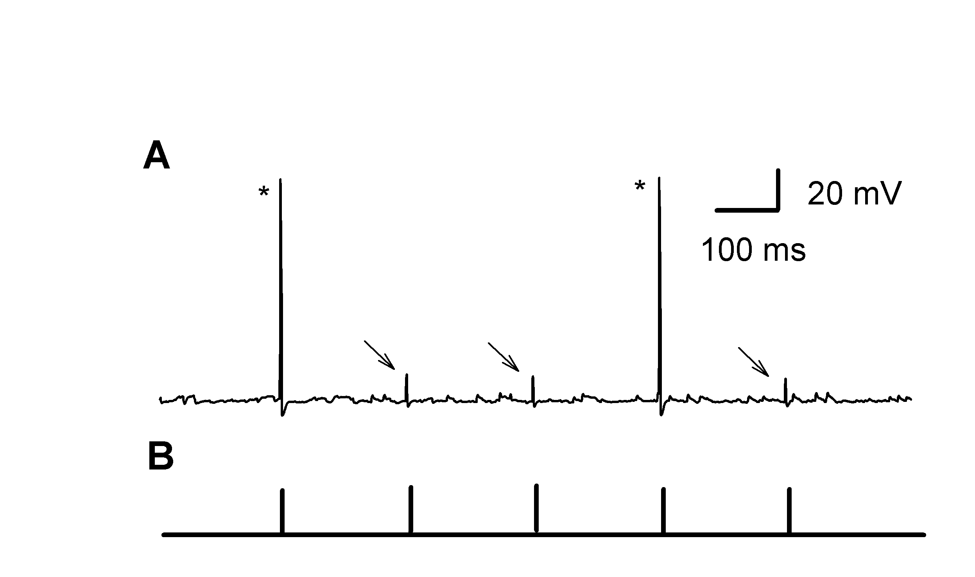

Fig. 3. Numerical simulation of the action potentials obtained from one motoneuron. A, Sequence of action potentials (asterisks) and synaptic potentials (arrows) evoked by electrical stimuli to the Ia afferents. B, Sequence of the five stimuli applied. Only in those cases in which the membrane potential crossed the threshold the action potentials were elicited.

Fig. 3A illustrates the numerical solution for a time interval of 1200 ms. In this case we employed a sub-threshold periodic pulse (Fig. 3B) of 5 Hz (a pulse every 200 ms). Note that although the pulse was sub-threshold in some cases the contribution of the excitatory and inhibitory synaptic inputs produced a response of the motoneuron (indicated with asterisks in Fig. 3A).

3.3 Experimental results and the simulation of the response of 100 motoneurons
In this section, we compare results obtained from the experiment with results obtained from numerical simulation of Equation (1) for the same parameter values indicated above, but for 100 different motoneurons.
Each motoneuron was characterized by a sequence of parameters t₀(k) and p_{k}, k= 1 to 30, described in (8)-(10), which were selected randomly.
We obtained a numerical simulation in epochs of 1600 ms (or 16000 ms), in which a sequence of 7 pulses of 0.5 ms and 5 Hz (or 0.5 Hz) were applied. We analyzed the numerical results for 100 epochs.
We used Matlab software (Mathworks, Inc.©, v. 6.5) to simulate the responses (for 1 to 100 motoneurons) and the random occurrence of the nSCDPs.
Fig. 4F shows the numerical simulation of the MSRs associated to n=10 motoneurons. The motoneurons were activated by the stimuli illustrated in Fig. 4A. Figures 4B, C, D and E illustrate the responses of four different motoneurons. To obtain the MSRs evoked by every pulse we used the algorithm indicated in equation (2). The MSR associated to the membrane potential variations for 10 motoneurons is illustrated in Fig. 4F. The fluctuations in the amplitude of successive MSRs were very similar to the fluctuations of the MSRs recorded in our experiments.

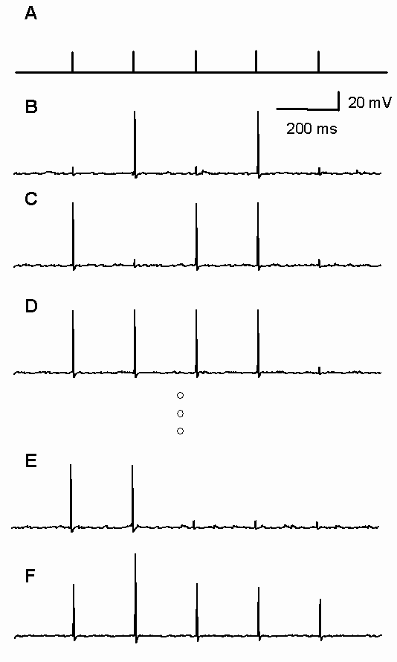

Fig. 4. Simulation of the monosynaptic reflexes (MSRs) generated by 10 motoneurons. A, Periodic pulses of stimulation at 5 Hz. B, C, D and E, numerical simulations of action potentials for 4 of 10 motoneurons. F, Numerical simulation of the MSRs corresponding to 10 motoneurons.

Fig. 5B and Fig. 6 show the numerical simulation of the MSRs associated to n=100 motoneurons in different time intervals. The motoneurons were activated by the stimuli illustrated in Fig. 5A.

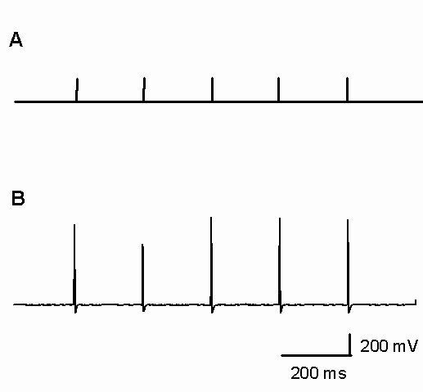

Fig. 5. Simulation of the monosynaptic reflexes (MSRs) generated by 100 motoneurons. A, Periodic pulses of stimulation at 5 Hz. B, Monosynaptic reflexes.

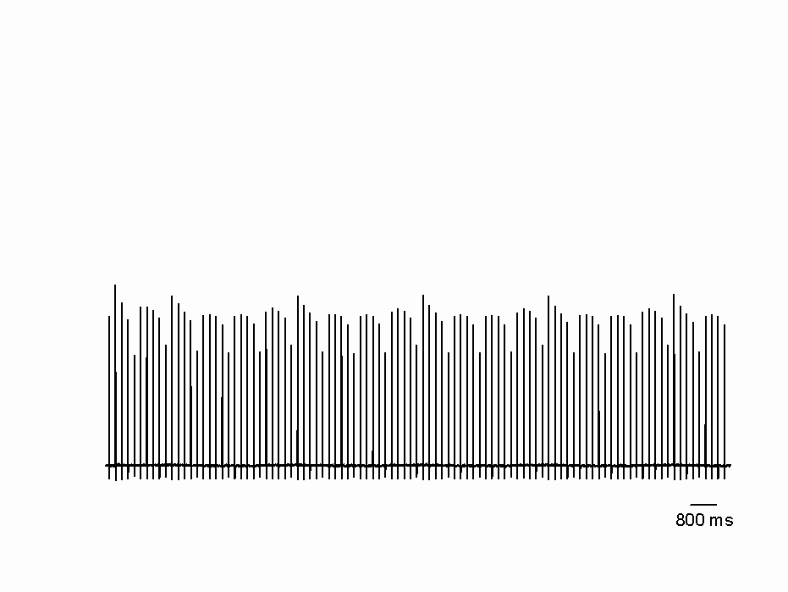
Fig. 6. Simulation of a sequence of 100 monosynaptic reflexes (MSRs) generated by 100 motoneurons. The pulses of stimulation were generated at 5 Hz.

We compared the serial distribution of amplitudes for a sequence of 180 MSRs obtained from the numerical simulation (Fig. 7A), and from the experiment (Fig. 7B). Note the clear similarity in the amplitude variations. The parameters used to obtain the numerical simulation of Fig. 7A were the same parameters used in Fig. 4F and 5B. Fig. 7B shows the amplitude fluctuations of successive MSRs elicited by periodic pulses of 5 Hz (one pulse every 200 ms). In this case, we used the experimental arrangement illustrated in Fig. 1.

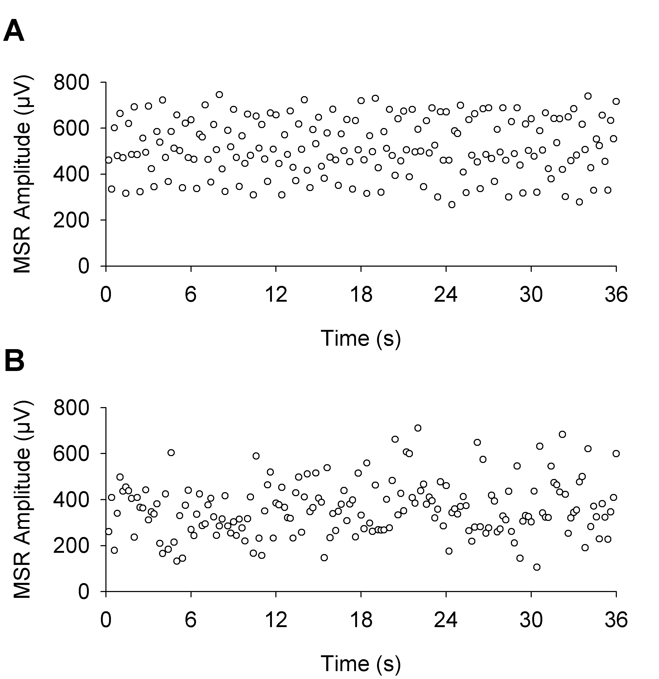

Fig. 7. Time course of monosynaptic reflex (MSR) amplitude fluctuations. A, Numerical simulation. B, Experimental results. MSRs were elicited by stimulation of the Posterior Biceps and Semitendinosus (PBSt) nerve, as in Fig. 1. Circles indicate the amplitude of successive MSRs elicited every 200 ms. Standard deviations of the data in figures A and B are 116.4 and 123.8, respectively.

4 Conclusion
We obtained a model of the membrane potential variations for one typical motoneuron based on the Hodgkin-Huxley formulation. With this model we explained the influence from dorsal horn neurons, inhibitory neurons, and excitatory supraspinal neurons on the fluctuations of the Ia monosynaptic reflex pathway.

References:
[1] Sherrington CS, The integrative action of the nervous system, Charles Scribner’s Sons, New York, 1906, pp. 433.
[2] Lloyd DPC, McIntyre AK, Monosynaptic reflex responses of individual motoneurons, J Gen Physiol, Vol. 38, 1955, pp. 771-787
[3] Hunt CC, Temporal fluctuation in excitability of spinal motoneurons and its influence on monosynaptic reflexes, J Gen Physiol, Vol. 38, 1955, pp. 801-811.
[4] Somjen GG, Heath CJ, Covariation of monosynaptic reflexes in spinal and decerebrate cats, Exp Neurol Vol.15, 1966, pp. 77-99.
[5] Rall W, Hunt CC, Analysis of reflex variability in terms of partially correlated excitability fluctuations in a population of motoneurons, J Gen Physiol, Vol. 39, 1956, pp. 397-422.
[6] Rudomin P, Dutton H, Effects of presynaptic and postsynaptic inhibition on the variability of the monosynaptic reflex, Nature, Vol. 216, 1967, pp. 292-293.
[7] Rudomin P, Dutton H, Effects of conditioning afferent volleys on variability of monosynaptic responses of extensor mononeurons, J Neurophysiol, Vol. 32, 1969, pp. 140-157.
[8] Rudomin P, Dutton H, Effects of muscle and cutaneous afferent nerve volleys on excitability fluctuations on Ia terminals. J Neurophysiol, Vol. 32, 1969, pp. 158-169.
[9] Rudomin P, Madrid J, Changes in correlation between monosynaptic responses of single motoneurons and in information transmission produced by conditioning volleys to cutaneous nerves, J Neurophysiol, Vol.35, 1972, pp. 44-64.
[10] Rudomin P, Burke RE, Nunez R, Madrid J, Dutton H, Control by presynaptic correlation: a mechanism affecting information transmission from Ia afferents to motoneurons, J Neurophysiol, Vol. 38, 1975, pp. 267-284.
[11] Gossard JP, Floeter MK, Kawai Y, Burke RE, Chang T, Schiff SJ, Fluctuations of Excitability in the Monosynaptic Reflex Pathway to Lumbar Motoneurons in the Cat, J Neurophysiol, Vol. 72, 1994, pp. 1227-1239.
[12] Manjarrez E, Rojas-Piloni G, Jimenez I, Rudomin P, Modulation of synaptic transmission from segmental afferents by spontaneous
activity of dorsal horn spinal neurones in the cat, J Physiol, Vol. 529, 2000, pp. 445-460.

[13] Hodgkin AL and Huxley AF, A quantitative description of membrane current and its application to conduction and excitation in nerve, J Physiol, Vol. 117, 1952, pp.500-544.
[14] Kelvin EJ, Bawa P (1997) Computer simulation of the responses of human motoneurons to composite Ia EPSPS: Effects of background firing rate, J Neurophysiol, Vol. 77, 1997, pp. 405-420.

