STATE ESTIMATION AND FAULT DIAGNOSIS OF INDUSTRIAL PROCESS WITH PARTICLE FILTERS

H.Bolandi S.Bahmanpour
Iran University of Science & Technology Iran University of Science & Technology

Abstract-We present a probabilistic approach to state estimation and fault diagnosis in complex industrial process. In particular, we adopt a jump markov linear Gaussian (JMLG) model to describe a continuous stirred tank reactor. The parameters of this process are identified with the expectation maximization (EM) algorithm. After identification, particle filtering algorithms are adapted to diagnosis, in real-time, the state of operation of continuous stirred tank reactor. For this application, we compare two particle filtering variants: standard particle filtering and Rao-Blackwellised particle filtering. The particle filtering estimates are then used to drive an automatic control system.

Keywords- State estimation, Fault diagnosis, JMLG model, Particle filtering, continuous stirred tank reactor.

1 Introduction
Real-time monitoring is important in many areas such as robot navigation or diagnosis of complex industrial systems [1,2]. This paper considers online monitoring of complex industrial processes. The processes have a number of discrete states, corresponding to different combinations of faults. The dynamics can be very different base on the discrete states. Even if there are very few discrete states, exact monitoring is computationally unfeasible as the state of the system depends on the history of the discrete states. However there is a need to monitor these systems in real time to determine what faults could have occurred.
Here, we propose a real-time, automatic strategy for estimating the states of industrial processes from noisy measurements of continuous variables. This approach enables us to reduce the cognitive load experienced by human operators. It also serves to minimize the number of instruments and to open up room for sophisticated control strategies.
In particular, we adopt a jump Markov linear Gaussian (JMLG) model to describe a continuous stirred tank reactor with different linear regimes of operation. A discrete state variable controls the switching between the various linear regimes. The parameters of each regime are identified off-line with the EM algorithm [3]. Once the stationary parameters have been identified, real-time Rao-Blackwellised particle filtering (RBPF) algorithms are used to estimate the continuous and discrete states of the system on-line [4,5]. These estimates are used to determine to control policy of a PID controller.

2 Process Monitored
The main goal of this research is to do real-time diagnosis and state estimation (as an inference task) in dynamic industrial processes. By diagnosis we mean the detection / determination of faults that could occur in the process itself, in its measuring instruments or in its actuators. By state estimation we mean the identification of different operating conditions which the process can be in. For dynamic industrial processes we consider a continuous stirred tank reactor. We are exclusively concerned with dynamic systems characterized by continuous-time operation. If the dynamic system has non-linear behavior, it has to be modeled as a series of linear segments. Let us consider a multi-input multi-output continuous dynamic system, as defined below.

2.1 Continuous Stirred Tank Reactor
A Continuous Stirred Tank Reactor (CSTR) is a complex nonlinear, multivariable system; see Figure 1. It involves a second-order exothermic reaction $(2A→B)$, where 2 components of A react irreversibly and at specific reaction rate k to form product B [6].The reaction rate constant k
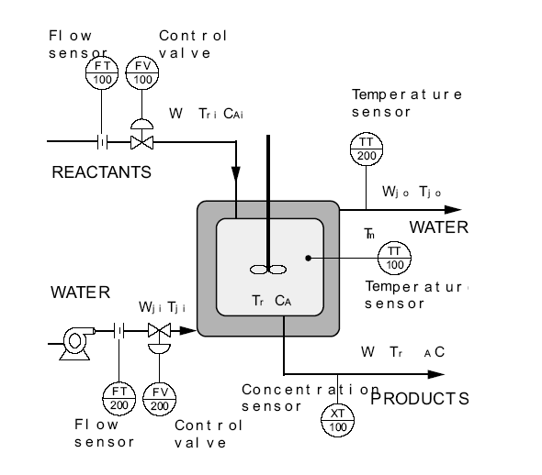
Figure 1. Continuous Stirred Tank Reactor

follows the Arrhenius equation (1). According to this equation, the effect of temperature, $T_{r}(t)$, on the specific reaction rate k is usually exponential. This exponential temperature dependence represents one of the most severe nonlinearities in chemical engineering systems. The overall reaction rate R is defined as the rate of change of moles of any component per volume due to chemical reaction divided by that component’s stoichiometric coefficient. Because of this reaction, we have $R={\text{kC}}_{A}^{2}$. Then, the overall rate R will vary with temperature, $T_{r}(t)$, and with the concentration of the reactant $C_{A}$ raised to the 2nd power (second-order reaction). As we can see, this term R is highly nonlinear.
$k(T_{r}(t))=k_{0}e^{\left[\frac{−a}{T_{r}(t)+\text{460}}\right]}$ (1)

2.2 Modeling
The mathematical model for this CSTR involves a mass balance on A, in which the flow of moles of component A into the system, minus the flow of moles of A out of the system, plus the rate of formation of moles of A component from chemical reactions is equal to time rate of change of moles of A component inside system. This

Table1. Variables
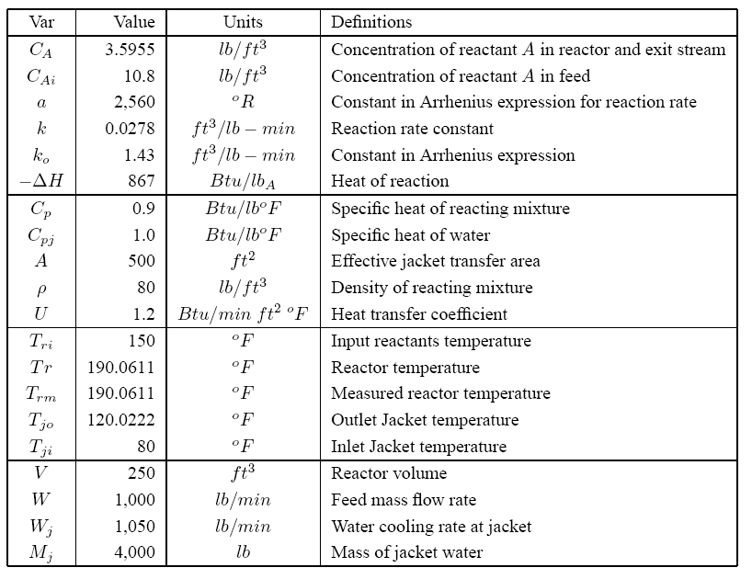
concept is expressed by equation (2), commonly known as a component continuity equation.
The first law of thermodynamics puts forward the principle of conservation of energy. The mathematical model must include an enthalpy balance on reaction mass, and an enthalpy balance on jacket (water is flowing through the jacket). In this case, the flow of internal energy into the system, minus the flow of internal energy out of the system, plus the heat added to the system by reaction is equal to the rate of change of internal energy inside the system. The balance on reacting mass is given by equation (3), and the balance on the jacket by equation (4).
$Vρ\frac{{\text{dC}}_{A}}{\text{dt}}=W(C_{\text{Ai}}−C_{A})−{\text{kC}}_{A}^{2}Vρ$ (2)
${VρC}_{P}\frac{{\text{dT}}_{r}}{\text{dt}}={\text{WC}}_{P}(T_{\text{ri}}−T_{r})−\text{UA}(T_{r}−T_{\text{jo}})+(−ΔH){\text{VkC}}_{A}^{2}$(3)
$M_{j}C_{\text{Pj}}\frac{{\text{dT}}_{\text{jo}}}{\text{dt}}=\text{UA}(T_{r}−T_{\text{jo}})−W_{j}C_{\text{Pj}}(T_{\text{jo}}−T_{\text{ji}})$ (4)
Some assumptions were made to derive these equations. These equations represent a very simplified nonlinear CSTR model (the t functionality was omitted for clarity). Nevertheless, this simpler model captures the nonlinearity we are interested in. we will only measure the following 3 variables: the output

Table2. CSTR Instrumentation.
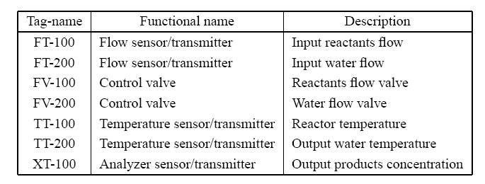

concentration $C_{A}(t)$, the reactor temperature $T_{r}(t)$, and the output jacket temperature $T_{\text{jo}}(t)$. See Table 1 for a complete definition of the variables; Figure 1 conveys their meaning graphically.
Figure 1 also shows some instruments for monitoring and control purposes. Table 2 gives a complete description of this instrumentation.
The nonlinear model described by equations (2-4) was linearized to build the JMLG model. Then 4 discrete modes were tested.
We consider a fouled surface (dirty surface) in the jacket as a possible faulty point (of course, there are many possible faulty points in this system). A fouled surface can be caused by normal operating conditions over an extended time, or by stochastic problems such as cooling water with a high concentration of minerals or salts. Surface fouling reduces the global heat transfer coefficient $U(t)$ in the mathematical model. We defined four of the possible discrete modes for this nonlinear multivariable system, Table 3.
Table3. CSTR Operating conditions
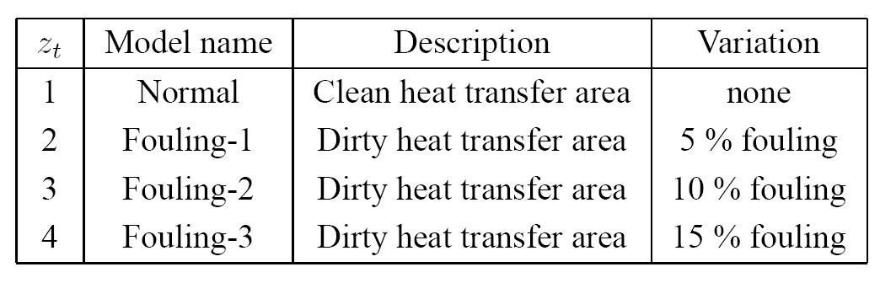

We obtain the sampled state-space representation using the continuous state-space representation. The continuous state-space is generated by the system of linear differential equations.
For the “normal” discrete mode, $z_{t}=1$:
$x_{t+1}=A(z_{t+1})x_{t}+B(z_{t+1})w_{t+1}+F(z_{t+1})u_{t+1}$ (5)
$y_{t}=C(z_{t})x_{t}+D(z_{t})v_{t}+G(z_{t})u_{t}$ (6)
Where:
$$x_{t}=\left[\begin{matrix}C_{A}(t) \\ T_{r}(t) \\ T_{\text{jo}}(t)\end{matrix}\right]y_{t}=\left[\begin{matrix}C_{A}(t) \\ T_{r}(t) \\ T_{\text{jo}}(t)\end{matrix}\right]u_{t}=\left[\begin{matrix}u_{1}(t) \\ u_{2}(t) \\ u_{3}(t)\end{matrix}\right]$$
$w_{t}$ and $v_{t}$ are the process and measurement noises; both follow $N(0,1)$. The matrices are:
$\begin{aligned}A(z_{t}=1)=\left[\begin{matrix}0\text{.}\text{9752} & −0\text{.}\text{000214} & −3\text{.}\text{55}(\text{10})^{−7} \\ 0\text{.}\text{2376} & 0\text{.}\text{9943} & 0\text{.}\text{00325} \\ 0\text{.}\text{00176} & 0\text{.}\text{01465} & 0\text{.}\text{9596}\end{matrix}\right] \\ F(z_{t}=1)=\left[\begin{matrix}0\text{.}\text{1299} & 0 & 0 \\ −0\text{.}\text{1635} & 0 & 0 \\ 2\text{.}\text{0560} & 0 & 0\end{matrix}\right]\end{aligned}$$B(z_{t}=1)=n_{\text{process}}I^{3×3}$, $C(z_{t}=1)=I^{3×3}$, $D(z_{t}=1)=n_{\text{measurement}}I^{3×3}$, $G(z_{t}=1)=0^{3×3}$. The values for $n_{\text{process}}$ and $n_{\text{measurement}}$ are fixed for each test. Corresponding results were obtained for each faulty discrete mode $(z_{t}=2,3,4)$. The initial states are $x_{0}\text{\sim }N(μ_{0},Σ_{0})$ and $z_{0}\text{\sim }P(z_{0})$. The important thing to notice is that for each realization of $z_{t}$, we have a single linear-Gaussian model. If we knew $z_{t}$, we could solve for $x_{t}$ exactly using the Kalman filter algorithm.
The aim of the analysis is to compute the marginal posterior distribution of the discrete states $P(z_{0:t}|y_{1:t})$. This distribution can be derived from the posterior distribution $P({\text{dx}}_{0:t},z_{0:t}|y_{1:t})$ by standard marginalization. The posterior density satisfies the following recursion: (7)
$\begin{aligned}p(x_{0:t},z_{0:t}|y_{1:t})= \\ p(x_{0:t−1},z_{0:t−1}|y_{1:t−1})\frac{p(y_{t}|x_{t},z_{t})p(x_{t},z_{t}|x_{t−1},z_{t−1})}{p(y_{t}|y_{1:t−1})}\end{aligned}$This recursion involves intractable integrals. One, therefore, has to resort to some form of numerical approximation scheme.

3 Problem Solutions
Most existing model-based fault diagnosis methods use a technique called analytical redundancy [7]. Real measurements of a process variable are compared to analytically calculated values. The resulting differences, named residuals, are indicative of faults in the process. Many of these methods rely on simplifications and heuristics. Here, we propose a principled probabilistic approach to this problem.

3.1 Particle Filtering
In the PF setting, we use a weighted set of samples (particles) ${\left\{\left(x_{0:t}^{(i)},z_{0:t}^{(i)}\right),w_{t}^{(i)}\right\}}_{i=1}^{N}$ to approximate the posterior with the following point-mass distribution
$${\hat{P}}_{N}({\text{dx}}_{0:t},z_{0:t}|y_{1:t})=\sum_{i=1}^{N}{w_{t}^{(i)}δ_{x_{0:t}^{(i)},z_{0:t}^{(i)}}({\text{dx}}_{0:t},z_{0:t})}$$
Where $δ_{x_{0:t}^{(i)},z_{0:t}^{(i)}}({\text{dx}}_{0:t},z_{0:t})$ denotes the Dirac-Delta function. Given N Particles ${\left\{x_{0:t−1}^{(i)},z_{0:t−1}^{(i)}\right\}}_{i=1}^{N}$ at time t-1, approximately distributed according to $P({\text{dx}}_{0:t−1}^{(i)},z_{0:t−1}^{(i)}|y_{1:t−1})$, PF enables us to compute N particles ${\left\{x_{0:t}^{(i)},z_{0:t}^{(i)}\right\}}_{i=1}^{N}$ approximately distributed according to $P({\text{dx}}_{0:t}^{(i)},z_{0:t}^{(i)}|y_{1:t})$, at time t. since we cannot sample from the posterior directly, the PF update is accomplished by introducing an appropriate importance proposal distribution $Q({\text{dx}}_{0:t},z_{0:t})$ from which we can obtain samples. The basic algorithm, Figure 2, consists of two steps: sequential importance sampling and selection (see [5] for a detailed derivation). This algorithm uses the transition priors as proposal distributions; for the selection step, we used a state-of-the-art minimum variance resampling algorithm [8].

3.2 Rao-Blackwellised Particle Filtering
By considering the factorization $p(x_{0:t},z_{0:t}|y_{1:t})=p(x_{0:t}|y_{1:t},z_{0:t})p(z_{0:t}|y_{1:t})$, it is possible to design more efficient PF algorithms.
The density $p(x_{0:t}|y_{1:t},z_{0:t})$ is Gaussian and can be computed analytically if we know the marginal posterior density $p(z_{0:t}|y_{1:t})$. This density satisfies the alternative recursion : (8)
$$\begin{aligned}p(z_{0:t}|y_{1:t})= \\ p(z_{0:t−1}|y_{1:t−1})\frac{p(y_{t}|y_{1:t−1},z_{0:t})p(z_{t}|z_{t−1})}{p(y_{t}|y_{1:t−1})}\end{aligned}$$
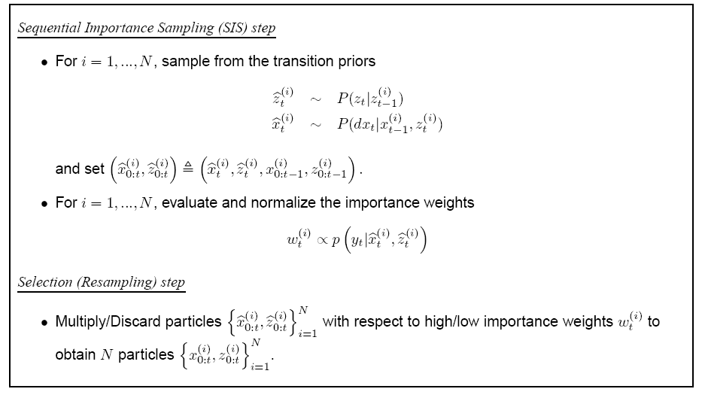
Figure2. Particle Filtering

If equation (7) does not admit a closed-form expression, then equation (8) does not admit one either and sampling-based methods are still required. (Also note that the term $p(y_{t}|y_{1:t−1},z_{0:t})$ in equation (8) does not simplify to $p(y_{t}|z_{t})$ because there is a dependency on past values through $x_{0:t}$.) Now assuming that we can use a weighted set of samples ${\left\{z_{0:t}^{(i)},w_{t}^{(i)}\right\}}_{i=1}^{N}$ to represent the marginal posterior distribution
$${\hat{P}}_{N}(z_{0:t}|y_{1:t})=\sum_{i=1}^{N}{w_{t}^{(i)}δ_{x_{0:t}^{(i)}}(z_{0:t})}$$
The marginal density of $x_{0:t}$ is a Gaussian mixture
$$\begin{aligned}{\hat{P}}_{N}(x_{0:t}|y_{1:t})= \\ \int{p(x_{0:t}|z_{0:t},y_{1:t})\text{dP}(z_{0:t}|y_{1:t})}= \\ \sum_{i=1}^{N}{w_{t}^{(i)}p(x_{0:t}|y_{1:t},z_{0:t}^{(i)})}\end{aligned}$$
That can be computed efficiently with a stochastic bank of kalman filters. That is, we use PF to estimate the distribution of $z_{t}$ and exact computations (kalman filter) to estimate the mean and variance of $z_{t}$. In particular, we sample $z_{t}^{(i)}$ and then propagate the mean $μ_{t}^{(i)}$ and covariance $Σ_{t}^{(i)}$ of $x_{t}$ with a kalman filter:
$$μ_{t|t−1}^{(i)}=A(z_{t}^{(i)})μ_{t−1}^{(i)}+F(z_{t}^{(i)})u_{t}$$
$$Σ_{t|t−1}^{(i)}=A(z_{t}^{(i)})Σ_{t−1}^{(i)}A(z_{t}^{(i)})^{T}+B(z_{t}^{(i)})B(z_{t}^{(i)})^{T}$$
$$S_{t}^{(i)}=C(z_{t}^{(i)})Σ_{t|t−1}^{(i)}C(z_{t}^{(i)})^{T}+D(z_{t}^{(i)})D(z_{t}^{(i)})^{T}$$
$$y_{t|t−1}^{(i)}=C(z_{t}^{(i)})μ_{t|t−1}^{(i)}+G(z_{t}^{(i)})u_{t}$$
$μ_{t}^{(i)}=μ_{t|t−1}^{(i)}+Σ_{t|t−1}^{(i)}C(z_{t}^{(i)})^{T}S_{t}^{−1(i)}(y_{t}−y_{t|t−1}^{(i)})$s
$$Σ_{t}^{(i)}=Σ_{t|t−1}^{(i)}−Σ_{t|t−1}^{(i)}C(z_{t}^{(i)})^{T}S_{t}^{−1(i)}C(z_{t}^{(i)})Σ_{t|t−1}^{(i)}$$
Where $μ_{t|t−1}\overset{Δ}{=}E(x_{t}|y_{1:t−1}),μ_{t}\overset{Δ}{=}E(x_{t}|y_{1:t}),y_{t|t−1}\overset{Δ}{=}E(y_{t}|y_{1:t−1})$$Σ_{t|t−1}\overset{Δ}{=}\text{cov}(x_{t}|y_{1:t−1}),Σ_{t}\overset{Δ}{=}\text{cov}(x_{t}|y_{1:t})$ and $S_{t}\overset{Δ}{=}\text{cov}(y_{t}|y_{1:t−1})$. This is a basis of the RBPF algorithm that was adopted in [4].

4 Results
We tested the 2 inference algorithms for N=100 and T=50. These simulations were designed using the transition matrix and prior probabilities shown in [9]:
$P(z_{t}|z_{t−1})=\left[\begin{matrix}0\text{.}\text{9983} & 0\text{.}\text{001} & 0\text{.}\text{0005} & 0\text{.}\text{00025} \\ 0\text{.}\text{001} & 0\text{.}\text{9975} & 0\text{.}\text{001} & 0\text{.}\text{0005} \\ 0\text{.}\text{0005} & 0\text{.}\text{001} & 0\text{.}\text{9975} & 0\text{.}\text{001} \\ 0\text{.}\text{00025} & 0\text{.}\text{0005} & 0\text{.}\text{001} & 0\text{.}\text{9983}\end{matrix}\right]$$P(z_{0})={\left[\begin{matrix}0\text{.}\text{9983} \\ 0\text{.}\text{001} \\ 0\text{.}\text{0005} \\ 0\text{.}\text{00025}\end{matrix}\right]}^{′}$
Figure 3 plots the tracking error for each algorithm. As you can see the RBPF algorithm can track the state better than PF algorithm. If we have several state (for example 3 or 4) Figure 4 will resulted. You can see in this plot that RBPF algorithm is better. Figure 5 and 6 show the states, outputs and discrete modes uses in simulation. Figure 7 and 8 plots the Probability density of PF and RBPF algorithms.
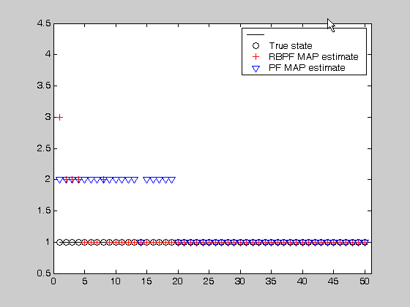
Figure3. CSTR (1 discrete Mode)

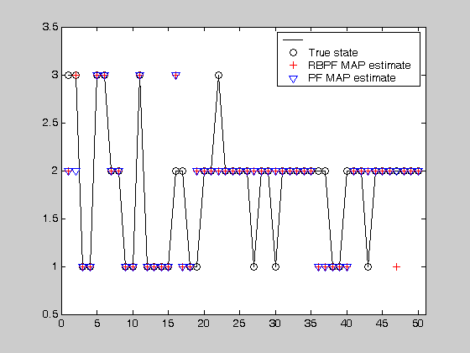
Figure4. CSTR (several discrete modes)

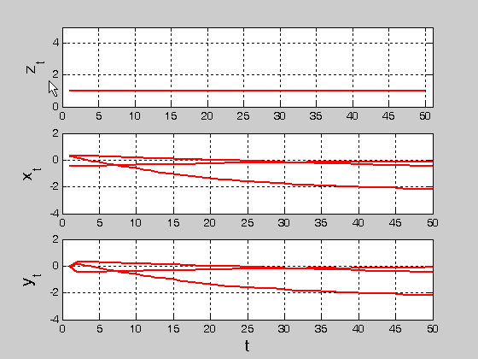
Figure5. 1Discrete mode, states, output

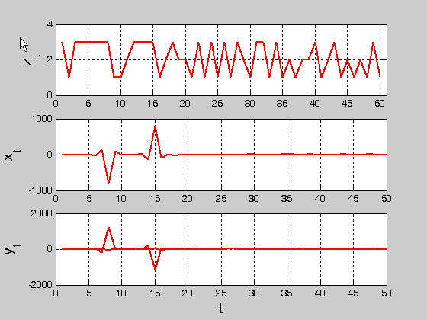
Figure 6. 3discrete modes, states, outputs

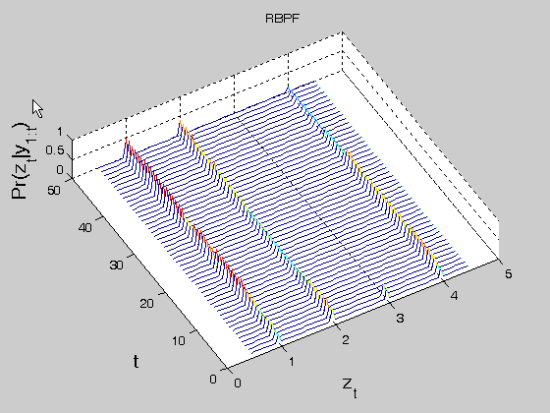
Figure7. Probability distribution (RBPF algorithm), 1 discrete mode

References
[1] J Chen and J Howell. A self-validating control system based approach to plant fault detection and diagnosis. Computers and chemical Engineering, 25:337-358, 2001.
[2] S Thruan, J Langford, and V Verma. Risk sensitive particle filters. In S Becker T. G Dietterich and Z Ghahramani, editors, Advances in Neural Information Processing Systems 14, Cambridge, MA, 2002. MIT Press.
[3] Z Ghahramani and G E Hinton. Parameter estimation for linear dynamical system. Technical Report CRG-TR-96-2, Department of Computer Science University of Toronto, Toronto, 1996.
[4] N de Freitas. Rao-Blackwellised particle filtering for fault diagnosis. In IEEE Aerospace Conference, 2001.
[5] A Doucet, N Freitas, and N J Gordon, editors. Sequential Monte Carlo Methodes in Practice. Springer-Verlag, 2001.
[6] W L Luyben. Process Modeling, Simulation and Control for chemical Engineers. Mc GrawHill Publishing Company, second edition, 1989.

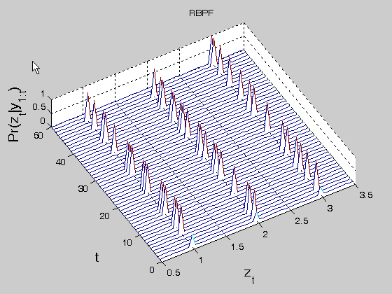
Figure8. Probability Distribution (RBPF algorithm), 3 discrete modes

[7] J Gertler. Fault detection and diagnosis in engineering systems. Marcel dekker, Inc., 1998.
[8] G Kitagawa. Monte Carlo filter and smoother for non-Gaussian nonlinear state space models. Journal of Computational and Graphical Statistics, 5: 1-25, 1996.
[9] R M Menendez. Real-time monitoring and diagnosis in dynamic systems using particle filtering methods. PHD Thesis in Intelligent systems, Monterry Institute, Mexico, 2003.

