Forecasting Daily Maximum Temperature Using
New Neuro-Fuzzy Network With Variable Structure

Saeid Soheily Khah Dr. Mohammad TeshnehLab
Dept. of Computer Engineering Dept. of Electrical Enginnering
Islamic Azad University Khajeh Nasir Toosi University
Iran - Tehran Iran - Tehran

Abstract : Nowadays, the usage of intelligent methods in predicting some quantities may be used as a powerful instrument for improvement of prediction models. In this paper, the objective has been the designing of a neuro-fuzzy network with a dynamic structure and effort has been made on the basis of the number of input-output data pairs, to train the system via a rather improved method. In this direction, first at all, using the previously mentioned parameters, we define the fuzzy collection in such a manner to cover the input-output pairs. Then we setup the fuzzy regulations base and the fuzzy system and finally, through considering the threshold amount for the y in the conclusion section of the neuro-fuzzy network, we train the system.

Key words : Fuzzy System, Neural Network, Neuro-fuzzy network, Back Propagation, Forecasting.

1 Introduction
Forecast is very important in complex systems to assure validity and economical operation. Specially, the initial operation to generate timing for tomorrow, to forecast daily maximum temperature. Using suitable methods to forecast, it's desired to forecast with high accuracy and to illustrate the results of meteorology in important terms. One of those prediction is using fuzzy systems[1].
Fuzzy system are general approximately, that could to approximate each function in closed set. In spite, it shows just optimization fuzzy system, but do not show the method to find it. In fact finding optimization fuzzy system is much more difficult that prove existence of it, and even depend on available information that we could not find optimization fuzzy system. These systems are based on rules and knowledge.
The heart of fuzzy system is database that consist from If-Then fuzzy rules and the If-Then rules, it means If-Then expression that some word of them are defined by continues membership functions[1]. At least, beginning point of generating fuzzy system, to obtain the sets of If-Then fuzzy rules from special region knowledge or expert people knowledge. In other step, we combine the rules in unique system.
Different fuzzy systems used different methods to combine the rules. So these systems are used to formularize human knowledge. Now, the important problem is to generate fuzzy system with pair of input-output. Because of, in many cases, we couldn't choose desired output for each input. So, the main aim to design neuro-fuzzy network to show behavior of input-output data. The different neuro-fuzzy network are proposed for this important, but the time of training network is much more important because of complexity in neuro-fuzzy network structure and also the numerous of connection weight parameters in network structure.
In this paper, we investigate about the threshold value for connection weight parameters ( y ^{l}) in conclusion part of networks and to reduce inference weight in output calculations.

2 Neuro -Fuzzy Network
For discussing about neuro-fuzzy networks, first we focus on fuzzy networks and then to combine these subject, to investigate and research. Fuzzy networks or systems are used by complete defined to nonlinear mapping input to output logical systems[1-2]. Also, fuzzy control is special nonlinear control that to define completely. These kind of networks are applied for systems that are not could be defined and explained exactly. In spite, it does not mean to unclear or unknown basic and theory of fuzzy system and fundamentally.
How ever, fuzzy systems illustrate uncertainly and unknown phenomena, but they are exact rules. Fuzzy systems are based onset of rules that could to deduct using experiments of scientist and human knowledge in each case. Now a day, fuzzy systems are used in many cases[2]. The special important parameter for these networks is tha , they do not require to mathematical model or formula to design. So, they are very useful to design systems that do not require to mathematical models. So, we need to assume to formularize human knowledge to systematic form and to accompany with engineering systems.
In other words, the basic question is how we can change human knowledge to mathematic formula. As the whole, fuzzy system process this alternation. In figure(1), we show the fully structure of neuro-fuzzy network.
It's designed with multi-input, single-output structure. The number of inputs or outputs are depend on the kind of task and it selected by designer. As show in figure(1), W_{s} and W_{d} are values of connection weights for inputs in antecedent part, W_{c} is connection weight for bias value also in antecedent part and y ^{l} is connection weight for outputs in conclusion part, that systems are able to do what we desire.

Antecedent-part Conclusion-part

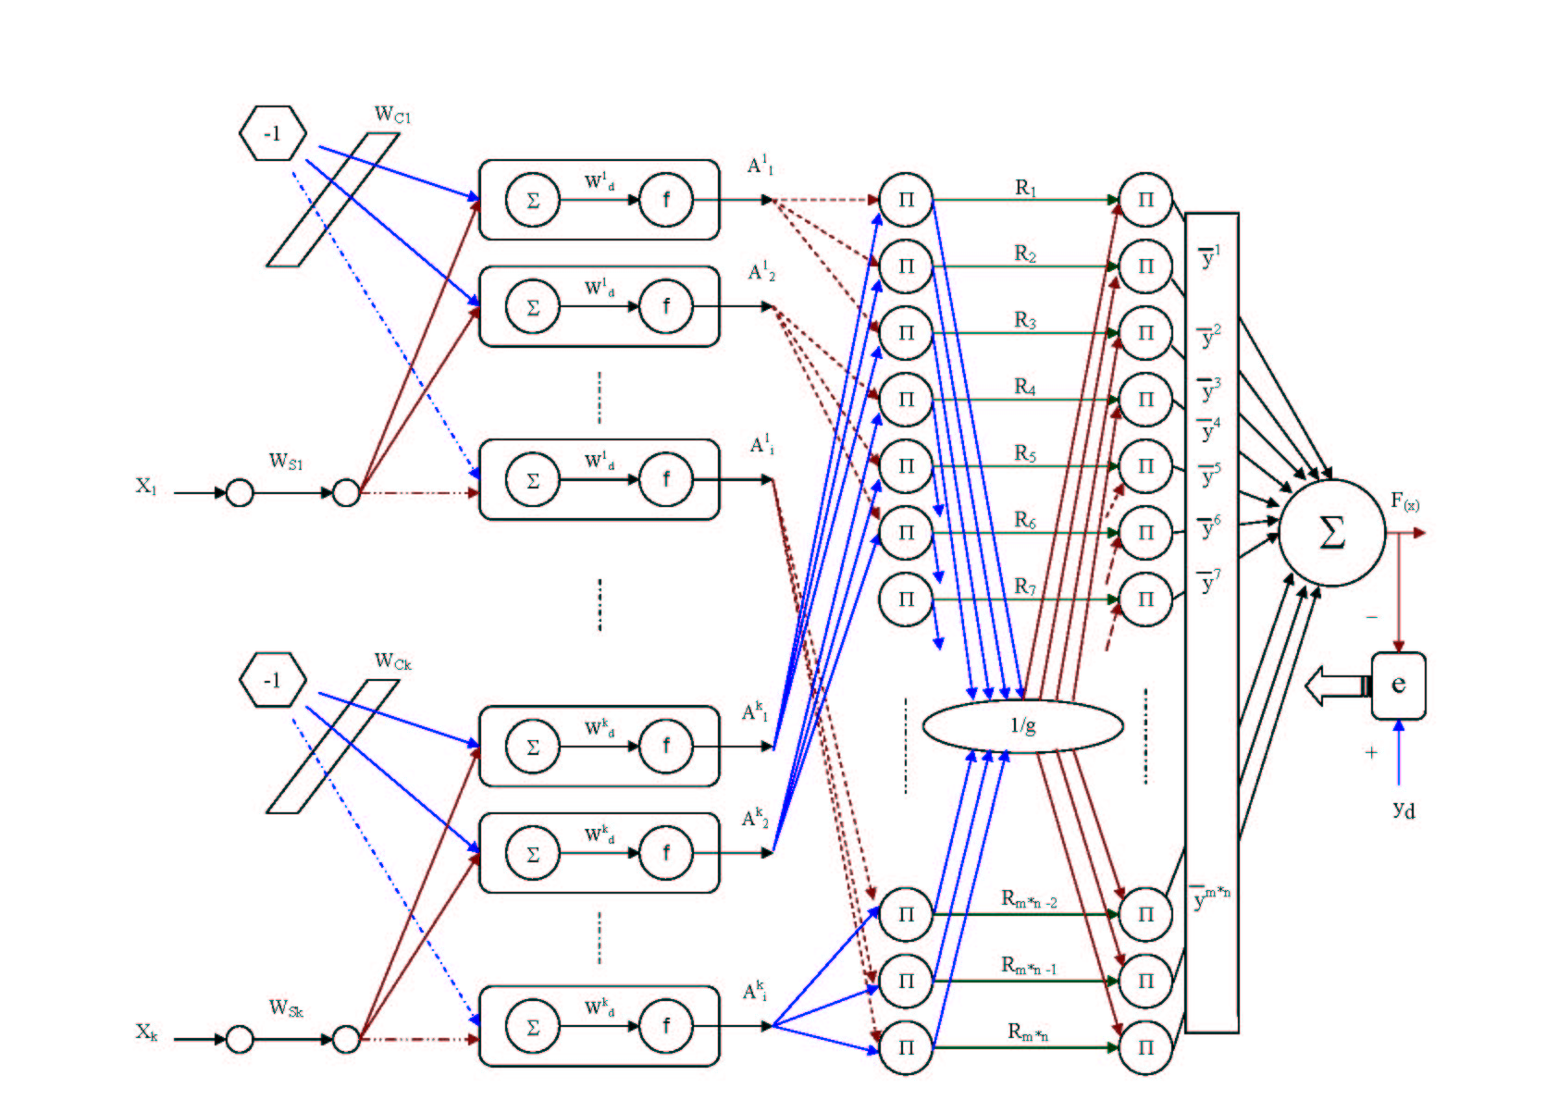
Fig. 1 : The fully structure of a mamdani neuro-fuzzy network .

3 Design Neuro-Fuzzy Networks
Now, it's a question that how to design and select mentioned parameters in previous section. The answer of this question is that using experiment's system designer or master people in this case, determined value and network structure. It's clear that, we may find more exact output by changing initial values in parameters, membership function, the kind of function and how to train.
How ever, if we can change fuzzy system that is possible to update above value, where as, the system has ability to optimize. In this case, we could find more accuracy in output of networks. To reach this important, it's possible to feedback value from the end through to first and it's possible through neural structure[3][6-7]. So, to generate fuzzy rules with neural network, we reach our ideal case.
For example, we could update connection weight in conclusion part with following rules
using gradient method:

E = ½ (y_{d} – f(x))²

E = y_{d} – f(x)

Δy^{l}_{i} = - τ ∂ E / ∂ y^{l}_{i}
= - τ [ ∂ E/∂ f(x) . ∂ f(x) / ∂ u_{p} . ∂ u_{p} / ∂ y^{l}_{i} ]
= - τ [ -e . 1 . p_{i} ]

−> Δy^{l}_{i} = τ .e. p_{i} (i=1,2,…,n ) (1)

Where u_{p} is the same network in neural network, p_{i} is output from one before last of hidden layer and n is the number of neuron in that layer and 0<τ≤ 1 is learning rate. So in general, updating rules for y ^{l} is :

y^{l}_{(new)} = y^{l}_{(old)} + Δ y^{l}

4 The Designing Proposed Neuro-Fuzzy Network
To designing neuro-fuzzy network, first fuzzy system structure is determined corresponding by (2) equation, parameters and variables depend on guassian function[1]. In the next step, the back propagation network is generated to product this fuzzy system that can train parameters and variables according following equation.

m
Σ y^{l} {Π_{i=1}^{n} exp[-((x_{i}-x^{l})/σ_{i}^{l})²]}
l=1
F(x)= (2)
m
Σ {Π_{i=1}^{n} exp[-((x_{i}-x^{l})/σ_{i}^{l})²]}
l=1

Where m is the number of rules, y ^{l} , x ^{l}, σ_{i}^{l} are various parameters in conclusion and antecedent parts.
How ever, in this step, neuro-fuzzy structure is selected, corresponding to above equation, but neuro-fuzzy network has not designed yet. Because of the mentioned parameters has not determined yet and in other words, the other design of neuro-fuzzy network is equal to set y ^{l} , x ^{l} and σ_{i}^{l} parameters. The inputs in combined neuro-fuzzy network, could transfer through layers that these layers are consisted of fuzzy fire, conclusion engine, de fuzzy fire that are shown in figure(2).
Fuzzifire
Conclusion engine
Defuzzifire
Input Output

Fuzzifire layer Conclusion layer Defuzzifire layer

Fig. 2 : General view of a neuro-fuzzy network.

Frist, input x is transferred from multiple guassian operator and according to (3) is changed in to z^{l}. After that, z^{l} is transferred from multiple operator with diagonal y ^{l} and outputs are transferred by deduction layer and the end output, f(x) is calculated according to (4). The problem that is basically changed to design fuzzy systems, is to reduce one hidden layer for y ^{l} and use y ^{l} instead of diagonal in problem that it can reduce efficiency of network.

n
z^{l} = Π exp[-((x_{i}-x ^{l})/σ_{i}^{l})²] (3)
i=1

m
b = Σ z^{l}
^{l=1}
m
a = Σ y ^{l}_{(q)} z^{l} (4)
l=1

f = a / b

Where the F is output of fuzzy system.

5 Trained Algorithm Proposed Neuro-Fuzzy Network
As mentioned before, the task of this network originally is to optimize y ^{l} , x ^{l} and σ_{i}^{l} parameters. where as e^{p} which network error is minimized. The network comparison error is calculated by following:

e ^{p} = ½ ( f(x ^{p}₀) – y ^{p}₀ )² = ½ ( y_{d} – f(x))²

To train average parameters output fuzzy center sets, we use back propagation method, that ultimate result is noticed in (5) [1][5-8]:
y ^{l}_{(q+1)} = y ^{l}_{(q)} – τ z^{l} (f-y)/b (5)

Now, to pay attention a threshold value for y ^{l}, we process to remove some y ^{l} that have less effect to calculate system output. In concept, that in each circle of output calculation, y ^{l} that are smaller than threshold, are omitted in calculation. With this task, we simple to generate network structure, reduce amount of calculation and also reduce error measurement respectively. It's which thoughtful in this case that with assuming threshold, the effect of some rules are increased that are most important to calculate output and the less important rules are removed. It's necessary to say that exist or not exist y ^{l} in output calculation in each cycle, depend on obtained value in the same cycle. Now to explain clearly of whole schematic proposed neuro-fuzzy network, we explain performance of simulation .

6 Simulation of Proposed Neuro-Fuzzy Network
In simulation this research, with neuro–fuzzy network, we could use learning ability of neural networks for training membership functions that it cause to increase ability to apply of multi input-output fuzzy systems and the power of training neural network could prove convergence speed in different desired value. The different parameters and climate and continental factors and of course their different effects in distribution of time and local elements for instance temperature, pressure and humidity is cause to different affect in output of networks from rules that gained in pair output-input data. In this paper, we try to remove the rules that are less important to calculate outputs with consider to threshold value by (6). Because, sometimes, it's better to omit variable y∈V, that membership value of them are very small[1-7]. It's clear that consider to threshold value is very important, because, if it's higher that normal value, cause to remove effective rules, and if it's very small, in face, we have done useless.
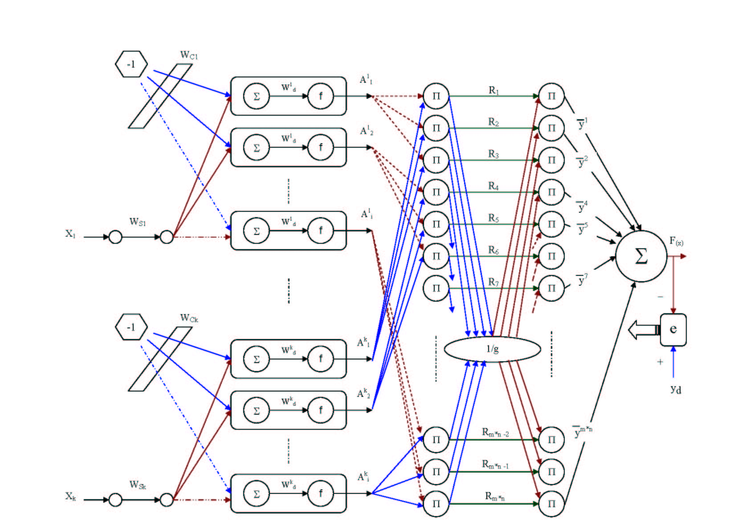
Fig. 3 : Model of proposed neuro-fuzzy netwok .
m
Lim Σ y ^{l} w_{l}
l=1
w_{l}>=α
y* = (6)
m
Lim Σ w_{l}
l=1
w_{l}>=α

Where α is threshold value which is constant. In proposed network simulation above, value of α is equal to 0.1. We show the model of proposed neuro-fuzzy netwok in figure (3).

7 Evaluation and Comparison
As mentioned above, we use pair of input-output meteorology data to test training and predicting proposed neuro-fuzzy networks, where we notice to various input, minimum average temperature, average of relation humidity, average of wind speed, the hours of sun luminosity and the number of clouds in daily maximum output temperature. In table (1) we show, the prediction of proposed network for pair applied input-output data to compare with prediction of common neuro-fuzzy networks.
Table 1 : Comparison of prediction for proposed neuro-fuzzy and common networks .

proposed network  output | common  network  output | desired value | Serial
10.99 | 10.81 | 11 | 1
11.78 | 10.43 | 12 | 2
8.99 | 8.98 | 9 | 3
8.01 | 7.98 | 8 | 4
7.78 | 7.76 | 7.8 | 5
6.95 | 6.84 | 7 | 6
8.69 | 8.66 | 8.7 | 7
6.71 | 6.66 | 6.7 | 8
5.91 | 6. 1 | 6 | 9
7.92 | 7.97 | 7.9 | 10
4.99 | 5.02 | 5 | 11
2.96 | 3.13 | 3 | 12
4.31 | 4.24 | 4.3 | 13
16.95 | 17.99 | 19 | 14
3.98 | 4.04 | 4 | 15
2.26 | 2.47 | 2.3 | 16
5.31 | 5.34 | 5.3 | 17
7.01 | 7.09 | 7 | 18
5.95 | 5.94 | 5.9 | 19
8.21 | 8.23 | 8.2 | 20
7.48 | 7.45 | 7.5 | 21
4.29 | 4.41 | 4.3 | 22
9.81 | 9.75 | 9.8 | 23
12.19 | 12.14 | 12.2 | 24
10.99 | 10.94 | 11 | 25
10.27 | 10.22 | 10.3 | 26
9.13 | 9.24 | 9.1 | 27
3.08 | 3.18 | 3.1 | 28
2.92 | 2.88 | 2.9 | 29
5.71 | 5.75 | 5.7 | 30

Just as observed in table (1), trained output in proposed neuro-fuzzy network, almost is closer to desired output more than trained output in common fuzzy system respectively .

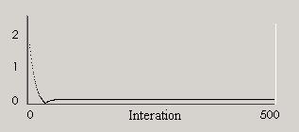Fig. 4 : The decrease square error in training process in common neuro-fuzzy network .

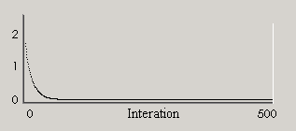Fig. 5: The decrease square error in training process in proposed neuro-fuzzy network .

In figures (4-5) we see the traing process curve of sum square error in mentioned networks to evaluate. From the result the use of threshold value to connection weights output ( y ^{l} ) to eliminate the effective rules in traning process which causes to reduce sum square error measurement.
8. Results and Conclusions
In simulate this research with neuro-fuzzy structure we could use learning ability of neural networks to train membership function, that it cause of application ability multi input-output fuzzy system and ability of training neural network could prove convergence rate in desired different value. Also, in some state that the number of input various and membership functions are increased, one of the best method to implementation fuzzy system, to use neural networks structures with different training that is increased practical application ability of fuzzy systems. To produce more simple neuro – fuzzy structure, it's by removing less important connection to calculate desired output and error. This is the most advantage of proposed algorithm and have positive effect and to use neural network with dynamical structure is powered and to increase prediction accuracy.

Reference:

[1] Wang L. / 1997 / A Cource in fuzzy system and control.
[2] Jang J. , Sun C. and Mizutani E. / 1997 / Neuro-Fuzzy and Soft Computing /Prentice Hall.
[3] Cox, E. / 1994 / The Fuzzy Systems Handbook / Academic Press / MA.
[4] Freeman J. / 1994 / Simulating Neural Networks with mathematics / Addison Wesley.
[5] Le Cun Y. / 1998 / A theoritical framework for Backpropagation.
[6] T. Lizaka, T. Matsui , Y. Fukuyama Member, IEEE , / A Novel Daily Peak Load Forecasting Method using Analyzable structured Neural Network / , IEEE T&D Asia, Yokohama,Oct. 2002.
[7] M. Ishikawa, /Rule extraction by successive regularization/, IEEE Proc.of ICNN, 1996.
[8] D. A. Miller, J. M. Zurada, /A dynamical system perspective /, IEEE Trans,Vol9 , No3, May 1998.

