Fuzzy Attitude Controller for a Spin Stabilized Microsatellite Using Only Magnetic Torquers

Harshitha .I. Singh¹, J. Shanmugam², P. Natarajan³
^{1,2}Department of Electronics Engineering, Madras Institute of Technology, Anna University, Chennai, India.
³ Scientist, Indian Satellite Research Organisations

Abstract: - A new approach using fuzzy controller is presented for attitude orientation and control of a spin stabilized Microsatellite using only magnetometer data and magnetic torquers. The intention of the study is also to find an inexpensive attitude control system with sufficient higher accuracy for a low Earth orbit Microsatellite. It is found that Fuzzy controller can achieve any orientation in effective way when compared with conventional methods such as B-Dot. Here Controller uses magnetic field of earth along spin axis as input to produce the required output moment to actuate torquer along the same to produce desired torque along the transverse axes (X & Y axes) to orient the spin axis in desired pointing direction. The input-domains and output domain are partitioned with membership functions, resulting in 14 fuzzy rules for each rule-base. Simulation results show the ability of the Fuzzy Controller to produce better results with accuracy lesser than 1° in lesser time when compared with conventional methods for any angle orientation control.

Key-Words: - Spin stabilized Microsatellite, Attitude determination through kalman filter, Attitude controller, B-dot, QOMT, Fuzzy Controller.

1 Introduction
A simple low cost means of attitude stabilization of small Microsatellite makes use of spin stabilization and active magnetic torquing. Attitude determination system (ADS) is required in order to the meet pointing requirements. Here Attitude is estimated through Kalman filter using only magnetometer data. The magnetic torquers are used as actuators to meet the desired pointing. The magnetic torquing is an attractive method as a control technique. The actuation principle in this method is to use the interaction between the earth’s magnetic field and the magnetic field generated by the coil set in the satellite. The control principle is inherently non-linear and generates a control torque perpendicular to the geomagnetic field variation.
T = M x B
The B vector is totally dependent on the orbital location. The moment (M) and polarity of moment can only be controlled to produce required torque. And numerous control techniques applied till date are only to produce required polarity moment. For the polar low earth orbit case, the geomagnetic field vector will rotate twice per orbit, almost within the orbital plane. The magnetic field vector components along X, Y, and Z are measured using a onboard triaxial magnetometer.

In this paper, an attempt is made on the rule based fuzzy controller for attitude orientation and control of a spin stabilized satellite in any required direction. The output of this controller is the polarity of moment, which is the only available to control the torque.
The Organization of this paper is as follows, Section 2 - Problem formulation,
Section 3 – Describes attitude determination,
Section 4 - The theory of conventional method B-dot technique.
Section 5 – Fuzzy attitude controller.
Section 6- Simulation Results

2. Problem formulation
The spin stabilized satellite moving in a polar orbit is oriented in any direction using rule based fuzzy controller. The block diagram explains the attitude control system of our spin stabilized Microsatellite. The attitude of the spin axis is determined and is compared with the desired attitude to produce attitude error which drives the fuzzy controller to produce required moment to actuate the spin axis torquer to orient the spin axis in any desired direction.

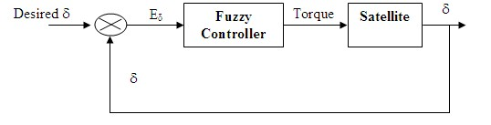
Fig.1:Block diagram of ACS system

The dynamic equations of the satellite can be linearized and uncoupled as

T = M_{i} x B_{i} (1)
(Where ‘I’ can denote any axes X, Y & Z)
For orienting the spin axis (Z) to any required direction, the torquers along spin axis is actuated to produce the following required torques along the axis.

Tx = M_{z} x B_{y} (2)
Ty = M_{z} x Bx (3)
Tz = 0 (4)

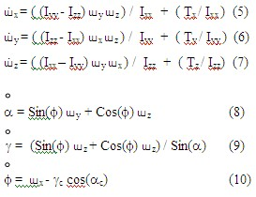
Where
Tx, Ty, Tz - are the torques produced in X, Y, & Z axes.
´_{x,} ´_{y,} ´_{z} - Rate of change of angular rates along X,Y & Z axes for the above torques.
α,γ, φ - Rate of change of alpha, gamma and phi for the change in angular rates.
The main objective of any algorithm is to make optimal use of M_{x}, M_{y}, & M_{z} to generate the desired torque. The control has to be done in minimum time with least amount of control energy – a typical optimal control problem.

3 Attitude Determination through Kalman Filter

Attitude determination and control of satellite is done only after stabilizing the satellite, that’s when it is free from any tumbling. Hence Linear Kalman filter is used.
Why do we need Kalman Filter?
(1)Generates optimal estimate of desired quantities given the set of measurements.
(2) For linear system and white Gaussian errors, Kalman filter is “best” to estimate based on all previous measurements.
(3)Kalman filter is best method to estimate and predicts attitude during failure of getting continuous data from magnetometer.
When the space craft travels in the orbit, position of spacecraft changes and hence earth's magnetic field strength will also change. So the angle between the spin vector & the earth’s magnetic vector will also change with time. Hence at a given  ,  & time the dot product between spin vector & magnetic vector is given as

SP.MAG₁ = cos (11)

Where,
SP (spin vector) = Xi+Yj+Zk.
MAG = B_{XI1}i+B_{YI1}j+B_{ZI1}k
cos= B_{XB1} / Sqrt(B_{XB1}+B_{YB1}+B_{ZB1})

Therefore taking Dot-Product of (11) =>
X .B_{XI1}+Y.B_{YI1}+Z.B_{ZI1} = cos   (12)

B_{XB,} B_{YB,} B_{ZB} : X-axis, Y-axis, Z-axis magnetic field strength in body frame measured in Gamma
B_{XI ,} B_{YI,} B_{ZI} : X-axis, Y-axis, Z-axis magnetic field strength in inertial frame measured in Gamma
Mag :  Magnetic field in inertial frame
: Angle between spin vector and sun vector.

In equation (12) we have three unknowns(X, Y, Z) to solve for, to estimate attitude which becomes state transition model matrix. Hence state model in matrix form is given below .

Equation (12) can be written as

AX = Z (13)

Where
A = [Bx By Bz]
x
X = y
z

Z = cos

From the above equation
Z is the measurement which we can calculate from the measured body field.
X is the state vector, which we have to be estimated &
A is the transition matrix, which relates measurement with state vector.

As we can find the magnetic field strengths of the body continuously through a magnetometer, and also calculate field in earth’s inertial frame, we can get values of A & Z at any instant of time.
Hence
X = A⁻¹ Z

X is a State transition matrix for kalman filter.

Simulation procedure:

- Initially the attitude of the space-craft i.e,   and are assumed and Time‘t’ is assumed as zero.
- Set the initial state estimate to zero
- Initial estimate error co-covariance as 1
- At time ‘t’, Lat, Long, & Altitude of the satellite are procured from the orbit model.
- The body’s magnetic field strength for Lat, Long, & Altitude is found from the IGRF model.
- Time update equations For Kalman Filter: Measurement noise modeled as white Gaussian with peak value ±500 gammas ; Initial estimated error –covariance is taken as identity matrix

- Previous covariance =I* current estimate *transpose(I); where I is identity matrix

- Estimating the gain K :
K=prevcov*transpose(A)/((.005)^2 +(A*prevcov*transpose (A)));

- Updating new estimate (Measurement update)
Current estimate =previous estimate
+K*(B- A*previous estimate));
Where B is a Measured Angle between Spin and Mag Vector from Magnetometer data

- Update estimate error covariance
Current covariance =(I-(K*A))*previous covariance

- Convert estimated state from Cartesian form to Polar form

4 Conventional method
There are number of conventional methods available for spin axis orientation of satellite. The well known and widely used are B-Dot and Quarter Orbit Magnetic control Technique (QOMT).

4.1 B-Dot law:
The B-Dot law uses the negative derivative of the magnetic field to orient the spin axis. Its attitude deviation is corrected using the magnetic torquer mounted along the spin axis. The magnetic dipole moment created by this torquer interacts with the local earth’s magnetic field and produces a torque in the transverse plane to reduce the deviation of the spin axis from the negative orbit normal.

4.2 Negative B-dot control law:
This control law works by setting i^{th} body axis dipole moment M_{i}, according to

Mi = -K dBi/dt {i = x,y, z} (14)

Where
K – Arbitrary Constant.
dBi/dt − Time derivative of the i^{th} body axis component of geomagnetic ield.

dBi/dt is obtained directly by differentiating the output of the body mounted magnetometer as follows

dBi/dt = Bi(t) – Bi(t-Λ

t) / Λ

t {i = x,y, z} (15)
Where Λ

t is sampling period

In this method, it is possible only to orient spin axis of the satellite normal to the orbit, which becomes a constraint, because there may be requirement depending on the solar panel placements, to orient spin axis in the direction or normal to the sun.

4.3 QOMT
In quarter orbit logic, the magnetic torquer along spin axis is turned on after a time delay. Here time delay is to ensure that the resultant torque in the transverse plane lies in required direction for spin axis orientation. After the delay the current is passed through the magnetic torquer for quarter orbit and subsequently the magnetic torquer current polarity is reversed in every quarter orbit. SAOC logic is shown in fig.
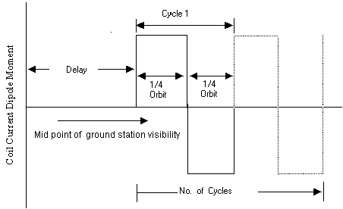

Fig.2: Quarter Orbit Magnetic Control Logic

From the satellite’s attitude ie. Right ascension of ascending node (γ_{c}), delay time calculated
Angular delay (θ_{d}) = π/4 + γ_{c}/2 deg (16)
Time delay = orbit period * θ_{d} / 360 sec (17)

Even though any orientation is possible in this technique, it requires accuracy in calculating Angular delay & Time delay which is again a constraint.

Hence, from the above conventional methods it can be inferred that there is requirement of developing a controller to overcome the constraints of the conventional methods in minimum time.

Fuzzy Controller
Fuzzy controller is one of the extending application fields in space. It does not necessarily need a mathematical model of the plant to be controlled and are therefore especially suited for the simulation where the planet is too complex to model the application.
The intension of the control design is to define a set of control values and implement them in such a way that orientation is done with much lesser time and with accuracy. The proposed block diagram of the fuzzy controlled system is shown in fig above. The input variable for the fuzzy controller are the measured state variable of the satellite and the output is moment polarity for actuation of torquers along the spin axis.

Input Output
X1 – BZ Y1 - moment polarity
Fuzzy controller is SISO system for an attitude control system

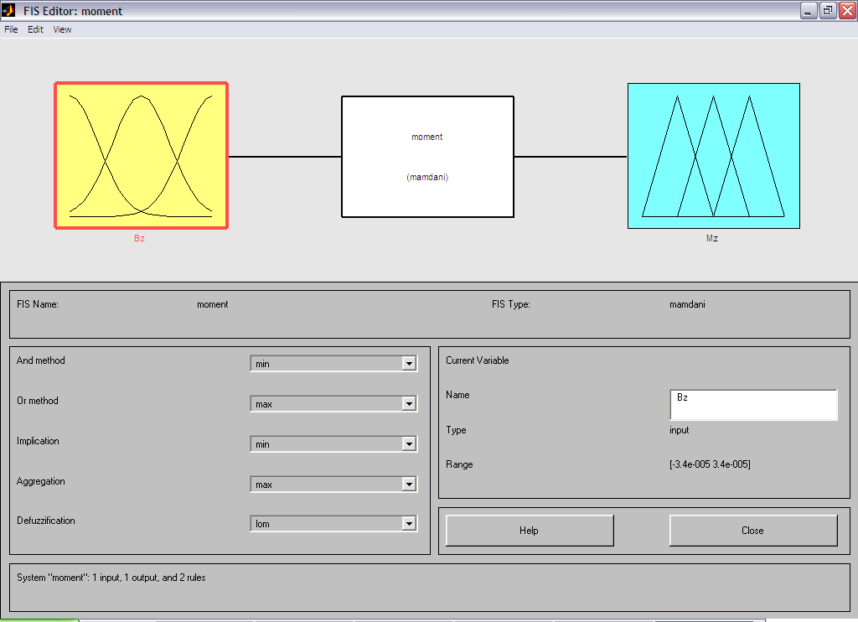

These variables are then mapped into fuzzy sets ( e.g. P for Positive, N for negative ). The Fuzzy set values are obtained from membership function, e.g :
X1 --> M_{N} (X1) (18)

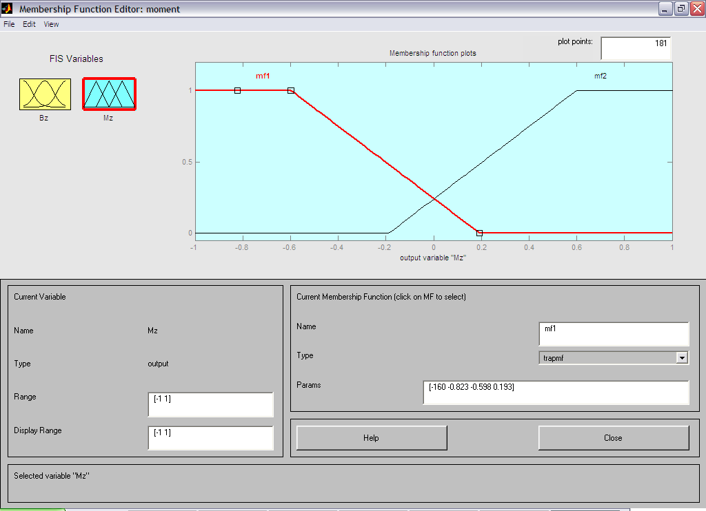

The reason of choosing the functions in this specific format were multiple, foremost it was done to limit the fuzzy sets but still obtain a linear mapping in the normal operating region of the system. The amount of overlap between the different fuzzy sets was optimized through simulation. The variables are mapped into three fuzzy set Positive, Negative and Zero rule. The input-domains and output domain are partitioned with membership functions, resulting in 14 fuzzy rules for each rule-base. Each fuzzy rule was constructed from a simple linguistic rule. Each fuzzy rule maps to crisp output (+1 or 0 or -1). The output variable indicates the desired magneto-torquer polarity. The Mx and My are used to fire the torquers along the transverse axes which orients the spin axis in any said direction.
A set of 14 rules are defined, only a set of 7 rules are shown in the table. As an example, take rule R¹
R¹ : U¹ = If X1 = P then U = -1

If the attitude error is positive and also when magnetic field along X axis is positive the torquer is switched on with negative polarity.
The rule consequent (truth value) is then inferred using correlation product encoding ie., the conjunctive (AND) combination of the antecedent fuzzy sets. For rule 2:
R² : U² = If X1 = N then U = +1

These truth values are then used to scale the binary output to the rule output:
R² : y² = μ² . u
All the rule outputs in the rule base are then combined disjunctively (OR) to obtain the crisp rule base output:
N
y = sgn (∑ y^{i} ). min( 1, ⎜∑ y^{i} ⎜)
i=1 (19)

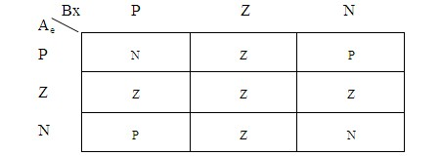
Fig 3:Fuzzy Rules

Here Bx (input) refers to the earth’s magnetic field of along X axis (transverse axis) and Ae (input) is the attitude error and My (output) is the moment polarity to produce the desired torque. The same sets of rules can be written for inputs By earth’s magnetic field of along Y axis (transverse axis) and attitude error to produce output of desired moment polarity.

To summaries the practical computing steps to be performed
- Obtain the magnetometer measurement of the geomagnetic field vector B.
- compute the attitude and attitude error ( from desired attitude)
- Maps the entire fuzzy input variable into their fuzzy set.
- Evaluate the fuzzy rule to get Mx & My to generate required torque.
- Compute attitude and attitude error for the influence made on satellite dynamics due to generated torque.
- Repeat steps 2, 3, &4 till attitude error is zero.
The optimality and performance (control response time) of the controller are therefore solely dependent on the choice of membership function.

5 Simulation results

5.1 Simulation results of Attitude determination through Kalman Filter

5.2 Simulation results of various Attitude controllers are shown for attitude of 45deg

5.2.1 B- Dot control technique

5.2.2 QOMT technique
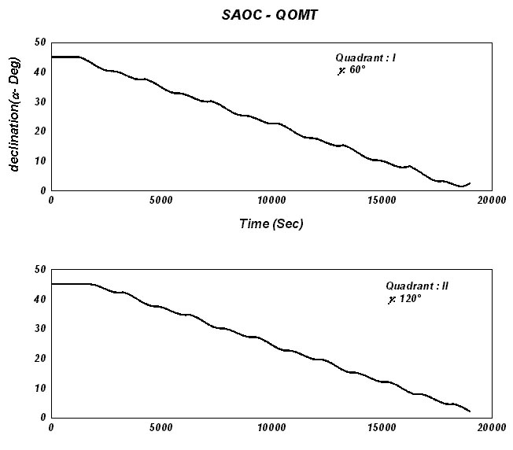

5.2.3 Fuzzy controller technique

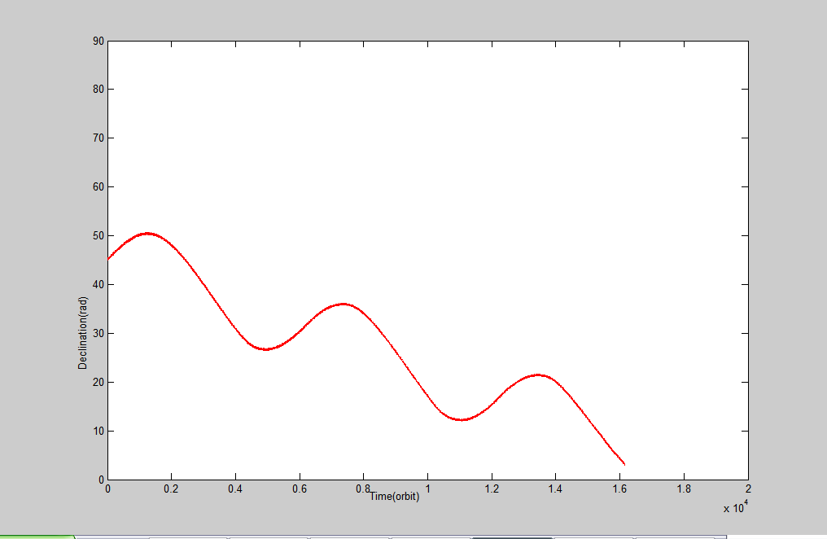

5.2.3Fuzzy Controller for Any Orientation (60°):

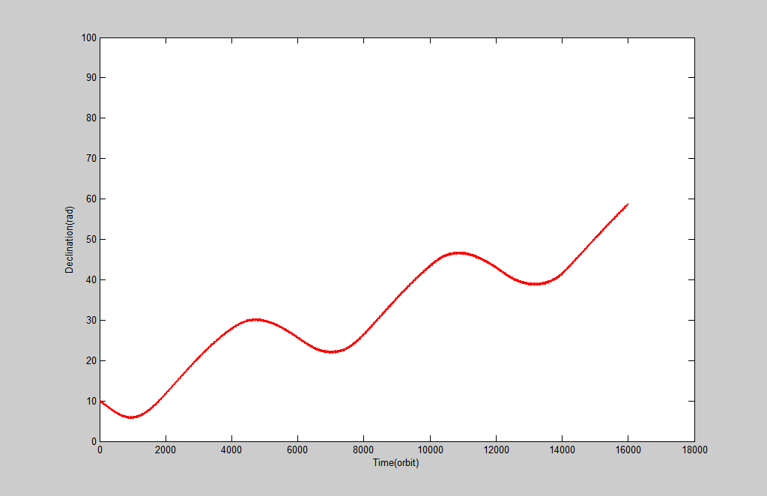

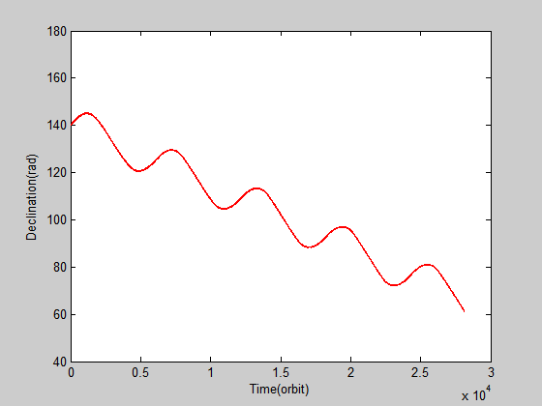

6 Conclusion
A rule based fuzzy controller was presented for an attitude control of spin stabilized satellite problem and investigated. It was also compared with the conventional methods for proving the efficiency of the controller. The Simulation results show the ability of the Fuzzy Controller to produce better results with accuracy lesser than 1° in lesser time when compared with conventional methods for any angle orientation control. It also has overcome the constraints of other methods.

References:
[1] W.H.Steyn, “Fuzzy Control for Non-linear power plant subject to control constraints”,IEEE Transaction on Systems,Man,and Cybernetics,vol24,No.10,oct
1994,65-70.
[2] Paulo Tabuada, “Attitude Control strategies for small satellites”. ISR/IST Torre Norte Posat,
Portugal,Sep 1998.
[3] JanJantzen, Design of Fuzzy Controller Technical University of Denmark, 1997.
[4] Torben Graversen,Attitude Control systems for AAU CubeSat ,AALBORG university,1996.
[5] Herman Steyn,A multimode attitude determination and control systems for SUNSAT,University of Stellenbosch,1994.
[6] Bart Kosko, “Neural Networks and Fuzzy Systems”,Prentice Hall,1992.
[7] J.R.Wertz and Wiley J.Larson: “Space Mission Analysis and Design”,Second Edition,Space
Technology Series,Space Technology
Library,Macrocosm Inc,Kluwer Academic Publishers.
[8] Marcel J.Sidi, “Spacecraft Dynamics and Control; A Practical Engineering Approach”,Cambridge Aerospace Series,1997.
[9] X1. Author, Title of the Paper, International Journal of Science and Technology, Vol.X, No.X, 19XX, pp. XX-XX.
[10] X2. Author, Title of the Book, Publishing House, 19XX

