Solution of Direct and Inverse Problems
for Laplace Type Equations by Gr-Method

ALEXANDRE GREBENNIKOV
Benemérita Universidad Autónoma de Puebla,
Av. San Claudio y Río verde, Ciudad Universitaria, CP 72570, Puebla,
MÉXICO

Abstract: - Laplace type equation with variable coefficient, written in divergent form, is considered. The General Ray (GR) method is applied for solution of direct boundary value problems and coefficient inverse problems for such equations. GR-method uses the explicit formulas with the fast inversion of the Radon transformation. That leads to fast algorithms realised in MATLAB software, whose quality is justified by numerical experiments.
Keywords: –Laplace equation, Boundary value problem, Coefficient inverse problem, Regularization.

1 Introduction
There are two main approaches for solving boundary value problems for partial differential equations in analytical form: Fourier decomposition and the Green function method. The numerical algorithms are based on the Finite Differences method, Finite Elements (Finite Volume) method and the Boundary Integral Equation method. All methods and algorithms constructed on the bases of these approaches have some difficulties in realization for the complex geometrical form of the domain$Ω$. The Green function method is the explicit one [1], but for arbitrary coefficients of equations it is difficult to construct the Green function even for the simple geometry of$Ω$. Numerical approaches lead to solutions of systems of linear algebraic equations [2] that require a lot of computer time and memory. Hence, the development of new fast algorithms for solution of the problems under investigation is very actual.
We consider here a new approach for the solution of direct and inverse problems on the base of the General Ray Principle (GRP), proposed by the author in [3], [4] for the stationary waves field. GRP leads to explicit analytical formulas (GR-method) and fast algorithms for the solution of Dirichlet boundary value problem and also the inverse coefficient problem for the Laplace type differential equation, written in the divergent form. GR-method was proposed firstly in [3] and developed in [4] – [6]. Here we extend the proposed approach to more general type of equations with variable coefficients for the direct boundary value problem. We describe also application of the GR-method to Electrical Tomography.

2 Statement of Direct Boundary Value Problem
Here we consider the Dirichlet boundary value problem for the Laplace type elliptic equations, namely
(1)
with respect to the function $u\left(x,y\right)$ inside the plane domain $Ω$ with a boundary $Γ$. Here $f(x,y)$ is a given function for , $ε\left(x,y\right)>0$. The problem (1) describes the distribution of the “potential” function $u\left(x,y\right)$ for any field of stationary waves, which can be interpreted as electrostatic, elastic or optic field [1], [2].

3 Local Ray Property and General Ray Method
In [3], [4] the General Ray (GR) principle was proposed that gives no traditional formalization of mathematical models for considered physical field and corresponding direct and inverse problems. GR-principle consists in the next main assumptions:
1) the physical field can be simulated mathematically by the superposition of plane vector fields $\vec{V}(l)$, each of them is parallel to the direction along some straight line $l$, at the superposition corresponds to all lines $l$;
2) the field $\vec{V}(l)$ is characterized by some function $u(x,y)$;
3) we know some characteristics such as values of function $u(x,y)$ and/or flow of the vector $\vec{V}(l)$ in any boundary point $P_{0}=\left(x^{0},y^{0}\right)$ of the domain.
Application of the GR Principle to the problems under investigation means to construct an analogue of the equation (1), describing the distribution of the function $u\left(x,y\right)$ along of “General Local Rays", which are presented by some straight line $l$ with parameterization due a parameter $τ$: $x=p\text{cos}ϕ−τ\text{sin}ϕ$, . Here $\left|p\right|$ is a length of the perpendicular from the centre of coordinates to the line $l$, $ϕ∈\left[0,π\right]$ is the angle between the axis x and this perpendicular. Using this parameterization, we shall define functions $u\left(x,y\right)$, $ε\left(x,y\right)$ , $f(x,y)$, at $\left(x,y\right)∈l$ for fixed p, $ϕ$ as functions $u\left(τ\right)$, $ε\left(τ\right)$, $f\left(τ\right)$, of variable $τ$. We suppose that the domain $Ω$ is a convex one. Let us define for every fixed $p$ and $ϕ$ the functions $u_{0}\left(p,ϕ\right)=u(τ_{0}),$ $u_{1}\left(p,ϕ\right)=u(τ_{1}),$ for parameters $τ_{0},τ_{1}$, which correspond to the points of the intersection of the line $l$ and boundary of the domain.
Hence, the GR Principle leads to the assemblage (depending of p,$ϕ$) of ordinary differential equations:
. (2)
Equation (2) for fixed p,$ϕ$ represents the local analog of the equation (1). Boundary conditions lead to the corresponding local boundary conditions for $u\left(τ\right)$ at points $τ_{0},τ_{1}$. We will designate the solution of the local problem (2) with such boundary conditions as $\bar{u}\left(τ\right)$. For standard domains $\bar{Ω}$ such as a circle or rectangular it is simple to calculate $τ_{0},τ_{1}$ and so the functions $u_{0}\left(p,ϕ\right),$ $u_{1}\left(p,ϕ\right),$ using boundary function $f$, and then obtain the solution $\bar{u}\left(τ\right)$ in explicit analytical or approximate form, using well known standard formulas and numerical methods for the solution of boundary value problems for ordinary differential equations.
Formulation of Local Ray property (LRP): the adequate local description of the solution $u$ on any straight line $l$ (Local Ray) can be represented by the function $\bar{u}\left(τ\right)$, so that the following final global formula for the solution of the equation (1) is true
, (3)
where $R^{−1}$ is inverse Radon transform.
Formula (3) gives the explicit solution for a considered class of boundary value problems in arbitrary convex domains $Ω$ with continuous contour$Γ$. Numerical realization of this formula we named the General Ray (GR) method for the direct problems. We will concretise below formula (3) for particular case $Ω$ as the unit circle and demonstrate it validity by numerical examples.
We suppose that the function $u(x,y)$and its first derivatives are localised in$Ω$, i.e., they are equal to zero outside $Ω$. We want to underline that under the assumption made we use the Radon transformation [12] in local imaging modality that implies validity of considerations presented below.

4 Solution of Direct Boundary Value Problem
We introduce the functions
(4)
Then, integrating twice equation (2), we obtain for the solution of the Dirichlet problem the following formula

(5)
For the case $ε\left(x,y\right)=1$ we have the more simple formula

$u\left(x,y\right)=R^{−1}\left[\frac{u_{1}(p,ϕ)+u_{0}(p,ϕ)}{2}(τ_{1}−τ_{0})\right]$.(6)

5 Transformations of Domains with Complicated Geometry to the Unit Circle
In [4] - [6] it was proposed a reduction of the Dirichlet problem for the Laplace equation for an arbitrary simply connected star domain $Ω$ with continuous contour$Γ$ to the same problem on the unit circle. We make some change of variables, using equation for the curve $Γ$, which leads to the same problem with the standard $Γ$ as the unit circle circumference. Let the continuous contour$Γ$ of the plane simply connected star shaped domain $Ω$ be represented as the curve, defined in the polar system of coordinates by equation, where is known function that does not vanish. The mentioned transformation of the domain $Ω$ to the unit circle is the mapping, determined in the new polar coordinates , by the following formula
, (7)
which does not change the Laplace equation.
The mapping (14) does not require solution of any equations, does not include any bulky manipulation with complex variables. Hence, this transformation is realised by very fast algorithm, which is justified in [4], [5], [6] by numerical experiments for sufficiently complicated functions and domains. The possibility to transform the domain with complicated geometry to the unit circle makes it sufficient in this paper to demonstrate the results of numerical experiments for the unit circle.

6 Results of Numerical Experiments for Direct Problems
We have constructed the algorithmic and program realization of GR–method in MATLAB. We used the uniform discretization of variables $p∈[−1, 1],$$ϕ∈[0,π]$, so as for variables x, y , with n nodes. To calculate the inverse Radon transform for discrete data we constructed the original modification [7] of iradon program from MATLAB package. We made testes on mathematically simulated model examples with known exact functions $u\left(x,y\right)$, $ε\left(x,y\right)$, $f(x,y)$.
We present below numerical experiments, which demonstrate the quality of the GR-method, for the case of the unit circle, because the case of more complicated domains $Ω$can be reduced to it. It is sufficiently to choose parameters $τ_{0},τ_{1}$ for the unit circle circumference by formulas$τ_{0,1}=∓(1−p^{2})^{1/2}$, and then calculate the functions $u_{i}\left(p,ϕ\right)=f(x^{i},y^{i}),$, .
Some results for solution the boundary value problem (1) in the unite circle for ,$ε\left(x,y\right)=1\text{/cos}(x+y)$ are presented in Fig. 1, for , - in Fig. 2, for , - in Fig. 3.

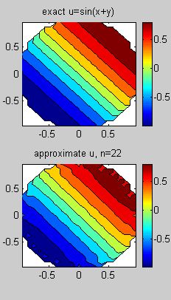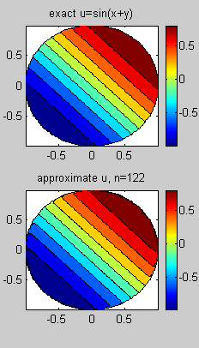

Fig. 1.

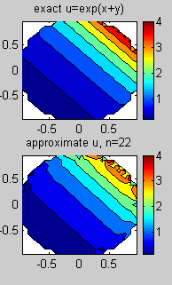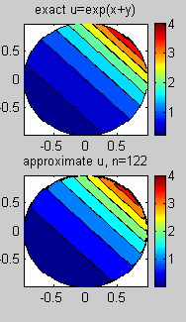

Fig. 2.

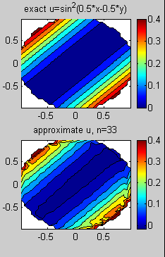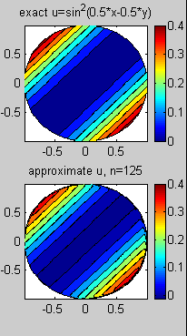

Fig. 3.
7 Statement of Coefficient Inverse Problem for the Laplace Type Equation
Let us consider a coefficient inverse problem for the Laplace type equation (1) with respect to the function , with functions$J_{n}\left(x,y\right)$, $u^{0}\left(x,y\right)$, given on the curve $Γ$ and the following boundary conditions satisfied:
, $\left(x,y\right)∈Γ$ (8)
$u\left(x,y\right)=u^{0}\left(x,y\right)$, $\left(x,y\right)∈Γ$ (9)
Here $\frac{∂}{∂n}$ is the normal derivative at the points of the boundary curve $Γ$. Traditional approach for solving this inverse problem leads to a nonlinear ill-posed problem [13], [15].
We propose here another approach and statement that use GR–principle, i.e. we consider the field described by potential function $u\left(x,y\right)$ as the stream flow of “general rays". Let us describe one example to demonstrate reasons in favour of applicability of the GR–principle. For simplicity we put below $Ω$ as the unit circle. In Fig. 4 we present the corresponding model structure, which consists of two concentric circles: unit circle $Ω$ as the homogeneous background with and one non-homogeneous element $Ω_{1}$ as the circle of radius r <1. Really, as it is analytically proved in [14] for the case of the electric field and is shown on the left part of Fig. 4, the field has a small perturbation in the neighbourhood of $Ω_{1}$, caused by this non-homogeneity. Let us change the region $Ω_{1}$ by $n$ rectangles with the long boards parallel to the line $l$ and with short ones intersecting the internal circumference, as it is shown in the right part of Fig. 4.

.
Fig. 4. Interpretation of the domain approximated by rectangles in justification of applicability of GR-principle.

Suppose that the values of the potential and induction at the points of this approximate boundary are equal to the values of the potential and induction of the external field. That is, we neglect the small perturbation of the external field in the neighbourhood of $Ω_{1}$, caused by this non-homogeneity. So, as it demonstrated in the right part of Fig. 4, even in the neighbourhood of $Ω_{1}$, we can consider the lines of the electric field as straight lines.
The GR–principle gives us equation (2). We consider also the following boundary conditions

(10)

, (11)
for given functions $v(p,ϕ)$ and $J(p,ϕ)$. Equations (2), (10), (11) constitute the basic mathematical model for the inverse problem of reconstructing the coefficient .
Supposing that different components in the considered structure have the smooth distribution, such that the functions and are continuous, and integrating twice equation (2) with respect to we obtain for the following formula
(12)

where $R^{−1}$ is the inverse Radon transform operator. Formula (12) represents the Scanning General Ray method for the inverse problem. This formula can be generalised and applied also for structures with piecewise constant characteristics.
We have constructed the numerical realization of formula (12) that we call "scanning GR–algorithm". This algorithm does not require solving any equation, because the Radon transform can be inversed by fast algorithm using discrete FFT algorithm, which are realised in MATLAB.
Analysis of formulas for inverse Radon transformation shows that its instability for discrete noised data is equivalent to the instability of the problem of the numerical differentiation of the noised function $\bar{v}(p,ϕ)$ with respect to the variable$p$. The regularization of the inversion of Radon transform was constructed by author on the base of the Recursive Smoothing (RS) by splines [8]. Theoretical and numerical justification of the regularization properties of this type of smoothing is presented in [6], [8] - [11]. If for structures with piecewise constant characteristics the set of the known values is given, then the algorithm includes also the projection of the pre-reconstructed data to the set with respect to the absolute or relative criterion [8].

8 Numerical Experiments for Inverse Problem
We tested scanning GR-algorithm on mathematically simulated model examples. Presented experiments correspond to piecewise constant structure inside the unit circle and the external field such that $J(p,ϕ)≡1$. In these model examples we use the mentioned interpretation of approximate form of the boundaries of internal elements to simulate approximations for functions . We calculate these by solving the Cauchy problem for equation (2) for values of variable outside the internal elements, then we prolong it inside$Ω_{1}$, using traditional boundary conditions of the continuity of the potential and the normal (with respect to the approximate rectangle boundary) component of the induction.
In the first example considering no homogeneous structure has the general characteristic of background , two different internal elements have , . Results of the structure image reconstruction in the first experiment are presented in Fig. 5: graph (a) – exact distribution; graphs (b), (c), (d) – reconstruction the structure image by GR–algorithm for number of discrete points $n=\text{20},$ $\text{40},$ $\text{100}$, correspondently.

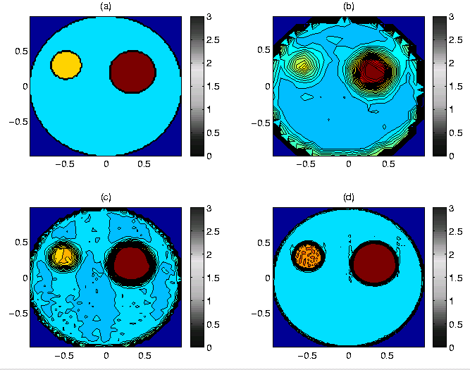
Fig. 5: Reconstruction of three component structure on exact input data by GR-algorithm.

More difficult case for the reconstruction corresponds to the greater scale of values, when the post-processing (projection) is required even for the pre-reconstruction that used exact data. In the second example we use exact values in discrete points for the case , , . In Fig. 6 there are presented reconstructions of the structure image by GR–algorithm: graph (a) – exact distribution; graph (b) – reconstruction without post-processing, graph (c) - reconstruction with the absolute criterion projection; (d) – reconstructions with the relative criterion projection.

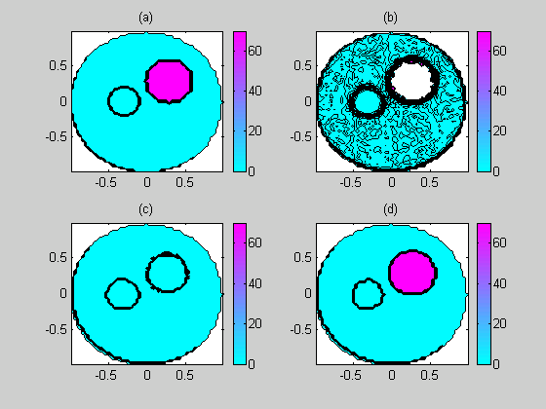

Fig. 6. Reconstruction of three component structure by GR-algorithm for , , .

The third presented numerical experiment corresponds to the reconstruction of the structure, using simulated noised input data, i.e., values of a function $\overline{ν}(p,ϕ)=ν(p,ϕ)(1+δ(p,ϕ)),$where $δ(p,ϕ)$ is the randomized function with estimation: $||δ(p,ϕ)||_{C[Ω]}≤δ$. Results of the regularized reconstruction for n=31, $δ=0\text{.}\text{05}$ are presented in Fig. 7: graph (a) - exact ; graph (b) - reconstruction with noised $\overline{ν}(p,ϕ)$ without regularization; graph (c) - reconstruction with noised $\overline{ν}(p,ϕ)$ with RS only; graph (d) - reconstruction with noised $\overline{ν}(p,ϕ)$ by RS and the absolute criterion projection of pre-reconstructed image.

9 Conclusion and Acknowledgement
The new approach and GR-method for the solution of the direct boundary value problems for the Laplace type differential equations so as for one inverse coefficient problem is proposed. The approximation properties of constructed algorithms are justified by numerical experiments. Developed approach can be applied to more general, including multidimensional, problems. Author acknowledges to VIEP BUAP for the partial support of the investigation in the frame of the Project No II 105-05/EXC/G.

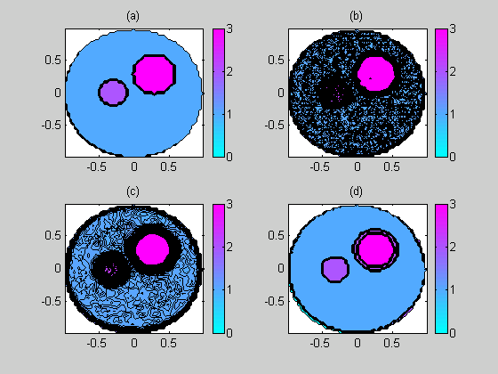

Fig. 7. Reconstruction of three component structure using noised data by regularised GR-algorithm for , , .

References:
[1] S.L. Sobolev, Equations of Mathematical Physics, Moscow, 1966.
[2] A.A. Samarsky, Theory of Difference Schemes, Moscow, 1977.
[3] A. Grebennikov, Fast Algorithm for Solution of Dirichlet Problem for Laplace Equation. WSEAS Transaction on Computers Journal. (2003), Issue 4, Vol. 2, pp. 1039 -1043.
[4] A. Grebennikov, The Study of the Approximation Quality of GR-Method for Solution of Dirichlet Problem for Laplace Equation. WSEAS Transaction on Mathematics Journal. (2003), Issue 4, Vol. 2, pp. 312 -317.
[5] A. Grebennikov, Transformation of Arbitrary simply Connected Star Domain to Unit Circle and Applications for Solution of Boundary Problems for Laplace Equation. WSEAS Transaction on Communications Journal. (2004), Issue 2, Vol. 3, pp. 794-796.
[6] A. I. Grebennikov. Spline Approximation Method and Its Applications. MAX Press, Russia, 2004.
[7] A.I. Grebennikov and R. Rosales Flores, Algorithms and MATLAB Software for the Scaled Direct and Inverse Radon Transform, Proceedings of the 5 International Conference “Computing Modelling 2004”, NESTOR Press, S.- Petersburg, 2004, V. 1, pp. 128- 131.
[8] A. Grebennikov, Regularization algorithms for electric tomography images reconstruction. WSEAS Transaction on Systems Journal. (2003), Issue 2, Vol. 2, pp. 487 -492.
[9] A. I. Grebennikov, Spline approximation method for solving some incorrectly posed problems. Doclady Akad. Nauk SSSR (1988) 298(3), 533-537.
[10] A. I. Grebennikov, Spline approximation method for restoring functions. Sov. J. Numer. Anal. Mathem. Modelling (1989) 4(4), 1-15.
[11] V.A. Morozov and A. I. Grebennikov, Methods for Solution of Ill-Posed Problems: Algorithmic Aspects, Moscow University Press, Moscow, 1992 (English edition in 2005).
[12] J. Radon, Uber Die Bestimmung von Funktionen Durch Ihre Integrawerte Langs Gewisser Mannigfaltigkeiten. Berichte Sachsische Academic der Wissenschaften, Leipzig, Math.-Phys. (1917), KI. N 69, pp. 262-267.
[13] V. Isakov, Inverse Problems for Partial differential Equations, Springer, New York, 1998.
[14] H. N. Murin and K. B. Morton, Electricity and Magnetism, John Wiley&Sons, N.Y., 1985.
[15] R.A. Williams and M.S. Beck, Process Tomography: Principles, Techniques and Applications, Butterworth-Heinemann, Oxford, 1995.

