Particle Filters for Real-Time Fault Diagnosis in Hybrid Systems

H.Bolandi S.Bahmanpour
Iran University of Science & Technology Iran University of Science & Technology

Abstract-Embedded systems are composed of a large number of components that interact with the physical world via a set of sensors and actuators, have their own computational capabilities, and communicate with each other via a wired or wireless network. Diagnostic systems for such applications must address new challenges caused by the distribution of resources, the networking environment, and the tight coupling between the computational and physical worlds. Our approach is to move from centralized, discrete or continuous techniques toward a distributed, hybrid diagnosis architecture. Monitoring and diagnosis of any dynamical system depend crucially on the ability to estimate the system state given the observations. Estimation for hybrid systems is particularly challenging because it requires keeping track of multiple models and the transitions between them. This paper presents a particle filtering based estimation algorithm that addresses the challenge of the interaction between continuous and discrete dynamics in hybrid systems.
Keywords- State estimation, Fault diagnosis, Hybrid systems, Particle filtering, JMLG model.

1 Introduction
Our diagnostic research is motivated by existing and emerging applications of embedded systems. In such systems the physical plant is composed of a large number of distributed nodes, each of which performs a moderate amount of computation, collaborates with other nodes via a wired or wireless network, and is embedded in the physical word via a set of sensors and actuators. Such systems can be best represented by hybrid models and present a number of interesting new challenges for diagnostic systems.
The diagnosis problem is to determine the current state of a system given a stream of observations of that system. In traditional model-based diagnosis systems such as livingstione [1], diagnosis is performed by maintaining a set of candidate hypotheses about the current state of the system, and using the model to predict the expected future state of the system given each candidate. The predicted states are then compared with the observations of what actually occurred. If the observations are consistent with a particular state that is predicted, that state is kept as a candidate hypothesis. If they are inconsistent, the candidate is discarded. Traditional diagnosis systems typically use a logic-based representation, and use monitors to translate continuous-valued sensor readings into discrete-valued variables. The system can then reason about the discrete variables, and compare them with the predictions of model using constraint propagation techniques.
In the hybrid model, the task is to determine the best action to perform given the current estimate of actual state of the system. This estimate, referred to as the belief state, is exactly what we would like to determine in the diagnosis problem, and the problem of keeping the belief state update is well understood in the decision theory literature. The belief state is a probability distribution over the system states- that is, for every state it gives the probability of being in that state, given our prior beliefs about the state of the system, and the sequences of observations and actions that have occurred so far.
Unfortunately, maintaining an exact belief state is computationally intractable for the types of problem we are interested in. since our model contains both discrete and continuous variables, the belief state is a set of multidimensional probability distributions over the continuous state variables, with one such distribution for each mode of the system. These distributions may not even be unimodal, so just representing the belief state is a complex problem, but updating it when new observations are made is intractable for hybrid models in all but the simplest model of models. Therefore, an approximation needs to be made. As we said above, we will use a particle filter to approximate the belief state and keep it update.
A particle filter represents a probability distribution using a set of discrete samples, referred to as particles, each of which has an associated weight. The set of weighted particles constitutes an approximation to the belief state, and has the advantage over other approaches such as kalman filters [2] that it can represent arbitrary distributions. to update the distribution when a new observation is made, we treat each particle as a hypothesis about the state of the system, apply the model to it to move it to a new state, and multiply the weight of the particle by the likelihood of making the observation in that new state. To prevent a small number of particles from dominating the probability distribution, the particles are then resample, with new set of particles, each of weight one, being constructed by selecting samples randomly based on their weight from old set.
Particle filters have already proven very successful for a number of tasks, including visual tracking [3] and robot navigation [4]. Unfortunately, they are less well suited to diagnosis tasks. This is because the mode transitions to fault states typically have very low probability of actually occurring. Thus, there is a risk that there will be no particle in a fault state when a fault occurs, and the system will be unable to diagnose the fault. An important thing to note is that standard particle filters treat the model essentially as a black box, using it only to predict future states of the system. We have described one approach which exploits some of the analytical structure of the model.
In the next section we discuss the hybrid model we use to test particle filtering algorithm. In section 3 we describe particle filtering and demonstrate its weaknesses when applied to diagnosis problems, and in section 4 we describe modifications to the standard particle filter in detail. In section 5 we present some preliminary results on experimental data, using a simple version of our proposed approach.

2 Hybrid Models
Many probabilistic time series models come from either Hidden Markov Models (HMMs) or stochastic linear dynamical systems commonly known as State-Space Models (SSMs). Using a single discrete random variable- the hidden state- hidden Markov models can represent the past information of a sequence. The prior probability distribution of this state can be calculated from the previous hidden state a stochastic transition matrix. If we know the state at any time, the past, present and future observations become statistically independent- the Markov independence property.
Similarly, using a real-valued hidden state vector, state-space models can represent past information. Again, conditioned on this state vector, the past, present, and future observations are statistically independent. The dependency between the present state vector and the previous state vector is specified through the dynamic equations of the system and the noise model. A common case occurs when these equations are linear and the noise model is Gaussian; this model is also known as a linear dynamical system or kalman filter model. HMMs and SSMs are well-known models; however, most real and interesting processes cannot be characterized by either purely discrete or purely linear-Gaussian dynamics.
Typical industrial processes, may have multiples discrete modes of behavior, each of which has approximately linear dynamics. We are interested in dynamical systems which are characterized by a combination of discrete and continuous dynamics. Switching state-space models, or Jump Markov Linear Gaussian (JMLG) systems, are a natural generalization of hidden Markov models and state space models in which the dynamics can transition in a discrete manner from one linear operating regime to another. [5]

2.1 State-Space Model (SSM)
A state-space model defines a probability density over a time series of real-valued observation vectors by assuming that the observations were generated from a sequence of hidden state vectors. The hidden state vectors obey the Markov independence property. The joint probability for the sequences of states and observations can be represented as:
$p(x_{1:T},y_{1:T})=p(x_{1})p(y_{1}|x_{1})\prod_{t=2}^{T}{p(x_{t}|x_{t−1})p(y_{t}|x_{t})}$(1)
Figure 1 shows the conditional indecencies specified by equation (1). Figure 1 is a Directed Acyclic Graph (DAG). Each node is conditionally independent of its non-descendents given its parents. Specifically, the variable $y_{t}$ is conditionally independent of all other variables given the state $x_{t}$; and $x_{t}$ is conditionally independent of $x_{1},…,x_{t−2}$ given $x_{t−1}$. Shaded nodes represent observable variables and unshaded nodes represent hidden variables.
The simplest model assumes that the transition and out put functions are linear and time-invariant, and the distributions of t at state and observation variables are multivariate Gaussian. The state transition function is
$x_{t+1}={\text{Ax}}_{t}+{Bω}_{t+1}$ (2)
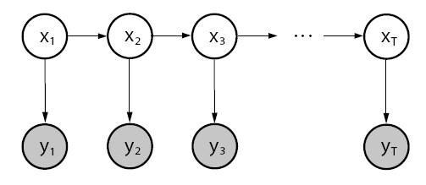
Figure1. state-space graph

Where A is a state transition matrix, B is the noise state matrix, $w_{t}$ is Gaussian, such as, $w_{t}\text{\sim }N(0,I)$ with covariance Q. The initial state is $x_{0}\text{\sim }N(μ_{0},Σ_{0})$. Equation (2) ensures that if $p(x_{t})$ is Gaussian, then $p(x_{t+1})$ is Gaussian too. Often, the observation vector can be divided into input and output variables
$x_{t+1}={\text{Ax}}_{t}+{Bω}_{t+1}+{\text{Fu}}_{t+1}$ (3)
Where $u_{t}$is the input observation and F is the input matrix. Equation (3) models the input-output behavior. The output function is
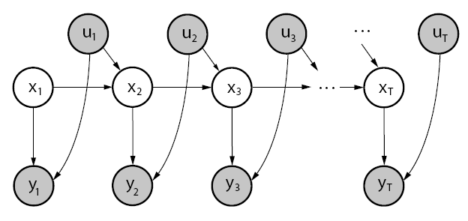
Figure2. Full state-space model.

$y_{t}={\text{Cx}}_{t}+{Dν}_{t}+{\text{Gu}}_{t}$ (4)
Where C is the output matrix, D is the output noise matrix, $v_{t}$ is Gaussian, such as $ν_{t}\text{\sim }N(0,I)$ with covariance R. G is usually a null matrix for most applications. Figure 2 shows a full state-space representation including input variables.
$p(y_{t}|x_{t})$ is also Gaussian, given by equation (5)
$p(y_{t}|x_{t})=(2π)^{−\frac{n_{y}}{2}}|R|^{−\frac{1}{2}}\text{exp}\left[−\frac{1}{2}(y_{t}−{\text{Cx}}_{t}−{\text{Gu}}_{t})^{'}R^{−1}(y_{t}−{\text{Cx}}_{t}−{\text{Gu}}_{t})\right]$(5)
The problem of state estimation or inference for state space models consists of estimating the posterior probabilities of the hidden variables given a sequence of the observed variables. Assuming the local likelihood functions for the observations are Gaussian and the priors for the hidden states are Gaussian, the resulting posterior is also Gaussian. [6]

2.2 Hidden Markov Model (HMM)
Like the state space model, the hidden Markov model defines probability distributions over sequences of observations, $y_{1:t}$. The distribution over sequences is obtained by specifying a distribution over observations at each time step t given a discrete hidden state $z_{t}$ (as opposed to the continuous state in an SSM), together with the probability of transitioning from one hidden state to another. The joint probability for the sequences of states $z_{t}$ and observations $y_{t}$ can be factored as in equation (6)
$p(z_{1:T},y_{1:T})=p(z_{1})p(y_{1}|z_{1})\prod_{t=2}^{T}{p(z_{t}|z_{t−1})p(y_{t}|z_{t})}$(6)
This equation obeys the Markov independence property. Figure 3 shows the conditional independencies specified by equation (6), where $z_{0}\text{\sim }p(z_{0})$. In the HMM framework, the state is represented by a single multinomial variable; this variable can take one of $n_{z}$ discrete values, $z_{t}∈\left\{1,…,n_{z}\right\}$. The state transition probabilities are defined by $p(z_{t}|z_{t−1})$. If the observables are discrete symbols taking one of $n_{y}$ values, the observation probabilities will be represented by $p(y_{t}|z_{t})$. However, for a continuous observation vector, $p(y_{t}|z_{t})$ can be modeled in many different forms, such as Gaussian, a mixture of Gaussian, etc.
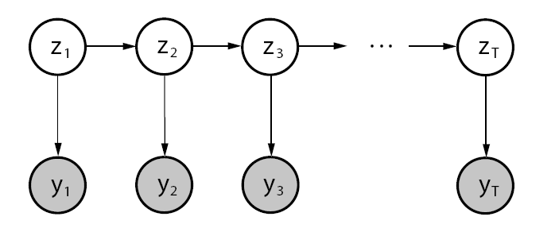
Figure 4. Hidden Markov model graph.

Given sequence of observations, we can use the Baum-Welch algorithm and learn maximum likelihood parameters for an HMM. The Baum-Welch algorithm follows Expectation-Maximization (EM) principles. For the E-step, it uses the forward-backward algorithm to infer the posterior probabilities of the hidden states; for the M-step, it uses expected counts of transitions and observations and observations to re-estimate the transition and output matrices. [7]

2.3 Hybrid Models
A natural way to improve both models is to combine them. Such combinations are known as hybrid models, state-space models with switching, and jump-linear systems. Basically, hybrid models combine the discrete transition structure of hidden Markov models with the linear dynamics of state space models. A lot of work has been done using this idea in different domains.
We will work with the following hybrid model, the jump Markov Linear Gaussian (JMLG) model, figure 5. the dynamic behavior for the simplest case of this model was described by equations (3-4). We will generalize it here:
$z_{t}\text{\sim }p(z_{t}|z_{t−1})$ (7)
$x_{t}=A(z_{t})x_{t−1}+B(z_{t})w_{t}+F(z_{t})u_{t}$ (8)
$y_{t}=C(z_{t})x_{t}+D(z_{t})v_{t}+G(z_{t})u_{t}$ (9)
Where $y_{t}∈R^{n_{y}}$ denotes the measurements, $x_{t}∈R^{n_{x}}$ denotes the unknown continuous states, $u_{t}∈U$ is a known input, and $z_{t}∈\left\{1,…,n_{z}\right\}$ denotes the unknown discrete modes. The noises are Gaussian: $w_{t}\text{\sim }N(0,I)$ and $v_{t}\text{\sim }N(0,I)$. Note that the parameters $(A(i),B(i),C(i),D(i),F(i),G(i))_{i=1}^{n_{z}}$ depend on the discrete mode. For each discrete mode, we have a single linear-Gaussian model. We ensure that $D(i)D(i)^{T}>0$ for any i. the initial states are $x_{0}\text{\sim }N(μ_{0},Σ_{0})$ and $z_{0}\text{\sim }p(z_{0})$.

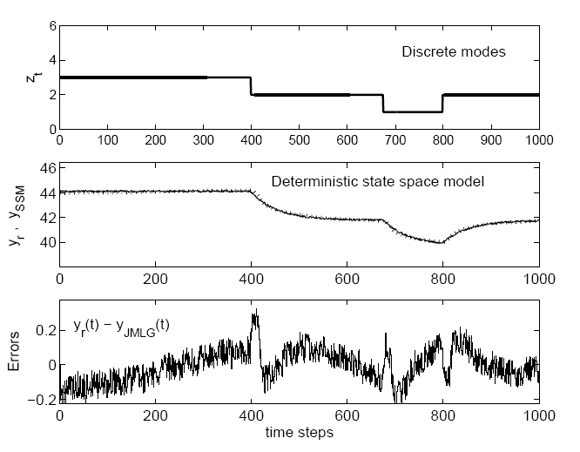
Figure 5. JMLG modeling result.

2.4 Inference Problem
Given a jump Markov linear Gaussian model, a sequence of observations $y_{1:t}$ and control inputs $u_{1:t}$, estimate (on-line) the most likely hybrid state $\left\{z_{t},x_{t}\right\}$ at each time t. essentially, we want to find the discrete modes (Figure 5, upper graph) given the observations (middle graph) over time.
The inference task for any property of the discrete modes and continuous states relies on the joint probability distribution $p(x_{0:t},z_{0:t}|y_{1:t},u_{1:t})$. The aim of the analysis is to compute the marginal posterior distribution of the discrete modes $p(z_{0:t}|y_{1:t})$. This distribution can be derived from the posterior distribution $p(x_{0:t},z_{0:t}|y_{1:t})$ by standard marginalization. The posterior density satisfies the following recursion:
$\begin{aligned}p(x_{0:t},z_{0:t}|y_{1:t})= \\ p(x_{0:t−1},z_{0:t−1}|y_{1:t−1})×\frac{p(y_{t}|x_{t},z_{t})p(x_{t},z_{t}|x_{t−1},z_{t−1})}{p(y_{t}|y_{1:t−1})}\end{aligned}$(10)
This recursion involves intractable integrals in the denominator; for this reason, we must use Particle Filtering techniques.

3 Particle Filtering
In the PF setting, we use a weighted set of samples (particles) ${\left\{\left(x_{0:t}^{(i)},z_{0:t}^{(i)}\right),w_{t}^{(i)}\right\}}_{i=1}^{N}$ to approximate the posterior with the following point-mass distribution
$${\hat{P}}_{N}({\text{dx}}_{0:t},z_{0:t}|y_{1:t})=\sum_{i=1}^{N}{w_{t}^{(i)}δ_{x_{0:t}^{(i)},z_{0:t}^{(i)}}({\text{dx}}_{0:t},z_{0:t})}$$
Where $δ_{x_{0:t}^{(i)},z_{0:t}^{(i)}}({\text{dx}}_{0:t},z_{0:t})$ denotes the Dirac-Delta function. Given N Particles ${\left\{x_{0:t−1}^{(i)},z_{0:t−1}^{(i)}\right\}}_{i=1}^{N}$ at time t-1, approximately distributed according to $P({\text{dx}}_{0:t−1}^{(i)},z_{0:t−1}^{(i)}|y_{1:t−1})$, PF enables us to compute N particles ${\left\{x_{0:t}^{(i)},z_{0:t}^{(i)}\right\}}_{i=1}^{N}$ approximately distributed according to $P({\text{dx}}_{0:t}^{(i)},z_{0:t}^{(i)}|y_{1:t})$, at time t. since we cannot sample from the posterior directly, the PF update is accomplished by introducing an appropriate importance proposal distribution $Q({\text{dx}}_{0:t},z_{0:t})$ from which we can obtain samples. The basic algorithm, Figure 6, consists of two steps: sequential importance sampling and selection. This algorithm uses the transition priors as proposal distributions; for the selection step, we used a state-of-the-art minimum variance resampling algorithm [8].

3.1 Problems with Particle Filters
Unfortunately, there are a number of difficulties in applying particle filters to diagnosis problems. In particular, the filter must have a particle in a particular state before the probability of that state can be evaluated. If a state has no particles in it, its probability of being the true state of the system is zero. This is a particular problem in diagnosis problems because the transition probabilities to fault states are typically very low, so particles are unlikely to end up in fault states during the Monte Carlo prediction step. This situation is known as sample impoverishment.
The simplest solution to the sample improvishment problem is to increase the number of particles being used. Given the constraints imposed on on-board systems, this approach is probably unrealistic. An important thing to note is that standard particle filters treat the model essentially as a black box, using it only to predict future states of the system. We have described one approach which exploits some of the analytical structure of the JMLG model. Basically, if we know the values of the discrete modes $z_{t}$, it is possible to compute the distribution of the continuous states $x_{t}$ exactly. We can therefore combine a particle filter to compute the distribution of the discrete modes with a bank of kalman filters to compute the distribution of the continuous states. That is, we approximate the posterior distribution with a recursive, stochastic mixture of Gaussian. This strategy is known as Rao-Blackwellization because it is related to the Rao-Blackwell formula [9].

4 Rao-Blackwellised Particle Filtering
By considering the factorization $p(x_{0:t},z_{0:t}|y_{1:t})=p(x_{0:t}|y_{1:t},z_{0:t})p(z_{0:t}|y_{1:t})$, it is possible to design more efficient PF algorithms.
The density $p(x_{0:t}|y_{1:t},z_{0:t})$ is Gaussian and can be computed analytically if we know the marginal posterior density $p(z_{0:t}|y_{1:t})$. This density satisfies the alternative recursion : (11)
$$\begin{aligned}p(z_{0:t}|y_{1:t})= \\ p(z_{0:t−1}|y_{1:t−1})\frac{p(y_{t}|y_{1:t−1},z_{0:t})p(z_{t}|z_{t−1})}{p(y_{t}|y_{1:t−1})}\end{aligned}$$
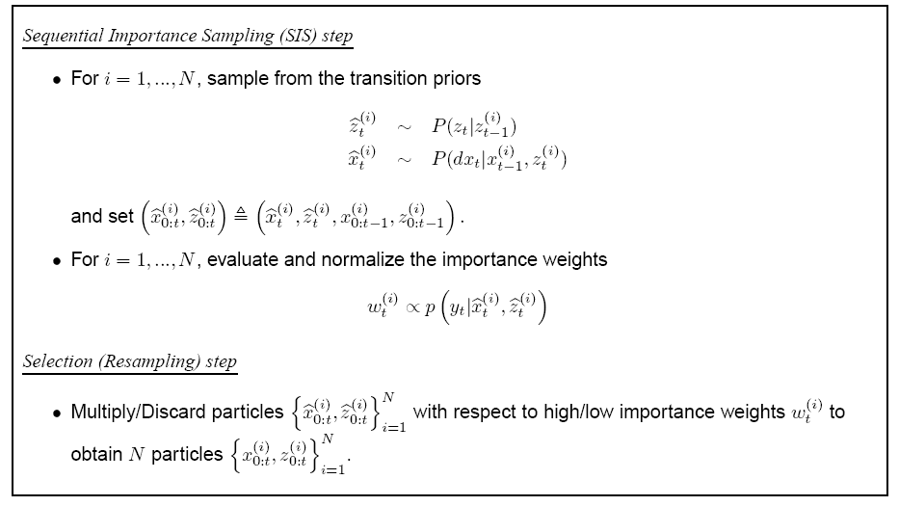
Figure6. Particle Filtering

If equation (10) does not admit a closed-form expression, then equation (11) does not admit one either and sampling-based methods are still required. (Also note that the term $p(y_{t}|y_{1:t−1},z_{0:t})$ in equation (11) does not simplify to $p(y_{t}|z_{t})$ because there is a dependency on past values through $x_{0:t}$.) Now assuming that we can use a weighted set of samples ${\left\{z_{0:t}^{(i)},w_{t}^{(i)}\right\}}_{i=1}^{N}$ to represent the marginal posterior distribution
$${\hat{P}}_{N}(z_{0:t}|y_{1:t})=\sum_{i=1}^{N}{w_{t}^{(i)}δ_{x_{0:t}^{(i)}}(z_{0:t})}$$
The marginal density of $x_{0:t}$ is a Gaussian mixture
$$\begin{aligned}{\hat{P}}_{N}(x_{0:t}|y_{1:t})= \\ \int{p(x_{0:t}|z_{0:t},y_{1:t})\text{dP}(z_{0:t}|y_{1:t})}= \\ \sum_{i=1}^{N}{w_{t}^{(i)}p(x_{0:t}|y_{1:t},z_{0:t}^{(i)})}\end{aligned}$$
That can be computed efficiently with a stochastic bank of kalman filters. That is, we use PF to estimate the distribution of $z_{t}$ and exact computations (kalman filter) to estimate the mean and variance of $z_{t}$. In particular, we sample $z_{t}^{(i)}$ and then propagate the mean $μ_{t}^{(i)}$ and covariance $Σ_{t}^{(i)}$ of $x_{t}$ with a kalman filter:
$$μ_{t|t−1}^{(i)}=A(z_{t}^{(i)})μ_{t−1}^{(i)}+F(z_{t}^{(i)})u_{t}$$
$$Σ_{t|t−1}^{(i)}=A(z_{t}^{(i)})Σ_{t−1}^{(i)}A(z_{t}^{(i)})^{T}+B(z_{t}^{(i)})B(z_{t}^{(i)})^{T}$$
$$S_{t}^{(i)}=C(z_{t}^{(i)})Σ_{t|t−1}^{(i)}C(z_{t}^{(i)})^{T}+D(z_{t}^{(i)})D(z_{t}^{(i)})^{T}$$
$$y_{t|t−1}^{(i)}=C(z_{t}^{(i)})μ_{t|t−1}^{(i)}+G(z_{t}^{(i)})u_{t}$$
$μ_{t}^{(i)}=μ_{t|t−1}^{(i)}+Σ_{t|t−1}^{(i)}C(z_{t}^{(i)})^{T}S_{t}^{−1(i)}(y_{t}−y_{t|t−1}^{(i)})$s
$$Σ_{t}^{(i)}=Σ_{t|t−1}^{(i)}−Σ_{t|t−1}^{(i)}C(z_{t}^{(i)})^{T}S_{t}^{−1(i)}C(z_{t}^{(i)})Σ_{t|t−1}^{(i)}$$
Where $μ_{t|t−1}\overset{Δ}{=}E(x_{t}|y_{1:t−1}),μ_{t}\overset{Δ}{=}E(x_{t}|y_{1:t}),y_{t|t−1}\overset{Δ}{=}E(y_{t}|y_{1:t−1})$$Σ_{t|t−1}\overset{Δ}{=}\text{cov}(x_{t}|y_{1:t−1}),Σ_{t}\overset{Δ}{=}\text{cov}(x_{t}|y_{1:t})$ and $S_{t}\overset{Δ}{=}\text{cov}(y_{t}|y_{1:t−1})$. This is a basis of the RBPF algorithm that was adopted in [4].

5 Results
We tested the 2 inference algorithms for the Jump Markov Linear Gaussian model which described in equations (7-9). We use experimental data.
This simulation, tested for N=100,200,300; T=50; and 3 and 10 discrete modes. The results are shown below.
Figure 7 and 8 plot the tracking error for N=100. In Figure 7 is for 3 discrete mode and Figure 8 shows 10 discrete mode. As you can see when the number of discrete modes grow up the RBPF algorithm show better result to estimate the state of the experimental system.
After that we change the number of particles as tested again for$n_{z}=3,\text{10}$. We do this process to times and the result graphs are shown in Figure 9 and 10. These
Figure7. Experimental simulation (N=100; $n_{z}=3$)

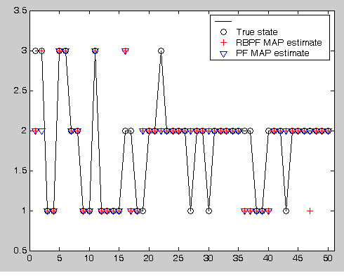
Figure8. Experimental simulation (N=100; $n_{z}=\text{10}$)

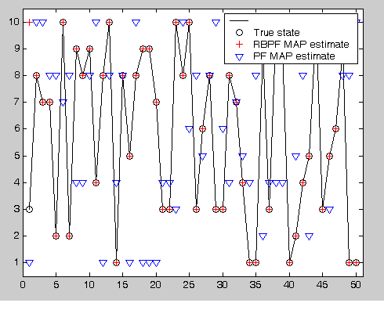

graphs illustrate that increasing in the number of particles will rich the result. But it increase computational time, and in some real-time purposes in could cost for a rapid processor.
The probability distribution of RBPF algorithm for N=100 and N=500 are shown in Figure 11 and 12.

Figure9. Experimental simulation (N=500; $n_{z}=3$)

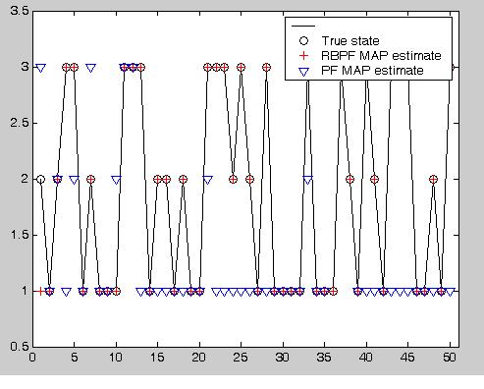
Figure 10. . Experimental simulation (N=500; $n_{z}=\text{10}$)

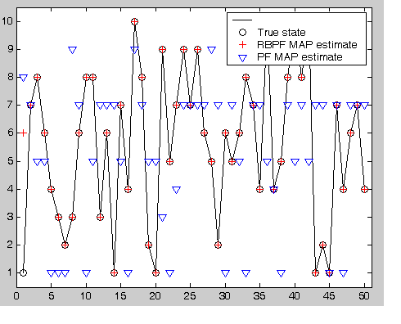
References
[1] Brian C. Williams and P. padndurang Nayak, “A model-based approach to reactive self-configuring systems”, inproceedings of the thirteenth National Conference on Artificial Intelligence and Eight Innovative Applications of Artificial Intelligence conference, pp. 971-978, port-land, oregan, 1996. AAAI Press/ The MIT Press.
[2] M. S. Grewal and A. P. Andrews, kalman filtering: Theory and Practice, Prentice Hall, 1993.
[3] M. Isard and A. Blake, “CONDENSATION: Conditional density propagation for visual tracking”, International Journal Of Computer Vision, 1998.
[4] Dieter Fox, Wolfram Bugard, and Sebastian Thuran, “Markov localization for mobile robots in dynamic environments”, Journal of Artificial Intelligence research, 11, 391-427, 1999.
[5] A Doucet, N Freitas, and N J Gordon, editors. Sequential Monte Carlo Methods in Practice. Springer-Verlag, 2001.
Figure 11. Probability distribution For RBPF algorithm N=100
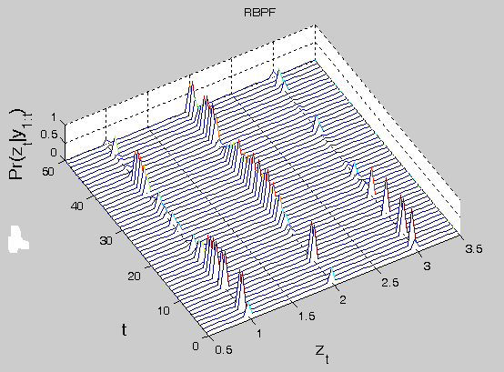

Figure 12. Probability distribution For RBPF algorithm N=500
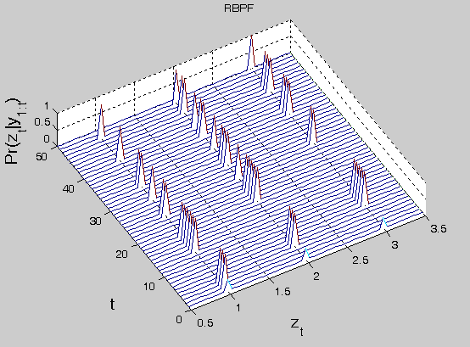

[6] Z Ghahramani and G. E. Hinton. “Variational learning for switching state space model”, Neural Computation, (12) 4: 963-996, 1998
[7] R. J. Elliot , L. Aggoun, and J. B. Moore. “ Hidden Markov Models estimation and control” . Springer-Verlag, New York, 1995.
[8] G Kitagawa. Monte Carlo filter and smoother for non-Gaussian nonlinear state space models. Journal of Computational and Graphical Statistics, 5: 1-25, 1996.
[9] R M Menendez. Real-time monitoring and diagnosis in dynamic systems using particle filtering methods. PHD Thesis in Intelligent systems, Monterry Institute, Mexico, 2003.

