Generalization of the Poisson Integral

ALEXANDRE GREBENNIKOV
Benemérita Universidad Autónoma de Puebla
Av. San Claudio y Río verde, Ciudad Universitaria, CP 72570, Puebla
MÉXICO

Abstract: — There are obtained Generalised formulas for the Poisson integral, which represent the solution of the Dirichlet boundary problem for the Laplace equation in explicit form on arbitrary simply connected star domain $Ω$ on a plane or in the space. Obtained formulas are realised as stable algorithms and fast MATLAB software and justified by numerical experiments.

Keywords: – Domain transformation, Laplace equations, Boundary problems.

1 Introduction
Boundary problems for the Laplace equation appear as the main mathematical models in different areas of applications [1].
One of the main approaches for solving these problems consists in constructing numerical algorithms based on the Finite Differences method, Finite Elements method and the Boundary Integral Equation method. All methods and algorithms constructed on the bases of this approach have some difficulties in realization for the complicated geometrical form of the domain$Ω$. Numerical approach leads to solving systems of linear algebraic equations that require a lot of computer time and memory. Another approach is analytical, based on the Fourier decomposition and the Green function method. The Fourier decomposition is used more for theoretical investigation, because the calculation of the coefficients of the Fourier serious also requires essential numerical expenses.
The Green function method is the explicit one, which permits to construct solution of the boundary problem in explicit form by the Poisson integral. But concrete formulas of Green functions for the domains $Ω$ with the complicated geometry were unknown. Some advantages in construction such formulas were achieved in [2] on the basis of Incompressible Influence Elements method that uses representation for Green’s functions in the form of integrals and also require sufficiently large volume of calculations.
Hence, construction of fast methods and algorithms of solution of mentioned problems for domains with complicated geometrical form is very topical.
In [3] – [7] it was proposed a reduction of the Dirichlet and Neumann problems for the Laplace equation on an arbitrary simply connected star domain $Ω$ on a plane with continue contour$Γ$ to the same problem on the unit circle . This reduction was constructed by a simple - transformation and was used there to obtain explicit formulas for solution of mentioned plane problems by GR-method.
Here we develop the -transformation methodology to construct the generalization of the Poisson integral, as it was announced in [7], for plane and space domains with complicated geometrical form. It leads to explicit formulas and fast algorithms for solution of the Dirichlet problem for the Laplace equation. Results of some numerical experiments with graphics illustrate the validity of the proposed method.

2 The generalization scheme.
We consider the Laplace equation:

(1)

with respect to the function inside the domain $Ω$ with a boundary $Γ$. The Dirichlet problem corresponds to the boundary condition

(2)

for a given function .

The scheme for construction of corresponding generalizations for the Poisson integral consists in the change of variables using - transformation, which present the affine mapping with properties: 1) it does not change the Laplace equation]; 2) it gives possibility to assign the same function on the boundary condition.
These properties can be the base of the possible theoretical justification of the proposing generalized formulas. We will present the detailed deduction and theoretical foundation in some next paper. The purpose of this article is to construct corresponding generalizations and demonstrate its validity by numerical examples.

3 Generalized formulas for the plane case
In the plane case we suppose that simply connected star domain $Ω$ has the has the boundary $Γ$ as a continue contour presented in the polar system of coordinates by equation

, (3)

where is a given function that does not vanish. The - transformation of the domain $Ω$ to the unit circle is the affine mapping, determined in the new polar coordinates , by the next formula

, (4)

without change the variable .
The well known formula of the Poisson integral for the Dirichlet problem on the unit circle is the next one [1]

(5)

The generalized Poisson formula for the plane domain $Ω$ can be written in the form

. (6)

4 Generalized formulas for the space case
In the space case we consider $Ω$ as a simply connected star domain with the boundary $Γ$ as a closed surface. Let x, y, z are Cartesian coordinates, - polar coordinates:

(7)

Let the surface $Γ$ is presented in the polar system of coordinates by equation

, (8)

where is known function that does not vanish. We define - transformation of the domain $Ω$ to the unit sphere as the affine mapping, determined in the new polar coordinates, , by formulas

, (9)

that does not change angle variables.
Formula of the Poisson integral for solution of the Dirichlet problem on the unit spherical solid is the next [1]:

(10)

where is the angle between the radius vector that corresponds to angles , and the unit vector, which corresponds to angles ,. The can be expressed by the formula:

(11)

Using - transformation (9) for formula (10) we obtain the generalized Poisson formula for the space domain $Ω$

(12)

5 Numerical experiments
We have constructed the algorithmic and program realization of the generalized Poisson formula in MATLAB system for considering problem. We used the uniform discretization of Cartesian variables x, y, z, so as polar variables with n nodes. We made testes on mathematically simulated model examples with known exact function . Some numerical examples with corresponding graphics for solution of the Dirichlet boundary problem for the Laplace equation in different sufficiently complex plane domains $Ω$ and for different functions $u\left(x,y\right)$ are presented in Fig. 1 – 6. Proposed method can be extended for any domain, composed of finite number of simple connected star sub domains. Some results obtained by the author for the domain “double cruz” are demonstrated on Fig. 7–10.
In the space case we present examples for the exact solution of the Laplace equation
(13)
and domain $Ω$ painted in Fig. 11 – 12 for different points of view. We calculated the approximate solution on the red with n=12 points for every variable. In Fig. 13 we see isoline maps of the exact solution (the left column of graphics) and of the recuperated by the generalized Poisson formula solution (the right column of graphics) for intersections of the domain $Ω$ by planes parallel to the coordinate plane xOz, which correspond to values of variable y marked bellow the graphics. Analysis of presented (and many other’s calculated by the author) numerical examples confirms the validity and good approximation properties of constructed formulas for the generalised Poisson integral.
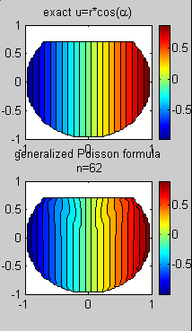
Fig. 1.

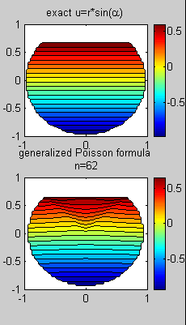

Fig. 2.

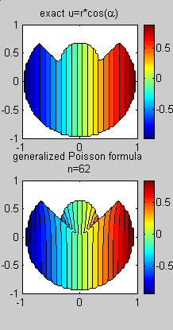

Fig. 3.
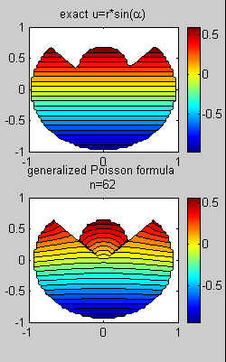

Fig. 4.

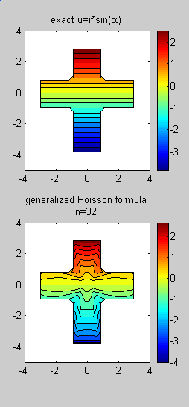

Fig. 5.
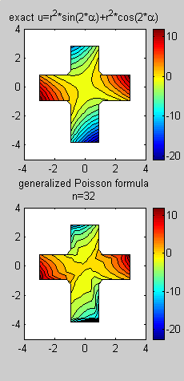

Fig. 6.

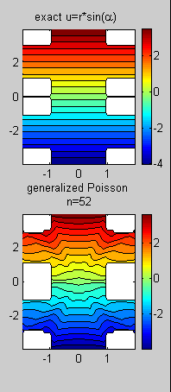

Fig. 7.

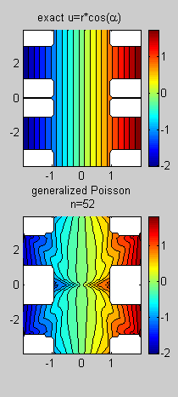

Fig. 8.

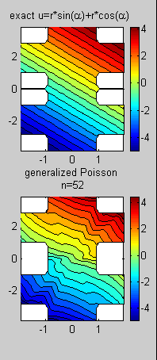

Fig. 9.
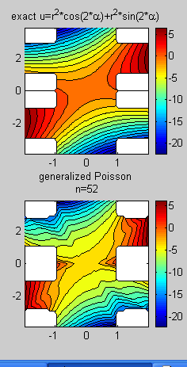

Fig. 10.

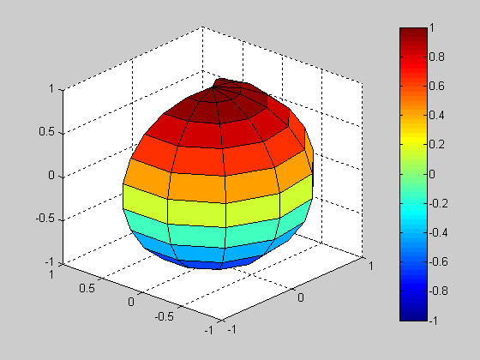

Fig. 11.

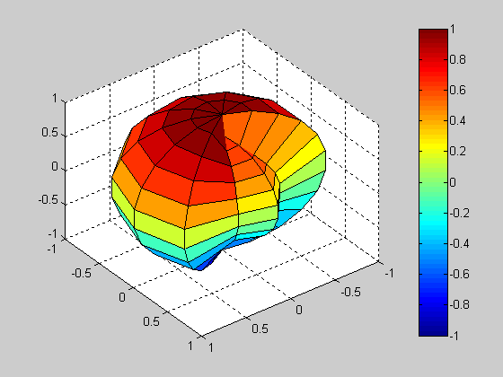

Fig. 12.
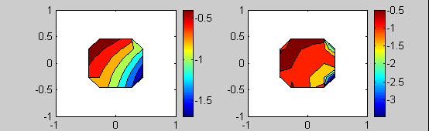
y = -0.8182;
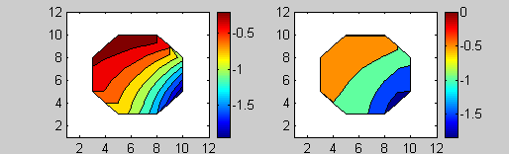
y = -0.6364
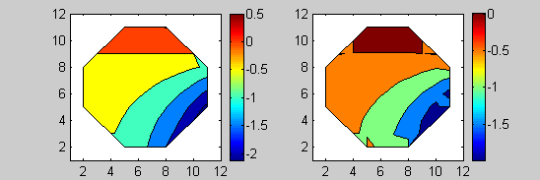
y = - 0.4545
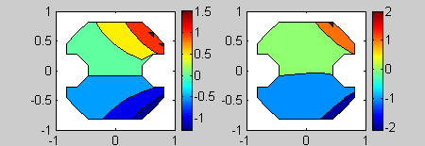
y = 0.0909
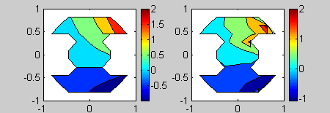
y = 0.2727
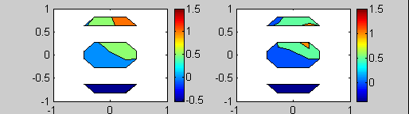
y =0.4545
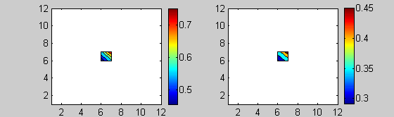
y = 0.6364

Fig. 13.
6 Conclusion and acknowledge
An effective transformation of a simply connected star domain $Ω$ to the unit circle (plane case) or to the unit spherical solid (space case) is proposed. It leads to the generalised formulas for the Poisson integral, which present solution of the Dirichlet problem for the Laplace equation in explicit form. These formulas are realised as fast algorithms and MATLAB software. Good approximation properties of constructed algorithms are justified by numerical experiments. Developed approach can be applied also to boundary problems for partial differential equations of other kinds.
Author acknowledges to VIEP BUAP for the partial support of the investigation in the frame of the Project No II-105G05.

References:
[1] S. L. Sobolev, Equations of Mathematical Physics., Moscow, 1966.

[2] V. D. Seremet, Handbook of Green's Functions and Matrices, WIT PRESS, London, 2002.

[3] A. Grebennikov. Fast Algorithm for Solution of Dirichlet Problem for Laplace Equation. WSEAS TRANSACTION on COMPUTERS Journal, Issue 4, Vol. 2, pp. 1039 -1043 (2003).

[4] A. Grebennikov, The Study of the Approximation Quality of GR-Method for Solution of Dirichlet Problem for Laplace Equation. WSEAS TRANSACTION on MATHEMATICS Journal, Issue 4, Vol. 2, pp. 312 -317 (2003).

[5] Alexandre Grebennikov. Transformation of Arbitrary simply Connected Star Domain to Unit Circle and Applications for Solution of Boundary Problems for Laplace Equation. WSEAS Transaction on Communications Journal, Issue 2, Vol. 3, pp. 794-796, 2004.

[6] A. Grebennikov. A Novel Approach for Solution of Boundary Problems for Differential Equations of Mathematical Physics. WSEAS TRANSACTION on SYSTEMS Journal, Issue 4, Vol. 3, pp. 1410-1415 (2004).

[7] A. I. Grebennikov. Spline Approximation Method and Its Applications. MAX Press, Russia, 2004.

