Simulation of an MPLS network using VHDL

M. MINERO-MUÑOZ, O. E. MORALES-HERNÁNDEZ, A. A. PÉREZ-LOYOLA, K. VÁZQUEZ-MUÑOZ, V. ALARCÓN-AQUINO
Departamento de Ingeniería Electrónica
Universidad de las Américas, Puebla
Ex-Hacienda Santa Catarina Mártir
Cholula, Puebla 72820 MEXICO

Abstract: This paper presents a simulation of an MPLS (MultiProtocol Label Switching) network using VHDL (Very high speed integrated circuits Hardware Description Language). Three MPLS switches are modelled and simulated as follows. The first switch assigns a label to the IP packet header, which will be used by the MPLS switches for its management inside the network. The middle switch changes the label depending on the destination of the packet. The final switch removes the label to the IP packet header and continues its path outside the MPLS network. The MPLS network is simulated using VHDL because of the simplicity and universality of its code. Simulation results show that network switching in MPLS networks may reduce congestion problems in IP networks.

Key-Words: MPLS, VHDL, FPGAs, IP network, switching table, Active HDL.

1. Introduction
Nowadays, there is a dramatic increment of Internet traffic due to the user demands for various service types (e.g. multimedia, VoIP, financial services, security, e-mail). Thus it makes impossible to meet user demands with conventional routers. MPLS is a solution to solve existing problems in the networks. MPLS is a paradigm that integrates higher layer's software routing functions including layer-3 routing with layer-2 switching. Therefore an MPLS network is chosen to be modelled and simulated using VHDL.
VHDL is an acronym for VHSIC Hardware Description Language and it is an IEEE-standard (IEEE 1076) hardware description language originally developed by the U.S. Department of Defense as a common mean of documenting electronic systems. Currently it is used by electronic designers to describe and simulate their chips and systems prior to fabrication. It can be used to model digital systems at many levels of abstraction ranging from the algorithmic level to the gate level [1], [2]. It is also commonly used for the implementation of algorithms in Field Programmable Gate Arrays (FPGAs) due to the capacity of parallel processing at high speeds.
The simulation of an MPLS network has been proposed in previous papers [3], [4], [5]. However none of these works have combined the main characteristics of MPLS technology and the simulation of an entire MPLS network using VHDL. The rest of the paper is organised as follows. Section 2 presents an overview of the MPLS technology. Section 3 describes the main components and characteristics of MPLS. Section 4 presents a simulation of an entire MPLS network using Active HDL. Simulation results for the MPLS switches are presented in Section 5. Finally, Section 6 presents the conclusions and future work.

2. MPLS Overview
In this section is presented the MPLS technology that has its roots in several label swapping protocols (mainly proprietary approaches developed by IBM, Cisco, Ipsilon, etc.). These approaches solve partially the problems presented by models like ATM and IP.
These different implementation approaches led to the formation of the IETF MPLS working group in 1997 to establish common agreements on the base technology for label-switched IP routing. The MPLS approach is a convergence of various implementations of "IP switching" that use ATM-like label switching to speed up IP packet forwarding without changes to existing IP routing protocols. This mean that it is possible the use of ATM switches that could be controlled by IP protocols rather than ATM signalling protocols [6].
Although better scalability and faster packet forwarding performance are the most obvious motivation for the development of MPLS, this technology could be focused on traffic engineering and new routing functionalities that are not possible with conventional IP routing.
Lastly, the MPLS traffic engineering approach has been extended and generalized to serve for different types of switched transport networks, ranging from packet-switched networks and time division multiplexing (TDM) capable interface technologies, to automatically switched optical transport networks. This generic MPLS-based control plane technology is presently being standardized by the IETF within the concept of generalized MPLS (GMPLS) [7], [8].

3. MPLS Components and Operation
This section presents the main components and operation of MPLS networks. The basic premise behind MPLS is to attach a short fixed-length label to packets at the ingress to the MPLS domain. This label is inserted at the beginning of the packet between layer 2 and 3 headers and it is a part of the shim header [9]. Inside the MPLS domain, the labels rather than the original packet headers are used to make forwarding decisions. The assignment of labels to packets is based on the concept of forwarding equivalence class (FEC). According to this concept, at an ingress node of an MPLS domain the same label is assigned to packets belonging to the same FEC. Thus, these packets traverse through the same path (or multi-path) across the MPLS network. The definition of forwarding equivalence class can be quite general. A FEC may consist of packets entering in a network through the same ingress node and leaving the network through the same egress node. A FEC may also consist of packets belonging to the same service class, entering and leaving the network through the same ingress and egress nodes, and requiring similar QoS (Quality of Service) or packet treatment across the MPLS domain. A FEC may even consist of packets belonging to the same flow.
Generally, the association of FECs to packets can be based on information contained in the packets such as the IP addresses, or on another type of information (such as the ingress port through which the packet entered the node or a combination of both). When the association is based on the IP address a switching table is used to determine which label corresponds to each network address. In essence, MPLS enables the allocation and binding of labels to various granularities of flows in a packet switched network. The path traversed by a ''forwarding equivalence class'' is called a label switched path (LSP) [6].
A signalling protocol is used to establish and tear-down LSPs. The signalling protocol is involved in label allocation, label distribution, and label binding. An explicit LSP is one whose route is determined at its originating node. Within the context of explicit routing for traffic engineering and QoS applications, the signalling protocol may also convey various types of attributes associated with explicit LSPs.
One of the characteristics that distinguishes MPLS from earlier label swapping technologies (such as frame relay and ATM) is the concept of 'label stacking' which is an ordered set of labels affixed to a packet. Label stacking allows multiple labels to be assigned to the same packets at one or more nodes in the network, in a hierarchical arrangement. Routers, which can forward both MPLS labelled packets and conventional IP packets, are called label switching routers (LSRs) [7].
From a topological perspective, the LSRs at the edge of an MPLS network that assign labels to packets are generally referred to as label edge routers (LERs). Fig. 1 depicts an MPLS network containing LERs at the boundary of the network and conventional LSRs within the core. It should be noted that LERs are simply roles played by LSRs with respect to FEC assignment at an ingress node (or removal of labels at an egress node) in an MPLS network.
Fig. 1. Interior and boundary nodes in an MPLS network.

MPLS consists of a forwarding (or transport) plane and a control plane. The two are decoupled and independent of one another. Fig. 2 shows a conceptual view of the MPLS control plane and forwarding plane.

Fig.2. Conceptual view of MPLS control plane and forwarding plane.

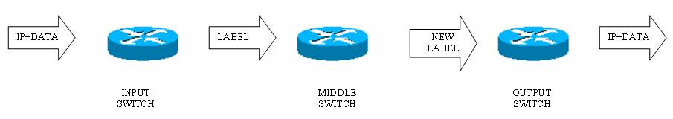
Fig.3 MPLS network with three MPLS switches.

The MPLS control plane is a collection of protocols concerned with network level coordination functions, such as routing and signalling that facilitate the movement of traffic across the entire MPLS network [6]. The protocols themselves are implemented as software processes that communicate with each other across node boundaries using message passing.
The protocol specifications detail the message formats, syntax, semantics, and transaction sequence for the message exchange. One of the main functions performed by the MPLS control plane is to facilitate the establishment of label switched paths (LSP) in MPLS networks. The establishment of LSPs may be subject to various types of preferences and constraints. This means that the control plane needs to distribute and manage network topology and resource availability information using a routing protocol, and perform signalling functions to establish and tear-down LSPs. In practice, signalling is one of the most fundamental aspects of the MPLS control plane. Indeed, much of the work of the IETF MPLS working group has been centred on developing signalling protocols for label distribution and LSP management.
The MPLS forwarding plane consists of the data path within a network element through which user traffic traverses. The forwarding plane performs label swapping operations using lookup tables and miscellaneous packet treatment functions such as scheduling, queue management, rate shaping, policing, and others [6].

4. MPLS Network Using VHDL
This section presents a simulation of an MPLS network that comprises three MPLS switches (see Fig. 3). The first MPLS switch analyses the IP packet header and assigns it a label which depends on the switching table. In this MPLS switch the label is considered the packet header instead of the IP address.
Once a label is assigned to the packet, it arrives to the second switch (middle switch in Fig. 3) where the label is analysed and changed by the switching table of the middle MPLS switch. Finally, when the packet is leaving the MPLS network through the output switch, the label is analysed and removed depending on the switching table and the IP address turns back as the packet header.
According to the MPLS characteristics, it is thus considered the implementation using VHDL because of its simplicity and ease to program. This programming language is focused on the development and implementation of algorithms in high speed platforms like FPGAs.
Therefore a hierarchical structure of an MPLS network VHDL model is proposed (fig. 4). The top level entity MPLS network instantiates three components: the MPLS input switch, the MPLS middle switch, and the MPLS output switch. The MPLS input and middle switch instantiates an encoder subcomponent itself, the MPLS output switch instantiates a decoder. The MPLS input, middle and output switch subcomponent instantiates a 10-1 multiplexer.

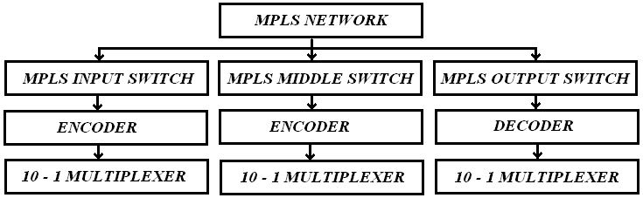

Fig. 4. Hierarchical structure of the MPLS network VHDL model.

The VHDL code implementation is structural at the top level of the VHDL hierarchy and behavioral at the bottom-level.
Thus the proposed MPLS network VHDL model simulates the three MPLS switches described above. These switches are designed to model the MPLS behaviour using IP addresses. By convenience the IP networks has been limited just to ten networks (120.0.0.0, 130.0.0.0, …, 210.0.0.0). See Fig. 3. The first MPLS switch receives the IP address with the data (information to transmit). The system labels the frame received with a label according to a switching table (see Table 1) and the IP analysis. The label contains eight bits, the first four indicate in use switch label number, while the last four bits indicate the output port where the information will be sent to the next switch.

Table 1. Input switching table.
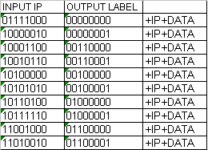

The first MPLS switch transmits the new frame to the second one where is re-labelled according to the switching table corresponding to this switch (see Table 2). As the first switch has previously analyzed the IP, it is not necessary to do it again. This new switch gives a new eight-bit label and a new port where information will be sent.

Table 2. Middle switching table.
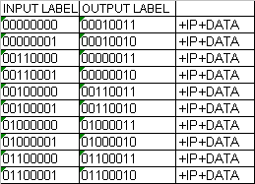

Finally, the last MPLS switch receives the label+IP+data and proceeds to cut the label off to release the IP address with the data (IP+data) into an IP network. Switching table for this switch is shown in Table 3.

Table 3. Output switching table.
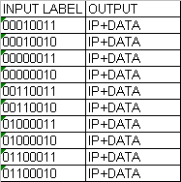

5. Simulation Results
In this section simulation results of the MPLS network are presented. The simulations are realized with ACTIVE HDL program, which were independent of any timing constraints. IP address and data are required to simulate MPLS network input switch. The IP address is formed by four eigth-bit fields (C1, C2, C3, C4 shown in Fig. 4) and the data just by one eight-bit field. The first IP field (C1) is analyzed by the first switch to label the input frame. The simulation results for the first switch are shown in Fig. 5. An IP address of type 10000010 is received, and using the switching table shown in Table 1 the corresponding label is "0000" and the output port is "0001" this results in an eight-bit label. The final size of the new frame (Eout) is forty-eight bits because it contains the label+IP address+data.

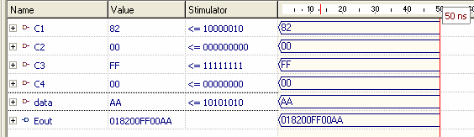
Fig.5. Input switch simulation.

The second simulation considers Eout ( see Fig. 6) as the input of the middle switch and analyse only the label. According to the switching table (see Table 2) the new corresponding label is 12 in hexadecimal format, formed by the label number "0001" and the output port "0010". The frame size is maintained in mpls2out because it is only re-labeled. The simulation is shown in Fig. 6.

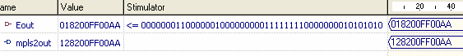
Fig.6. Middle switch simulation.

The output switch simulation cut the label off of the labeled frame received (mpls2out) and it is sent to a different network. The finalout size is reduced to forty-bits that contains the IP address and the data information. This new frame now can be analysed by any IP network. The function realised by this switch is shown in Fig. 7.

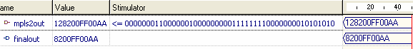
Fig.7. Output switch simulation.
Since each program simulates an MPLS switch and the main goal of the work reported in this paper is to simulate an entire MPLS network it is thus required to create a master program whose function is to call the three programs described previously to simulate the entire system. The results obtained by this system are presented in Fig. 8. It is observed that an IP address is received with data in the first stage of the MPLS network and a label is assigned (Eout). The second stage corresponds to the change of the label due to the switching table (mpls2out) and finally the last stage cut the eight-bit label off (finalout).

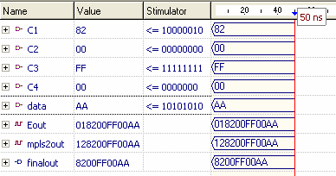

Fig.8. MPLS network simulation.

The design approach employed to design this MPLS network was based in the following VHDL model synthesis flow. (see fig. 9).

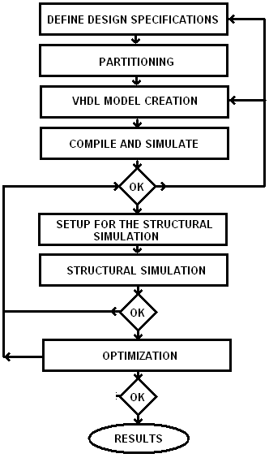

Fig. 9. VHDL model synthesis flow.

The design begins defining the overall specifications of the MPLS network. After that a partitioning into smaller parts was made. This parts leads to easier to implement models (MPLS switches) for the different levels of the hierarchical structure of the MPLS network.
The next step is a simulation to verify the behaviour of the models. Once the models are functional, a fully structural design for the top-level entity of the MPLS network was made.
The design of the top-level entity was revised and optimized giving the results exposed above.

6. Conclusions and future work

This paper has presented a simulation of an MPLS network using VHDL. The results reported in this paper show that an MPLS network may help in reducing congestion problems in IP networks. This is due to the fact that the use of switching tables in MPLS networks helps to reduce the routing decision time improving data packets addressing. Furthermore, it offers a great compatibility with the rest of the networks so that it is simple to incorporate to other existing networks. The results reported in this paper may be used as a base for its implementation in IP networks.
Future work can be focused in the development of a simulation including more middle switches with a larger dynamic switching tables resulting in a deeper IP analysis. Moreover, some control mechanisms (video cameras, sensors, servo motors) could be managed at the same time with an FPGA implementation.

References:
[1] IETF: RFC 3031 (January 2001): Multiprotocol Label Switching Architecture.

[2] Maxínez, Alcalá. El arte de programar sistemas digitales. Editorial Continental. México 2004

[3] Rubio Sánchez D. Modelado y simulación de un conmutador MPLS (Multi Protocol label Switching) in VHDL. BSc Degree Thesis, Universidad de las Américas-Puebla. May 2004.

[4] M. T. Khadir, V. Muresan, M. Colliers, The VHDL model of a three stage ATM switch, featuring a cell-level path allocation algorithm, National University of Ireland, Austria, 2001.

[5] J. A. Pérez López, Simulación del Multi-Protocol Label Switching, Barcelona, 25 de Octubre de 2003. http://www-entel.upc.es/xavierh/mpls/
[6] D. O. Awduche, B. Jabbari, Internet traffic engineering using MPLS, Computer Networks pp.111-129, (2002)

[7] T. M. Chen, T. H. Oh, Southern Methodist University, Reliable Services in MPLS, IEEE Communications Magazine, December 1999.

[8] G. Swallow, Cisco Systems, MPLS Advantages for traffic Engineering, IEEE Communications Magazine, December 1999.

[9] V. Alarcón-Aquino, Y. L. Takahashi-Iturriaga, J. C. Martinez-Suarez, L. G. Guerrero-Ojeda. MPLS/IP Análisis and Simulation for the Implementation of Path Restoration Schemes. WSEAS Transactions on Computers, Issue 6, Volume 3, December 2004.

