Computer Study of Information Transfer in Living Things

VALERY Poltev, ALEXANDRA Deriabina, EDuardo Gonzalez
Facultad de Ciencias Físico Matemáticas
Benemérita Universidad Autónoma de Puebla
Av. San Claudio y Río Verde, Ciudad Universitaria, Puebla, 72570
MÉXICO

Abstract: The problem of biological functioning of living things is discussed from viewpoint of information transfer. Physical nature of genetic processes on molecular level is considered in terms of accuracy and reliability of elementary steps of these processes. The role of atom level structure of informational macromolecules is discussed. Applications of computational tools of physics and chemistry to simulations of genetic processes are discussed. Computer simulation using modern molecular mechanics and quantum mechanics methods enables to construct atom level models of heredity material and its functioning, as well as to explain physical nature of extremely high fidelity of all the genetic processes.

Key-Words: - Information Transfer, Computer Simulations, Intermolecular Interactions, Nucleic Acids

1 Introduction
One of the most interesting features of living things is very exact self reproduction. A biological problem of heredity and hereditable variations is very interesting one from a viewpoint of physics and mathematics. Arising, storage, reproduction, and variations of information are most important processes of life. Many famous mathematicians, physicists, and chemists devoted papers and books to these problem. One of such books is that of the founder of quantum mechanics, Erwin Schrodinger [1] issued in 1944, before discovery of molecular structure of heredity material and beginning molecular biology and molecular biophysics.
Schrodinger considered a question: “How can “microscopic” molecular arrangements responsible for heredity govern processes in whole cell (and cell ensemble), i.e. “macroscopic objects”, in spite of “noise” of environment and temperature?” In that period, it was known practically nothing about molecular basis of heredity, hence Schrodinger cannot give atomic level answer to this question, but he drew attention of mathematicians, physicists, chemists to the problem. His conception of genes and chromosomes as “aperiodic crystals” continues to be attractive till now.
The problems of heredity and fidelity of information transfer during biological processes became to be consider quantitatively after discovery of DNA (deoxyribonucleic acid) double helix model by James Watson and Francis Crick in 1953 [2].

2 Problem Formulation
Physics and mathematics description of the mechanisms of accuracy of information transfer during life processes. Constructing atom level models of elementary steps of genetic processes. Elucidation of the most important for information transfer properties of molecular subunits.

3 Problem Solution

3.1 Computational Methods for Study Structure, Properties, and Functioning of Biologically Important Molecular Complexes.
Two main computational methods of theoretical physics are used in a study of structure, properties, and interactions of molecular systems, including biologically important substances. These methods are Molecular Mechanics (MM) and Quantum Mechanics (QM).
Molecular mechanics methods suggest calculation of system energy, E, using formulae of classical physics and additivity of terms describing different types of interactions.
E_{t}=E_{aa}+E_{tor}+E_{an}+E_{b}+E_{ad} (1)
In this formula E_{t} is total energy; E_{aa}, energy of atom-atom interactions; E_{tor}, torsion energy for rotation around chemical bonds; E_{an}, the energy of bond angle distortion; E_{b}, the energy of bond length deviations from equilibrium values; E_{ad,} additional terms used for description of spesific quantum effects or for adjustment of the results to experimental data.
E_{aa} is a sum of all pairwise interactions of atoms, not bonding to each other or to common atom, each E_{aa} term being calculated via 1-6-12 (Eq. 2) or (for hydrogen bond atoms) via 1-10-12 (Eq. 3) formula.
E_{ij}=Ke_{i}e_{j}/r_{ij}-A_{ij}/r_{ij}⁶+B_{ij}/r_{ij}¹² (2)
E_{ij}=Ke_{i}e_{j}/r_{ij}-A_{ij}⁽¹⁰⁾/r_{ij}¹⁰+B_{ij}⁽¹⁰⁾/r_{ij}¹² (3)
In these equations r_{ij} is the distance between atoms i and j, e_{i} and e_{j} are charges on atoms i and j . The coefficients A_{ij}⁽¹⁰⁾, B_{ij}⁽¹⁰⁾, A_{ij} and B_{ij} are adjustable parameters.
Other terms of the total energy are calculated according to rather simple formulae as well.
E_{tor}=V₀(1+cos(nφ-γ)) (4)
E_{an}=K_{an}(An-An_{o})² (5)
E_{b}=K_{b}(L-L_{o})² (6)
V₀, n, γ, K_{an}, An_{o}, K_{b}, and L_{o} are parameters. Thus, reliability of the results obtained depends on accuracy of parameter adjustments.
Quantum Mechanics methods suggest approximate solution of Schrodinger equation
ĤΨ=EΨ (7)
In this equation, Ĥ is operator of energy, Ψ is wave function, E is energy values. All the quantum mechanics computations, including the most rigorous ab initio ones, can give approximate results only, the results are more physically based ones as compared to those obtained by MM methods, but such results can be obtained for rather simple systems only.
Combined use of these two methods enables constructing atom level models of elementary biological processes, including the most important of them, the processes of storage, replication, repair, and expression of genetic information.

3.2 Heredity, genes, and DNA structure
Genetics, a science about heredity and hereditable changes, starting from the first Gregor Mendel’s works, became a quantitative branch of biology. The main problem of genetics, and, possibly, all the biology is a mechanism of covariant reproduction of living things. After fundamental discovery by Watson and Crick of DNA three-dimensional structure, the main features of the phenomenon became clear.
Heredity material, DNA macromolecule, contains two polynucleotide chains. The chain consists of a specific sequence of four monomer units, nucleotides, each nucleotide being composed of the base, sugar, and phosphate subunits. The sugar and phosphate subunits are the same in four nucleotides, while the bases differ in molecular structure and ability to interact with each other. Four bases of DNA are Adenine, A, Guanine, G, Thymine, T, Cytosine, C. The first two of them are purine derivatives, the last ones are pyrimidines. Base sequence of one chain of DNA molecule (or a set of DNA molecules) contains all the information necessary for life and reproduction of the cell and whole organism. The second chain contains the same information as the first one because the base sequence of one chain determines base sequence in the second one according to base pairing rule, namely A pairs with T, and G with C. A:T and G:C pairs have nearly equal shape and base arrangements. The scheme of Watson-Crick base pairing via hydrogen bonds is displayed in Fig. 1.
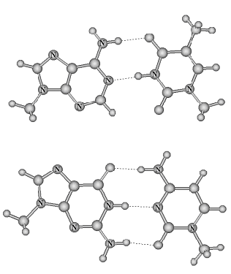

Fig.1. Watson-Crick A:T (top) and G:C (bottom) base pairs of DNA. Methyl groups are attached to bases in positions corresponding to bonds with sugar subunits. Dotted lines are used for hydrogen bonds.

The model suggests the mechanism of DNA replication, namely, strand separation and synthesis of new chains using parent chains as templates. The information containing in DNA molecule is transcribed into base sequence of RNA single chain macromolecule, than (during translation) this information is used for synthesis of protein chains, containing unique sequence of amino acids. The protein molecules are information containing molecules as well, they fulfill a lot of functions in cells, most interesting of which is enzyme (catalyzer) function for all the molecular transformations, including DNA and RNA synthesis.
All base pairs but Watson-Crick ones differ from them in shape and/or dimensions, and their formation during biosynthesis is less probable. The formation of these “wrong” pairs suggests a mechanism of information content changes, mutations. Examples of mispairs are displayed in Fig.2.
We refer to review paper [3] for detailed consideration of biochemistry and molecular biology of DNA replication and its accuracy. In the next subsections we consider this problem from a viewpoint of relation between probability of error arising and atomic structure and interactions of the bases.

3.3 Interactions in DNA macromolecule and probability of error arising
The model of Watson and Crick describes qualitatively a stability of heredity substance and a possibility of errors during replication and expression of genetic information. Watson-Crick A:T and G:C pairs are the only ones, which can be adjusted to the model of DNA helix, but there are a lot of other hydrogen-bonded base pairs. A quantitative consideration of the helix subunits is necessary for estimations of probability of mispair arising.
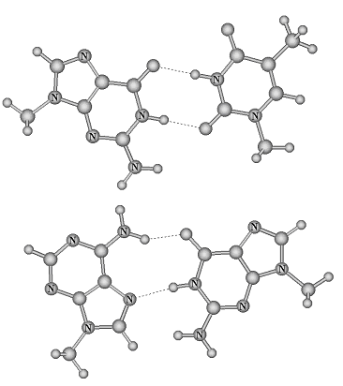
Fig.2. Two possible wrong pair of DNA bases, G:T (top) and A:G (bottom).

Detailed calculations of interactions between nucleic acid bases using MM method demonstrate an existence of rather favorable base pairs with mutual base positions slightly different from Watson-Crick pairs (see, e.g., [4]). This result had been confirmed by QM calculations as well. Besides, the values of energy of interaction of neighbor base pairs are close to those in base pairs, and they are nearly the same for Watson-Crick and wrong pairs. MM calculations of energy for DNA duplexes with mispairs demonstrate that such helices can be less favorable than helices without mispairs by 2.5 or 3.0 kcal/mol [5]. From statistical mechanics viewpoint, it corresponds to error probability about 10⁻³, i.e. nearly one of 1000 pairs formed during biosynthesis could be wrong one. This value is too small from viewpoint of physics and chemistry, it is nearly impossible to register such a level of errors by physical or chemical methods of DNA study. On the other side, this probability is too great from a viewpoint of life. As genetic information is written by 10⁶ or 10⁷ nucleotides, hundreds and thousand errors could arise during each replication, and preservation of genetic information could be impossible. Genetic experiments demonstrate, that a probability of errors varies from 10⁻⁶ to 10⁻⁹. How is it possible from viewpoint of molecular structure and interactions? We consider an answer to this question it the next subsection.

3.4 Interactions of DNA with proteins during biosynthesis provide a basis for high accuracy
The Nature uses several ways to reduce a probability of errors of genetic processes. It is impossible to eliminate the errors completely from physics viewpoint, and a probability of error is a basis of evolution, hence the life itself. One way of error reducing is “checking and editing” of newly synthesized chains. All cells contain repair system, repair enzymes, which can eliminate “wrong” nucleotide and replace it by “normal” one.
But the main way of error avoiding is checking during incorporation new nucleotide. The bases have a possibility to form hydrogen bonds additional to those involved in base pairing. Both Watson-Crick base pairs have two atoms capable to form hydrogen bonds and arranged in a similar manner, namely N3 of purines and O2 of pyrimidines (Fig. 3). There is no such atom arrangements in all other base pairs, including pairs displayed in Fig. 2. One of us in 1974 [6] suggested, that polymerizing enzyme recognize correct base pairs via these interactions. MM computations performed later [7], approve this suggestion. Thus, atomic structure of nucleic acid bases, “letters” of “genetic message” enables sufficiently correct functioning of molecular machinery of cells and living things as a whole.

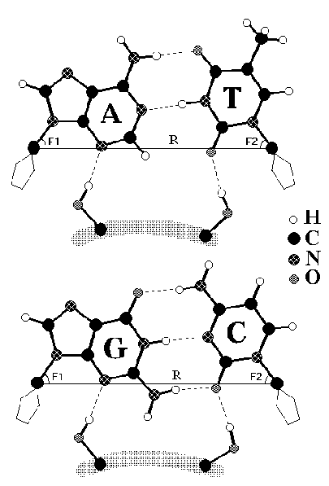

Fig.3. Scheme of recognition of Watson-Crick base pairs by enzymes. Hydrogen bonds between OH groups of the enzyme and N3 of A or G and O2 of T or C are marked. R is the distance between the first atoms of sugar subunits, F1 and F2, angles, characterizing base pairs. These values are the same for the two pairs.

4 Conclusion
High level of information transfer accuracy in the processes of storage, replication and expression of genetic information is a result of unique organization of herediry material arosed in evolution. Each process consists of sequence of molecular steps involving specific interactions via hydrogen bonds and steric repulsion. These steps can be quantitatively simulated using molecular mechanics method enhanced by quantum mechanics computations of simple components.

5 Acknowledgements
This work is partially supported by the CONACyT, Mexico, and VIEP, Benemerita Universidad Autonoma de Puebla.

References:
[1] E. Schrodinger, What is Life? The Physical Aspects of a Living Cell, 1944
[2] JD. Watson, FHC. Crick, Nature Vol.171, No. 4356, 1953, pp.737-738
[3] TA. Kunkel, K. Bebenek, Annu. Rev. Biochem. Vol. 69, 2000, pp.497–529
[4] VI. Poltev, NV. Shulyupina, Journal of Biomolecular Structure & Dynamics, Vol.4, No.3, 1986, pp.739-765.
[5] VP. Chuprina, VI. Poltev, Nucleic Acids Res. Vol. 11, No.15, 1983, pp. 5205-5222; Vol.13, No. 1, 1985, pp. 141-154.
[6] VI. Bruskov, VI. Poltev, Dokl. Akad. Nauk. SSSR Vol. 219, 1974, pp. 231-234
[7] V I. Poltev, NV. Shulyupina, VI. Bruskov, Molecular Biology vol. 32, 1998, pp. 268-276.

