Photonic properties in biological objects

A. V. ILINSKI, F. SILVA-ANDRADE*,
Instituto de Ciencias, Benemérita Universidad Autónoma de Puebla
Priv. 17 Norte 3417, San Miguel Hueyotlipan, Puebla,72050 Pue., México;
*Instituto de Ciencias y Posgrado en Ciencias Ambientales.

E. B. SHADRIN
Physico-Technical Institute Ioffe, Saint Petersburg, Russia.

Abstract: Since a few years ago, it has been observed that diverse research teams have a great interest for the study of photonic crystals: i. e., transparent or semitransparent volumetric structures for electromagnetic waves, whose period is comparable with the wavelength. The photonic crystals has been considered as a general rule synthetic structures, however it is possible to find them in the nature and often in the alive nature. The present work is dedicated to the experimental study of photonic properties in some biological objects.

Key- Words: Photonic structure, photonic band gap, reflection spectra, atomic force microscopy.

1 Introduction
The photonic crystals has been considered in general form as a synthetic structures, the period may be as greater as the equivalent for the radio-waves or microwaves, or as smaller as some hundred of nanometers for the visible light. For the visible light, the natural, synthetic and composite-based opals represent a structure that allows to model objects like a pattern. The opal has a transparent structure formed by silicon dioxide (SiO₂) spheres; the diameter of the spheres is around the 200-400 nanometers, and for this circumstance opals of different colors are observed. The SiO₂ spheres present a periodic arrangement and they form a cubic structure, then considering a 3D (3 dimensional) nanostructure, a periodic 3D system is obtained. Interesting properties are shown during the interaction with the light and it bears to define the photonic properties [1]. Between the SiO₂ spheres there exist holes or interstitial places those which are filled with material of different refraction index (for example for the most frequent case the air). There exists the possibility to fill the interstitial places with substances of different refraction index such as liquids (water, alcohol, etc.) or solids (semiconductors, metals). The main property of this structure is the presence of a (PBG), that means as follows, the light with energy of the photon that corresponds to the value of the photonic band gap, is reflected total or partially from the structure and practically it cannot spread inside the photonic crystal; the above mentioned results as transparency property in the photonic crystal for photons with another energy of the visible light, generating a dark fringe in the transparency spectrum. These properties are explained based on the interference phenomenon of diffracted electromagnetic beams by the bulk of the periodic structure. The location of the maximum intensity of reflected light from the structure (minimum intensity from the transparency spectrum) on the electromagnetic waves scale, λ_{m} is given by the Bragg’s formula:

λ_{m} = 2d $\sqrt{\left\langle ε\right\rangle −{\text{sen}}^{2}α}$ ,
where d is the period of the structure on the normal direction to the illuminated surface, ⟨ε⟩ is the average dielectric constant of the material, α is the angle from incident radiation.
From this formula we can observe that filling the interstitial places in the opal matrix (using water for example), the value of ⟨ε⟩ is increased, that means the refraction index n=$\sqrt{\left\langle ε\right\rangle }$, then the location of the maximum intensity in the reflection spectrum moves toward the direction of greater wavelengths.
If the incident angle α increases (and as a consequence the reflection angle), as shows in Fig. 1.
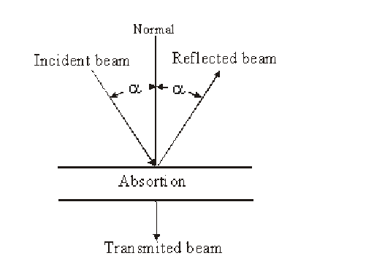

Fig. 1 Interaction of the light with the matter.
The maximum intensity of reflection is expected in direction toward greater wavelengths, however the maximum intensity of reflection moves toward direction of smaller wavelengths. Using these qualitative dependencies, we can shows photonic properties on the biological objects.

2 Materials and methods
Making reference to the synthetic photonic crystal, it is necessary to notice that at this date there exist only a few real objects to be modeled efficiently. It is evident because the construction of photonic crystal is quite difficult from the technological point of view and mainly to obtain photonic nanostructures whose correspondence is with an interval of the visible light. At the same time, objects that can be modeled for a range of visible light exist in the alive nature [2]. This is, on the feathers of some birds, wings of some butterflies or cuticle of insects, skin of some reptiles, some types of shell of mollusks and others. In this work we present only the photonic properties of two biological objects: we show the properties of shells of mollusks from the Mexican Caribbean (shell of mollusks of haliotidae family well-known as pearly abalone) shown in Fig. 2; and the properties of a part of the peacock’s feather (birds of phasianidae family, class pavo cristatus), which is shown in the Fig. 3.

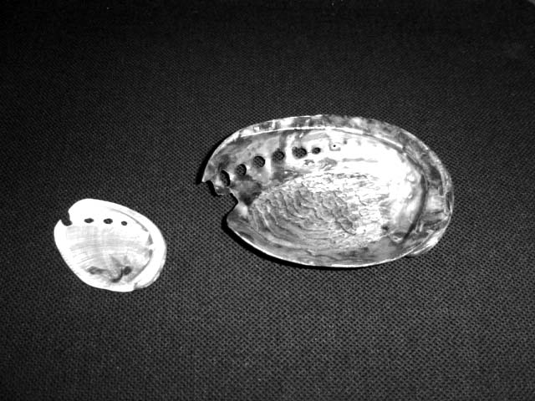

Fig. 2 Abalone shells.

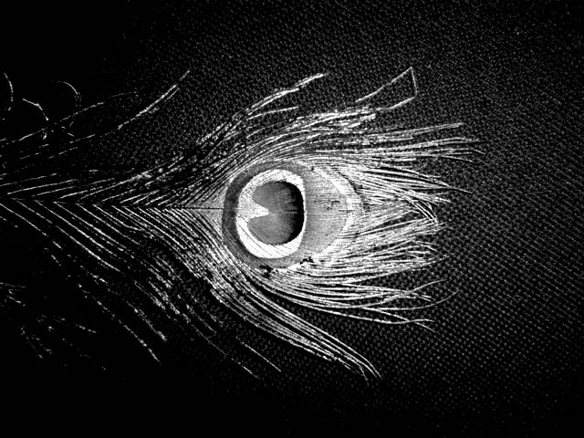

Fig. 3 Peacock’s feather.

3 Results
For the case of the abalone’s shell, depending on the size, we can see surfaces with diverse bend radios; the external surface of the shell contain a rough aspect with stony or saline inlays, but the internal surface is flat, brilliant and chromatic; in some places of the internal surface, selecting an homogeneous area with greatest bend radio, and observing the reflected light, appears a like-mirror reflection containing a band of chromatic radiation (red, green, yellow, blue or violet). The procedure to prepare the samples was making a “cleavage” process in a part of the shell, reducing the bulk, and finally polishing the surface. The reflection properties in the bulk are conserved for a radiation band (monochromatic light). The reflection spectrum of the prepared sample with this methodology has a narrow and intense maximum, that is a fundamental characteristic from the photonic crystal, see Fig. 4.
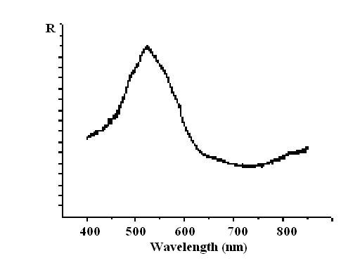
Fig. 4 Reflection spectrum of green color and polished shell.

Illuminating the surface of the shell with a white light beam, and choosing the incident angle at α ≠ 0⁰, the selected areas reflect different color bands; instead of the green color for α ≠ 0⁰, blue color appears, and at α = 45⁰ from the yellow color, green color appears. The latest means that the position of the reflection maximum, increasing the α angle, moves toward the direction of smaller wavelength.
The Fig. 5 shows the image obtained by using an atomic force microscope [3] from the same polished surface. On this image it is possible to see a topology like terraces, which will form steps with constant height, approximately d = 270 nm, it is to say, the shell in its bulk has a periodic structure and the layers of this structure are approximately parallel to the surface of the shell. On this way, the shell reflects the light such as a interferometric filter: the monochromatic light with wavelength around 2d =540 nm (green light) is reflected efficiently, the wavelength λ_{m} from the maximum on the reflection spectrum corresponds according the Bragg’s formula, to the period of the structure. Using this formula is possible to explain the change of color between normal incidence and incidence for α>0º. This is an example of one-dimensional (1D) photonic crystal.

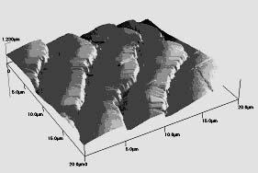

Fig. 5 Atomic force microscopy image from the surface of polished shell.

For the case of the peacock’s feather, we need to consider an analogy to a coniferous tree containing many branches where each branch contains other smaller branches that contain leaves like needles with similar shape and size. However, the coniferous contain green leaves, but the peacock’s feather contain leaves or “hairs” with different colors: blue, green, yellow, red and for this reason instead of a monochromatic feather, a chromatic pattern is formed. It is necessary to notice that each hair contains small mirrors in rectangular shape that reflects the light like small " lamps".

It is evident that the reflection spectra for the peacock’s feather are different for areas of different color. Here, we will described only the green color pattern (the reflected light from the green hairs).
In the Fig. 6 are presented the reflection spectrum for the colors pattern. The spectrum has a maximum of intensity, the position of the maximum corresponds to a wavelength λ_{m} = 520 nm, it is to say the green light. However, if the feather is wet (with water or isopropyl alcohol for a better absorption), in this case the feather changes its color to yellow-green, that corresponds to a great displacement in the position of the maximum of intensity in the reflection spectrum and with direction toward greater wavelength until a value λ_{m} = 550 nm (see Fig. 6b). This displacement, as it has been described for the opal, corresponds also to the Bragg’s formula.

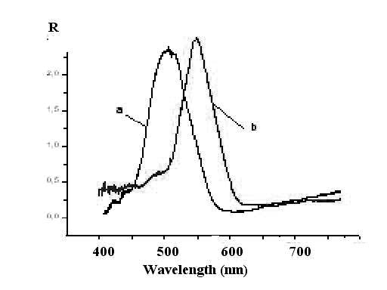

Fig. 6 Reflection spectrum of colors pattern from the feather, a) green color from dry hair; b) the same hair but wet and for that reason now is yellow.
The Fig. 7 present the phenomenon of displacement of the position of the maximum in the reflection spectrum toward the direction of smaller wavelengths when the angle of incidence (and reflection) increase its value for the same area (green for normal direction of the illumination) of the colors pattern. Using an angle of incidence α = 45⁰ the intensity of the maximum decrease a lot and it moves until λ_{m} = 480 nm that corresponds to the blue light. This phenomenon is interesting when is observed directly with the eyes and inclined illumination (α ≠ 0⁰) of the colors pattern on the feather. Under this condition all the elements of the colors pattern change their colors in the following way: the green areas change to the blue color, the yellow ones to green and the red ones to yellow.
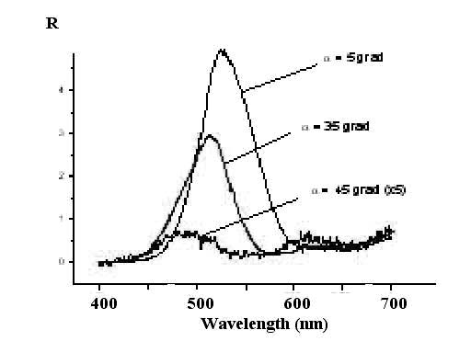
Fig. 7 Reflection spectrum of a green area (normal incidence) of the colors pattern on the peacock’s feather for different values of the incident angle (and reflection).

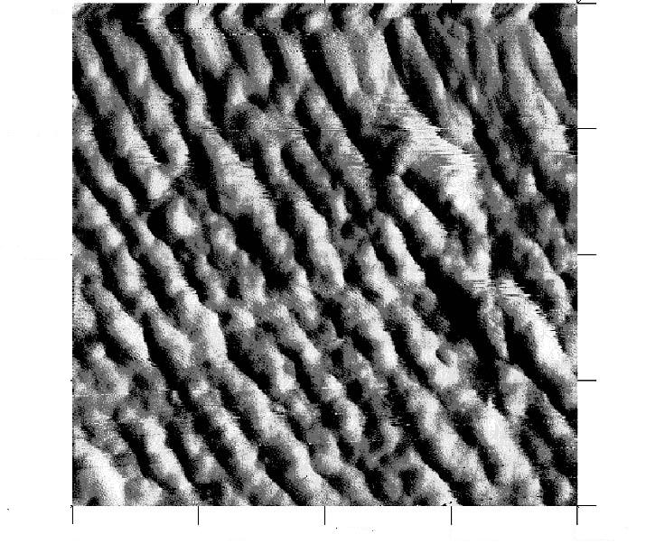
0 1μm 2μm
Fig. 8 AFM image of the green hair from the peacock’s feather.
The presence of both displacement phenomenons in the position of the maximum in the reflection spectra that have correspondence with the Bragg’s formula, evidences the photonic properties of the hair in the peacock’s feather. However, it is very desirable a direct demonstration of the periodic structure of the hair. In the Fig. 8 are presented the image of the surface of the green hair, this image was obtained using an atomic force microscope.
On Fig. 8 we can see the surface of the hair containing a periodic structure, very similar to the structure of the surface of a cable with thin fibers. The diameters of these fibers are around 130 nm, and these build from our point of view, the bulk of the two-dimensional (2D) photonic crystal. In accordance with Bragg’s formula the location of maximum of reflection spectrum, of this periodic structure, should be λ_{m} = 2d = 260 nm, this is the ultraviolet region of the spectrum. However, the second order λ_{m} = 4d = 520 nm that corresponds well with the wavelength of the maximum in the reflection spectrum for the green hair.

4 Discussion
It is clear that the reflection spectra for the peacock’s feather are different for areas containing different color. The spectrum has a maximum of intensity, the position of the maximum corresponds to wavelength λ_{m} = 520 nm that corresponds to the green color, but when changes the refraction index, due the incorporation of water or alcohol, then the feather changes its color from yellow to green; that corresponds to a great displacement in the position of the maximum of intensity in the reflection spectrum and toward direction of greater wavelengths until a value λ_{m} = 550 nm. This displacement, as has been described for the opal, corresponds also to the Bragg’s formula. On the other hand, by changing the incidence light angle, shift of the position of the maximum is presented toward the direction of smaller wavelengths. For an angle of incidence α = 45⁰ the intensity of the maximum decreases and it moves until λ_{m} = 480 nm that corresponds to the blue light. Under this condition the colors pattern change from green to blue, from yellow to green and from red to yellow. The presence of both displacement phenomenons in the position of the maximum on the reflection spectra that have correspondence with the Bragg’s formula, and the images of the superficial morphology, shown evidences of the existence of photonic properties in the green hair of the peacock’s feather, for the second order λ_{m} = 4d = 520 nm.

Gratefulness: The authors are grateful for the financial support of this work by the CONACyT, research project 2002-C01-40921; and VIEP-BUAP.

References

- C. M. Soukoulis 1996. Photonic Band Gap Materials, edited by Advanced Studies Institute of NATO, (Kluwer, Dordrecht) Ser. E, Vol. 315.
- P. Vukusic and J. R. Sambles 2003. Photonic structures in biology, Nature, Vol. 424:852-855.
- F. Silva-Andrade, A. V. Ilinskii, F. Chávez, T. A. Prutskij 2002. Microscopía de fuerza atómica: control de la superficie de semiconductores. Ciencia y Desarrollo, Vol. XXVIII, No. 16:68-77.

