Time Optimal Design Strategy Analysis for Nonlinear
Electronic Circuits

EDUARDO RIOS
Department of Electronics
Puebla Autonomous University
Edificio 129, Ciudad Universitaria, 72570 Puebla, Pue.
MEXICO

Abstract:- This is the next step of the time optimal design strategy investigation. The present objective is the formulation of a time-optimal nonlinear systems design methodology. The optimal control theory and a set of special control functions are introduced in order to generalize the design methodology and to produces many different design strategies inside the same optimization procedure. The combination of some of these strategies defines the optimal or quasi-optimal design trajectory on computer time viewpoint. The numerical results were obtained by PC with a C++ language program. The design of some nonlinear electronic circuits shows that this methodology can reduces the total operations number to many times and accelerates the design process. The study shows that the computer time gain of these design methodology with respect to the traditional design methodology increases when the size and the complexity of the system grows.

Key-Words: - System Design, Control Theory, Time-Optimal, Nonlinear, Time Gain.

1. Introduction

Any system design methodology includes two main parts: the model of the system, which needs to be analyzed during the optimization process and a parametric optimization procedure that achieves the objective function optimal point. The design time reduction is one of the essential problems of the total quality design improvement.
The reduction of the necessary time for the circuit analysis and improvement of the optimization algorithms are two main sources for the reduction of the total design time. There are some powerful methods that reduce the necessary time for the circuit analysis. Because a matrix of the large-scale circuit is a very sparse, the special sparse matrix techniques are used successfully for this purpose [1]-[3]. Other approach to reduce the amount of computational required for the linear and nonlinear equations is based on the decomposition techniques.
The well-known ideas for partitioning of a circuit matrix into bordered-block diagonal form were described in original works using the branches tearing [4] or nodes tearing [5] and jointly with direct solution algorithms give the solution of the problem. The extension of the direct solution methods can be obtained by hierarchical decomposition and macromodel representation [6].
The optimization technique that is used for the circuit optimization and design exerts a very strong influence on the total necessary computer time too. The numerical methods are developed both for the unconstrained and for the constrained optimization and can be improved in future.
Meanwhile there is another way to reduce the total computer design time. The reformulation of the optimization process on heuristic level was proposed decades ago [7]-[8]. This process was named as generalized optimization and it consists of the Kirchhoff law ignoring for some parts of the optimization process. The special cost function is minimized instead of the circuit equation solution. In practical aspects this idea was developed for the microwave circuit optimization [9] and for the synthesis of high-performance analog circuits [10]-[11]. Nevertheless all of these ideas are needed to generalize.
Another way can be proposed for the reformulation of the design problem and for it generalization to obtain a set of different design strategies inside the same optimization procedure. The new approach for the system design on the basis of control theory formulation was elaborated in some previous works [12]-[15]. This approach serves for the time-optimal design algorithm definition and can be proposed as a theoretical basis for the time-optimal design algorithm searching.

2. Problem Formulation

The problem of the analog system design can be formulated on the basis of optimal control theory and it was described in [13]. This approach defines a large set of different design strategies inside the optimization procedure and describes the possibility to control the design process by means of changing between varies design strategies. This possibility appears owing to redistribution of the independent variables between system model and the general cost function of the optimization process. We suppose that the electronic circuit is described by means of the mathematical model:

$g_{j}\left(X\right)=0$, $j=1,2,\text{.}\text{.}\text{.},M$ (1)

The parametric optimization process for the general cost function $F\left(X\right)$ minimization for two-step procedure is defined as the following vector equation:

$X^{s+1}=X^{s}+t_{s}⋅H^{s}$ (2)

where s is the iterations number, $t_{s}$ is the iteration parameter, $t_{s}∈R^{1}$, H is the direction of the cost function $F\left(X\right)$ decreasing, which is defined by any optimization procedure. The main idea of the new approach is to define the special vector U of the control functions that control the design process, $U=\left(u_{1},u_{2},\text{.}\text{.}\text{.},u_{m}\right)$, where m is the number of dependent variables, $u_{j}ÎΩ$; $Ω=\left\{0;1\right\}$. In this case the generalized cost function has dependency not only the variable vector X but the vector U too. This function $F\left(X,U\right)$ can be defined for instance as an additive function:

$F\left(X,U\right)=C\left(X\right)+ψ\left(X,U\right)$ (3)

where $C\left(X\right)$ is the ordinary cost function of the design process and $ψ\left(X,U\right)$ is the additional penalty function, which includes some equations of the system (1) and can be defined for instance as:

$ψ\left(X,U\right)=\frac{1}{ξ}\sum_{j=1}^{M}{u_{j}⋅g_{j}^{2}\left(X\right)}$ (4)

The system (1) can be re-defined by the following form:

$\left(1−u_{j}\right)g_{j}\left(X\right)=0$, $j=1,2,\text{.}\text{.}\text{.},M$ (5)

All control variables $u_{j}$ are the functions of the current point of the design process and can change the value from 0 to 1 and vice versa at any time moment. The total number of the different design trajectories, which are produced inside the same optimization procedure, is practically infinite. Among all of these strategies one or few optimal strategies can minimize the computer time. Therefore, the problem of the time-optimal design strategy determination is formulated as the typical problem for the functional minimization of the control theory. The main problem of this definition is unknown optimal dependencies of all control functions $u_{j}$.
The idea of the system design problem formulation as the problem of the control theory can be embedded into any optimization procedure. Next section shows the design of some passive and active circuits using the gradient optimization method. The optimal dependencies of the functions $u_{j}$ were found by approximated methods of the control theory [14]-[15]. The main result of this previous analysis shows that the potential computer time gain of the time-optimal strategy with respect to the traditional approach increases when the size and complexity of the system increase.

3. Nonlinear circuit design

Fig. 1 shows a circuit with four nodes. This is a passive nonlinear circuit with five independent variables, $K=5$, admittances $y_{1}$, $y_{2}$, $y_{3}$, $y_{4}$ y $y_{5}$, and four dependent variables, $M=4$, nodal voltages $V_{1}$, $V_{2}$, $V_{3}$ y $V_{4}$. The fase vector is: $X=\left(x_{1},x_{2},…,x_{9}\right)$, where each element is an admittance or a nodal voltage and in order to get a physical sense the admittances are changed to: $x_{1}^{2}=y_{1}$, $x_{2}^{2}=y_{2}$, $x_{3}^{2}=y_{3}$, $x_{4}^{2}=y_{4}$, $x_{5}^{2}=y_{5}$, $x_{6}=V_{1}$, $x_{7}=V_{2}$, $x_{8}=V_{3}$ and $x_{9}=V_{4}$.
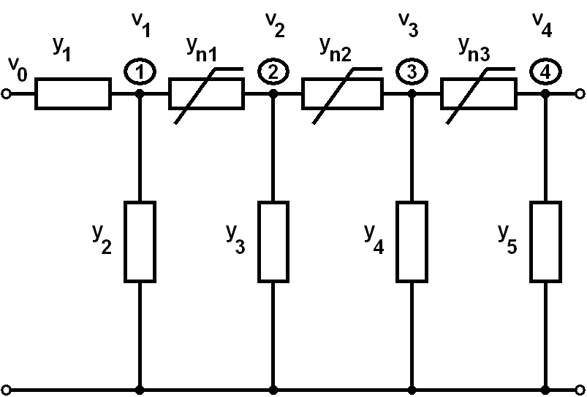

Figure 1. Four node nonlinear passive
circuit topology.

The non linear dependency in general case is $y_{\text{ni}}=a_{n}+b_{n}⋅x_{K+i}$, where $a_{n}$ and $b_{n}$ are constants. The design process gets values of $y_{j}$, with $j=1…K$, to found, as example, $V_{M} = w⋅V_{0}$, where $w∈ \left[0,1\right]$. The system model is:

$\begin{aligned}g_{1}\left(X\right)≡ \left(x_{1}^{2}+ x_{2}^{2}+ y_{0}+ a⋅x_{6}\right)⋅x_{6} \\ − \left(y_{0}+ a⋅x_{6}\right)⋅x_{7}−x_{1}^{2}⋅V_{0}=0 \\ g_{2}\left(X\right)≡− \left(y_{0}+ a⋅x_{6}\right)⋅x_{6} \\ + \left(2⋅y_{0}+ a⋅x_{6}+ x_{3}^{2}+ a⋅x_{7}\right)⋅x_{7} \\ − \left(y_{0}+ a⋅x_{7}\right)⋅x_{8}=0 \\ g_{3}\left(X\right)≡− \left(y_{0}+ a⋅x_{7}\right)⋅x_{7} \\ + \left(2⋅y_{0}+ a⋅x_{7}+ x_{4}^{2}+ a⋅x_{8}\right)⋅x_{8} \\ − \left(y_{0}+ a⋅x_{8}\right)⋅x_{9}=0 \\ g_{4}\left(X\right)≡− \left(y_{0}+ a⋅x_{8}\right)⋅x_{8} \\ +\left(y_{0}+ a⋅x_{8}+ x_{5}^{2}\right)⋅x_{9}=0\end{aligned}$ (6)

The objective function is defined by the formula:

$C(X)={\left(x_{9}− w⋅V_{0}\right)}^{2}$ (7)

For all the examples in this section the minimal of $C(X)$ is $ε={\text{10}}^{−9}$. The control vector variables is $U=\left(u_{1},u_{2},u_{3},u_{4}\right)$. The total number of the design strategies with a fixed control vector results $2^{4}=\text{16}$. The results of the analysis of the traditional design
Table 1. Some general design strategies for the four node nonlinear passive circuit.

n | Control functions vector  $$u_{1}u_{2}u_{3}u_{4}$$ | Total design time  (seg.) | Iterations number
1 | 0000 | 1.742 | 721
2 | 0100 | 0.891 | 873
3 | 1000 | 0.917 | 971
4 | 1011 | 0.425 | 634
5 | 1111 | 0.672 | 1567

Table 2. Some quasi-optimal design strategies for the four node nonlinear passive circuit.

n | Optimal control  functions  $$u_{1}u_{2}u_{3}u_{4}$$ | Total  design time (seg.) | Switch points | Iter. number | Time  gain
1 | (0110);  (1101);  (1111) | 0.1481 | 18;50 | 281 | 11.75
2 | (1111);  (1110);  (0000);  (1111) | 0.1467 | 48;74;  112 | 147 | 11.87
3 | (0110);  (1110);  (0101);  (1111) | 0.142 | 15;34;  94 | 213 | 12.26

strategy, modified traditional strategy and some intermediate strategies with the fixed value of the control functions are given in Table 1. The data of the optimal strategies are given in Table 2. The control functions vector of the optimal strategy needs three switching points and his computer time gain with respect to the traditional strategy is 12.26.

In Fig. 2 there is a circuit of the amplifier that consists of one transistor cell. In this case the circuit includes three nodes only.
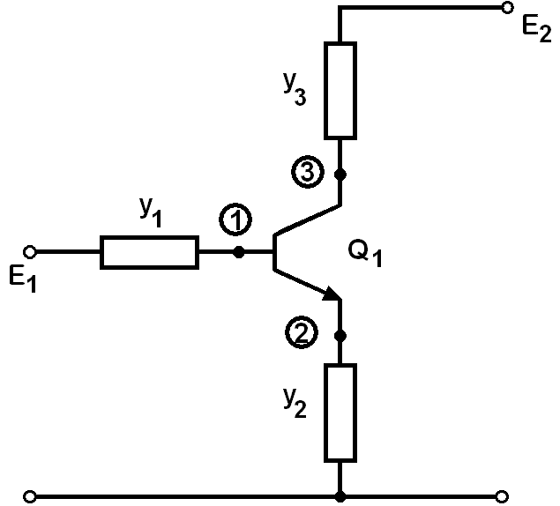

Figure 2. Three node nonlinear active
circuit topology.

The design process has been realized on DC mode by the Ebers-Moll static model of the transistor. This is an active nonlinear three node circuit with three independent variables,$K=3$, admittances $y_{1}$, $y_{2}$ y $y_{3}$, and three dependent variables, nodal voltages $V_{1}$, $V_{2}$ y $V_{3}$ $\left(M=3\right)$. The purpose of the design process is to find $y_{j}$, where $j=1…K$, to situate the transistor in the active region. The fase vector is: $X=\left(x_{1},x_{2},…,x_{6}\right)$, where the elements are admittances or voltages. The fase vector components are defined by the formulas: $x_{1}^{2}=y_{1}$, $x_{2}^{2}=y_{2}$, $x_{3}^{2}=y_{3}$, $x_{4}=V_{1}$, $x_{5}=V_{2}$ y $x_{6}=V_{3}$. The system model is:

$\begin{aligned}g_{1}\left(X\right)≡x_{1}^{2}⋅x_{4}−x_{1}^{2}⋅E_{1}+I_{B}=0 \\ g_{2}\left(X\right)≡x_{2}^{2}⋅x_{5}−I_{E}=0 \\ g_{3}\left(X\right)≡x_{3}^{2}⋅x_{6}−x_{3}^{2}⋅E_{2}+I_{C}=0\end{aligned}$ (8)

The objective function has been determined as the sum of the squared differences between beforehand-defined values and current values of the voltages for the transistor junctions:

$C\left(X\right) = {\left(x_{6}−\text{mm}0\right)}^{2}+{\left(x_{4} −x_{5}−\text{mm}1\right)}^{2}$ (9)

where $\text{mm}0$ y $\text{mm}1$ are constants. The control vector variables is $U=\left(u_{1},u_{2},u_{3}\right)$. The total number of design strategies with a fixed control vector results $2^{3}=8$. The results of the analysis of the traditional design strategy, modified traditional strategy and some intermediate strategies with the fixed value of the control functions are given in Table 3. The data of the optimal strategies are given in Table 4.

Table 3. Some general design strategies for the three node nonlinear active circuit.

n | Control functions vector  $$u_{1}u_{2}u_{3}$$ | Total design  time  (seg.) | Iterations number
1 | 000 | 5.438 | 2517
2 | 010 | 8.143 | 5438
3 | 100 | 4.451 | 2654
4 | 101 | 0.612 | 576
5 | 111 | 0.438 | 945

Table 4. Some quasi-optimal design strategies for the three node nonlinear active circuit.

n | Optimal control functions  $$u_{1}u_{2}u_{3}$$ | Total design time (seg.) | Switch. points | Iter. number | Time gain
1 | (000);(100);  (111) | 0.1804 | 38;63 | 187 | 30.14
2 | (111);(101);  (011) | 0.1655 | 107;  180 | 209 | 32.85
3 | (110);(000);  (111) | 0.1578 | 29;47 | 221 | 34.46

The control functions vector of the optimal strategy needs two switching points and his computer time gain with respect to the traditional strategy is 34.46.

The circuit of the Fig. 3 has three transistor cells. It has seven independent variables as admittances, $K=7$, and seven dependent variables as nodal voltages, $M=7$. The purpose of the design process is to find $y_{j}$, where $j=1…K$, to situate the transistor in the active region. The fase vector for this example is: $X=\left(x_{1},x_{2},…,x_{\text{14}}\right)$ , where the
elements are admittances or voltages. The fase vector components are: $y_{j}=x_{j}^{2}$. The system model is:

$\begin{aligned}g_{1}\left(X\right)≡x_{1}^{2}⋅x_{8}−x_{1}^{2}⋅E_{1}+I_{B1}=0 \\ g_{2}\left(X\right)≡x_{2}^{2}⋅x_{9}−I_{E1}=0 \\ g_{3}\left(X\right)≡x_{3}^{2}⋅x_{\text{10}}−x_{3}^{2}⋅E_{2}+I_{C1}+I_{B2}=0 \\ g_{4}\left(X\right)≡x_{4}^{2}⋅x_{\text{11}}−I_{E2}=0 \\ g_{5}\left(X\right)≡x_{5}^{2}⋅x_{\text{12}}−x_{5}^{2}E_{2}+I_{C2}+I_{B3}=0 \\ g_{6}\left(X\right)≡x_{6}^{2}⋅x_{\text{13}}−I_{E3}=0 \\ g_{7}\left(X\right)≡x_{7}^{2}⋅x_{\text{14}}−x_{7}^{2}⋅E_{2}+I_{C3}=0\end{aligned}$ (10)

The objective function is:

$C\left(X\right) = {\left(x_{\text{14}}−\text{mm}0\right)}^{2}$$+{\left(x_{8} −x_{9}−\text{mm}1\right)}^{2}$$+{\left(x_{\text{10}} −x_{\text{11}}−\text{mm}2\right)}^{2}$$+{\left(x_{\text{12}} −x_{\text{13}}−\text{mm}3\right)}^{2}$ (11)

where $\text{mm}0$, $\text{mm}1$, $\text{mm}2$ y $\text{mm}3$ are constants. The control vector variables is $U=\left(u_{1},u_{2},…,u_{7}\right)$. The total number of design strategies with a fixed control vector results $2^{7}=\text{128}$.

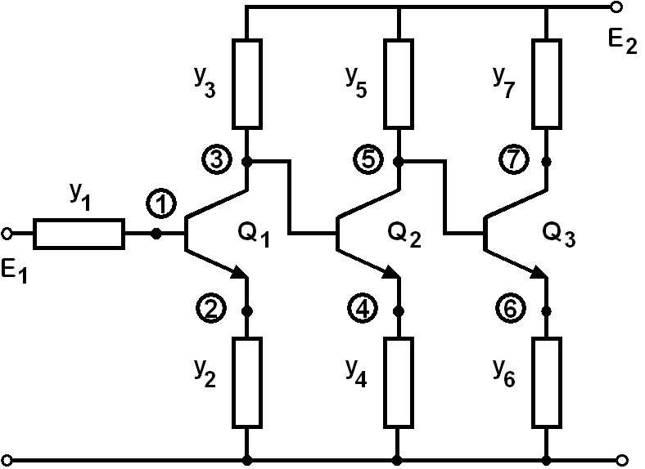

Figure 3. Seven node nonlinear active
circuit topology.
The results of the analysis of the traditional design strategy, modified traditional strategy and some intermediate strategies with the fixed value of the control functions are given in Table 5. The number five is the best strategy (31.675 seg) with a fixed control vector. The data of the optimal strategies are given in Table 6. The control functions vector of the optimal strategy needs three switching points and his computer time gain with respect to the traditional strategy is 272.92.

Table 5. Some general design strategies for the seven node nonlinear active circuit.

n | Control functions vector  $$u_{1}u_{2}…u_{7}$$ | Total design time  (seg.) | Iterations number
1 | 0000000 | 417.543 | 7421
2 | 0000101 | 98.416 | 3453
3 | 0001111 | 305.783 | 4165
4 | 0111000 | 84.016 | 1875
5 | 1111111 | 31.675 | 2374

Table 6. Some quasi-optimal design strategies for the seven node nonlinear active circuit.

n | Optimal control functions  $u_{1}u_{2}…u_{7}$ | Total design time (seg.) | Switch. points | Iter. number | Time gain
1 | (0001111);  (1111110);  (1111111) | 1.6683 | 6;16 | 59 | 260.15
2 | (0111000);  (0000000);  (1111111) | 1.587 | 12;16 | 78 | 263.1
3 | (0001111);  (0111011);  (0000000);  (1111111) | 1.5299 | 5;14;  22 | 33 | 272.92
4. Conclusions

The traditional approach to the analog system design is not time-optimal. The problem of the time-optimal algorithm construction can be solved as the functional optimization problem of the control theory. The potential computer time gain of the time-optimal design strategy increases when the size and complexity of the system increase. The combination of the general strategy and the optimal switching points serve as the principal ideas for the quasi optimal and optimal algorithm construction.

References
[1] Bunch J.R., and D.J. Rose, Eds., Sparse Matrix Computations, Acad. Press, N.Y., 1976.
[2] George A., On Block Elimination for Sparse Linear Systems, SIAM J. Numer. Anal. Vol. 11, No.3, 1984, pp. 585-603.
[3] Osterby O., and Z. Zlatev, Direct Methods for Sparse Matrices, Springer-Verlag, N.Y., 1983.
[4] Wu F.F., Solution of Large-Scale Networks by Tearing, IEEE Trans. Circuits Syst., Vol. CAS-23, No. 12, 1976, pp. 706-713.
[5] Sangiovanni-Vincentelli A., L.K. Chen, and L.O. Chua, An Efficient Cluster Algorithm for Tearing Large-Scale Networks, IEEE Trans. Circuits Syst., Vol. CAS-24, No. 12, 1977, pp. 709-717.
[6] Rabat N., A.E. Ruehli, G.W. Mahoney, and J.J. Coleman, A Survey of Macromodeling, IEEE Int. Symp. Circuits Systems, 1985, pp. 139-143.
[7] I.S. Kashirskiy, General Optimization Methods, Izvestiya VUZ USSR - Radioelectronica, Vol. 19, No. 6, 1976, pp. 21-25.

[8] I.S. Kashirskiy and Ya.K. Trokhimenko, General Optimization for Electronic Circuits, Tekhnika, Kiev, 1979.
[9] V. Rizzoli, A. Costanzo, C. Cecchetti, Numerical optimization of broadband nonlinear
microwave circuits, IEEE MTT-S Int. Symp., Vol. 1, 1990, pp. 335-338.
[10] E.S. Ochotta, L.R. Carley, R.A.Rutenbar, Analog circuit synthesis for large, realistic cells: Designing a pipelined A/D converter with ASTRX/OBLX, Custom Itegrated Circuits Conf., Vol.15, no. 4, May 1994, pp. 1-4.
[11] E.S. Ochotta, R.A.Rutenbar, L.R. Carley, Synthesis of High-Performance Analog Circuits in ASTRX/OBLX, IEEE Trans. on CAD, Vol.15, No. 3, 1996, pp. 273-294.
[12] A. Zemliak, System Design Problem Formulation by Control Theory, Proc. of the IEEE ISCAS 2001, Sydney, Australia, 2001, Vol. 5, pp. 5-8.
[13] A.M. Zemliak, Analog System Design Problem Formulation by Optimum Control Theory, IEICE Trans. on Fundamentals of Electronics, Comunications and Computer Sciencies, Vol. E84-A, No. 8, 2001, pp. 2029-2041.
[14] A.M. Zemliak, Acceleration Effect of System Design Process, IEICE Trans. on Fundamentals of Electronics, Comunications and Computer Sciencies, Vol. E85-A, No. 7, 2002, pp. 1751-1759.
[15] A. Zemliak, Comparative Analysis of the Different Design Strategies for the Analog Electronic System Design, WSEAS Transactions on Circuits and Systems, Vol. 3, No. 2, 2004, pp. 294-299.

