“Managerial Decision Making process and use of Information Technology for better decision making-an overview of it’s content & case analysis.”

MD.MAHFUZ ASHRAF & SUNTU KUMAR GHOSH
Management and Business Department
BRAC University.66 Mohakhali, Dhaka-1212
BANGLADESH

Abstract:- Managerial decision- making process is a dynamic process and adapts managerial decision making function ability over time. The aim of this paper is to give a vivid idea on decision-making process as well as managerial decision- making process where Information technology i.e. DSS technology is continuously changing and developing. Significant recent research in the decision support area has been concentrating on the human side of the person-technology relation. Furthermore various information technologies focus the criterion of right or wrong decisions validation as well as validation of information source and systems. Finally we used a case of a telecommunication industry in UK as an implementation of managerial decision-making software tools. The findings have shown that the managerial decision making process based on available knowledge both past and upcoming knowledge which lead to a huge application of effective and efficient managerial decisions.

Key-words:- Decision making process, decision support systems, Dataming, Decision Tree.

1 Introduction
Managerial decision-making process is a significant branch of decision-making process where management theories are based on the act of decision by considering subjective, objective & both personal and impersonal attitude [Carlos liano, 2001]. Decision-making is an evolving area of study and one of considerable importance of practicing managers. However the subject of decision making is usually seen as merely one of several activities that differentiate managers from other employees in organization; but decision making is a complex process that must be understood complete before it can be practiced effectively. [E.Frank, 1995]. So we need to investigate the decision-making process before route to managerial decision-making process.
2 Objectives and Background
The ultimate objective of this paper is describing the concept of decision-making as well as managerial decision-making process. Basic skeleton is based on DSS where the significant arena explored.
This paper initially motivated by the Herbert A.Simon, 1997 where he emphasised managerial decision making process as a legal framework of an organization. Decisions are at the heart of success of an organization. At time there are critical moments when these decisions can be difficult, perplexing and nerve-wracking. Making decisions can be hard for a variety of structural, emotional, and organizational reasons but proper procedure/process of handling those difficulties may eliminate those suffering.All those complications and prospects leaded our research work more valuable towards a fine end.
3 Methodology
The methodology we adapted thoroughly is literature review. Secondary data considered for constructing diagrams and parameters. As we emphasised objective approach rather than subjective, several scrutinized on managerial decision making process and tools made our discussion quite simple and acceptable.

4 Overview of Decision Making & Process
The complexities of today’s business operations, aggressive competition, and government controls have made the job of the manager increasingly difficult. It is no longer possible for one individual to be aware of the details of every characteristic of the firm or to make all decisions regarding its operation. Making decision of all types at all level is the principal thrust of significant managerial actions & the true measure of management is reflected in the success of its decision over time. In this section we focuses various aspects of decision making.

5 Theory & concept
Decision-Making is central to human activity. Thus, we are all decision-makers. However, "good" decision-making starts with a consecutive, purposeful, strategic-thinking process.
According to Herbet A.Simon “Decision making comprises three principal phases: finding occasional for making a decision; finding possible course of action; and choosing among courses of action” [HerbertA.Simon, 1960]
Here we can reach a conclusion towards the systematic and scientific era and all of our further definitions are based on the Herbert brilliant thoughts over decision-making process. The further scrutinised of Herbert definition has developed the following decision-making process framework:
5.1 A case scenario of Decision Making Environment: implementing decision making tools
In making important decisions, any information sources that contain relevant important information are going to be accessed and used, if possible. The decision maker uses the whole network of information sources and variety of available media.
On the other hand , the number of growing IT support is must for better decision making towards the manager. In this case Knowledge, Information and Data are the vitals part of consideration .
Our research cased based one telecommunication industry named “TELCO”, UK for generating quick and better decision regarding their business prospect; especially finding the types of customer. The primary data collected by researching more than 2000 different types of customer for identifying the customer types of TELCO company.
As a decision making tools, we used KnowledgeSEEKER software for analysing our primary data .KnowledgeSEEKER is a data analysis, data mining, package that enables users to quickly analyse and understand the relationships between variables in a data set. It performs a thorough, interactive analysis of linear and non-linear relationships and presents the results in the form of a statistical decision tree. In minutes, KnowledgeSEEKER performs the type of analysis that would take a skilled statistician days to complete.
Here we used KnowledgeSEEKER for the following purposes:
- The decision making software that is KnowledgeSEEKER is a menu-driven. The results of an analysis are displayed graphically as a statistical decision tree using percentages or averages to communicate meaningful information.
- The software searches for the relationships of our data while insignificant detail is left in the background.
- The software lets our test a variety of hypotheses quickly. We can direct our analysis by interactively previewing alternative results.
- This software can express the relationships it discovers as a set of rules. These rules can be stored as a knowledge base which lets our construct an expert system to conduct prediction, planning, diagnosis or consultation tasks.
6 Market Survey for TELCO company
Our primary research based on market survey of around 2000 customer. The data layout is given below:
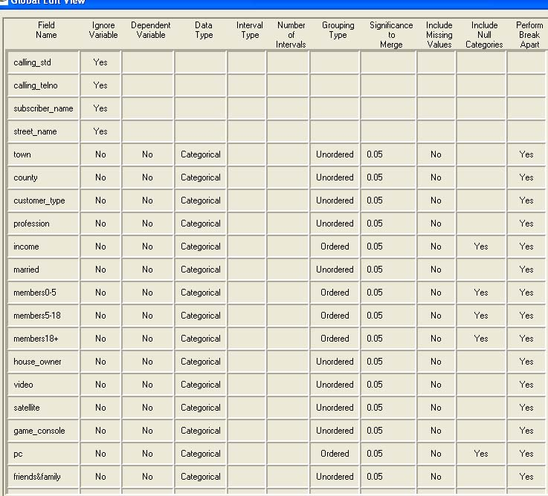
Fig. 1 Data category
We have classified our data from Calling standard rate to Friends & family usages.On
Basis of our designed data layout we gathered approximately 2000 peoples market survey report. A synopsis of partial collected data are given below:
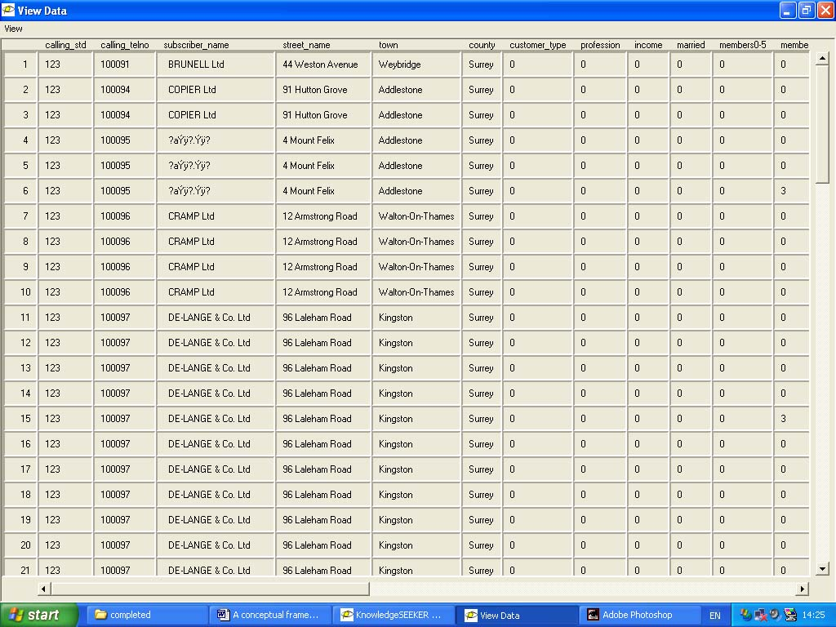
Fig. 2 Partial Collected data

7 Data analysis and findings
We have chosen the Decision Tree system for analysing our data that is a data mining techniques for generating better decision by the manager. By analysing the data we will able to say the following key issues:
- Who will be our best customer?
- Which target market we need to penetrate?

Our data represent the business data hugely that may need to focus for our business or managerial decision implementation. The final part of our decision based on the shortest root of decision making tree that will maximize the profit. When we inputed our survey data to KnowledgeSEEKER software, then the shortest roots or tree generated automatically on basis of customer preference criteria. It is not always true that the market survey report can produce the real world success always but the best prediction always focus the success of a better managerial decision making. Here we attached the output generated by KnowledgeSEEKER software.

Fig. 3 Decision Tree that determine the shortest path of better decision making process
The above scenario we have presented as a support of IT to the management personnel for better managerial decision making process.

8 Recent and Further Research
Numerous researches have been done on DSS technology for analysing decision and its process. Those inventions and researches bring new learning, better decision, improvised response capability, time and cost saving etc. Basically the application area is “environmental –automation- organization” where DSS technologies are using for better decision -making process
9 Conclusion
Since the early 1970s, decision support systems (DSS) technology and applications have evolved significantly which assists managerial decision-making process tremendously. [J.P. Shim et al.] Decision makers, who are used to depending on their past experiences, must make decisions and take actions in the rapidly changing world we face today. In this turbulent environment, the ability to successfully view the current situation through the traditional "good judgment" viewpoint is weakened through increasing external noise (a multitude of information sources on multiple topics), changing paradigms of how we think about social, cultural, organizational and economic issues, creating internal noise within our prevailing mental models and the implementation those models.

Reference:
- Carlos liano, “Fundamental of Managerial decision making process”, 2001
- E.Frank Harrison, “The Managerial Decision-making Process”, 1995,4th edition, Page: ix.
- Milan Zeleny, “Descriptive Decision Making and Its Applications.” in Application of Management Scinece, ed. Randall L.Schultz(Greenwich,Conn.: JAIApress,1981,I,333
- HerbertA.Simon, “The new Science of Management Decision” (New York: Harper & Row, 1960), p.1
- Nozick R., “Invariances: The Structure of the Objective World”, Belknap Pr., 2001.
- Hambrick, D.C., Mason, P.A., 1984, "Upper echelons: the organisation as a reflection of its top manager", Academy of Management Review, 27, 271-91.
- Rajogopalan, N., Rasheed, A.M., Datta, D.K., 1993, "Strategic decision processes: critical review and future directions", Journal of Management, 12, 2, 349-84.
- E.turban et Aronson, “Decision Support Systems and Intelligent Systems”6th edition 2001
- Ian rooks, “Managerial Problem Solving (Problem solving by rational or no rational)”, Management Decision. Volume 32 Number 7 1994 pp. 53-59.
- Ólafsson S., Teaching mathematical modelling to business students, Annals of Operations Research, 82, 1998, 49-58.

Adapted from Kim D., Introduction to Systems Thinking , Pegasus Communications, 1999.
Adapted from the lecture (week:02) by Ddembe Williams, Centre for Advanced Systems Modelling and Simulation, School of Computing, Information Systems and Mathematics..Page:02

