IMPLEMENTATION OF SVPWM BASED ON HYSTERESIS CONTROL STRATEGY APPLIED ON AUTONOMOUS PARALLEL ACTIVE FILTER

T. BENSLIMANE, K. ALIOUANE, B. CHETATE
Power Electronics Laboratory E. M. P.
P.O.BOX 17, Bordj El Bahri , Algiers, Algeria
Research Laboratory of Electrification in Industrial Entreprises
Independance avenue, Boumerdes (35000), Algeria
Phone/Fax : +213 24 8170 50, Fax : +213 24 81 91 72

ABSTRACT: - This paper presents a study on the harmonic depollution of the electric power network as well as the compensation of reactive power by an autonomous three-phase active filter at parallel structure. The presentation of the system of filtering starts initially with the presentation of the modeling of the whole of the system network, parallel active filter and polluting load. In second place, the principle of identification of the harmonic currents by the method of the instantaneous real and imaginary powers is developed, followed by the presentation of the SPACE VECTOR PULSES WIDTH MODULATION BASED ON HYSTRERESIS applied to the inverter of the active filter. A strategy which makes it possible to control the inverter of the filter to generate the harmonic currents required with the optimization of the number of commutations of the semiconductors used. The following part is devoted to the presentation of regulation system of the terminal condenser voltage of the autonomous active filter and in the last are presented the digital simulation and experimental results.

Key-Words: - Parallel active filter, SVPWM , HYSTERESIS, Two level voltage inverter, reactive power, acquisition card.

1 Introduction
The static converters absorb non-sinusoidal currents even if they are fed under sinusoidal voltages, they also absorb reactive energy. They behave then like generators of harmonic currents. These harmonic currents constitute a source of harmful problems for the network and the converter itself [1]. Traditional solutions of depollution are conceived primarily by passive filters. The lack of adaptability as well as the problem of resonance between the filter and inductance of the network was the major inconvenient of this depollution technique. Thanks to the development of the electronics of power, new structures of depollution of the networks appeared under the name of active filter in order to adapt an effective solution to the problems of harmonics and the strong consumption of reactive energy [2 ].

2 System modelisation
In the figure (1) is given the synoptic diagram of the association active filter-electric network-non linear load.
where :
$\left(\begin{matrix}e_{1} \\ e_{2} \\ e_{3}\end{matrix}\right)=\sqrt{2}\text{.}E\text{.}\left(\begin{matrix}\text{sin}(θ) \\ \text{sin}(θ−2\text{.}\frac{π}{3}) \\ \text{sin}(θ−4\text{.}\frac{π}{3})\end{matrix}\right)$ (1)
with : $θ=ω\text{.}t$ ω : network.
the mathematical model of the total system will be as follows:
$$\left(\begin{matrix}V_{F1} \\ \\ V_{F2} \\ \\ V_{F3}\end{matrix}\right)\begin{matrix} & & \end{matrix}\begin{matrix}\left(\begin{matrix}\text{Vs}1 \\ \\ \text{Vs}2 \\ \\ \text{Vs}3\end{matrix}\right) & \begin{matrix}\begin{matrix} & + & \begin{matrix} & \text{Rf} & \begin{matrix} & \left(\begin{matrix}I_{F1} \\ \\ I_{F2} \\ \\ I_{F3}\end{matrix}\right) & \begin{matrix} & + & \begin{matrix} & \text{Lf} & \begin{matrix} & \frac{d}{\text{dt}} & \end{matrix}\end{matrix}\end{matrix}\end{matrix}\end{matrix}\end{matrix} & \left(\begin{matrix}I_{F1} \\ \\ I_{F2} \\ \\ I_{F3}\end{matrix}\right) & \end{matrix}\end{matrix}$$
(2)
with :
$$\left(\begin{matrix}\text{Vs}1 \\ \\ \text{Vs}2 \\ \\ \text{Vs}3\end{matrix}\right)\begin{matrix} & & \end{matrix}\begin{matrix}\left(\begin{matrix}e1 \\ \\ e2 \\ \\ e3\end{matrix}\right) & \begin{matrix}\begin{matrix} & − & \begin{matrix} & \text{Rcc} & \begin{matrix} & \left(\begin{matrix}\text{Is}1 \\ \\ \text{Is}2 \\ \\ \text{Is}3\end{matrix}\right) & \begin{matrix} & − & \begin{matrix} & \text{Lcc} & \begin{matrix} & \frac{d}{\text{dt}} & \end{matrix}\end{matrix}\end{matrix}\end{matrix}\end{matrix}\end{matrix} & \left(\begin{matrix}\text{Is}1 \\ \\ \text{Is}2 \\ \\ \text{Is}3\end{matrix}\right) & \end{matrix}\end{matrix}$$
(3)

3 Implementation of control strategy

3.1 Identification of the harmonic currents by the method of instantaneous real and imaginary powers
The figure (2) presents the diagram of ordering of the active filter of which the identification forms part.
$$\left[\begin{matrix}Vα \\ \\ Vβ\end{matrix}\right]\begin{matrix} & & \begin{matrix} & \begin{matrix}\sqrt{\frac{2}{3}} & \begin{matrix} & \begin{matrix}\left[\begin{matrix}1 & & −1/2 & & −1/2 \\ & & & & \\ 0 & & \sqrt{3}/2 & & −\sqrt{3}/2\end{matrix}\right] & \begin{matrix} & \left[\begin{matrix}\text{Vs}1 \\ \\ \text{Vs}2 \\ \\ \text{Vs}3\end{matrix}\right]\end{matrix}\end{matrix}\end{matrix}\end{matrix}\end{matrix}\end{matrix}$$
(4)
$$\left[\begin{matrix}Iα \\ \\ Iβ\end{matrix}\right]\begin{matrix} & & \begin{matrix} & \begin{matrix}\sqrt{\frac{2}{3}} & \begin{matrix} & \begin{matrix}\left[\begin{matrix}1 & & −1/2 & & −1/2 \\ & & & & \\ 0 & & \sqrt{3}/2 & & −\sqrt{3}/2\end{matrix}\right] & \begin{matrix} & \left[\begin{matrix}\text{Ic}1 \\ \\ \text{Ic}2 \\ \\ \text{Ic}3\end{matrix}\right]\end{matrix}\end{matrix}\end{matrix}\end{matrix}\end{matrix}\end{matrix}$$
(5)
The instantaneous real and imaginary powers, noted by p and q, are defined by:
$$\left[\begin{matrix}p \\ \\ q\end{matrix}\right]\begin{matrix} & & \begin{matrix} & \left[\begin{matrix}Vα & \begin{matrix} & \end{matrix} & Vβ \\ & & \\ −Vβ & \begin{matrix}\begin{matrix} & \end{matrix} & \end{matrix} & Vα\end{matrix}\right] & \begin{matrix} & \left[\begin{matrix}Iα \\ \\ Iβ\end{matrix}\right]\end{matrix}\end{matrix}\end{matrix}$$
(6)
the powers are then filtered by high-pass filters, which gives ph and qh and the harmonic components of the currents will be:
$$\left[\begin{matrix}\text{Ic}1h \\ \\ \text{Ic}2h \\ \\ \text{Ic}3h\end{matrix}\right]\begin{matrix} & & \begin{matrix}\begin{matrix}\sqrt{\frac{2}{3}} & \begin{matrix} & \frac{1}{V_{α}^{2}+V_{β}^{2}} & \end{matrix} & \left[\begin{matrix}1 & & 0 \\ & & \\ −1/2 & & \sqrt{3}/2 \\ & & \\ −1/2 & & −\sqrt{3}/2\end{matrix}\right]\end{matrix} & \begin{matrix}\begin{matrix} & \left[\begin{matrix}Vα & \begin{matrix} & \begin{matrix} & \end{matrix}\end{matrix} & −Vβ \\ & & \\ Vβ & \begin{matrix} & \begin{matrix} & \end{matrix}\end{matrix} & Vα\end{matrix}\right]\end{matrix} & \end{matrix} & \left[\begin{matrix}\text{ph} \\ \\ \text{qh}\end{matrix}\right]\end{matrix}\end{matrix}$$
(7)

3.2 Control of active filter with SVPWM based on Hysteresis
At any sampling time t, the vector Imes can be expressed as follow :
$$\left[\begin{matrix}\text{Im}\text{es} \\ \\ \text{Iréf}\end{matrix}\right]\begin{matrix} & & \begin{matrix} & \begin{matrix}\left[\begin{matrix}\text{Is}α & & + & & \text{jIs}β \\ & & & & \\ \text{Is}α\text{réf} & & + & & \text{jIs}β\text{réf}\end{matrix}\right] & \end{matrix}\end{matrix}\end{matrix}$$
(8)
To keep the filter current vector inside the hysteresis boundary around its reference current vector, its positioning area must be initially detected. That can be done by calulating the errors S_{α}k , S_{β}k between filter current and its reference :
$$\left[\begin{matrix}Sαk \\ \\ Sβk\end{matrix}\right]\begin{matrix} & & \begin{matrix} & \begin{matrix}\left[\begin{matrix}\text{Is}α\text{réf}(k) & & − & & \text{Is}α(k) \\ & & & & \\ \text{Is}β\text{réf}(k) & & − & & \text{Is}β(k)\end{matrix}\right] & \end{matrix}\end{matrix}\end{matrix}$$
(9)

According to S_{α}k and S_{β}k, we can distinguish four zones for Imes compared to Iréf :

S_{α}k | Positive | Negative | Negative | Positive
S_{β}k | Positive | Positive | Negative | Negative
Zone | 4 | 3 | 1 | 2

Table 1 : positioning zones of the measured current vector

Once the errors of current were calculated. it remains to determine how to detect their tendency, due only to electrical network voltage. It is simply given by the signs of errors derivatives when the filter voltage vector is null [3].
The evolution of current errors is linked to the electrical network voltage and the filter voltage by the relation (10) expressed in Concordia frame :
dS_{α}/dt = V_{α}-VF_{α}
dS_{β}/dt = V_{β}-VF_{β}
(10)

The signs of the derivatives are given only when the null voltage vector is applied. They are calculated as follow :
$\left[\begin{matrix}\text{dS}α/{\text{dt}} \\ \\ \text{dS}β/{\text{dt}}\end{matrix}\right]\begin{matrix} & & \begin{matrix} & \begin{matrix}\left[\begin{matrix}Sα(k) & & − & & Sα(k−1) \\ & & & & \\ Sβ(k) & & − & & Sβ(k−1)\end{matrix}\right] & \end{matrix}\end{matrix}\end{matrix}$
(11)

To choose the appropriate filter voltage vector to be applied, according to errors and their derivatives sign, we distinguish 16 cases indicated below.
After the application of the null voltage vector (V₀ or V₇), we may have one of the following four cases :
The choice between the two null voltage vectors V₀ and V₇ is made so as to minimize the number of commutations of power electronic components.

4 Regulation of capacitor voltage
The regulation of the continuous voltage Vc at the boundaries of the capacitor being ensured by a regulator made up of a low-pass filter of time constant τc and proportional regulator with Kc as a gain, figure (4), which makes it possible to compensate losses in the inverter.

5 Simulation and experimental results

5.1 Results of digital simulation
The simulation is done by using the software programmation language C++ with following parameters:
Rcc = 1 Ω , Lcc = 0.045 H , RF = 5 Ω ,
LF = 0.05 H , Vcréf = 700 V , C = 150 μF ,
τc = 0.0038s , Kc = 14.09 , h = 0.25 A.

5.1.1 Compensation of the harmonic currents without compensation of reactive power
5.1.2 Compensation of the harmonic currents with compensation of reactive power

5.2 Experimental results
The load (R-L), fed with the rectifier (non-linear load), absorbs a current of 1.5 A.
The reference voltage standard to the input of the inverter of the filter is 120 V.
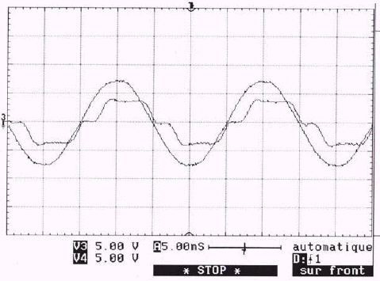
Fig.5 : Results of acquisition line voltage and non-linear load current

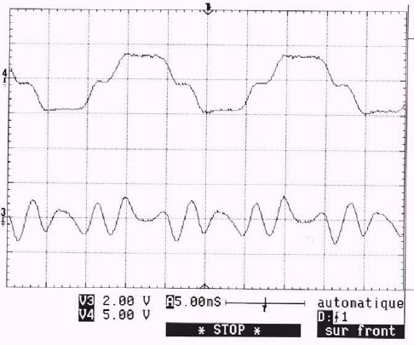
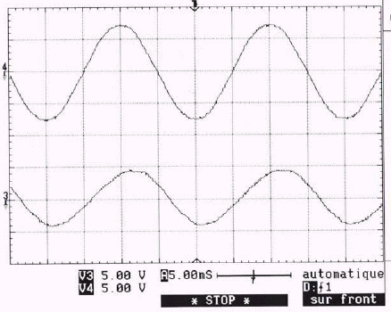
Fig.6 : Results of acquisition and identification of harmonic current
without reactive power compensation
a)
b)
a)
b)
nonlinear load current ;
b)current resulting of identification.

Line voltage ;
Load current without identified harmonic current.
c)
d)

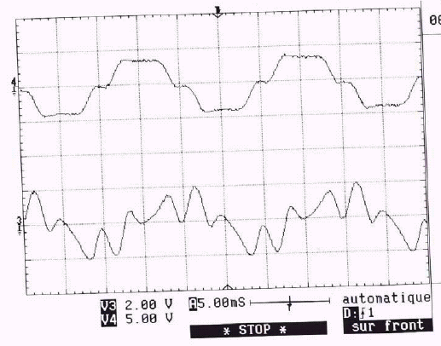
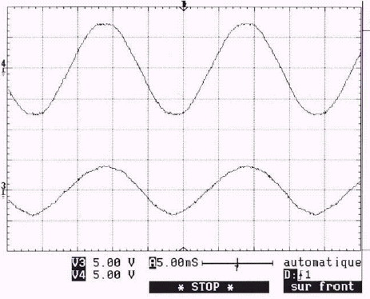
Fig.7 : Results of acquisition and identification of harmonic current
with reactive power compensation
a)
b)
nonlinear load current ;
b)current resulting of identification.

Line voltage ;
Load current without identified harmonic current.
c)
d)

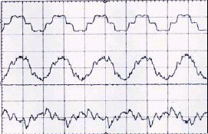
a)
b)
c)
nonlinear load current ;
source current after harmonic current
compensation ;
active filter current ;

Fig.8 : Results of harmonic current compensation

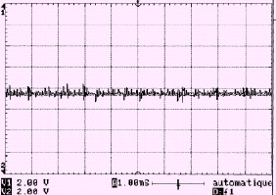
Fig.9 : Capacitor voltage with its reference

6 Conclusion
This paper presents a study on new control strategy named “SPACE VECTOR PULSES WIDTH MODULATION BASED ON HYSTRERESIS controller” applied to parallel active filter in order to compensate harmonic currents and reactive power with optimization of commutations of the power electronic components composing the inverter of the filter. The results of simulation show that the active filter offers a good quality of filtering of harmonic currents with the correction of the power factor. The experimental results confirm the good performances of active filtering when the parameters of the system of filtering are correctly selected.

References :
L. Moller,’’problèmes techniques posés par
le raccordement de convertisseurs de grandes puissance’’, Revue EDF, No.2, 1985, pp. 5-9.
K. Aliouane, A. Kheloui, M. Medjaoui, ‘’Limitation des perturbations harmoniques par un filtre actif triphasé’’, GRENOBLE Mars 2002.
E. Aldabas, J. L. Romeral, A. Arias, D. Bedford ‘’A new vector control hysteresis-band current controller for three phase load’’, Lausanne EPE 1999.

[1]

[2]

[3]

