A New Method for Implementation of Radio Frequency
Power Meters
Hossein Mohseni, Mohammad Hossein Alavi, Mohammad Reza Malek Mohammadi
Department of Electrical Engineering
Sharif University of Technology
Azadi Ave, Tehran
Iran
www.sharif.edu

Abstract: - A component or system's output signal level is often the critical factor in the design and ultimately the purchase and performance of almost all RF and microwave equipment. Because signal power level is so important to the overall system performance, it is critical when specifying the component that builds up the system. Most of power sensors convert high frequency power to a DC or low frequency signal that the power meter can then measure and relate it to a certain RF power level. The three main types of sensors for sensing power are thermistor, thermocouple and diode detector. In this paper, we explain a new method used for power measurement in the frequency range of 10MHz to 1GHz. In this method, we use a D-type flip-flop to convert the main signal to a low frequency signal.

Key-Words: - Power Meter, Subsampling, Down Conversion, D Flip Flop, Microwave, Measurement

1 Introduction
Nowadays the output power level in RF and microwave circuits is a very critical factor for designers. At low frequencies, the strength of the signals is calculated by measuring the RMS value of voltage and current, and power is defined as the product of them. At the middle band frequencies, it is enough for power measurement of sine wave to measure the peak or RMS of voltage or current because the load resistance is fixed to$\text{50}Ω$. At microwave frequencies, voltage and current measurements are less appropriate because they depend on the physical characteristics of the transmission medium (dimensions, dielectric constant and permeability) and field strength. Therefore in these frequencies the best way for measuring power of signals is using a device that converts power to heat or a low frequency measurable signal.
In this paper, we explain a new method to convert the amplitude of signals to a measurable DC value. This method is suitable for frequencies up to 1GHz and the error of power measurement is less than or equal to$±0\text{.}5\text{dB}$.

2 Down Conversion
There are several methods for down converting a signal, such as using analog switch, mixer and Flip-Flop. Analog switch and mixer are analog devices, but, Flip-Flop is a digital device and suitable for digital circuits.
Consider a D-FF as the one shown in Fig. 1 to which signals are applied to D and clock inputs with frequencies equal to f+df and f respectively, and df<f. In this condition, the output frequency of Flip-Flop is df. Therefore down converting is performed. If the frequency of D-input is changed to N*f+df and the clock frequency remains at f, the output frequency of D-FF remains at df. By this method, it is possible to downconvert a high frequency signal to a low frequency signal by the use of a low frequency clock. This configuration is shown in Fig. 2.

D

Clk
Q
f+df

f
df

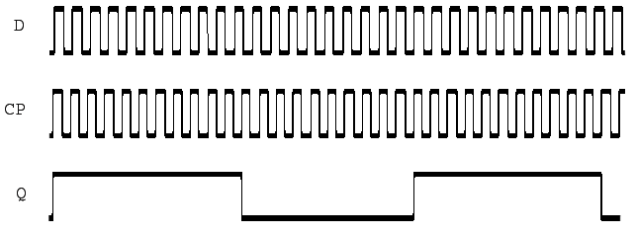
Fig. 1. Down converting with Flip-Flop when frequencies applied to D and Clock inputs are f+df and f respectively

For example, in our circuit, the range of input frequency is 10MHz to 1GHz and the output frequency is 10 kHz, but the range of D-input frequency is 10MHz to 20MHz. Note that with this range of D-input frequency, we can cover all input frequencies. This operation is called subsampling.

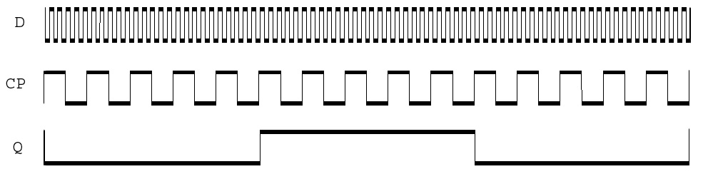
D

Clk
Q
N*f+df

f
df

Fig. 2. Down converting with Flip-Flop when frequencies applied to D and Clock inputs are N*f+df and f respectively

3 Subsampling
The process of sampling the input signal at a rate lower than the highest frequency components of the input signal, commonly referred to as subsampling, performs a function equivalent to that of mixing. The idea is that a bandpass signal with bandwidth $Δf$ can be translated to a lower band if sampled at a rate equal to or greater than $2Δf$. This operation creates replicas of the spectrum with no aliasing. The location of the spectral images is given by

$f_{i}={\text{nf}}_{s}±f_{0}$ (1)

Where $f_{i}$ is the location of image, $f_{0}$ is the frequency of the input, $f_{s}$ is the sampling frequency, and n is an integer.

4 Subsampling Disadvantages
A. Noise Aliasing
One of the most important disadvantages of subsampling is aliasing of noise. It can be proved that subsampling by a factor of m multiplies the downconverted noise power of the sampling circuits by a factor of 2m [1]. m is defined as

$m=\frac{f_{0}}{f_{s}}$ (2)
B. Sensitivity to Jitter
Jitter of the sampling clock results in phase noise that is transferred onto the sampling RF input. Also it can be proved that the clock phase noise power is amplified by m² [2].

5 Main Idea
The main idea of this method is down converting the main signal to a low frequency signal by a D-FF by using subsampling technique. Before explaining how to use subsampling techniques, we should explain how to use a D-FF for Power measurement. Consider a D-FF that two signals are applied to D and Clock inputs and the clock frequency is much greater than input frequency. If the amplitude of the sine wave that applied to D input is greater than the threshold voltage of the D-FF then we can apply this signal to the D-input for power measurement according to the fig. 3.

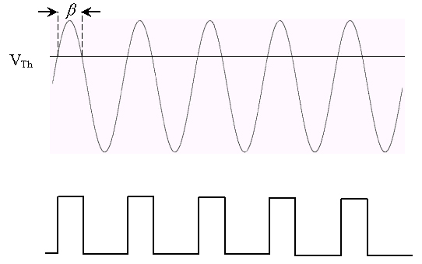

Fig. 3. Implementation of a power meter with D-FF for sine wave input

In these conditions, the duty cycle of the output signal varies with the amplitude of the sine wave. Therefore, we can write the following relations:

$V_{\text{Th}}=V_{\text{ipeak}}(\text{Cos}\frac{β}{2})$ (3)

$D=\frac{β}{2π}=\frac{1}{π}{\text{Cos}}^{−1}(\frac{V_{\text{Th}}}{V_{\text{ipeak}}})$ (4)

By the use of this method, it is possible to construct a power meter. Since the frequency range of the D-FF is limited to the certain frequency so this method is suitable for low frequency applications. For solving this problem, we can use subsampling techniques. Consider a D-FF that two signals are applied to D and clock inputs have frequencies equal to N*f+df and f respectively according to fig. 4. In these conditions, the effective input signal at the D input is a sine wave with the amplitude equal to the amplitude of the main signal and frequency equal to df. Therefore by using subsampling technique down converting is performed.

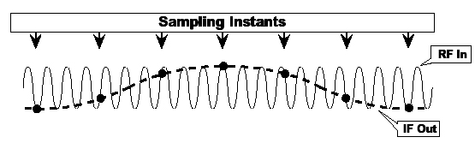
Fig. 4. Effective input signal for D-FF

By the use of this method, it is possible to construct a RF power meter, but since the amplitude of the sine wave should be grater than the threshold voltage of the D-FF, the dynamic range of this power meter is limited. Another problem of this circuit is that the relation between D and V_{ipeak} is nonlinear. For solving these problems, we can use negative feedback loop to increase linear dynamic range and linearity of this circuit. The block diagram of this circuit is shown in fig. 5. In this method, the input frequency is measured and the clock frequency is tuned, therefore the output frequency is fixed to a certain frequency. Feedback control theory tells us that the duty cycle of the output of D-FF must remains fix by changing the amplitude of the input sine wave if the loop has enough gain. On the other word by changing the amplitude of the input sine wave the bias voltage at the D-input is changed so that the duty cycle of the output is remain fix.

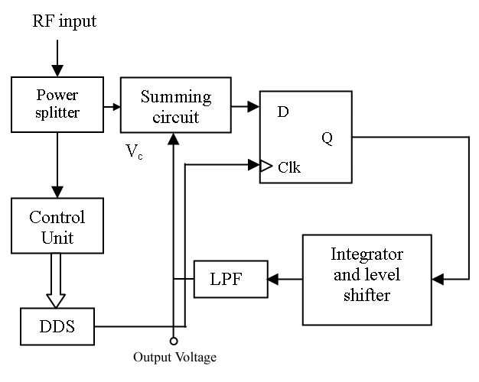
Fig. 5. Block diagram of circuit

If the duty cycle of the output signal is tuned to 25% and the sampling frequency is much greater than the output frequency then we can write the following relation:

$V_{\text{th}}=V_{c}+V_{\text{ipeak}}(\text{Cos45})$ (5)

We can rewrite this relation as follows:

$V_{\text{ipeak}}=\sqrt{2(}V_{\text{th}}−V_{c})$ (6)

$V_{\text{iRMS}}=(V_{\text{th}}−V_{c})$ (7)

If the input resistance of the circuit is fixed to 50Ω the power of sine wave will be obtained by the following relationship:

$P_{\text{in}}=\frac{(V_{\text{iRMS}})^{2}}{\text{50}}$ (8)

6 Experimental Results
For implementation of this method, we use a high speed ECL D-FF to maximize the frequency range of the circuit. The results of the implementation of this method are shown in figures 6 and 7 for input frequency equal to 200MHz and 1GHz respectively.

P_{out} (dBm)
P_{in} (dBm)
P_{in} (dBm)
Error (dB)

Fig.6 .Results of the implementation of this method when the input frequency is 200MHz

As shown in figures 6 and 7 the linear dynamic range of this method are greater than 30dB and 10dB for ranged input frequencies 200MHz and 1GHz respectively. By using a look-up table, it is possible to increase the linear dynamic range of this circuit up to 40dB.

P_{out} (dBm)
P_{in} (dBm)
-
30
-
20
-
10
0
10
20
-
30
-
25
-
20
-
15
-
10
-
5
0
5
10
15
20
P_{in} (dBm)
Error (dB)

Fig.7. Results of the implementation of this method when the input
frequency is 1GHz.

7 Source of Error
As we mentioned, for tuning the sampling frequency, we measured the input frequency and by using a DDS, we generated the sampling clock. Error at measuring input frequency and generating sampling signal may be a source of the total error. In addition, using D-FF that is a nonlinear devise increased the total error of power measurements.

8 Conclusion
In this paper, we explained a new method for implementation of radio frequency power meters that is suitable for frequencies up to 1GHz. By using a look-up table, it is possible to increase the linear dynamic range of this circuit.

9 Acknowledgment
We would like to thanks Iran Telecommunication Research Center (ITRC) for funding support of this research. Also the first author would like to thanks S. Mohhamdi for his useful helps.

References:
- B. Razavi, “RF Microelectronics”, Prentice Hall, 1998.
- D. H. Shen., “A 900-MHz RF Front-End with Integrated Discrete-Time Filtering”, IEEE Journal of Solid-State Circuits, Vol. 31, pp. 1945-1954, December 1996.
- Agilent Fundamentals of RF and Microwave Power Measurements, Application Note 64-1c, Agilent Technologies, 2001.
- A. V. Oppenheim, A. S. Willsky, “Signals & Systems”, Prentice Hall, 1997.

